Sparks fade with distance: The effect of electric field distribution on global motion perception using different tES techniques

Andrea Pavan^{1,2*}, Filippo Ghin^{2,3}, Adriano Contillo⁴, Sibel Akyuz⁵, and Gianluca Campana^{6,7}

¹University of Bologna, Department of Psychology, Viale Berti Pichat, 5, 40127 Bologna, Italy
²University of Lincoln, School of Psychology, Brayford Wharf East, Lincoln, LN5 7AY, United Kingdom
³Cognitive Neurophysiology, Department of Child and Adolescent Psychiatry, Faculty of Medicine of the TU Dresden, Fetscherstraße 74, Schubertstraße 42, 01309, Dresden, Germany.
⁴Elettra-Sincrotrone Trieste S.C.p.A, 34149, Trieste, Italy.
⁵University of Bergamo, Department of Human and Social Sciences, Bergamo, Italy.
⁶University of Padova, Department of General Psychology, Via Venezia 8, 35131 Padova, Italy
⁷Human Inspired Technology Research Centre, University of Padova, Via Luzzati 4, 35121 Padova, Italy

*Corresponding Author
Andrea Pavan
University of Bologna
Department of Psychology
Viale Berti Pichat, 5, 40127, Bologna, Italy
Email: andrea.pavan2@unibo.it

Supplementary Material

This document contains electric field (EF) modeling figures obtained using SimNIBS 4.1 (Thielscher et al., 2015; Saturnino et al., 2019), based on the stimulation parameters reported in Salehinejad et al. (2022), Duffy et al. (2024), Fertonani et al. (2011), Martin et al. (2011). The simulations illustrate how electrode placement can significantly influence the location and intensity of the resulting EF, thereby affecting the extent to which the intended region of interest (ROI) is targeted. These deviations may partly explain the variability in behavioral outcomes reported across studies.
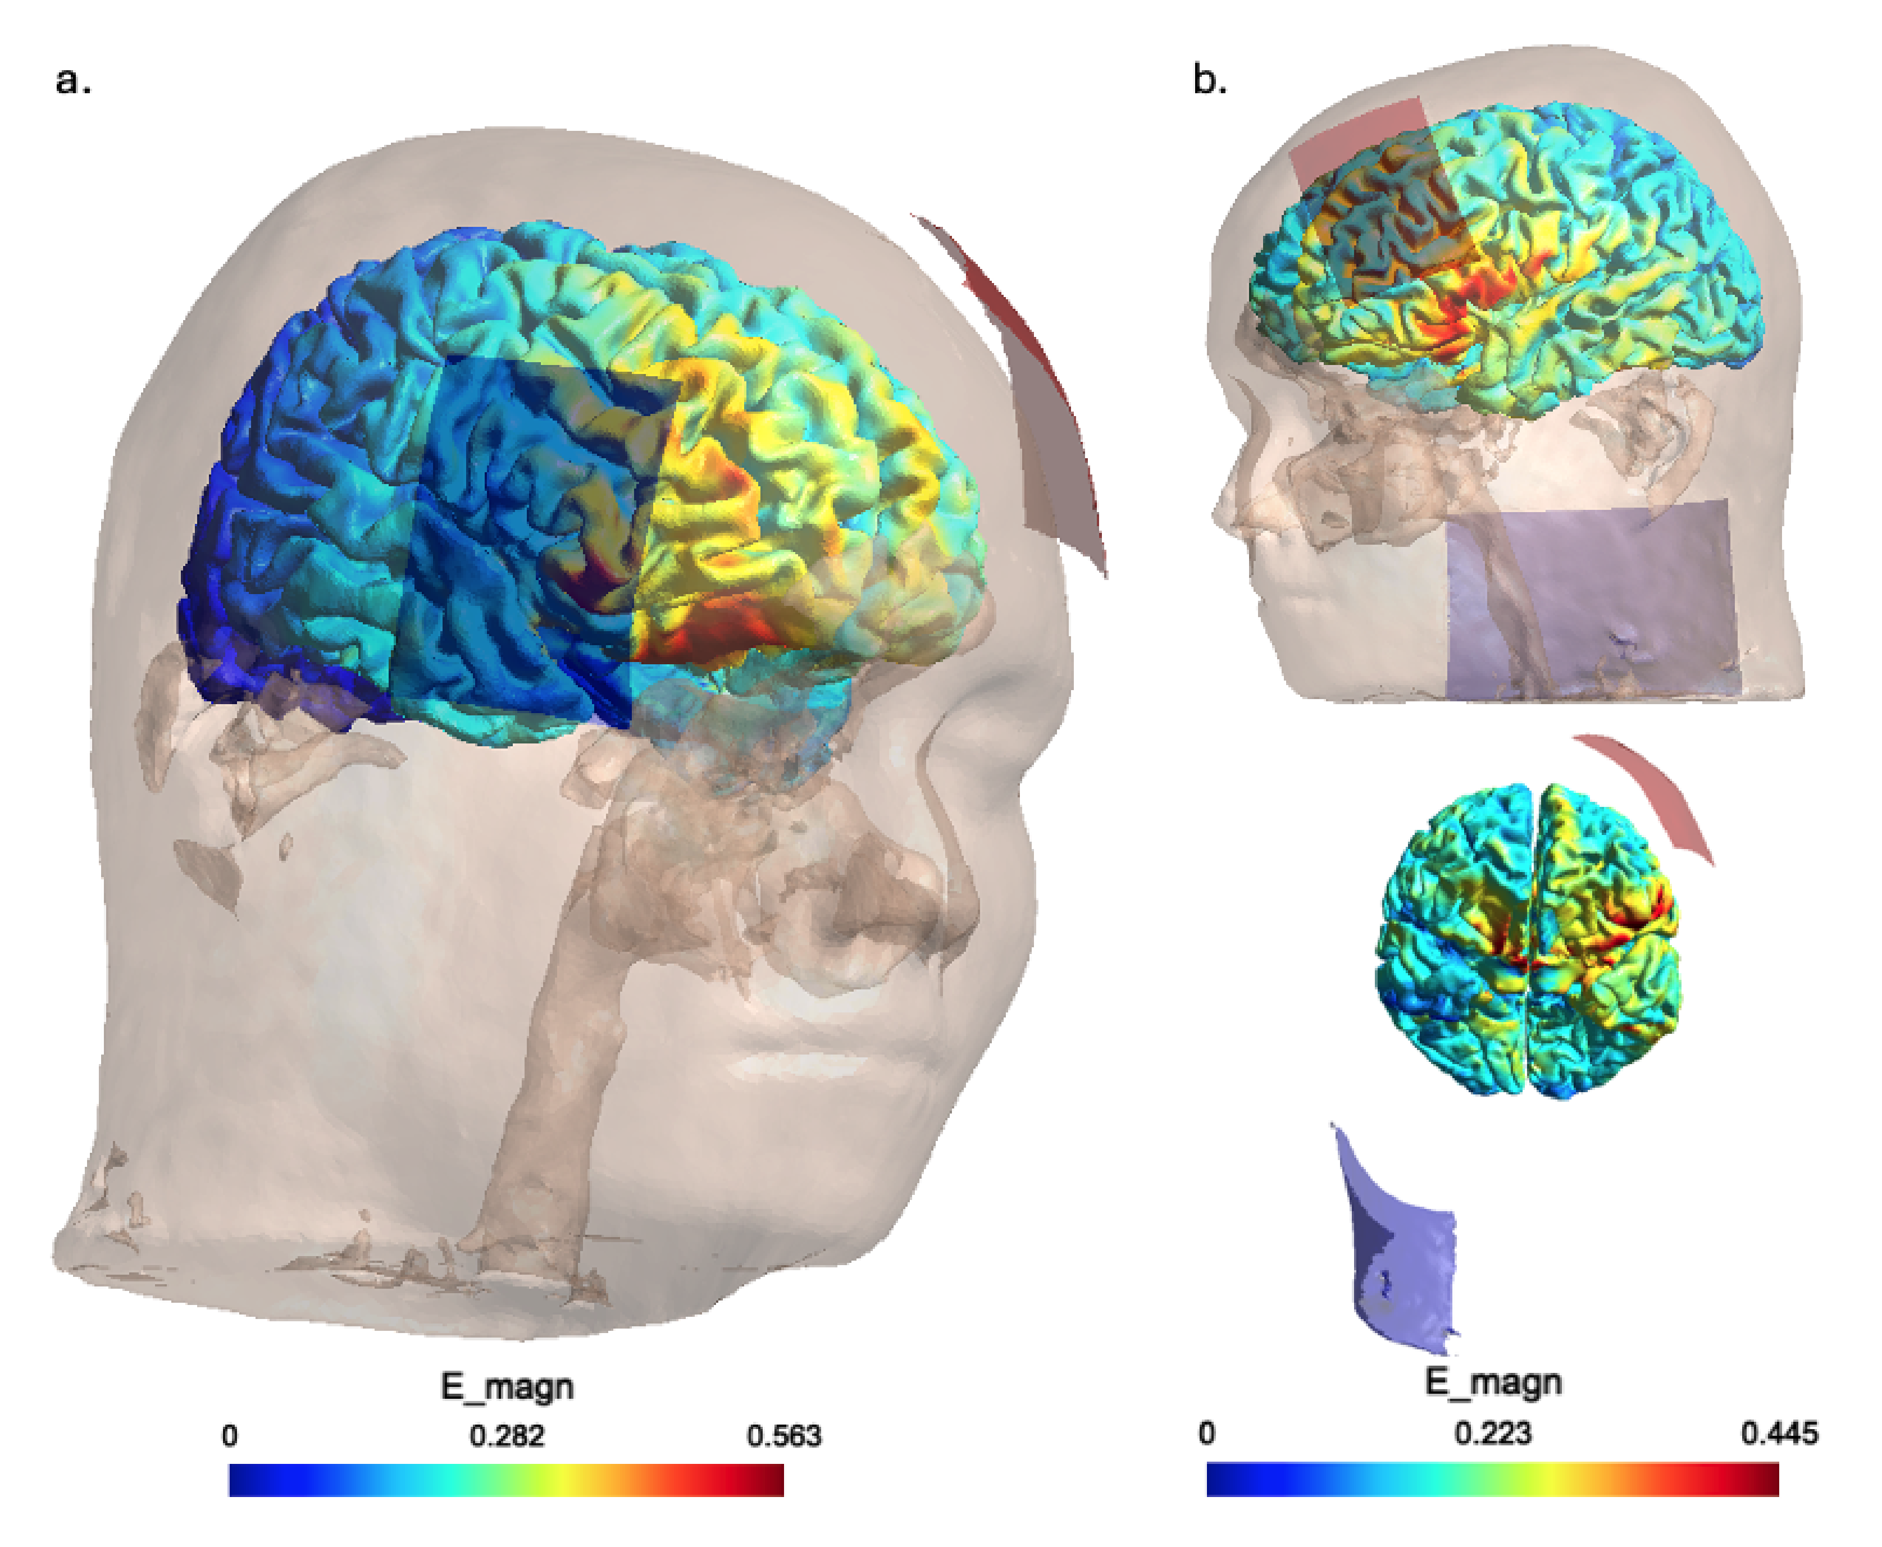
Figure S1. Simulated EF distribution based on the parameters from Salehinejad et al. (2022). Both left and right sagittal views are shown to illustrate the field spread. The stimulation electrode was positioned over the dorsolateral prefrontal cortex (DLPFC), while the return electrode was placed extracephalically. The simulation shows peak EF magnitudes centered over the ventrolateral prefrontal cortex (VLPFC) rather than the intended DLPFC target, potentially accounting for the absence of significant behavioral effects reported in the original study.
The E_magn color bar represents the electric field magnitude in volts per meter (V/m), with blue indicating low EF values and red indicating peak EF intensity (up to ~0.597 V/m in this simulation).

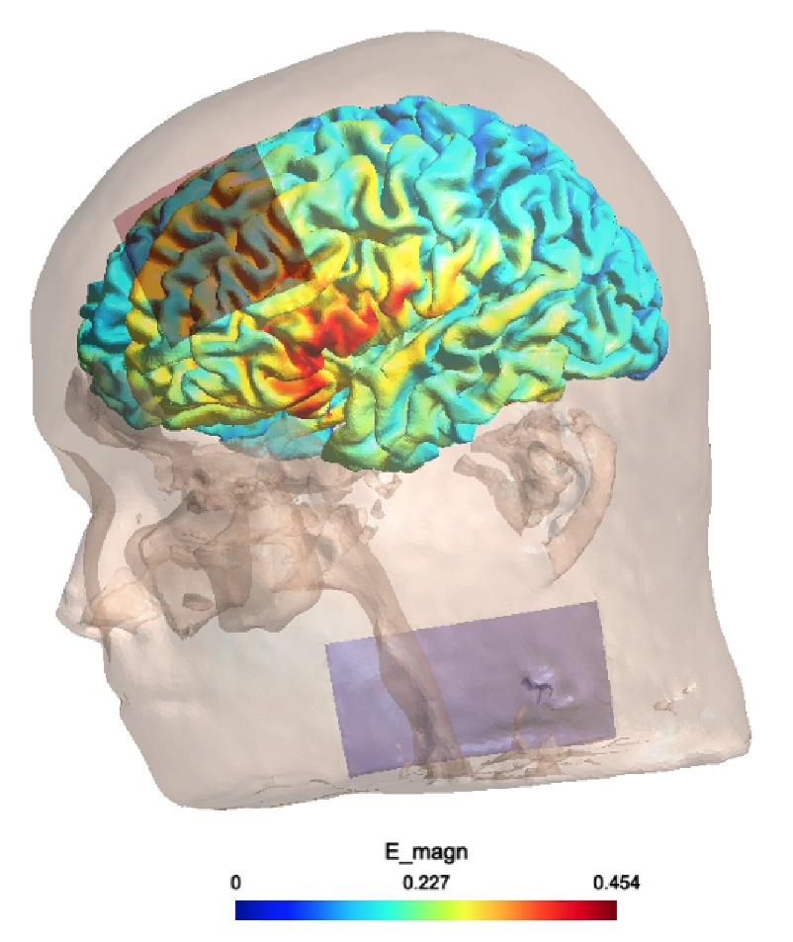
Figure S2. Simulated electric field distribution based on stimulation parameters reported in Duffy et al. (2022). The figure shows a left sagittal view with a contralateral extracephalic electrode placement. The simulation reveals that the peak electric field (EF) is centered over the ventrolateral prefrontal cortex (VLPFC), rather than the intended dorsolateral prefrontal cortex (DLPFC), which may explain the mixed behavioral outcomes observed in the study. The E_magn color bar indicates the EF magnitude in volts per meter (V/m), with blue representing lower intensities and red denoting peak field strength (up to ~0.454 V/m).

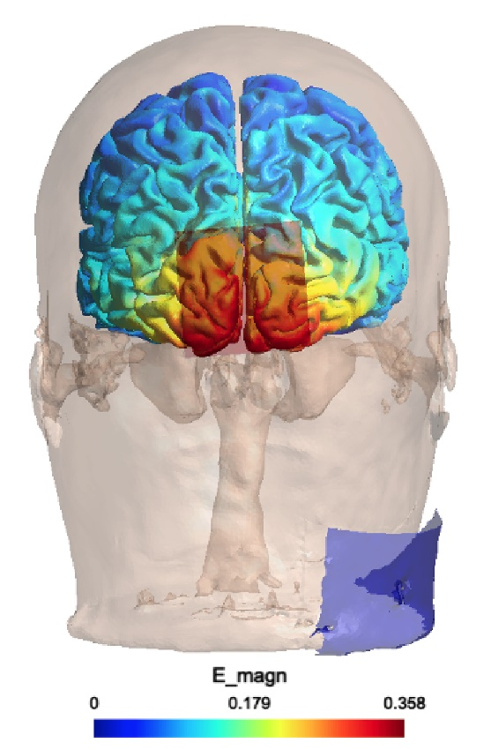
Figure S3. Simulated electric field distribution using stimulation parameters from Fertonani et al. (2011). The posterior view reveals that the peak EF magnitudes are symmetrically distributed across both occipital cortices, aligning well with the intended stimulation target. This accurate targeting likely contributed to the behavioral improvement observed in the study.
The E_magn color bar indicates the electric field magnitude in volts per meter (V/m), ranging from 0 (blue) to 0.358 V/m (red), with red areas representing the peak EF strength.

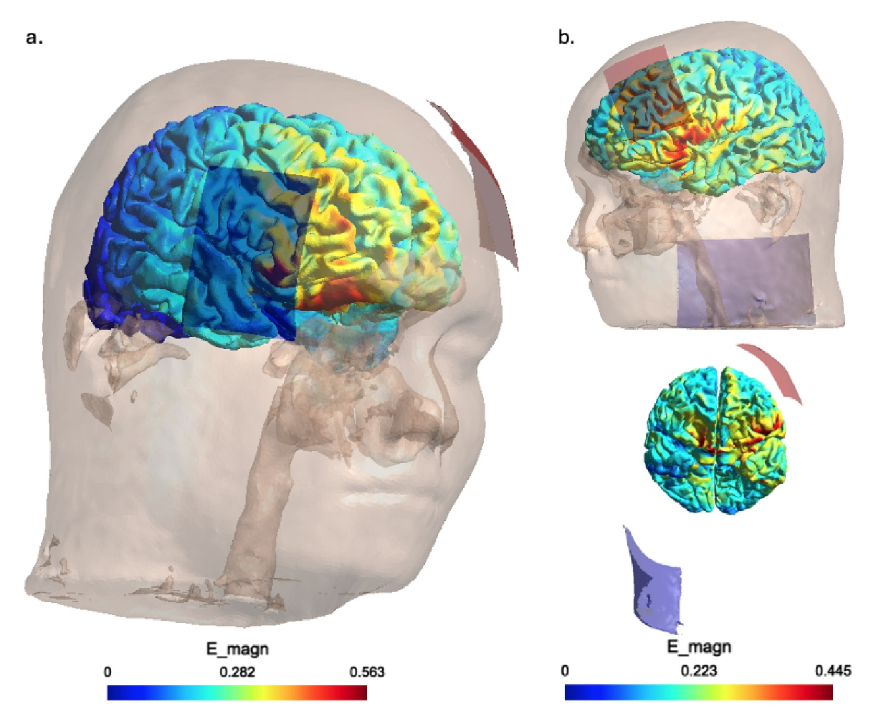
Figure S4. Simulated electric field (EF) distributions based on stimulation parameters from Martin et al. (2011). Panel (a) shows the bifrontal montage simulation, while panel (b) illustrates the extracephalic configuration (side and top views). In both cases, peak EF intensity appears localized around the orbitofrontal cortex, which may relate to the reported clinical improvements in depression (Drevets, 2007). Notably, the extracephalic configuration also results in a distinct EF peak in the left ventrolateral prefrontal cortex (VLPFC), deviating from the intended dorsolateral prefrontal cortex (DLPFC) target. In contrast, the bifrontal montage shows limited EF directly beneath the electrode sites, suggesting a more diffuse or misaligned field distribution. The E_magn color bars indicate EF magnitude (in V/m), with warmer colors (yellow to red) representing higher intensities. Panel (a): 0–0.563 V/m; Panel (b): 0–0.445 V/m.

References
Drevets W. C. (2007). Orbitofrontal cortex function and structure in depression. Annals of the New York Academy of Sciences, 1121, 499–527. https://doi.org/10.1196/annals.1401.029

Duffy, M. J., Feltman, K. A., Kelley, A. M., & Mackie, R. (2024). Limitations associated with transcranial direct current stimulation for enhancement: considerations of performance tradeoffs in active-duty Soldiers. Frontiers in human neuroscience, 18, 1444450. https://doi.org/10.3389/fnhum.2024.1444450

Fertonani, A., Pirulli, C., & Miniussi, C. (2011). Random noise stimulation improves neuroplasticity in perceptual learning. The Journal of neuroscience, 31(43), 15416–15423. https://doi.org/10.1523/JNEUROSCI.2002-11.2011

Martin, D. M., Alonzo, A., Mitchell, P. B., Sachdev, P., Gálvez, V., & Loo, C. K. (2011). Fronto-extracephalic transcranial direct current stimulation as a treatment for major depression: an open-label pilot study. Journal of affective disorders, 134(1-3), 459–463. https://doi.org/10.1016/j.jad.2011.05.018

Salehinejad, M. A., Vosough, Y., & Nejati, V. (2022). The Impact of Bilateral Anodal tDCS over Left and Right DLPFC on Executive Functions in Children with ADHD. Brain sciences, 12(8), 1098. https://doi.org/10.3390/brainsci12081098

Thielscher, A., Antunes, A., & Saturnino, G. B. (2015). Field modeling for transcranial magnetic stimulation: A useful tool to understand the physiological effects of TMS?. Annual International Conference of the IEEE Engineering in Medicine and Biology Society. IEEE Engineering in Medicine and Biology Society. Annual International Conference, 2015, 222–225. https://doi.org/10.1109/EMBC.2015.7318340

Saturnino, G. B., Puonti, O., Nielsen, J. D., Antonenko, D., Madsen, K. H., & Thielscher, A. (2019). SimNIBS 2.1: A Comprehensive Pipeline for Individualized Electric Field Modelling for Transcranial Brain Stimulation. In S. Makarov (Eds.) et. al., Brain and Human Body Modeling: Computational Human Modeling at EMBC 2018. (pp. 3–25). Springer.

