Supplementary Information

Effects of the Perceived Temporal Distance of events on Mental Time Travel and on its underlying brain circuits.
Claudia Casadio^{1,▲,⋆}, Ivan Patané^{2,▲}, Michela Candini², Fausta Lui¹, Francesca Frassinetti^{2,3} and Francesca Benuzzi¹
¹ Department of Biomedical, Metabolic and Neural Sciences, University of Modena and Reggio Emilia, Modena Italy
² Department of Psychology “Renzo Canestrari”, University of Bologna, Bologna, Italy
³ Istituti Clinici Scientifici Maugeri, Hospital IRCCS, Castel Goffredo, Italy
▲These authors share the first authorship.
⋆ corresponding author
e-mail address: claudia.casadio@unimore.it

List of event stimuli used in the MTT task

Supplementary Table 1 List of events. Columns indicate the Self-Projection conditions (Past, Present, Future); lines indicate the correct Self-Reference condition (relative-past, relative-future) for each event, divided between personal and public events (Anelli et al. 2016b).

 | PAST | PRESENT | FUTURE
relative-past- personal | First best friend | First time at the dentist | Graduate
relative-past- personal | First school trip | 10th birthday | 30th birthday
relative-past- personal | First time at the sea | First school day | Maturity examination
relative-past- personal | Bicycle without wheels | First political vote | First political vote
relative-past- personal | 10th birthday | Maturity examination | First salary
relative-past- personal | First day of school | Driving licence | Driving licence
relative-future- personal | 30th birthday | 30th birthday | Living on the moon
relative-future- personal | First political vote | First son | Retirement
relative-future- personal | First son | Silver wedding | Silver wedding
relative-future- personal | Maturity examination | Son marriage | Son marriage
relative-future- personal | Leave the hometown | Graduate | Son graduate
relative-future- personal | Driving licence | First salary | 50th birthday
relative- past-  public | Princess Diana’s death | Obama’s election | Obama’s election
relative- past-  public | Freddy Mercury’s death | Milan Expo | First use of Euro
relative- past-  public | Fall of Berlin wall | Notre Dame fire | Gaddafi’s death
relative- past-  public | Chernobyl disaster | Charlie Hebdo attack | Pope Francesco’s election
relative- past-  public | September 11th | September 11th | Tokyo Olympics
relative- past-  public | Man on the moon | Gaddafi’s death | Napolitano’s election
relative-future- public | Notre Dame’s fire | Peace in middle east | Flying car
relative-future- public | Charlie Hebdo attack | Completely defeat illnesses | World peace
relative-future- public | Milan Expo | Woman president in USA | Completely defeat mafia
relative-future- public | Tokyo Olympics | Completely defeat mafia | Completely defeat illnesses
relative-future- public | Pope Francesco’s election | End of the world | End of the world
relative-future- public | Woman president in USA | Completely defeat world hunger | Completely defeat world hunger

Behavioural results: Accuracy

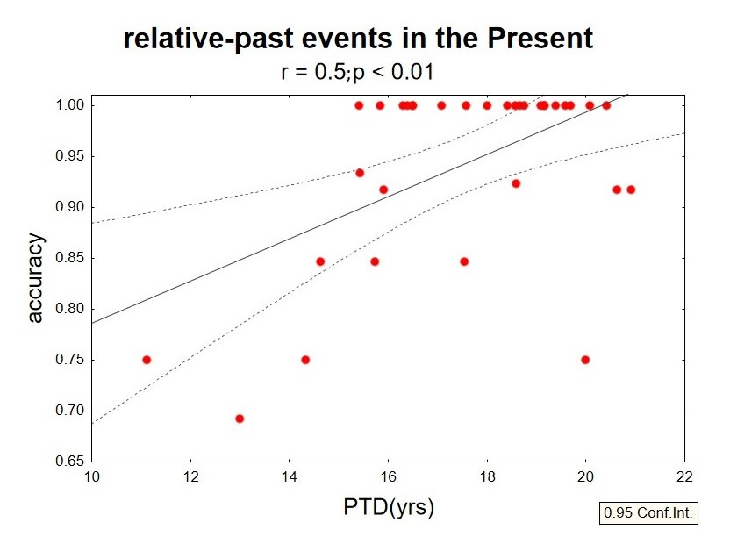

Supplementary Fig. 1 Behavioural results. Mean accuracy (percentage of correct answers) as a function of mean PTD for relative-past events (absolute value) in the Present self-projection condition.
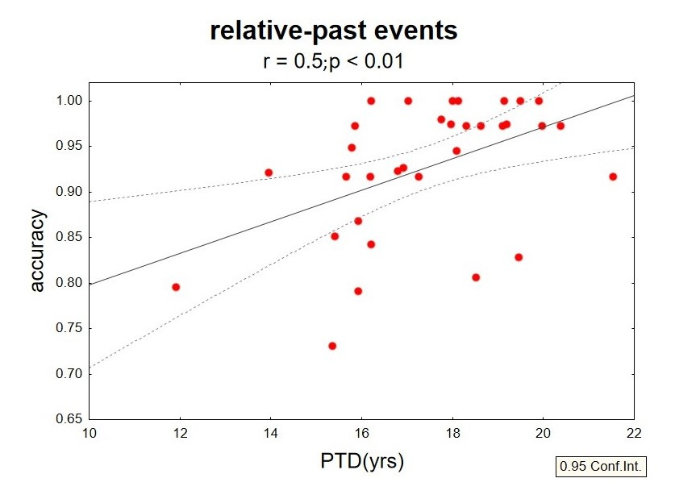

Supplementary Fig. 2 Behavioural results. Mean accuracy (percentage of correct answers) as a function of mean PTD for overall relative-past events (absolute value; Self-Reference condition).

Functional results: parametric analyses conducted on RTs

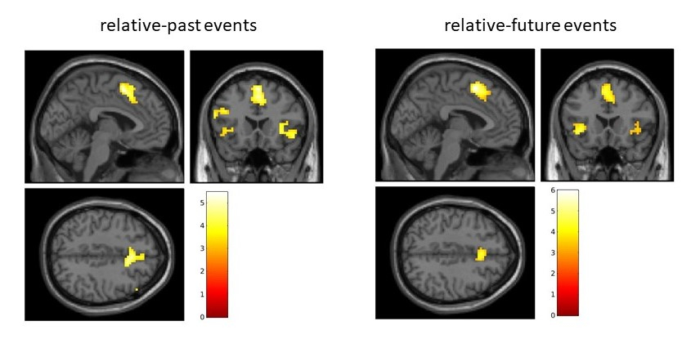
Supplementary Fig. 3 Brain regions whose activity exhibits linear relationships with RTs as a function of Self-Reference conditions. A double statistical threshold was applied to obtain a combined significance, corrected for multiple comparisons, of α < 0.05 (p < 0.001 and k > 69 voxels). Images are in neurological convention (right is right). Color bars represent T-values.

Supplementary Table 2 Results of the linear relationship with RT for relative-past events
Anatomical regions | BA | Side | Cluster | Voxel level | MNI coordinates
 |  |  | K | T | x | y | z
Supplementary Motor Area, Superior Frontal Gyrus, Cingulate Gyrus | 6, 8 | L | 323 | 5.45 | 0 | 11 | 53
Insula, Inferior Frontal Gyrus | 45, 47 | R | 104 | 4.90 | 33 | 26 | -1
Insula, Inferior Frontal Gyrus | 45, 47 | L | 88 | 4.75 | -30 | 26 | -1
Inferior Frontal Gyrus | 9 | R | 81 | 4.46 | 39 | 53 | 23
Inferior Frontal Gyrus | 9, 10 | L | 142 | 4.32 | -48 | 14 | 26

Areas of significant changes in fMRI signal as a function of RT for relative-past events; BA = Brodmann area; L = left; R = right. A double statistical threshold was applied to obtain a combined significance, corrected for multiple comparisons, of α < 0.05 (p < 0.001, k > 69 voxels)

Supplementary Table 3 Results of the linear relationship with RT for relative-future events
Anatomical regions | BA | Side | Cluster | Voxel level | MNI coordinates
 |  |  | K | T | x | y | z
Supplementary Motor Area, Superior Frontal Gyrus, Cingulate Gyrus | 6, 8 | L | 242 | 5.97 | -3 | 8 | 53
Insula, Inferior Frontal Gyrus | 45, 47 | R | 76 | 4.93 | 33 | 26 | 2
Insula, Inferior Frontal Gyrus | 45, 47 | L | 100 | 4.84 | -39 | 17 | -4

Areas of significant changes in fMRI signal as a function of RT for relative-future events; BA = Brodmann area; L = left; R = right. A double statistical threshold was applied to obtain a combined significance, corrected for multiple comparisons, of α < 0.05 (p < 0.001, k > 69 voxels)

Behavioural data analyses and results at MTT task
Two Separate Repeated-measures ANOVAs were conducted on reaction times (RTs) and accuracy, having Self-Projection (Past, Present, Future) and Self-Reference (relative-past, relative-future) as within-participants factors. Effect size was reported as partial eta squared (η²_{p}). When significant, interactions were followed-up by Duncan Post-hoc tests. Mean values and standard error means (SEM) were reported for each condition.

Reaction Time
Data showed a significant main effect of Self-Projection (F_{2,64}= 76.91; p< 0.0001; η²_{p}= 0.71) with all the conditions different from each other (mean RT in Past 3866.87 ± 64.1; Present 3365.28 ± 47.4; Future 3625.9 ± 52.2). There was also a significant Self-Projection x Self-Reference interaction (F_{2,64}= 6.65; p< 0.01; η²_{p}= 0.17). Post-hoc analysis showed that performances for relative-future events were significantly faster as compared to relative-past events when participants were projected to the Future (mean 3526.24 ± 50.21 vs 3725.72 ± 68.29 ms; p<0.01).

Accuracy
Data showed a significant main effect of Self-Projection (F_{2,64}= 10.63; p< 0.0001; η²_{p}= 0.25), with significantly lower accuracy in Past Self-Projection (0.88 ± 0.0) as compared to both the other conditions (1; Present 0.92 ± 0.01; Future 0.93 ± 0.01), which did not different from each other . The Self-Reference main effect was also significant (F_{1,32}= 8.81; p< 0.01; η²_{p}= 0.21), with lower accuracy for relative-future as respect to relative-past events (mean 0.89 ± 0.01 vs 0.93 ± 0.01).

Functional data analyses and results of the MTT task
Functional data were pre-processed and analysed using MatLab (MathWorks Inc., Natick, MA, USA) and SPM12 softwares (Wellcome Department of Imaging Neuroscience). The following pre-processing steps were used: slice-timing, spatial realignment, normalization to the MNI template and smoothing with a 6 mm full width Gaussian filter. Single-subject statistical analysis was performed using the General Linear Model (GLM), where the time-series data were modelled as a series of events convolved with a canonical hemodynamic response function. Regressors of interest were as many as the combinations of factors, i.e., the experimental conditions. Motor answer, errors and head-motion parameters (translations and rotations) were entered as nuisance variables. Each experimental condition was compared to the baseline and the other conditions and individual contrast images were used for the whole brain random effect analysis. A full-factorial ANOVA with Self-Projection (Past, Present, Future) and Self-Reference (past, future) as factors was conducted on single subject contrast images.
During the MTT task execution a widespread network was activated, comprising right Parahippocampal gyrus and Postcentral Gyrus (BA 1, 2, 3, 30, 36), and bilateral Posterior Parietal Cortex (BA 39, 40), Precuneus (BA 19), Occipital cortex (BA 18, 19), Cerebellum, Basal Ganglia and Inferior, Middle and Superior Frontal gyri (BA 10, 45, 46, 47). For more detailed results, Casadio et al. (in press).

