Supplementary Material
Table of contents
Detailed patient and variant information 2
Familial analysis 4

Details of centres involved
Study | Reference publication
Dublin-Ireland (Beaumont Hospital) | Benson et al 2021[1]
Leipzig-Germany (University of Leipzig Medical Center) | Schӧnhauer et al 2020[2]
Bologna-Italy (Alma Mater Studiorum, University of Bologna) | Mantovani et al 2020[3]
Sydney-Australia (Garvan Institute of Medical Research) | Mallawaarachchi et at 2016[4]
Nantes-France (Nantes University Hospital) | Currently unpublished
Rochester-United States (Mayo Clinic) | Mallawaarachchi et al 2021[5]
London-United Kingdom (Genomics England) | The National Genomic Research library 2020[6]

Detailed patient and variant information
Supplementary Table S1: Summary of the RAPPA variants in this cohort. The ACMG classification of each variant, along with its global gnomAD frequency and count in this dataset are also given.
RAPPA | ACMG Class | gnomAD frequency | Count
p.Arg1547His | VUS (PM2) | 0.00001924 | 1
p.Arg3647Trp | VUS (PM2, BS2) | 0.0004605 | 2
p.Ser1957Arg | VUS (PM2) | 0 | 1
p.Gln1908Pro | VUS (PM2) | 0.0000012 | 1
p.Arg3748Trp | VUS (PM2, PP3) | 0.0000006853 | 1
p.Pro450Thr | VUS (PM2, BP4) | 0.0001805 | 2
p.Arg2186Cys | VUS (PM2) | 0.00001732 | 1
p.Cys874Phe | VUS (PM2) | 0.0000012 | 1
p.Thr775Met | VUS (PM2) | 0.00001302 | 1
p.Leu3477Ile | VUS (PM2, BP4) | 0.0003457 | 2
p.Ser2807Tyr | VUS (PM2) | 0 | 1
p.Leu1442Phe | VUS (PM2) | 0.00000137 | 1
p.Pro398Leu | VUS (PM2, PP3, PP5) | 0.00003721 | 1
p.Arg2220Gly | VUS (PM2, PM5) | 0.000008703 | 1
p.Asp2972Asn | VUS (PM2, BP4) | 0.0001312 | 1
p.His2998Gln | VUS (PM2) | 0.000001371 | 1
p.Thr1589Met | VUS (PM2) | 0.000006848 | 1
p.Arg2024Cys | VUS (PM2, PP3) | 0.0000237 | 2
p.Gly3877Ser | VUS (PM2) | 0.000009066 | 2
p.Pro655Leu | VUS (PM2, BP1) | 0.0001294 | 1
p.Arg3247Cys | VUS (PM2, PM5, PP3) | 0.00001133 | 1
p.Gly1944Arg | VUS (PM2, PP3) | 0 | 1
p.Ala989Thr | VUS (PM2) | 0.00000809 | 2
p.Ala1985Thr | VUS (PM2) | 0.000002081 | 2
p.Asp1246Asn | VUS (PM2) | 0.00003288 | 1
p.Ala2871Thr | VUS (PM2) | 0.00009129 | 1
p.Lys3607Met | VUS (PM2, PP3) | 0 | 2
p.Val49Leu | VUS (PM2, BP4) | 0 | 1
p.Gly60Cys | VUS (PM2) | 0 | 1
p.Ile2646Thr | VUS (PM2, BS2) | 0.0002447 | 1
p.Glu2810Lys | VUS (PM2, BP4) | 0.0001068 | 1
p.Thr1354Met | VUS (PM2) | 0.0000447 | 1
p.Glu3925Ala | VUS (PM2) | 0.000004691 | 1
p.Gly2452Cys | VUS (PM2, PM1) | 0 | 1
p.Ala3991Val | VUS (PM2) | 0.00002894 | 1
p.Arg2518His | VUS (PM2) | 0.00002298 | 1
p.Arg3209Cys | VUS (PM2, BP1) | 0.00004594 | 1
p.Asp3239Asn | VUS (PM2, PP3) | 0.00001374 | 1
p.Asn2620Ser | VUS (PM2, PP3) | 0.0002506 | 1
p.Arg3348Gln | VUS (PM2, BS2) | 0.009045 | 1
p.Met2760Thr | VUS (PM2) | 0.000001864 | 1
p.Glu685Gly | VUS (PM2, PM5) | 0.0000007005 | 1
p.Pro2965Ala | VUS (PM2, BP4) | 0 | 1
p.Gln2670Arg | VUS (PM2, BS4) | 0.0002911 | 1
p.Arg1425Cys | VUS (PM2, BP4) | 0.00002358 | 1
p.Arg600Trp | VUS (PM2, BP4) | 0.00003548 | 1
RAPPA: Rare, Additional, Potentially Protein Altering (RAPPA) VUS: variant of unknown significance

Familial analysis
Supplementary Table S2. The impact of RAPPA variants on kidney survival, taking just one individual from each family. Cox model controlling for diagnostic variant type and sex.
Characteristic | HR (95% CI) | P-value
Kidney survival (n = 747, R² = 0.22)
Diagnostic variant type
PKD1-T | 1 | -
PKD1-NT | 0.38 (0.30, 0.47) | <0.001
Sex
Female | 1 | -
Male | 1.52 (1.24, 1.85) | <0.001
RAPPA variant (n = 42) | 1.55 (1.05, 2.25) | 0.03
CI: Confidence Interval, HR: Hazard ratio, RAPPA: Rare, Additional, Potentially Protein Altering (RAPPA) PKD1 variants, PKD1-NT: PKD1-non truncating mutation, PKD1-T: PKD1 truncating mutation.

Survival curves for individuals with and without RAPPA variants
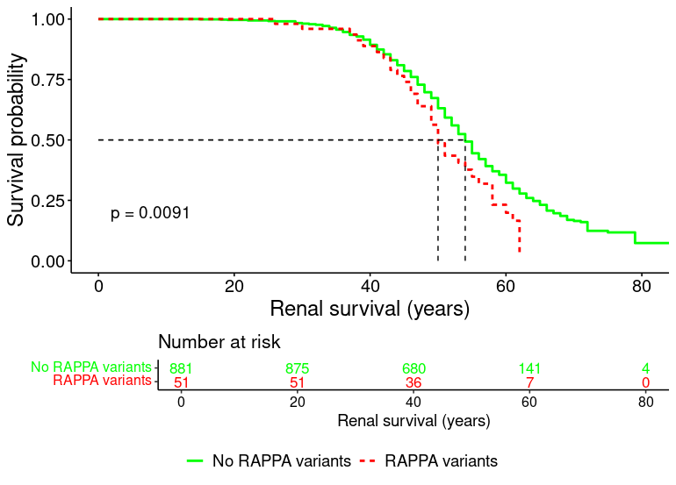
Supplementary Figure S1: Kaplan-Meier plot comparing kidney survival of patients with and without RAPPA variants. Dotted lines indicate median survival for each group. With RAPPA variants n=51, without n=881. Median survival of those without RAPPA variants is 54 years, median survival of those with RAPPA variants is 50 years (P = 0.009).

References
[1] K. A. Benson et al., “The genetic landscape of polycystic kidney disease in Ireland,” European Journal of Human Genetics, vol. 29, no. 5, pp. 827–838, 2021, doi: 10.1038/s41431-020-00806-5.
[2] R. Schönauer et al., “Matching clinical and genetic diagnoses in autosomal dominant polycystic kidney disease reveals novel phenocopies and potential candidate genes,” Genetics in Medicine, vol. 22, no. 8, pp. 1374–1383, Aug. 2020, doi: 10.1038/s41436-020-0816-3.
[3] V. Mantovani et al., “Gene Panel Analysis in a Large Cohort of Patients With Autosomal Dominant Polycystic Kidney Disease Allows the Identification of 80 Potentially Causative Novel Variants and the Characterization of a Complex Genetic Architecture in a Subset of Families,” Frontiers in Genetics, vol. 11, no. May, pp. 1–14, May 2020, doi: 10.3389/fgene.2020.00464.
[4] A. C. Mallawaarachchi et al., “Whole-genome sequencing overcomes pseudogene homology to diagnose autosomal dominant polycystic kidney disease,” European Journal of Human Genetics, vol. 24, no. 11, pp. 1584–1590, Nov. 2016, doi: 10.1038/ejhg.2016.48.
[5] A. C. Mallawaarachchi et al., “Genomic diagnostics in polycystic kidney disease: an assessment of real-world use of whole-genome sequencing,” European Journal of Human Genetics, pp. 1–11, Jan. 2021, doi: 10.1038/s41431-020-00796-4.
[6] Genomics England, “The National Genomic Research Library v5.1.”

