Supplementary material for:

Application of whole-eDNA sequencing for monitoring broodstock genetic diversity in breeding groups of gilthead seabream (Sparus aurata)

Francesca Bertoliniª, Valeria Taurisanoª, Samuele Bovoª, Jacopo Vegni ª, Riccardo Napolitano^{b}, Marco Martinoli^{b}, Fabrizio Capoccioni^{b}, Luca Fontanesiª
ª Department of Agricultural and Food Sciences, Division of Animal Sciences, University of Bologna, Viale G. Fanin 46, 40127 Bologna, Italy
^{b} Centro di Ricerca Zootecnia e Acquacoltura, Consiglio per la ricerca in agricoltura e l’analisi dell’economia agraria (CREA), 00198, Roma, Italy.

Correspondence: francesca.bertolini3@unibo.it

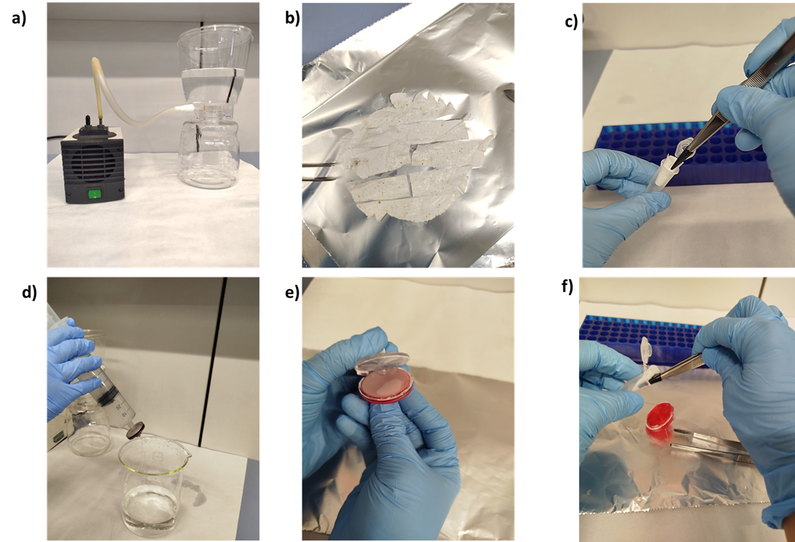

Figure S1. Water filtering main steps with the 0.2 µm and 1.2 and 5 µm. For the 0.2 µm, filtering with the vacuum pump (a), extraction of the filter (b), and collection of the tube (c). For the 1.2 and 5 1.2 and 5 µm, manual filtering (d), opening of the filter envelope (e), and collection of the filter (f).

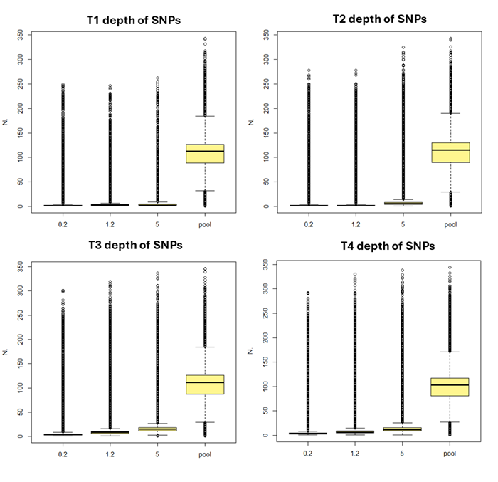
Figure S2. Depth of the called SNPs divided by Tanks (T1-T4) and by type of genomic information (eDNA from filters of 0.2, 1.5, and 5 μm and DNA pools).

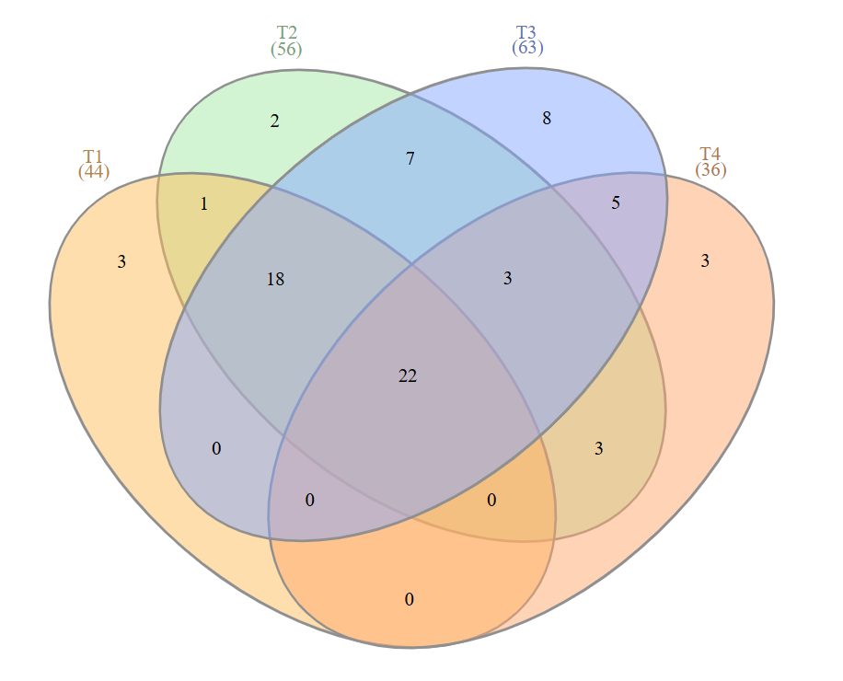

Figure S3. Venn diagram showing the distribution of phyla with significant differences (p<0.05, Bonferroni-corrected) in relative abundance among eDNA samples from filters with different pores (0.2 µm, 1.2 µm, 5 µm) across the four tanks (T1–T4). Numbers within each area indicate the count of phyla uniquely or jointly identified as significant in the respective tanks.

See Excel
Supplementary Table S1. Genome-wide estimates of within-tank genetic diversity (F_{IS}-like index) for eDNA samples from filters with different pores (0.2 µm, 1.2 µm, 5 µm) and corresponding DNA pools across tanks (T1–T4). For each dataset, the table reports the number of SNPs shared with the respective DNA pool, F_{IS}-like estimates, standard errors (SE), and 95% confidence intervals (CI95%) obtained using a leave-one-chromosome-out (LOCO) jackknife. ΔF_{IS} corresponds to the difference between eDNA samples and DNA pool estimates, with its SE, CI95%, and the corresponding F_{ST} values reported for both unbalanced and depth-balanced analyses.
Supplementary Table S2. Relative read abundance and statistical comparison of phylum-level taxonomic composition among eDNA samples from filters with different pores (0.2 µm, 1.2 µm, 5 µm) for Tank 1. For each phylum, the table reports the percentage of total reads assigned to that taxon in each filter (perc_1, perc_2, perc_3), the p-values obtained from a test of equal proportions (p_value), and Bonferroni-adjusted p-values (p_bonf). Only significant phyla after Bonferroni correction (p_bonf<0.05) are reported
Supplementary Table S3. Relative read abundance and statistical comparison of phylum-level taxonomic composition among eDNA samples from filters with different pores (0.2 µm, 1.2 µm, 5 µm) for Tank 2. For each phylum, the table reports the percentage of total reads assigned to that taxon in each filter (perc_1, perc_2, perc_3), the p-values obtained from a test of equal proportions (p_value), and Bonferroni-adjusted p-values (p_bonf). Only significant phyla after Bonferroni correction (p_bonf<0.05) are reported
Supplementary Table S4. Relative read abundance and statistical comparison of phylum-level taxonomic composition among eDNA samples from filters with different pores (0.2 µm, 1.2 µm, 5 µm) for Tank 3. For each phylum, the table reports the percentage of total reads assigned to that taxon in each filter (perc_1, perc_2, perc_3), the p-values obtained from a test of equal proportions (p_value), and Bonferroni-adjusted p-values (p_bonf). Only significant phyla after Bonferroni correction (p_bonf <0.05) are reported
Supplementary Table S5. Relative read abundance and statistical comparison of phylum-level taxonomic composition among eDNA samples from filters with different pores (0.2 µm, 1.2 µm, 5 µm) for Tank 4. For each phylum, the table reports the percentage of total reads assigned to that taxon in each filter (perc_1, perc_2, perc_3), the p-values obtained from a test of equal proportions (p_value), and Bonferroni-adjusted p-values (p_bonf). Only significant phyla after Bonferroni correction (p_bonf <0.05) are reported

