Appendix S1. Details on the APEHQ questionnaire (Ikeda et al.,2002).

This questionnaire is comprehensive of 34 items arranged in five subscales, each of which assessing different eating aspects: swallowing, appetite, eating habits, food preference and other oral behaviours. In each section there are several questions, each of which requires to state the frequency of the behaviour on a scale from 0 to 4 (with 0 corresponding to “never”, 1 to “less than once a week”, 2 to “about once a week”, 3 to “several times a week”, 4 to “daily or continuously”) and its severity (0, “none”; 1, “mild”; 2, “moderate”; and 3, “severe”). The score at each question is the product of frequency * severity. The minimum score for each question is 0, whereas the maximum is 12. The first subscale describes difficulties related to Swallowing, such as “Has he/she ever had difficulty in swallowing food?”. The maximum score that can be obtained at the swallowing subscale is 96 as well as at the appetite subscale – both scales have 8 items. The latter describes behaviour such as hyperphagia, by asking for instance “Does he/she search for food in-between meals?”. The scale Changes in eating habits (6 items) describes changes in habits such as that described by the item “Does he/she want to cook or eat exactly the same food every day?”. The maximum score for this scale is 72. The scale of changes in eating preferences describes this dimension by asking questions such as “Has his/her taste changed in some way (e.g., does he/she eat more meat, more fried food?)” and the maximum score is 84. Finally, the subscale investigating the presence of other oral behaviours, includes questions such as “Has he/she become a heavy smoker or has taken up smoking again?”, with a maximum score of 60.

Appendix S2. Error analysis on naming and word-picture matching tasks.
The purpose of this analysis is to provide more information as to the type of deficit entailed by patients’ disorder. For what concerns naming task, errors could be: anomia (not remembering the noun), visual (visually misinterpreting the stimulus), semantic (name an object belonging to the same category or the subordinate), poor circumlocutions (poorly articulated descriptions of the object), good circumlocution (effective description of the object), verbal paraphasia (uttering a noun that sounds similar to that of the target), confabulations (the patient starts talking about unrelated topics when asked to name the object). For what concerns the word-picture matching task, errors could be: visual (pointing an object visually similar to the target), semantic (pointing an object from the same semantic category), verbal (pointing an object that has a name that sounds similar to the target’s).
Means and standard deviations for the type errors made by patients are described in Table 1. At the naming task, the mean of semantic errors is greater for patients with svPPA, if qualitatively compared to the other two groups. In addition, for what concerns food and non-food, we found an interesting significant difference when running paired t-tests comparing the error types at the naming task for these two categories. Specifically, semantic errors were significantly more for food than non-food items (t = -3.4, p = .003), whereas the pattern was inverted for visual errors, good circumlocutions and poor circumlocutions. No significant difference was found for anomia and verbal paraphasia ( Table 1).
At the word picture matching task, all patients make more semantic errors than visual errors, and verbal errors are extremely rare. In addition, based on the mean values, we can observe that svPPA patients make more semantic errors in general, and specifically for food items. Also AD patients show a similar pattern, whereas it seems to be the opposite for bvFTD.
It is to note that, regardless of diagnosis, anomia is a very common error type, and also patients with bvFTD and AD make semantic errors (Table 1).

Table 1

Naming and word-picture matching errors , divided by food and non-food. Semantic errors are significantly more frequent for food if compared to non-food, whereas this is not true for the other error types.
Naming
 |  | bvFTD |  |  | AD |  |  | svPPA
 |  | Mean | SD |  | Mean | SD |  | Mean | SD
Nonfood | Anomia | 1.71 | 2.56 |  | 3.60 | 6.48 |  | 1.20 | 0.84
 | Visual | 2.14 | 0.90 |  | 1.30 | 1.16 |  | 1.20 | 1.30
 | Semantic | 3.00 | 1.63 |  | 2.80 | 1.99 |  | 3.60 | 2.88
 | Poor circ. | 2.14 | 1.95 |  | 3.10 | 4.28 |  | 6.80 | 6.61
 | Good circ. | 1.43 | 1.13 |  | 1.50 | 1.18 |  | 1.60 | 2.19
 | Verbal | 0.14 | 0.38 |  | 0.20 | 0.42 |  | 0.00 | 0.00
 | Confabulations | 0.00 | 0.00 |  | 0.00 | 0.00 |  | 0.20 | 0.45
Food | Anomia | 2.71 | 2.50 |  | 3.60 | 8.00 |  | 4.00 | 3.39
 | Visual | 0.71 | 0.76 |  | 0.90 | 1.10 |  | 0.80 | 0.84
 | Semantic | 4.29 | 2.06 |  | 6.20 | 4.85 |  | 6.60 | 4.16
 | Poor circ. | 0.14 | 0.38 |  | 1.20 | 1.40 |  | 3.60 | 4.51
 | Good circ. | 0.71 | 0.95 |  | 0.60 | 0.84 |  | 0.80 | 1.30
 | Verbal | 0.00 | 0.00 |  | 0.20 | 0.42 |  | 0.00 | 0.00
 | Confabulations | 0.00 | 0.00 |  | 0.10 | 0.32 |  | 0.00 | 0.00

Word-picture matching
 | bvFTD |  |  | AD |  |  | svPPA
 | Mean | SD |  | Mean | SD |  | Mean | SD
Nonfood
Semantic | 1.14 | 1.46 |  | 1.09 | 1.58 |  | 1.60 | 2.30
Visual | 0.00 | 0.00 |  | 0.91 | 1.81 |  | 0.20 | 0.45
Verbal | 0.14 | 0.38 |  | 0.18 | 0.60 |  | 0.20 | 0.45
Food
Semantic | 0.86 | 1.21 |  | 1.55 | 2.94 |  | 2.20 | 2.59
Visual | 0.00 | 0.00 |  | 0.18 | 0.40 |  | 0.00 | 0.00
Verbal | 0.00 | 0.00 |  | 0.09 | 0.30 |  | 0.20 | 0.45

Appendix S3. Semantic performance for food and non-food items on patients versus healthy controls
In the ANOVA comparing performance on naming food and non-food performance, no Type of item effect was found [F (1, 38) = .35, p = .56, η² = 01]. A significant effect of Group emerged [F (3, 38) = 22.56, p < .001, η² = .64]. Specifically, performance of healthy controls was higher thanthose of bvFTD, svPPA and Alzheimer’s patients (ps < .001). In addition, svPPA performed worse than all of the other patients’ groups (ps < .05) and bvFTD perfomed worse than Alzheimer’s patients (p < .001). No significant interaction between Type of item * Group was observed [F (3, 38) = 0.7, p = .52, η² = .06].
The ANOVA on the word to picture matching tasks revealed a quasi-significant main effect of Type of item [F (1, 38) = 3.88, p = .06, η² = .09], with food being tendentially better recognized than non-food. As for the naming task, bvFTD and svPPA patients (ps < .04), but not Alzhiemer’s patients (p = .19) performed significantly worse than healthy controls. Differently from the naming task, no differences were observed between patients’ groups performance. No significant interaction between Type of item * Group was observed [F (3, 38) = 1.9, p = .14, η² = .06].

Appendix S4. Scores at the APEHQ subscales for each of our patients.

Group | Swallowing | Appetite | Habits | Preferences | Oral Behaviours
bvFTD
P1 | 1 | 3 | 9 | 5 | 5
P2 | 21 | 71 | 7 | 17 | 19
P3 | 0 | 0 | 0 | 0 | 0
P4 | 2 | 2 | 7 | 5 | 0
P5 | 0 | 0 | 14 | 8 | 11
P6 | 0 | 17 | 1 | 0 | 0
P7 | 0 | 0 | 8 | 5 | 13
SD
P1 | 10 | 0 | 3 | 0 | 3
P2 | 11 | 0 | 11 | 15 | 0
.. | 0 | 0 | 23 | 0 | 0
.. | 0 | 15 | 44 | 35 | 0
P5 | 0 | 5 | 5 | 13 | 0
AD
P1 | 0 | 1 | 0 | 41 | 0
P2 | 0 | 17 | 9 | 0 | 0
P3 | 0 | 12 | 8 | 19 | 0
P4 | 0 | 5 | 6 | 12 | 1
P5 | 0 | 0 | 17 | 11 | 0
P6 | 11 | 21 | 35 | 68 | 35
P7 | 0 | 0 | 0 | 0 | 0
P8 | 0 | 0 | 0 | 0 | 0
… | 0 | 0 | 0 | 0 | 0
.. | 0 | 0 | 0 | 0 | 0
P11 | 0 | 2 | 1 | 0 | 0
Appendix S5. Regression analyses with non-food accuracy as a predictor. We carried out regression models with non-food as a predictor for the scores at the two subscales (changes in habits, changes in preferences) that were significantly predicted by food accuracy scores, as reported in the main text. Non-food semantic performance significantly predicts changes in eating habits but not in preferences.
Specifically, accuracy at naming nonfood significantly predicts the pathological score at the subscale changes in eating habits [F (1,42) = 9.63, p = .004], with an R² of .19. Similarly, accuracy at word-picture matching performance for nonfood predicts the pathological scores at changes in eating habits [F (1, 42) = 8.78, p = .005], with an R² of .18.
For what concerns changes in eating preferences, neither naming non-food naming non-food [F (1,42) = 3.7, p = .06], with an R² of .05, and word-picture matching non food [F (1,42) = 2.28, p = .15] with an R² of .06, significantly predict the scores at this subscale.

Appendix S6. VBM for naming task only. pFWE <.05.
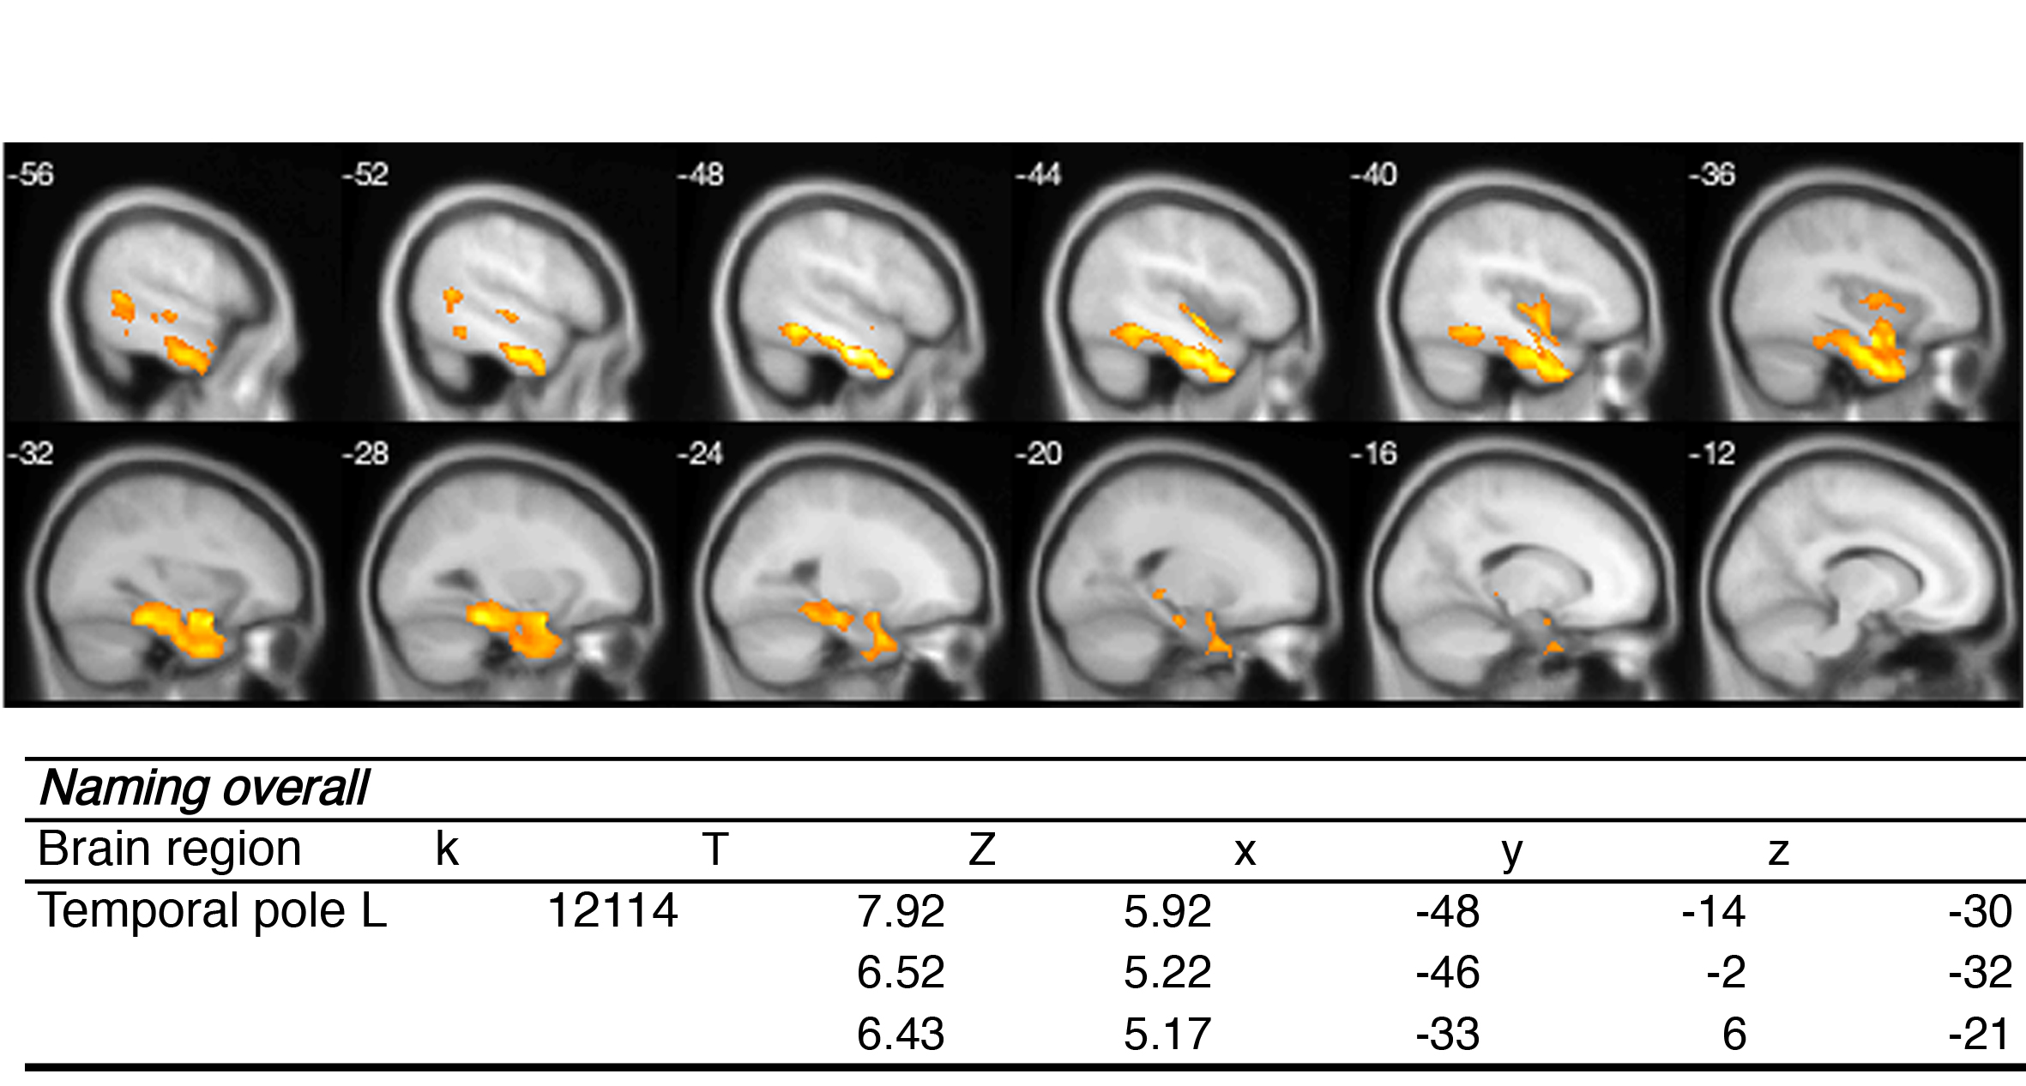

Appendix S7. VBM for word-picture matching only. p uncorrected <.001.
