Supplementary Results

Trial-by-trial descriptive representation of physiological responses
Skin conductance response (SCR). Figure 1 illustrates the trial-by-trial moving average of SCR (window length = 2 trials) for CS+ and CS−, averaged across participants, separately for the contralateral and ipsilateral hands. Descriptively, SCR appears greater for the CS+ than the CS−, during the majority of trials in both hands. Notably, at the beginning of reversal, a few trials are required before the difference between CS+ and CS- re-emerges.
To further quantify the dynamic nature of prediction updating, we conducted a follow-up analysis on the reversal phase, to investigate within-phase changes in SCR. Specifically, reversal trials were divided into early (first 10 trials) and late segments (second 10 trials), and, for each participant, mean SCR was computed separately for each segment. The 2 (CS Type: CS+, CS−) × 2 (Reversal Segment: Early, Late) × 2 (Laterality: Ipsilateral, Contralateral Hand) repeated-measures ANOVA revealed no significant main effect or interaction involving the factor Reversal Segment (all ps ≥ .170), indicating that mean SCRs did not significantly change between the early and late portions of the reversal phase.

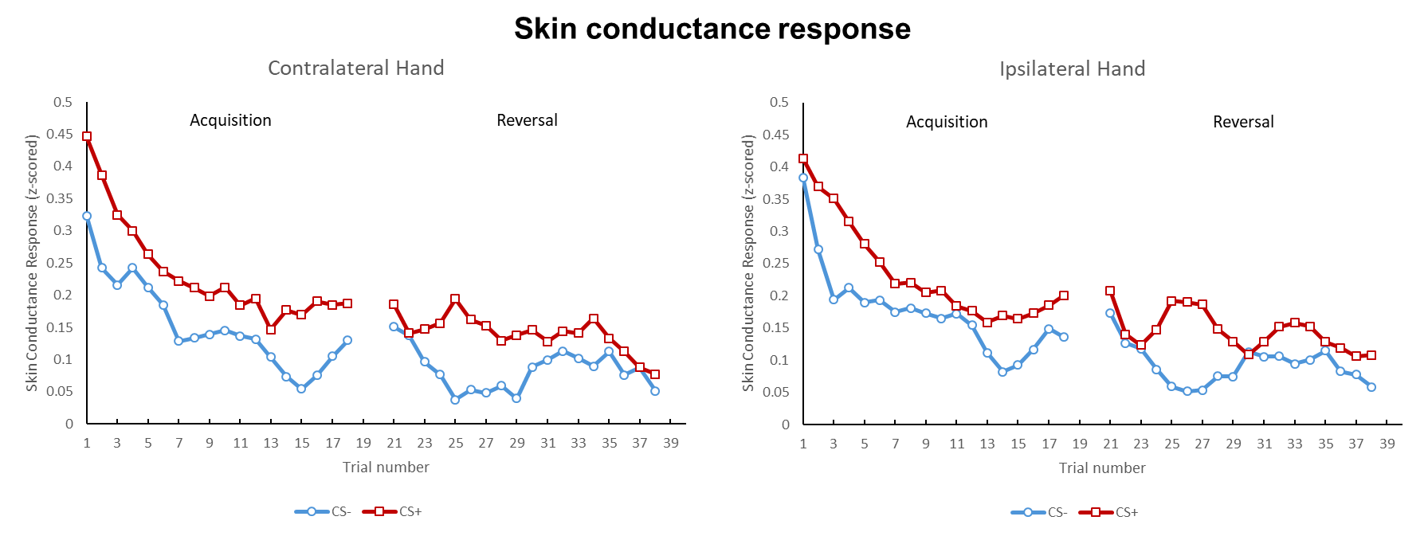Figure 1. Trial-by-trial moving average (window length = 2 trials) of z-scored skin conductance response to CS+ and CS−, averaged across participants, for the contralateral and ipsilateral hand.
Somatomotor alpha. Figure 2 illustrates the trial-by-trial moving average of alpha power (window length = 2 trials) for CS+ and CS−, averaged across participants, separately for the contralateral and ipsilateral hemispheres. Descriptively, following the first acquisition trial, reduced alpha power for the CS+ relative to the CS− is evident for the majority of acquisition and reversal trials, but only in the hemisphere contralateral to the predicted pain location. In contrast, no clear discrimination between CS+ and CS− is observed in the ipsilateral hemisphere.
To further quantify the dynamic nature of prediction updating, we conducted a follow-up analysis on the reversal phase, to investigate within-phase changes in alpha power. Specifically, reversal trials were divided into early (first 10 trials) and late segments (second 10 trials), and, for each participant, mean alpha power was computed separately for each segment. The 2 (CS Type: CS+, CS−) × 2 (Reversal Segment: Early, Late) × 2 (Laterality: Ipsilateral, Contralateral Hemisphere) repeated-measures ANOVA revealed a significant main effect of the factor Reversal Segment (F(1,23) = 10.118, p = 0.004, η²_{p} = 0.306; early MM=12.056, SE=0.838; late MM=13.093, SE=0.945), but no significant interaction with the other factors (all ps ≥ .157). Thus, mean alpha power increased from early to late reversal, but such change occurred regardless of CS Type or Laterality.

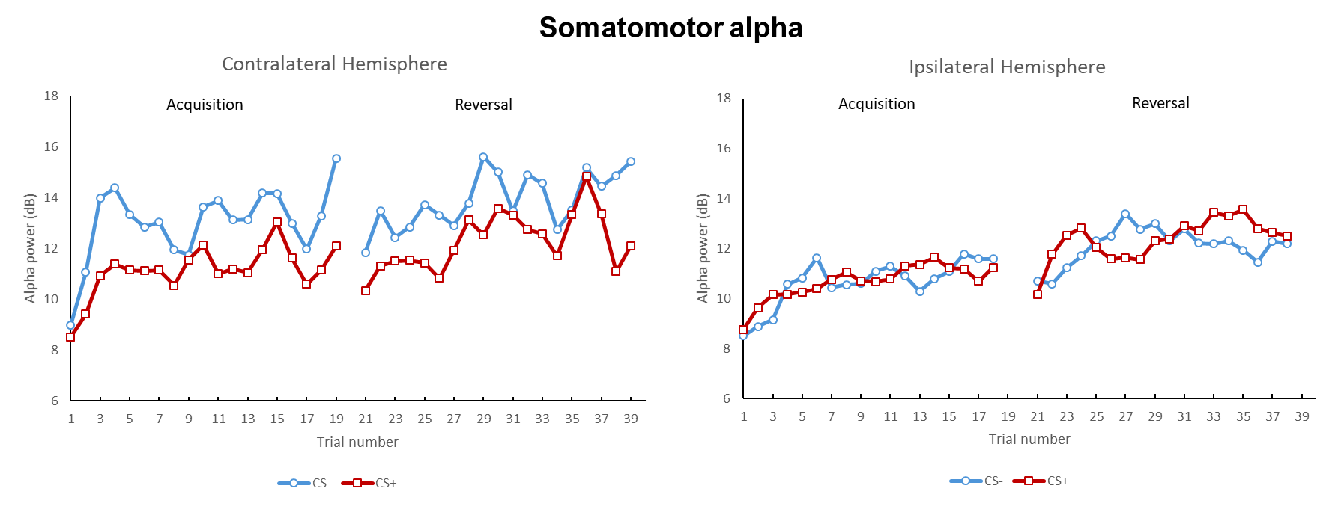Figure 2. Trial-by-trial moving average (window length = 2 trials) of alpha power to CS+ and CS−, averaged across participants, for the contralateral and ipsilateral hemisphere.
Corticospinal excitability (CSE). Figure 3 illustrates the trial-by-trial moving average of CSE (window length = 2 trials) for CS+ and CS−, averaged across participants, separately for the contralateral and ipsilateral hemispheres. Descriptively, following the first acquisition trial, reduced CSE for the CS+ relative to the CS− is evident throughout acquisition and reversal, but only in the hemisphere contralateral to the predicted pain location. In contrast, no clear discrimination between CS+ and CS− is observed in the ipsilateral hemisphere during acquisition. Interestingly, during reversal, the ipsilateral hemisphere appears to show a modest differentiation between CS+ and CS−, although this effect is less pronounced and less consistent than in the contralateral hemisphere. Such effect may reflect the reversal in CS+/US spatial contingencies between left and right pain locations across phases.
To further quantify the dynamic nature of prediction updating, we conducted a follow-up analysis on the reversal phase, to investigate within-phase changes in CSE. Specifically, reversal trials were divided into early (first 10 trials) and late segments (second 10 trials), and, for each participant, mean CSE was computed separately for each segment. The 2 (CS Type: CS+, CS−) × 2 (Reversal Segment: Early, Late) × 2 (Laterality: Ipsilateral, Contralateral Hemisphere) repeated-measures ANOVA revealed no significant main effect or interaction involving the factor Reversal Segment (all ps ≥ .149), indicating that mean CSE did not significantly change between the early and late portions of the reversal phase.

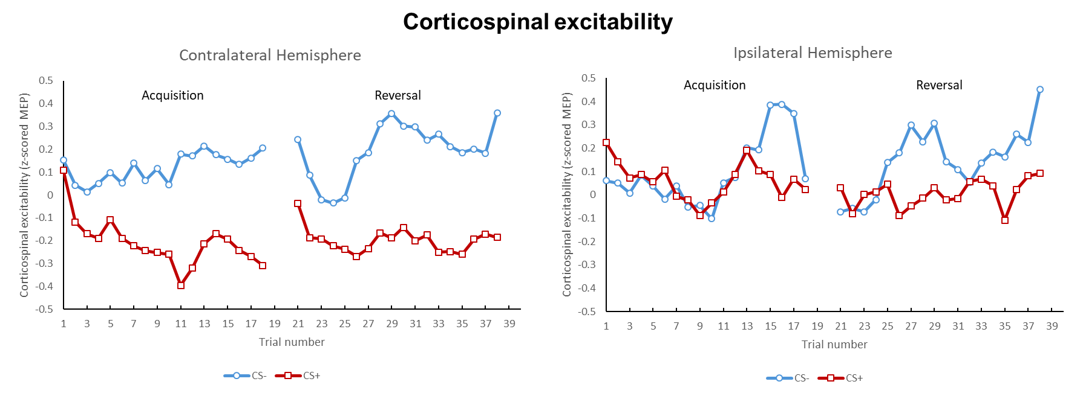 Figure 3. Trial-by-trial moving average (window length = 2 trials) of corticospinal excitability to CS+ and CS−, averaged across participants, for the contralateral and ipsilateral hemisphere.

Frontocentral theta. Figure 4 illustrates the trial-by-trial moving average of theta power (window length = 2 trials) for CS+ and CS−, averaged across participants. Descriptively, no consistent discrimination between CS+ and CS− is observed over trials. In contrast, theta power appears to increase over trials, being overall higher during reversal as compared to acquisition.
To further quantify the dynamic nature of prediction updating, we conducted a follow-up analysis on the reversal phase, to investigate within-phase changes in theta power. Specifically, reversal trials were divided into early (first 10 trials) and late segments (second 10 trials), and, for each participant, mean theta power was computed separately for each segment. The 2 (CS Type: CS+, CS−) × 2 (Reversal Segment: Early, Late) repeated-measures ANOVA revealed no significant main effect or interaction involving the factor Reversal Segment (all ps ≥ .164), indicating that mean theta power did not significantly change between the early and late portions of the reversal phase.

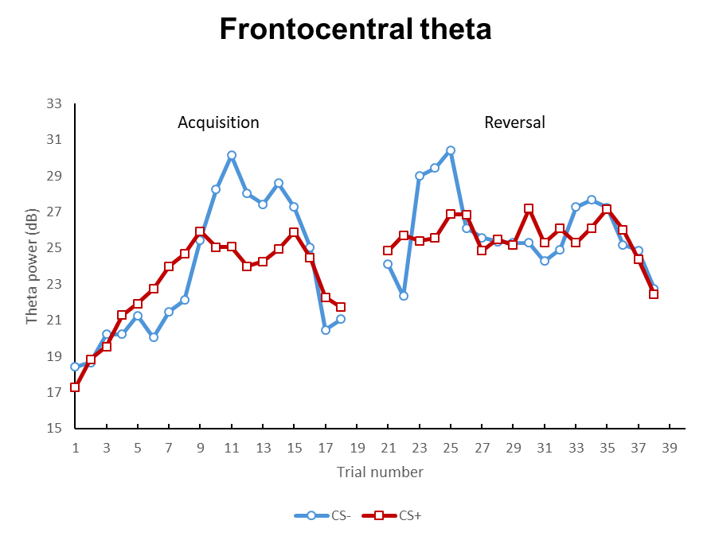
Figure 4. Trial-by-trial moving average (window length = 2 trials) of theta power to CS+ and CS−, averaged across participants.

Influence of age and sex on physiological responses
To address the potential influence of age and sex on the main study outcomes (CS+ vs. CS−), we included age as a covariate and sex as a between-subject factor in separate statistical analyses. No significant effects of age were observed for any of the core analyses, i.e. RM ANOVAs on somatomotor alpha power, frontocentral theta power, corticospinal excitability, or skin conductance responses (all ps>0.05). Similarly, no significant effects of sex emerged for RM ANOVAs on somatomotor alpha power, frontocentral theta power, or skin conductance responses (all ps>0.05).
For corticospinal excitability, however, sex significantly interacted with CS type (CS × Sex, F _{(2,56)} =6.686, p=0.015, η²_{p}=0.198) and learning phase (CS × Phase × Sex, F _{(1,27)} =4.891, p=0.036, η²_{p}=0.153), indicating that the difference between CS+ and CS− was more pronounced in males than females and, in males, it was enhanced during reversal compared to acquisition (table 1). Importantly, sex did not interact with the critical CS × Laterality effect (CS × Laterality x Sex: p=0.312). These findings indicate that while sex modulated the overall magnitude of corticospinal responses, it did not affect the spatially specific encoding of predicted pain location, which constitutes the core finding of the present study.

Table 1. Marginal Means - sex ✻ block ✻ CS
sex | Phase | CS | Marginal Mean | SE
F | Acq | CS- | 0.068 | 0.053
M |  |  | 0.184 | 0.063
F | Rev |  | 0.055 | 0.062
M |  |  | 0.352 | 0.074
F | Acq | CS+ | -0.035 | 0.027
M |  |  | -0.097 | 0.032
F | Rev |  | -0.031 | 0.033
M |  |  | -0.185 | 0.039

