SUPPORTING INFORMATION
Perovskite detectors for X-ray detection
Material | Sensitivity  (μC Gy^{–1} cm^{–2}) | LoD (nGy_{air} s⁻¹) | Electric field (V μm⁻¹) | Flexibility | Ref
CsPbBr₃ Quasi‐Monocrystalline Film | 55684 | - | 4200 | No | ¹
MA₃Bi₂I₉ polycrystalline wafer | 563 | 9.3 | 0.2 | No | ²
CH₃NH₃PbI₃ wafer | 122000 |  | 0.013 | No | ³
Cs₂AgBiBr₆ in a polymer matrix | 40 | - | 4 | 10 mm | ⁴
MAPb(I_{0.9}Cl_{0.1})₃-filled membranes | 8696 ± 228 | - | 0.05 | 45 mm x 10 cycles | ⁵
MAPbI₃ filled PET | 6722 | 1.87 | 8.7 | 0.5 mm x 3000 cycles | ⁶
Layered polymer-perovskite (CsPbBr₃ , MAPBr₃; Cs₂AgBiBr₆, FAPbI₃) | 8380 | 26 | 1 (LoD: 0.5) | 1.5 mm x 30000 cycles | ⁷
CsBi₃I₁₀ | 1622.53 | 220 |  | Yes, radius n/a | ⁸
CsPbBr₃-PBMA composite | 106 ± 1 | 37.2 ±1.1 | 0.43 | 0.5 mm max  5 mm x 1500 cycles | This work
Table S1: Comparison of the detection performance of flexible and rigid perovskite X-ray detectors.

Perovskite detectors for proton detection
Material | Proton energy (MeV) | Electric field (V μm⁻¹) | Sensitivity (C H⁺ ⁻¹) | Ref.
CsPbCl₃ film | 100-228 | 2 | 4·10⁻²⁰ | ⁹
MAPbBr₃-(PEA)₂PbBr₄ film | 5 | 0.2 | (1.12 ± 0.01)·10⁻¹⁸ | ¹⁰
MAPbBr₃ single crystal | 3 | 0.01 | (2.19 ± 0.03)·10-18 | ¹¹
(PEA)₂PbBr₄ film | 5 | 0.5  0.5 | (1.0 ± 0.2) × 10⁻¹⁷ (2 μm film)  (5.7 ± 0.1) × 10⁻¹⁸ (10 μm film) | ¹²
CsPbBr₃ – PBMA composite | 5 | 2  0.1  0.1 | (9.3 ± 0.2)∙10⁻¹⁸ (100 μm)  (1.1 ± 0.1)∙10⁻¹⁹ (100 μm)  (6.3 ± 0.3)∙10⁻¹⁹ (470 μm) | This work
Table S2: Comparison of the detection performance perovskite proton detectors.

Polymer-perovskite composites
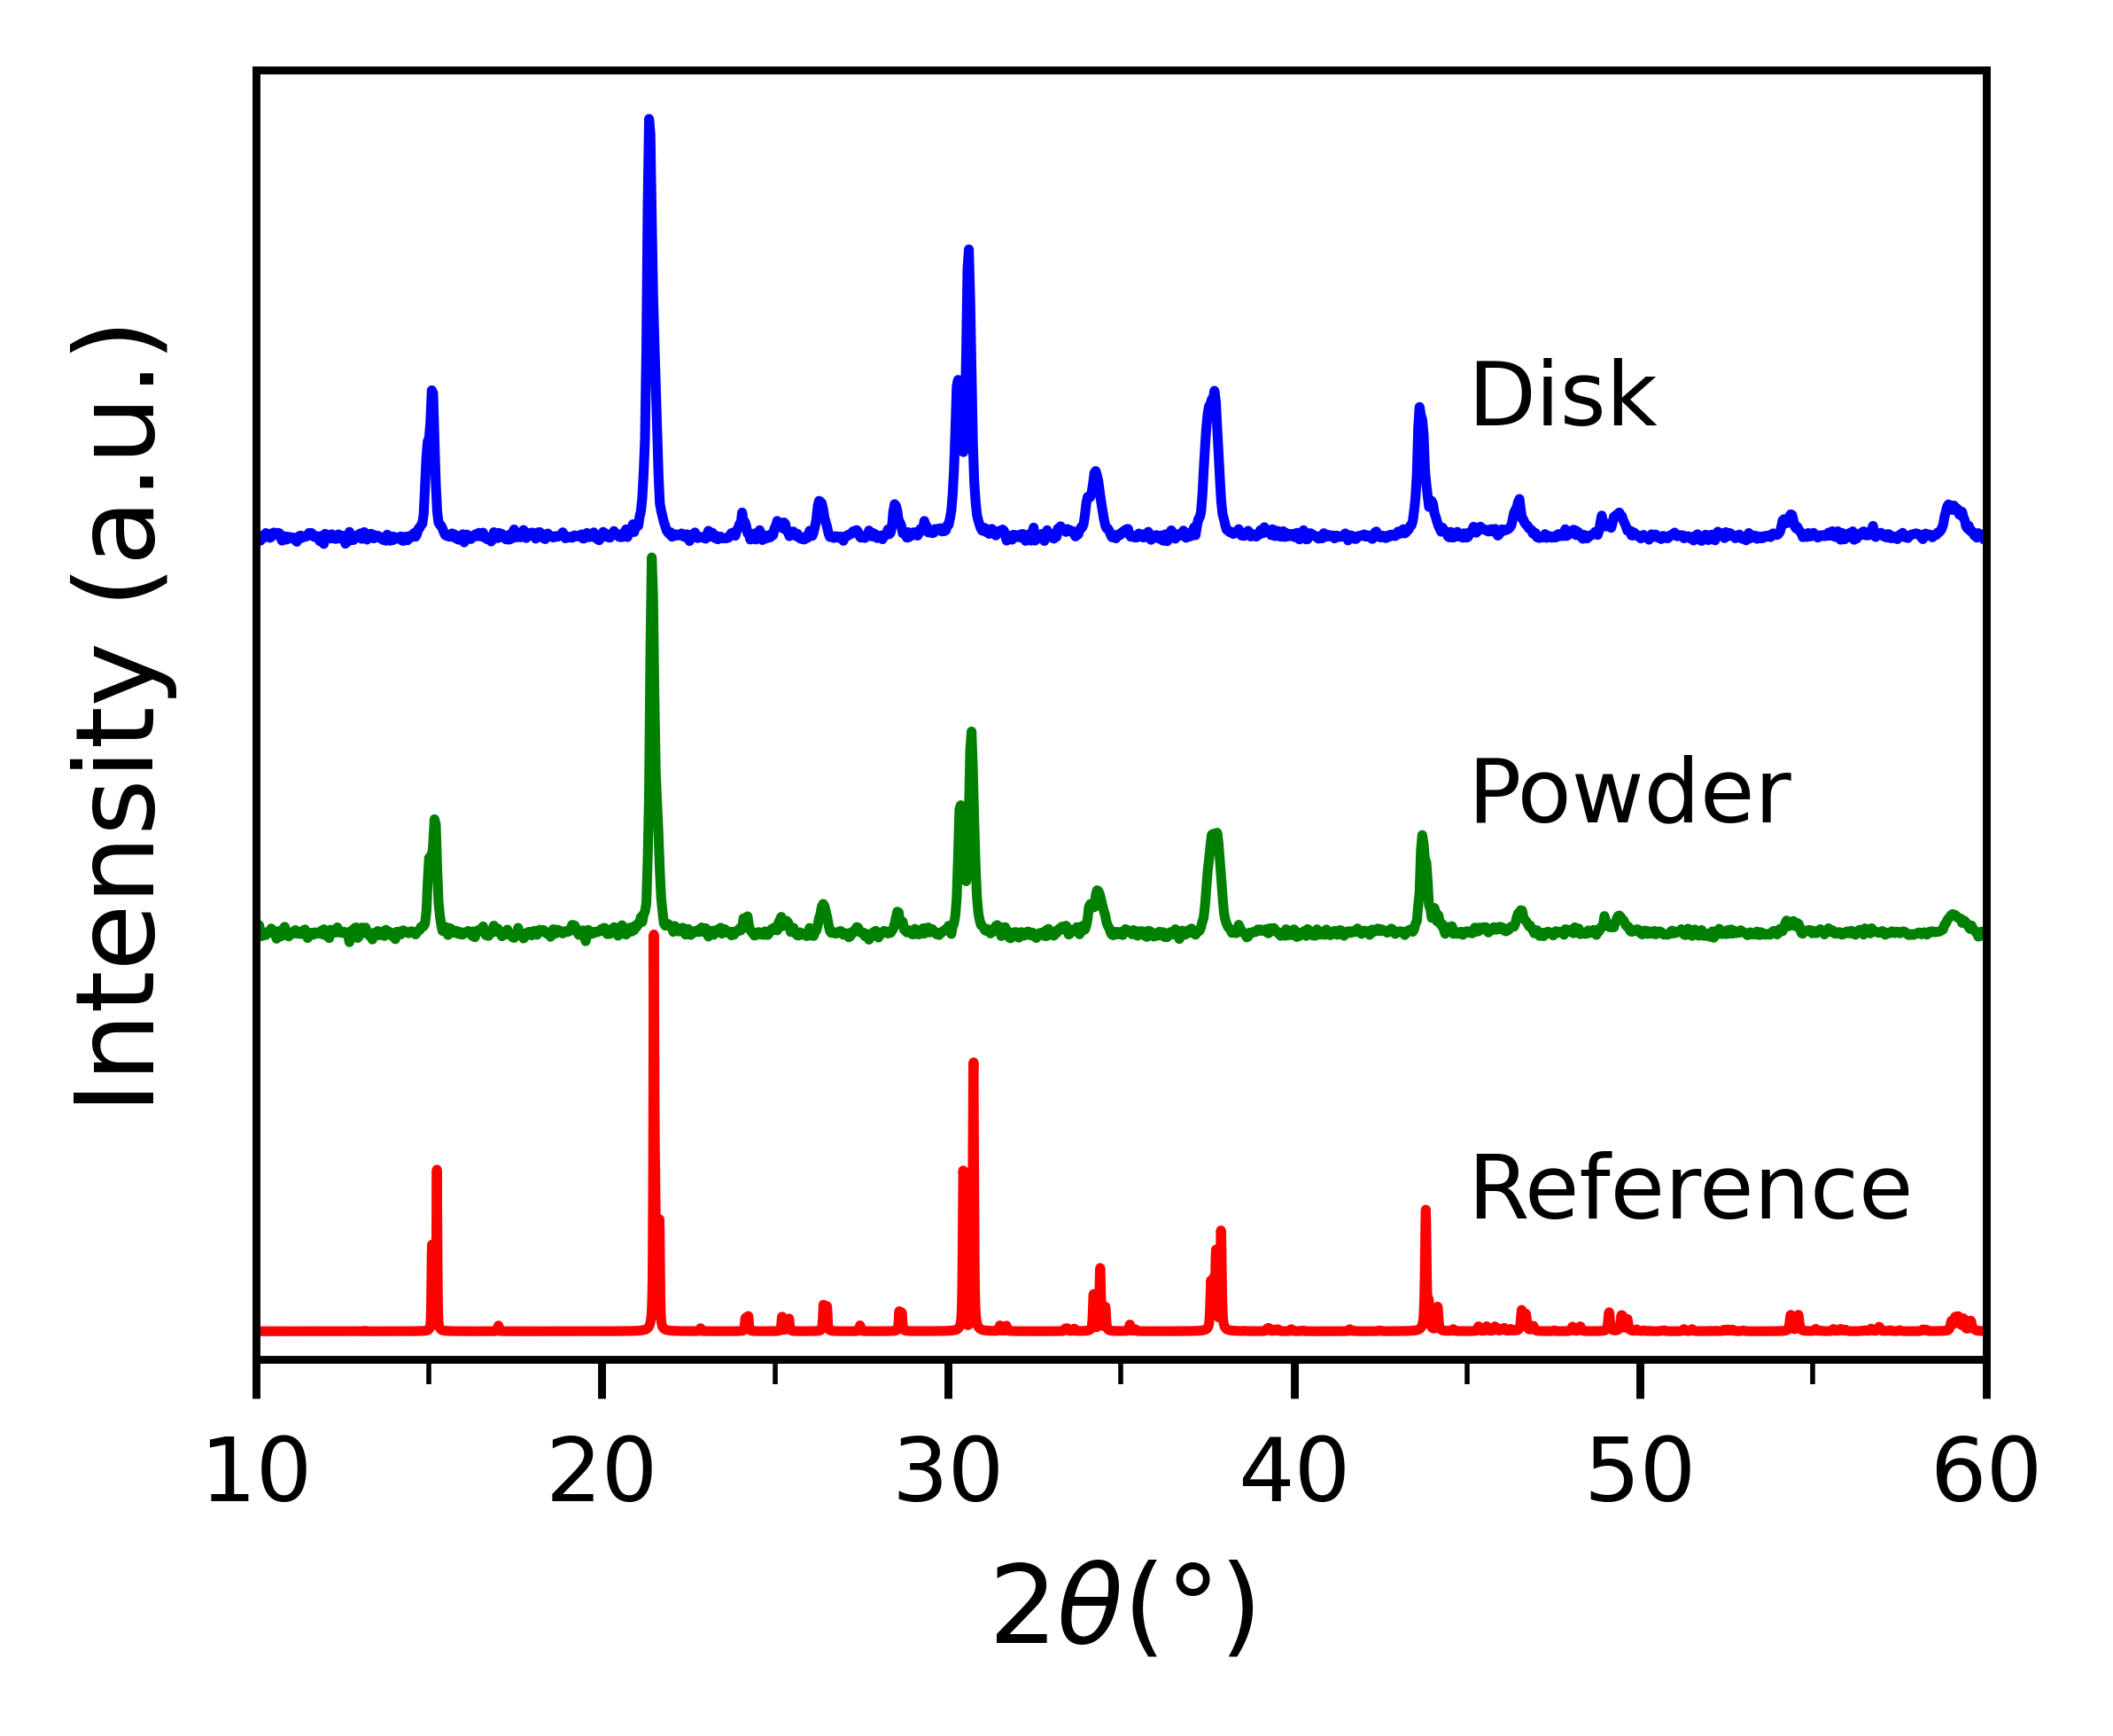
Figure S1: XRD spectrum of the composite pellet and of the powder before pressing compared with reference orthorhombic CsPbBr₃ spectrum.

Photoconducting properties
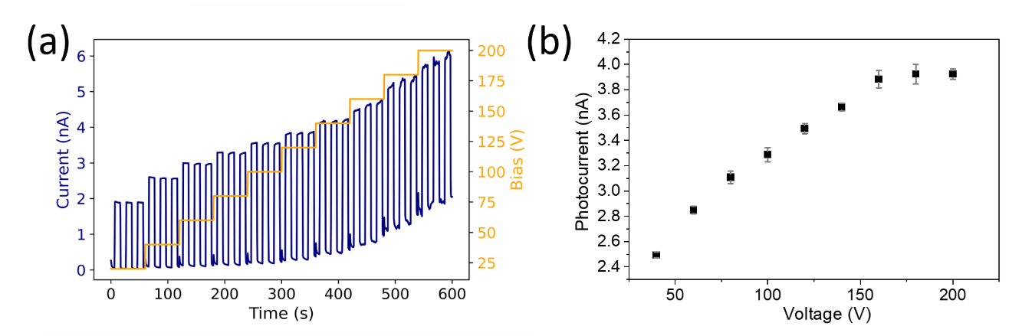
Figure S2: : (a) Bias study of the 100 µm sample to maximize the photocurrent, three peaks for each applied bias are acquired shining an X-ray beam at 40 kVp with dose rate 410 µGy/s. (b) Photocurrent values extracted from the dynamics acquired in (a)

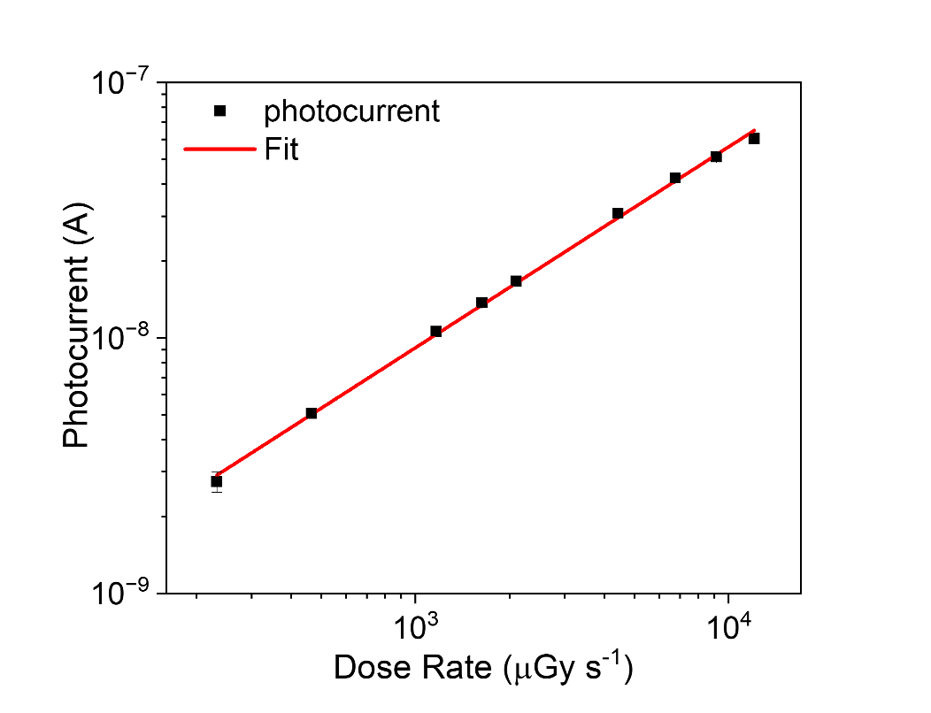
Figure S3: Photocurrent as a function of dose rate over an extended dose rate range showing an exponential trend y=x^{α} with α = 0.79.
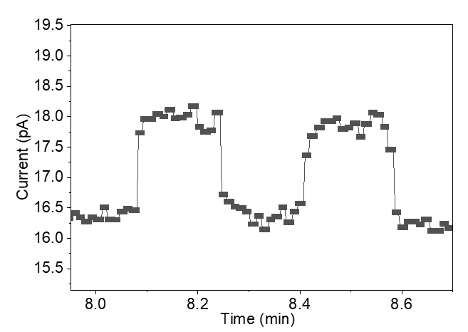
Figure S4: Irradiations performed at 58 nGy/s of the 470 µm pellet biased at 0.426 V/µm
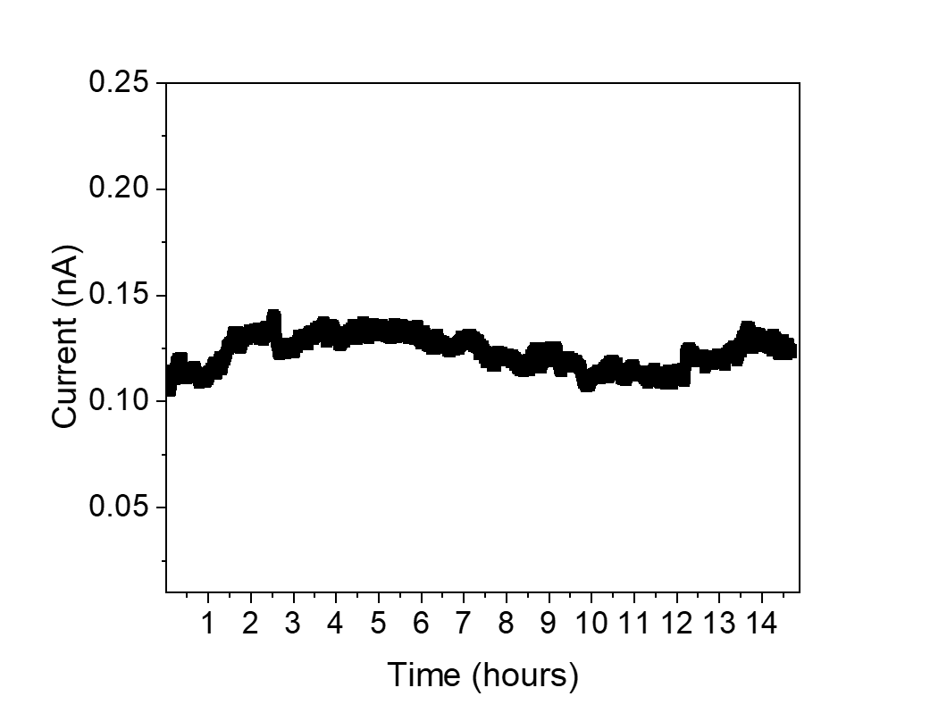
Figure S5: dark current of 100 µm pellet operated at 1.6 V µm⁻¹ for 14 hours and 41 minutes. The insert shows the typical initial bias relaxation trend.

Flexible photoconductors
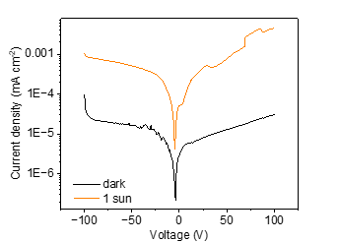
Figure S6: IV characteristic of 100 µm pellet on PET in dark conditions and under 1 sun illumination.
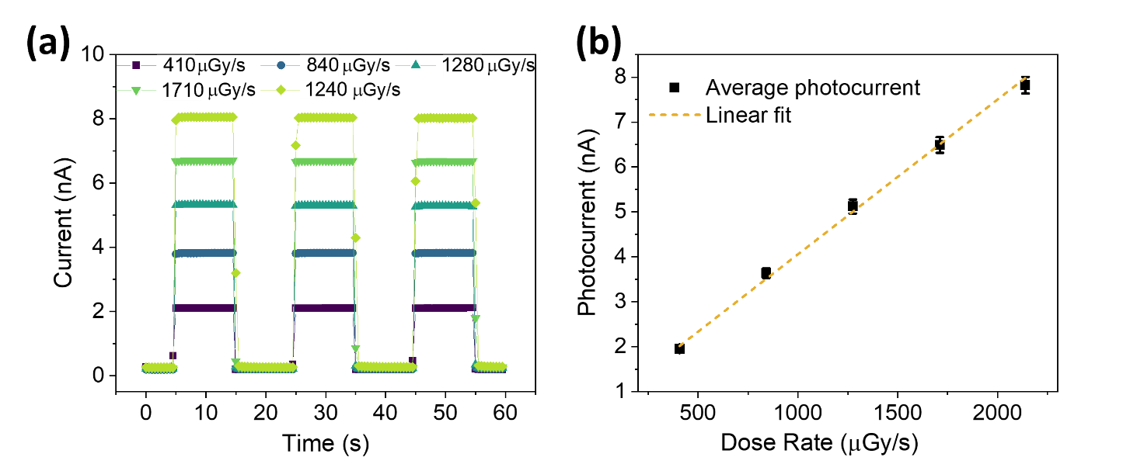
Figure S7: (a) dynamic response of one pixel in the 100 μm sample on PET biased at 0.426 V/µm. (b) Average sensitivity of 4 pixel in the 100 μm sample biased at 0.426 V/µm from which the sensitivity is extracted though a linear fit.
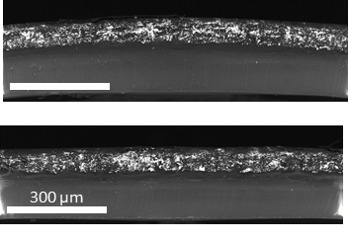
Figure S8: (top) cross-section SEM image of the bent portion of the device. (bottom) Cross-section SEM image a portion of the composite where no bending has occurred. Both images refer to a part of the sample not delaminated form the plastic substrate.

Proton detection
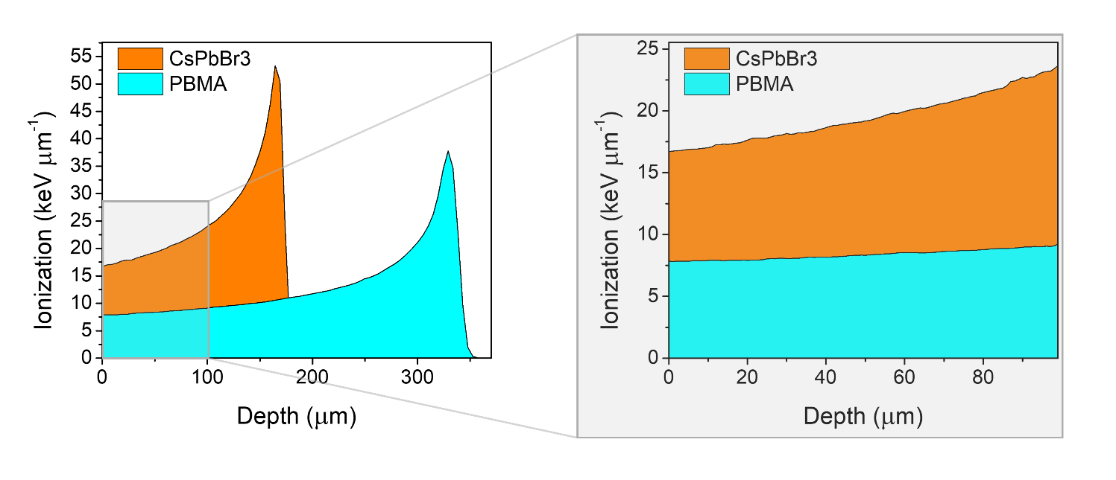
Figure S9: the SRIM simulations of the linear energy transfer of a proton beam of 4.4 MeV protons with only CsPbBr₃ (ρ = 4.55 g cm⁻³), and only PBMA (ρ = 0.89 g cm⁻³).

