This Online Supplementary Material file contains four appendices which complement the content of the article “Business, as usual? The impact of organised economic interests on the stringency of Covid-19 containment policies. Insights from Italian regions.”.
Appendix 1 provides evidence regarding the saliency of Covid-19 in Italian public opinion during the period of interest.
Appendix 2 details the process of construction of the regional stringency index.
Appendix 3 details the process of construction of the index of business and trade union pressures and the methodological details of the sentiment analysis of tweets.
Appendix 4 presents additional regression models that analyse the impact of regional stringency on mobility.
The dataset containing all variables used for the analysis is provided as a separate Excel file.
Appendix 1: Saliency of Covid-19 in online searches
Search data from Google Trends for the term “coronavirus” – by far the most popular denomination for the Covid-19 pandemic in the period of interest – shows that Italy during the first phase of the pandemic (February 2020-May 2020) displayed a higher average interest for the term “coronavirus” than the other largest EU countries (the average interest score over the period was of 29.7 in Italy, compared to 26.9 for Spain, 26.2 for Germany, 21.3 for France and 21.09 for the UK). As figure 1A shows, the trend of interest over time is similar across all major EU countries: from a peak in interest reached between mid-February and mid-March as the pandemic “explodes” in each country, the trend in interest decreases in a roughly linear fashion as time progresses.

Figure 1A

Source: GoogleTrends (“interest over time” score for the term “Coronavirus”).
Appendix 2: Constructing the regional stringency index
The weekly regional stringency index was constructed by hand-coding all relevant national and regional ordinances and regulations in the period February-June 2020. Out of a total of 1,109 sources analysed, 364 contained Covid-19 related measures and were subsequently coded. The corpus of ordinances and regulations includes: regional ordinances, decrees of the presidency of the region, regional laws, deliberations of the regional council, ordinances of national Ministries pertaining to a specific region, operational rules of the Covid-19 crisis units or of the regional competent ministries, as well as attachments and clarifications to the various regulations and ordinances issued by the regional and national authorities.
This original composite index is built, for each region, from eighteen indicators. The first seventeen indicators capture for each week the policies in force at the regional level on closings of schools and universities, closing of workplaces, cancelling of public events, restrictions on private gatherings, closing of public transport, stay-at-home requirements, restrictions on internal movements, and restrictions on international travel. Each indicator can take four values, indicating whether no measures, a low, medium, or high level of restrictions had been imposed, using the same coding procedure described in Hale et al. (2020). The details of the coding scheme followed are reported in Table 1A below. The dimensions comprising our Regional stringency index deviate from Hale et al. (2020) because we operate a more fine-grained disaggregation of economic sectors affected by restrictions. When coding the restrictions for workplaces and commercial activities, we distinguish between different kinds of public/commercial activities (public ones such as museums vs private ones such as bars, restaurants); between macro-sectors (retail, professionals, industry, agriculture); and between sectors which were categorised as ‘essential’ and ‘non-essential’ by Italian state authorities, because different general rules for operation applied to these macro-categories of sectors and commercial activities. We treat the measures in force for each sub-sector as a separate dimension of the total stringency indicator. That is why our index comprises seventeen indicators of containment measures, compared to the eight dimensions of the Hale et al. (2020) Stringency Index. In weeks where multiple measures were introduced at the regional level for the same dimension, the most stringent value was recorded.
To these seventeen dimensions, we added an additional eighteenth dimension, which captures whether the regional authorities introduced specific exemptions and dispensation from national rules with regard to the operation of specific sectors or sub-sectors. In the coding process, the presence (0 if absent, 1 if present) and content of such exemptions were recorded. Cases were an exception was present were then assigned a positive score (+1), if they entailed higher restrictions than the national baseline for the operation of the specific sector; and a negative score (-1), if they entailed lower restrictions. The score assigned was scaled based on the relative occupational importance of each economic category with respect to the regional total, by multiplying it by the share of people employed in the affected sector at the regional level. In the absence of such information at a regional level, the national weight was used. The synthetic indicator of regional stringency is then computed as an unweighted sum of the simple scores of the eighteen indicators listed.

Table 2A: Codebook for constructing the regional stringency index
 | Domain | Level of Restriction and value attributed to variable
 |  | No measures (=0) | Low (=1) | Medium (=2) | High (=3)
D1 | Stay at home requirements | No Measures | Recommend not to leave the house | Require not leaving the house except for essential activities | Require not leaving the house with minimal exceptions (only once a week, only one person per household)
D2 | Restrictions on internal movements | No Measures | Require to communicate to Heath Care units in case of travels in red-zones | Require not to travel outside the Region/city | Require not to leave the city
D3 | International travel control | No Measures | Communication to the authorities, screening (swab) or quarantine arrivals from high-risk regions | Communication to the authorities, screening (swab) or quarantine arrivals from everywhere | Ban on arrivals from high-risk regions or from everywhere
D4 | School closing | No Measures | Recommendations | Closing only some | Closing all
D5 | Restrictions on gatherings | No Measures | Restrictions on very large gatherings (more than 100) or precautions required (distancing, open air, masks, etc.) | Restrictions on gatherings between 100 and 10 people | Restrictions on all gatherings
D5a | Museum, Public libraries | No Measures | Recommend precautions | Require precautionary measures (closure if precautions are not taken) | Closure for all
D5b | Bar, tourism, agritourism | No Measures | Recommend precautions | Require precautionary measures (closure if precautions are not taken) | Closure for all
D5c | Public Gardens, Parks, Common Yards | No Measures | Recommend precautions | Require precautionary measures (closure if precautions are not taken) | Closure for all
D6 | Cancelling public events | No Measures | recommend cancelling or precautionary measures | Require precautionary measures (cancellation if precautions are not taken) | Require total cancelling
D7 | Closing of public transport | No Measures | Recommendations | Require sanitisation, distancing, or reduced usage | Only essential service
D8 | Workplace closing
D8a | Essential
D8a1 | Retail | No Measures | Recommendations | Mandatory Protocols | Closure
D8a2 | Professionals | No Measures | Recommendations | Mandatory Protocols | Closure
D8a3 | Industry | No Measures | Recommendations | Mandatory Protocols | Closure
D8a4 | Agriculture | No Measures | Recommendations | Mandatory Protocols | Closure
D8b | Non-essential
D8b1 | Retail | No Measures | Recommendations | Mandatory Protocols | Closure
D8b2 | Industry | No Measures | Recommendations | Mandatory Protocols | Closure
D8b3 | Professionals | No Measures | Recommendations | Mandatory Protocols | Closure
D9 | Exemptions to general rules on workplace closures | Not present | Present

Appendix 3: Constructing the index of business and trade union pressures
To measure the intensity of the pressure exercised by business organisations and trade unions on policymakers (our proxy for instrumental power), due to the lack of information about direct lobbying activities, we construct an indicator of public pressure by analysing through text-as-data methods the social media communications on Twitter of business associations and trade unions in the period of interest, which we take as a proxy of the public pressure exercised by these organisations in the public sphere and on policymakers. To do so, we conduct a dictionary-based sentiment analysis (Moreno and Iglesias, 2020) of all the Covid-19-related tweets published in the period February-June 2020 by the regional chapters of the main organised producer groups in Italy: Confindustria, CNA, Confcommercio and Confartigianato for the business organisations side, CGIL, CISL and UIL for the trade unions side. Since the presence of some organisations is uneven on the national territory, when a regional Twitter page for the relevant regional chapter of one organisation was not available, information was collected from the accounts of the organisation’s chapters based in regional capitals.
Then, the set of tweets was divided into two groups: from the total number of tweets, we isolated those containing keywords related to the COVID-19 pandemic (for similar analyses, see also Delizo et al., 2020; Villavicencio et al., 2021; Samuel et al., 2020). The data were aggregated by separating the associations representing entrepreneurs, craft and commerce sector firms from trade union representatives for each region. This allowed us to obtain a much more homogeneous national representation, although there remain unavoidable aspects of unevenness in the coverage across regions (especially in the smaller regions).
Tables 3A and 3B report the total number of tweets and the total number of Covid-specific tweets for unions and employer organisations respectively, divided by region and by polarity.
Table 3A Number of tweets by union organisations, by regions and polarity
 | All tweets (polarity) |  |  |  | COVID-related tweets (polarity)
Regioni | Negative | Neutral | Positive | TOTAL | Negative | Neutral | Positive | TOTAL
Valle d'Aosta | 15 | 8 | 18 | 41 | 2 | 1 | 1 | 4
Piemonte | 542 | 129 | 774 | 1445 | 174 | 32 | 197 | 403
Lombardia | 287 | 94 | 501 | 882 | 67 | 20 | 123 | 210
Trentino Alto Adige | 0 | 0 | 0 | 0 | 0 | 0 | 0 | 0
Friuli Venezia Giulia | 16 | 5 | 56 | 77 | 5 | 1 | 14 | 20
Veneto | 257 | 119 | 509 | 885 | 66 | 27 | 100 | 193
Liguria | 280 | 70 | 358 | 708 | 77 | 14 | 75 | 166
Emilia Romagna | 680 | 218 | 1478 | 2376 | 198 | 50 | 373 | 621
Toscana | 529 | 140 | 906 | 1575 | 158 | 33 | 245 | 436
Umbria | 340 | 96 | 712 | 1148 | 93 | 23 | 188 | 304
Marche | 618 | 136 | 1146 | 1900 | 190 | 42 | 304 | 536
Abruzzo | 376 | 94 | 803 | 1273 | 111 | 30 | 207 | 348
Molise | 0 | 0 | 0 | 0 | 0 | 0 | 0 | 0
Lazio | 230 | 89 | 464 | 783 | 78 | 27 | 131 | 236
Campania | 131 | 27 | 148 | 306 | 49 | 6 | 48 | 103
Basilicata | 138 | 38 | 258 | 434 | 45 | 15 | 78 | 138
Puglia | 583 | 170 | 1262 | 2015 | 177 | 46 | 322 | 545
Calabria | 95 | 54 | 207 | 356 | 26 | 5 | 54 | 85
Sicilia | 368 | 108 | 637 | 1113 | 125 | 35 | 178 | 338
Sardegna | 64 | 15 | 58 | 137 | 26 | 6 | 19 | 51
ITALIA | 5549 | 1610 | 10295 | 17454 | 1667 | 413 | 2657 | 4737

Table 3B Number of tweets by employer organisations, by region and polarity
 | All tweets (polarity) |  |  |  | COVID-related tweets (polarity)
Regions | Negative | Neutral | Positive | TOTAL | Negative | Neutral | Positive | TOTAL
Valle d’Aosta | 40 | 18 | 177 | 235 | 11 | 4 | 49 | 64
Piemonte | 91 | 35 | 399 | 525 | 21 | 8 | 93 | 122
Lombardia | 195 | 103 | 481 | 779 | 59 | 35 | 109 | 203
Trentino Alto Adige | 2 | 1 | 44 | 47 | 0 | 0 | 13 | 13
Friuli Venezia Giulia | 23 | 14 | 68 | 105 | 7 | 4 | 17 | 28
Veneto | 197 | 64 | 463 | 724 | 61 | 21 | 130 | 212
Liguria | 195 | 262 | 730 | 1187 | 53 | 30 | 191 | 274
ER | 149 | 68 | 515 | 732 | 45 | 23 | 112 | 180
Toscana | 172 | 50 | 556 | 778 | 50 | 6 | 112 | 168
Umbria | 21 | 17 | 162 | 200 | 6 | 0 | 33 | 39
Marche | 140 | 60 | 279 | 479 | 50 | 15 | 76 | 141
Abruzzo | 113 | 52 | 536 | 701 | 31 | 12 | 126 | 169
Molise | 0 | 0 | 0 | 0 | 0 | 0 | 0 | 0
Lazio | 167 | 142 | 549 | 858 | 67 | 54 | 203 | 324
Campania | 131 | 92 | 573 | 796 | 37 | 11 | 91 | 139
Basilicata | 68 | 57 | 187 | 312 | 20 | 4 | 45 | 69
Puglia | 45 | 25 | 153 | 223 | 8 | 6 | 28 | 42
Calabria | 0 | 0 | 0 | 0 | 0 | 0 | 0 | 0
Sicilia | 27 | 8 | 47 | 82 | 3 | 1 | 8 | 12
Sardegna | 716 | 202 | 1196 | 2114 | 202 | 66 | 306 | 574
ITALIA | 2492 | 1270 | 7115 | 10877 | 731 | 300 | 1742 | 2773

The content of each tweet was pre-processed according to the methods envisaged by textual analysis – standardisation, text cleansing, lemmatisation, analysis of negations and intensifiers, and so on (see Jo, 2019; Gupta and Lehal, 2009) – while the polarity (positive or negative) was attributed to each tweet by comparing the results of three polarised dictionaries: Subjectivity Lexicon, NRC Word-Emotion Association Lexicon, and OpeNER Sentiment Lexicon Italian - LMF. For each lexicon, two algorithms for calculating the positivity and negativity scores were used: Naive Bayes (Ting et al., 2011; McCallum and Nigam, 1998) and SentimentR (Rinker, 2017). The latter considers negations, intensifiers and de-intensifiers. For each of the six combinations, the mean and median of the scores were considered, while the sentiment was attributed based on the orientation (positive or negative) of the mean score obtained for the combinations of cases for the same tweet. A neutral orientation was also attributed when the coefficient of variation exceeded the value of 1.5. In such a way, the tweets were classified into positive, negative, and neutral (+, -, =).
To give an idea of the content of the lexicons, we report the Wordclouds of positive (green) and negative (red) terms contained in the tweets of unions and business’ organisations respectively, that forms the basis of the estimation (Figures 2A and 2B). The Wordcloud represents a summary of the annotated lexicons used to determine the whole mood of the sentences. In the process of estimation of the mood are also involved polarity shifters, intensifiers and weakeners which are absent from the cloud, because they simply increase, decrease or invert the polarisation. The differences in the two Wordclouds simply depend on different frequencies of the same terms, as the positive or negative polarisation of each term remains constant.
Figure 3A Wordcloud of positive and negative tweets by trade unions
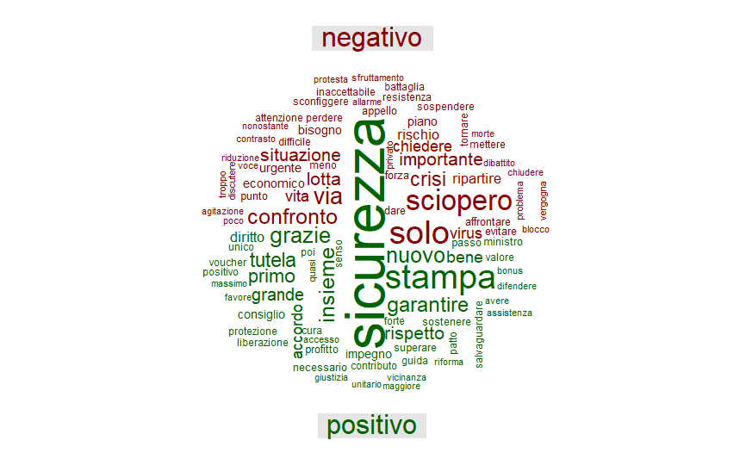
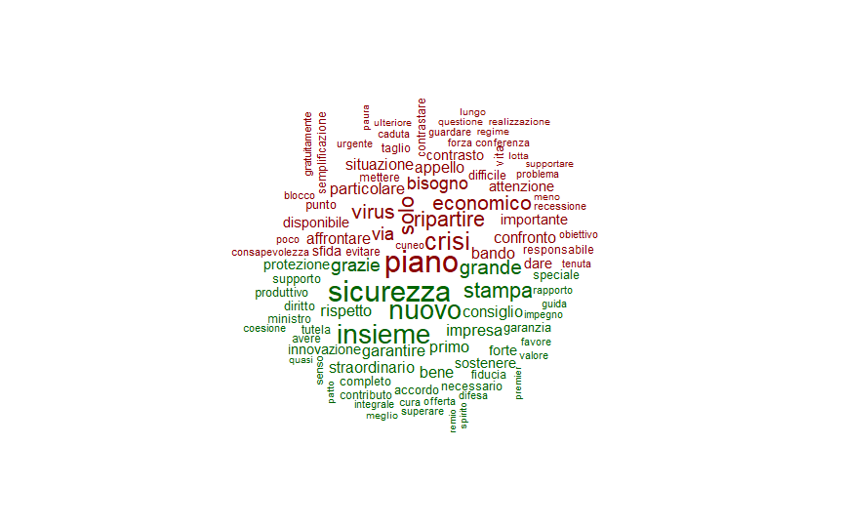
Figure 3B Wordcloud of positive and negative tweets by business organisations

Appendix 4: The impact of regional stringency on mobility
To verify whether variations in the regional stringency index have actual impacts on variations of mobility towards workplaces on the ground (i.e. whether regional stringency really matters to what happens in the real economy), we report here the results of models A1 to A4. These are regressions of the percentage change in mobility towards workplaces – derived from Google data – on stringency level, cumulative deaths by population, the pressure indexes of trade unions and employer organisations, and the time-invariant variables already included in the main models reported and described in the main text.
Table 4A: Results from Models A1-A4
Variable (dependent: Google Mobility – Workplaces) | Coefficient (Model A1) | Coefficient (Model A2) | Coefficient (Model A3) | Coefficient (Model A4)
Regional stringency (lag 2) | -0.117** | -0.121** | -0.123** | -0.127**
 | (0.0537) | (0.0533) | (0.0530) | (0.0524)
Cumulative deaths by population (lag 2) | -793.835 | 344.023 | -784.623 | 364.989
 | (645.4927) | (719.1881) | (638.3676) | (706.9249)
Pressure: Trade Unions (lag 2) | -4.851* | -4.558*
 | (2.7290) | (2.7222)
Pressure: Employers (lag 2) | 2.149 | 1.921
 | (3.3585) | (3.3505)
Absolute number of Trade Unions’ negative COVID tweets (lag 2) |  |  | -0.127*** | -0.131***
 |  |  | (0.0372) | (0.0370)
Absolute number of Employers’ negative COVID tweets (lag 2) |  |  | 0.047 | 0.062
 |  |  | (0.0532) | (0.0538)
Percentage of firms with 10+ employees | -1.201** | 0.300 | -1.370*** | 0.312
 | (0.4872) | (0.7422) | (0.4889) | (0.7141)
Unemployment rate | 0.209* | -0.183 | 0.210* | -0.196
 | (0.1133) | (0.1367) | (0.1117) | (0.1329)
Political spectrum (0=centre-left; 1=centre-right) | 0.920 | 0.207 | 0.483 | -0.228
 | (0.8363) | (0.9574) | (0.8404) | (0.9275)
Electoral cycle (1=regional elections taking place within 12 months; 0=otherwise) | 0.268 | 0.604 | 0.208 | 0.527
 | (0.8371) | (1.0401) | (0.8323) | (1.0000)
Thousands of employees in manufacturing over regional population | 37501.906** |  | 47334.001**
 | (1.87e+04) |  | (1.88e+04)
Thousands of employees in hotels, restaurants and retail over regional population | 1.26e+05*** |  | 1.27e+05***
 | (3.89e+04) |  | (3.86e+04)
Per capita GDP |  | -0.000* |  | -0.000*
 |  | (0.0001) |  | (0.0001)
Services value-added over GDP |  | -0.361 |  | -0.338
 |  | (0.3501) |  | (0.3361)
Manufacturing value-added over GDP |  | -0.309 |  | -0.250
 |  | (0.3312) |  | (0.3173)
4.Time | -10.777*** | -10.777*** | -10.779*** | -10.779***
 | (0.7749) | (0.7698) | (0.7640) | (0.7582)
5.Time | -9.015*** | -9.006*** | -8.991*** | -8.969***
 | (0.8000) | (0.7947) | (0.7871) | (0.7809)
6.Time | -37.505*** | -37.503*** | -37.360*** | -37.348***
 | (0.9113) | (0.9058) | (0.8514) | (0.8447)
7.Time | -60.363*** | -60.336*** | -59.896*** | -59.870***
 | (1.0028) | (0.9958) | (0.9830) | (0.9749)
8.Time | -63.360*** | -63.244*** | -62.482*** | -62.343***
 | (2.1083) | (2.0929) | (2.1112) | (2.0905)
9.Time | -59.350*** | -60.473*** | -58.476*** | -59.589***
 | (2.4677) | (2.4779) | (2.4608) | (2.4613)
10.Time | -60.950*** | -62.186*** | -59.926*** | -61.130***
 | (2.4824) | (2.4965) | (2.4824) | (2.4855)
11.Time | -53.113*** | -54.435*** | -52.436*** | -53.733***
 | (2.4957) | (2.5136) | (2.4755) | (2.4838)
12.Time | -51.763*** | -53.163*** | -51.366*** | -52.759***
 | (2.4125) | (2.4341) | (2.3856) | (2.3987)
13.Time | -45.570*** | -47.040*** | -45.343*** | -46.790***
 | (2.4073) | (2.4317) | (2.3708) | (2.3872)
14.Time | -34.119*** | -35.614*** | -33.755*** | -35.244***
 | (2.3690) | (2.3956) | (2.3421) | (2.3612)
15.Time | -26.564*** | -28.086*** | -26.231*** | -27.748***
 | (2.3308) | (2.3589) | (2.3037) | (2.3247)
16.Time | -19.634*** | -21.185*** | -19.463*** | -21.010***
 | (2.3061) | (2.3354) | (2.2752) | (2.2979)
17.Time | -28.445*** | -30.053*** | -28.216*** | -29.822***
 | (1.7805) | (1.8136) | (1.7584) | (1.7856)
18.Time | -19.499*** | -21.116*** | -19.281*** | -20.899***
 | (1.7321) | (1.7660) | (1.7109) | (1.7395)
19.Time | -17.590*** | -19.220*** | -17.447*** | -19.073***
 | (1.6895) | (1.7234) | (1.6649) | (1.6949)
20.Time | -16.109*** | -17.752*** | -16.010*** | -17.655***
 | (1.6428) | (1.6781) | (1.6205) | (1.6504)
Intercept | -8.996** | 35.908 | -8.626** | 34.427
 | (4.0165) | (28.8946) | (3.9710) | (27.7107)
Observations | 378 | 378 | 378 | 378
R-squared (within) | 0.988 | 0.988 | 0.989 | 0.988
R-squared (between) | 0.318 | 0.488 | 0.285 | 0.479
R-squared (overall) | 0.983 | 0.984 | 0.983 | 0.984
Notes: Standard errors in brackets. *, ** and *** stand for p < 0.10, p < 0.05 and p < 0.01.
Among time-varying variables, the significant coefficients pertain to the regional stringency and to public pressure by trade unions. Time fixed-effects also have an effect on the dependent variable. Our results clearly show that an increase in regional stringency directly brings about a reduction in mobility towards workplaces. This is an indicator of the fact that the level of stringency does in fact matter in terms of affecting developments on the ground in terms of workplace/economic activity. Hence, it shows that there are good reasons why employer groups would care about influencing the intensity of regulations at the regional level. Most structural variables pertaining to the socio-economic context are not significant, except for the employment-related variables in Models A1 and A3 as well as per capita Gross Domestic Product in Models A2 and A4.
In Models A1 and A3, as we would expect, the coefficients pertaining to the share of employees in manufacturing and hospitality-related sectors are both significant and with a positive sign. The unemployment rate is also significant and with a positive sign, which can be rationalised as a reason for regional governments to be less “stringent” in the execution of COVID-19-related restrictions so as to not negatively affect employment dynamics. Lastly, the percentage of firms with ten or more employees has a negative relationship with workplaces-related mobility. This can be interpreted as a consequence of the fact that larger firms are also more structured and can organise remote working more easily compared to the smaller ones.
As regards per capita GDP (Models A2 and A4), it must be borne in mind that the activities characterised by the highest value-added (business services, banks, insurance companies, service activities incorporated in manufacturing businesses) are easily transferable into a remote-working model, which obviously results in mobility reductions. By contrast, non-teleworkable, material-type production activities have a lower per capita value-added.
References for appendices
Breiman L, Friedman JH, Olshen RA and Stone CJ (1984) Classification and regression trees. Monterey, CA: Wadsworth & Brooks/Cole Advanced Books & Software. ISBN 978-0-412-04841-8.
Delizo JPD, Abisado MB and De Los Trinos MIP (2020) Philippine Twitter Sentiments during Covid-19 Pandemic using Multinomial Naïve-Bayes. International Journal of Advanced Trends in Computer Science and Engineering 9(1.3).
Gupta V and Lehal GS (2009) A survey of text mining techniques and applications. Journal of emerging technologies in web intelligence, 1(1): 60-76.
Jo T (2019) Text mining. Studies in Big Data. Cham: Springer International Publishing.
McCallum A and Nigam K (1998) A comparison of event models for naive bayes text classification. In: AAAI-98 workshop on learning for text categorization (Vol. 752, No. 1, pp. 41-48).
Moreno A and Iglesias CA (2020) Sentiment Analysis for Social Media. MDPI - Multidisciplinary Digital Publishing Institute. DOI: 10.3390/books978-3-03928-573-0.
Rinker T (2017) Package ‘sentimentr’: Calculate Text Polarity Sentiment. Available at: https://github.com/trinker/sentimentr.
Rokach L and Maimon O (2008) Data mining with decision trees: theory and applications. World Scientific Pub. Co. Inc.
Samuel J, Ali GG, Rahman M, Esawi E and Samuel Y (2020) Covid-19 public sentiment insights and machine learning for tweets classification. Information, 11(6): 314.
Ting SL, Ip WH and Tsang AH (2011) Is Naive Bayes a good classifier for document classification. International Journal of Software Engineering and Its Applications, 5(3): 37-46.
Villavicencio C, Macrohon JJ, Inbaraj XA, Jeng JH and Hsieh JG (2021) Twitter Sentiment Analysis towards COVID-19 Vaccines in the Philippines Using Naïve Bayes. Information, 12(5): 204.

http://mpqa.cs.pitt.edu/lexicons/subj_lexicon/
https://saifmohammad.com/WebPages/AccessResource.htm
https://dspace-clarin-it.ilc.cnr.it/repository/xmlui/handle/20.500.11752/ILC-73

