Supplementary information
Characterization of partially Ni substituted manganese hexacyanoferrate cathode material
Mariam Maisuradzeª, Min Liª, Giuliana Aquilanti^{b}, Jasper Plaisier^{b} Marco Giorgettiª
ªDepartment of Industrial Chemistry “Toso Montanari”, University of Bologna, Viale Risorgimento 4, 40136 Bologna, Italy;
^{b}Elettra Sincrotrone Trieste, ss 14, km 163.5, 34149, Basovizza, Trieste, Italy
* Correspondence: marco.giorgetti@unibo.it.

Synthesis
For the synthesis of manganese hexacyanoferrate 0.1 M solutions of Na₄Fe(CN)₆ (Sigma Aldrich), MnSO₄ and Na₂SO₄ were used. At 41˚C temperature (approximately), under magnetic stirrer and nitrogen flow in sodium sulfate solution slowly was added (3.3mn/min) manganese sulfate and sodium hexacyanoferrate (also under N₂ flow). After reagents were fully added, stirring continued additional 2 minutes. The mixture was aged for 5 days, in the dark place, at the room temperature. Following centrifugation and sample washing with distilled water for three times was performed. The newly synthesize material was dried at 60˚C for 48 hours and after grinded in mortar.

Characterization
For the MP-AES measurements 2.5 mg of the samples were transferred to the 25 ml flasks, dissolved in 5 ml 65% HNO₃ and further filled with the distilled water. Sonification and heating on the water bath were also adopted for the better solvation. Standards were prepared by using the HNO₃ solution (50mL 65% HNO₃ transferred to 250 mL flask and diluted with the distilled water), three wavelengths were used for the analysis of each element.
TGA was carried out from room temperature (25°C) to 500°C for MnHCF and to 550 °C for the samples with the additional nickel, with a ramp of 5°C /min, and rapid cooling.
The X-ray diffraction (XRD) pattern was collected consecutively in the range 5°<2θ<70°, with steps of 0.01° and an acquisition time of 1s/step. Additionally, on samples, containing nickel, longer acquisition times were also recorded: 3s/step. For the measurement calibration Si standard was used (NIST, space group Fd-3m), which led to the wavelength correction from 1 Å to 0.9997 Å.

Presence of vacancies
PBAs are a large family of transition metal hexacyanoferrates (A_{x}M[Fe(CN)₆]_{γ}□_{1-γ}∙zH₂O, where A is an alkali metal ion, M is transition metal ion and □ is a vacancy; 0<x<2; 0<y<1), with open framework structure, redox-active sites and strong structural stability. The existence of vacancies can increase the ionic conductivity, especially for the larger insertion ions, possibly by offering an alternative diffusion route, in case the adjacent vacancies connect to form the channels [1] Water molecules can be coordinated in those interstitial sites (Figure S1).

Details of the XAS-EXAFS analysis
Spectra were collected from 6380 eV to 7080 eV and from 7000 V to 7969 eV and from 8200 to 9100 eV, respectively for Mn, Fe and Ni K-edges, respectively. The energies were calibrated by assigning the first inflection points of the spectra of manganese, iron and nickel metal to 6539 and 7112, and 8333 eV, respectively. XAFS data pre-treatment and XANES calibration were carried out using ATHENA [2]. The extended X-ray absorption fine structure (EXAFS) analysis was performed using the GNXAS package [3,4], which is based on the decomposition of the EXAFS signals into a sum of two-body γ(2), three-body γ(3), and four-body γ(4) multiple scattering (MS) terms [5]. Since Fe-C-N-Mn chains feature angles close to 180°, the actual number of parameters used to define the three-body and the four-body peaks was reduced by symmetry. More details on the use of parameter correlation in the four-body term are out of the aim of the present work and can be found in references [6,7]. Data analysis was performed by minimizing a χ²-like residual function that compares the theoretical (model) signal, μ_{mod}(E), to the experimental one, μ_{exp}(E). The phase shifts for the photo absorber and backscattered atoms were calculated starting from the structure reported by Song et al. [8], according to the muffin-tin approximation and allowing a 10% overlap between the muffin-tin spheres. The Hedin-Lundqvist complex potential [9] was used for the exchange-correlation potential of the excited state. The core-hole lifetime, Γ_{c}, was fixed to the tabulated value [10] and was included in the phase shift calculation.

Table S1. Formula and the unit cell parameters of the materials
Material | Formula | Space group | Cell parameters | Cell Volume
MnHCF | Na_{1.99}Mn[Fe(CN)₆]_{0.91}∙1.57H₂O | P 21/n | a=10.5766 Å; b=7.5220 Å; c=7.3472 Å  β=92.0630° | V=584.1437 Å³
10% Ni-substituted MnHCF | Na_{1.09}Ni_{0.10}Mn_{0.90}[Fe(CN)₆]_{0.76}∙2.04H₂O | Fm-3m | a=b=c=10.4837 Å  α= β=γ=90.0° | V=1152.2389 Å³
30% Ni-substituted MnHCF | Na_{1.52}Ni_{0.32}Mn_{0.68}[Fe(CN)₆]_{0.76}∙2.15H₂O | Fm-3m | a=b=c=10.4317 Å  α= β=γ=90.0° | V=1135.1813 Å³

Table S2. Relevant EXAFS refined parameters for the studied manganese hexacyanoferrate samples.
 | P sample | 10% | 30%
Fe-C* / Å  σ² Fe-C / Å² | 1.877(3)*  0.003(1) | 1.875(7)*  0.003(1) | 1.876(4)*  0.003(1)
C≡N* / Å  σ ² C≡N / Å² | 1.188(6)  0.009(1) | 1.181(7)  0.009(2) | 1.18(1)  0.011(2)
Mn-N* / Å  σ ² Mn-N / Å² | 2.183(2)  0.007(2) | 2.15(2)  0.011(5) | 2.12(1)  0.011(4)
Ni-N*/ Å  σ ² Ni-N / Å² |  | 2.06(2)  0.007(4) | 2.06(1)  0.00(2)
θ Fe-C-N / deg  θ Mn-N-C / deg | 175 FIX  175 FIX | 175 FIX  175 FIX | 175 FIX  175 FIX
E₀ Mn | 6542(1) | 6541(1) | 6542(1)
E₀ Fe | 7118(1) | 7117.5(8) | 7117.5(7)
E₀ Ni |  | 8338(1) | 8338(1)
S₀² Mn | 0.68(4) | 0.67(3) | 0.67(5)
S₀² Fe | 0.81(5) | 0.82(5) | 0.83(6)
S₀² Ni |  | 0.75(5) | 0.75(4)
χ²-like residual / (10⁻⁶) | 1.87 | 1.92 | 2.84
*CN = 6

Figure S1. Schematic Diagram of the Unit Cell of perfect PB (A) and PB with coordinated water (B)[11].

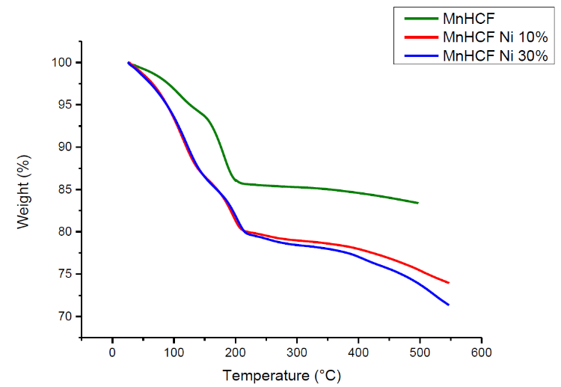
199.27°C
210.55°C
218.17°C
Figure S2. The results obtained from TGA analysis: pure MnHCF - green, 10% Ni-substituted - red, and 30% Ni-substituted - blue.

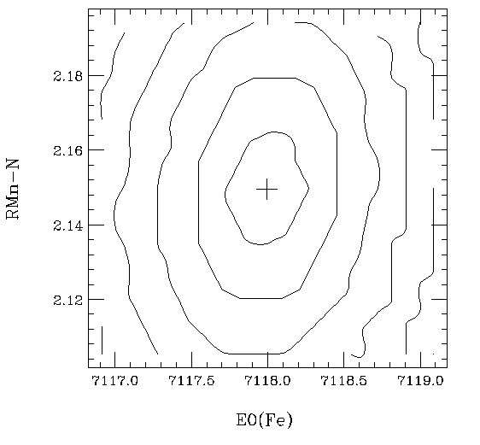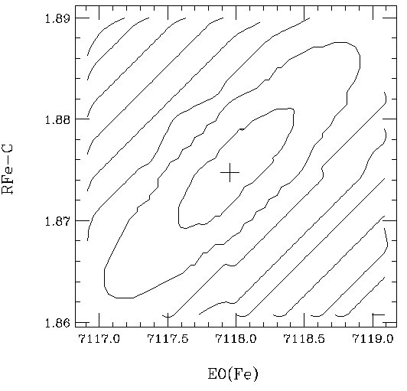
a.
b.
Figure S3. The examples of the error determination in EXAFS Multiple edge refinement of the two section plots for of the Fe-C (a) and Ni-N (b) first shell distances of the 10% Ni-substituted MnHCF.

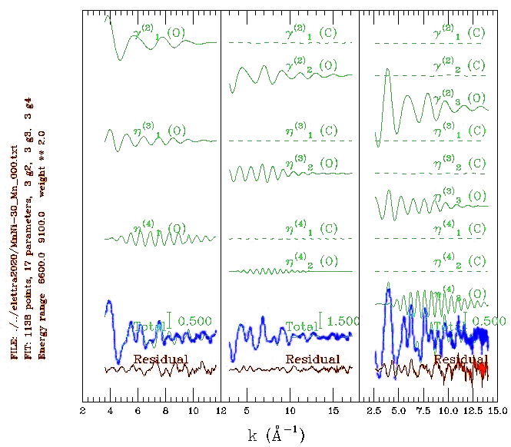
Figure S4. EXAFS Multiple edge refinement of the 30% Ni-substituted MnHCF.

References
[1] S. Kjeldgaard, et al., Materials Advances 2 (2021) 2036-2044. https://doi.org/ 10.1039/d0ma00949k.
[2] B. Ravel, et al., Journal of Synchrotron Radiation. 12 (2005) 537–541. https://doi.org/10.1107/S0909049505012719.
[3] A. Filipponi, et al., Physical Review B. 52 (1995) 15122–15134. https://doi.org/10.1103/PhysRevB.52.15122.
[4] Filipponi, et al., Phys Rev B Condens Matter. 52 (1995) 15135–15149. https://doi.org/10.1103/physrevb.52.15135.
[5] M. Giorgetti, et al., Chemical Physics Letters. 275 (1997) 108–112. https://doi.org/10.1016/S0009-2614(97)00724-0.
[6] M. Giorgetti, et al., Inorganic Chemistry. 47 (2008) 6001–6008. https://doi.org/10.1021/ic800289c.
[7] A. Mullaliu, et al., Small Methods. 4 (2020) 1900529. https://doi.org/10.1002/smtd.201900529.
[8] J. Song, et al., J Am Chem Soc. 137 (2015) 2658–2664. https://doi.org/10.1021/ja512383b.
[9] L. Hedin, et al., Solid State Communications. 9 (1971) 537–541. https://doi.org/10.1016/0038-1098(71)90141-4.
[10] M.O. Krause, et al., Journal of Physical and Chemical Reference Data. 8 (1979) 329–338. https://doi.org/10.1063/1.555595.
[11] X. Wu, et al., ACS Applied Materials & Interfaces. 8 (2016) 23706–23712. https://doi.org/10.1021/acsami.6b06880.

