Supplementary Material
Welfare Assessment of Dromedary Camels Kept Under Pastoralism in Pakistan
Barbara Padalino^{1,2}, Asim Faraz³, Naod Thomas Masebo^{1,4*}, Abdul Waheed³, Hafiz Muhammad Ishaq³, Nasir Ali Tauqir⁵, Ali Raza Abbasi⁶, Laura Menchetti⁷
¹Department of Agricultural and Food Sciences, University of Bologna, Italy.
²Faculty of Science and Engineering, Southern Cross University, Lismore, NSW, Australia,
³Department of Livestock and Poultry Production, Bahauddin Zakariya University Multan, Pakistan
⁴School of Veterinary Medicine, Wolaita Sodo University, Wolaita Sodo, Ethiopia
⁵Department of Animal Nutrition, The Islamia University of Bahawalpur, Pakistan
⁶Faculty of Veterinary and Animal Sciences, MNS University of Agriculture, Multan, Pakistan
⁷School of Biosciences and Veterinary Medicine, University of Camerino, Italy
* Correspondence:
Naod Thomas Masebo
naodthomas.masebo2@unibo.it

Supplementary Figures and Tables
  - Supplementary table
Supplementary Table 1: Median, minimum, maximum and interquartile ranges (IQR) of partial indices (PIs) of fifty-four (n=54) Caretaker-Herd level assessments corresponding to the four welfare principles (i.e., Good feeding, Good housing, Good health and Appropriate Behavior).

Assessment level | Welfare principle | Partial Index (PI) | Min | Max | Median | Q1 | Q3 | IQR
Caretaker-Herd | Good Feeding | PI Good Feeding at Caretaker-Herd level | 25 | 75 | 50 | 50 | 50 | 0
Caretaker-Herd | Good Housing | PI Good Housing at Caretaker-Herd level | 50 | 87.5 | 50 | 50 | 75 | 25
Caretaker-Herd | Good Health | PI Good Health at Caretaker-Herd level | 35.7 | 71.4 | 42.9 | 42.9 | 42.9 | 0
Caretaker-Herd | Appropriate Behavior | PI Appropriate Behavior at Caretaker-Herd level | 50 | 100 | 100 | 87.5 | 100 | 12.5

Supplementary Table 2: Median, minimum, maximum and interquartile ranges (IQR) of partial indices (PIs) of five hundred ten (n=510) Animal-level assessments corresponding to the four welfare principles (i.e., Good feeding, Good housing, Good health and Appropriate Behavior).

Assessment level | Welfare principle | Partial Index (PI) | Min | Max | Median | Q1 | Q3 | IQR
Animal | Good Feeding | PI Good Feeding at Animal level | 0 | 100 | 50 | 33 | 67 | 34
Animal | Good Housing | PI Good Housing at Animal level | 25 | 94 | 75 | 62 | 75 | 13
Animal | Good Health | PI Good Health at Animal level | 27 | 100 | 91 | 82 | 100 | 18
Animal | Appropriate Behavior | PI Appropriate Behavior at Animal level | 10 | 100 | 80 | 60 | 90 | 30

Supplementary Table 3: The classification of each camel herd's (n=54) welfare status determined by the Principal Aggregate Indices (PAIs) in Pakistan in 2023. (excellent, satisfactory, unsatisfactory, unacceptable).
Herd ID | PAI Good Feeding | PAI Good Housing | PAI Good Health | PAI Appropriate Behavior | Welfare category
1 | 51.7 | 68.4 | 81.3 | 87 | Satisfactory
2 | 40.6 | 68.3 | 71.6 | 70.7 | Satisfactory
3 | 49.4 | 63.3 | 87 | 85.8 | Satisfactory
4 | 45 | 62.5 | 84 | 71.1 | Satisfactory
5 | 39.4 | 56.7 | 81.3 | 63.8 | Satisfactory
6 | 50.2 | 57.9 | 80.8 | 76.6 | Satisfactory
7 | 42.8 | 67.1 | 76.5 | 92.2 | Satisfactory
8 | 46.5 | 51.1 | 88.6 | 70.1 | Satisfactory
9 | 48.7 | 73 | 84.5 | 76.8 | Satisfactory
10 | 47 | 71.4 | 86.1 | 77.6 | Satisfactory
11 | 51.3 | 73 | 81.9 | 76.2 | Satisfactory
12 | 45.6 | 71.7 | 79.8 | 60.3 | Satisfactory
13 | 56.1 | 75.9 | 83.8 | 74 | Satisfactory
14 | 54.4 | 76.7 | 81.3 | 86 | Satisfactory
15 | 52.7 | 74 | 91.1 | 64.8 | Satisfactory
16 | 24.7 | 69.5 | 76.4 | 69.4 | Unsatisfactory
17 | 28.2 | 73.6 | 75.5 | 68.4 | Unsatisfactory
18 | 33.3 | 70 | 88.6 | 76.8 | Satisfactory
19 | 32.2 | 70 | 78.9 | 82.3 | Satisfactory
20 | 34.4 | 70 | 82 | 81.8 | Satisfactory
21 | 23.3 | 70 | 77.7 | 80 | Unsatisfactory
22 | 26 | 70 | 82.6 | 86.4 | Unsatisfactory
23 | 24.7 | 69 | 81 | 82.3 | Unsatisfactory
24 | 31 | 81.1 | 86.9 | 78.3 | Satisfactory
25 | 23.3 | 70 | 82.5 | 79.2 | Unsatisfactory
26 | 28.7 | 70 | 82.5 | 82.4 | Unsatisfactory
27 | 40.6 | 62.1 | 72.2 | 82.3 | Satisfactory
28 | 49 | 56 | 76.5 | 79.2 | Satisfactory
29 | 52 | 72.8 | 82.9 | 71.2 | Satisfactory
30 | 62.4 | 68.3 | 86 | 72.8 | Satisfactory
31 | 58 | 72.2 | 84.4 | 87.6 | Satisfactory
32 | 62.6 | 74.3 | 83.8 | 84.9 | Excellent
33 | 53.3 | 77.5 | 82.2 | 77 | Satisfactory
34 | 53.7 | 71.5 | 83.4 | 73.4 | Satisfactory
35 | 44.3 | 76.4 | 80.1 | 78.3 | Satisfactory
36 | 52.3 | 61 | 73.5 | 76 | Satisfactory
37 | 53.3 | 70 | 81.3 | 78 | Satisfactory
38 | 45.6 | 61.7 | 76.5 | 73.3 | Satisfactory
39 | 36.7 | 53.8 | 56.7 | 75.7 | Satisfactory
40 | 29 | 64.6 | 78 | 65.6 | Unsatisfactory
41 | 74.6 | 71.2 | 81.3 | 93.8 | Excellent
43 | 84 | 69.1 | 85.8 | 89.9 | Excellent
44 | 72.6 | 65.4 | 81.3 | 75 | Satisfactory
45 | 73.7 | 62.8 | 77.1 | 87 | Excellent
46 | 38.7 | 71.2 | 80.7 | 86.7 | Satisfactory
47 | 35.6 | 57 | 73.9 | 82 | Satisfactory
48 | 45 | 53.1 | 71.1 | 81 | Satisfactory
49 | 50 | 57.1 | 65.1 | 79.4 | Satisfactory
50 | 51.3 | 58 | 79.4 | 92.8 | Satisfactory
51 | 81.1 | 65.2 | 70.3 | 74.9 | Satisfactory
52 | 78.7 | 63 | 80.8 | 74.4 | Satisfactory
53 | 58.8 | 64.6 | 81.2 | 87.4 | Satisfactory
54 | 50 | 66.9 | 78.9 | 86.3 | Satisfactory
55 | 50.8 | 60.6 | 79.9 | 69.9 | Satisfactory

Supplementary Table 4: The classification of the welfare category of each camel herd (n=54) based on the total welfare indices (TWIs) in Pakistan in 2023.
Herd ID | TWI | Welfare category
1 | 72.1 | Green light
2 | 62.8 | Red light
3 | 71.4 | Green light
4 | 65.7 | Orange light
5 | 60.3 | Red light
6 | 66.4 | Orange light
7 | 69.6 | Orange light
8 | 64.1 | Red light
9 | 70.7 | Green light
10 | 70.5 | Orange light
11 | 70.6 | Orange light
12 | 64.3 | Red light
13 | 72.4 | Green light
14 | 74.6 | Green light
15 | 70.6 | Green light
16 | 59.9 | Red light
17 | 61.4 | Red light
18 | 67.2 | Orange light
19 | 65.9 | Orange light
20 | 67.1 | Orange light
21 | 62.7 | Red light
22 | 66.3 | Orange light
23 | 64.2 | Red light
24 | 69.3 | Orange light
25 | 63.8 | Red light
26 | 65.9 | Orange light
27 | 64.3 | Red light
28 | 65.2 | Red light
29 | 69.7 | Orange light
30 | 72.4 | Green light
31 | 75.5 | Green light
32 | 76.4 | Green light
33 | 72.5 | Green light
34 | 70.5 | Orange light
35 | 69.8 | Orange light
36 | 65.7 | Orange light
37 | 70.7 | Green light
38 | 64.3 | Red light
39 | 55.7 | Red light
40 | 59.3 | Red light
41 | 80.2 | Green light
43 | 82.2 | Green light
44 | 73.6 | Green light
45 | 75.1 | Green light
46 | 69.3 | Orange light
47 | 62.1 | Red light
48 | 62.6 | Red light
49 | 62.9 | Red light
50 | 70.4 | Orange light
51 | 72.9 | Green light
52 | 74.2 | Green light
53 | 73.0 | Green light
54 | 70.5 | Orange light
 | 65.3 | Red light

Supplementary Table 5: Functions at Group Centroids of the Discriminant Analyses investigating the classification of the "welfare profiles system” and “light traffic system”.

Classification system
Welfare profiles |  |  |  | Light traffic
Category | Function |  |  | Category | Function
Category | 1 | 2 |  | Category | 1 | 2
Excellent | 2.995 | 0.768 |  | Green light | 2.263 | -0.313
Satisfactory | 0.128 | -0.165 |  | Orange light | 0.003 | 0.624
Unsatisfactory | -2.168 | 0.480 |  | Red light | -2.266 | -0.311
Unstandardized canonical discriminant functions evaluated at group means

Supplementary figures

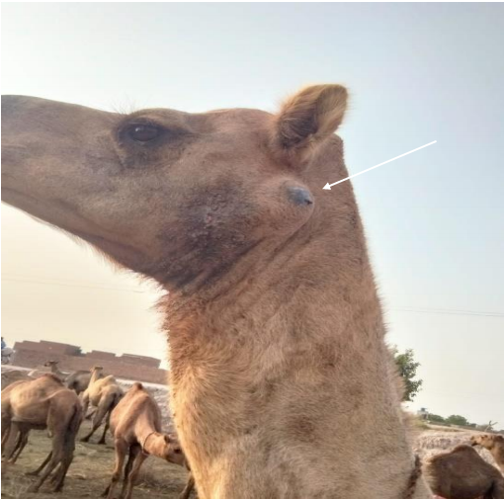
Supplementary Figure 1: Examples of camels not included in the welfare assessment due to health conditions: An absecces (indicated in the arrow).

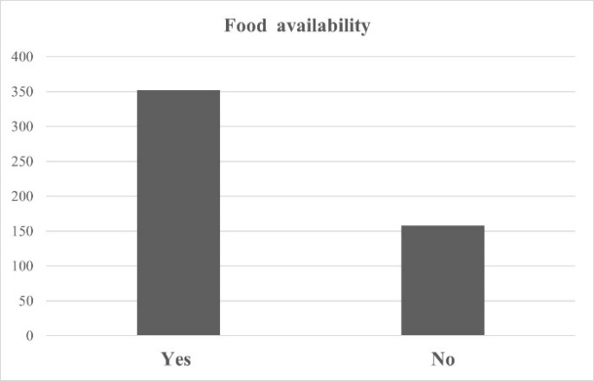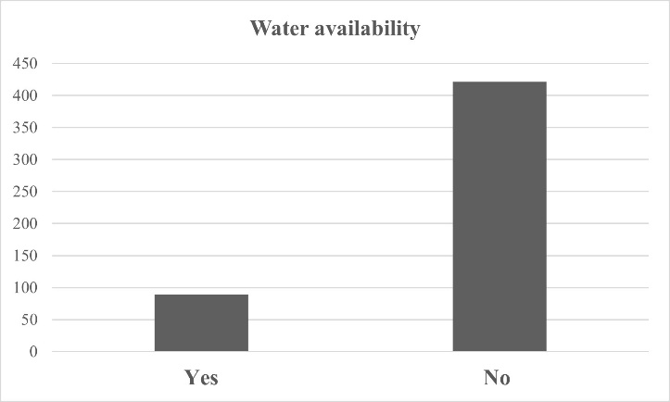
(A) (B)
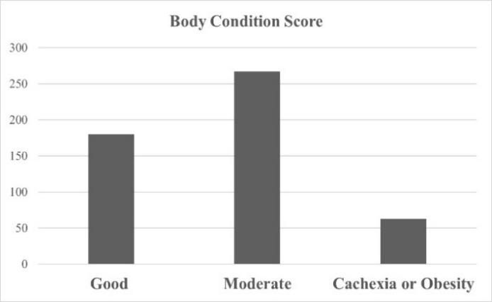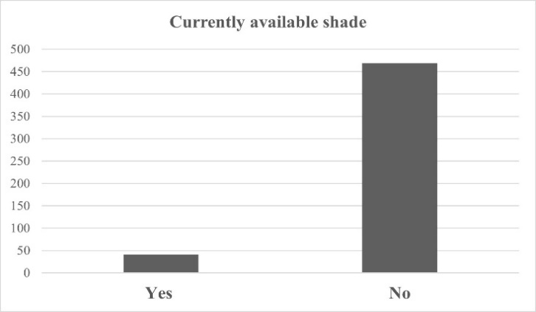
(C) (D)
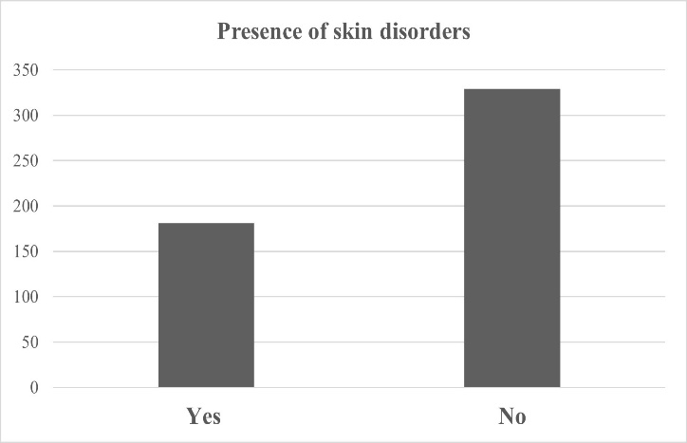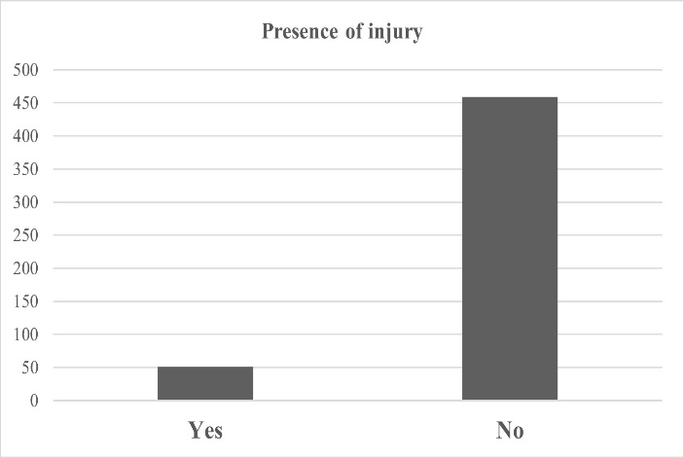
(E) (F)
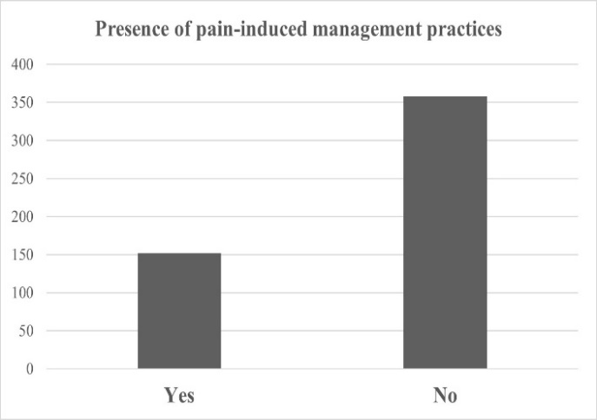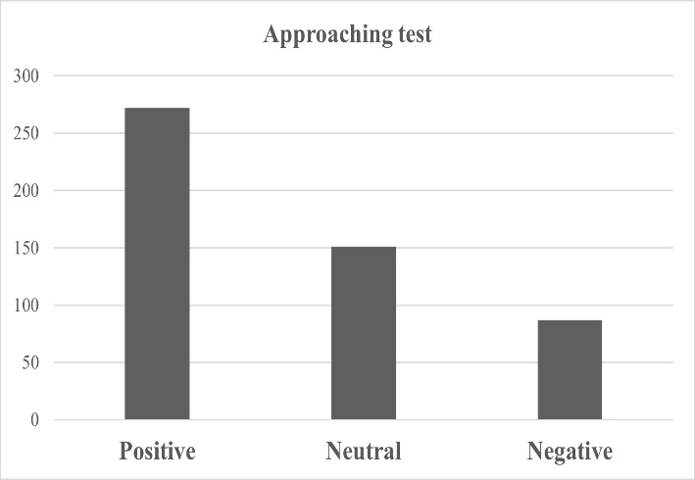
(G) (H)

Supplementary Figure 2: Distribution of selected animal-level assessment indicators (A) Food Availability, (B) Water Availability, (C) Body condition score, (D) Currently Available shade, (E) Presence of skin disorder, (F) Presence of injury, (G) Presence of pain-induced management practices, (H) Approaching test

Supplementary Figure 3. Boxplot for partial indices (PIs) at Caretaker-Herd (C-H) and Animal levels corresponding to the four welfare principles (i.e., Good feeding, Good housing, Good health, and Appropriate Behavior). The whiskers on the plot define the range from the 2.5 to the 97.5 percentile while the dots show the outliers (that fall below or above this range).

