Supplementary Information
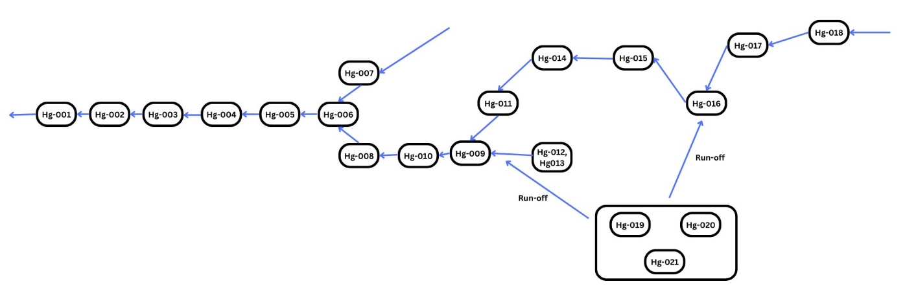
Supplementary Figure 1a: Flow chart of samples along river at Rosterman mine, Kenya, with arrows depicting the direction of river flow

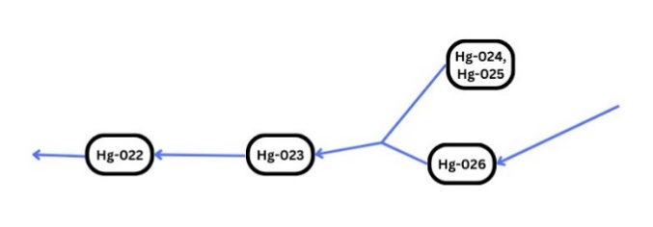
Supplementary Figure 1b: Flow chart of samples along river at Malinya mine, with arrows depicting the direction of river flow

