Effect of climate extremes and grazing on functional traits of grassland communities: insights from a 20-year experiment
Nicola Pavanetto, Enrico Tordoni, Francesco Petruzzellis, Simona Maccherini, Andrea Nardini, Eleonora Beccari, Carlo Ricotta, Duccio Rocchini, Luisa Conti, Emanuele Fanfarillo, Miris Castello, Giovanni Bacaro

Supplementary Information

Detailed method S1 – Study area
The experimental area lies on a calcareous massif within the Uccellina - Monte Amiata ridge. This site, forming part of the Special Area of Conservation/Special protected area (SPC/SPA) "Monte Labbro and Upper Albegna Valley," is characterized by a diverse landscape predominantly comprising semi-natural calcareous grasslands, dense scrub in abandoned ex-arable lands dominated by Prunus spinosa, Rubus ulmifolius and Cytisus scoparius, and small woods with Acer campestre and A. monspessulanum. Historically, the summit area (1193 m a.s.l.) experienced extensive grazing, but a reduction in anthropogenic grazing pressure since the 1960s led to a shift from semi-natural grasslands to dense shrublands, triggering secondary succession patterns (Maccherini and Santi 2012). In late summer 2000 and early spring 2001, all shrubs were removed manually as part of two restoration projects funded by the European Union (LIFE NAT/IT/99/6229 and LIFE04NAT/IT/000173). Grazing by donkeys, which were reintroduced as part of the restoration, continued post-restoration; the site is occasionally grazed by sheep, cattle and hares. The average stocking density was maintained at 0.5 ha⁻¹ year⁻¹, consistent throughout the following years (Maccherini and Santi, 2012). Following this, in 2001, a non-replicated randomized block design was established in an area characterized by a dense cover of P. spinosa (80%). Four 3 m × 5 m experimental plots were established in each of four blocks stratified over a few meters of altitude in a 12 × 20 m area. Individual plots in each block were randomly assigned to one of four treatments: no grazing or sowing with native species (sowing rate of 4 g m⁻²); sowing without grazing; grazing without sowing; sowing and grazing.

References
Maccherini, Simona, and Elisa Santi. 2012. “Long-Term Experimental Restoration in a Calcareous Grassland: Identifying the Most Effective Restoration Strategies.” Biological Conservation 146 (1): 123–35.

Detailed methods S2 – Functional traits measurement
For each species and treatment (i.e. grazed, ungrazed), we collected two to three whole individuals, preserved them in cling film, sealed in plastic bag with wet paper, and stored them in cool bags. Once in the laboratory, entire plants, still wrapped in plastic film, were left rehydrating under dark condition overnight. For each individual, 1 to 10 leaves were randomly selected to reach a substantial mass for traits measurement. We measured a set of plant functional traits usually associated with the LES, HSE, leaf vein architecture and water-use efficiency (see Petruzzellis et al. 2021).
Specific leaf area (SLA, mm² mg⁻¹) and Leaf Dry Matter Content (LDMC, mg g⁻¹) were calculated as follows:
SLA = (Leaf Area) / (Leaf Dry Weight) [mm² mg⁻¹]
LDMC = (Leaf Dry Weight) / (Leaf Fresh Weight) [mg g⁻¹]
Leaf area was measured using ImageJ software (Schneider, Rasband, and Eliceiri 2012) after scanning the leaves without petiole. After that, leaf fresh weight was measured using an analytical balance and leaf dry weight was obtained after oven-drying samples for 48 h at 70 °C.
Minor vein length per unit area (VLA, mm mm⁻²) was measured as follows:
VLA = Vein Length (from 3rd to higher orders) / Leaf sample area [mm mm⁻²]
Leaves were cleared by immersion in a 1 M NaOH for 72 h, carefully replacing the solution when it changed from transparent to dark colour. Leaf pieces of about 1 cm² were cut and bleached in NaClO 5 % for about 2-3 minutes. Then, samples were put in sequential ethanol solutions at an increasing concentration (25%, 50%, 75%, and 100%) and left soaking in an alcoholic solution of toluidine blue overnight. Samples were then treated in sequential solutions of ethanol at decreasing concentration and put on microscope slides. We captured images of leaves of about 5 mm², using an optical microscope equipped with a digital camera (model Syrio-2 Pbinternational), and VLA was measured using the PhenoVein software (Bühler et al. 2015).
To estimate species-specific turgor loss point (Ψ_{tlp}, MPa), leaves were crumbled, sealed in a plastic film, and immersed in liquid nitrogen for about 1 min, and then carefully ground while still in cling film and stored in sealed plastic bottles at -20°C. Osmotic potential (π_{0_osm}) was measured using a dew point potentiometer (Model WP4, METER Group Inc., Pullman, Washington, USA) and Ψ_{tlp} was obtained following Petruzzellis et al. (2019), after correction for LDMC. Specifically, π₀ and Ψ_{tlp} were calculated with the following equations:
π₀ = 0.506 π_{0_osm} - 0.002 LDMC (expressed in mg g -1) [MPa]
Ψ_{tlp} = 1.31 π₀ – 0.03 [MPa]
To measure Carbon isotope composition (δ¹³C, ‰), Leaf Nitrogen Content (LNC, %), and Leaf Carbon Content (LCC, %), leaves were dried at 70 °C for 48 h and then pulverized with a mixer mill. Measurements were done by the Center for Stable Isotopes Biogeochemistry (University of California, Berkeley) by a continuous flow dual isotope analysis using a CHNOS Elemental Analyzer interfaced to an IsoPrime100 mass spectrometer. Long-term external precision based on reference material “NIST SMR 1577b” (bovine liver) is 0.10‰ and 0.15‰, respectively for C and N isotope analyses.

References
Bühler, Jonas, Louai Rishmawi, Daniel Pflugfelder, Gregor Huber, Hanno Scharr, Martin Hülskamp, Maarten Koornneef, Ulrich Schurr, and Siegfried Jahnke. 2015. “phenoVein—A Tool for Leaf Vein Segmentation and Analysis.” Plant Physiology 169 (4): 2359–70.
Petruzzellis, Francesco, Tadeja Savi, Giovanni Bacaro, and Andrea Nardini. 2019. “A Simplified Framework for Fast and Reliable Measurement of Leaf Turgor Loss Point.” Plant Physiology and Biochemistry 139 (June): 395–99.
Petruzzellis, Francesco, Enrico Tordoni, Martina Tomasella, Tadeja Savi, Vanessa Tonet, Chiara Palandrani, Miris Castello, Andrea Nardini, and Giovanni Bacaro. 2021. “Functional Differentiation of Invasive and Native Plants along a Leaf Efficiency/Safety Trade-Off.” Environmental and Experimental Botany 188 (August): 104518.
Schneider, Caroline A., Wayne S. Rasband, and Kevin W. Eliceiri. 2012. “NIH Image to ImageJ: 25 Years of Image Analysis.” Nature Methods 9 (7): 671–75. https://doi.org/10.1038/nmeth.2089.

Table S1. Summary of trait measurements for each species in each treatment.

Species | Functional  Group | Family | Treatment | Replicates | LDMC  [mg g⁻¹] | SLA  [mm²mg⁻¹] | Ψ_{tlp}  [MPa] | VLA  [mm mm⁻²] | δ¹³C  [‰] | LCC  [%] | LNC  [%]
Acer monspessulanum | Shrubs | Sapindaceae | Ungrazed | 3 | 384.68 ± 7.31 | 15.79 ±  2.25 | -2.32 ±  0.62 | 11.3 ±  0.5 | -26.96 ±  1.06 | 48.68 ±  1.02 | 1.91 ±  0.07
Acer monspessulanum | Shrubs | Sapindaceae | Grazed | 3 | 382.57 ± 16.98 | 15.88 ±  2.07 | -2.3 ±  0.13 | 11.78 ± 1.21 | -27.72 ± 1.01 | 47.93 ± 0.83 | 2.53 ±  0.45
Acinos arvensis | Forbs | Lamiaceae | Ungrazed | 3 | 278.24 ± 8.45 | 13.17 ±  1.68 | -1.65 ±  0.02 | 11.68 ± 0.82 | -30.12 ± 0.37 | 46.86 ± 0.71 | 1.08 ±  0.08
Acinos arvensis | Forbs | Lamiaceae | Grazed | 3 | 286.76 ± 21.65 | 14.16 ±  1.6 | -1.62 ±  0.29 | 11.27 ± 0.64 | -29.74 ± 0.72 | 47.15 ± 0.92 | 1.33 ±  0.09
Arrhenatherum elatius | Grasses | Poaceae | Ungrazed | 2 | 239.01 ± 59.73 | 36.44 ± 2.13 | -2.37 ±  0.24 | 4.22 ±  0.29 | -30.85 | 42.62 | 2.94
Arrhenatherum elatius | Grasses | Poaceae | Grazed | 3 | 284.82 ± 23.96 | 31.65 ± 3.32 | -1.96 ±  0.15 | 5.81 ±  0.61 | -29.83 ± 1.37 | 45.08 ± 2.29 | 3.12 ±  0.32
Bromus erectus | Grasses | Poaceae | Ungrazed | 3 | 346.37 ± 19.45 | 13.16 ±  2.7 | -2.21 ±  0.05 | 4.45 ±  0.28 | -27.4 ±  1.13 | 44.57 ± 0.63 | 2 ±  0.43
Bromus erectus | Grasses | Poaceae | Grazed | 3 | 305.29 ± 23.7 | 20.62 ± 1.26 | -2.26 ±  0.01 | 5.7 ±  0.72 | -28.69 ± 0.39 | 44.67 ± 0.18 | 2.32 ±  0.08
Bromus sterilis | Grasses | Poaceae | Ungrazed | 3 | 239.82 ± 44.99 | 23.09 ± 3.61 | -1.87 ±  0.2 | 5.56 ±  0.53 | -28.84 ± 0.15 | 42.72 ± 1.02 | 2.61 ±  0.13
Bromus sterilis | Grasses | Poaceae | Grazed | 2 | 220.48 ± 20.94 | 39.59 ± 4.83 | -1.41 ±  0.07 | 5.38 ±  1.32 | -30.02 ± 1.51 | 45.88 ± 1.05 | 3.13 ±  0.35
Bupleurum baldense | Forbs | Apiaceae | Ungrazed | 3 | 292.68 ± 20.09 | 23.34 ± 3.34 | -3.21 ±  0.16 | 9.25 ±  0.96 | -29.89 ± 0.35 | 43.61 ± 1.84 | 1.42 ±  0.48
Carlina corymbosa | Forbs | Asteraceae | Ungrazed | 3 | 188.03 ± 14.99 | 12.03 ± 1.58 | -0.97 ±  0.01 | 7.03 ±  0.74 | -28.46 ± 0.17 | 45.17 ± 1.05 | 2.34 ±  0.44
Centaurea solstitialis | Forbs | Asteraceae | Grazed | 3 | 174.59 ± 29.68 | 28.75 ± 4.93 | -1.43 ±  0.33 | 8.82 ±  1.77 | -30.15 ± 0.69 | 43.51 ± 2.56 | 2.58 ±  1.09
Cerastium arvense var. etruscum | Forbs | Caryophyllaceae | Ungrazed | 3 | 163.12 ± 22.97 | 33.25 ±  7.3 | -1.59 ±  0.19 | 4.75 ±  0.37 | -30.81 ± 0.38 | 41.24 ± 2.83 | 2.87 ±  0.87
Convolvulus arvensis | Forbs | Convolvulaceae | Ungrazed | 3 | 193.68 ± 25.4 | 22.49 ± 4.32 | -1.36 ±  0.01 | 11.24 ± 2.14 | -27.74 ± 0.84 | 45.95 ±  1.1 | 3.14 ±  0.57
Convolvulus arvensis | Forbs | Convolvulaceae | Grazed | 3 | 168.23 ± 15.95 | 28.9 ±  4.15 | -1.32 ±  0.1 | 11.18 ± 1.91 | -28.98 ± 0.31 | 45.24 ± 1.39 | 4.16 ±  0.45
Cynosurus echinatus | Grasses | Poaceae | Grazed | 3 | 242.4 ± 23.72 | 30.04 ± 5.61 | -2.42 ±  0.51 | 5.37 ±  0.95 | -30.69 ±  0.4 | 45.34 ± 2.09 | 3.18 ±  0.47
Dactylis hispanica | Grasses | Poaceae | Ungrazed | 3 | 324.34 ± 15.22 | 20.94 ± 0.93 | -2.04 ±  0.3 | 5.51 ±  0.65 | -27.75 ± 0.89 | 43.86 ± 0.46 | 1.8 ±  0.24
Dactylis hispanica | Grasses | Poaceae | Grazed | 3 | 257.01 ± 33.37 | 25.08 ± 5.32 | -2.1 ±  0.75 | 6.32 ±  0.48 | -29.31 ± 0.73 | 44.07 ± 1.36 | 2.84 ±  0.82
Echium vulgare | Forbs | Boraginaceae | Grazed | 3 | 176.77 ± 4.19 | 14.73 ± 3.12 | -1.44 ±  0.25 | 8.19 | -28.46 ± 0.74 | 37.81 ± 1.58 | 1.44 ±  0.36
Erysimum pseudorhaeticum | Forbs | Brassicaceae | Grazed | 3 | 217.96 ± 10.24 | 12.53 ± 0.25 | -1.17 ±  0.07 | 10.81 ± 0.71 | -29 ±  0.39 | 41.96 ±  2.4 | 2.28 ±  0.76
Festuca inops | Grasses | Poaceae | Ungrazed | 3 | 386.84 ± 38.28 | 7.08 ±  0.97 | -2.6 ±  0.21 | 8 ±  0.78 | -27.59 ± 0.71 | 45.9 ±  0.85 | 1.69 ±  0.19
Festuca inops | Grasses | Poaceae | Grazed | 2 | 378.47 ± 24.55 | 8.25 ±  0.51 | -2.64 ±  0.41 |  | -28.64 ±  0.2 | 45.73 ± 0.57 | 1.9 ±  0.28
Geranium columbinum | Forbs | Geraniaceae | Ungrazed | 3 | 238.06 ± 18.85 | 31.89 ± 0.71 | -1.64 ±  0.46 | 8.13 ±  0.58 | -29.67 ± 0.34 | 44.3 ±  2.01 | 3.25 ±  0.17
Hypericum perforatum | Forbs | Hypericaceae | Ungrazed | 3 | 338.64 ± 6.44 | 18.94 ± 1.03 | -2.09 ±  0.31 | 17.69 ± 2.82 | -29.32 ± 0.38 | 47.72 ± 1.06 | 2.05 ±  0.27
Hypericum perforatum | Forbs | Hypericaceae | Grazed | 3 | 314.33 ± 27.49 | 19.6 ±  2.4 | -1.84 ±  0.22 | 18.22 ± 2.74 | -30.43 ± 1.73 | 48.02 ± 0.21 | 1.89 ±  0.21
Marrubium incanum | Forbs | Lamiaceae | Grazed | 3 | 283 ± 15.13 | 13.85 ± 0.99 | -2.38 ±  0.43 | 11.5 ±  3.03 | -29.04 ± 0.62 | 45.85 ± 0.69 | 2.63 ±  0.36
Opopanax chironium | Forbs | Apiaceae | Ungrazed | 3 | 179.22 ± 23.1 | 27.94 ± 5.92 | -1.42 ±  0.04 | 5.24 ±  0.92 | -28.74 ± 0.85 | 41.36 ± 1.55 | 2.36 ±  0.42
Opopanax chironium | Forbs | Apiaceae | Grazed | 3 | 206.65 ± 17.99 | 21.98 ± 3.12 | -1.48 ±  0.02 | 8.95 ±  1.32 | -28.49 ± 0.48 | 44.56 ± 1.92 | 3.05 ±  0.34
Orlaya grandiflora | Forbs | Apiaceae | Ungrazed | 3 | 240.21 ± 3.26 | 17.4 ±  3.87 | -1.62 ±  0.15 | 7.72 ±  1.64 | -29 ±  0.6 | 42.23 ± 0.96 | 2.13 ±  0.41
Orlaya grandiflora | Forbs | Apiaceae | Grazed | 4 | 261.65 ± 60.92 | 14.09 ±  2.6 | -1.89 ±  0.35 | 9.04 ±  0.9 | -29.48 ± 0.66 | 43.92 ± 5.28 | 2.02 ±  0.14
Phleum ambiguum | Grasses | Poaceae | Ungrazed | 3 | 315.91 ± 16.22 | 19.66 ± 2.32 | -2.05 ±  0.13 | 7.52 ±  1.95 | -29.22 ± 0.81 | 43.4 ±  1.31 | 2.02 ±  0.39
Phleum ambiguum | Grasses | Poaceae | Grazed | 3 | 312.37 ± 18.36 | 19.54 ± 2.59 | -2.18 ±  0.32 | 7.11 ±  1.71 | -28.7 ±  1.71 | 45.76 ± 1.83 | 2.26 ±  0.3
Phleum pratense | Grasses | Poaceae | Grazed | 3 | 282.25 ± 39.2 | 24.66 ±  3.7 | -2.02 ±  0.29 | 5.87 ±  0.13 | -28.1 ±  1.17 | 45.96 ±  0.7 | 2.64 ±  0.57
Prunus spinosa | Shrubs | Rosaceae | Ungrazed | 3 | 286.3 ±  41 | 20.75 ±  5.7 | -1.93 ±  0.26 | 11.52 ± 2.15 | -27.61 ± 1.42 | 46.69 ± 2.27 | 2.48 ±  0.18
Prunus spinosa | Shrubs | Rosaceae | Grazed | 3 | 295.62 ± 24.53 | 17.72 ± 0.93 | -1.94 ±  0.25 | 13.21 ± 1.86 | -27.28 ± 0.75 | 50.34 ±  1.8 | 3.04 ±  0.12
Rubus ulmifolius | Shrubs | Rosaceae | Ungrazed | 3 | 362.22 ± 11.48 | 13.53 ± 1.76 | -2.3 ±  0.46 | 13.86 ± 2.56 | -26.16 ±  1.1 | 47.5 ±  2.3 | 2.31 ±  0.78
Rubus ulmifolius | Shrubs | Rosaceae | Grazed | 3 | 405.3 ± 13.4 | 14.09 ± 3.54 | -2.49 ±  0.06 | 13.42 ± 1.66 | -26.02 ± 2.06 | 47.92 ± 0.29 | 2.29 ±  0.46
Sanguisorba minor | Forbs | Rosaceae | Ungrazed | 3 | 337.28 ± 38.43 | 19.39 ± 3.97 | -2.07 ±  0.25 | 11.72 ± 2.36 | -29.69 ± 0.46 | 44.24 ± 2.02 | 1.57 ±  0.52
Sanguisorba minor | Forbs | Rosaceae | Grazed | 3 | 384.55 ± 35.34 | 16.25 ± 0.77 | -2 ±  0.2 | 13.92 ± 1.27 | -29.2 ±  0.38 | 44.72 ± 4.57 | 1.63 ±  0.56
Stachys heraclea | Forbs | Lamiaceae | Grazed | 3 | 283.86 ± 13.4 | 14.51 ± 1.11 | -1.6 ±  0.01 | 15.15 ± 2.37 | -28.18 ± 0.29 | 44.44 ± 0.23 | 2.41 ±  0.67
Teucrium chamaedrys | Forbs | Lamiaceae | Ungrazed | 3 | 338.15 ± 45.96 | 13.26 ±  2.4 | -1.74 ±  0.18 | 9.97 ±  0.35 | -28.94 ± 0.04 | 47.8 ±  0.72 | 1.67 ±  0.35
Teucrium chamaedrys | Forbs | Lamiaceae | Grazed | 3 | 326.29 ± 39.91 | 13.29 ±  2.2 | -1.83 ±  0.21 | 9.97 ±  2.66 | -28.48 ± 0.97 | 49.26 ± 2.07 | 1.73 ±  0.23
Thymus longicaulis | Forbs | Lamiaceae | Grazed | 3 | 294.76 ± 19.22 | 15.73 ± 0.84 | -1.63 ±  0.14 | 11.52 ± 2.72 | -28.97 ± 0.66 | 46.14 ± 0.25 | 1.62 ±  0.08
Torilis arvensis | Forbs | Lamiaceae | Ungrazed | 3 | 277.76 ± 39.14 | 22.19 ± 5.47 | -1.87 ±  0.1 | 8 ±  1 | -29.93 ± 0.14 | 41.67 ± 1.62 | 2.89 ±  0.49
Torilis arvensis | Forbs | Apiaceae | Grazed | 1 | 250 | 25.22 | -1.65 | 11.85 | -29.44 | 42.45 | 2.93
Trifolium incarnatum | Legumes | Apiaceae | Ungrazed | 3 | 239.72 ± 29.45 | 27.04 ± 4.75 | -1.89  ± 0.36 | 11.84 ± 1.77 | -30.09 ± 0.76 | 45.65 ± 1.35 | 2.96 ±  0.07
Trifolium incarnatum | Legumes | Fabaceae | Grazed | 3 | 223.82 ± 26.38 | 28.62 ± 7.07 | -1.52 ±  0.19 | 11.12 ± 1.53 | -29.93 ±  0.8 | 44.87 ± 1.04 | 3.02 ±  0.34
Xeranthemum cylindraceum | Forbs | Asteraceae | Ungrazed | 3 | 257.85 ± 107.72 | 30.56 ± 13.35 | -1.58 ±  0.42 | 7.77 ±  1.07 | -30.56 ± 0.58 | 46.34 ± 1.93 | 2.27 ±  0.43
Xeranthemum cylindraceum | Forbs | Asteraceae | Grazed | 3 | 174.71 ± 17.38 | 40.77 ± 5.98 | -1.42 ±  0.01 | 8.75 ±  0.93 | -31.33 ± 0.04 | 44.49 ± 0.27 | 2.86 ±  0.23
Mean and standard deviations of each trait for each species across the two different treatment. LDMC= leaf dry matter content; SLA = specific leaf area; Ψ_{tlp} = water potential at turgor loss point; VLA = minor vein length per area; δ¹³C = carbon stable isotope composition; LCC = leaf carbon content, LNC = leaf nitrogen content. Each species was classified in a functional group following Methods S1.

Table S2. Relative recorded abundance of each species in each treatment across the years.

Treatment | Species | 2002 | 2003 | 2004 | 2006 | 2007 | 2008 | 2009 | 2010 | 2011 | 2012 | 2013 | 2014 | 2015 | 2016 | 2019 | 2020 | 2021 | 2022
Ungrazed | Acer.monspessulanum | 0 | 0.01 | 0 | 0 | 0 | 0 | 0 | 0.01 | 0.01 | 2.44 | 6.82 | 6.44 | 11.3 | 11.9 | 15.7 | 16.4 | 17.1 | 19.3
Ungrazed | Acinos.arvensis | 0.62 | 0.01 | 1.5 | 0 | 0.22 | 0.48 | 0.06 | 0.31 | 0.39 | 0.88 | 0 | 0.06 | 0.01 | 0.06 | 0 | 0.01 | 0.01 | 0.06
Ungrazed | Arrhenatherum.elatius | 0.31 | 0.32 | 0 | 0.03 | 0.01 | 0.31 | 0.56 | 0.5 | 0.44 | 0 | 0 | 0 | 0 | 0.19 | 0.2 | 0.57 | 0.1 | 0.01
Ungrazed | Bromus.erectus | 9.03 | 24.1 | 15.6 | 15.6 | 16.8 | 26.3 | 25.1 | 23.6 | 26.9 | 37.1 | 31.6 | 31.7 | 39.8 | 26 | 17.7 | 20.6 | 20.3 | 20.4
Ungrazed | Bromus.sterilis | 2.88 | 1.94 | 5.91 | 4.75 | 4.29 | 5.13 | 5.31 | 3.06 | 3.38 | 0.06 | 0.94 | 0.26 | 0.13 | 0.07 | 0.46 | 0.82 | 2.93 | 0.21
Ungrazed | Bupleurum.baldense | 0.75 | 0.11 | 0.94 | 0.2 | 0.14 | 0.2 | 0.44 | 0.03 | 0.13 | 0.01 | 0.07 | 0.01 | 0.01 | 0.12 | 0.32 | 0.19 | 0.63 | 0.38
Ungrazed | Carlina.corymbosa | 0.47 | 0.51 | 0.41 | 0.19 | 0.28 | 2.5 | 1.25 | 1.63 | 1.88 | 0 | 2.19 | 2.62 | 1.12 | 1.19 | 1.44 | 1.31 | 1.5 | 2.81
Ungrazed | Centaurea.solstitialis | 0.69 | 0.11 | 0.19 | 0.29 | 0.16 | 0.38 | 1.5 | 0.38 | 0.69 | 0.07 | 1.12 | 1.31 | 0 | 0 | 0 | 0.01 | 0.13 | 0
Ungrazed | Cerastium.arvense.ssp..arvense.var..etruscum | 0.38 | 0.41 | 1.22 | 0.76 | 0.1 | 0.69 | 0.32 | 0.95 | 0.58 | 0.44 | 0.14 | 0.02 | 0.14 | 0.07 | 0.8 | 0.15 | 0.71 | 0.46
Ungrazed | Convolvulus.arvensis | 1.41 | 2.63 | 1.5 | 2.06 | 0.72 | 2.88 | 2.44 | 2.32 | 2.19 | 1.13 | 0.58 | 0.46 | 0.09 | 0.19 | 0.25 | 0.01 | 0.51 | 0.13
Ungrazed | Cynosurus.echinatus | 1.31 | 0.29 | 1.04 | 0.22 | 0.26 | 0.51 | 0.38 | 2.51 | 3.44 | 0.01 | 0.13 | 0.31 | 0.01 | 0.01 | 0.01 | 0 | 0.01 | 0.06
Ungrazed | Dactylis.hispanica | 4.94 | 21.8 | 8.28 | 6.44 | 4.72 | 6.51 | 7 | 7.25 | 6.69 | 5.82 | 4 | 7.31 | 5.31 | 10 | 4.98 | 2.53 | 1.3 | 1.14
Ungrazed | Echium.vulgare | 0.22 | 1.13 | 0 | 0.04 | 0.01 | 1.25 | 0.12 | 0.01 | 0.07 | 0 | 0.19 | 0.19 | 0.12 | 0.01 | 0 | 0 | 0 | 0
Ungrazed | Erysimum.pseudorhaeticum | 0.61 | 0.23 | 0.03 | 0.35 | 0.16 | 0 | 0 | 0.13 | 0.01 | 0 | 0.12 | 0.01 | 0 | 0 | 0 | 0 | 0 | 0.01
Ungrazed | Festuca.inops | 0 | 0 | 0 | 0 | 0 | 0 | 0 | 0 | 0 | 0 | 0 | 0 | 0 | 0 | 0 | 0.27 | 1.07 | 0.31
Ungrazed | Geranium.columbinum | 0.63 | 0.24 | 0.38 | 0.08 | 0.46 | 0.62 | 0.94 | 1.82 | 0.9 | 0.08 | 2.31 | 0.76 | 0.21 | 0.83 | 0.46 | 0.87 | 1.01 | 0.42
Ungrazed | Hypericum.perforatum | 0.12 | 0.41 | 0.03 | 0 | 0.03 | 1.07 | 0.26 | 0.63 | 1.75 | 2.89 | 0.14 | 1.19 | 5.88 | 1 | 0.69 | 2.88 | 0.08 | 0
Ungrazed | Marrubium.incanum | 0.19 | 0.32 | 0.19 | 0.03 | 0.09 | 0.01 | 0.06 | 0.01 | 0.07 | 0.01 | 0 | 0 | 0 | 0 | 0 | 0 | 0 | 0
Ungrazed | Opopanax.chironium | 0.44 | 0.22 | 0.41 | 0.01 | 0.44 | 1.56 | 0.62 | 1.19 | 0.88 | 0 | 0.38 | 0.25 | 0 | 0.12 | 0.32 | 0.05 | 0.01 | 0.01
Ungrazed | Orlaya.grandiflora | 7.22 | 0.22 | 2.34 | 0.91 | 4.47 | 0.58 | 12.7 | 5.69 | 5.75 | 1.19 | 10.8 | 6.56 | 0.07 | 2.81 | 0.38 | 2.51 | 0.92 | 0.7
Ungrazed | Phleum.ambiguum | 3.84 | 2.07 | 0.69 | 0.34 | 1.47 | 0.4 | 1.32 | 8.38 | 7.94 | 1.38 | 4.12 | 5.69 | 0.95 | 0.39 | 0.62 | 1.25 | 0.39 | 0.75
Ungrazed | Phleum.pratense | 2.38 | 3.28 | 3.75 | 6.69 | 1.85 | 0.88 | 0.29 | 0.88 | 1.19 | 0.32 | 0.19 | 0.01 | 0 | 0.06 | 0.12 | 0 | 0 | 0
Ungrazed | Prunus.spinosa | 10.2 | 15.2 | 20.8 | 10.3 | 8.51 | 8.12 | 6.69 | 5.76 | 5.26 | 11.6 | 6.63 | 6.19 | 11.9 | 11.9 | 20.9 | 17 | 20.2 | 22.2
Ungrazed | Rubus.ulmifolius | 0.29 | 0.62 | 0.28 | 0.53 | 0.34 | 2.81 | 0.44 | 1.19 | 1.5 | 1.94 | 0.94 | 1.19 | 3.25 | 6.69 | 1.66 | 1.04 | 1.72 | 0.08
Ungrazed | Sanguisorba.minor | 0.59 | 0.59 | 0.41 | 1 | 1.26 | 1.88 | 1.06 | 1.34 | 0.64 | 0.81 | 0.26 | 0.33 | 0.52 | 0.44 | 0.2 | 0.2 | 0.2 | 0.08
Ungrazed | Stachys.heraclea | 0.38 | 0.25 | 0.19 | 0.25 | 0.13 | 1.19 | 0.12 | 1.44 | 1.25 | 0.01 | 0.01 | 0.38 | 0 | 0 | 0 | 0 | 0.01 | 0
Ungrazed | Teucrium.chamaedrys | 2.79 | 3.5 | 4.56 | 7.03 | 5.5 | 11 | 2.12 | 3.57 | 5.25 | 17.1 | 2.7 | 3.95 | 11.5 | 6.75 | 15.7 | 14.1 | 8.9 | 7.5
Ungrazed | Thymus.longicaulis | 0.75 | 0.41 | 0.07 | 0.34 | 0.26 | 0.19 | 0.07 | 0.14 | 0.39 | 0.57 | 0 | 0 | 0.25 | 0 | 0.38 | 0.12 | 0.06 | 0.38
Ungrazed | Torilis.arvensis | 0.12 | 0 | 0.07 | 0.22 | 0.5 | 0.07 | 0.5 | 0.07 | 0.26 | 0.12 | 1.07 | 0.14 | 0.01 | 0.14 | 0.2 | 0.05 | 0.36 | 0.28
Ungrazed | Trifolium.incarnatum | 18 | 0.02 | 0.69 | 0.2 | 2.41 | 0.32 | 0.64 | 1.32 | 2.08 | 0.19 | 1.38 | 0.94 | 0 | 0.12 | 0.25 | 0.13 | 0.25 | 0.12
Ungrazed | Xeranthemum.cylindraceum | 4.38 | 0.94 | 3.41 | 6.22 | 2.72 | 10.3 | 14.6 | 14.6 | 10.3 | 3.51 | 9.12 | 9.88 | 0.07 | 2.01 | 1.41 | 2.07 | 6.61 | 6.75
Grazed | Acer.monspessulanum | 0 | 0 | 0 | 0.01 | 0 | 0 | 0 | 0 | 0.01 | 0.06 | 0.02 | 0.07 | 0.19 | 0.06 | 0.07 | 0.07 | 0.13 | 0.25
Grazed | Acinos.arvensis | 0.01 | 0.07 | 0.63 | 0 | 0.19 | 2.63 | 3.5 | 0.14 | 2.94 | 1.57 | 1.19 | 0.06 | 0.01 | 2.19 | 2.95 | 2.31 | 0.09 | 0.38
Grazed | Arrhenatherum.elatius | 0.06 | 0 | 0 | 0 | 0 | 0 | 0 | 0 | 0.19 | 0 | 0 | 0 | 0 | 0 | 0.06 | 0 | 0 | 0
Grazed | Bromus.erectus | 5.31 | 11.1 | 4.38 | 7.51 | 7 | 6.69 | 6.06 | 4.56 | 9.88 | 8.5 | 3.82 | 9.75 | 20.6 | 6.5 | 6.62 | 17.4 | 17.6 | 20.3
Grazed | Bromus.sterilis | 2.31 | 0.32 | 0.64 | 0.89 | 0.69 | 0.51 | 1 | 0.44 | 0.65 | 0.12 | 0.12 | 0.02 | 0 | 0.12 | 0.07 | 0 | 0.19 | 3.56
Grazed | Bupleurum.baldense | 0.89 | 0.28 | 0.52 | 0.51 | 0.34 | 0.21 | 0.32 | 0.1 | 0.21 | 0 | 0.07 | 0.02 | 0.09 | 0.12 | 0.12 | 0.13 | 0.2 | 0.13
Grazed | Carlina.corymbosa | 0.25 | 0 | 0 | 0 | 0 | 0.12 | 0.12 | 0.19 | 0.46 | 0 | 0 | 0 | 0 | 0.56 | 0.06 | 0.31 | 0.25 | 0.5
Grazed | Centaurea.solstitialis | 0.56 | 0.57 | 1.12 | 1.69 | 3.44 | 6.69 | 15.3 | 3.64 | 4.69 | 0.82 | 10.1 | 12.2 | 1 | 6.32 | 0.01 | 2.5 | 3.44 | 1.5
Grazed | Cerastium.arvense.ssp..arvense.var..etruscum | 1.25 | 0.69 | 2.33 | 1.25 | 0.07 | 0.25 | 0.01 | 0.32 | 0.63 | 0.25 | 0.13 | 0.07 | 0.26 | 0.26 | 1.69 | 0.32 | 0.32 | 1.26
Grazed | Convolvulus.arvensis | 0.38 | 0.19 | 0.31 | 0.26 | 0.2 | 0.82 | 0.33 | 0.58 | 1.39 | 1.06 | 0.76 | 0.95 | 1.12 | 1.69 | 1 | 1 | 1.25 | 0.89
Grazed | Cynosurus.echinatus | 0.39 | 0.39 | 1.06 | 5.5 | 4.19 | 2.12 | 2.32 | 3.75 | 5.5 | 0.56 | 1.31 | 2.62 | 1.31 | 0.45 | 1.06 | 0.58 | 2.12 | 2
Grazed | Dactylis.hispanica | 2 | 10.3 | 2.44 | 3.25 | 3.5 | 7.62 | 3.94 | 2.12 | 2.88 | 5.25 | 1.51 | 3.75 | 7.94 | 3.44 | 6.44 | 4.31 | 2.69 | 2.94
Grazed | Echium.vulgare | 0.12 | 0.38 | 0 | 0.25 | 0.07 | 0.25 | 0.06 | 0.31 | 0.44 | 0 | 0.06 | 0.56 | 0 | 0 | 1.38 | 0.12 | 0.01 | 0
Grazed | Erysimum.pseudorhaeticum | 0.25 | 1.01 | 0.63 | 1.07 | 0.51 | 0.38 | 0.14 | 0.19 | 0.27 | 1.62 | 0.44 | 0.51 | 0.13 | 0.25 | 0.31 | 0.64 | 0.51 | 0.01
Grazed | Festuca.inops | 0.06 | 0 | 0.06 | 0.06 | 0 | 0 | 0 | 0.01 | 0.02 | 0 | 0 | 0 | 0.25 | 0.06 | 0.06 | 0.07 | 0.58 | 0.07
Grazed | Geranium.columbinum | 2.13 | 0.28 | 0.51 | 0.32 | 0.39 | 0.58 | 0.52 | 1.13 | 0.65 | 0.26 | 1.25 | 0.29 | 0.39 | 1.2 | 0.62 | 0.94 | 0.39 | 0.08
Grazed | Hypericum.perforatum | 0 | 0.01 | 0 | 0 | 0 | 0 | 0 | 0 | 0.62 | 0 | 0 | 0 | 0.81 | 0.12 | 0.38 | 1.63 | 0.19 | 0.01
Grazed | Marrubium.incanum | 0.13 | 0.51 | 0.64 | 1.63 | 1.75 | 1.81 | 0.31 | 0.2 | 1.69 | 0.5 | 0.39 | 1.5 | 1 | 1.57 | 0.69 | 1.25 | 0.96 | 1.94
Grazed | Opopanax.chironium | 0 | 0 | 0.88 | 0.31 | 0.88 | 0.81 | 0.31 | 0.75 | 0.56 | 0.06 | 0.31 | 0.5 | 0 | 1.31 | 0.38 | 0.31 | 0.69 | 1.12
Grazed | Orlaya.grandiflora | 5.19 | 1.13 | 2.25 | 0.57 | 1.81 | 1.06 | 11.3 | 6.5 | 7.25 | 1.13 | 7.75 | 6 | 6.75 | 10.3 | 2.62 | 12.1 | 10.2 | 3.19
Grazed | Phleum.ambiguum | 0.38 | 0.7 | 0.38 | 1.06 | 0.75 | 0.26 | 0.32 | 0.62 | 2.57 | 0.62 | 0.56 | 0.82 | 0.57 | 1.31 | 1.44 | 2 | 1.01 | 1.38
Grazed | Phleum.pratense | 1.76 | 1.76 | 2.13 | 3.88 | 2.81 | 3.56 | 1.12 | 1.44 | 3.56 | 3.07 | 3.25 | 3.26 | 3.69 | 3.69 | 8.38 | 2.25 | 1.76 | 0.31
Grazed | Prunus.spinosa | 9.94 | 7.44 | 9.25 | 4.44 | 2.19 | 0.94 | 0.88 | 0.21 | 0.57 | 1.44 | 0.57 | 0.51 | 3 | 4.25 | 4.06 | 5.25 | 6.45 | 8.88
Grazed | Rubus.ulmifolius | 0.38 | 0.38 | 0.62 | 0.38 | 0.01 | 0.38 | 0.12 | 0.12 | 0.69 | 0.75 | 0.25 | 0.44 | 0.69 | 0.31 | 0.56 | 0.19 | 0.01 | 0.25
Grazed | Sanguisorba.minor | 0.13 | 0.27 | 0.26 | 1.38 | 1.26 | 2.12 | 1.44 | 1.08 | 2.82 | 2.69 | 0.63 | 0.7 | 1.81 | 1.69 | 3.06 | 1.94 | 2 | 2.38
Grazed | Stachys.heraclea | 0.32 | 1.07 | 0.69 | 2.56 | 0.5 | 1.38 | 0.07 | 1.5 | 1.5 | 0.76 | 0.38 | 0.69 | 0.12 | 0.82 | 0.75 | 0.13 | 0.39 | 0.5
Grazed | Teucrium.chamaedrys | 6.38 | 8.81 | 7.94 | 10.5 | 7.06 | 12.1 | 5.06 | 5.19 | 8.69 | 21.6 | 4 | 6.88 | 18.3 | 13.1 | 15.2 | 15 | 8.88 | 11.2
Grazed | Thymus.longicaulis | 1.12 | 0.57 | 0.5 | 0.26 | 0.12 | 0.62 | 0.38 | 0.26 | 0.76 | 0.19 | 0.02 | 0 | 0.06 | 0 | 0 | 0 | 0.07 | 0
Grazed | Torilis.arvensis | 0.57 | 0.01 | 0.02 | 0.07 | 0 | 0.01 | 0.12 | 0.07 | 0.03 | 0.01 | 0.06 | 0 | 0.25 | 0.07 | 0.12 | 0.01 | 0.19 | 0.5
Grazed | Trifolium.incarnatum | 25.6 | 9.12 | 23.9 | 16.9 | 25.3 | 10.9 | 17.1 | 22.8 | 10.6 | 8.75 | 32.2 | 22.4 | 4.31 | 18 | 9.62 | 4.44 | 13.8 | 2.64
Grazed | Xeranthemum.cylindraceum | 3.19 | 0.52 | 0.88 | 2.56 | 2.19 | 9.69 | 13 | 17.4 | 12.1 | 5.25 | 5.06 | 7.94 | 3.12 | 1.44 | 1.76 | 1 | 4.81 | 6.94

Detailed method S3 - Functional groups characterization
Sampled species were classified in functional groups (i.e., groups of species that share similar functional trait attributes) following Lavorel et al. (1999) classification for Mediterranean grasslands.
For each functional group we calculated the relative percentage coverage in each year, which was used to interpret trends in community composition during the time series. Species nomenclature follows The Plant List v.1.1, updated using the R package Taxonstand (Cayuela et al., 2021). Four functional groups were identified:

- Grasses: includes mainly biennial and perennial graminoids of the Poaceae family (e.g., Bromus spp, Dactylis glomerata, Phleum spp., Arrhenatherum elatius);
- Forbs: includes small rosettes species and small species with leaves distributed all along the stems, mainly from the Asteraceae and Lamiaceae families (e.g., Hypericum perforatum, Orlaya grandiflora, Teucrium chamaedrys, Xeranthemum cylindraceum);
- Legumes: includes only one species of the Fabaceae family, the annual – biennial Trifolium incarnatum, one of the dominant species in grazed plot and the main competitor of the other graminoids species;
- Shrubs: includes small shrubs and woody species of the Sapindaceae and Rosaceae families (Acer monspessulanum, Rubus ulmifolius, Prunus spinosa).
References
Cayuela, L., Macarro, I., Stein, A., Oksanen, J., 2021. Taxonstand: Taxonomic Standardization of Plant Species Names.
Lavorel, S., McIntyre, S., Grigulis, K., 1999. Plant response to disturbance in a Mediterranean grassland: How many functional groups? Journal of Vegetation Science 10, 661–672. https://doi.org/10.2307/3237081

Figure. S1. Relative ground cover values for the four functional groups used to classify the community in ungrazed (a) and grazed plots (b). Forbs (light green): small rosettes species and small species with leaves distributed all along the stems mainly from Asteraceae and Lamiaceae family (e.g., Hypericum perforatum, Teucrium chamaedrys, …); Grasses (dark green): graminoids of the Poaceae family (e.g., Bromus spp, ...); Shrubs (red): small woody shrubs (Acer monspessulanum, Prunus spinosa, Rubus ulmifolius, …); Legumes (yellow): comprehends only Trifolium incarnatum.

Figure S2. Temporal trends of the climatic variables considered in this study over a 20 year period. (a) Maximum consecutive number of consecutive days with precipitation <1 mm (DRY.DAYS, orange), and maximum consecutive number of annual days with T>30° C (HEATWAVES, red); (b) Number of days with a minimum temperature (Tmin) ≤ 0°C (FROST.DAYS, green), and Number of days with precipitation ≥ 20 mm (HEAVY.RAINS, blue).

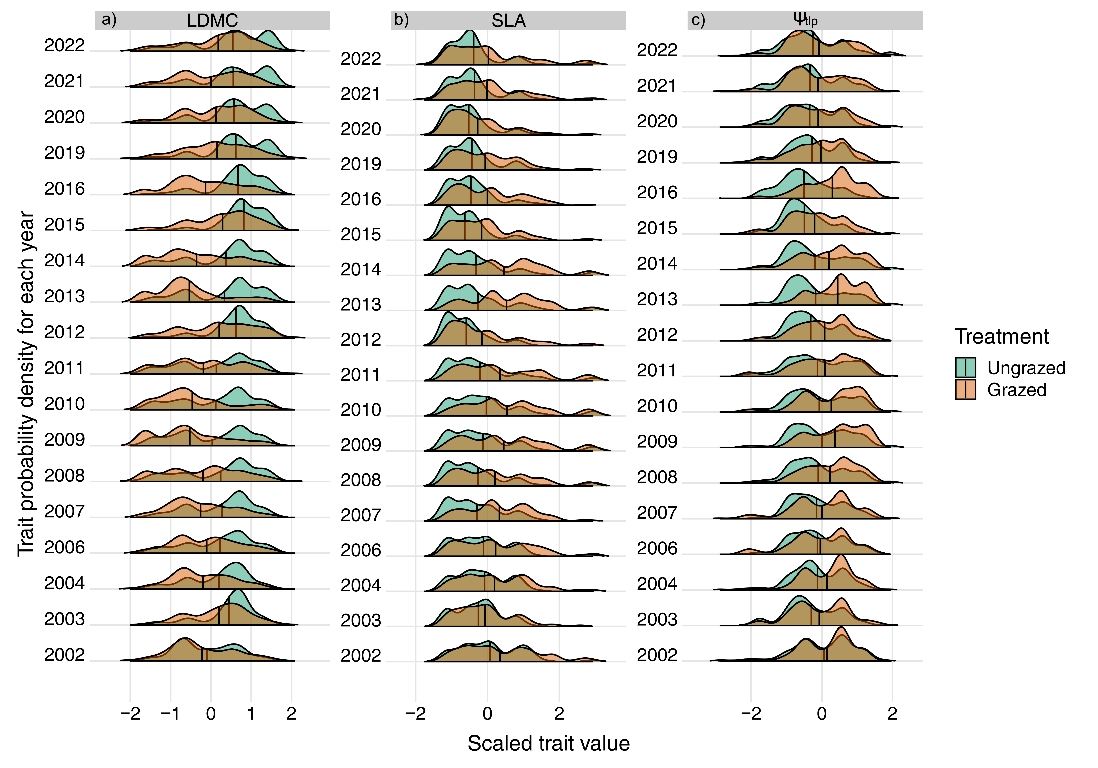

Figure S3. Probability density distributions across all years of (a) leaf dry matter content (LDMC), (b) specific leaf area (SLA), and (c) water potential at turgor loss point (Ψ_{tlp}) in grazed (orange) and ungrazed (green) community. Probability density estimations were obtained with non-parametric bootstrapping of trait data (see Methods in main text). The vertical black lines within the density plots represent the mean value of the distribution.
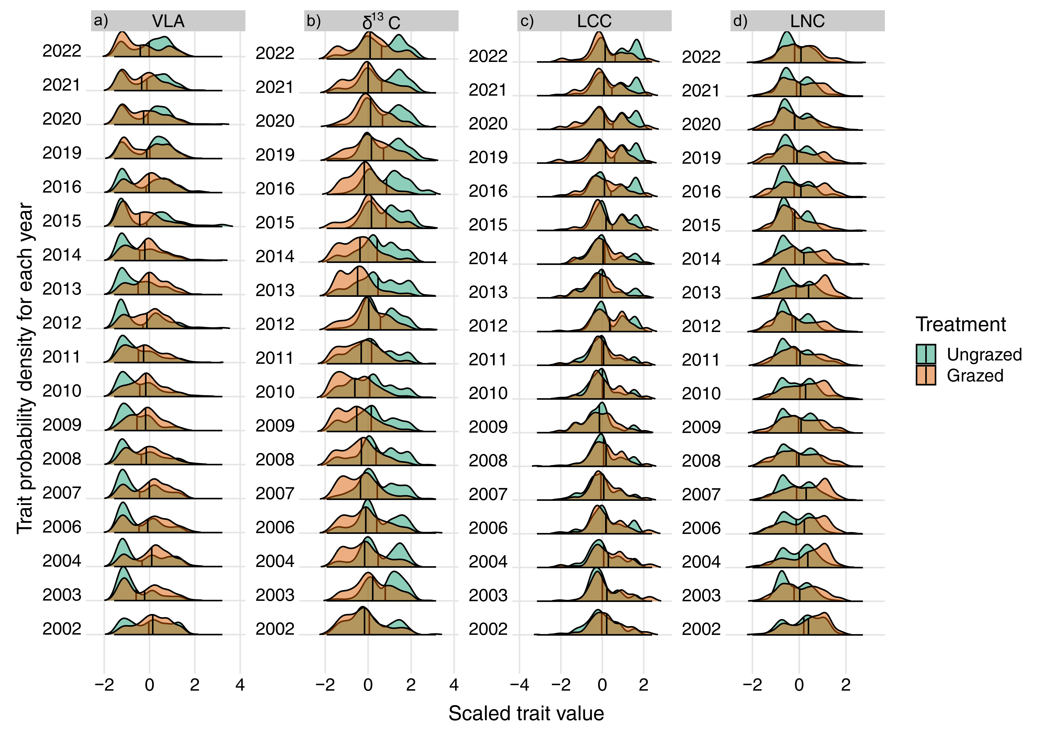
Figure S4. Probability density distributions across all years of (a) minor vein length per unit area (VLA), (b) carbon stable isotope composition (δ¹³C), (c) leaf carbon content (LCC), and (d) leaf nitrogen content (LNC) in grazed (orange) and ungrazed (green) community. Probability density estimations were obtained with non-parametric bootstrapping of trait data (see Methods in main text). The vertical black lines within the density plots represent the mean value of the distribution.

Figure S5. Probabilistic distribution of traits combinations in the functional trait space defined by the PCA considering each species' average functional trait values. The colours indicate the probability densities, from high (dark brown) to low (light brown) probability. Contour lines indicate the 0.99, 0.50 and 0.25 quantile of the total probability distribution. Functional richness (FRic) values estimated considering 0.50 and 0.99 quantile for each community and temporal interval are reported. Variables are: leaf dry matter content (LDMC), specific leaf area (SLA), water potential at turgor loss point (Ψ_{tlp}), minor vein length per unit area (VLA), carbon stable isotope composition (δ13C), leaf carbon content (LCC), leaf nitrogen content (LNC).

Detailed method S4 - Testing the effect of species phylogenetic relatedness
Phylogenetic data were retrieved using the V.PhyloMaker R package (Jin & Qian, 2019), which uses a megatree combining the phylogenies developed by Zanne et al. (2014) and Smith & Brown (2018). Of the 31 species in our dataset, 21 were directly pruned from the megatree ad 10 were bonded using the ‘Scenario 3’ as described in the original contribution (see Jin & Qian 2019 for more detail). We then used a phylogenetic PCA, where phylogenetic PCs are evolutionarily independent (Revell 2009), to test if phylogenetic relatedness among species affect their position in the trait space. We compared species’ position in the original PCA (see Methods - Changes in the functional structure over time) with those of the phylogenetic PCA. Phylogenetic PCA was computed with the ‘phyl.pca’ function in the phytools R package (Revell, 2024).
Finally, we tested the relationship between the original PCA and its phylogenetic counterpart using a Procrustes analysis via the function ‘protest’ available in vegan R package (Oksanen et al. 2025) using default settings. The results of the comparison between the original PCA and its phylogenetic counterpart showed a high and significant degree of correlation (Procrustes correlation = 0.988, p = 0.001), conforming that phylogenetic relatedness in our dataset has a negligible effect on the position of the species in the trait space allowing a reliable interpretation of original PC scores.
References
Dray S, Dufour A-B, Thioulouse and J, et al. 2021. ade4: Analysis of Ecological Data: Exploratory and Euclidean Methods in Environmental Sciences.
Jin Y, Qian H. 2022. V.PhyloMaker2: An updated and enlarged R package that can generate very large phylogenies for vascular plants. Plant Diversity 44: 335–339.
Oksanen J, Simpson GL, Blanchet FG, et al. 2025. vegan: Community Ecology Package.

Revell LJ. 2009. Size-Correction and Principal Components for Interspecific Comparative Studies. Evolution 63: 3258–3268.

Revell, L. J. (2024) phytools 2.0: an updated R ecosystem for phylogenetic comparative methods (and other things). PeerJ, 12, e16505. Smith SA, Brown JW. 2018. Constructing a broadly inclusive seed plant phylogeny. American Journal of Botany 105: 302–314.
Zanne AE, Tank DC, Cornwell WK, et al. 2014. Three keys to the radiation of angiosperms into freezing environments. Nature 506: 89–92.

Table S3. Correlation matrix (Pearson’s r) of the climatic variables used in this study. In bold the significant coefficients (p-value < 0.05)

 | DRY.DAYS | HEAVY.RAINS | FROST.DAYS | HEATWAVES
DRY.DAYS | 1.00
HEAVY.RAINS | -0.67 | 1.00
FROST.DAYS | 0.31 | -0.25 | 1.00
HEATWAVES | -0.22 | 0.09 | -0.02 | 1.00

Table S4. Loadings of the PCA. PCA was performed considering the average functional traits value of each species.
Variables | Loadings
 | PC1 | PC2 | PC3 | PC4 | PC5 | PC6 | PC7
LDMC | 0.90 | -0.17 | -0.26 | 0.08 | -0.02 | 0.17 | -0.24
SLA | -0.81 | 0.06 | -0.49 | 0.16 | -0.02 | 0.27 | 0.10
Ψ_{tlp} | -0.54 | 0.51 | 0.59 | -0.12 | -0.23 | 0.12 | -0.12
VLA | 0.54 | 0.65 | 0.14 | 0.34 | 0.38 | 0.05 | 0.05
δ¹³C | 0.66 | 0.07 | 0.05 | -0.72 | 0.05 | 0.13 | 0.12
LCC | 0.62 | 0.52 | -0.40 | 0.09 | -0.41 | -0.08 | 0.07
LNC | -0.61 | 0.41 | -0.50 | -0.38 | 0.19 | -0.12 | -0.14

LDMC = leaf dry matter content; SLA = specific leaf area; Ψ_{tlp} = water potential at turgor loss point; VLA = minor vein length per area; δ¹³C = carbon stable isotope composition; LCC = leaf carbon content, LNC = leaf nitrogen content.

Table S5. Standardized effect size (ses) of functional richness (FRic) and functional divergence (sesFDiv) for each year and treatment. P-values were obtained by comparing the SES values with a cumulative normal distribution with mean = 0 and standard deviation = 1.
Year | Treatment | sesFRic | p-value | sesFDiv | p-value
2002 | Ungrazed | -1.17 | 0.2019 | -6.39 | 0.0000
2003 | Ungrazed | -0.40 | 0.3681 | 2.23 | 0.0331
2004 | Ungrazed | -1.94 | 0.0609 | -2.04 | 0.0497
2006 | Ungrazed | -1.50 | 0.1292 | -2.92 | 0.0056
2007 | Ungrazed | -1.14 | 0.2095 | -3.17 | 0.0026
2008 | Ungrazed | -0.80 | 0.2889 | 2.29 | 0.0293
2009 | Ungrazed | -0.78 | 0.2935 | -3.50 | 0.0009
2010 | Ungrazed | -0.87 | 0.2736 | -3.99 | 0.0001
2011 | Ungrazed | -0.89 | 0.2692 | -1.50 | 0.1301
2012 | Ungrazed | -0.58 | 0.3367 | 3.70 | 0.0004
2013 | Ungrazed | -0.17 | 0.3932 | 0.91 | 0.2630
2014 | Ungrazed | -0.59 | 0.3350 | 2.30 | 0.0283
2015 | Ungrazed | 0.79 | 0.2913 | 6.83 | 0.0000
2016 | Ungrazed | 0.86 | 0.2757 | 6.07 | 0.0000
2019 | Ungrazed | 1.14 | 0.2094 | 2.94 | 0.0052
2020 | Ungrazed | 3.52 | 0.0008 | 1.19 | 0.1967
2021 | Ungrazed | 2.74 | 0.0093 | 1.82 | 0.0767
2022 | Ungrazed | 1.96 | 0.0589 | 2.39 | 0.0229
2002 | Grazed | 9.11 | 0.0000 | 2.41 | 0.0222
2003 | Grazed | 6.52 | 0.0000 | -1.85 | 0.0725
2004 | Grazed | 7.28 | 0.0000 | 1.53 | 0.1247
2006 | Grazed | 8.05 | 0.0000 | -3.58 | 0.0007
2007 | Grazed | 6.36 | 0.0000 | -5.75 | 0.0000
2008 | Grazed | 5.92 | 0.0000 | -4.22 | 0.0001
2009 | Grazed | 6.25 | 0.0000 | -4.91 | 0.0000
2010 | Grazed | 8.81 | 0.0000 | 1.67 | 0.0984
2011 | Grazed | NA | NA | NA | NA
2012 | Grazed | 1.68 | 0.0970 | 3.80 | 0.0003
2013 | Grazed | 6.07 | 0.0000 | -7.47 | 0.0000
2014 | Grazed | 6.14 | 0.0000 | -4.41 | 0.0000
2015 | Grazed | 7.62 | 0.0000 | -6.88 | 0.0000
2016 | Grazed | 8.47 | 0.0000 | -10.08 | 0.0000
2019 | Grazed | 14.29 | 0.0000 | -21.55 | 0.0000
2020 | Grazed | 8.59 | 0.0000 | -11.49 | 0.0000
2021 | Grazed | 17.52 | 0.0000 | -12.63 | 0.0000
2022 | Grazed | 8.13 | 0.0000 | 2.28 | 0.0294

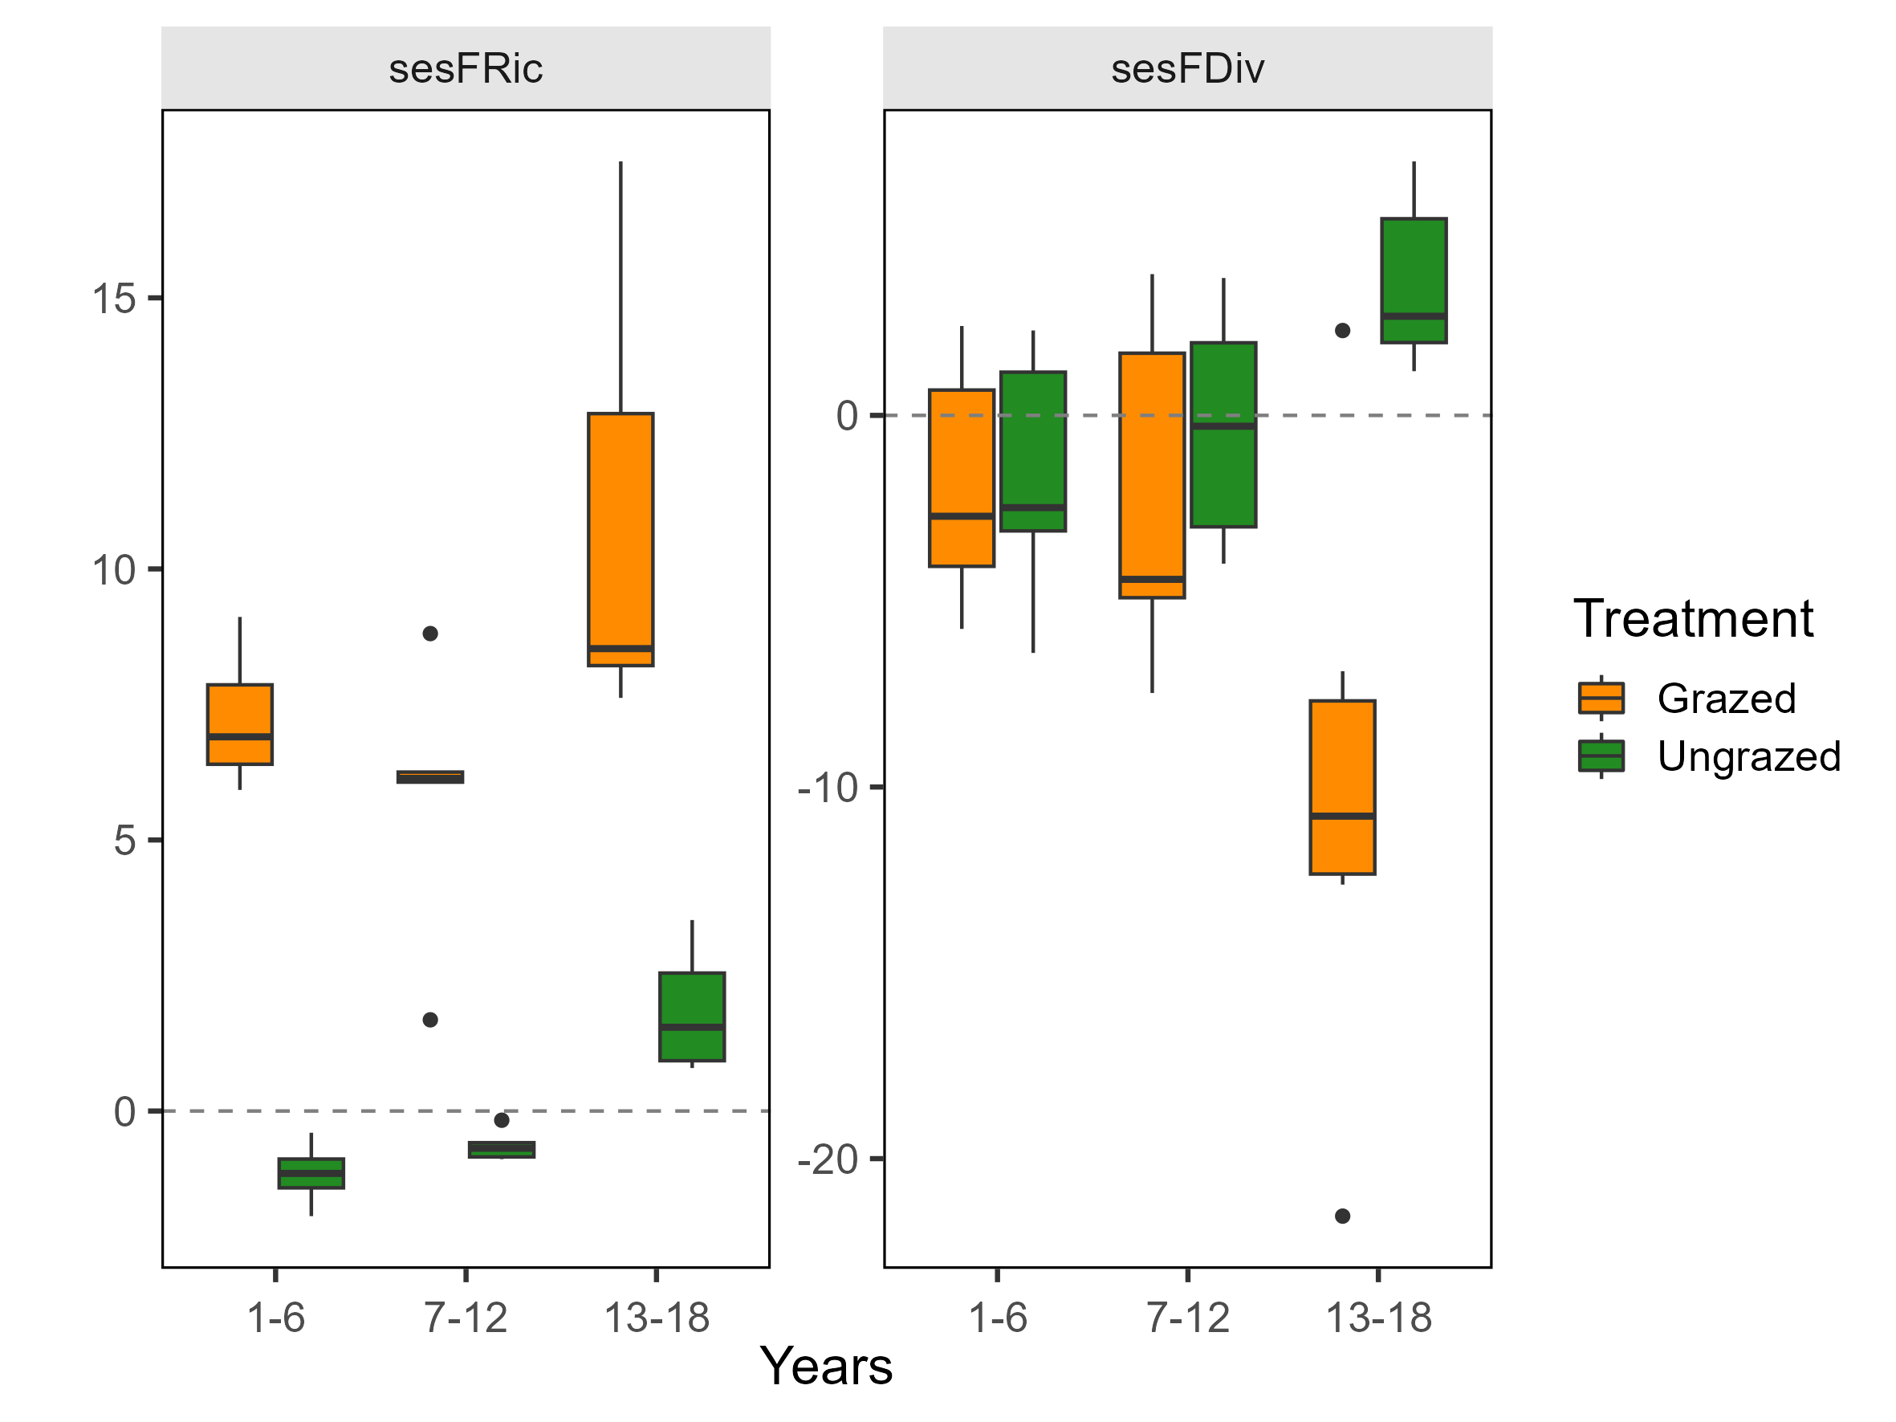

Figure S6. Changes of standardized effect size (ses) values of functional richness (FRic) and functional divergence (FDiv) along the temporal intervals. Boxplots show the variation of standardized effect size for each combination of temporal interval and treatment.

Table S6. Standardized effect size (SES) of functional richness (FRic) and functional divergence (sesFDiv) of the functional space defined by PCA, for each combination of temporal interval and treatment. P-values were obtained by comparing the SES values with a cumulative normal distribution with mean = 0 and standard deviation = 1.
Years | Treatment | sesFRic | p-value | sesFDiv | p-value
1-6 | Grazed | -0.49 | 0.353 | -2.82 | 0.008
7-12 | Grazed | 0.65 | 0.323 | -6.06 | 0.000
13-18 | Grazed | 0.22 | 0.390 | -13.55 | 0.000
1-6 | Ungrazed | 0.78 | 0.295 | -4.77 | 0.000
7-12 | Ungrazed | -0.46 | 0.359 | 1.21 | 0.192
13-18 | Ungrazed | -0.24 | 0.388 | 6.12 | 0.000

Table S7. Standardized effect size (SES) of dissimilarity metrics among temporal intervals between ungrazed and grazed communities. P-values were obtained by comparing the SES values with a cumulative normal distribution with mean = 0 and standard deviation = 1. Metrics were reported at 99% and 50% quantile thresholds of the total probability distribution.

Years | Quantile | Dissimilarity | p-value | Nestedness | p-value
1-6 | 0.99 | 1.739 | 0.088 | -1.245 | 0.184
7-12 | 0.99 | 2.348 | 0.025 | -3.438 | 0.001
13-18 | 0.99 | 2.976 | 0.006 | -0.986 | 0.245
1-6 | 0.50 | 3.416 | 0.001 | -128.335 | <0.001
7-12 | 0.50 | 4.062 | <0.001 | -213.440 | <0.001
13-18 | 0.50 | 5.348 | <0.001 | -84.245 | <0.001

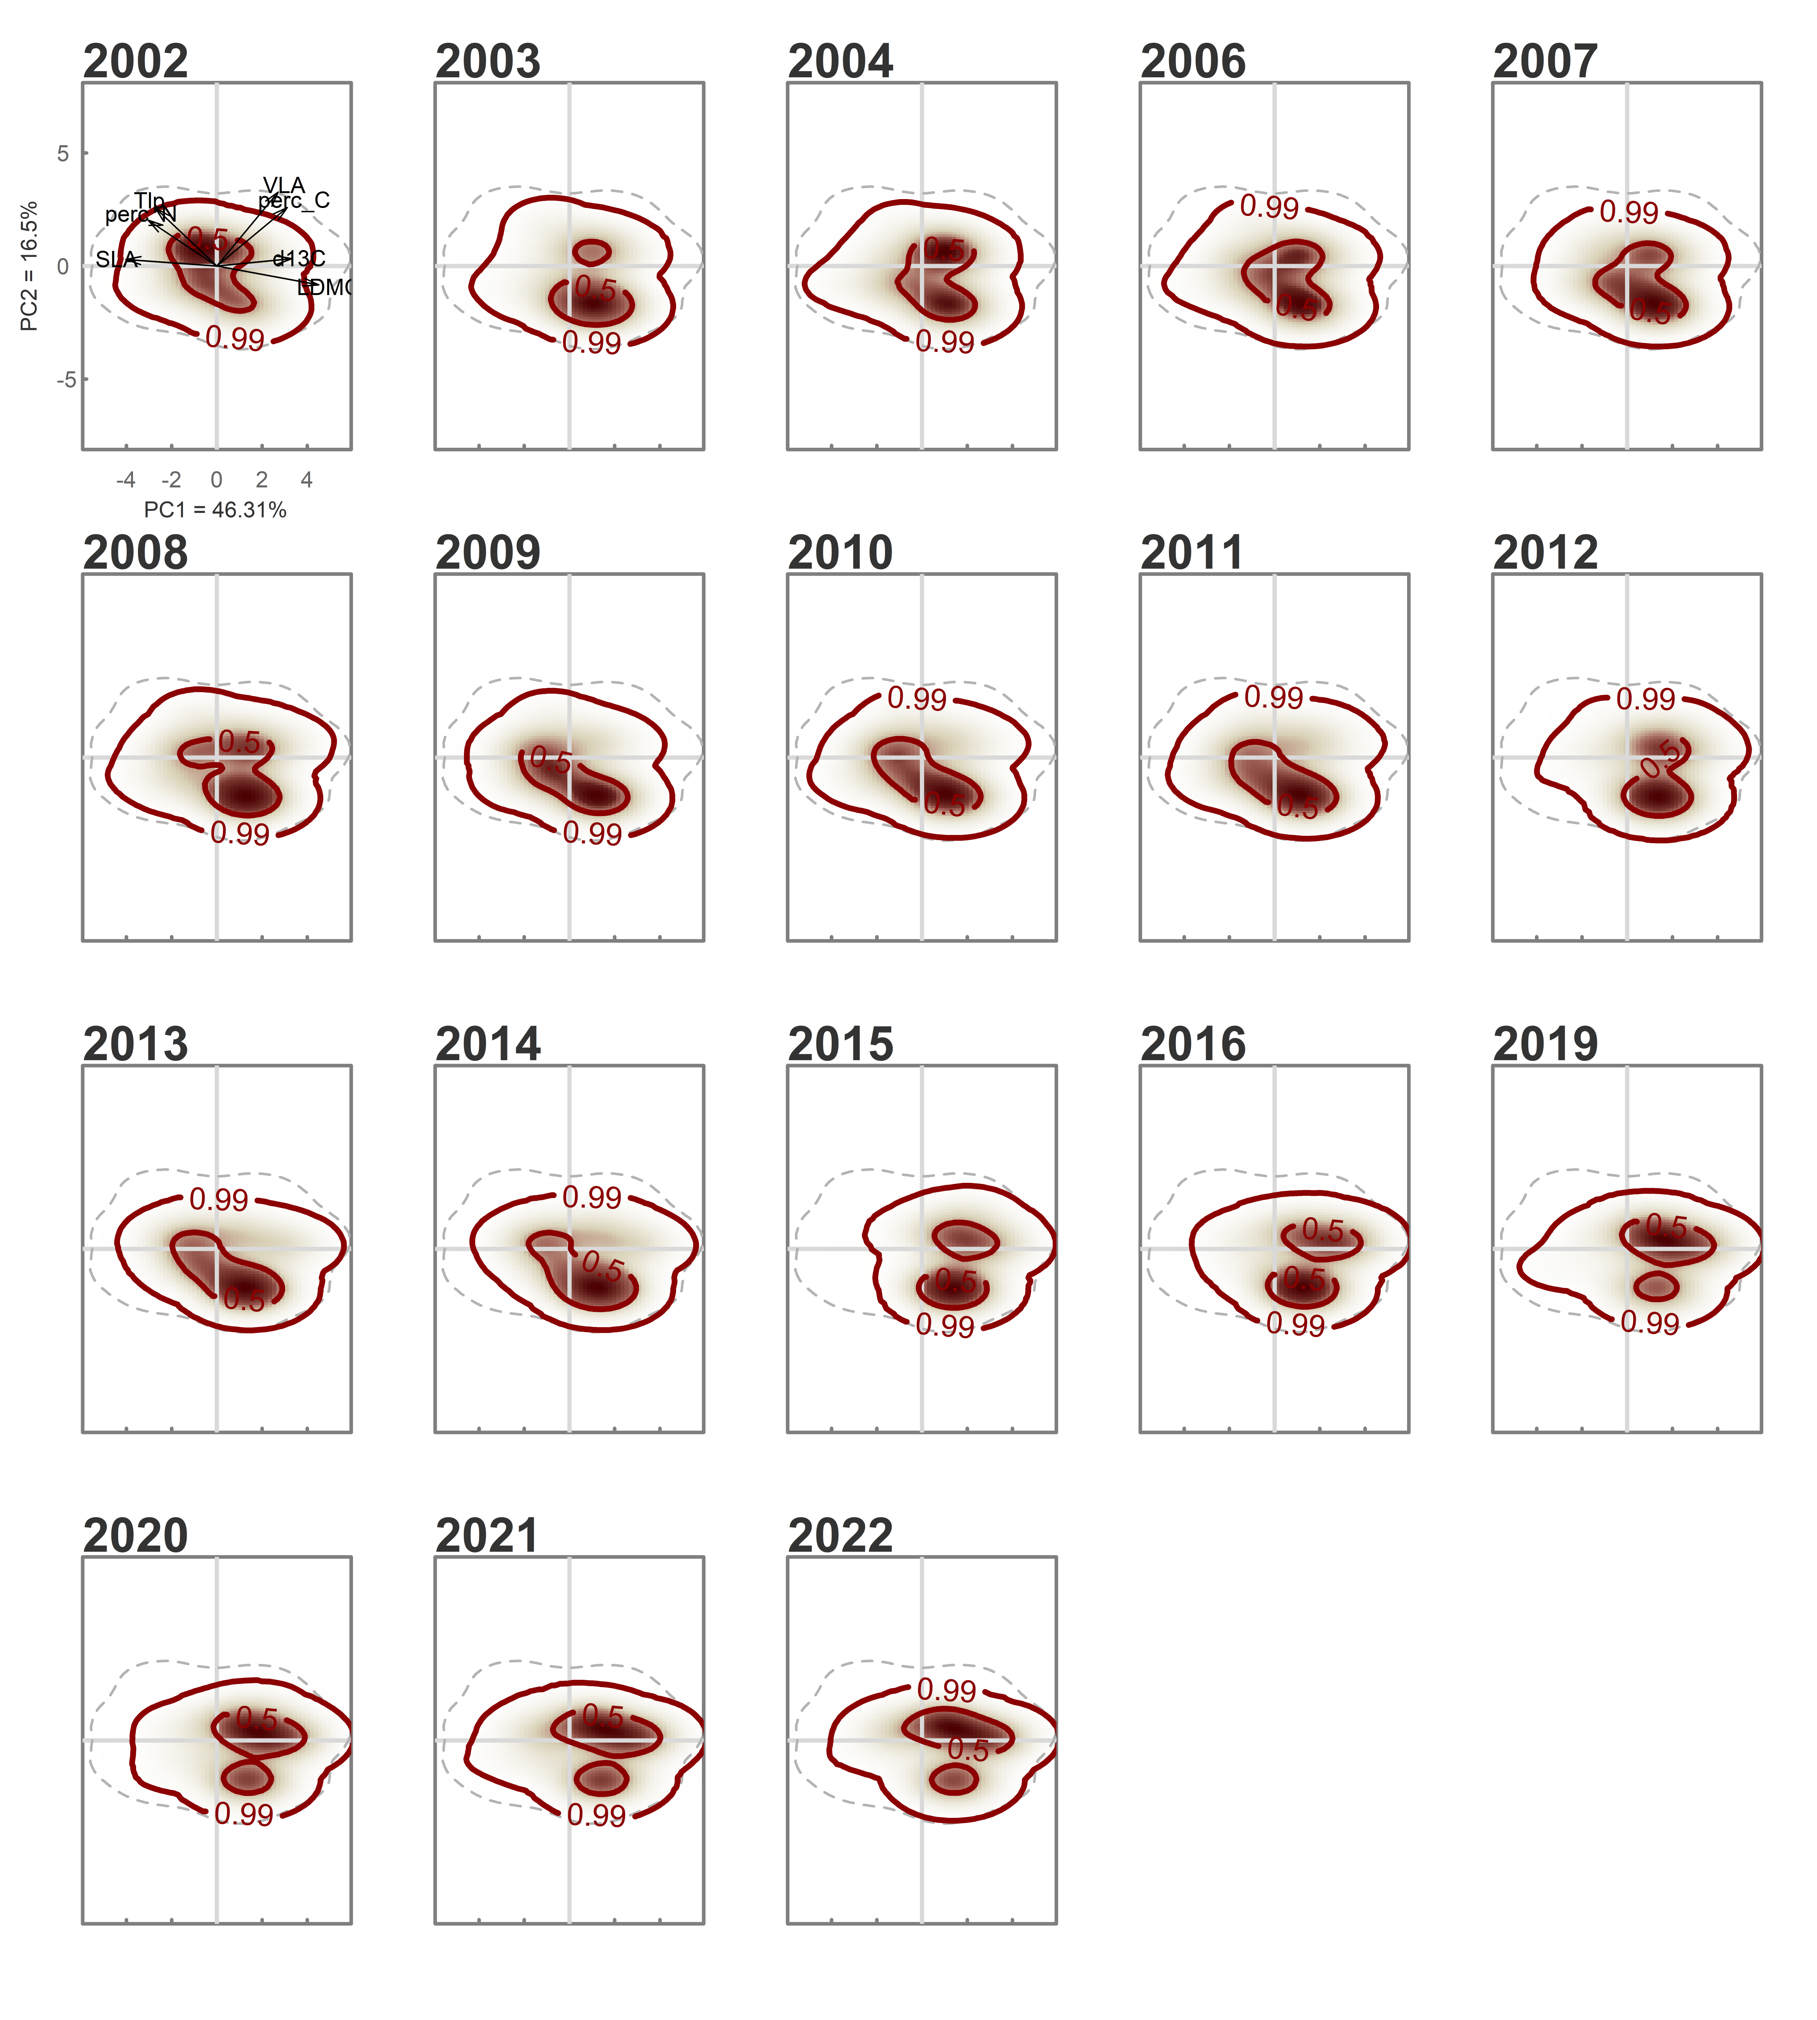
Figure S7. Probabilistic distribution of traits combinations in the functional trait space defined by the PCA for ungrazed community, for each year. The colours indicate the probability densities, from high (dark brown) to low (light brown) probability. Contour lines indicate the 0.99, 0.50 and 0.25 quantile of the total probability distribution.

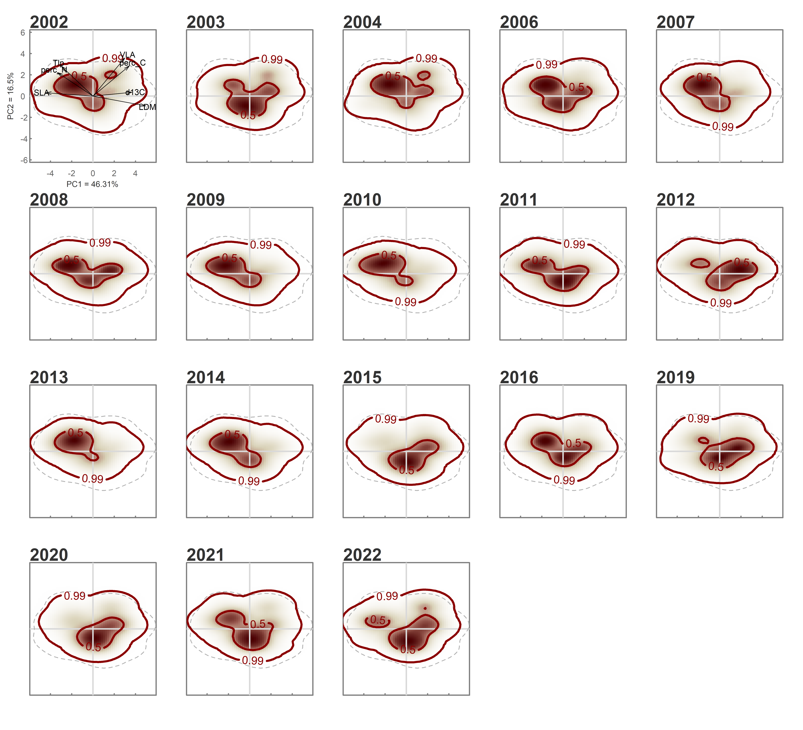
Figure S8. Probabilistic distribution of traits combinations in the functional trait space defined by the PCA for grazed community, for each year. The colours indicate the probability densities, from high (dark brown) to low (light brown) probability. Contour lines indicate the 0.99, 0.50 and 0.25 quantile of the total probability distribution.

Table S8. Relationships between CWM of each trait and climatic variables for ungrazed and grazed community.

Functional Trait (CWM) |  | Ungrazed Community |  |  |  |  |  | Grazed Community
 |  | Estimate | Standard Error | df | statistic | p-value |  | Estimate | Standard Error | df | statistic | p-value
LDMC | (Intercept) | 2.205 | 0.946 | 151 | 2.332 | 0.021 | * | 1.246 | 1.316 | 151 | 0.947 | 0.3452
 | poly(DRY.DAYS, 2)1 | 81.624 | 15.773 | 151 | 5.175 | 0 | *** | 154.528 | 21.951 | 151 | 7.04 | 0 | ***
 | poly(DRY.DAYS, 2)2 | 70.595 | 17.155 | 151 | 4.115 | 0.0001 | *** | 74.936 | 23.874 | 151 | 3.139 | 0.002 | **
 | poly(HEATWAVES, 2)1 | -85.391 | 12.804 | 151 | -6.669 | 0 | *** | -94.848 | 17.819 | 151 | -5.323 | 0 | ***
 | poly(HEATWAVES, 2)2 | 45.167 | 12.611 | 151 | 3.582 | 0.0005 | *** | 52.353 | 17.549 | 151 | 2.983 | 0.0033 | **
 | poly(FROST.DAYS, 2)1 | -16.616 | 13.786 | 151 | -1.205 | 0.23 |  | -26.365 | 19.185 | 151 | -1.374 | 0.1714
 | poly(FROST.DAYS, 2)2 | 4.768 | 12.829 | 151 | 0.372 | 0.7106 |  | 64.111 | 17.853 | 151 | 3.591 | 0.0004 | ***
 | poly(HEAVY.RAINS, 2)1 | 59.682 | 16.158 | 151 | 3.694 | 0.0003 | *** | 158.129 | 22.486 | 151 | 7.032 | 0 | ***
 | poly(HEAVY.RAINS, 2)2 | -41.346 | 16.318 | 151 | -2.534 | 0.0123 | * | -70.483 | 22.709 | 151 | -3.104 | 0.0023 | **
 |  | Coefficient of determination (R²) 0.49 |  |  |  |  |  | Coefficient of determination (R²) 0.52
 |  | Estimate | Standard Error | df | statistic | p-value |  | Estimate | Standard Error | df | statistic | p-value
SLA | (Intercept) | -0.195 | 0.116 | 151 | -1.682 | 0.0945 | . | -0.138 | 0.157 | 151 | -0.876 | 0.3826
 | poly(DRY.DAYS, 2)1 | -11.773 | 1.938 | 151 | -6.075 | 0.0000 | *** | -17.396 | 2.623 | 151 | -6.633 | 0.0000 | ***
 | poly(DRY.DAYS, 2)2 | -3.796 | 2.108 | 151 | -1.801 | 0.0737 | . | -5.934 | 2.853 | 151 | -2.080 | 0.0392 | *
 | poly(HEATWAVES, 2)1 | 8.803 | 1.573 | 151 | 5.596 | 0.0000 | *** | 12.115 | 2.129 | 151 | 5.690 | 0.0000 | ***
 | poly(HEATWAVES, 2)2 | -5.742 | 1.549 | 151 | -3.706 | 0.0003 | *** | -6.440 | 2.097 | 151 | -3.071 | 0.0025 | **
 | poly(FROST.DAYS, 2)1 | 0.261 | 1.694 | 151 | 0.154 | 0.8778 |  | 4.049 | 2.292 | 151 | 1.766 | 0.0794 | .
 | poly(FROST.DAYS, 2)2 | 0.346 | 1.576 | 151 | 0.220 | 0.8264 |  | -5.765 | 2.133 | 151 | -2.702 | 0.0077 | **
 | poly(HEAVY.RAINS, 2)1 | -8.198 | 1.985 | 151 | -4.129 | 0.0001 | *** | -16.078 | 2.687 | 151 | -5.984 | 0.0000 | ***
 | poly(HEAVY.RAINS, 2)2 | 2.683 | 2.005 | 151 | 1.338 | 0.1829 |  | 2.786 | 2.713 | 151 | 1.027 | 0.3061
 |  | Coefficient of determination (R²) 0.43 |  |  |  |  |  | Coefficient of determination (R²) 0.47
 |  | Estimate | Standard Error | df | statistic | p-value |  | Estimate | Standard Error | df | statistic | p-value
Ψ_{tlp} | (Intercept) | -0.008 | 0.005 | 151 | -1.413 | 0.1596 |  | -0.007 | 0.007 | 151 | -0.949 | 0.3443
 | poly(DRY.DAYS, 2)1 | -0.223 | 0.089 | 151 | -2.520 | 0.0128 | * | -0.427 | 0.115 | 151 | -3.724 | 0.0003 | ***
 | poly(DRY.DAYS, 2)2 | -0.399 | 0.096 | 151 | -4.138 | 0.0001 | *** | -0.313 | 0.125 | 151 | -2.512 | 0.0130 | *
 | poly(HEATWAVES, 2)1 | 0.383 | 0.072 | 151 | 5.326 | 0.0000 | *** | 0.331 | 0.093 | 151 | 3.559 | 0.0005 | ***
 | poly(HEATWAVES, 2)2 | -0.036 | 0.071 | 151 | -0.503 | 0.6158 |  | -0.021 | 0.092 | 151 | -0.233 | 0.8163
 | poly(FROST.DAYS, 2)1 | 0.131 | 0.077 | 151 | 1.693 | 0.0926 | . | 0.018 | 0.100 | 151 | 0.183 | 0.8553
 | poly(FROST.DAYS, 2)2 | 0.081 | 0.072 | 151 | 1.125 | 0.2624 |  | -0.151 | 0.093 | 151 | -1.616 | 0.1082
 | poly(HEAVY.RAINS, 2)1 | -0.184 | 0.091 | 151 | -2.025 | 0.0446 | * | -0.586 | 0.117 | 151 | -4.987 | 0.0000 | ***
 | poly(HEAVY.RAINS, 2)2 | 0.089 | 0.092 | 151 | 0.967 | 0.3351 |  | 0.177 | 0.119 | 151 | 1.493 | 0.1375
 |  | Coefficient of determination (R²) 0.35 |  |  |  |  |  | Coefficient of determination (R²) 0.30
 |  | Estimate | Standard Error | df | statistic | p-value |  | Estimate | Standard Error | df | statistic | p-value
VLA | (Intercept) | 0.016 | 0.066 | 151 | 0.246 | 0.8058 |  | -0.081 | 0.058 | 151 | -1.397 | 0.1646
 | poly(DRY.DAYS, 2)1 | 0.211 | 1.099 | 151 | 0.192 | 0.8478 |  | -2.861 | 0.971 | 151 | -2.947 | 0.0037 | **
 | poly(DRY.DAYS, 2)2 | -2.663 | 1.196 | 151 | -2.227 | 0.0274 | * | -3.115 | 1.056 | 151 | -2.951 | 0.0037 | **
 | poly(HEATWAVES, 2)1 | -0.341 | 0.892 | 151 | -0.382 | 0.7027 |  | 1.509 | 0.788 | 151 | 1.915 | 0.0573 | .
 | poly(HEATWAVES, 2)2 | 3.966 | 0.879 | 151 | 4.513 | 0.0000 | *** | 2.291 | 0.776 | 151 | 2.952 | 0.0037 | **
 | poly(FROST.DAYS, 2)1 | -0.817 | 0.961 | 151 | -0.851 | 0.3963 |  | 0.389 | 0.848 | 151 | 0.459 | 0.6470
 | poly(FROST.DAYS, 2)2 | 0.494 | 0.894 | 151 | 0.552 | 0.5816 |  | -2.862 | 0.789 | 151 | -3.626 | 0.0004 | ***
 | poly(HEAVY.RAINS, 2)1 | 1.835 | 1.126 | 151 | 1.630 | 0.1053 |  | -2.800 | 0.994 | 151 | -2.816 | 0.0055 | **
 | poly(HEAVY.RAINS, 2)2 | 0.764 | 1.137 | 151 | 0.671 | 0.5029 |  | 1.883 | 1.004 | 151 | 1.875 | 0.0627 | .
 |  | Coefficient of determination (R²) 0.17 |  |  |  |  |  | Coefficient of determination (R²) 0.25
 |  | Estimate | Standard Error | df | statistic | p-value |  | Estimate | Standard Error | df | statistic | p-value
δ¹³C | (Intercept) | 0.043 | 0.021 | 151 | 2.007 | 0.0466 | * | 0.019 | 0.022 | 151 | 0.841 | 0.4016
 | poly(DRY.DAYS, 2)1 | 1.576 | 0.355 | 151 | 4.439 | 0.0000 | *** | 2.693 | 0.372 | 151 | 7.247 | 0.0000 | ***
 | poly(DRY.DAYS, 2)2 | 1.381 | 0.386 | 151 | 3.575 | 0.0005 | *** | 1.126 | 0.404 | 151 | 2.785 | 0.0060 | **
 | poly(HEATWAVES, 2)1 | -1.330 | 0.288 | 151 | -4.613 | 0.0000 | *** | -1.530 | 0.302 | 151 | -5.071 | 0.0000 | ***
 | poly(HEATWAVES, 2)2 | 0.687 | 0.284 | 151 | 2.419 | 0.0168 | * | 0.557 | 0.297 | 151 | 1.876 | 0.0626 | .
 | poly(FROST.DAYS, 2)1 | -0.418 | 0.310 | 151 | -1.346 | 0.1803 |  | -0.301 | 0.325 | 151 | -0.925 | 0.3563
 | poly(FROST.DAYS, 2)2 | 0.066 | 0.289 | 151 | 0.227 | 0.8205 |  | 0.896 | 0.302 | 151 | 2.966 | 0.0035 | **
 | poly(HEAVY.RAINS, 2)1 | 1.121 | 0.364 | 151 | 3.081 | 0.0025 | ** | 2.778 | 0.381 | 151 | 7.298 | 0.0000 | ***
 | poly(HEAVY.RAINS, 2)2 | -0.491 | 0.367 | 151 | -1.337 | 0.1832 |  | -0.879 | 0.384 | 151 | -2.287 | 0.0236 | *
 |  | Coefficient of determination (R²) 0.37 |  |  |  |  |  | Coefficient of determination (R²) 0.50
 |  | Estimate | Standard Error | df | statistic | p-value |  | Estimate | Standard Error | df | statistic | p-value
LCC | (Intercept) | 0.074 | 0.039 | 151 | 1.907 | 0.0585 | . | 0.000 | 0.035 | 151 | 0.010 | 0.9921
 | poly(DRY.DAYS, 2)1 | 2.192 | 0.651 | 151 | 3.367 | 0.0010 | *** | 2.615 | 0.589 | 151 | 4.438 | 0.0000 | ***
 | poly(DRY.DAYS, 2)2 | 0.806 | 0.708 | 151 | 1.138 | 0.2567 |  | 0.882 | 0.641 | 151 | 1.376 | 0.1709
 | poly(HEATWAVES, 2)1 | -0.593 | 0.529 | 151 | -1.122 | 0.2635 |  | -0.887 | 0.478 | 151 | -1.854 | 0.0657 | .
 | poly(HEATWAVES, 2)2 | 3.546 | 0.521 | 151 | 6.811 | 0.0000 | *** | 2.599 | 0.471 | 151 | 5.518 | 0.0000 | ***
 | poly(FROST.DAYS, 2)1 | -0.435 | 0.569 | 151 | -0.765 | 0.4456 |  | -0.054 | 0.515 | 151 | -0.105 | 0.9166
 | poly(FROST.DAYS, 2)2 | 0.782 | 0.530 | 151 | 1.476 | 0.1419 |  | 1.135 | 0.479 | 151 | 2.369 | 0.0191 | *
 | poly(HEAVY.RAINS, 2)1 | 2.480 | 0.667 | 151 | 3.717 | 0.0003 | *** | 2.716 | 0.604 | 151 | 4.501 | 0.0000 | ***
 | poly(HEAVY.RAINS, 2)2 | -1.586 | 0.674 | 151 | -2.354 | 0.0199 | * | -1.948 | 0.609 | 151 | -3.196 | 0.0017 | **
 |  | Coefficient of determination (R²) 0.37 |  |  |  |  |  | Coefficient of determination (R²) 0.38
 |  | Estimate | Standard Error | df | statistic | p-value |  | Estimate | Standard Error | df | statistic | p-value
LNC | (Intercept) | -0.010 | 0.007 | 151 | -1.411 | 0.1603 |  | -0.013 | 0.011 | 151 | -1.172 | 0.2431
 | poly(DRY.DAYS, 2)1 | -0.680 | 0.119 | 151 | -5.705 | 0.0000 | *** | -1.376 | 0.187 | 151 | -7.350 | 0.0000 | ***
 | poly(DRY.DAYS, 2)2 | -0.394 | 0.130 | 151 | -3.044 | 0.0028 | ** | -0.596 | 0.204 | 151 | -2.924 | 0.0040 | **
 | poly(HEATWAVES, 2)1 | 0.378 | 0.097 | 151 | 3.911 | 0.0001 | *** | 0.643 | 0.152 | 151 | 4.228 | 0.0000 | ***
 | poly(HEATWAVES, 2)2 | -0.169 | 0.095 | 151 | -1.774 | 0.0780 | . | -0.242 | 0.150 | 151 | -1.616 | 0.1083
 | poly(FROST.DAYS, 2)1 | -0.073 | 0.104 | 151 | -0.698 | 0.4863 |  | 0.436 | 0.164 | 151 | 2.665 | 0.0085 | **
 | poly(FROST.DAYS, 2)2 | -0.167 | 0.097 | 151 | -1.723 | 0.0869 | . | -0.855 | 0.152 | 151 | -5.615 | 0.0000 | ***
 | poly(HEAVY.RAINS, 2)1 | -0.313 | 0.122 | 151 | -2.561 | 0.0114 | * | -1.086 | 0.192 | 151 | -5.659 | 0.0000 | ***
 | poly(HEAVY.RAINS, 2)2 | 0.381 | 0.123 | 151 | 3.093 | 0.0024 | ** | 0.517 | 0.194 | 151 | 2.669 | 0.0084 | **
 |  | Coefficient of determination (R²) 0.36 |  |  |  |  |  | Coefficient of determination (R²) 0.50
Linear Mixed Models (LMM) results run using CWM value of each trait calculated at plot level as the response variable and the climatic variables as the independent variable. Second degree orthogonal polynomial terms were included for each independent variable to account for non-linear relationship. LDMC= leaf dry matter content; SLA = specific leaf area; Ψtlp = water potential at turgor loss point; VLA = minor vein length per area; δ13C = carbon stable isotope composition; LCC = leaf carbon content, LNC = leaf nitrogen content. Main model statistics are shown. P-value statistic was estimated using Satterthwaite's method. Coefficient of determination (R²) was estimated using Nakagawa and Schielzeth approach with the r2glmm R function.

Figure S8. Relationships between prolonged periods of intense rain and frost and annual rate of change (i.e. velocity) of (community weighted) trait means for grazed and ungrazed community. Trait velocity of zero represents no change over time, while positive and negative values represent an increase vs decrease in trait community value respectively. Linear mixed models were fitted separately for the two treatments. Only significant relationships are reported (see Table S8 for models’ coefficients and statistics). Each point represents the trait velocity for each plot in a given year, for grazed (orange) and ungrazed (green) community. Ribbons represent the 95% confidence intervals. Climatic variables were scaled to mean zero and variance one. Traits are (a,h) leaf dry matter content (LDMC), (b,i) specific leaf area (SLA), (c,j) water potential at turgor loss point (Ψtlp), (d,k) minor vein length per unit area (VLA), (e,l) carbon stable isotope composition (δ13C), (f,m) leaf carbon content (LCC), (g,n) leaf nitrogen content (LNC).Climate variables are: Number of days with a minimum temperature (Tmin) ≤ 0°C in a given year (FROST.DAYS); Number of days with precipitation ≥ 20 mm in a given year (HEAVY.RAINS).

