Supporting Information for
Structure and dynamics of confined water in naphthalene-diimide based molecular crystals

Filippo Tommaso Garattoni^{a$}, Marco Severi^{a$}, Gabriele Amante^{b}, Christian B. Nielsen^{c}, Giuseppe Cassone^{b}, Daniele Fazziª
a) Department of Chemistry ‘‘Giacomo Ciamician’’, University of Bologna, via Piero Gobetti 85, 40129, Bologna, Italy.
b) Institute for Chemical-Physical Processes , National Research Council of Italy, viale Ferdinando Stagno d'Alcontres 37, 98158 Messina, Italy.
c) Department of Chemistry, Queen Mary University of London, Mile End Road, London, E1 4NS, UK.

$Equal contribution to the work.

Supplementary analyses 2
Simulation Details 5
Force Field 5
Equilibration of the Pristine Materials 5
Analyses details 6
Fitting of the mean square displacement 6
Fitting of $C2$correlation function 6
$C2$correlation function at longer time scales 7
Additional figures 7
Cluster analyses 8

Supplementary analyses
Here below, are reported the oxygen-oxygen radial distribution function (g(r)) for NDI-TEG, NDI-C6 at different hydration levels (100, 200 and 300 water molecules), and bulk water at 300 K and 200 K. A comparison of the tetrahedral order parameters (q) and bond orientational order parameters (q₄, q₆) for each case is also reported.

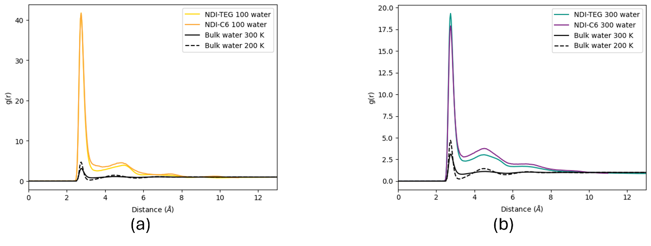
Figure S1: Water oxygen-oxygen radial distribution function for the 1:1 NDI:water ratio (panel a) and 1:3 ratio (panel b)
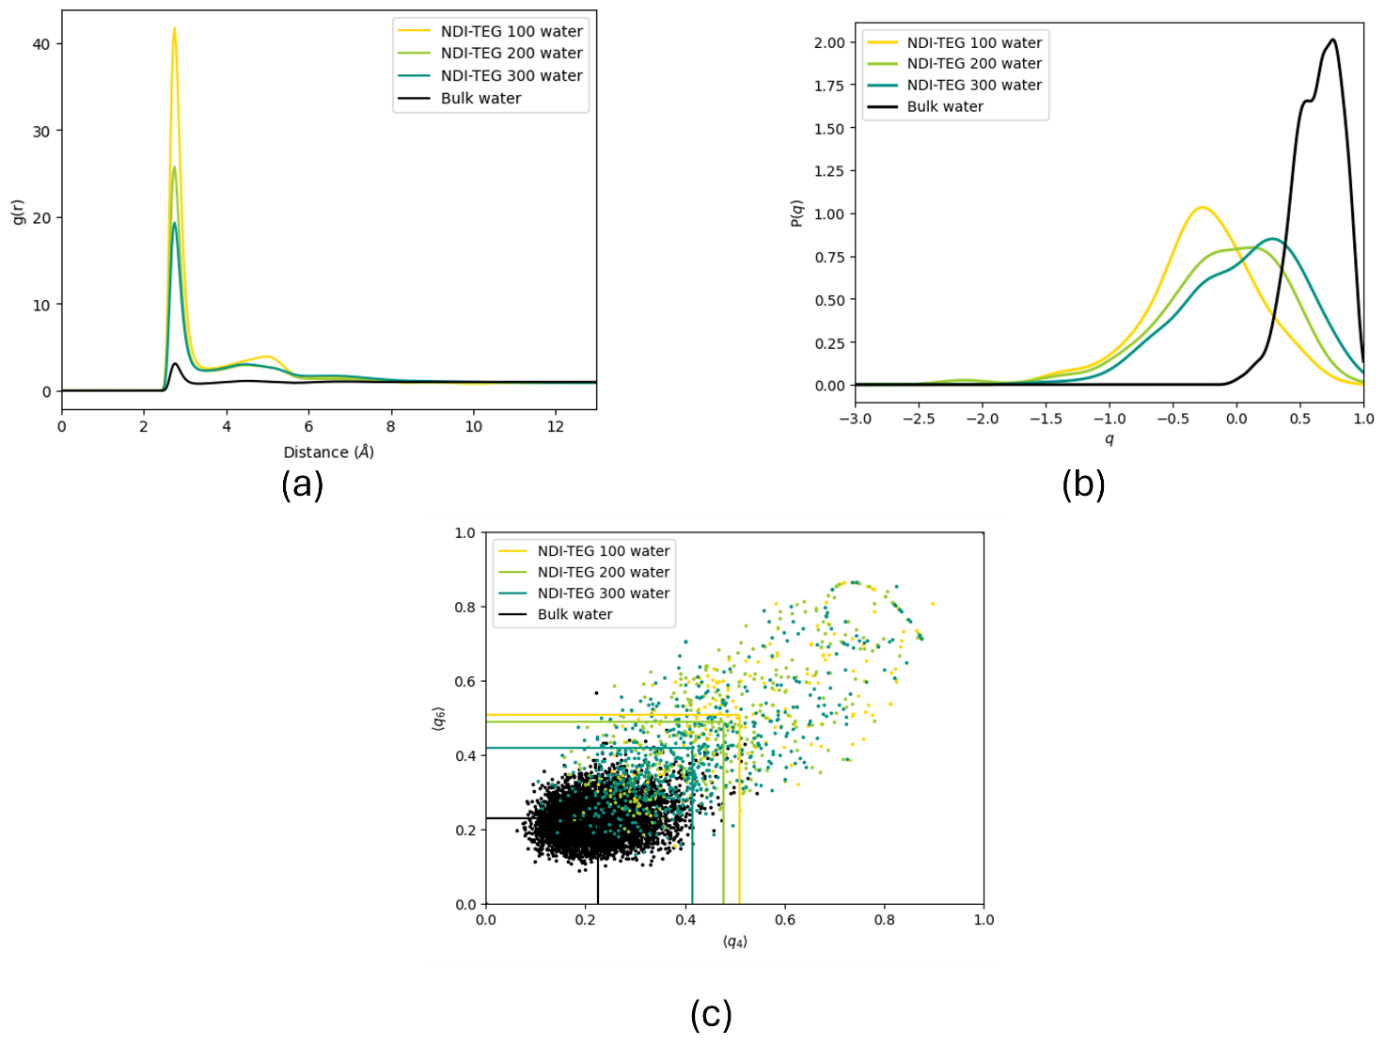
Figure S2: Analyses performed on the NDI-TEG crystal at various water concentrations: water oxygen-oxygen radial distribution function (panel a), tetrahedral order parameter (panel b), Lechner-Dellago order parameters (panel c)
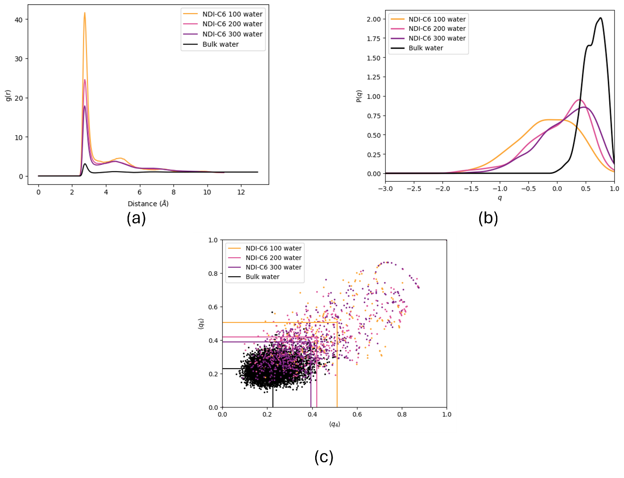
Figure S3:Analyses performed on the NDI-C6 crystal at various water concentrations: water oxygen-oxygen radial distribution function (panel a), tetrahedral order parameter (panel b), Lechner-Dellago order parameters (panel c)

In Figure S4 are reported the computed N-N radial distribution functions for both NDI-C6 and NDI-TEG at 1:3 hydration, comparing the results with respect to the respective single crystals as equilibrated via MD simulations, and the experimental XRD structures reported in literature.

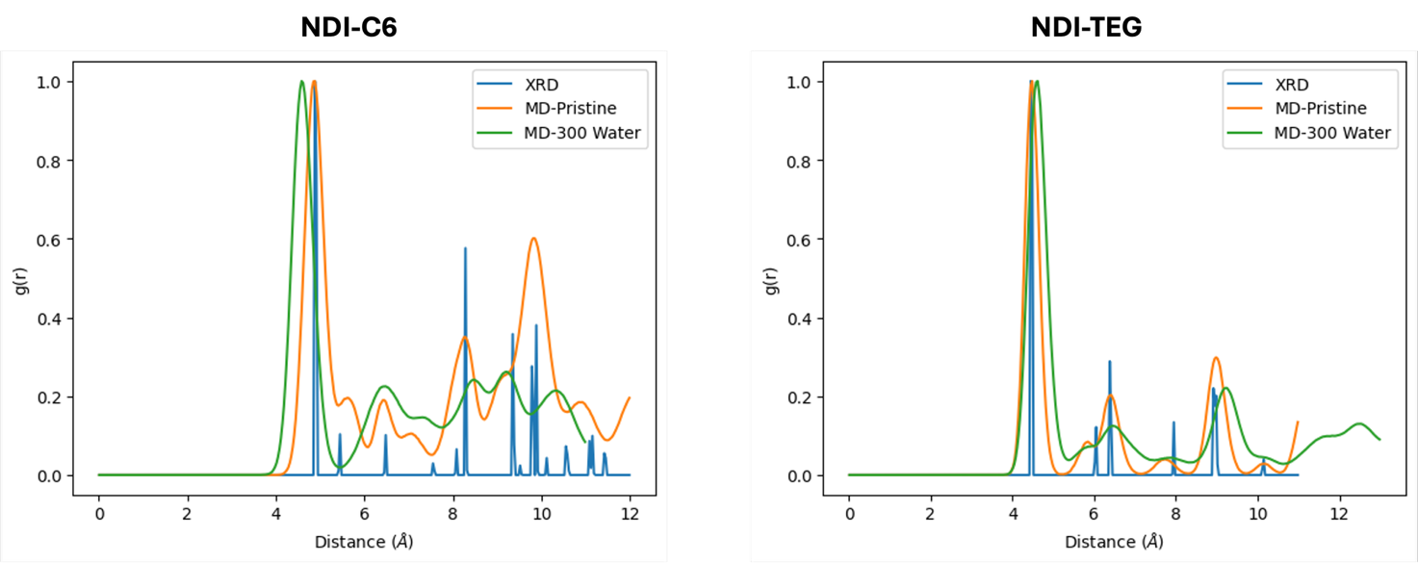
Figure S4: (left panel) NDI-C6 N-N g(r) comparing experimental XRD structure (blue), equilibrated MD simulation of pristine crystal (orange) and NDI-C6:water (1:3) (green). (right panel) NDI-TEG N-N g(r) comparing experimental XRD structure (blue), equilibrated MD simulation of pristine crystal (orange) and NDI-TEG:water (1:3) (green).

Simulation Details

Force Field
The force field employed for the description of NDI-TEG and -C6 has been obtained following the same procedure reported in ref¹. The bonded parameters have been taken from the OPLS-AA/2020² force field. We reparametrized the non-bonded parameters applying the Tkatchenko–Scheffler (T-S) method^{3–5}. The T-S method requires a quantum chemical calculation to derive the atomic effective volume, which has been performed using Gaussian16⁶ considering the ωB97X-D2 range separated functional and the def2-TZVPP basis set^{7,8}. The T-S method has been applied with the script reported in ref⁴.
Water molecules have been described with the OPC3 force field without any modifications⁹.

Equilibration of the Pristine Materials
After the construction of the simulation cell starting from the crystallographic structure, the structure was minimised with the conjugated gradient algorithm. In all the subsequent simulations the bonds involving hydrogen atoms have been constrained with the SHAKE method¹⁰. Then, the system was heated from 0K to 300K in 1 ns in the NVT ensemble, using the Nosé-Hoover thermostat with a time constant of 200fs. The MD integration time step was 2 fs. For the Coulomb interactions, the particle–particle–particle–mesh method for long-range electrostatics was used, and the van-der-Waals and Coulomb cut-offs were set to 1.0 nm. After heating, the system was equilibrated in the NVT ensemble at 300 K for 2 ns. Then, a 20 ns simulation was performed in the NPT ensemble with a Nosé–Hoover barostat and Martyna, Tuckerman, and Klein correction, at 300 K and 1 atmosphere, with a time constant of 2 ps. The barostat was first set such that anisotropic cell fluctuations were allowed (tri keyword in LAMMPS). The same settings have been employed for all the subsequent simulations, in presence of water, in the NPT ensemble.

Analyses details
All the static order parameters have been computed after an equilibration of 200ns.
The calculation of the Lechner-Dellago order parameters requires a definition of the nearest neighbours of each water molecule. We chose to rely on a geometrical criterion, defining as “nearest neighbours” all the water molecules within 3.5Å with respect to the reference molecules. The cutoff distance corresponds to the first minimum of the oxygen-oxygen radial distribution function of bulk water at 300K, such that all particles within the first solvation shell are included.
For the calculation of the time-dependent correlation functions (Eqs 5-6 and 7-8 of the main text) we produced 50ps-long trajectories, dumping every 2fs, after an initial equilibration of 200 ns. The analyses of the reorientational dynamics have been performed with TRAVIS^{11,12}, while the correlation of the tetrahedral order parameter and the hydrogen bond analyses have been carried out with in-house developed scripts.

Fitting of the mean square displacement
To test the linearity of the mean square displacement and the consequent presence of a diffusive or sub-diffusive regime, we fitted the mean square displacement as function of time with a function of the form $y=at^{α}+b$
 | $$α$$ | $$R^{2}$$
Bulk water 300K | 0.99 | 0.99
Bulk water 200K | 0.95 | 0.99
NDI-TEG 100 water molecules | 1.07 | 0.99
NDI-C6 100 water molecules | 1.07 | 0.99
NDI-TEG 300 water molecules | 0.94 | 0.99
NDI-C6 300 water molecules | 1.08 | 0.99

Fitting of $C_{2}$correlation function
Here we report the fit of the $C_{2}$ correlation function obtained with an exponential function of the form $y=a+e^{-τt}+c$
 | $$τ\left(ps^{-1}\right)$$ | $$R^{2}$$
Bulk water 300K | 0.4366 | 0.99
NDI-TEG 100 water molecules | 0.1849 | 0.97
NDI-C6 100 water molecules | 0.1904 | 0.97
NDI-TEG 300 water molecules | 0.1753 | 0.98
NDI-C6 300 water molecules | 0.2362 | 0.98

$C_{2}$correlation function at longer time scales
Here below we report the computed C₂(t) at long time scales (up to 200 ps) for NDI:water 1:3 and bulk water at 300 K and 200K.
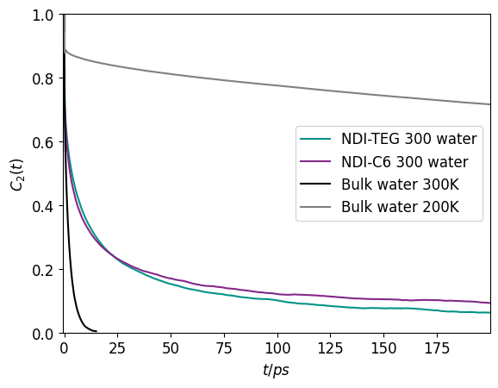

Additional figures
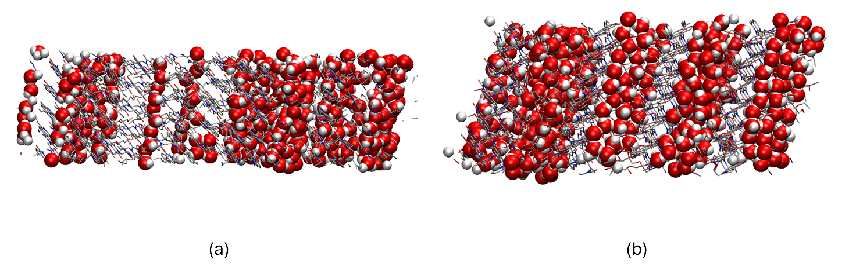
Figure S5: Side view of the simulation boxes (a 4x4x6 NDI-TEG supercell and on a 5x5x4 NDI-C6 supercell) after a 200 ns simulation. Panel a): NDI-C6 and 300 water molecules (1:3). Panel b): NDI-TEG and 300 water molecules (1:3).

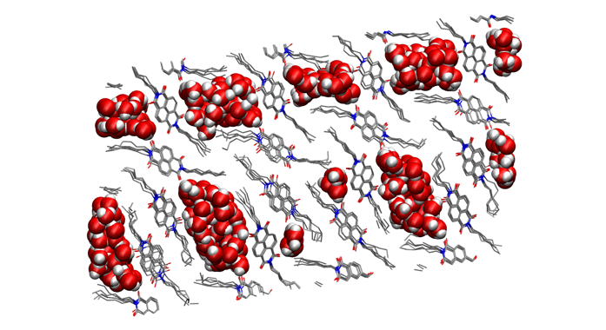 | 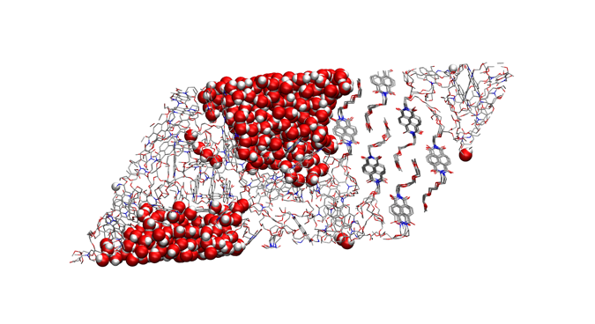
Figure S6: Simulation boxes (a 4x4x6 NDI-TEG supercell and on a 5x5x4 NDI-C6 supercell) after a 200 ns simulation. Panel a): NDI-C6 and 500 water molecules (1:3). Panel b): NDI-TEG and 500 water molecules (1:5).

Cluster analyses
A cluster analysis for the 1:3 hydration cases (i.e., 300 water molecules) was performed. For the cluster analysis we considered the commands compute cluster/atom and compute chunk/atom in LAMMPS, to generate clusters and count the atoms within each cluster. To generate the clusters, we considered oxygen atom-type (i.e., water molecule) within a radius of 3.5 Å (i.e., approximately the first peak in the oxygen-oxygen radial distribution function). We applied the analysis for NDI-C6, NDI-TEG, bulk water at 300K and supercooled at 200 K.
Here below are reported the final analyses.
For NDI-C6 the number of identified (types of) clusters is 9. The distribution of water molecules in each cluster is the following: 64, 62, 36, 52, 11, 10, 6, 55, and 4 (total = 300).
For NDI-TEG the number of identified clusters is 9. The distribution of water molecules in each cluster is the following: 21, 32, 134, 40, 19, 33, 1, 17, and 3 (total = 300).
For bulk water cases (300 K and 200 K), the analyses returned only one type of cluster.
We observed that for NDI-TEG the size distribution of the clusters is quite heterogeneous, showing a large cluster containing 134 water molecules, followed by smaller clusters (e.g., 40, 33, 32, 21). This reflects the presence of a large cluster promoted by the hydrophilicity of the side chains. For NDI-C6, instead, the cluster analysis reveals a more homogeneous size distribution than NDI-TEG, with clusters containing relatively similar amount of water molecules (e.g., 64, 62, 55, 52).
For bulk water, a homogenous phase is present, and accordingly our analysis returns one type of cluster.

References
¹ M. Severi, S. Yu, I. Abrahams, C.B. Nielsen, and D. Fazzi, “Disclosing the molecular structure and dynamics of naphthalene diimide based organic semiconductors in the solid state,” J. Mater. Chem. C, (2025).
² W.L. Jorgensen, M.M. Ghahremanpour, A. Saar, and J. Tirado-Rives, “OPLS/2020 Force Field for Unsaturated Hydrocarbons, Alcohols, and Ethers,” J. Phys. Chem. B 128(1), 250–262 (2024).
³ A. Tkatchenko, and M. Scheffler, “Accurate Molecular Van Der Waals Interactions from Ground-State Electron Density and Free-Atom Reference Data,” Phys. Rev. Lett. 102(7), 073005 (2009).
⁴ K.-H. Lin, L. Paterson, F. May, and D. Andrienko, “Glass transition temperature prediction of disordered molecular solids,” Npj Comput. Mater. 7(1), 1–7 (2021).
⁵ D.J. Cole, J.Z. Vilseck, J. Tirado-Rives, M.C. Payne, and W.L. Jorgensen, “Biomolecular Force Field Parameterization via Atoms-in-Molecule Electron Density Partitioning,” J. Chem. Theory Comput. 12(5), 2312–2323 (2016).
⁶ M.J. Frisch, G.W. Trucks, H.B. Schlegel, G.E. Scuseria, M.A. Robb, J.R. Cheeseman, G. Scalmani, V. Barone, G.A. Petersson, H. Nakatsuji, X. Li, M. Caricato, A.V. Marenich, J. Bloino, B.G. Janesko, R. Gomperts, B. Mennucci, H.P. Hratchian, J.V. Ortiz, A.F. Izmaylov, J.L. Sonnenberg, D. Williams-Young, F. Ding, F. Lipparini, F. Egidi, J. Goings, B. Peng, A. Petrone, T. Henderson, D. Ranasinghe, V.G. Zakrzewski, J. Gao, N. Rega, G. Zheng, W. Liang, M. Hada, M. Ehara, K. Toyota, R. Fukuda, J. Hasegawa, M. Ishida, T. Nakajima, Y. Honda, O. Kitao, H. Nakai, T. Vreven, K. Throssell, J.A. Montgomery Jr., J.E. Peralta, F. Ogliaro, M.J. Bearpark, J.J. Heyd, E.N. Brothers, K.N. Kudin, V.N. Staroverov, T.A. Keith, R. Kobayashi, J. Normand, K. Raghavachari, A.P. Rendell, J.C. Burant, S.S. Iyengar, J. Tomasi, M. Cossi, J.M. Millam, M. Klene, C. Adamo, R. Cammi, J.W. Ochterski, R.L. Martin, K. Morokuma, O. Farkas, J.B. Foresman, and D.J. Fox, “Gaussian˜16 Revision C.01,” (2016).
⁷ J.-D. Chai, and M. Head-Gordon, “Long-range corrected hybrid density functionals with damped atom–atom dispersion corrections,” Phys Chem Chem Phys 10(44), 6615–6620 (2008).
⁸ F. Weigend, “Accurate Coulomb-fitting basis sets for H to Rn,” Phys. Chem. Chem. Phys. 8(9), 1057–1065 (2006).
⁹ S. Izadi, and A.V. Onufriev, “Accuracy limit of rigid 3-point water models,” J. Chem. Phys. 145(7), 074501 (2016).
¹⁰ J.-P. Ryckaert, G. Ciccotti, and H.J.C. Berendsen, “Numerical integration of the cartesian equations of motion of a system with constraints: molecular dynamics of n-alkanes,” J. Comput. Phys. 23(3), 327–341 (1977).
¹¹ M. Brehm, and B. Kirchner, “TRAVIS - A Free Analyzer and Visualizer for Monte Carlo and Molecular Dynamics Trajectories,” J. Chem. Inf. Model. 51(8), 2007–2023 (2011).
¹² M. Brehm, M. Thomas, S. Gehrke, and B. Kirchner, “TRAVIS—A free analyzer for trajectories from molecular simulation,” J. Chem. Phys. 152(16), 164105 (2020).

