APPENDIX S2
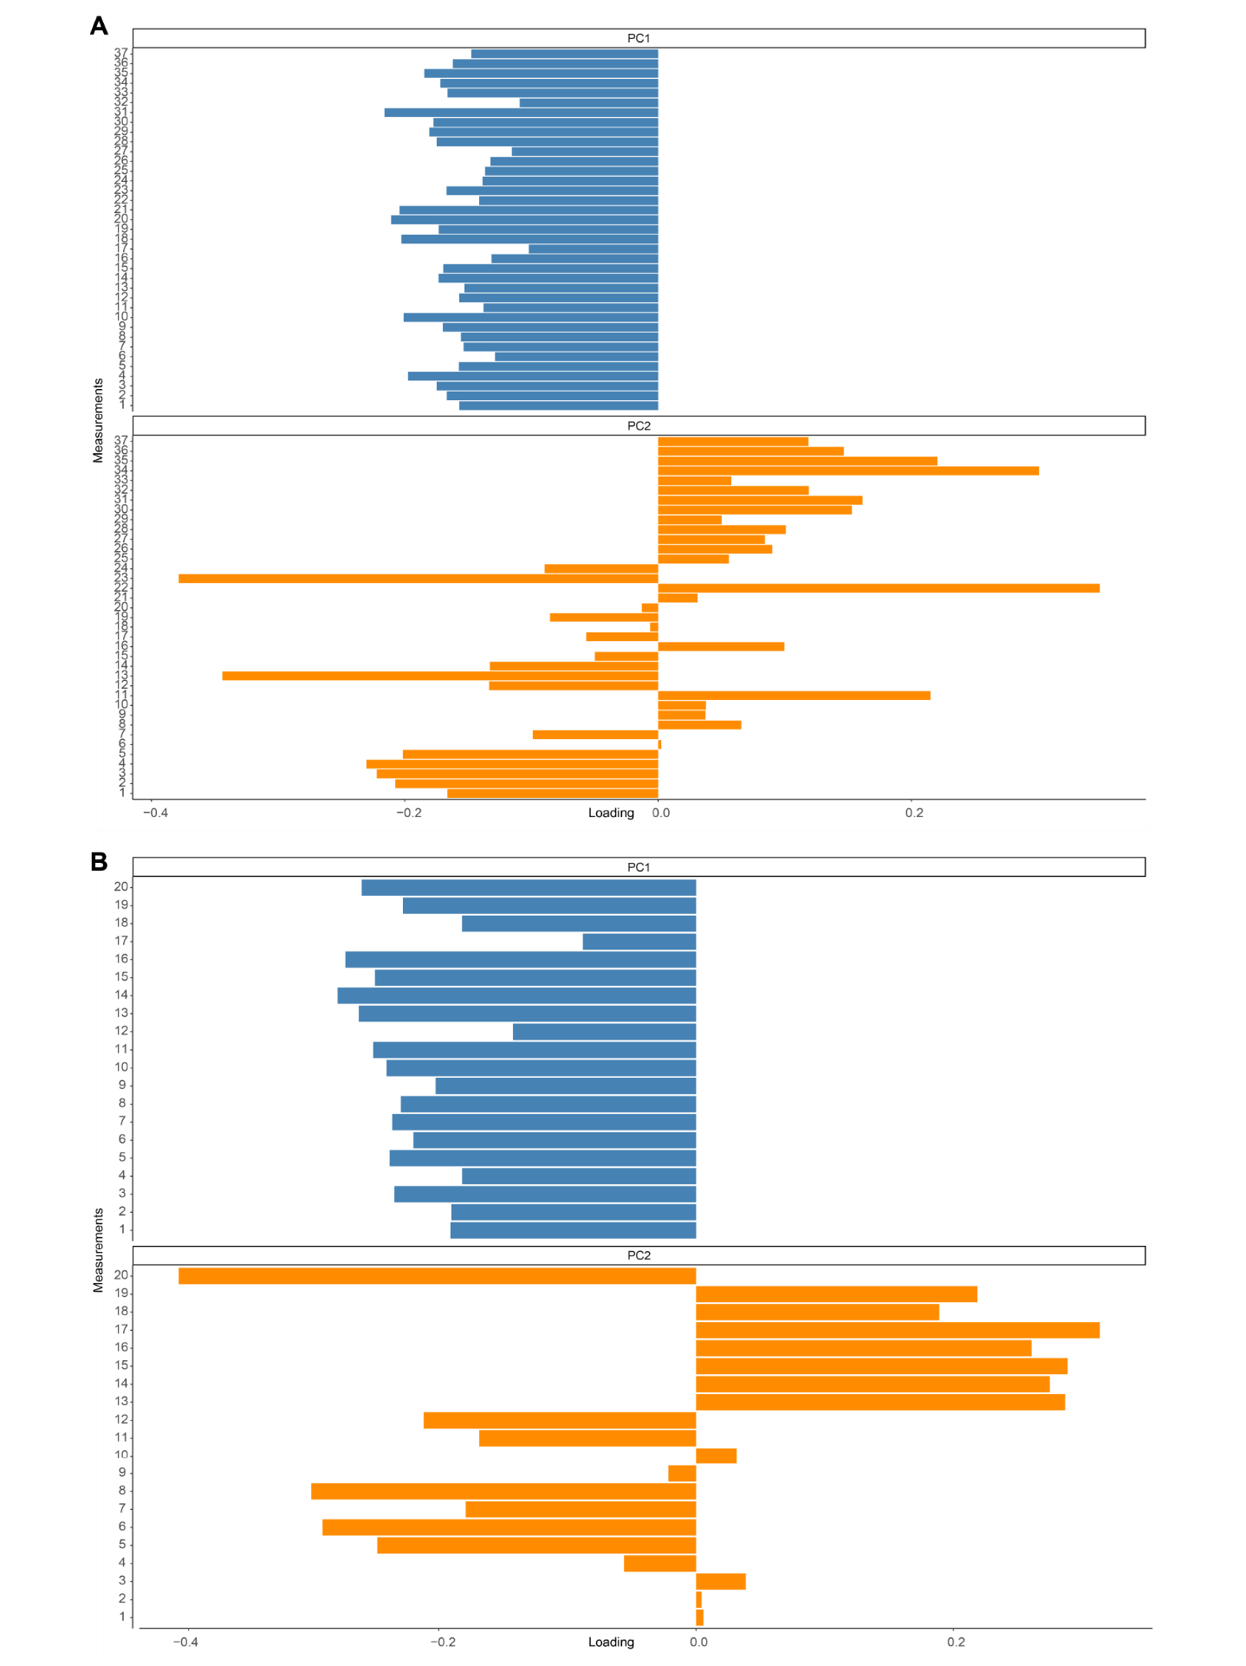FIG. S2.1. Loadings of the PCAs. Blue histogram for the loadings of the PC1. Orange histogram for the loadings of the PC2. A, loadings for the PCA on the femora. B, loadings for the PCA on the tibiae.
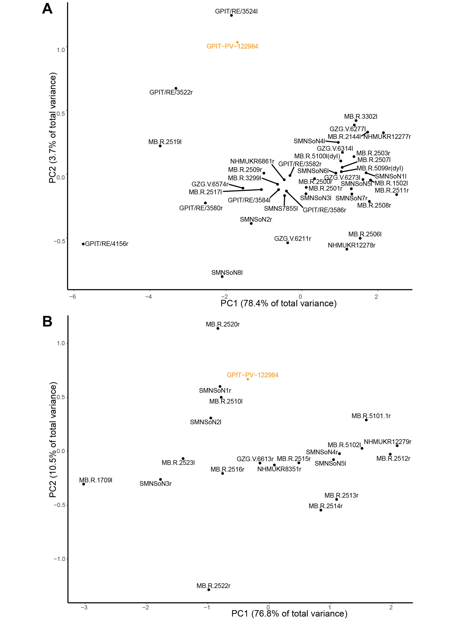
FIG. S2.2. PCAs resulting plots (PC1 vs PC2). GPIT-PV-122984 position is marked in orange. A, PCA on the femora. B, PCA on the tibiae.

