Table S1 - Primers sequences and qPCR performances.
 | Gene | Primers | Amplicon size bp | Amplification efficiency (%) | Accession number (Chameleabase)
target genes | ABCC | 5’- GTGCTGGATCAGGGAAAGATAA -3’  5’- GCATCTGAGGCCATACCATAAA -3’ | 92 | 108 | -
target genes | AMYL | 5’- GCAGTACACTTCTCTGGGTTAT -3’  5’- GTGTCCGGAGTCAGTCATATTC -3’ | 127 | 91 | -
target genes | CAT | 5’- ACACAGCCGACGATGATAAC -3’  5’- ACAGCACGCTTCTGGATAAA -3’ | 139 | 114 | Chamelea_c30562
target genes | CTSL | 5’- CCATATAGAGCTAGGGACCAGTA -3’  5’- GACCCTAGTTCACTTTGGAGAG -3’ | 116 | 114 | Chamelea_rep_c27205
target genes | SOD | 5’- GGCTTCCATGTGCATCAATTT -3’  5’- GTTGGAGCACCATGTTGTTTAC-3’ | 95 | 112 | Chamelea_c10658
target genes | GST | 5’- ACATCAGAAGGTAGCAGTTTGT -3’  5’- CGGCGAACTTGTTGTGAATG -3’ | 93 | 107 | Chamelea_rep_c657
target genes | HSP90 | 5’- GCAGAGGATTCCCAAGTGTAAG -3’  5’- TGGTCAGTTTGGTGTAGGTTTC -3’ | 105 | 114 | Chamelea_rep_c2316
target genes | IDH | 5’- GTCGGGCGTCACATTCTT-3’  5’- AAATGGGCTCTCACCTTGG -3’ | 108 | 111 | Chamelea_rep_c12181
target genes | LYS | 5’- CCATCTGCCGCTTTCAATTTC-3’  5’- TGGATCCTCTCGAGCCTTATT -3’ | 148 | 93 | -
target genes | MT10 | 5’- GTGTAAGTGATGGGACGAAGT -3’  5’- CAGCGGTTCATGGAGTATCTT -3’ | 99 | 109 | Chamelea_rep_c20174
target genes | PK | 5’- CCATTACCAGAAACGCTCAAAC -3’  5’- GGTCTACATCCACTGTCCATTC -3’ | 108 | 98 | -
Reference genes | 28S | 5’- CCCGTCATCGAGAGCTTAAA -3’  5’- GCGTCGTTTCCTCATTTCATC -3’ | 101 | 110 | Chamelea_rep_c41133
Reference genes | EF1 | 5’- GTACTCTGGTGATGCCTGTATG -3’  5’- TACAGCAAATCGTCCAAGGG -3’ | 97 | 110 | Chamelea2_rep_c1644
Reference genes | GAPDH | 5’- AGCATTAGAAAGAGTCCAGTCATC -3’  5’- ACCGTATTAGGTTACTGTCGATTG -3’ | 136 | 95 | Chamelea_rep_c3622
Reference genes | RPS20 | 5’- ATCACACTCACCAGCAGAAAT -3’  5’- CGGAGGATCTTAGTTGGCATAC -3’ | 122 | 95 | Chamelea_rep_c6834
Reference genes | TUB | 5’- GACTTGATGTACGCCAAGAGAG -3’  5’- TCTCAAGGGCAGCCAAATC -3’ | 103 | 101 | Chamelea_rep_c2525
ABCC = Multidrug resistance protein; AMYL = α-Amylase; CAT = Catalase; CTSL = Cathepsin L; SOD = Superoxide dismutase Cu/Zn; GST = Glutathione S-transferase; HSP90 = Heat Shock Protein 90kDa; IDH = Isocitrate dehydrogenase; LYS = Lysozime; MT10 = Metallothionein 10kDa; PK = Pyruvate kinase; 28S = 28S rRNA; EF1 = Elongation factor-1α; GAPDH = Glyceraldehyde 3-phosphate dehydrogenase; RPS20 = 40s Ribosomal Protein s20; TUB = Tubulin.

Fig S1. Principal Component Analysis for environmental variables. Symbols indicates the mean value for each sampling month and site.
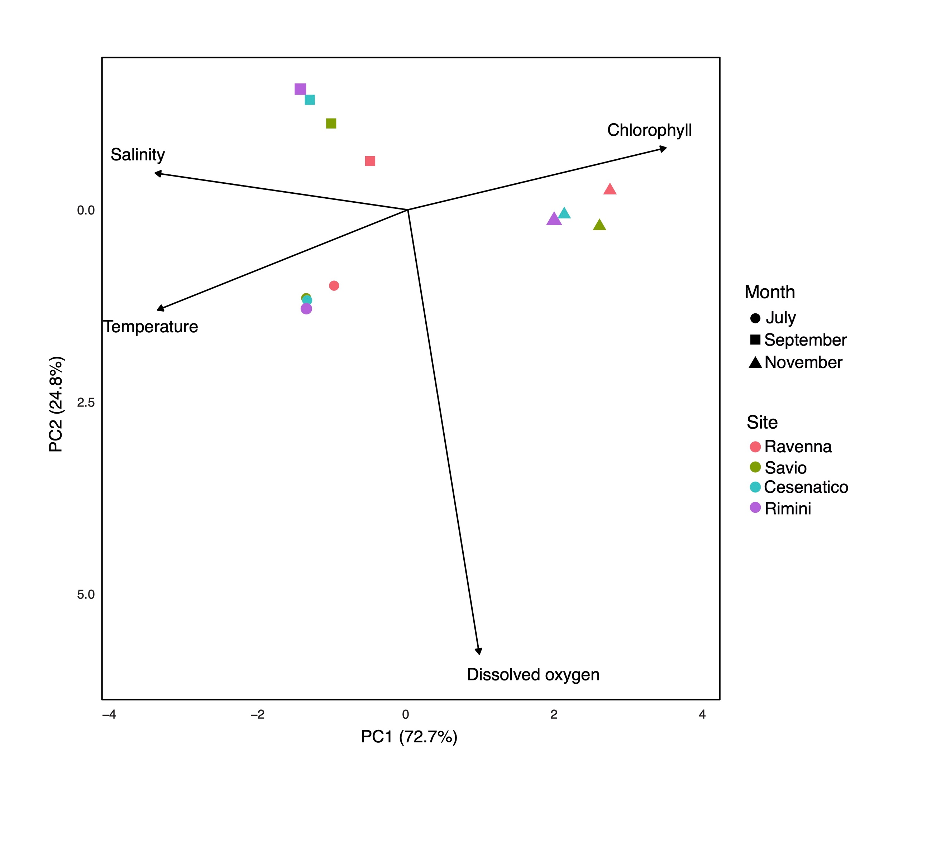

Table S2. PERMANOVA results on the extracted environmental parameters for sampling Sites and Months (999 permutations). Significant P values are in bold.

 |  | Temperature |  | Salinity |  | Dissolved oxygen |  | Chlorophyll
Source | df | Pseudo-F | P(perm) | Pseudo-F | P(perm) | Pseudo-F | P(perm) | Pseudo-F | P(perm)
Site | 3 | 1.51 | 0.201 | 94.22 | 0.001 | 4.77 | 0.001 | 12.10 | 0.001
Month | 2 | 1159.20 | 0.001 | 686.99 | 0.001 | 126.46 | 0.001 | 398.02 | 0.001
Site x Month | 6 | 4.86 | 0.001 | 13.43 | 0.001 | 3.15 | 0.005 | 1.39 | 0.223
df: degree of freedom; Pseudo-F: F value by permutation (Anderson et al., 2008); P(perm): probability of pseudo-F.

Table S3 PERMANOVA pairwise comparisons between sampling months for the environmental parameters for different sampling Sites (999 permutations). Significant P values are in bold.
 | Ravenna |  | Savio |  | Cesenatico |  | Rimini
 | t | P(perm) | t | P(perm) | t | P(perm) | t | P(perm)
Temperature
July vs September | 7.38 | 0.001 | 7.58 | 0.001 | 6.36 | 0.001 | 3.18 | 0.005
July vs November | 23.15 | 0.001 | 27.75 | 0.001 | 26.01 | 0.001 | 23.54 | 0.001
September vs November | 2.18 | 0.001 | 15.61 | 0.001 | 16.51 | 0.001 | 17.51 | 0.001
Salinity
July vs September | 0.38 | 0.720 | 3.17 | 0.003 | 3.17 | 0.003 | 7.57 | 0.001
July vs November | 13.14 | 0.001 | 13.63 | 0.001 | 13.63 | 0.001 | 11.08 | 0.001
September vs November | 12.97 | 0.001 | 15.03 | 0.001 | 15.03 | 0.001 | 18.50 | 0.001
Dissolved oxygen
July vs September | 5.60 | 0.001 | 8.82 | 0.001 | 9.97 | 0.001 | 9.23 | 0.001
July vs November | 2.54 | 0.001 | 1.16 | 0.255 | 1.73 | 0.096 | 2.07 | 0.055
September vs November | 1.83 | 0.083 | 7.18 | 0.001 | 8.29 | 0.001 | 8.33 | 0.001
Chlorophyll
July vs September | 4.09 | 0.002 | 3.22 | 0.001 | 3.23 | 0.001 | 3.37 | 0.001
July vs November | 10.61 | 0.001 | 13.13 | 0.001 | 13.49 | 0.001 | 18.55 | 0.001
September vs November | 6.98 | 0.001 | 9.80 | 0.001 | 9.89 | 0.001 | 13.54 | 0.001
t: t-Statistics; P(perm): probability of t.

Table S4. PERMANOVA results on biometric parameters and calculated meat yield and condition index assessed in C. gallina from different sampling Sites and Months (998 permutations). Significant P values are in bold.

 |  | Shell length |  | Shell weight |  | Soft tissue weigth |  | Meat yield |  | Condition index
Source | df | Pseudo-F | P(perm) | Pseudo-F | P(perm) | Pseudo-F | P(perm) | Pseudo-F | P(perm) | Pseudo-F | P(perm)
Site | 3 | 85.45 | 0.001 | 59.58 | 0.001 | 46.13 | 0.001 | 10.12 | 0.001 | 9.75 | 0.001
Month | 2 | 50.47 | 0.001 | 36.53 | 0.001 | 16.91 | 0.001 | 2.93 | 0.051 | 2.42 | 0.11
Site x Month | 6 | 13.22 | 0.001 | 15.24 | 0.001 | 10.23 | 0.001 | 13.67 | 0.001 | 13.99 | 0.001
df: degree of freedom; Pseudo-F: F value by permutation (Anderson et al., 2008); P(perm): probability of pseudo-F.

Table S5. PERMANOVA pairwise comparisons between sampling months for biometric parameters and calculated meat yield and condition index assessed in C. gallina from different sampling Sites (999 permutations). Significant P values are in bold.
 | Ravenna |  | Savio |  | Cesenatico |  | Rimini
 | t | P(perm) | t | P(perm) | t | P(perm) | t | P(perm)
Shell length
July vs September | 4.26 | 0.001 | 1.79 | 0.082 | 4.16 | 0.001 | 2.90 | 0.009
July vs November | 1.12 | 0.29 | 1.91 | 0.069 | 4.42 | 0.001 | 4.40 | 0.001
September vs November | 2.09 | 0.045 | 0.29 | 0.77 | 9.35 | 0.001 | 6.47 | 0.001
Shell weight
July vs September | 2.66 | 0.014 | 2.27 | 0.025 | 1.44 | 0.16 | 0.22 | 0.818
July vs November | 1.47 | 0.139 | 0.78 | 0.446 | 5.14 | 0.001 | 5.85 | 0.001
September vs November | 0.73 | 0.46 | 1.33 | 0.204 | 6.93 | 0.001 | 6.14 | 0.001
Soft tissue weight
July vs September | 3.08 | 0.003 | 3.05 | 0.005 | 2.59 | 0.011 | 2.37 | 0.02
July vs November | 1.36 | 0.181 | 1.79 | 0.092 | 4.39 | 0.001 | 1.71 | 0.084
September vs November | 4.01 | 0.001 | 1.46 | 0.148 | 8.31 | 0.001 | 0.86 | 0.407
Meat yield
July vs September | 1.53 | 0.151 | 4.18 | 0.002 | 2.31 | 0.017 | 2.39 | 0.03
July vs November | 2.77 | 0.011 | 2.57 | 0.012 | 0.89 | 0.377 | 3.55 | 0.002
September vs November | 4.01 | 0.001 | 2.48 | 0.016 | 3.70 | 0.002 | 5.98 | 0.001
Condition index
July vs September | 1.52 | 0.137 | 4.21 | 0.003 | 2.31 | 0.034 | 2.39 | 0.028
July vs November | 2.84 | 0.014 | 2.64 | 0.017 | 0.83 | 0.398 | 3.59 | 0.001
September vs November | 4.06 | 0.001 | 2.46 | 0.022 | 3.70 | 0.001 | 5.69 | 0.001
t: t-Statistics; P(perm): probability of t.

Table S6. PERMANOVA results on gene transcriptions assessed in digestive glands of C. gallina from different sampling Sites and Months (998 permutations). Significant P values are in bold.
 |  | Source
 |  | Site  (df = 3) | Month  (df = 2) | Site x Month  (df = 6)
AMYL | Pseudo-F | 0.77 | 0.42 | 0.87
 | P(perm) | 0.51 | 0.65 | 0.52
IDH | Pseudo-F | 9.68 | 0.86 | 2.73
 | P(perm) | 0.001 | 0.44 | 0.02
PK | Pseudo-F | 4.59 | 6.05 | 4.49
 | P(perm) | 0.007 | 0.005 | 0.001
CAT | Pseudo-F | 8.03 | 10.32 | 6.39
 | P(perm) | 0.002 | 0.002 | 0.002
GST | Pseudo-F | 2.96 | 0.99 | 3.84
 | P(perm) | 0.043 | 0.35 | 0.005
SOD | Pseudo-F | 2.77 | 7.24 | 4.11
 | P(perm) | 0.06 | 0.004 | 0.002
ABCC | Pseudo-F | 3.15 | 22.60 | 6.45
 | P(perm) | 0.04 | 0.001 | 0.002
LYS | Pseudo-F | 2.61 | 27.03 | 4.82
 | P(perm) | 0.07 | 0.001 | 0.002
MT10 | Pseudo-F | 0.78 | 15.28 | 3.05
 | P(perm) | 0.52 | 0.001 | 0.02
HSP90 | Pseudo-F | 1.60 | 22.92 | 1.31
 | P(perm) | 0.22 | 0.001 | 0.28
CTSL | Pseudo-F | 4.47 | 6.10 | 3.24
 | P(perm) | 0.008 | 0.006 | 0.01
df: degree of freedom; Pseudo-F: F value by permutation (Anderson et al., 2008); P(perm): probability of pseudo-F.

Table S7. PERMANOVA pairwise comparisons between sampling time months for gene transcriptions assessed in digestive glands of C. gallina from different sampling Sites (999 permutations). Significant P values are in bold.
 | Ravenna |  | Savio |  | Cesenatico |  | Rimini
 | t | P(perm) | t | P(perm) | t | P(perm) | t | P(perm)
AMYL
July vs September | 0.02 | 0.973 | 1.26 | 0.235 | 1.62 | 0.174 | 0.18 | 0.856
July vs November | 1.03 | 0.374 | 0.50 | 0.694 | 1.66 | 0.198 | 0.63 | 0.550
September vs November | 1.10 | 0.360 | 0.92 | 0.416 | 2.31 | 0.112 | 0.14 | 0.911
IDH
July vs September | 3.96 | 0.038 | 1.39 | 0.193 | 1.63 | 0.200 | 1.71 | 0.141
July vs November | 3.48 | 0.017 | 0.90 | 0.338 | 1.14 | 0.301 | 0.32 | 0.909
September vs November | 1.76 | 0.135 | 0.62 | 0.576 | 0.43 | 0.705 | 2.61 | 0.027
PK
July vs September | 1.03 | 0.292 | 3.34 | 0.028 | 0.63 | 0.432 | 0.74 | 0.562
July vs November | 1.09 | 0.426 | 4.16 | 0.027 | 3.70 | 0.032 | 1.76 | 0.176
September vs November | 2.84 | 0.023 | 0.90 | 0.457 | 2.24 | 0.085 | 4.48 | 0.034
CAT
July vs September | 0.21 | 0.863 | 6.08 | 0.031 | 2.57 | 0.066 | 0.99 | 0.358
July vs November | 0.72 | 0.527 | 1.34 | 0.313 | 5.28 | 0.024 | 3.42 | 0.026
September vs November | 1.36 | 0.271 | 3.87 | 0.030 | 10.27 | 0.035 | 1.67 | 0.201
GST
July vs September | 1.35 | 0.214 | 2.16 | 0.069 | 3.63 | 0.032 | 1.08 | 0.342
July vs November | 0.44 | 0.686 | 0.70 | 0.553 | 1.76 | 0.142 | 1.09 | 0.324
September vs November | 2.19 | 0.059 | 2.93 | 0.066 | 0.79 | 0.478 | 1.80 | 0.155
SOD
July vs September | 3.04 | 0.034 | 5.02 | 0.027 | 1.53 | 0.247 | 1.15 | 0.292
July vs November | 0.63 | 0.586 | 0.35 | 0.701 | 0.92 | 0.307 | 0.30 | 0.791
September vs November | 2.04 | 0.107 | 6.15 | 0.026 | 3.02 | 0.058 | 1.98 | 0.121
ABCC
July vs September | 2.76 | 0.034 | 3.63 | 0.032 | 0.42 | 0.807 | 6.01 | 0.029
July vs November | 2.82 | 0.030 | 2.60 | 0.056 | 4.65 | 0.036 | 5.64 | 0.029
September vs November | 0.17 | 0.882 | 2.10 | 0.122 | 3.37 | 0.034 | 0.16 | 0.794
LYS
July vs September | 2.58 | 0.052 | 5.04 | 0.032 | 2.72 | 0.055 | 4.44 | 0.027
July vs November | 2.82 | 0.033 | 3.14 | 0.032 | 1.50 | 0.324 | 4.30 | 0.028
September vs November | 0.74 | 0.547 | 5.14 | 0.041 | 2.09 | 0.024 | 1.69 | 0.223
HSP90
July vs September | 0.78 | 0.563 | 0.15 | 0.977 | 0.10 | 0.925 | 2.74 | 0.059
July vs November | 2.10 | 0.067 | 3.11 | 0.037 | 5.01 | 0.036 | 4.76 | 0.029
September vs November | 2.65 | 0.053 | 3.57 | 0.030 | 2.59 | 0.083 | 2.30 | 0.057
MT10
July vs September | 8.43 | 0.027 | 1.91 | 0.105 | 1.38 | 0.276 | 4.53 | 0.035
July vs November | 0.17 | 0.924 | 3.80 | 0.032 | 0.90 | 0.488 | 0.36 | 0.751
September vs November | 3.95 | 0.032 | 1.43 | 0.288 | 0.61 | 0.548 | 3.62 | 0.026
CTSL
July vs September | 1.32 | 0.228 | 0.79 | 0.450 | 1.50 | 0.195 | 0.18 | 0.812
July vs November | 2.77 | 0.078 | 0.70 | 0.513 | 5.01 | 0.029 | 1.33 | 0.220
September vs November | 0.41 | 0.696 | 1.46 | 0.177 | 3.45 | 0.061 | 1.07 | 0.312
t: t-Statistics; P(perm): probability of t.

