Supplementary Table 1. Detailed clinical-pathological features of patients included in the dataset.
FEATURES |  | N. of patients | BRCA status
 |  | N. of patients | BRCA1 carriers (%) | BRCA2 carriers (%) | BRCA1/2 carriers (%)* | BRCA wt (%)
Histotype | High grade serous carcinoma (HGS) | 630 | 111 (17.6%) | 62 (9.8%) | 172 (27.3%) | 458 (72.7%)
Histotype | Low grade serous carcinoma (LGS) | 30 | 1 (3.3%) | 0 (0.0%) | 1 (3.3%) | 29 (96.7%)
Histotype | Unspecified serous carcinoma | 24 | 3 (12.5%) | 2 (8.3%) | 5 (20.8%) | 19 (79.2%)
Histotype | Mixed tumour with serous component | 25 | 3 (12.0%) | 1 (4.0%) | 4 (16.0%) | 21 (84.0%)
Histotype | Endometrioid carcinoma | 132 | 5 (3.8%) | 8 (6.0%) | 13 (9.8%) | 119 (90.2%)
Histotype | Clear cell carcinoma | 53 | 0 (0.0%) | 1 (1.9%) | 1 (1.9%) | 52 (98.1%)
Histotype | Undifferentiated carcinoma | 42 | 7 | 3 | 10 (23.8%) | 32 (76.2%)
Histotype | Other types eligible for testing° (total)  Carcinosarcoma with G3 serous/endometrioid component  Mixed tumour without serous component  Carcinosarcoma  Mesonephric-like adenocarcinoma  Undifferentiated with prevalent neuroendocrine component | 22  2  6  7  6  1 | 1 (4.5%)  1 (50.0%)  0 (0.0%)  0 (0.0%)  0 (0.0%)  0 (0.0%) | 1 (4.5%)  1 (50.0%)  0 (0.0%)  0 (0.0%)  0 (0.0%)  0 (0.0%) | 2 (9.1%)  2 (100.0%)  0 (0.0%)  0 (0.0%)  0 (0.0%)  0 (0.0%) | 20 (90.9%)  0 (0.0%)  6 (100.0%)  7 (100.0%)  6 (100.0%)  1 (100.0%)
Histotype | Other types non eligible for testing° (total)  Borderline  Mucinous  Adult-type ganulosa cell tumour | 8  2  5  1 | 0 (0.0%)  0 (0.0%)  0 (0.0%)  0 (0.0%) | 1 (12.5%)  1 (50.0%)  0 (0.0%)  0 (0.0%) | 1 (12.5%)  1 (50.0%)  0 (0.0%)  0 (0.0%) | 7 (87.5%)  1 (50.0%)  5 (100.0%)  1 (100.0%)
Histotype | Total with information | 966 | 131 (13.6%) | 79 (8.2%) | 209 (21.6%) | 757 (78.4%)
Histotype | Unknown | 51 | 7 (13.7%) | 1 (2.0%) | 8 (15.7%) | 43 (84.3%)
Grade | G1 | 68 | 1 (1.5%) | 2 (2.9%) | 3 (4.4%) | 65 (95.6%)
Grade | G2-G3 | 828 | 127 (15.3%) | 73 (8.8%) | 199 (24.0%) | 629 (76.0%)
Grade | Total with information | 896 | 128 (14.3%) | 75 (8.4%) | 202 (22.5%) | 694 (77.5%)
Grade | Unknown | 121 | 10 (8.3%) | 5 (4.1%) | 15 (12.4%) | 106 (87.6%)
FIGO stage | I-II | 218 | 23 (10.6%) | 14 (6.4%) | 36 (16.5%) | 182 (83.5%)
FIGO stage | III-IV | 538 | 80 (14.9%) | 50 (9.3%) | 130 (24.2%) | 408 (75.8%)
FIGO stage | Total with information | 756 | 103 (13.6%) | 64 (8.5%) | 166 (22.0%) | 590 (78.0%)
FIGO stage | Unknown | 261 | 35 (13.4%) | 16 (6.1%) | 51 (19.5%) | 210 (80.5%)
Age at diagnosis | ≤ 50 years | 231 | 49 (21.2%) | 15 (6.5%) | 64 (27.7%) | 167 (72.3%)
Age at diagnosis | > 50 years | 768 | 88 (11.5%) | 65 (8.5%) | 152 (19.8%) | 616 (80.2%)
Age at diagnosis | Total with information | 999 | 137 (13.7%) | 80 (8.0%) | 216 (21.6%) | 783 (78.4%)
Age at diagnosis | Unknown | 18 | 1 (5.6%) | 0 (0.0%) | 1 (5.6%) | 17 (94.4%)
Personal breast cancer history | Yes | 110 | 25 (22.7%) | 20 (18.2%) | 45 (40.9%) | 65 (59.1%)
Personal breast cancer history | No | 842 | 110 (13.1%) | 58 (6.9%) | 167 (19.8%) | 675 (80.2%)
Personal breast cancer history | Total with information | 952 | 135 (14.2%) | 78 (8.2%) | 212 (22.3%) | 740 (77.7%)
Personal breast cancer history | Unknown | 65 | 3 (4.6%) | 2 (3.1%) | 5 (7.7%) | 60 (92.3%)
Family history of ovarian cancer | Yes | 106 | 42 (39.6%) | 24 (22.6%) | 66 (62.3%) | 40 (37.7%)
Family history of ovarian cancer | No | 806 | 90 (11.2%) | 55 (6.8%) | 144 (17.9%) | 662 (82.1%)
Family history of ovarian cancer | Total with information | 912 | 132 (14.5%) | 79 (8.7%) | 210 (23.0%) | 702 (77.0%)
Family history of ovarian cancer | Unknown | 105 | 6 (5.7%) | 1 (1.0%) | 6 (5.7%) | 98 (93.3%)
Family history of breast cancer | Yes | 338 | 71 (21.0%) | 44 (13.0%) | 115 (34.0%) | 223 (66.0%)
Family history of breast cancer | No | 580 | 65 (11.2%) | 36 (6.2%) | 100 (17.2%) | 480 (82.8%)
Family history of breast cancer | Total with information | 918 | 136 (14.8%) | 80 (8.7%) | 215 (23.4%) | 703 (76.6%)
Family history of breast cancer | Unknown | 99 | 2 (2.0%) | 0 (0.0%) | 2 (2.0%) | 97 (98.0%)
TOTAL |  | 1017 | 138 (13.6%) | 80 (7.9%) | 217 (21.3%) | 800 (78.7%)

*Carriers of at least one pathogenic or likely pathogenic variant in the BRCA1/2 genes (one patient carries variants in both genes)
° According to current recommendations

Supplementary Table 2. Features of the sub-sample used for the statistical analyses.
 | BRCA1/2 non-carriers (N=496) | BRCA1/2 carriers (N=152)
Features |  |  | p-value
Age, mean (SD) | 60.1 (11.6) | 57.1 (11.1) | 0.003°
Histotype, N (%) |  |  | <0.001^
Non-low-grade serous | 353 (71.2) | 144 (94.7)
Low-grade serous | 16 (3.2) | 1 (0.7)
Non-low-grade endometrioid | 33 (6.7) | (3.9)
Low-grade endometrioid | 50 (10.1) | 1 (0.7)
Clear cell | 42 (8.5) | 0
Mesonephric-like adenocarcinoma | 2 (0.4) | 0
Family history of OC, N (%) | 29 (5.8) | 53 (34.9) | <0.001^
Family history of BC, N (%) | 169 (34.1) | 78 (51.3) | <0.001^
Personal history of BC, N (%) | 36 (7.3) | 29 (19.1) | <0.001^
FIGO stage, N (%) |  |  | 0.007^
I/II | 154 (31.0) | 30 (19.7)
III/IV | 342 (69.0) | 122 (80.3)

°t-test ^chi-square test
Supplementary Table 3. Performance metrics of logistic regression model.

 |  | Value
Accuracy |  | 0.812
AUC |  | 0.791
Sensitivity |  | 0.355
Specificity |  | 0.952
Precision |  | 0.692

Supplementary Table 4. Performance metrics of Decision Tree Classification model.
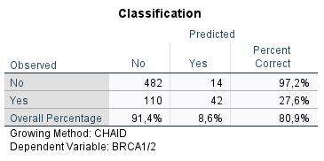

Supplementary Figure 1. ROC curves of each variable and of the score.
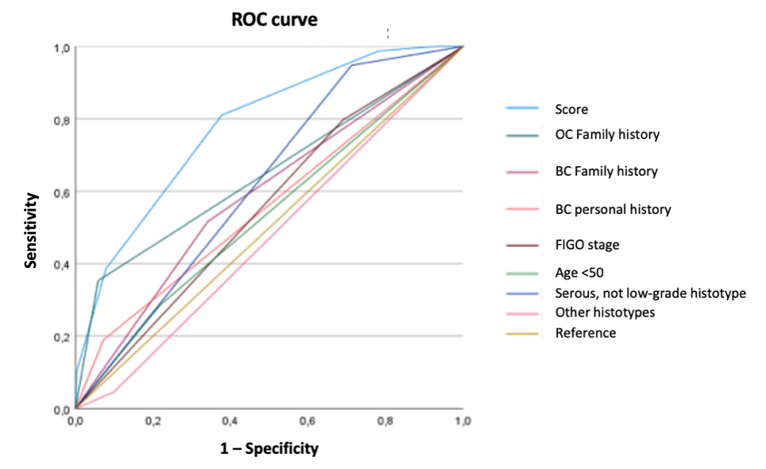

Supplementary Table 5. AUC of the ROC curves of each variable and of the score.
Variable | AUC | SE(AUC) | p* | 95% CI
 |  |  |  | Low | High
Risk score | 0.778 | 0.021 | <0.001 | 0.738 | 0.818
OC family history | 0.647 | 0.028 | <0.001 | 0.592 | 0.702
BC family history | 0.588 | 0.027 | 0.001 | 0.536 | 0.640
BC personal history | 0.558 | 0.028 | 0.029 | 0.504 | 0.613
FIGO stage | 0.554 | 0.026 | 0.044 | 0.503 | 0.605
Age at diagnosis <50y | 0.534 | 0.027 | 0.204 | 0.481 | 0.587
Histotype  1 | 0.618 | 0.024 | <0.001 | 0.572 | 0.664
Histotypes  2/3 | 0.473 | 0.026 | 0.321 | 0.422 | 0.524
*Null hypothesis: true, area = 0.5
Histotype 1 = non-low-grade serous; Histotype 2 = low-grade serous; Histotype 3 = high-grade endometrioid; Histotype 4 = low-grade endometrioid; Histotype 5 = clear cell; Histotype 7 = mesonephric-like adenocarcinoma.

Supplementary Table 6. Coordinates of the ROC curve at the different cut-offs of the score.
Score | Sensitivity | 1 - Specificity | Specificity | Youden's J
0 | 1.000 | 1.000 | 0.000 | 0.000
1 | 1.000 | 0.935 | 0.065 | 0.065
2 | 0.993 | 0.849 | 0.151 | 0.145
3 | 0.987 | 0.780 | 0.220 | 0.207
4 | 0.810 | 0.377 | 0.623 | 0.433
5 | 0.386 | 0.079 | 0.921 | 0.307
6 | 0.105 | 0.004 | 0.996 | 0.101
7 | 0.000 | 0.000 | 1.000 | 0.000

