SUPPORTING INFORMATION

SUPPLEMENTARY MATERIALS AND METHODS

UHPLC Analysis of (Poly)phenolic Compounds in Experimental Beverages
Pomegranate juice (POMJ) and placebo were extracted and analyzed as previously described [1], with minor modifications. Briefly, thawed samples were centrifuged for 10 min at 14460 × g at room temperature (~20−25 °C). Then, the supernatant was diluted (1:20) with methanol:water:formic acid (79:20 :1, v/v), vortexed, filtered using 0.22-μm PVDF filters before UHPLC-ESI-MS^{n} analysis. The samples were analyzed by ultra-high-performance liquid chromatography (UHPLC) coupled with mass spectrometry (MS) using Accela UHPLC 1250 instrument equipped with a linear ion trap MS (LIT-MS) (LTQ XL, Thermo Fisher Scientific Inc., San José, CA, USA) fitted with a heated-ESI (H-ESI-II) probe (Thermo Fisher Scientific Inc.). Separation was carried out by means of an Acquity HSS T3 column (100x 2.1 mm; 1.8 μm particle size; Waters, Milford, MA, USA) installed with a precolumn cartridge, maintained at 40 °C. The mobile phase was pumped at a flow rate of 0.4 mL/min, consisted of a mixture of acidified acetonitrile (0.1% formic acid) (solvent A) and 0.1% aqueous formic acid (solvent B). Following 0.3 min of 5% solvent A in B, the proportion of A was increased linearly to 90% over a period of 6.7 min and maintained for 1.5 min and then the start conditions were re-established in 0.5 min and maintained for 3 min to re-equilibrate the column (total run:12 min). Samples were analyzed in negative ionization mode to identify most of the (poly)phenols, while anthocyanins were identified in positive ionization mode, at the following conditions: capillary temperature of 275 °C, source heater temperature was 200 °C, the sheath gas (N₂) flow rate was set at 40 (arbitrary units), and the auxiliary gas (N₂) flow rate at 5, the source, capillary, and tube lens voltages were 4 kV, −42 V, and −118 V, respectively. For anthocyanins, the following conditions were applied: a capillary temperature of 275 °C, source heater temperature of 300 °C, sheath and auxiliary gas (N₂) flow rates of 40 and 5 units, and source, capillary, and tube lens voltages of 4.5 kV, 20, and 95 V, respectively. Identification was carried out using MS² and MS³ information, as previously described by Mena et al. (2012) [1], and as reported in Supplementary Table 1. Quantification was performed using calibration curves constructed using all the available standard compounds. Data processing was performed using XCalibur Version 2.1 (Thermo Fisher Scientific Inc.).

Validation of Gene Expression Microarray Results by qPCR
To identify genes for validation of the microarray data by quantitative real-time PCR (qPCR), our candidate genes (ATF2, HSPA14, PMS1, MTIF3) were selected. cDNA was obtained using a High-Capacity RNA-to-cDNA Kit (Applied Biosystems, Foster City, CA, USA) following the manufacturer’s instructions. The expression of candidate genes was evaluated using the TaqMan Fast Advanced Master Mix (Applied Biosystems) with TaqMan Gene Expression Assay probes (Applied Biosystems) on a CFX Connect Real-Time PCR Detection System (Bio-Rad Laboratories, Hercules, CA, USA). TaqMan probes are listed in Supplementary Table 3. Samples were run in duplicate using the following program: uracil-N glycosylase incubation at 50 °C for 2 min and polymerase activation at 95 °C for 20 s, followed by 40 cycles (95 °C for 3 s and 60 °C for 30 s). Four reference genes (GAPDH, glyceraldehyde-3-phosphate dehydrogenase; PPIA, peptidylprolyl isomerase A; RPLP0, ribosomal protein lateral stalk subunit P0; RPS3A, ribosomal protein S3A) were confirmed as stable genes, with M values < 0.5, and used to normalizing gene expression data by the 2^{-ΔΔCq} method. Data were processed using Bio-Rad CFX Maestro 2.3 Version 5.3.

SUPPLEMENTARY FIGURES

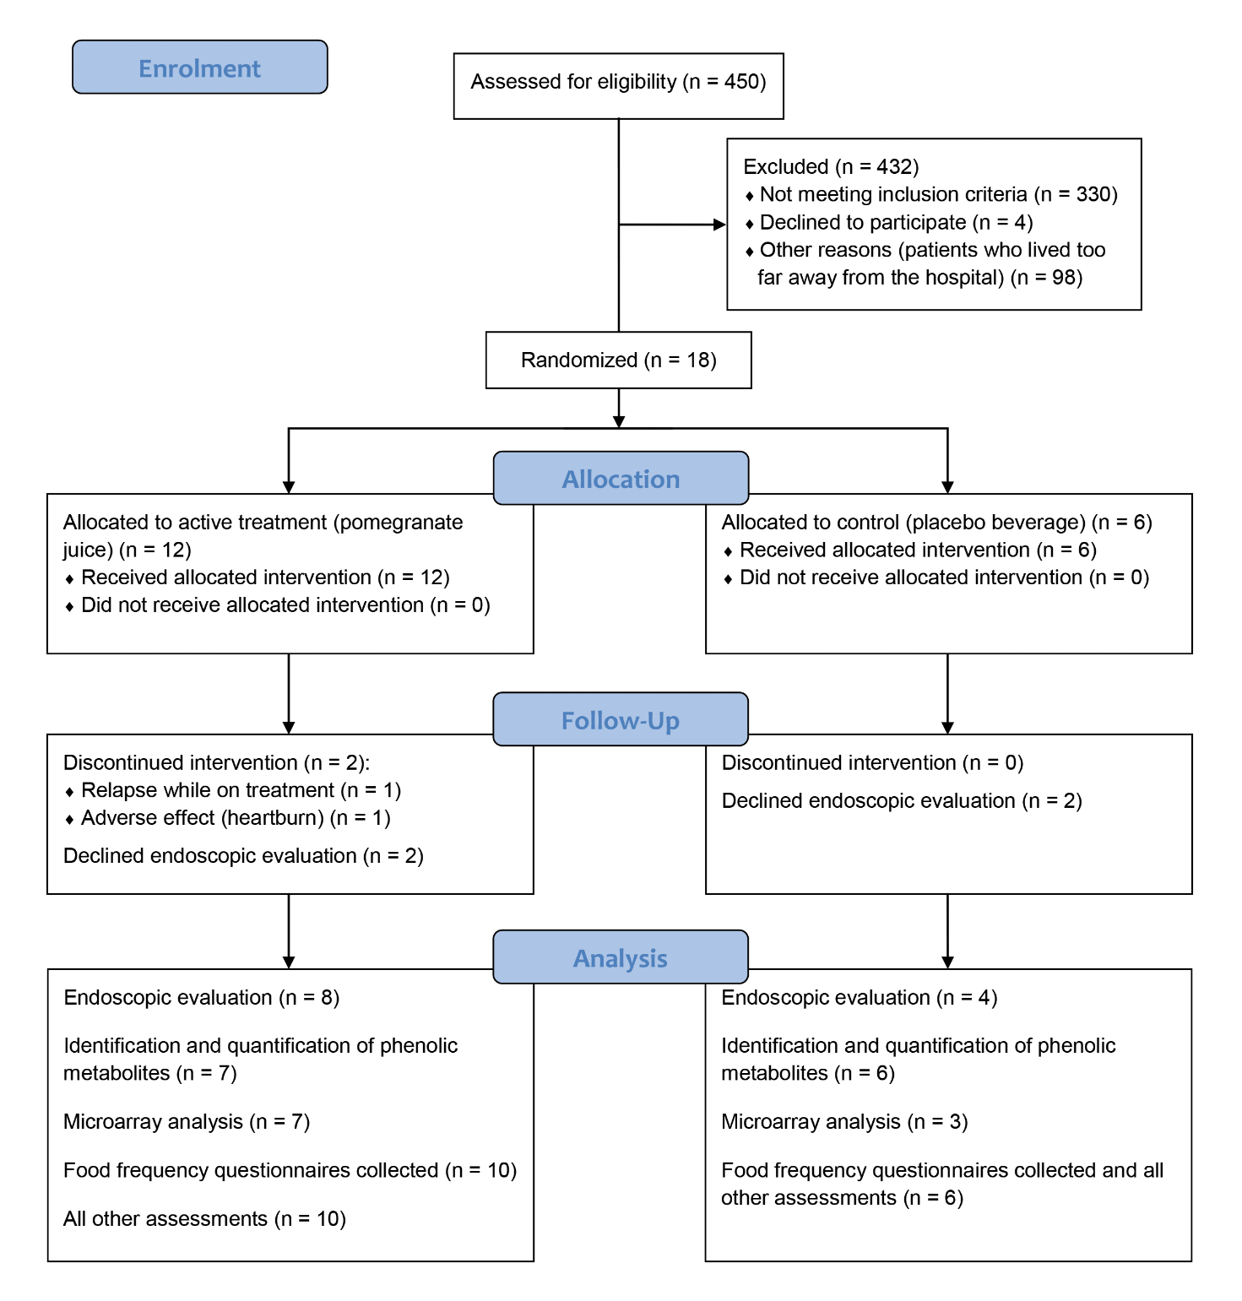
Supplementary Figure 1 CONSORT (Consolidated Standards of Reporting Trials) [48] diagram of participant flow.
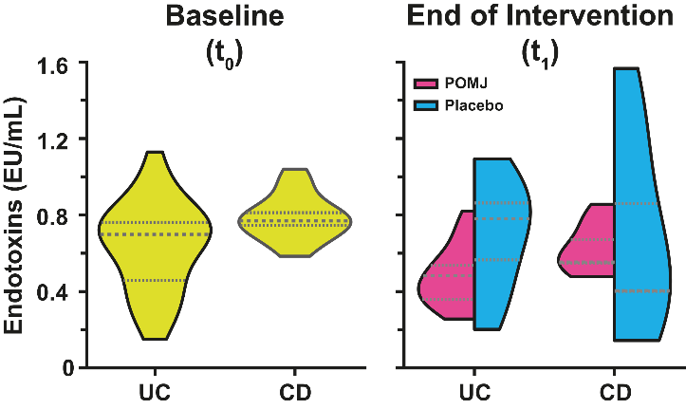
Supplementary Figure 2 Probability density distributions of plasma endotoxin levels in patients with IBD in clinical remission at baseline (t₀) and at the end of the intervention (t₁). The violin plots, generated using kernel density estimation (KDE), illustrate endotoxin distributions in patients with ulcerative colitis (UC) or Crohn's disease (CD) receiving either pomegranate juice (POMJ) or placebo. Horizontal lines within each plot represent the median (dashed) and interquartile range (dotted lines at 25th and 75th percentiles).

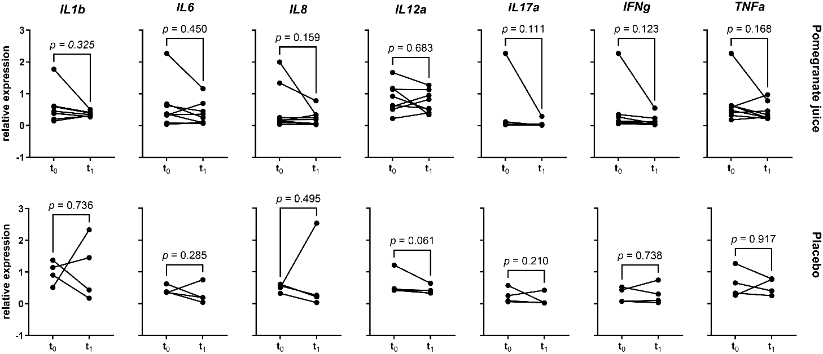
Supplementary Figure 3 Quantitative real-time PCR analysis of the cytokine gene expression in the biopsy of the colon mucosa at baseline (t₀) and 12 weeks after intervention (t₁) with pomegranate juice or placebo in patients with IBD in clinical remission. Each line connects a subject’s baseline relative expression (left) to its own endpoint (right). p-values were reported from comparisons by ratio-paired t-test. IFNg: interferon γ; IL: interleukin; TNFa: tumor necrosis factor α.

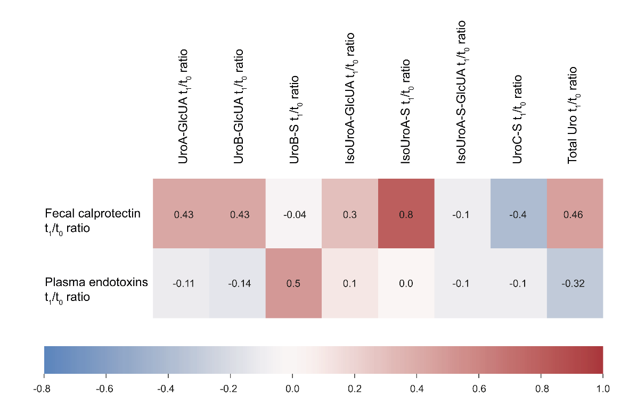
Supplementary Figure 4 Correlation of changes in urinary urolithin levels with changes in inflammatory markers after 12-week pomegranate juice intervention in patients with IBD in clinical remission. The heatmap shows Spearman correlation coefficients (ρ) between the ratios (t₁/t₀) of urinary urolithins (columns) and the ratios (t₁/t₀) of inflammatory outcomes (rows) that showed significant variation post-intervention (fecal calprotectin and plasma endotoxins). The correlation was considered significant with p-values < 0.05 for ρ ≥ 0.64 or ≤ −0.64 [2]. IsoUroA-GlcUA: isourolithin A- glucuronide; IsoUroA-S: isourolithin A-sulfate; IsoUroA-S-GlcUA: Isourolithin A-sulfate-glucuronide; Total Uro: total urolithins; UroA-GlcUA: urolithin A-glucuronide; UroB-GlcUA: urolithin B-glucuronide; UroB-S: urolithin B-sulfate; UroC-S: urolithin C-sulfate.
Supplementary Figure 5 Normalized expression values of genes differentially expressed in peripheral blood mononuclear cells of patients in the placebo group and involved in canonical pathways with z-score > 0 and p-value ≤ 0.01, as determined by Ingenuity Pathway Analysis and indicated by row annotation. Rows are centered; unit variance scaling is applied to rows. Rows are clustered using Euclidean distance and complete linkage. cAMP: cyclic adenosine monophosphate; eNOS: endothelial nitric oxide synthase; HIF1a: hypoxia inducible factor 1 subunit α; ILK: integrin-linked kinase; NO: nitric oxide; PKA: protein kinase A; POMJ: pomegranate juice.

Supplementary Figure 6 Normalized expression values of genes differentially expressed in peripheral blood mononuclear cells of patients in the pomegranate juice (POMJ) group and located upstream to (left) “inflammatory response” or (right) “Inflammation of gastrointestinal tract”. The predicted downstream effect of each gene on the function, according to Ingenuity Pathway Analysis, is reported. Rows are centered; unit variance scaling is applied to rows. Rows are clustered using Euclidean distance and complete linkage.
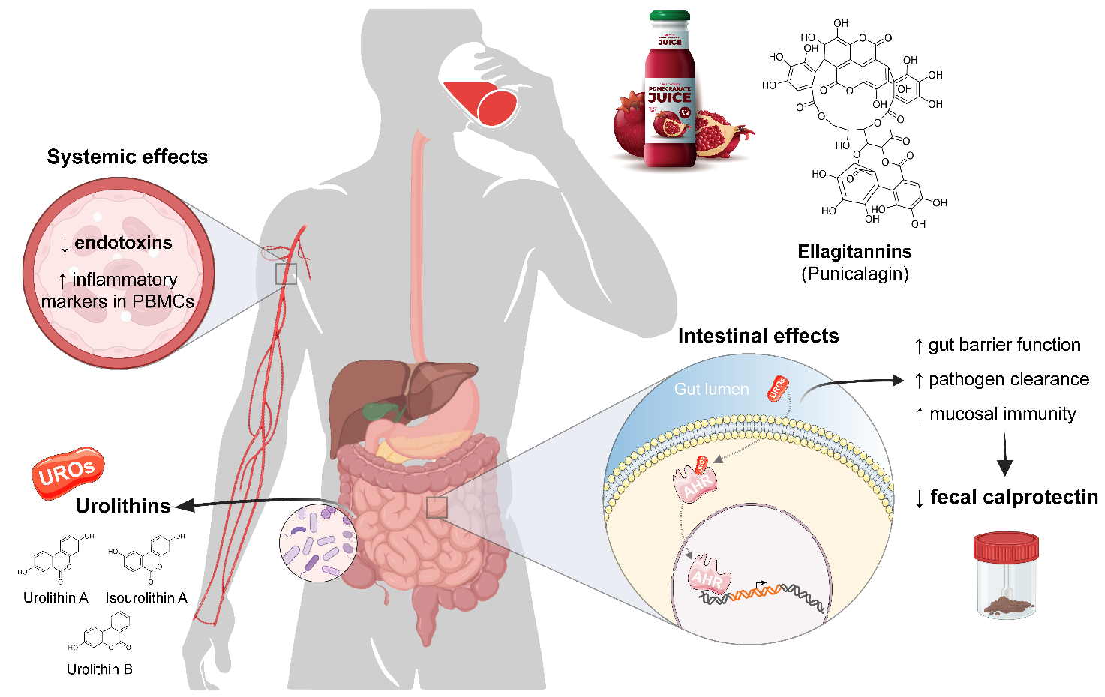
Supplementary Figure 7 Proposed mechanisms of action for pomegranate juice (POMJ) in patients with IBD in clinical remission, integrating observed effects, Ingenuity Pathway Analysis (IPA) predictions and literature knowledge [3]. Gut microbiota metabolizes ellagitannins (punicalagin) from POMJ to ellagic acid and urolithins (UROs), which exert both local intestinal and systemic effects. In the gut, urolithins modulate the aryl hydrocarbon receptor (AHR) [3]; IPA predicts improved barrier function, enhanced mucosal immunity, and improved pathogen clearance, which together contribute to reduced fecal calprotectin levels. Improved barrier function leads to reduced plasma endotoxin levels. In addition, an increase in systemic inflammatory response is predicted, potentially representing a compensatory immune response. This dual action of localized anti-inflammatory effects in the gut and modulated systemic inflammatory response may contribute to the maintenance of remission in patients with quiescent IBD. Figure partially created with BioRender.com, incorporating original images.
SUPPLEMENTARY TABLES

Supplementary Table 1 Chromatographic and spectrometric properties of the monitored metabolites. ‘STD’ means that the reference standard is available for quantification. Fragments were ordered by abundance, and the most abundant MS² was chosen for MS³ fragmentation.
ID Compounds | RT (min) | [M−H]⁻  (m/z) | MS² ion fragments (m/z) ^{c} | MS³ ion fragments (m/z) ^{c}
Punicalagin-like | 0.67 | 1101 | 1083, 301, 781, 601 | 781, 601, 575, 721
HHDP-hexoside | 1.03 | 481 | 301, 275, 257, 363, 391 | 257, 229, 273,185
Galloyl-hexoside (STD) | 1.07 | 331 | 169, 241, 125 | -
Galloyl-HHDP-gluconate (lagerstannin C) | 1.17 | 649 | 301, 497 | 257, 229
Gallic acid (STD) | 1.32 | 169 | 125 | -
Punicalin α/A | 1.51 | 781 | 601, 721, 575, 677 | 299, 271, 215, 243
Punicalin β/B | 1.55 | 781 | 601, 721, 299, 449 | 299, 271, 583, 243, 215
Galloyl-HHDP-gluconate | 1.95 | 649 | 497, 301 | -
Punicalagin isomer | 2.17 | 1083 | 1065, 807, 601, 721 | 721, 575, 1047, 1021, 601
Delphinidin 3,5-O-diglucoside | 2.20 | [M]⁺: 627 | 465, 303 | -
Cyanidin 3,5-O-diglucoside | 2.36 | [M]⁺: 611 | 449, 287 | -
Hydroxybenzoic acid-hexoside | 2.43 | 299 | 239, 179, 137, 209, 93 | 179, 137, 93
Datiscetin-hexoside | 2.44 | 447 | 285, 267 | 241, 257, 125, 217, 243
Punicalagin α (STD) | 2.58 | 1083 | 781, 601 | 601, 721
Pelargonidin 3,5-O-diglucoside | 2.58 | [M]⁺: 595 | 433, 271 | -
Delphinidin 3-O-glucoside (STD) | 2.62 | [M]⁺: 465 | 303 | -
Pedunculagin I isomer | 2.67 | 783 | 481, 721, 765, 301 | -
Cyanidin 3-O-glucoside (STD) | 2.74 | [M]⁺: 449 | 287 | -
Punicalagin β (STD) | 2.75 | 1083 | 781, 601 | 601, 721
Kaempferol-hexoside | 2.80 | 447 | 285, 284, 327, 255 | 257, 267, 229, 241
Pelargonidin 3-O-glucoside | 2.90 | [M]⁺: 433 | 271 | -
Galloyl-HHDP-hexoside | 3.03 | 633 | 301, 463, 275, 481 | 301, 257, 229
Ellagic acid-hexoside | 3.15 | 463 | 301 | 301, 257, 229
Dihydrokaempferol-hexoside | 3.18 | 449 | 287, 269, 259,431 | 259, 243, 269, 201
Vanillic acid (STD) | 3.30 | 167 | 125, 123, 151 | 123, 108, 81, 95
Quercetin-rutinoside (rutin) (STD) | 3.31 | 463 | 301 | 179, 151, 257, 301, 273
Syringetin-hexoside | 3.31 | 507 | 327, 345, 315 | 312, 283
Ellagic acid-pentoside | 3.32 | 433 | 301 | 300, 257, 229
Ellagic acid-deoxyhexoside | 3.41 | 447 | 300, 301, 285, 373 | 257, 229, 243, 216
Coumaric acid derivative | 3.46 | 429 | 163, 265,325 | 145, 119, 103, 89
Ellagic acid (STD) | 3.58 | 301 | 301, 257, 229, 185 | 229, 185
Secoisolariciresinol-hexoside | 3.65 | 523 | 361, 347 | 346, 165, 179, 313
Phloretin-hexoside (phlorizin) (STD) | 4.16 | 435 | 273, 297 | 167
Pinocembrin | 4.65 | 255 | 213, 211, 151, 145, 227, 187 | 213, 211, 151, 187, 169, 141, 145, 195
CE: collision energy; HHDP: hexahydroxydiphenoyl; RT: retention time.

Supplementary Table 2 The minimum detectable dose (MDD) of each analyte for the Quantikine ELISA Immunoassay (CRP) and the Magnetic Luminex Performance Assay (IL-1β, IL-6, IL-8, IL-10, and TNF-α) (R&D Systems Inc., Minneapolis, MN, USA).
Analyte | MDD range | Mean MDD
CRP | 0.005–0.022 ng/mL | 0.010 ng/mL
IL-1β | 0.03–0.18 pg/mL | 0.08 pg/mL
IL-6 | 0.08–0.31 pg/mL | 0.14 pg/mL
IL-8 | 0.02–0.07 pg/mL | 0.04 pg/mL
IL-10 | 0.066–0.671 pg/mL | 0.211 pg/mL
TNF-α | 0.13–0.54 pg/mL | 0.29 pg/mL
CRP: C-reactive protein; IL: interleukin; TNF-α: tumor necrosis factor α.

Supplementary Table 3 TaqMan assays used for gene expression analysis (Applied Biosystems, Foster City, CA, USA).
Gene symbol | Gene name | TaqMan Assay ID
Target genes
ATF2 | activating transcription factor 2 | Hs01095345_m1
HSPA14 | heat shock protein family A (Hsp70) member 14 | Hs01102298_g1
IFN-γ | interferon gamma | Hs00989291_m1
IL-1β | interleukin 1 beta | Hs01555410_m1
IL-6 | interleukin 6 | Hs00174131_m1
IL-8 | interleukin 8 | Hs00174103_m1
IL-12a | interleukin 12A | Hs01073447_m1
IL-17a | interleukin 17A | Hs00174383_m1
MTIF3 | mitochondrial translational initiation factor 3 | Hs00794538_m1
PMS1 | PMS1 homolog 1 | Hs00922262_m1
TNF-α | tumor necrosis factor alpha | Hs00174128_m1
Reference genes
B2M | beta-2-microglobulin | Hs99999907_m1
GAPDH | glyceraldehyde-3-phosphate dehydrogenase | Hs99999905_m1
HPRT | hypoxanthine guanine phosphoribosyl transferase | Hs99999909_m1
PPIA | peptidylprolyl isomerase A | Hs99999904_m1
RPLP0 | ribosomal protein lateral stalk subunit P0 | Hs99999902_m1
RPS3A | ribosomal protein S3A | Hs00832893_sH

Supplementary Table 4 Chromatographic and spectrometric properties of the monitored metabolites.
Compound | RT (min) | Parent ion [M-H]¯ (m/z) | S-Lens | Quantifier |  | Qualifier(s) |  | Standard used for quantification
 |  |  |  | Product ion (m/z) | CE (V) | Product ion (m/z) | CE (V) | Standard used for quantification
Isourolithin A (IsoUroA) | 5.5 | 227 | 92 | 198 | 36 | 171, 181, 183, 159 | 29, 30, 24, 28 | Not found
Urolithin B (UroB) | 6.22 | 211 | 116 | 167 | 27 | 139, 117 | 34, 36 | Not found
Urolithin C (UroC) | 5.05 | 243 | 122 | 187 | 32 | 171, 199 | 29, 29 | Not found
Urolithin D (UroD) | – | 259 | 109 | 242 | 29 | 213, 241 | 33, 25 | Not found
Dimethylellagic acid-glucuronide (DMEAG) | 5.15 | 505 | 78 | 329 | 17 | 314, 113 | 35, 20 | IsoUroA-3-GlcUA
Isourolithin A-sulfate (IsoUroA-S) | 6.68 | 307 | 78 | 227 | 19 | – | – | UroA-8-S
Urolithin A-glucuronide (UroA-GlcUA) † | 4.89 | 403 | 78 | 227 | 37 | 113 | 15 | UroA-8-GlcUA
Isourolithin A-glucuronide (IsoUroA-GlcUA) † | 4.97 | 403 | 78 | 227 | – | 113 | 15 | IsoUroA-3-GlcUA
Isourolithin A-sulfate-glucuronide (IsoUroA-S-GlcUA) | 6.9 | 483 | 78 | 307 | 37 | 227, 403 | 15, 19 | IsoUroA-3-GlcUA
Urolithin B-glucuronide (UroB-GlcUA) † | 5.38 | 387 | 83 | 211 | 35 | 113 | 17 | UroB-GlcUA
Urolithin B-sulfate (UroB-S) | 7.5 | 291 | 78 | 211 | 19 | – | – | UroA-8-S
Urolithin C-glucuronide (UroC-GlcUA) | 4.9 | 419 | 78 | 243 | 37 | 113 | 15 | IsoUroA-3-GlcUA
Urolithin C-sulfate (UroC-S) | 6.45 | 323 | 78 | 243 | 19 | – | – | UroA-8-S
Urolithin D-glucuronide (UroD-GlcUA) | – | 435 | 78 | 259 | 37 | 113 | 37 | Not found
Urolithin D-sulfate (UroD-S) | – | 339 | 78 | 259 | 19 | – | – | Not found
†Compounds used for metabotyping. Abbreviations for the compound names are reported in parentheses. CE: collision energy; RT: retention time.

Supplementary Table 5 Nutrient composition of the experimental beverages, per 100 mL. The beverages were supplied by Conserve Italia (Bologna, Italy).
Nutrient | Pomegranate juice | Placebo
Water (g) | 84.09 | 83.65
Energy (kcal) | 63 | 67
Protein (g) | 0.26 | 0.10
Fat (g) | 0.17 | 0.26
Carbohydrates (g) | 15.05 | 16.09
Sugars, total (g) | 13.42 | 15.41
Fiber, total (g) | < 0.50 | < 0.50
Ash (g) | 0.43 | 0.10
Vitamin C (ascorbic acid) (mg) | < 1.00 | < 1.00
Citric acid (g) | 0.99 | 1.86

Supplementary Table 6 (Poly)phenolic composition of the pomegranate juice, per 100 mL (mean ± SD, n = 3).
Compound | Concentration (mg/100 mL)
Ellagitannins
Punicalagin-α | 5.62 ± 0.73
Punicalagin-β | 10.90 ± 0.71
Punicalagin isomer | 1.19 ± 0.68
Punicalagin-like | 9.49 ± 0.70
Punicalin-α | 11.73 ± 6.25
Punicalin-β | 8.91 ± 3.09
HHDP-hexoside | 14.59 ± 0.99
Galloyl-hexoside | 13.07 ± 0.61
Galloyl-HHDP-gluconate (lagerstanin-C) | 4.32 ± 1.44
Galloyl-HHDP-gluconate | 2.27 ± 1.42
Pedunculagin I isomer | 3.86 ± 1.07
Galloyl-HHDP-hexoside | 21.28 ± 1.60
Ellagic acid | 58.19 ± 7.71
Ellagic acid-hexoside | 99.68 ± 4.71
Ellagic acid-pentoside | 2.32 ± 0.30
Ellagic acid-deoxyhexoside | 23.89 ± 1.05
Total ellagitannins | 291.29 ± 17.50
Anthocyanins
Cyanidin-3-O-glucoside | 10.96 ± 0.14
Cyanidin-3,5-O-diglucoside | 15.20 ± 0.37
Pelargonidin-3-O-glucoside | 2.02 ± 0.30
Pelargonidin-3,5-O-diglucoside | 1.87 ± 0.28
Delphinidin-3-O-glucoside | 0.37 ± 0.02
Delphinidin-3,5-O-diglucoside | 0.72 ± 0.11
Total anthocyanins | 31.14 ± 1.23
Chalcone
Phloretin-hexoside (phlorizin) | 1.91 ± 0.22
Flavanone
Pinocembrin | 0.04 ± 0.00
Flavone
Datiscetin-hexoside | 1.64 ± 0.68
Flavonol
Kaempferol-hexoside | 0.39 ± 0.10
Dihydrokaempferol-hexoside | 0.98 ± 0.05
Quercetin-rutinoside (rutin) | 0.08 ± 0.09
Syringetin-hexoside | 3.12 ± 0.43
Total flavonols | 4.57 ± 0.41
Hydroxybenzoic acid
Vanillic acid | 3.29 ± 0.42
Gallic acid | 1.75 ± 0.33
Hydroxybenzoic acid-hexoside | 1.79 ± 0.24
Total hydroxybenzoic acid | 6.82 ± 0.59
Hydroxycinnamic acid
Coumaric acid derivate | 20.20 ± 1.86
Lignan
Secoisolariciresinol-hexoside | 0.13 ± 0.01
Total (poly)phenols | 359.74 ± 18.40
HHDP: hexahydroxydiphenoyl.

Supplementary Table 7 Disease activity scores at baseline (t₀) and 12 weeks after intervention (t₁) with pomegranate juice (POMJ) or placebo in patients with IBD in clinical remission. p-values were reported from comparisons using the ratio-paired t-test.
Disease activity scores | Median (IQR)  POMJ t₀ | Median (IQR)  POMJ t₁ | p-value | Median (IQR)  Placebo t₀ | Median (IQR)  Placebo t₁ | p-value
Mayo Endoscopic Subscore (MES) | 1.00 (0.00–1.00) | 1.00 (1.00–1.00) | 0.3739 | 1.00 (1.00–1.00) | 1.00 (0.75–1.00) | > 0.9999
Simple Clinical Colitis Activity Index (SCCAI) † | 1.00 (1.00–3.50) | 1.00 (0.00–1.50) | 0.2317 | 1.00 (0.50–1.50) | 0.00 (0.00–1.00) | > 0.9999
Crohn’s Disease Activity Index (CDAI) ‡ | 36.00 (33.30–48.50) | 37.80 (31.50–39.40) | 0.4544 | 52.60 (44.70–59.60) | 30.80 (23.65–53.30) | 0.2832
† only for patients with UC; ‡ only for patients with CD. Zero values were excluded from statistical analysis. IQR: interquartile range (Q1 to Q3).

Supplementary Table 8 Plasma levels of trimethylamine N-oxide (TMAO) and its precursors at baseline (t₀) and 12 weeks after intervention (t₁) with pomegranate juice (POMJ) or placebo in patients with IBD in clinical remission. p-values are reported from comparisons by ratio-paired t-test; significant values (< 0.05) are marked in bold.
Plasma TMAO and TMAO precursors (μM) | Median (IQR)  POMJ t₀ | Median (IQR)  POMJ t₁ | p-value | Median (IQR)  Placebo t₀ | Median (IQR)  Placebo t₁ | p-value
TMAO | 4.08 (2.52–4.80) | 3.71 (3.39–4.28) | 0.9923 | 4.13 (2.80–4.63) | 4.30 (3.03–10.00) | 0.2058
Carnitine | 49.54 (47.33–54.60) | 49.67 (46.77–55.61) | 0.9896 | 47.47 (41.14–54.36) | 52.86 (43.26–57.86) | 0.9284
Dimethylglycine | 4.07 (3.49–4.46) | 4.48 (3.20–5.16) | 0.0926 | 4.33 (3.20–4.95) | 4.54 (3.37–5.46) | 0.3052
Betaine | 23.74 (18.56–25.19) | 20.82 (19.18–25.78) | 0.4874 | 23.33 (20.52–27.68) | 25.39 (21.93–29.42) | 0.0388
Choline | 23.24 (20.62–29.37) | 22.68 (21.54–26.84) | 0.4875 | 29.42 (22.54–35.69) | 26.54 (23.06–28.55) | 0.9005
IQR: interquartile range (Q1 to Q3); TMAO: trimethylamine N-oxide.
Supplementary Table 9 Plasma metabolites were characterized and quantified at baseline (t₀) and 12 weeks after intervention (t₁) with pomegranate juice (POMJ) or placebo in patients with IBD in clinical remission. p-values were reported from comparisons using the ratio-paired t-test.
Urolithin (μM) | Median (IQR)  POMJ t₀ † | Median (IQR)  POMJ t₁ † | p-value | Median (IQR)  Placebo t₀ | Median (IQR)  Placebo t₁ | p-value
UroB-GlcUA | 0.000 (0.000–0.008) | 0.015 (0.000–0.071) | 0.9656 | 0.000 (0.000–0.000) | 0.000 (0.000–0.000) | > 0.9999
UroB-S | 0.000 (0.000–0.000) | 0.000 (0.000–0.000) | > 0.9999 | 0.000 (0.000–0.000) | 0.000 (0.000–0.000) | > 0.9999
UroA-GlcUA | 0.000 (0.000–0.023) | 0.024 (0.001–0.109) | 0.7183 | 0.000 (0.000–0.000) | 0.000 (0.000–0.000) | > 0.9999
IsoUroA-GlcUA | 0.000 (0.000–0.008) | 0.023 (0.000–0.037) | 0.7119 | 0.000 (0.000–0.000) | 0.000 (0.000–0.000) | > 0.9999
IsoUroA-S | 0.000 (0.000–0.000) | 0.000 (0.000–0.000) | > 0.9999 | 0.000 (0.000–0.000) | 0.000 (0.000–0.000) | > 0.9999
IsoUroA-S-GlcUA | 0.000 (0.000–0.000) | 0.000 (0.000–0.000) | > 0.9999 | 0.000 (0.000–0.000) | 0.000 (0.000–0.000) | > 0.9999
UroC-GlcUA | 0.000 (0.000–0.000) | 0.000 (0.000–0.000) | > 0.9999 | 0.000 (0.000–0.001) | 0.000 (0.000–0.000) | > 0.9999
UroC-S | n.d. | n.d. | – | n.d. | n.d. | –
DMEAG | 0.000 (0.000–0.002) | 0.002 (0.000–0.009) | 0.8559 | 0.000 (0.000–0.000) | 0.000 (0.000–0.000) | > 0.9999
Total urolithins | 0.002 (0.000–0.039) | 0.129 (0.002–0.192) | 0.7832 | 0.000 (0.000–0.000) | 0.000 (0.000–0.000) | > 0.9999
† Three subjects were excluded from the analysis because plasma samples were not available for both t₀ and t₁. Zero values were excluded from statistical analysis. DMEAG: dimethylellagic acid-glucuronide; IQR: interquartile range (Q1 to Q3); IsoUroA-GlcUA: isourolithin A- glucuronide; IsoUroA-S: isourolithin A-sulfate; IsoUroA-S-GlcUA: isourolithin A-sulfate-glucuronide; n.d.: non detected; UroA-GlcUA: urolithin A-glucuronide; UroB-GlcUA: urolithin B-glucuronide; UroB-S: urolithin B-sulfate; UroC-GlcUA: urolithin C-glucuronide; UroC-S: urolithin C-sulfate.

Supplementary Table 10 Urolithin metabotypes at baseline (t₀) and 12 weeks after intervention (t₁) with pomegranate juice (POMJ) or placebo in patients with IBD in clinical remission.
Urolithin metabotypes | POMJ t₀ † | POMJ t₁ † | Placebo t₀ | Placebo t₁
UM-0 | – | – | 1 (17%) | –
UM-A | 1 (14%) | – | – | –
UM-B | 6 (86%) | 7 (100%) | 5 (83%) | 6 (100%)
† Three subjects were excluded from the analysis because samples were not available for both t₀ and t₁. UM-0: urolithin metabotype 0; UM-A: urolithin metabotype A; UM-B: urolithin metabotype B.

Supplementary Table 11 Changes in gene expression in peripheral blood mononuclear cells of the study subjects were observed using microarray-based transcriptomic analysis and quantitative real-time PCR. p-values were reported from comparisons by paired t-test; significant fold changes and p-values (log₂ fold-change ≥ 0.5 or ≤ −0.5; p-values < 0.05) are marked in bold.
 | POMJ t₁ vs t₀ |  |  |  | placebo t₁ vs t₀
 | microarray analysis |  | qPCR analysis |  | microarray analysis |  | qPCR analysis
Gene | log₂ fold-change | p-value | log₂ fold-change | p-value | log₂ fold-change | p-value | log₂ fold-change | p-value
ATF2 | −0.430 | 0.001 | −0.437 | 0.045 | 0.011 | 0.861 | −0.111 | 0.435
HSPA14 | −0.312 | 0.001 | −0.425 | 0.030 | −0.028 | 0.680 | −0.313 | 0.042
MTIF3 | −0.203 | 0.008 | −0.401 | 0.042 | −0.047 | 0.753 | −0.009 | 0.940
PMS1 | −0.614 | 0.002 | −0.536 | 0.018 | −0.145 | 0.575 | −0.129 | 0.165
ATF2: activating transcription factor 2; HSPA14: heat shock protein family A (Hsp70) member 14; MTIF3: mitochondrial translational initiation factor 3; PMS1: PMS1 homolog 1; POMJ: pomegranate juice; qPCR: quantitative real-time PCR.

REFERENCES
[1] P. Mena, L. Calani, C. Dall'Asta, G. Galaverna, C. García-Viguera, R. Bruni, A. Crozier, D. Del Rio, Molecules 2012, 17, 14821.
[2] D. G. Bonett, T. A. Wright, Psychometrika 2000, 65, 23.
[3] C. J. G. Pinto, M. A. Ávila-Gálvez, Y. Lian, P. Moura-Alves, C. Nunes Dos Santos, Redox Biol. 2023, 61, 102622.

