Supporting Information
Glycerol oxi-dehydration to acrylic acid experimental assessment: Effect of catalyst properties, reaction parameters, and bed configurations
Yash Bansod^{1*}, Prashant Pawanipagar¹, Umar Abubakar¹, Min Hu^{1*}, Hassan Alhassawi¹, Kamran Ghasemzadeh¹, Luke Forster¹, Sarayute Chansai¹, Christopher Hardacre¹, Vincenzo Spallina^{1*} and Carmine D’Agostino^{1,2*}

¹ Department of Chemical Engineering, University of Manchester, Manchester, M13 9PL, UK
² Dipartimento di Ingegneria Civile, Chimica, Ambientale e dei Materiali (DICAM), Alma Mater Studiorum – Università di Bologna, Via Terracini, 28, 40131 Bologna, Italy
* Corresponding authors:
Yash Bansod, email: yash.bansod@postgrad.manchester.ac.uk
Min Hu, email: min.hu@manchester.ac.uk
Vincenzo Spallina, email: vincenzo.spallina@manchester.ac.uk
Carmine D’Agostino, email: carmine.dagostino@manchester.ac.uk

Figure S1. Nitrogen adsorption-desorption isotherms of HZSM-5 (23), HZSM-5 (30), HZSM-5 (80), HZSM-5 (200) and HZSM-5 (500).

Table S1. TGA analysis of the spent HZSM-5 catalysts.
Spent catalyst | Weight loss for reaction with air (%) |  |  |  | Weight loss for reaction without air (%)
Spent catalyst | Total weight loss | 150°C - 350°C  (soft coke) | 350°C - 750°C (hard coke) | Total weight loss |  | 150°C - 350°C  (soft coke) | 350°C - 750°C  (hard coke)
HZSM5 (23) | 7.3 | 1.1 | 4.4 | 9.3 |  | 0.5 | 6.2
HZSM5 (30) | 7.9 | 0.4 | 5.8 | 8.7 |  | 0.4 | 6.4
HZSM5 (80) | 6.9 | 0.4 | 6.1 | 7.2 |  | 0.6 | 5.6
HZSM5 (200) | 2.8 | 0.4 | 2.0 | 6.8 |  | 0.5 | 4.9
HZSM5 (500) | 3.4 | 0.8 | 2.1 | 4.6 |  | 0.5 | 3.1

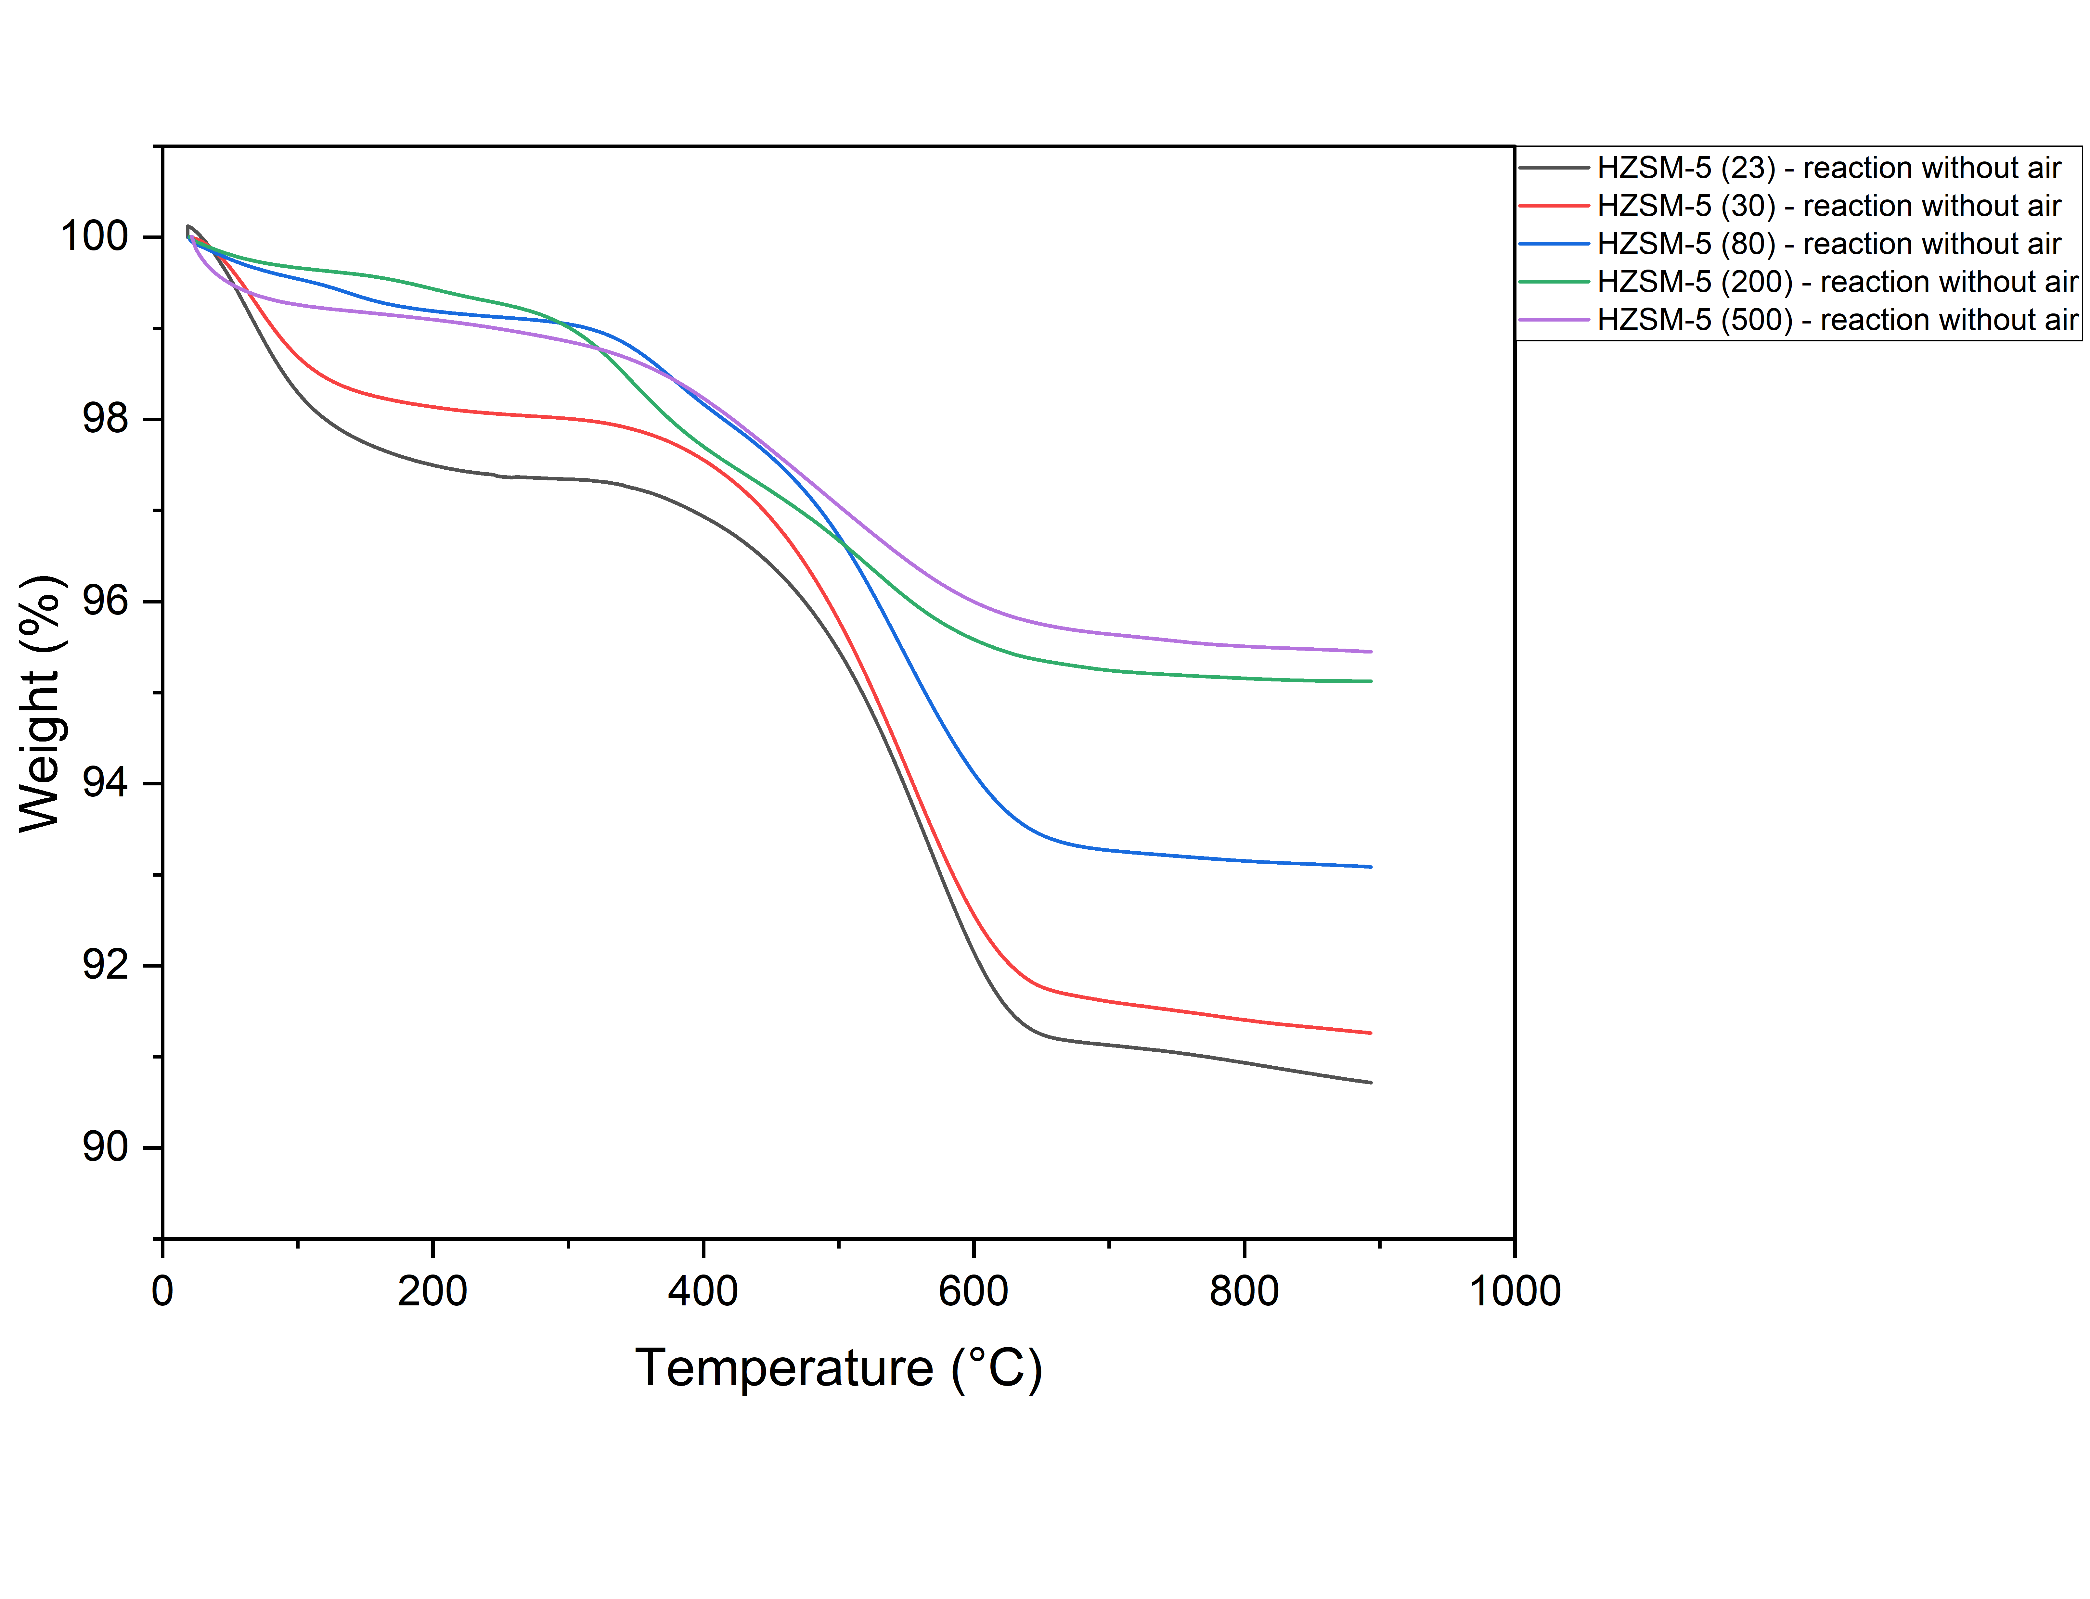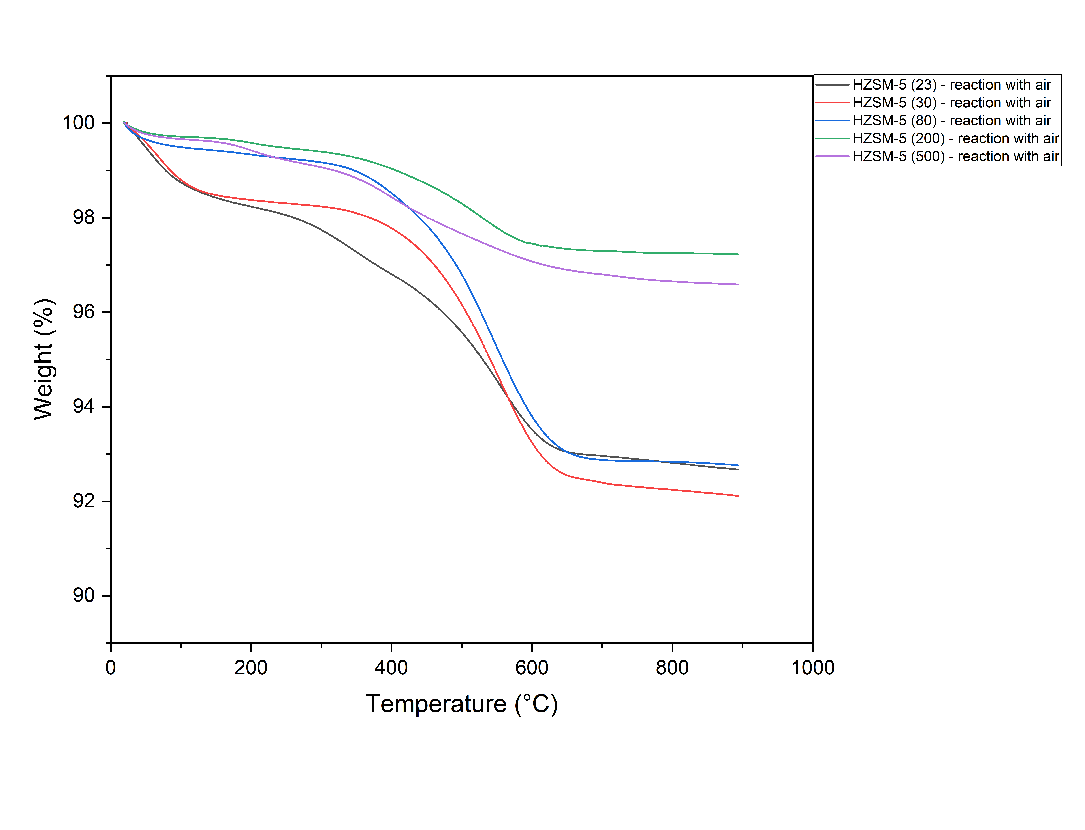
a)
b)
Figure S2. Thermogravimetric analysis (TGA) analysis of spent HZSM-5 catalysts for reactions run in the absence (a) and presence (b) of air.

Table S2. TGA analysis of the spent Ortho-MoVO catalyst.
Temperature Range | Weight Loss (%) | Interpretation
25 °C – 200 °C | 2.97% | Moisture evaporation
200 °C – 700 °C | 1.63% | Oxidation of soft and hard coke
700 °C – 900 °C | 59.54% | Catalyst decomposition (non-coke loss)
Total | 64.15%

Figure S3. Thermogravimetric analysis (TGA) analysis of fresh and spent Ortho-MoVO catalysts.

Table S3. Effect of temperature on the conversion and yield for glycerol oxi-dehydration to acrylic acid for dual and mixed-bed reactor system. Reaction conditions: dehydration catalyst was HZSM-5 (200) and oxidation catalyst was Ortho-MoVO; GHSV = 4978 h⁻¹; feed composition (mol%) glycerol/O₂/H₂O/N₂/He = 1/9.5/45.2/35.7/45.2; Conversion and yield data was taken after 3 h time-on-stream.
Bed Configuration | Mixed Bed |  |  |  | Dual Bed
Temperature (℃) | Compound | 260℃ | 280℃ | 300℃ | Compound | 260℃ | 280℃ | 300℃
Conversion (%) | Glycerol | 100.00 | 100.00 | 100.00 | Glycerol | 100.00 | 100.00 | 100.00
Yield (%) | Acetaldehyde | 3.61 | 3.84 | 0.47 | Acetic acid | 13.59 | 13.56 | 14.59
Yield (%) | Propanal | 6.47 | 4.85 | 0.00 | Formic acid | 0.00 | 0.98 | 0.00
Yield (%) | Acetone | 0.00 | 0.00 | 0.48 | Propanoic acid | 1.94 | 2.40 | 1.66
Yield (%) | Acrolein | 3.11 | 0.00 | 0.00 | Acrylic acid | 46.02 | 58.75 | 46.41
Yield (%) | Acetic acid | 13.72 | 13.70 | 15.88 | CO_{x} | 38.45 | 24.30 | 35.34
Yield (%) | Formic acid | 7.40 | 3.26 | 1.36
Yield (%) | Propanoic acid | 2.25 | 1.76 | 3.08
Yield (%) | Acrylic acid | 30.37 | 31.62 | 41.27
Yield (%) | CO_{x} | 33.08 | 40.96 | 37.46

Table S4. Effect of gas hourly space velocity (GHSV) on the conversion and yield for glycerol oxi-dehydration to acrylic acid for dual and mixed-bed reactor system. Reaction conditions: dehydration catalyst was HZSM-5 (200) and oxidation catalyst was Ortho-MoVO; Temperature = 280 ℃; feed composition (mol%) glycerol/O₂/H₂O/N₂/He = 1/9.5/45.2/35.7/45.2; Conversion and yield data was taken after 3 h time-on-stream.
Bed Configuration | Mixed Bed |  |  |  | Dual Bed
Gas hourly space velocity (h⁻¹) | Compound | 553 | 1660 | 4977 | Compound | 553 | 1660 | 4977
Conversion (%) | Glycerol | 100.00 | 100.00 | 100.00 | Glycerol | 100.00 | 100.00 | 100.00
Yield (%) | Acetaldehyde | 0.00 | 0.00 | 3.84 | Acetic acid | 17.00 | 18.43 | 13.56
Yield (%) | Propanal | 0.00 | 0.00 | 4.85 | Formic acid | 0.00 | 0.18 | 0.98
Yield (%) | Acetic acid | 16.18 | 14.71 | 13.70 | Propanoic acid | 0.62 | 1.90 | 2.40
Yield (%) | Formic acid | 0.06 | 0.22 | 3.26 | Acrylic acid | 25.11 | 52.25 | 58.75
Yield (%) | Propanoic acid | 1.20 | 1.37 | 1.76 | CO_{x} | 57.27 | 27.23 | 24.30
Yield (%) | Acrylic acid | 20.86 | 24.61 | 31.62
Yield (%) | CO_{x} | 61.71 | 58.09 | 40.96

Table S5. Effect of oxygen-to-glycerol ratio on the conversion and yield for glycerol oxi-dehydration to acrylic acid for dual and mixed-bed reactor system. Reaction conditions: dehydration catalyst was HZSM-5 (200) and oxidation catalyst was Ortho-MoVO; Temperature = 280 ℃; GHSV = 4978 h⁻¹; Conversion and yield data was taken after 3 h time-on-stream.
Bed Configuration | Mixed Bed |  |  |  | Dual Bed
O₂ : Glycerol (molar ratio) | Compound | O₂ : Gly 14.2 : 1 | O₂ : Gly 9.5 : 1 | O₂ : Gly 4.5 : 1 | Compound | O₂ : Gly 14.2 : 1 | O₂ : Gly 9.5 : 1 | O₂ : Gly 4.5 : 1
Conversion (%) | Glycerol | 100.00 | 100.00 | 100.00 | Glycerol | 100.00 | 100.00 | 100.00
Yield (%) | Acetaldehyde | 0.00 | 3.84 | 8.92 | Acetic acid | 14.98 | 13.56 | 13.02
Yield (%) | Propanal | 2.03 | 4.85 | 11.10 | Formic acid | 0.00 | 0.98 | 0.00
Yield (%) | Acrolein | 0.00 | 0.00 | 11.61 | Propanoic acid | 1.88 | 2.40 | 2.61
Yield (%) | Acetic acid | 14.73 | 13.70 | 7.47 | Acrylic acid | 57.14 | 58.75 | 53.98
Yield (%) | Formic acid | 2.20 | 3.26 | 4.10 | CO_{x} | 25.99 | 24.30 | 27.38
Yield (%) | Propanoic acid | 2.22 | 1.76 | 2.24
Yield (%) | Acrylic acid | 39.51 | 31.62 | 29.41
Yield (%) | CO_{x} | 39.30 | 40.96 | 25.02

Table S6. Conversion and yield for glycerol oxi-dehydration to acrylic acid for dual and mixed-bed reactor system. Reaction conditions: dehydration catalyst was HZSM-5 (200) and oxidation catalyst was Amor-MoVO; GHSV= 4978 h⁻¹; Conversion and yield data was taken after 3-hour time-on-stream.
Bed Configuration | Mixed Bed |  |  |  | Dual Bed
Temperature (℃) | Compound | 260℃ | 280℃ | 300℃ | Compound | 260℃ | 280℃ | 300℃
Conversion (%) | Glycerol | 79.6 | 100 | 100 | Glycerol | 100 | 100 | 100
Yield (%) | Acetaldehyde | 1.0 | 8.5 | 2.0 | Acetaldehyde | 1.6 | 0.0 | 0.0
Yield (%) | Propanal | 0.9 | 3.6 | 6.4 | Propanal | 1.9 | 0.0 | 0.0
Yield (%) | Acrolein | 10.1 | 7.3 | 1.6 | Acetic acid | 14.6 | 15.6 | 17.4
Yield (%) | Acetic acid | 1.7 | 11.2 | 15.3 | Formic acid | 3.0 | 0.5 | 0.1
Yield (%) | Formic acid | 3.5 | 8.9 | 6.4 | Propanoic acid | 3.0 | 2.4 | 2.0
Yield (%) | Propanoic acid | 11.7 | 2.1 | 2.6 | Acrylic acid | 63.8 | 67.2 | 48.0
Yield (%) | Acrylic acid | 23.0 | 26.7 | 42.9 | CO_{x} | 8.6 | 14.3 | 32.5
Yield (%) | CO_{x} | 4.5 | 13.0 | 18.0
Yield (%) | Others | 23.3 | 18.7 | 4.8

Figure S4. Gas chromatograph analysis peaks of calibration standard mixture containing all expected products (top), liquid product mixture from glycerol dehydration over HZSM-5(200) at 280 °C (middle), and (3) liquid product mixture from oxi-dehydration reaction using dual-bed configuration at 280 °C (bottom).

Table S7. Compounds detected in GC analysis of liquid trap with their chemical formulas and retention times.
Formula | Compounds | Retention time (min)
CH3CHO or C2H4O | Acetaldehyde | 4.056
C3H6O | Propanal | 4.735
CH3C(O)CH3 OR C3H6O | Acetone | 5.016
C3H4O | Acrolein | 5.427
H2O | Water | 11.346
CH3C(O)CH2OH OR C3H6O2 | Hydroxyacetone | 15.44
CH3COOH or C2H4O2 | Acetic acid | 17.688
HCOOH | Formic acid | 18.634
CH3CH2C(O)OH or C3H6O2 | Propanoic acid | 19.2
CH₃CH(OH)CH₂OH or C3H8O2 | 1,2 Propane diol | 20.189
CH2CHC(O)OH or C3H4O2 | Acrylic acid | 20.883
C₃H₈O₂ | 1,3 Propane diol | 23.571
C₃H₈O₃ | Glycerol | 32.088

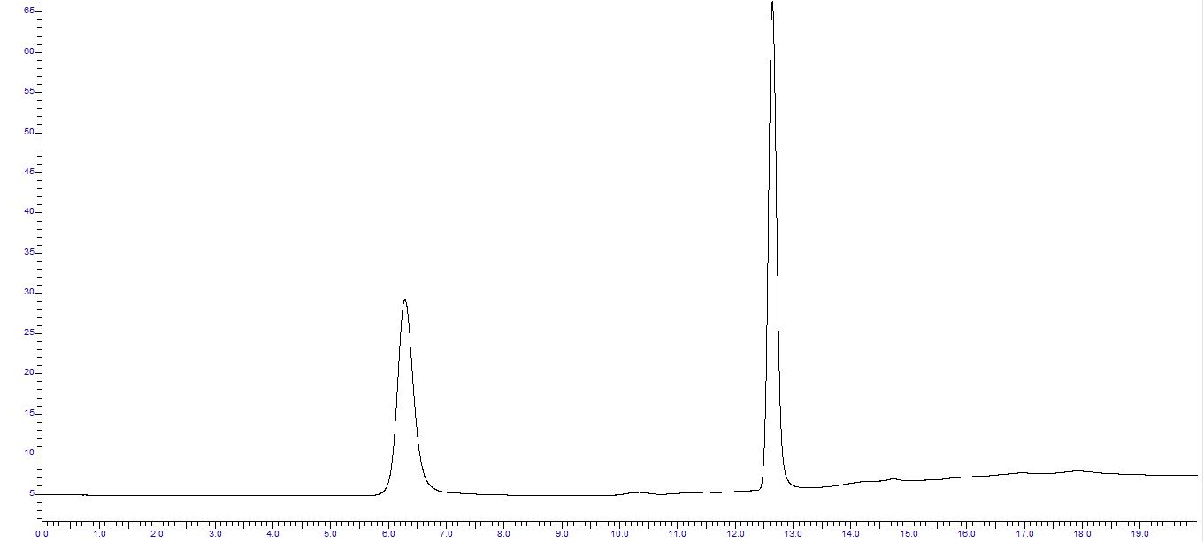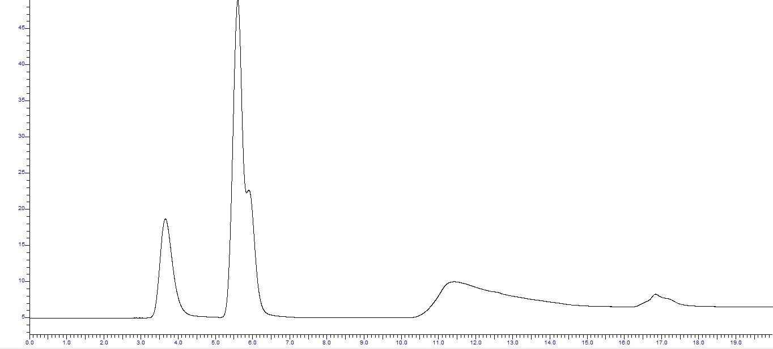
Figure S5. Gas chromatograph analysis peaks of gaseous product mixture by FID detector (top) and TCD detector (bottom).

Table S8. Compounds detected in GC analysis of gaseous trap with their chemical formulas and retention times.
Formula | Compounds | Retention time (min)
H₂ | Hydrogen | 3.8
CO | Carbon monoxide | 6.3
CO₂ | Carbon dioxide | 12.7

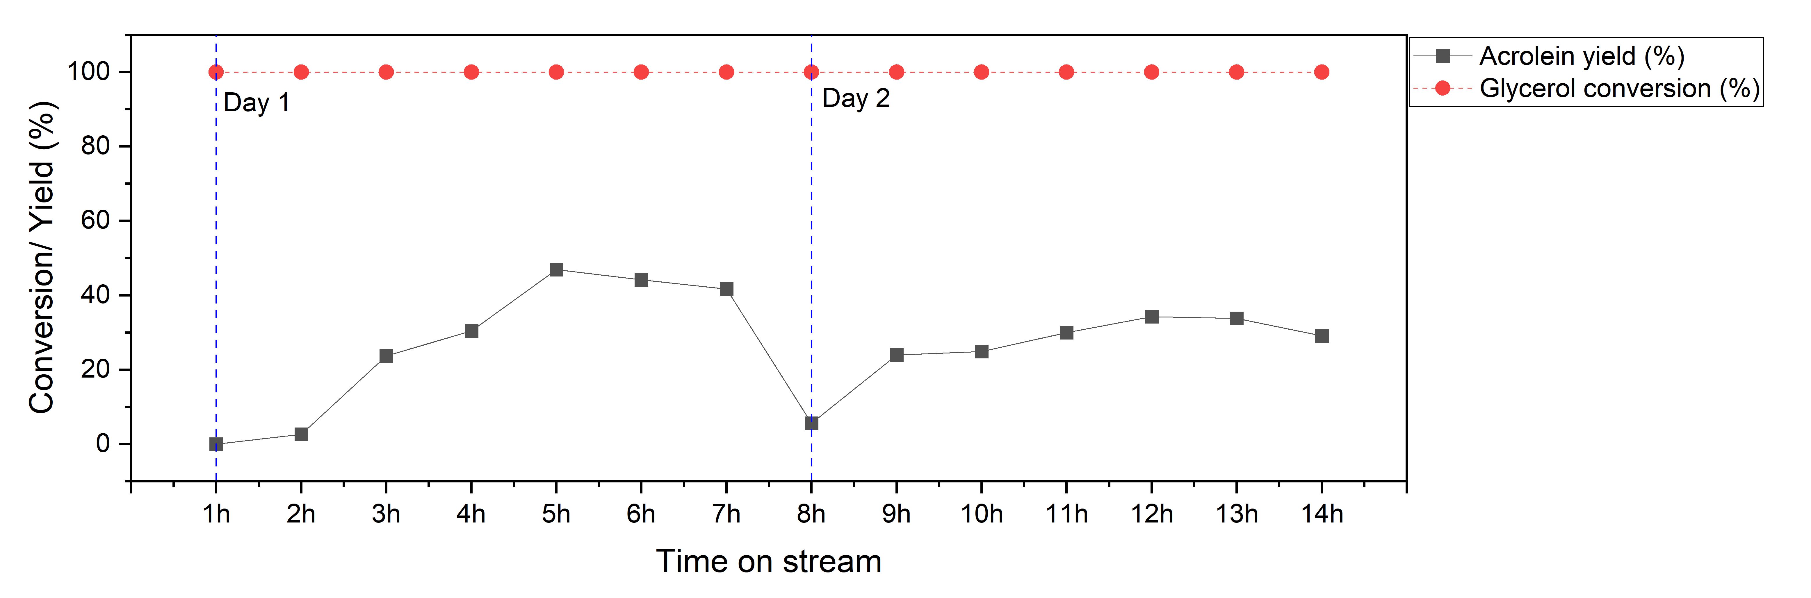
Figure S6. Acrolein yield and glycerol conversion with time-on-stream over HZSM-5 (200) catalyst in the presence of air during extended 14-hour experiment. Reaction conditions: Temperature = 280 °C; GHSV = 1412 h⁻¹; feed composition (mol%) Gly/O₂/H₂O/He/N₂=1.1/5.1/49.9/24.5/19.3.

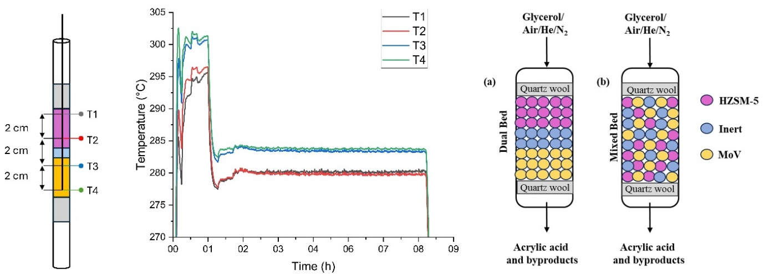
Figure S7. Temperature profile at four different points along the reactor (T1 and T2 within the HZSM-5 bed (first bed), and T3 and T4 within the MoVO bed (second bed))

