ONLINE APPENDIX A. ADDITIONAL GRAPHS AND TABLES

Table A1. The share of cumulative income owned by each decile of the distribution
 | All 2,717 aristocratic households | All 7,399 elite asset-holding households
Bottom 10% | 0% | 1%
Bottom 20% | 1% | 2%
Bottom 30% | 2% | 3%
Bottom 40% | 4% | 5%
Bottom 50% | 7% | 6%
Bottom 60% | 11% | 9%
Bottom 70% | 17% | 12%
Bottom 80% | 27% | 20%
Bottom 90% | 42% | 35%
Top 10% | 58% | 65%

Table A2. Threshold income for each decile (before tax)
 | All 2,717 aristocratic households | All 7,399 elite asset-holding households
1 Decile | 400AR | 500AR
2 Decile | 700AR | 560AR
3 Decile | 1,000AR | 560AR
4 Decile | 1,500AR | 560AR
5 Decile (Median) | 2,285AR | 600AR
6 Decile | 3,546AR | 1,100AR
7 Decile | 5,539AR | 2,060AR
8 Decile | 8,656AR | 4,000AR
9 Decile | 15,310AR | 9,100AR

Figure A1: Correlation between the number of male serfs and the incomes from property declared by the members of the landed aristocracy in Moscow Province for 1811. Censored at 1500
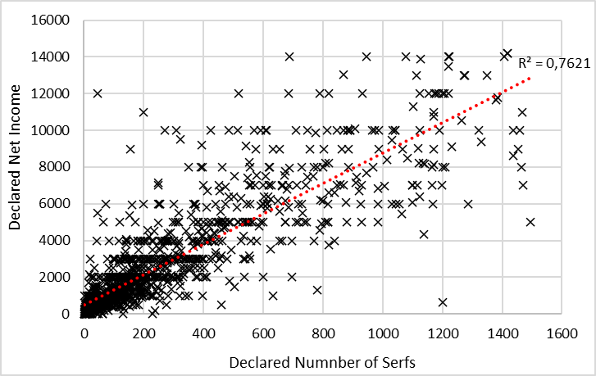
Source: our dataset.

Figure A2: Similarity between the Lorenz curves of the aristocratic incomes from land consisting of serf duties with and without interest on debt payments deduction
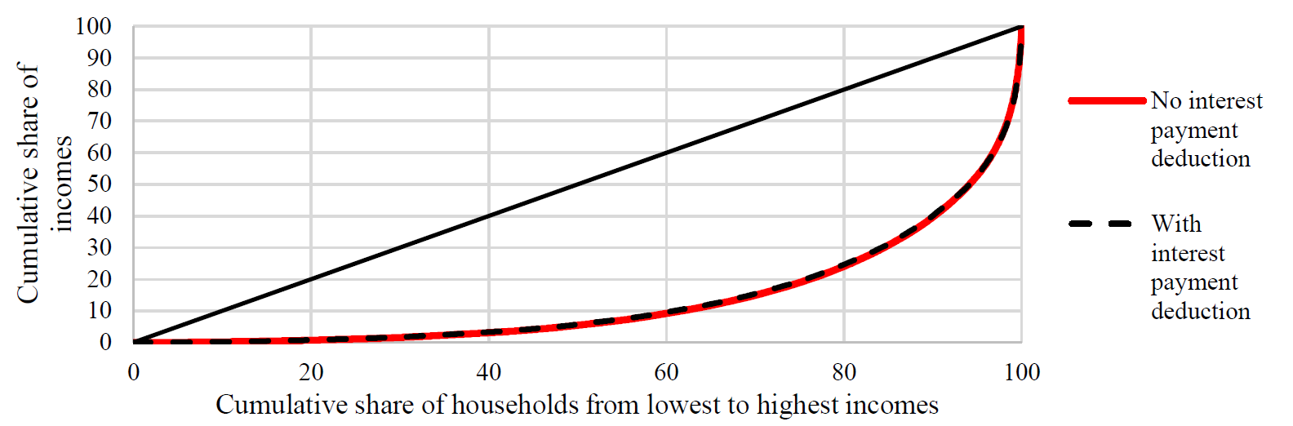
Source: see the text.
Note: The taxpayers were allowed to deduct their interest payments on outstanding private loans and state credits when calculating their taxable income. The tax declarations indicate both the gross and net incomes before and after the deduction. All of our calculations are based on gross income. The conventional knowledge propagated by popular works of fiction and based on anecdotal evidence is that the Russian aristocracy was deeply indebted (see Shovlin 2006). However, our new archival information based on complete tax records shows that interest payment deductions (and therefore debts) were, in fact, limited. According to the tax data, only 594 (22%) aristocratic households made a deduction. Jointly, as little as 1,438,361AR (8% of income) was deducted as interest on debt payments. Figure 3 below compares Lorenz’s curves of the income distribution of gross and net incomes and demonstrated that, contrary to the conventional knowledge, the debt had no distributional impact, and its deduction did not change the income distribution.

Figure A3: Similarity between the Lorenz curves of pre- and post-tax incomes

APPENDIX B. INCOME FROM INDUSTRY

Table B1: Industrial profits by branch in 1811 according to the census of 1809. Profit margins are based on the 1805 data
Branch of industry | Russian names | Number of factories in 1809 | Gross revenue in AR in 1809 | Profit in AR in 1809 using profit rate from 1805 | Profit margin in 1805
leather | кожевенное | 93 | 942,296.00 | 489,993.92 | 0.52
chemical (paint making production) | красочное | 7 | 32,025.00 | 3,202.50 | 0.1
copper production | медный | 13 | 396,360.00 | 118,908.00 | 0.3
textile | мишурная | 2 | 2,695.00 | 377.30 | 0.14
soap and candle production | мыловаренное, свечное | 2 | 116,136.00 | 11,613.60 | 0.1
paper production | писчей бумаги | 6 | 159,840.00 | 15,984.00 | 0.1
neckwear production | платошная | 1 | 3,840.00 | 1,382.40 | 0.36
galloon making production | позументная | 14 | 559,510.00 | 223,804.00 | 0.4
cloth production | полотняное | 19 | 579,232.20 | 173,769.66 | 0.3
sulfur production | серные | 1 | 4,500.00 | 450.00 | 0.1
calico production | ситцевое и миткалевое | 51 | 1,780,385.50 | 721,056.13 | 0.405
woolen production | суконное | 46 | 580,962.40 | 173,707.76 | 0.299
snuffbox | табакерочное | 1 | 7,250.00 | 761.25 | 0.105
vinegar production | уксусных водок | 1 | 1,500.00 | 307.50 | 0.205
silk production | шелковое | 178 | 3,602,088.00 | 1,458,845.64 | 0.405
hat production | шляпное | 11 | 444,225.00 | 46,643.63 | 0.105
Total |  | 446 | 9,212,845.10 | 3,440,807.28
Source: RGIA, f. 16, op. 1. D. 3
Note: The source also details the branch of the industry, the volume/number of produced and sold goods, the number of employed workers, and the factory’s equipment. To calculate the gross revenue generated by each factory for the owner, we multiplied the volume/number of sold goods by their 1811 prices based on the Moscow Newspaper (Moscovskie Vedomosti). We calculated the profit margin for every industry using the self-reported revenues and costs of 200 factories submitted in 1805 (RGIA Russian State Historical Archive — St Petersburg F. 16. Op. 1. D. 3.). The margin varied between 52 percent in the leather to 10 percent in the chemical industries. We use this profit margin based on the 1805 data to calculate the profits from sales in 1811 (see Appendix). The tax source does not account for the distilleries. The number of factories in 1809 is consistent with the number of factories according to the 1795 sources.

APPENDIX C: INCOMES OF SERFS AND STATE PEASANTS

To reconstruct the income of serfs and peasants from agriculture, we look at the data on agricultural output compiled by Kovalchenko and Milov (1966). The authors calculated how much rye, oats, buckwheat, wheat, and pea was harvested by one adult male. According to their calculations, oats were by far the most common crop, while the importance of wheat was marginal. This demonstrates that Moscow Province’s agriculture focused on low-value grains. To calculate the exact incomes from agriculture, we compiled grain prices from the Moscow Gazette (Moskovskie Vedomosti) in 1811 and computed the average price. Table C1 compiles the information and yields that one male adult contributed 45.5 AR income from agriculture to the household. We assume that both large and small households had two male adult workers. Thus, the annual income of tenant farmers household from agriculture (crops) was 91 AR.

Table C1: Agricultural output per one male adult worker
Grain | Output in chetvert | Price per chetvert  (AR) | Income from harvest  (AR)
Rye | 2.42 | 1183 | 28.64
Oats | 2.76 | 4.42 | 12.21
Buckwheat | 0.13 | 16.30 | 2.12
Wheat | 0.10 | 21.00 | 2.10
Pea | 0.03 | 15.67 | 0.47
Total |  |  | 45.50
Sources: Kovalchenko & Milov (1966, p. 75), Moscow Gazette 1811/1812.

Notably, this does not include profits from husbandry which in Russia was poorly developed due to the lack of pastures (Kovalchenko & Milov 1966). To account for this, we use the data on the animal stock in different types of agricultural households compiled by a contemporary statistician, Sergei Chernov (1812). Following Malinowski and Van Zanden (2017), to translate the animal stock to flow data on annual incomes we divide the stock by the average life-span of each animal taken from their article and multiply it by its price (Moskovskie Vedomosti 1811). We assume that horses were only used as input in agricultural production and transport services and were not sold for income. Table C2 shows the estimated incomes from animal husbandry per household type. It indicates that, in the case of the rich peasants, animals were only 10 percent of their total income from agriculture. This is consistent with the conventional knowledge that Russian agriculture was relatively underdeveloped vis-à-vis the West (see Allen 2000). It also corroborates the abovementioned dire assessment of the state of Moscow Province agriculture as reported by its Governor to the Ministry of the Interior in 1810.

Table C2: Estimated incomes from animal husbandry
Household | Stock of horses  (used as input) | Stock of cows  (1= 0.6 AR annual income) | Stock of sheep  (1= 0.08 AR annual income) | Stock of pigs  (1= 0.2 AR annual income) | Total income from the stock  (AR)
rich | 8 | 10  (6 AR) | 15  (1.2 AR) | 5  (1 AR) | 8.2 AR
middle | 2 | 2  (1.2 AR) | 3  (0.24 AR) | 2  (0.4 AR) | 1.84 AR
poor | 1 | 1  (0.06 AR) | 2  (0.16 AR) | 1  (0.2 AR) | 0.42 AR
Note: Price for sheep was not available. In 16th century Poland, one sheep was worth half a pig. We assume the same relationship. See Malinowski and Van Zanden 2017.
Regarding the income from crafts and services, Kovalchenko and Milov (1966) argued that households could expect it to be between 25 and 50 AR. We assume that larger households have access to more labor and human capital (presence of seniors). We expect that the productive output of the smaller households was smaller than that of the larger ones. For convenience, we assume that the smaller households of six people from the middle-income group earned an additional 25 AR from crafts and services, while the larger households of eight people from the middle and top-income groups earned an additional 50 AR.

APPENDIX D: WAGE AND SALARY EARNERS

HOUSEHOLD SERFS (DVOROVYE)
The majority of the aristocrats lived in Moscow. The elite employed many household servants who lived in the city and came from their countryside estates. Next to lodging, these servants received monetary compensation for their work. They did not receive boarding and had to purchase food with their salary. According to the census of 1811, there were 58,871 household serfs in Moscow. Their cohabitation with the employers prohibited the formation of multigenerational households with seniors typical of the countryside. According to the records of the Goltysin family for 1780 the dvorovye families/households in their city estates in the 1780s were two to five people (RGADA, f. 1204, op. 1, d. 19330). We assume that the dvorovye lived in households of four, i.e., two parents and two children, with both parents being employed in the service. Due to their low annual salaries, different assumptions would put this group much below the subsistence level (see Table 7 in the main text). This assumption indicates that there were 14,718 dvorovye households (58,871 divided by 4). To identify the income of household serfs, we collected new archival data on annual salaries paid for different services for 1810 and identified that one household serf earned 23 AR per annum (RGADA, f. 1204, op. 1, d. 19330). This implies that a household with two such employees earned 46 AR. In total, the whole group had a combined income of 677,028 AR.

WAGE WORKERS (SERFS IN MANUFACTURING AND TOWNSMEN)
The census of 1811 combines information on various groups of wage workers. Regarding the unskilled workers, these were (A) townsfolk in Moscow (9,332 people), (B) townsfolk outside of Moscow (34,289), (C) peasants who work in the factories in Moscow (masterovoi, 1,900 people), and (D) serfs who worked in the factories belonging to the aristocracy (8,058). Regarding the mid-level skilled workers, the census details (E) 14,628 craft guild members who did not have a permanent place with the guild and (F) 1,081 coachmen (yamtshiki). Regarding the skilled workers, the census lists (G) 3,508 permanent craft guild members/masters (tsekhovoi); (H) 880 academics; (I) 2,844 clerks, and (J) 876 medical personnel. Notably, groups A and B list a social class rather than a profession. This implies that the census lists all the members of a household, not just the breadwinner and that those groups need to be divided into households. On the other hand, groups C–J count specific professions. In those cases, we assume that the census only listed the heads of households with that occupation. Following Malinowski and Van Zanden (2017), we assume that non-agricultural workers formed nuclear households of four people with just one breadwinner. In total, we count 44,680 households.
To proxy workers’ incomes, we look at the annual wages of weavers in a range of textile manufacturers located in Moscow (Tugan-Baranovskii 1922, p. 147). A male weaver could earn 36, 45, 48, 79, 94, and 120 AR per year depending on qualifications. These salaries are consistent with the high skill premiums identified for Eastern Europe by Malinowski (2016b). We assume that the lower three values (36, 45, 48 AR) are indicative of the salary of the unskilled workers and that the unskilled workers outside of Moscow (groups B and D) all earned the lowest unskilled wage, i.e., 36 AR. We divide the unskilled workers in Moscow (groups A and C) into three equal size groups and assume that each of the two workers in a household earned 36, 45, or 48 AR. We divide the mid-skilled households into halves that earned 79 and 94 AR each. We assume that all skilled households earned 120 AR annually. On top of that, we include 200 individual townsfolk and 7 artisan household from the dataset. We assume that as factory and property owners they did not perform any wage labor except for four individuals who, according to the tax data, were employed in the civil service at rank 15 (we already accounted for that income of 100 AR per townsmen in Table 3 in the main text). In sum, we estimate the incomes from unskilled, mid-skilled, and skilled (non-household-serf) wage work at 3.3 million AR (see online appendix for tabulated numbers).

Table D1: Workers’ annual income including townsmen and serfs in manufacturing
Group | Number of households | Household’s average income  (AR) | Combined annual income  (AR)
Unskilled workers outside of Moscow (B&D)
Serfs in factories (group) | 8,058 | 36 | 290,088
Unskilled workers outside of Moscow (B&D) (group) | 8,572 | 36 | 308,592
Unskilled workers inside Moscow (A&C)
Townsfolk (individuals) | 200 | 1126 | 141,659
Top 33.3% (group) | 1,344 | 48 | 64,512
Middle 33.3% (group) | 1,344 | 45 | 60,480
Bottom 33.3% (group) | 1,344 | 36 | 48,384
Mid-skilled workers (E&F)
Top 50% (group) | 7,855 | 79 | 620,545
Bottom 50% (group) | 7,855 | 94 | 738,370
Skilled workers (G-J)
Artisans (individuals) | 19 | 1,009 | 19,172
Skilled workers (G-J) (group) | 8089 | 120 | 970,680
Total | 44,680 | 75 | 3,262,482
Source: see the text.

CLERGY, FOREIGNERS, AND SOLDIERS
The census identifies 3,508 clergymen that lived in Moscow and 10,029 who lived outside. The majority of them were monks paid by the state. For convenience, we assume that they did not form households. According to the books of revenues and expenditure (RGADA f. 1204, op. 1. D. 19329) clergy outside of Moscow received annual remuneration of 40 AR. For clergy within Moscow, we assume that they received the equivalent of the highly skilled wage, 120AR. Moreover, 81 clergymen declared individual income from real estate. In total this group’s income was 850,932 AR.
Furthermore, according to the census, there were 14,393 soldiers. We assume they were all male and single. According to the books of revenues and expenditure (RGADA f. 1204, op. 1. D. 19329), they earned an annual salary of 48.5 AR. Moreover, four of them reported income from property (no factories). In sum, the soldiers earned 698,491 AR. Lastly, 22 foreigners declared income from property (18,090 AR in total). They owned no factories. We assume that they did not form households and had no other sources of income.

NON-HEREDITARY NOBLES (PERSONAL NOBLES, LICHNYE DVORYANE)
Non-hereditary/personal nobles were civil servants who occupied ranks 14 to 9 in the Table of Ranks. In comparison with the hereditary nobles, this group had no aristocratic origins. Vladimir Kabuzan and Sergei Troitskii (1971) compiled a detailed administrative list of all public officials in Russia in 1811. According to their data, there were 6,131 personal nobles in Moscow Province. All civil servants were male. We assume that they led one household of four each. As discussed, the civil servant salaries were standardized by the government and depended on rank. 156 personal nobles submitted a tax declaration that stated their rank. Unfortunately, we have no individual data on the ranks and incomes of the remaining 5,975 personal nobles. Since Kabuzan and Troitskii (1971) only published aggregate data, we do not know the exact distribution of the ranks between the remaining personal nobles. We assume that they obtained their income solely from the civil service. Since the entry to each subsequent rank was more restrictive, we assume, for convenience, that 10, 20, 30, and 40 percent served in ranks 9, 10, 12, and 14, respectively (in practice, no one worked in ranks 11 as a naval secretary [Moscow Province is landlocked] and 13 as a provincial registrar. While the salaries of the upper ranks were fixed, the salary of rank 14 ranged between 250 and 200 AR. We assume that half of this group earned 250 AR while the other half earned 200 AR annually. In sum, we estimate the total income of the personal nobles at 1,666,902 AR.

Table D2. The combined income of personal nobles in 1811
Group | Number of households | Average income per household (AR) | Total income per group (AR)
Known individuals | 156 | 341 | 124,454
Rank 9 (group income) | 598 | 375 | 224,250
Rank 10 (group income) | 1,195 | 300 | 358,500
Rank 12 (group income) | 1,793 | 275 | 493,075
Rank 14 high (group income) | 1,195 | 250 | 298,750
Rank 14 low (group income) | 1,195 | 200 | 239,000
Total | 6,131 | 278 | 1,738,029
Source: see the text.

APPENDIX E: COST OF SUBSISTENCE

Table E1. Cost of a bare-bone basket for one adult in Moscow Province in the 1800s, annual average prices per unit in AR
year | rye | oats | beef | butter | salt | tallow candle | linen cloth | soap | costs of firewood | 5% of rent | the costs of barebone basket
Units | chetvert | chetvert | pound | pound | pood | pood | arshin | pood | 0.26 of sazhen | AR | AR
1800 | 4.54 | 2.84 | 0.05 | 0.19 | 0.40 | 5.74 | 0.09 | 5.10 | 1.92 | 0.74 | 13.63
1801 | 5.18 | 2.57 | 0.04 | 0.17 | 0.40 | 5.46 | 0.09 | 5.00 | 1.73 | 0.73 | 12.37
1802 | 4.20 | 2.52 | 0.04 | 0.13 | 0.41 | 6.05 | 0.09 | 4.62 | 1.53 | 0.64 | 11.58
1803 | 5.95 | 3.83 | 0.04 | 0.16 | 0.40 | 6.64 | 0.09 | 4.62 | 0.31 | 0.76 | 13.70
1804
1805 | 3.50 | 3.46 | 0.04 | 0.13 | 0.40 | 6.20 | 0.10 | 6.40 | 2.48 | 0.72 | 15.00
1806 | 4.75 | 4.3 | 0.02 | 0.26 | 0.40 | 3.1 | 0.14 | 3.20 | 0.95 | 0.77 | 15.70
Average |  |  |  |  |  |  |  |  |  |  | 13.66
Sources: Moscow vedomosti, 1800, 1801, 1805, RGADA, f. 1204, op. 1, 19324, 19338, 19341, 19342, 19343, RGADA, f. 1290, op. 3 d. 42, 50, 51, 63, RGADA. F. 1205. op. 1. d. 79., Zamechania k tablitsam, pokazuvauthim tseny nyzheishie k pripasam v Mosckve 1782 – 1844, TsGA Moskvy, f. 421, op. 1, d. 5312
Notes: We use the consumption needs from Allen et al. 2011 to calculate the costs a barebone basket. Specifically, oats (chetvert)*2.11+ beef (pound)*12.2* + butter (pound)*12.2 + salt (pood)*0.43 + tallow candle (pood)*0.16 + linen cloth (arshin)*7.04 + soap (pood)*0.08 + firewood (sazhen)*0.26*

APPENDIX F: RECONSTRUCTION OF NATIONAL INCOME

To compare this income level across time and space, we convert the national income per capita of the inhabitants of the Moscow Province in 1811 represented in assignat rubles (44 AR) to the 1990 purchasing power parity Geary-Khamis international dollars (hereafter 1990$PPP). The Napoleonic Wars of the early 19th century distorted the international capital market and the nominal rates of exchange between European currencies. For this reason, we use the standard implicit conversion ratios method (e.g., Malinowski and Van Zanden 2017). Specifically, we use the purchasing power parities (PPPs) to link the Russian estimate (44 assignat rubles in 1811) with similar estimates for Holland, Poland, and Italy to represent the North-West, East, and South of Europe. This selection is determined by the limited availability of the nominal GDP estimates in the literature. Moreover, due to the Continental Blockade that separated Britain from the mainland European markets, we do not include it in the conversion.
This method also faces limitations due to its reliance on the use of standardized bare-bones consumption basket based on Western European consumption patterns. Specifically, while Western European consumers typically purchased firewood on the market, predominately agricultural Russian households collected it themselves. Moreover, due to the Continental Blockade prices of imported manufactured goods in Russia were exceptionally high. For this reason, for example, the Russian peasantry was using readily available ash instead of scarce soap. Those different consumption patterns indicate that the costs of Russian barebones costs of living incurred by a typical Russian peasant were in fact lower than indicated by the cost of the basket. This by extension lowers the Russian GDP expressed in 1990$PPP. Despite those limitations, to ensure consistency, we stick to the standard method of conversion. We include the only available GDP estimates for another preindustrial Eastern European country, Poland, in the conversion (Malinowski & Van Zanden 2017). Because the Polish results for nominal GDP are only available for the 1560s, we use that estimate. All the other estimates are contemporaneous. Table below shows the calculations. The geometric average of the conversions is 1012 1990$PPP. This is almost equal to the conversion via the subsistence ratio, i.e., since the poverty line in 1990$PPP is 300 and the substance ratio based on the bare-bones basket in Moscow Province in 1811 is 3.225, the National Income in Moscow Province in 1811 directly via the ratio is 967 1990$PPP. Our estimate is much higher than Maddison’s guestimate of 688 1990$PPP for the territory of the Soviet Union.

Table F1: Estimates of the Moscow Province GDI per capita in 1811
Country  (Estimates for 1811) | Ratio GDP pc/subsistence  (a) | GDP PC in 1990 $PPP  (b) | Moscow Province GDP PC in 1990 $PPP in 1811  (3.225*b/a)
Holland | 8.48 | 2609 | 991
Region of Cracow  (Estimates for the 1560s) | 2.93 | 810 | 904
Northern Italy | 3.95 | 1402 | 1143
Geometric average | - | - | 1012
Source: Nominal GDP per capita and the costs of substance taken from Van Zanden and Van Leeuwen (2012), Malinowski and Van Zanden (2017), Malanima (2010).

APPENDIX G: CONVERSION FROM NATIONAL TO DOMESTIC INCOME

While national income accounts for the incomes of inhabitants of a territory irrespective of the geographical location of their assets, domestic income accounts only for the sources of income located on the territory. This study focuses on the national income. It accounts for the estates located within and outside of Moscow Province owned by the aristocracy that resided in Moscow Province. In their tax declarations, the aristocrats declared only the total income from all the owned estates (domestic and “foreign”). They also declared the number of estates owned in various provinces (but no income per province or individual estate).
According to our tax data, 421 individual landowners had only a single estate in Moscow Province. Jointly, those estates were inhabited by 28,508 male serfs, who generated 518,066 AR of the reported income. Therefore, the average income per serf was 18.17 AR in Moscow Province. This was above the average income per male serf, which suggests that landowners were able to extract more from serfs closer to where they lived possibly via more intensive supervision.
According to the census, there were 275,512 male serfs working on the estates belonging to the aristocracy within Moscow Province. By multiplying the number of serfs (275,512) by the income they generated (18.17 AR), we can conclude that the Moscow Province aristocracy earned 5,006,053 AR in domestic income from serfdom.
Moreover, our estimates of the national income do not account for the income of the emperor from his private land located in Moscow Province because he resided in Saint Petersburg. By multiplying the known number of male appanage/court serfs working at those estates (22,760 from the census) by 18,17 AR average generated income, we estimate it at around 413,500 AR.
Together, serfdom generated 5,419,553 AR in terms of the domestic income and 17,260,887 AR in terms of the national income, i.e., 14% and 33% of the respective total. Because we do not account for factories located outside of Moscow Province we do not need to estimate that source of income. We do not expect it to be a major omission since Moscow Province was the industrial/economic center. In total, the national income in Moscow Province in 1811 was 51,861,129. The domestic income was 40,019,795 AR (51,861,129 - 17,260,887 + 5,419,553).
To estimate the distribution of the domestic income we readjusted the incomes of the aristocrats from their estates. 82 aristocratic households held no estates while 421 held only one estate located in Moscow Province. Those households were not affected by the conversion to domestic income. However, the reported income from real estate of the remaining households came from estates located both within and outside of Moscow Province. We do not know the exact income generated by provinces located inside and outside of Moscow Province. However, in total, exactly 1/3 of all the estates of the remaining aristocratic household were located in Moscow Province. To rescale their incomes from national to domestic, we divided the incomes of each such household by 3. We also added the income of the emperor, which is absent in the national income. The domestic income thus constructed amounts to 41 million AR, i.e., very close to the 40 million AR rubles obtained by using other sources. Based on these assumptions, the Gini coefficient of the domestic income distribution was 57.

Figure G1: Lorentz curve of domestic income distribution in Moscow Province in 1811.

APPENDIX H: URBANIZATION LEVELS

Table H1: Urbanization level in European Russia
towns and cities by the populations (female) | number of cities | population  (urbanization level in bracket)
less than 5,000 | 492 | 1,002,600
from 5,000 to 9,999 | 91 | 622,900
more than 10,000 | 37 | 1,215,800 (4%)
Total | 620 | 2,841,300 (9%)
Source: Mironov, 1990, p. 24.
Notes: Table below presents the available information on the population (male and female) of all urban dwellings with the city status in European Russia in the 1800s. This does not include large settlements without the city status. The whole population of European Russia was 30,746,000. The urbanization levels counting cities over 10.000 inhabitants is 4%.

Table H2. All the data for Moscow province.
Provinces | Number of noblemen  (1795) | Number of male serfs (1795) | number of male merchants (1795) | density (male population per versta) | Number of city resident (1795) | total male population per province (1806) | share of the population of the province in total Russian population (1806) | share of male serfs 1806 | share of male nobles 1806 | mean rye low | share of male merchants (1806) | share of urban population (1806)
Arkhangelsk | 851 | 0 | 451 | 0.3 | 11,000 | 90,050 | 0.76 | 0.00 | 0.95 | 639 | 0.005 | 6.11
Astrakhan | 826 | 624 |  | 0.4 | 37,800 | 27,819 | 0.23 | 2.24 | 2.97 | 2,920
Don Cossack lands | 2,142 | 60,566 | 0 | 1.4 | 14,010 | 118,019 | 1.00 | 51.32 | 1.81 | 6,854 | 0.000 | 5.94
Kaluga | 1,673 | 292,687 | 4,932 | 36.4 | 23,100 | 382,105 | 3.22 | 76.60 | 0.44 | 6,344 | 0.013 | 3.02
Kazan | 995 | 70,177 | 2,096 | 20.5 | 53,900 | 413,742 | 3.49 | 16.96 | 0.24 | 9,024 | 0.005 | 6.51
Kherson | 1,998 |  |  | 5.4 |  | 186,198 | 1.57 |  | 1.07 | 8,805
Kostroma | 3,025 | 272,963 | 2,520 | 10.5 | 10,100 | 404,270 | 3.41 | 67.52 | 0.75 | 5,647 | 0.006 | 1.25
Kursk | 5,317 | 130,173 | 6,016 | 37.7 | 23,500 | 587,901 | 4.96 | 26.37 | 0.90 | 9,457 | 0.010 | 2.00
Moscow | 6,020 | 275,512 | 15,910 | 40.8 | 210,200 | 476,181 | 4.02 | 57.86 | 1.26 | 5,706 | 0.033 | 22.07
Nizhny Novgorod | 1,558 | 274,890 | 4,283 | 22.2 | 14,400 | 421,704 | 3.56 | 65.19 | 0.37 | 8,139 | 0.010 | 1.71
Novgorod | 1,487 | 152,461 | 5,709 | 6.2 | 6,300 | 311,638 | 2.63 | 48.92 | 0.48 | 5,261 | 0.018 | 1.01
Olonets | 333 | 6,047 | 2,181 | 1.4 | 4,700 | 98,635 | 0.83 | 6.13 | 0.34 | 3,830 | 0.022 | 2.38
Orel | 3,315 | 297,503 | 8,573 | 33.2 | 24,600 | 497,673 | 4.20 | 59.78 | 0.67 | 8,675 | 0.017 | 2.47
Orenburg | 1905 |  |  | 2.8 | 5,400 | 379,588 | 3.20 |  | 0.50 | 6,366 |  | 0.71
Penza | 1,462 | 202,009 | 1,655 | 22.6 | 14,800 | 346,012 | 2.92 | 58.38 | 0.42 | 8,954 | 0.005 | 2.14
Perm | 1,335 | 119,698 | 810 | 3.8 | 3,100 | 451,393 | 3.81 | 26.52 | 0.30 | 5,643 | 0.002 | 0.34
Pskov | 2,126 | 211,027 | 3,513 | 15.3 | 9,300 | 312,278 | 2.64 | 67.58 | 0.68 | 6,288 | 0.011 | 1.49
Ryazan | 4,128 | 306,926 | 5,933 | 36.2 | 7,800 | 447,264 | 3.77 | 68.62 | 0.92 | 8,001 | 0.013 | 0.87
Saratov | 1,602 | 178,751 | 7,240 | 4.2 | 30,500 | 378,710 | 3.20 | 47.20 | 0.42 | 6,626 | 0.019 | 4.03
Simbirsk | 1,740 | 210,525 | 1,529 | 14.7 | 17,700 | 418,730 | 3.53 | 50.28 | 0.42 | 8,757 | 0.004 | 2.11
Smolensk | 6,450 | 345,722 | 4,551 | 24.1 | 12,400 | 463,905 | 3.91 | 74.52 | 1.39 | 5,616 | 0.010 | 1.34
St. Petersburg | 8,376 | 57,773 | 5,131 | 14.4 | 220,200 | 194,185 | 1.64 | 29.75 | 4.31 | 5,317 | 0.026 | 56.70
Tambov | 3,730 | 217,677 | 7,611 | 24.2 | 16,800 | 510,971 | 4.31 | 42.60 | 0.73 | 8,119 | 0.015 | 1.64
Taurida | 1,857 | 12,653 | 1,226 | 2.6 | 2,500 | 142,427 | 1.20 | 8.88 | 1.30 | 7,470 | 0.009 | 0.88
Tula | 1,858 | 338,736 | 4,015 | 45.6 | 52,100 | 447,714 | 3.78 | 75.66 | 0.41 | 9,668 | 0.009 | 5.82
Tver | 2,896 | 292,757 | 7,308 | 21.6 | 17,500 | 494,304 | 4.17 | 59.23 | 0.59 | 5,539 | 0.015 | 1.77
Viatka | 371 | 7,968 | 1,059 | 10.0 | 4,200 | 463,364 | 3.91 | 1.72 | 0.08 | 6,317 | 0.002 | 0.45
Vladimir | 2,625 | 289,804 | 6,947 | 25.7 | 5,700 | 457,812 | 3.86 | 63.30 | 0.57 | 6,607 | 0.015 | 0.62
Vologda | 644 | 86,914 | 1,828 | 1.7 | 9,600 | 291,395 | 2.46 | 29.83 | 0.22 | 3,819 | 0.006 | 1.65
Voronezh | 2,955 | 131,978 | 2,614 | 16.8 | 22,100 | 503,828 | 4.25 | 26.20 | 0.59 | 8,425 | 0.005 | 2.19
Vyborg |  | 21,000 | 405 |  |  | 91,628 | 0.77 | 22.92 | 0.00 | 3,891 | 0.004 | 0.00
Yaroslavl | 1,447 | 266,688 | 4,890 | 29.3 | 23,800 | 382,346 | 3.23 | 69.75 | 0.38 | 5,677 | 0.013 | 3.11
Yekaterinoslav | 2,295 | 118,081 | 3,175 | 15.9 | 23,600 | 238,414 | 2.01 | 49.53 | 0.96 | 7,723 | 0.013 | 4.95
Notes: All share variables are calculated using the following sources. There is a slight discrepancy between the data on male serfs and male nobles from the sources and our data for 1811. This difference arises because our data for Moscow is more precise, offering a better account of the number of resident nobles and serfs in the city. For Moscow, we rely on improved sources from 1811. These numbers are used to ensure consistency when comparing provinces using data from the same year.
Sources. share of male serfs per province and share of male merchants (Perepisi, 1972, vol. 6); Share of the population of a province in the total Russian population (1806) (Den, 1902), Share of nobles (Kabuzan and Vodarskii), level of soil suitability (Derived from Food and Agriculture Organization (FAO) and International Institute for Applied Systems Analysis (IIASA) (2021), grain yields (Chapman and Korchmina, ongoing project), population density level (Rashin, 1956), level of urbanisaion (our calculations based on Rashin, 1956)

APPENDIX I: COMPUTATION OF THE POST-TAX INCOME

Czarist Russia was characterized by low levels of taxation. Moreover, taxation was regressive with, in general, poorer individuals paying higher taxes relatively to their income. This is because a fixed poll tax formed the base of taxation. In general, the aristocracy was exempted from taxation apart for a tax on the value of their houses. Regarding the other groups, the following direct taxes were levied:

- Peasant male population in Moscow Province, regardless of age, was subject to 2 AR annual poll tax plus 6 AR obrochnya podat, so altogether 8 AR
- 5 AR poll tax levied on every townsman (all groups but academics, medical personnel)
- 2 AR poll tax levied on male serfs (see estimate in table below)
- 0.16 AR tax on males in rural areas (see estimate in table below)
- 1.25% tax on declared capital for merchants. We assume that the declared capital was equal to the minimum capital required to enter the guild each merchant was a member of (see main tax). This undercounts the tax. We estimate the size of this tax levied at merchants at 62,470 AR.
- 0.5% tax on the value of houses. We have information on the self-reported annual income from a house submitted in tax declarations (see main article), but not on the value of the houses. To confirm income from a house to its value, we assume that the value of a house is equivalent to 20 years of income from the house. Therefore, we assume that the tax is equal to 10% on declared income from houses (income *20 * 0.5%). We estimate the size of this tax levied at all house-owners at 155.393 AR.

As an exception, in 1812 aristocracy paid direct income tax on their income from land in 1811. In total, this amounted to 1,249,173AR. The table below details the taxation rates on aristocratic income:

Table I1: Tax thresholds for the aristocracy for the special property tax
0 – 500 AR | Excluded from taxation
501 – 2000 | 1%
2001–4000 | 2%
4001–6000 | 3%
6001–8000 | 4%
8001–10000 | 5%
10001–12000 | 6%
12001–14000 | 7%
14001–16000 | 8%
16001–18000 | 9%
18001 and up | 10%

We expand from 21 to 27 average income groups to differentiate between peasants and serfs due to their different tax statuses but similar incomes. We assume that the distribution of incomes between the two groups was similar. Table below details all the incomes and tax burdens:
Table I2: Pre- and post-tax incomes of various groups with reconstructed average incomes
Estate | Category with the same income | Pre-tax income per household average | Total no. of households | Assumed number of males of any age | Poll tax per male of any age | Tax per household to the Moscow budget in rural areas, 0.16 AR per male of any age (zemskie povinnosti) | Assumed sales | Taxes to Moscow budget. 0.25% of sales | Tax per household | Tax share of income | Total tax paid AR
Personal noble | Rank 9 | 375 | 598 | 2 | 0 | 0 | 0 | 0 | 0 | 0% | 0
Personal noble | Rank 10 | 300 | 1195 | 2 | 0 | 0 | 0 | 0 | 0 | 0% | 0
Personal noble | Rank 12 | 275 | 1793 | 2 | 0 | 0 | 0 | 0 | 0 | 0% | 0
Personal noble | Rank 14 high income | 250 | 1195 | 2 | 0 | 0 | 0 | 0 | 0 | 0% | 0
Personal noble | Rank 14 low income | 200 | 1195 | 2 | 0 | 0 | 0 | 0 | 0 | 0% | 0
Peasant | Poor I | 91.42 | 9562 | 3 | 8 | 0.48 | 0 | 0 | 27.84 | 30% | 266200
Peasant | Medium I | 117.48 | 9562 | 3 | 8 | 0.48 | 0 | 0 | 27.84 | 24% | 266200
Peasant | Medium II | 142.84 | 7171 | 4 | 8 | 0.64 | 0 | 0 | 37.12 | 26% | 266200
Peasant | Rich 1 | 149.2 | 2806 | 4 | 8 | 0.64 | 0 | 0 | 37.12 | 25% | 104167
Serf | Poor I | 91.42 | 28685 | 3 | 2 | 0.48 | 0 | 0 | 6.96 | 8% | 199650
Serf | Medium I | 117.48 | 28685 | 3 | 2 | 0.48 | 0 | 0 | 6.96 | 6% | 199650
Serf | Medium II | 142.84 | 21514 | 4 | 2 | 0.64 | 0 | 0 | 9.28 | 6% | 199650
Serf | Rich 1 | 149.2 | 8419 | 4 | 2 | 0.64 | 0 | 0 | 9.28 | 6% | 78125
Non-agro serf | Household serfs group | 46 | 14718 | 2 | 2 | 0 | 0 | 0 | 4 | 9% | 58872
Non-agro serf | Serfs worked in manufactures belonging to the nobility | 36 | 8058 | 2 | 2 | 0 | 0 | 0 | 4 | 11% | 32232
Townsfolk | Townsfolk outside of Moscow | 36 | 8572 | 2 | 5 | 0 | 0 | 0 | 10 | 28% | 85720
Townsfolk | Top 33.3% | 48 | 1344 | 2 | 5 | 0 | 0 | 0 | 10 | 21% | 13440
Townsfolk | Middle 33.3% | 45 | 1344 | 2 | 5 | 0 | 0 | 0 | 10 | 22% | 13440
Townsfolk | Bottom 33.3% | 36 | 1344 | 2 | 5 | 0 | 0 | 0 | 10 | 28% | 13440
Townsfolk | Top 50% | 79 | 7855 | 2 | 5 | 0 | 0 | 0 | 10 | 13% | 78550
Townsfolk | Bottom 50% | 94 | 7855 | 2 | 5 | 0 | 0 | 0 | 10 | 11% | 78550
Townsfolk | G) Permanent craft guild members | 120 | 3508 | 2 | 5 | 0 | 0 | 0 | 10 | 8% | 35080
Townsfolk | H) Academics | 120 | 8089 | 2 | 0 | 0 | 0 | 0 | 0 | 0% | 0
Townsfolk | J) Medical personnel | 120 | 8089 | 2 | 0 | 0 | 0 | 0 | 0 | 0% | 0
Clergy | Clergy Town | 40 | 10029 | 1 | 0 | 0 | 0 | 0 | 0 | 0% | 0
Clergy | Clergy Moscow | 120 | 3440 | 1 | 0 | 0 | 0 | 0 | 0 | 0% | 0
Soldiers | Soldiers group | 48.5 | 14389 | 1 | 5 | 0 | 0 | 0 | 5 | 10% | 71945
TOTAL |  |  | 221,014 |  |  |  |  |  |  |  | 2,061,112

APPENDIX J: MAPS

Map J1. The spatial distribution of estates belonging to the Moscow aristocracy in 1811
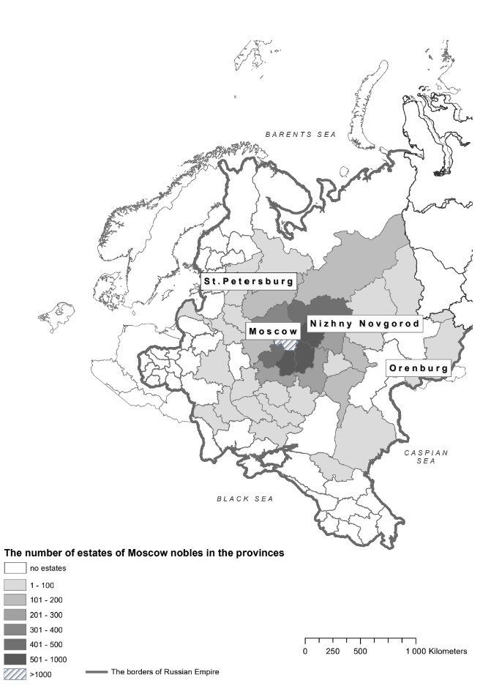
Source: Konchakov R., Korchmina E. The Structure of Noble Property of the Moscow Gentry in 1812 //ISTORIYA. 2020. V. 11. Issue 3 (89)

Map J2: Location of Moscow Province within the European Russian Empire in the 19th century
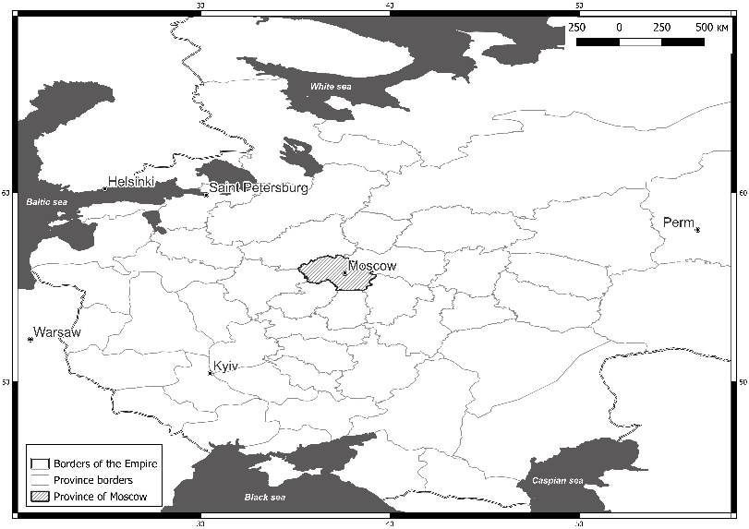

Prices for missing products such as sulfur (sera) taken from Prieskurant of 1811, a price list published by the government.
See laws no. 20143 and 24188 in: Polnoe sobranie zakonov Rossiiskoi Imperii [The Complete Register of Russian laws]. Kniga shtatov. Vol. XLIV. Part 2. Department III and IV. 1830 p. 233–236

