Symmetric azobenzene-substituted diketopyrrolopyrroles dyes as acid-base switchable molecular-probe for colorimetric paper-based sensors
Stefano Scurti^{1*}, Ottavia Racchi², Vincenzo Spinoso³, Alessio Bussolari¹, Giada D’Altri¹, Isacco Gualandi¹, Francesco di Maiolo^{2*}, Cristina Sissa², Daniele Caretti¹
¹ Industrial Chemistry “Toso Montanari” Department, University of Bologna, Via Piero Gobetti 85, 40129, Bologna, Italy
² Department of Chemical, Life and Environmental Sustainability Sciences, University of Parma, Parco Area delle Scienze 17A, 43124, Parma, Italy
³ European Laboratory for Non-Linear Spectroscopy (LENS), University of Florence, via Nello Carrara 1, 50019 Sesto Fiorentino, Italy

Synthesis of dyes

¹H-NMR (600 MHz, d₆-DMSO): δ 8.09 (bs, 2H, NH), 8.00 (dd, 4H, ArH), 7.79 (dd, 4H, ArH), 7.75 (dd, 4H, ArH), 7.42 (bs, 2H, ArOH), 6.80 (dd, 4H, ArH)
¹³C-NMR (600 MHz, d₆-DMSO): δ 167.9, 154.5, 143.8, 134.8, 133.8, 129.0, 126.0, 122.1, 121.8, 117.9
HR-MS (MALDI Q-TOF) m/z calcd. for [C₃₀H₂₀N₆O₄]: 551.1546. Found [M+Na]: 551.1446
Purification: Crystallization in methanol
Yield: 85%

¹H-NMR (600 MHz, d₆-DMSO): δ 10.07 (bs, 2H, ArOH), 8.04 (dd, 4H, ArH), 7.80 (dd, 4H, ArH), 7.48 (bs, 2H, NH), 6.59 (s, 4H, ArH), 2.51 (s, 12H, Ar-CH₃)
¹³C NMR (600 MHz, d₆-DMSO) δ 167.4, 162.5, 153.9, 146.4, 131.9, 130.6, 128.8, 125.4, 122.5, 119.4, 115.5, 25.2
HR-MS (MALDI Q-TOF) m/z calcd. for [C₃₄H₂₈N₆O₄]: 584.2172. Found [M+Na]: 607.2076
Purification: Chromatography on silica (EtOAc:Hexane 7:3)
Yield: 71%

¹H-NMR (600 MHz, d₆-DMSO): δ 8.03 (dd, 4H, ArH), 7.81 (dd, 4H, ArH), 7.44 (bs, 2H, NH), 6.17 (d, 2H, ArH), 6,07 (d, 2H, ArH), 5.56 (bs, 2H, OH), 3.95 (s, 6H, O-CH₃), 3.85 (s, 6H, O-CH₃)
¹³C NMR (600 MHz, d₆-DMSO) δ 175.8, 167.5, 146.7, 142.4, 134.2, 132.8, 130.5, 128.8, 127.2, 126.4, 122.1, 117.6, 58.9
HR-MS (MALDI Q-TOF) m/z calcd. for [C₃₄H₂₈N₆O₈]: 648.1969. Found [M]⁺: 647.1945
Purification: Chromatography on silica (Et₂O:MeOH 7:3)
Yield: 43%

¹H-NMR (600 MHz, d₆-DMSO): δ 8.52 (d, 2H, Napth-H), 8.02 (dd, 4H, ArH), 7.96 (d, 2H, Napth-H), 7.88 (dd, 4H, ArH), 7.76 (dd, 2H, Napth-H), 7.62 (m, 2H, Napth-H), 7.48 (m, 2H, Napth-H), 7.41 (bs, 2H, NH), 6.84 (d, 2H, Napth-H)
¹³C NMR (600 MHz, d6-DMSO): δ 173.9, 167.1, 145.9, 141.6, 133.2, 132.2, 129.7, 129.5, 129.2, 128.0, 126.6, 125.1, 121.7, 120.8, 117.6
HR-MS (MALDI Q-TOF) m/z calcd. for [C₃₈H₂₄N₆O₄]: 628.1859. Found [M] ⁺⁺: 314.0934
Purification: Precipitation in acid solution and filtration
Yield: 75%

¹H-NMR (600 MHz, d₆-DMSO): δ 8.00 (dd, 4H, ArH), 7.82 (m, 8H, ArH), 7.42 (bs, 2H, NH), 6.85 (dd, 4H, ArH), 3.08 (s. 12H, N-CH₃)
¹³C-NMR (600 MHz, d₆-DMSO): δ 167.7, 159.5, 154.8, 143.1, 136.3, 135.6, 129.7, 129.1, 121.9, 117.2, 116.6, 20.3
HR-MS (MALDI Q-TOF) m/z calcd. for [C₃₄H₃₀N₈O₂]: 582.2492. Found [M] ⁺: 582.2494
Purification: Precipitation in basic solution and filtration
Yield: 80%

Characterization of 1

a)
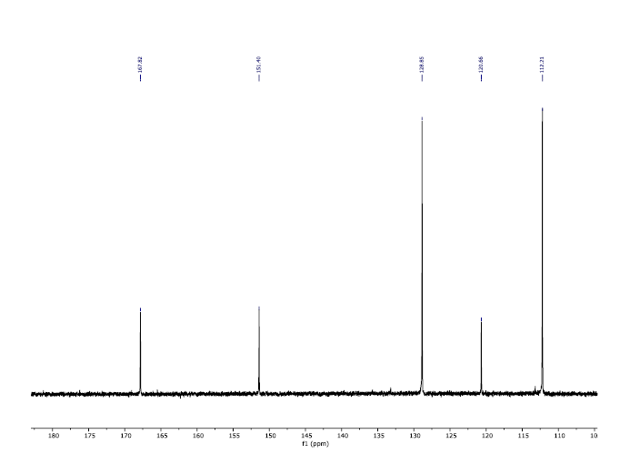
b)
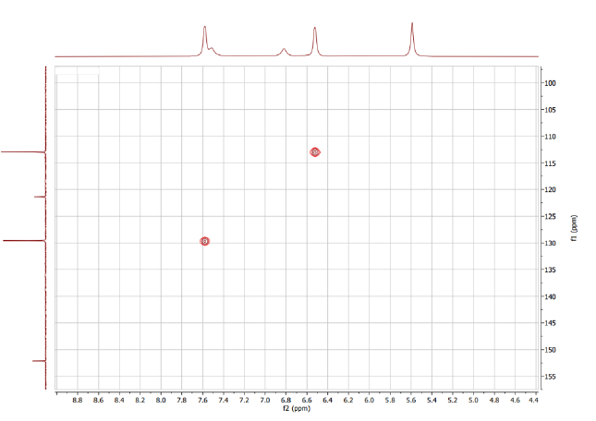
c)

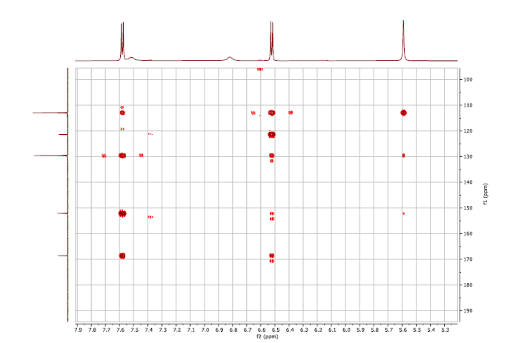
d)

Figure S1: ¹H-NMR (a), ¹³C-NMR (b), HSQC-2dNMR (c), HMBC-2dNMR (d) of 3,6-bis(4-aminophenyl)pyrrolo[3,2-b]pyrrole-2,5(1H,4H)-dione (1) in d₆-DMSO

Characterization of 2a

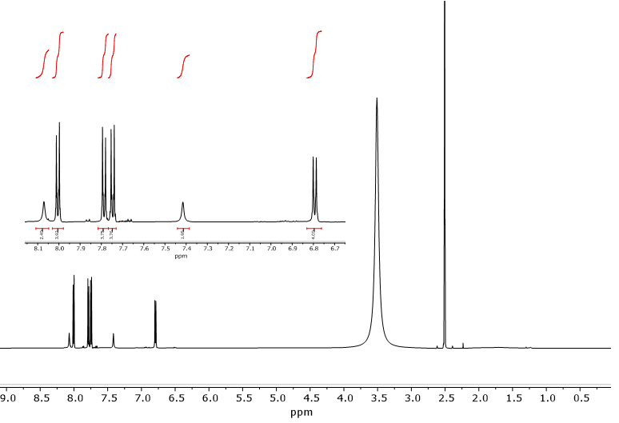
AcOH
AcOH
a)
b)

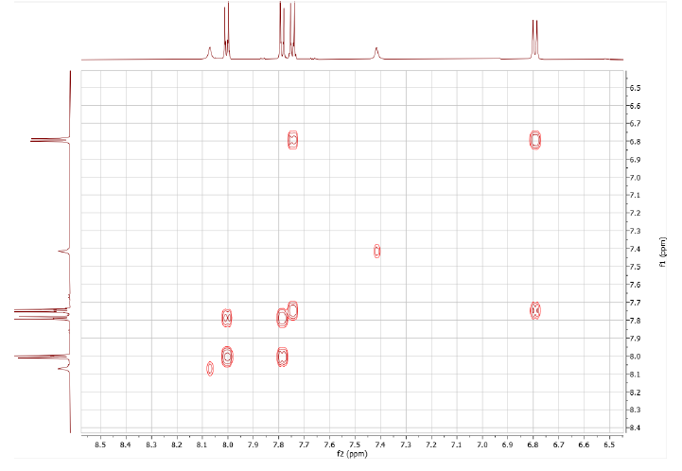
c)

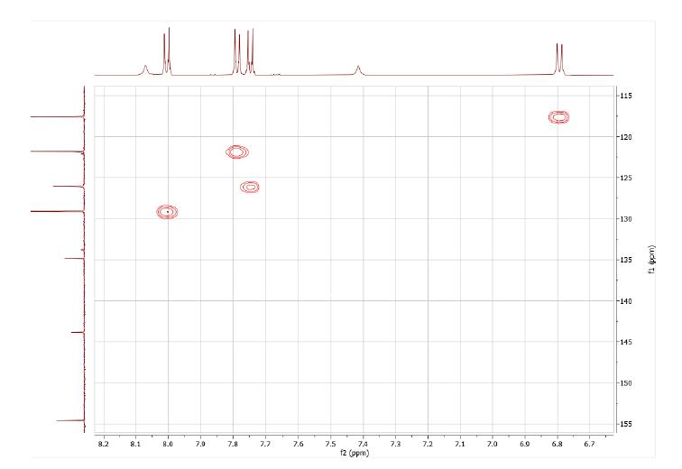
d)

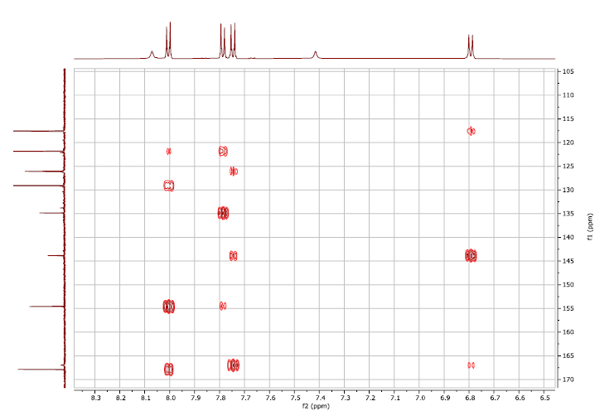
e)

Figure S2: ¹H-NMR (a), ¹³C-NMR (b), COSY-2dNMR (c), HSQC-2dNMR (d), HMBC-2dNMR (e) of 2a in d₆-DMSO

Characterization of 2b

a)
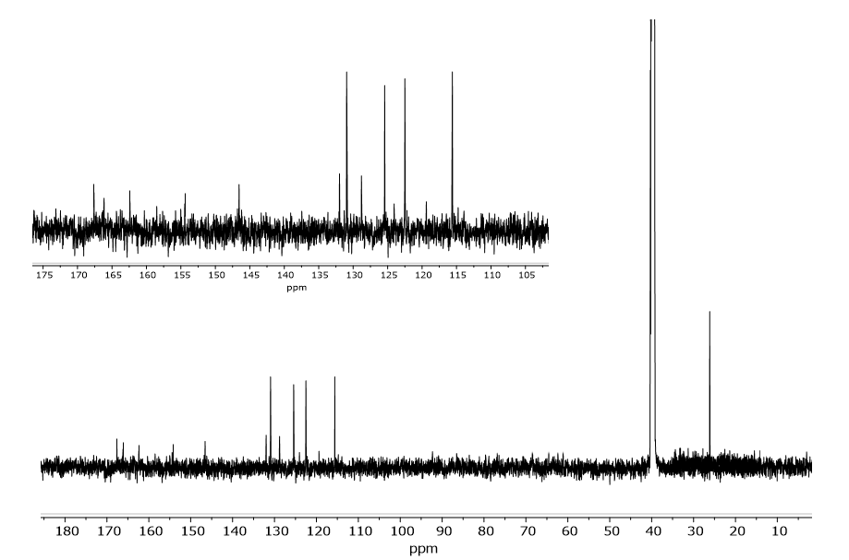
b)

Figure S3: ¹H-NMR (a), ¹³C-NMR (b) of 2b in d₆-DMSO
Characterization of 2c

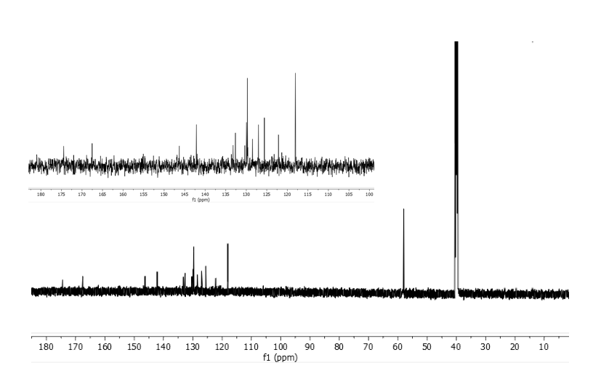
a)
b)

Figure S4: ¹H-NMR (a), ¹³C-NMR (b) of 2c in d₆-DMSO
Characterization of 2d

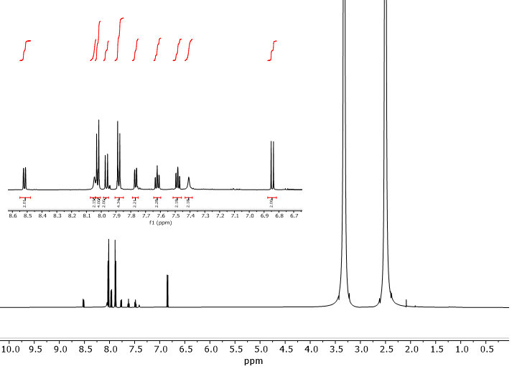
a)
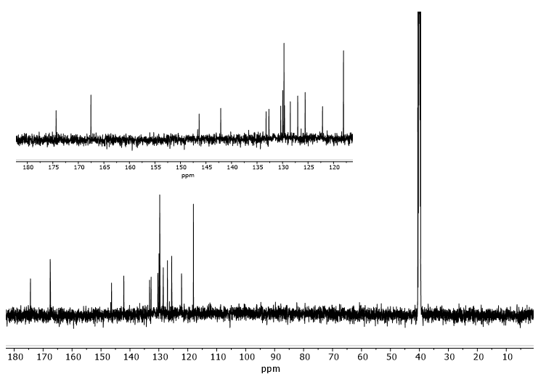
b)
Figure S5: ¹H-NMR (a), ¹³C-NMR (b) of 2d in d₆-DMSO
Characterization of 2e

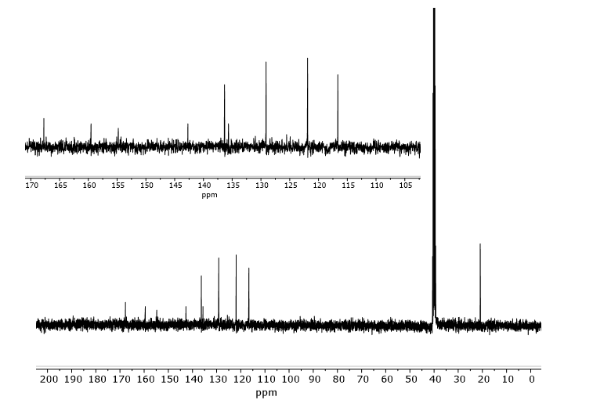
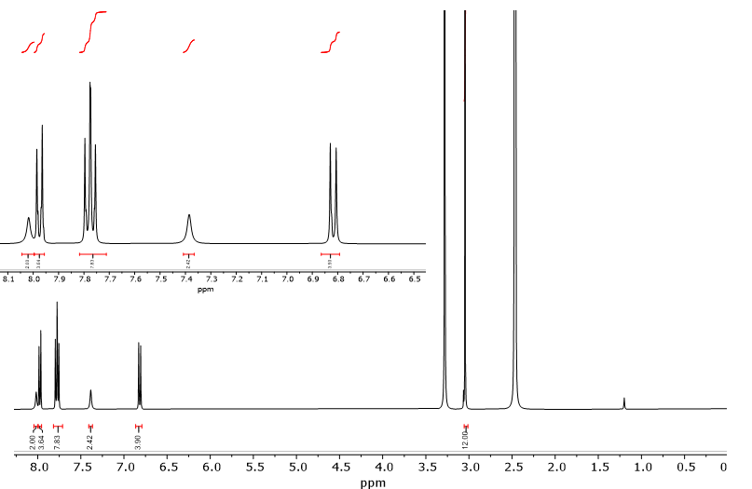
a)
b)
Figure S6: ¹H-NMR (a), ¹³C-NMR (b) of 2e in d₆-DMSO

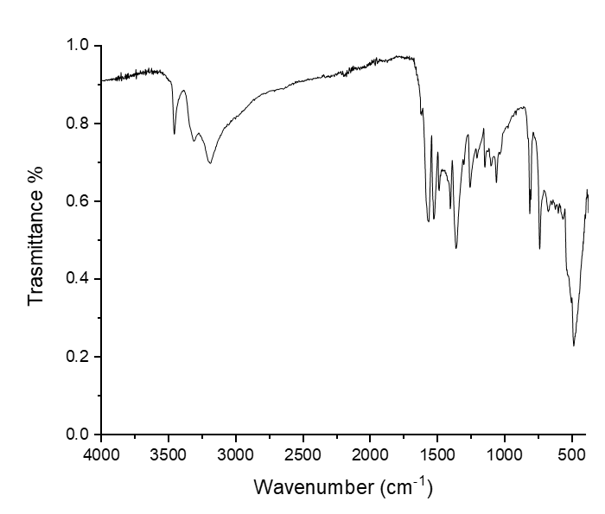
a)
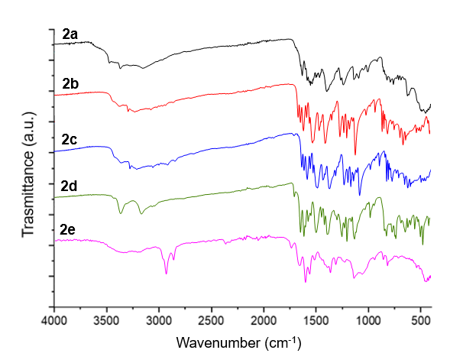
b)

Figure S7: ATR-IR spectra of compounds 1 (a) and 2a-e (b)

Photophysical properties

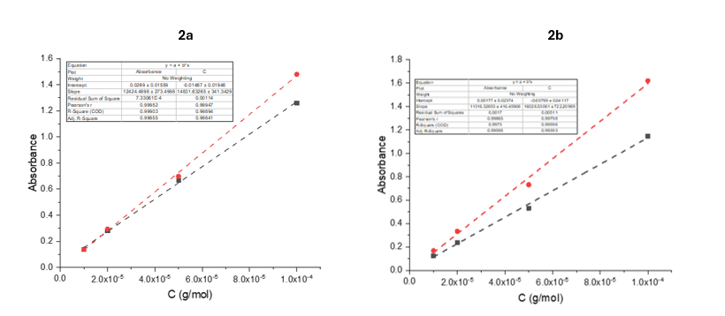
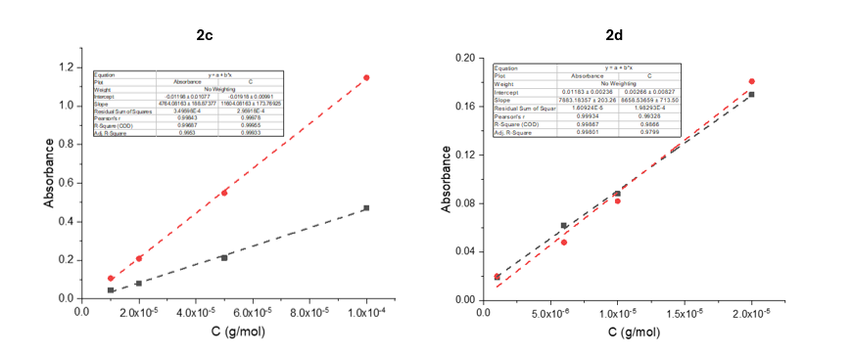
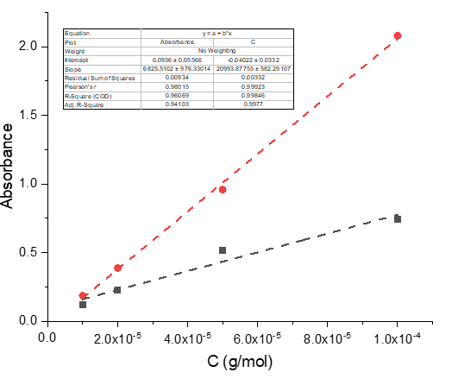
2e

Figure S8: Abs vs C (g/mol) graphs of compound 2a-e to determine the extinction molar coefficient ε (M⁻¹cm⁻¹) (the black dash line is related to the acid form, while the red one at the basic form)

Electrochemical properties
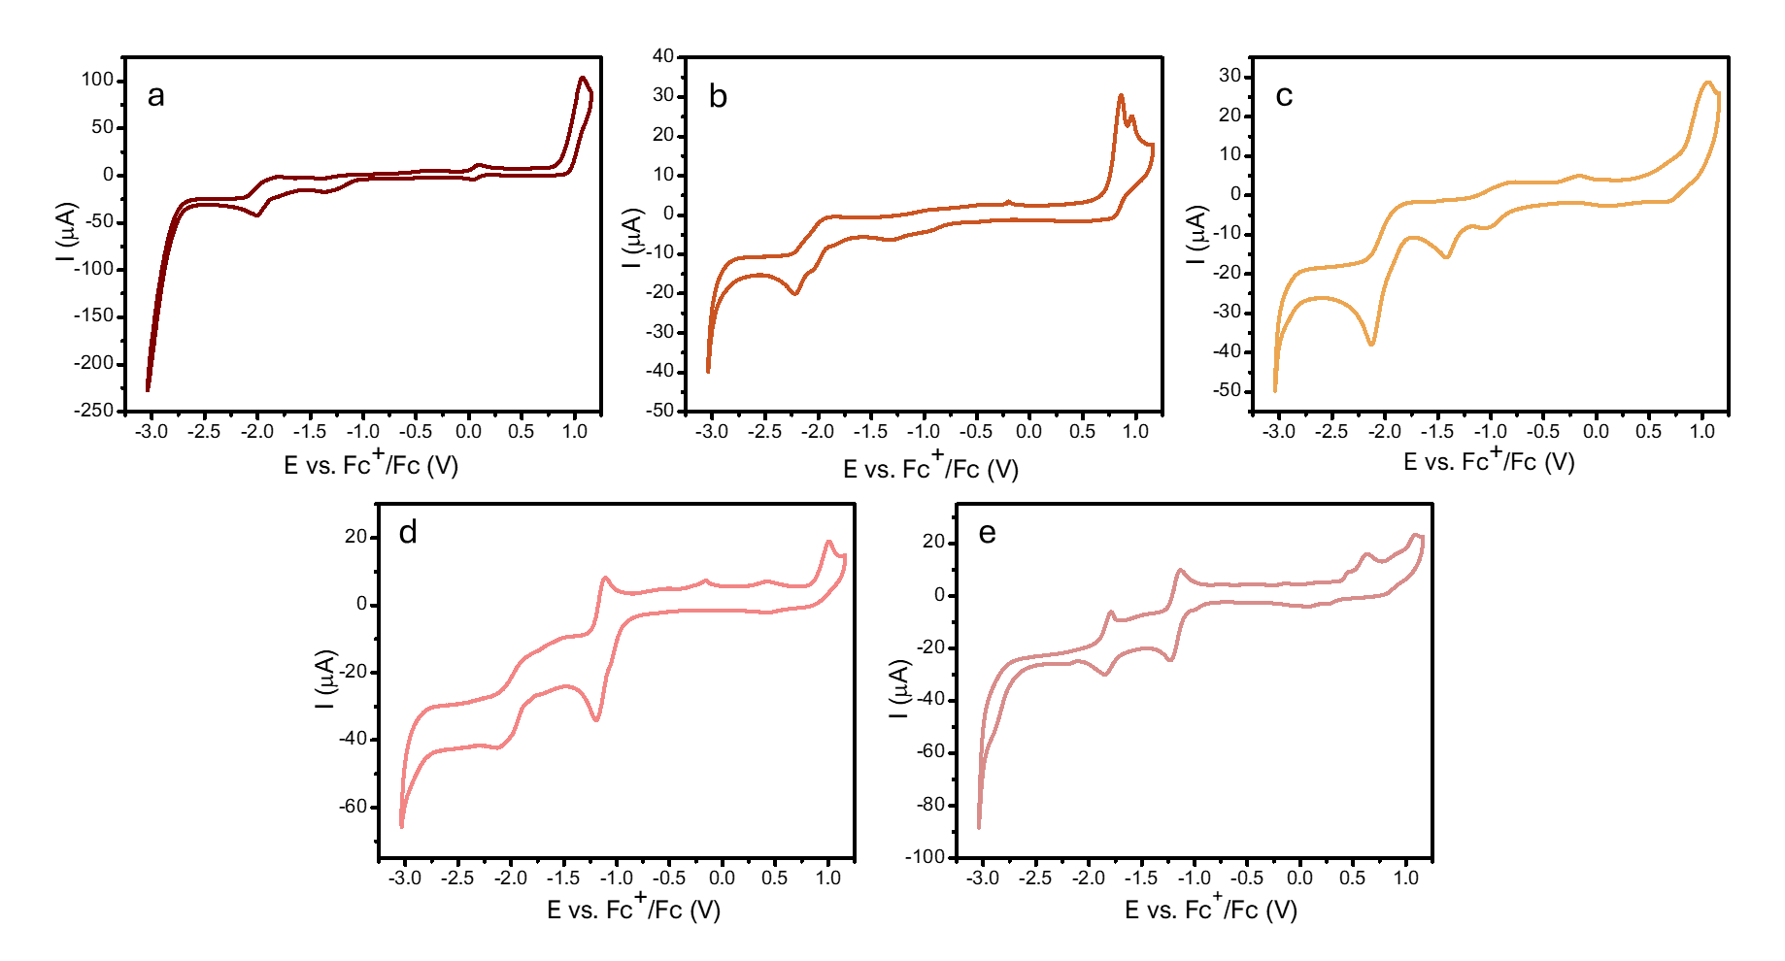
Figure S9 shows the fifth cycle that is consistent with the description in the Results and Discussion section under Electrochemical Properties.
Figure S9. Fifth cycle of cyclic voltammograms of a) 2a; b) 2b; c) 2c; d) 2d; e) 2e recorded at 50 mV/s in acetonitrile respect to ferrocenium/ferrocene reference.

The redox waves reported in Figure S9 b-e are representative of the redox behaviour of the analysed compounds both in cathodic and anodic direction. Regarding 2a, the redox wave identified at a potential of -1.06 is due to a degradation product observed following the redox wave recorded at -2.01 V. This is because it is not present in the first cycle of the CVs recorded in the cathodic direction but appears in subsequent cycles (Figure S10). Therefore, this redox wave is not attributable to 2a itself but to a product formed as a result of the redox processes affecting it.

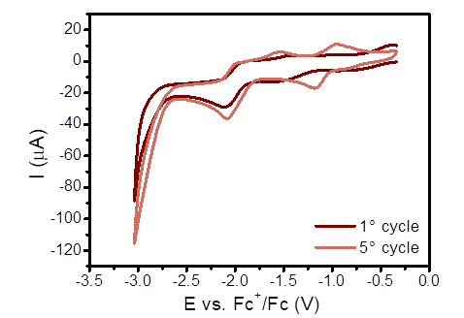

Figure S10. First and fifth cycle of cyclic voltammogram of 2a compound at 50 mV/s in acetonitrile respect to ferrocenium/ferrocene reference.

Titration curves
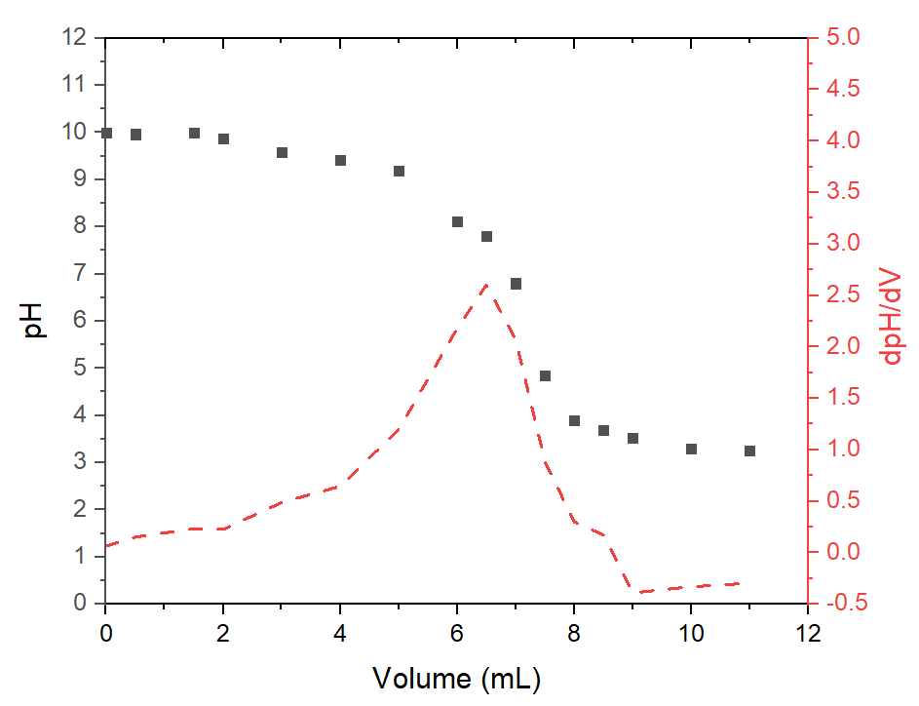
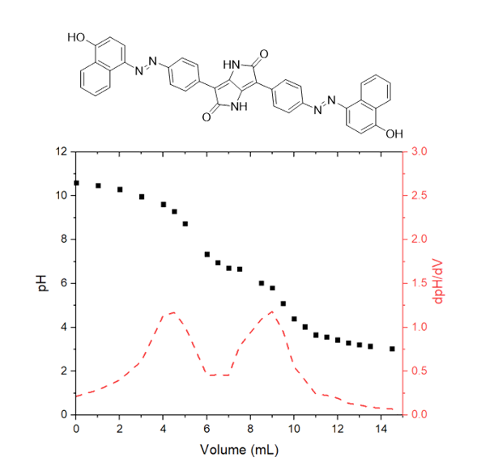
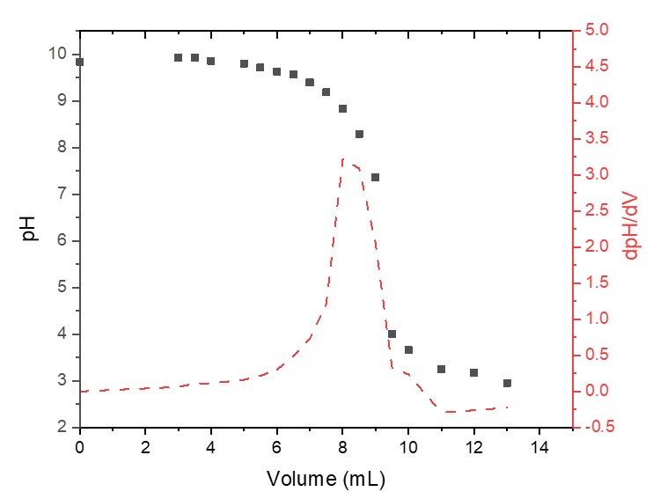
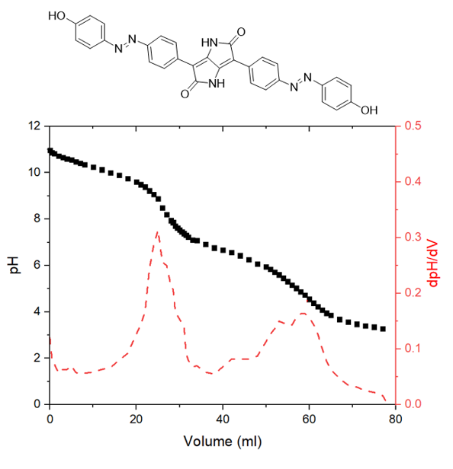
2d)
2c)
2a)
2b)

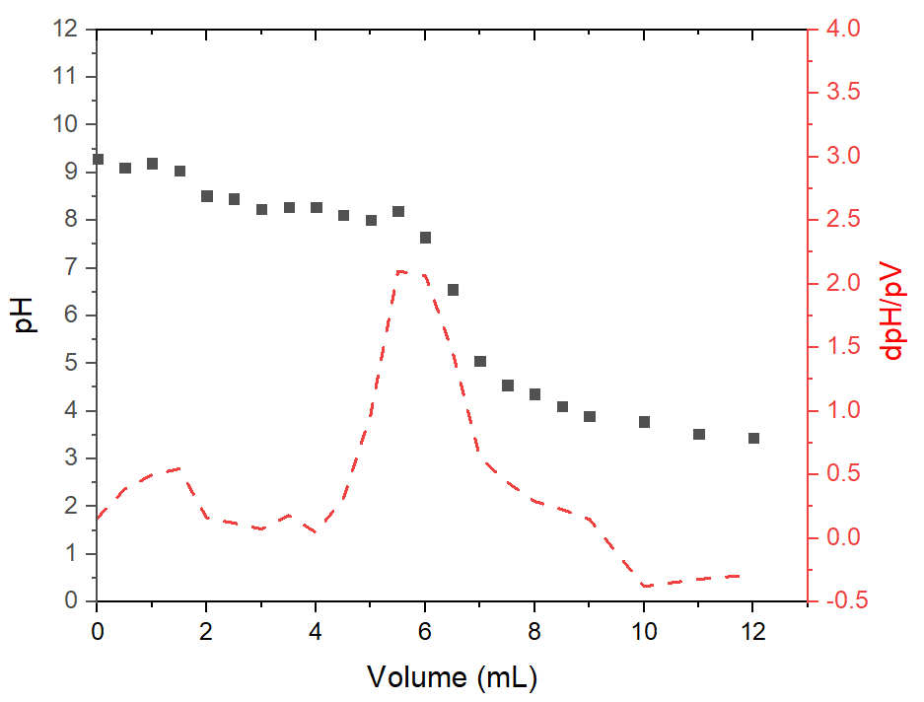
2e)

Fig.S11: Titration curves of 2a-e

Table S1: Gas-phase TD-DFT/B3LYP/6-31+G(d) results for 2a-acid and 2a-base. Transition energies of the first few excited singlet states are shown together with the relevant oscillator strengths.
2a-acid |  |  | 2a-base
Excited state | Energy  (eV) | Oscillator strength | Energy  (eV) | Oscillator strength
S₁ | 2.3460 | 0.0128 | 1.4044 | 1.3799
S₂ | 2.3588 | 0.0011 | 1.5961 | 0.0041
S₃ | 2.4255 | 1.5524 | 2.2455 | 0.0002
S₄ | 2.4407 | 0.0004 | 2.2602 | 0.0001

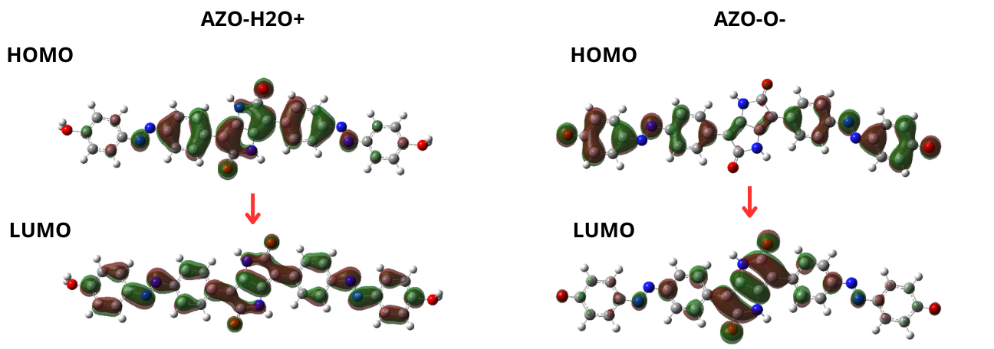
2a-acid
2a-base
Figure S12: The most important Kohn-Sham molecular orbitals involved in the brightest transition of 2a-acid (S₀→S₃) and 2a-base (S0→S₁). Calculations performed using TD-DFT with the CAM-B3LYP functional and 6-31+G(d) basis set in the gas-phase at the ground-state (S₀) optimized geometry.
2a-base
2a-acid
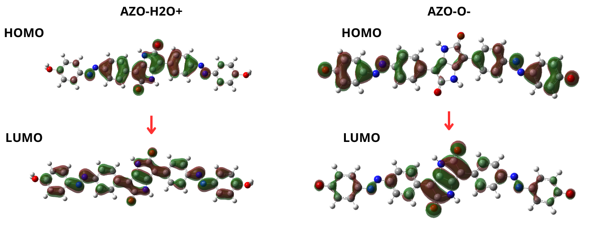

Figure S13: The most important Kohn-Sham molecular orbitals involved in the brightest transition of 2a-acid (S₀→S₃) and 2a-base (S0→S₁). Calculations performed using TD-DFT with the B3LYP functional and 6-31+G(d) basis set in the gas-phase at the ground-state (S₀) optimized geometry.
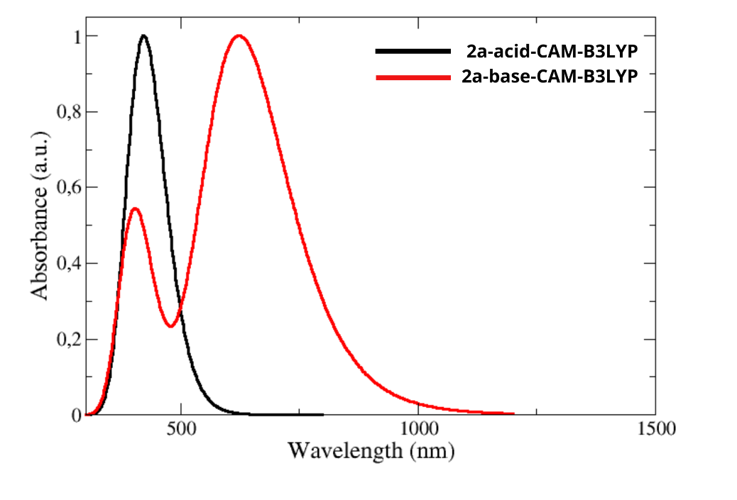
Figure S14: Calculated UV-Vis absorption spectra for 2a-acid and 2a-base in the gas-phase using TD-DFT with the CAM-B3LYP functional and the 6-31G+(d) basis set.
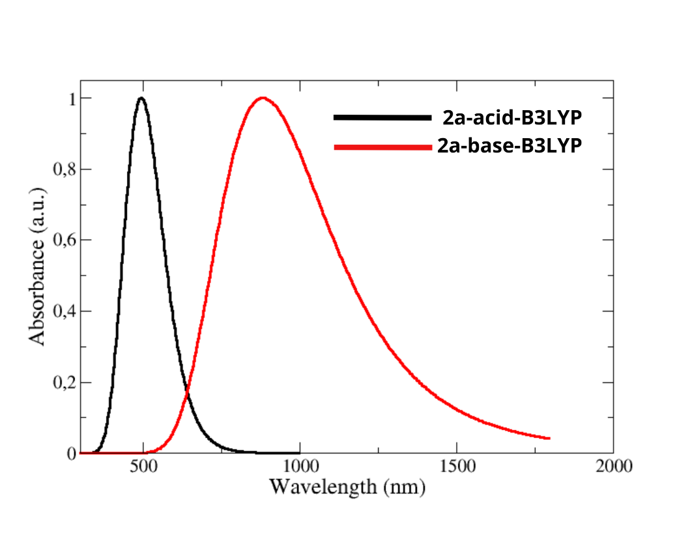
Figure S15: Calculated UV-Vis absorption spectra for 2a-acid and 2a-base in the gas-phase using TD-DFT with the B3LYP functional and the 6-31G+(d) basis set.

Cartesian coordinates in Å together with the relevant atom symbol for the S₀ optimized geometry of 2a-acid obtained at DFT level (CAM-B3LYP/6-31+G(d)):
C -0.2663866718 1.0206875974 1.5113055668
C -0.2624409513 2.1979138635 2.4525189139
C -0.1220720273 3.0332467792 0.3340421287
C -0.1878254303 1.5673838845 0.2615634127
C -0.0436395623 3.580671141 -0.9152256595
C -0.0471538989 2.4043186527 -1.8569033568
H -0.2464184365 4.2935408918 2.0607104872
H -0.0607281264 0.3088064249 -1.4665059717
O 0.0301355059 2.3807608302 -3.0666670118
O -0.3388270721 2.2218817308 3.6622117768
N -0.1474357075 1.2299263914 -1.0603079574
N -0.1628168375 3.3717631743 1.6552738705
C -0.5202054976 -3.076988431 2.7157191644
C -0.1133757861 -2.091285834 3.6323763711
C -0.0353924824 -0.7573694347 3.2531380032
C -0.3583481592 -0.3714447761 1.9347175192
C -0.7804458111 -1.3739312702 1.0232446541
C -0.8608095053 -2.7030492116 1.3972607896
H 0.1396213687 -2.3935536154 4.6442257321
H 0.2697079838 -0.007177762 3.9721361559
H -1.0872952696 -1.0955163915 0.0192997465
H -1.1947674668 -3.4586667773 0.694960007
C 0.0504517862 4.9741899567 -1.3343389182
C 0.4795833279 5.9703116293 -0.4297785192
C 0.5556421759 7.2999739629 -0.8193332274
C 0.2070014962 7.6758478877 -2.1295631085
C -0.2127590369 6.68971313 -3.0474638687
C -0.2851893076 5.3637308641 -2.6557776549
H 0.7951539863 5.6983829039 0.5728387402
H 0.894429984 8.0655478593 -0.1277130323
H -0.476717759 6.9790532387 -4.0584786769
H -0.597603664 4.6090909191 -3.3674410751
N 0.3232488965 9.0426062286 -2.4164322694
N -0.56461655 -4.3844711472 3.2153023627
N -0.9281915933 -5.2819798502 2.4019199254
N 0.0137295489 9.3901610112 -3.5921724285
C 0.1517817174 10.7778474351 -3.8388262062
C 0.6041953838 11.7182524059 -2.8894052448
C -0.1957551797 11.1937080539 -5.1352317188
C 0.7092366469 13.0641901302 -3.2307598229
H 0.8692309036 11.3812975065 -1.8937184097
C -0.1004209929 12.5372147807 -5.5039489214
H -0.5402386793 10.4516392002 -5.8482258897
C 0.3491811838 13.4033848468 -4.5266850944
H 1.056992456 13.8001543526 -2.5103547948
H -0.3634312333 12.8801939483 -6.4990646888
C -0.961396206 -6.5827783145 2.9623843551
C -1.3496964782 -7.6077546389 2.0833701267
C -0.6398167135 -6.8821574305 4.3031778419
C -1.4229522265 -8.9326423721 2.5189551771
H -1.593094811 -7.3533491649 1.0568717943
C -0.7047983449 -8.1945306707 4.7637825307
H -0.342900228 -6.0799172115 4.9690646309
C -1.0948663639 -9.1547993243 3.8419986142
H -1.720242911 -9.7395757644 1.8574955479
H -0.4606430852 -8.4398325209 5.7942158472
O -1.1822041051 -10.5905591221 4.2911447782
O 0.4460094735 14.8473016803 -4.9467107119
H 1.3577628562 15.2131639295 -4.9584400576
H -0.1580110684 15.4573229469 -4.4689358613
H -0.3259980183 -10.9910927912 4.5591078249
H -1.8669577452 -10.7677597129 4.9731162815

Cartesian coordinates in Å together with the relevant atom symbol for the S₀ optimized geometry of 2a-base obtained at DFT level (CAM-B3LYP/6-31+G(d)):
C -0.193828638 1.0879663266 1.699796115
C -0.1272830327 2.2868475055 2.6112665832
C -0.0557845126 3.0602335362 0.4648323924
C -0.1591119547 1.6211897008 0.4356988441
C -0.0209660845 3.5946949147 -0.7980586157
C -0.0899760202 2.3967440592 -1.7110223587
H -0.1478433726 4.3584405313 2.1705130232
H -0.0822827202 0.3229093489 -1.2725277682
O -0.0379262417 2.3406334481 -2.932324142
O -0.1839041225 2.3450087321 3.8327783191
N -0.210947023 1.2500968199 -0.8953383921
N -0.0008676027 3.4328496861 1.7958369291
C -0.4514047197 -3.0356305436 2.9521094794
C -0.0543590392 -2.019869083 3.8500005937
C 0.0183156327 -0.6882142834 3.4636457831
C -0.2985800489 -0.2943445075 2.142590653
C -0.7122166617 -1.3147214954 1.2487973892
C -0.78835581 -2.6442902778 1.6315837722
H 0.1972981051 -2.312554001 4.8664198734
H 0.3196317958 0.0665159965 4.181329795
H -1.0148248431 -1.0491191626 0.2379221675
H -1.1165628855 -3.4051750627 0.9318171846
C 0.0903934788 4.9783908349 -1.2348018694
C 0.5214751169 5.9872948549 -0.3400806807
C 0.6008413944 7.3159671161 -0.7290131239
C 0.2540836058 7.7205645784 -2.0385849359
C -0.1639309426 6.7134255653 -2.9432002655
C -0.2388308556 5.3842426003 -2.5518141818
H 0.8347586615 5.7179973198 0.6660209757
H 0.942787187 8.0790222088 -0.0341311688
H -0.4267463775 7.0035821861 -3.9546695948
H -0.5543703667 4.6323178246 -3.2670632351
N 0.3672470998 9.0817240018 -2.3170871049
N -0.4861913422 -4.3365182522 3.4514485739
N -0.8527812871 -5.2282022423 2.5880094333
N 0.0444961458 9.4058323863 -3.5277756401
C 0.133187177 10.722688298 -3.8686072553
C 0.5543213369 11.7846512622 -3.0034735949
C -0.2271548948 11.0640995793 -5.2074571757
C 0.6079346254 13.0791676883 -3.4484482244
H 0.8297541792 11.5308174159 -1.9837941298
C -0.1782995136 12.3567959145 -5.6667683741
H -0.5456114464 10.2501514283 -5.857129236
C 0.2448592859 13.4583262289 -4.8135848508
H 0.9280282099 13.8858521495 -2.7909530623
H -0.4555797637 12.6034878656 -6.6896505874
C -0.910621422 -6.5230814879 3.0103287605
C -1.3155490553 -7.4950508098 2.0459285391
C -0.6015747727 -6.9869126029 4.3304853218
C -1.4109177155 -8.8294560414 2.3537828761
H -1.5483308151 -7.1329456005 1.0455302943
C -0.6924295712 -8.3155398705 4.651673076
H -0.2931881171 -6.2517566415 5.0683705183
C -1.1040564373 -9.3331302182 3.6851509138
H -1.7207505066 -9.5600013956 1.6092522369
H -0.4577525979 -8.6676537822 5.6548818559
O -1.184848641 -10.552468919 3.9891141557
O 0.2969250677 14.6510390173 -5.2141338602

Details on the ¹H-NMR Spectra Simulation
The ¹H-NMR chemical shifts were calculated at the CAM-B3LYP/6-31+G(d) level of theory using the optimized geometries obtained at the same level of theory. All calculations were performed using DMSO as solvent within the Polarizable Continuum Model (PCM) framework to account for solvation effects. Relevant Cartesian coordinates are provided below. The NMR shielding tensors were computed using the Gauge-Independent Atomic Orbital (GIAO) method to ensure gauge invariance of the calculated magnetic properties. Chemical shifts were referenced to tetramethylsilane (TMS) using the standard formula δ = σ(TMS) - σ(compound), where σ represents the calculated isotropic shielding constant. The chemical shifts of the aromatic hydrogens adjacent to the hydroxyl groups, which are discussed in the main text and show significant pH-dependent variations, are summarized in Table S1. All calculations were performed with Gaussian 16 (revision B.01) package.

Table S2: Comparison of calculated and experimental ¹H-NMR chemical shifts (ppm) for the aromatic hydrogens adjacent to the hydroxyl groups in the different protonation states of compound 2a. Calculated values obtained at CAM-B3LYP/6-31+G(d) level of theory with DMSO as solvent (PCM model).
Dye | δ_{calc} (ppm) | δ_{exp} (ppm)
2a | 6.95 | 6.80
2a-base | 6.35 | 6.10
2a-acid | 7.98 | 6.95

Cartesian coordinates in Å together with the relevant atom symbol for the S₀ optimized geometry of 2a obtained at DFT level (CAM-B3LYP/6-31+G(d)) in DMSO solvent:

C -1.6494880 1.0041340 -0.0833110
C -0.8890590 2.2632740 -0.3896010
C 0.6378810 0.6447270 0.0067880
C -0.7013800 0.0678650 0.1340000
C 1.5861330 -0.2908960 0.2251660
C 0.8263490 -1.5498150 0.5324570
H 1.1960540 2.6335220 -0.5496870
H -1.2581450 -1.9197480 0.6963160
O 1.2637130 -2.6439610 0.8310650
O -1.3258550 3.3584370 -0.6852650
N -0.5408860 -1.2563270 0.4381820
N 0.4779180 1.9686470 -0.2978350
C -5.9010100 0.6320930 -0.0116810
C -5.2990750 1.8498420 0.3042890
C -3.9172520 1.9837790 0.2754980
C -3.1084960 0.8951820 -0.0730470
C -3.7269660 -0.3226450 -0.4057640
C -5.1037210 -0.4597720 -0.3737140
H -5.9291560 2.6898640 0.5794120
H -3.4623860 2.9339540 0.5281630
H -3.1211690 -1.1674420 -0.7192760
H -5.5694110 -1.4021630 -0.6363040
C 3.0451730 -0.1794040 0.2210110
C 3.6611850 1.0293180 0.5692600
C 5.0432010 1.1517970 0.5419050
C 5.8391750 0.0673990 0.1732650
C 5.2361870 -1.1485170 -0.1681370
C 3.8566690 -1.2676520 -0.1423390
H 3.0603230 1.8748170 0.8892810
H 5.5217110 2.0870210 0.8147240
H 5.8544750 -1.9907010 -0.4556270
H 3.3955180 -2.2109540 -0.4103260
N 7.2392400 0.3019800 0.1812030
N -7.3188600 0.6079410 0.0559820
N -7.8435200 -0.5010540 -0.1740600
N 7.9461900 -0.6776710 -0.1325160
C 9.3422860 -0.4557580 -0.1289530
C 9.9546970 0.7632460 0.1878990
C 10.1347510 -1.5548260 -0.4708290
C 11.3343160 0.8743960 0.1628220
H 9.3429880 1.6178030 0.4523480
C 11.5170300 -1.4510860 -0.4974770
H 9.6491350 -2.4943520 -0.7153070
C 12.1178860 -0.2338350 -0.1791380
H 11.8104770 1.8201330 0.4073390
H 12.1394890 -2.2995940 -0.7610720
C -9.2550870 -0.5406160 -0.1127150
C -9.8388840 -1.7906110 -0.3355280
C -10.0734520 0.5649570 0.1508220
C -11.2155980 -1.9475970 -0.2926470
H -9.1948600 -2.6398640 -0.5411540
C -11.4491950 0.4161630 0.1932790
H -9.6240510 1.5363640 0.3204920
C -12.0221570 -0.8420570 -0.0256150
H -11.6767940 -2.9148310 -0.4618870
H -12.0853050 1.2736960 0.3961220
O -13.3662270 -1.0437440 0.0095780
O 13.4758740 -0.1781800 -0.2171230
H 13.7913640 0.7070260 0.0238810
H -13.8334730 -0.2181080 0.2120350

Cartesian coordinates in Å together with the relevant atom symbol for the S₀ optimized geometry of 2a-acid obtained at DFT level (CAM-B3LYP/6-31+G(d)) in DMSO solvent:

C -1.64922700 0.98704100 -0.07869500
C -0.89352900 2.24402100 -0.40344000
C 0.63987700 0.63584000 0.01045600
C -0.69844700 0.05590600 0.15011000
C 1.59044100 -0.29563600 0.23786200
C 0.83502300 -1.55178800 0.56539600
H 1.19089400 2.61775900 -0.57325400
H -1.24838300 -1.92345700 0.74339300
O 1.27519700 -2.64052900 0.87639100
O -1.33338600 3.33396900 -0.71056600
N -0.53391400 -1.26165500 0.47320600
N 0.47533800 1.95294700 -0.31356700
C -5.89333500 0.60142800 -0.00180500
C -5.29972500 1.82973400 0.28798200
C -3.91881800 1.96802700 0.25700100
C -3.10731500 0.87306400 -0.06464300
C -3.71927700 -0.35650600 -0.36869000
C -5.09431400 -0.49851300 -0.33571600
H -5.93449500 2.67248200 0.54242100
H -3.46694300 2.92520300 0.48645400
H -3.10936300 -1.20557400 -0.66083300
H -5.55668300 -1.44850200 -0.57560000
C 3.04901300 -0.18438700 0.22327300
C 3.66785300 1.02891600 0.55027600
C 5.04985300 1.14677100 0.51724700
C 5.83782900 0.05251700 0.16094800
C 5.23311500 -1.16838400 -0.16025200
C 3.85460600 -1.28246700 -0.12649400
H 3.07018800 1.88016300 0.85998700
H 5.53341700 2.08341600 0.77514900
H 5.84840100 -2.01665100 -0.43573200
H 3.38872600 -2.22820700 -0.37592200
N 7.23618900 0.27906000 0.16449500
N -7.30796500 0.57445600 0.06188900
N -7.83635900 -0.52854800 -0.17498100
N 7.93901400 -0.69295700 -0.17159900
C 9.34195500 -0.45202900 -0.15004900
C 9.92615800 0.73922900 0.29573000
C 10.13173500 -1.50876600 -0.60120000
C 11.30652000 0.87472200 0.29004800
H 9.29867700 1.54844000 0.64761600
C 11.51768600 -1.39043200 -0.61884400
H 9.65308800 -2.42152500 -0.93779600
C 12.04327500 -0.20065200 -0.16998100
H 11.78669100 1.78408000 0.63513500
H 12.15958900 -2.19170700 -0.96500300
C -9.25872300 -0.53518900 -0.11149000
C -9.85669100 -1.77469000 -0.33507700
C -10.03708600 0.59851700 0.14896300
C -11.24165400 -1.90137200 -0.30009100
H -9.23026500 -2.63640600 -0.53646300
C -11.41948200 0.49267200 0.18758100
H -9.55723600 1.55422800 0.31821700
C -11.96203500 -0.75826600 -0.03974300
H -11.73731100 -2.84974400 -0.46981700
H -12.04528700 1.35588900 0.38637500
O -13.41416800 -0.92233000 -0.01390600
O 13.50188600 -0.10958700 -0.19177700
H 13.93131000 -0.07128700 0.69251200
H 13.86691800 0.59618200 -0.77120100
H -13.83504600 -0.77518500 0.86280000
H -13.90094200 -0.42086600 -0.70564600

Cartesian coordinates in Å together with the relevant atom symbol for the S₀ optimized geometry of 2a-base obtained at DFT level (CAM-B3LYP/6-31+G(d)) in DMSO solvent:

C -1.65422900 1.05181000 -0.05651200
C -0.89095500 2.30777400 -0.37375000
C 0.63240700 0.68899400 0.03513500
C -0.70476700 0.11765900 0.16707600
C 1.58217300 -0.24463200 0.25737900
C 0.82036200 -1.50056600 0.57532500
H 1.19252300 2.67388900 -0.54039300
H -1.26243300 -1.86684800 0.74721800
O 1.25761600 -2.59325000 0.88534400
O -1.32680000 3.40124800 -0.68301700
N -0.54512000 -1.20847600 0.47744900
N 0.47391700 2.01474700 -0.27595600
C -5.92178800 0.68162600 -0.00048000
C -5.30959500 1.90448800 0.29177600
C -3.92830300 2.03717100 0.26932700
C -3.11267100 0.94351700 -0.05089300
C -3.73420100 -0.27845500 -0.35925000
C -5.11219000 -0.41418200 -0.33363900
H -5.93794500 2.75348300 0.54401200
H -3.47638500 2.99367000 0.50445600
H -3.12882700 -1.13186900 -0.65148200
H -5.57356000 -1.36256400 -0.58182800
C 3.04055800 -0.13268600 0.25209900
C 3.65920700 1.07955000 0.58765000
C 5.04008800 1.20517400 0.55755000
C 5.84957600 0.12350700 0.19579100
C 5.23832000 -1.09521200 -0.13263800
C 3.85818700 -1.21827400 -0.10245300
H 3.05770200 1.92796800 0.90063100
H 5.51328300 2.14560500 0.82323800
H 5.85553900 -1.94010700 -0.41437700
H 3.40114700 -2.16661800 -0.36159200
N 7.24245700 0.36194600 0.19897000
N -7.33384400 0.66154600 0.04983600
N -7.85021600 -0.48004500 -0.12565300
N 7.94933600 -0.63516900 -0.12751200
C 9.31831900 -0.47029800 -0.14452100
C 10.00453900 0.72759500 0.17813600
C 10.08636400 -1.59588500 -0.51565900
C 11.37287300 0.78860100 0.12945800
H 9.42735100 1.60030000 0.46630000
C 11.45898600 -1.54799400 -0.56876200
H 9.55756600 -2.51392800 -0.76202600
C 12.18370800 -0.34708400 -0.24825700
H 11.89305600 1.71045100 0.37844400
H 12.03401300 -2.42436400 -0.85676200
C -9.22586000 -0.57162100 -0.10396200
C -9.77527500 -1.86092500 -0.27853800
C -10.11911800 0.51447400 0.07661600
C -11.13289600 -2.07458900 -0.27215400
H -9.08769200 -2.69200600 -0.41862700
C -11.47515900 0.31509700 0.08312100
H -9.71190800 1.51185000 0.20821700
C -12.06453600 -0.99372600 -0.08857500
H -11.53775600 -3.07426700 -0.40699200
H -12.15519500 1.15258900 0.21971000
O -13.32373800 -1.16983200 -0.07788300
O 13.45280600 -0.28123200 -0.29150100

