Keeping the Horse with the Cart: Are We Underdosing Tazobactam Even When Using Continuous-Infusion Ceftolozane/Tazobactam Against ESBL-producing Enterobacterales?
Manjunath P. Pai , Pier Giorgio Cojutti, Milo Gatti, Matteo Rinaldi, Tommaso Tonetti, Antonio Siniscalchi, Pierluigi Viale, Federico Pea

Supplemental File Contents
TABLES
Table S1. Body size descriptors and kidney function estimation equations used in this study
Table S2. Parameter estimates of the base pharmacokinetic model
Table S3. Univariate analyses to identify significant covariates on CL_{TOL}
Table S4. Univariate analyses to identify significant covariates on CL_{TAZ}
Table S5. Comparison of different kidney function equations as covariates of CL with the best identified structural model based on the greatest reduction in the Akaike Information Criterion (AIC) value and confidence in parameter estimates
Table S6. Parameter estimates of the final pharmacokinetic model
Table S7. Distribution of participants across estimated glomerular filtration rate groups including central tendency and variance of the population to support simulations
FIGURES
Figure S1. Structure of the base pharmacokinetic model for ceftolozane
Figure S2. Ceftolozane (A) and Tazobactam (B) population-predictions vs. observations and individual-predictions vs. observations for the final population pharmacokinetic model
Figure S3. Scatter plot of the residual vs. time and of the residual vs. individual predictions of ceftolozane (A) and tazobactam (B) for the final population pharmacokinetic model
Figure S4. Distribution of the Individual Weighted Residuals and of the Normalized Prediction Distribution Errors of ceftolozane (A) and tazobactam (B) for the final population pharmacokinetic model
Figure S5. Visual predictive check (VPC) for the ceftolozane (A) and tazobactam(B) final population pharmacokinetic model
Figure S6. Distribution of the individual parameters

Table S1. Body size descriptors and kidney function estimation equations used in this study
Descriptor | Full Name | Unit
wt | Weight | Weight in kg
ht | Height | Height in cm
bmi | Body mass index | Computed in kg/m²
ibw | Ideal body weight | Estimated in kg
adjbw | Adjusted body weight | Estimated in kg
dw | Dosing weight | Estimated in kg
lbw | Lean body weight | Estimated in kg
bsa_m | Body surface area using Mosteller’s adaptation | Estimated in m²
bsa_dd | Body surface area using Dubois-DuBois equation | Estimated in m²
clcr_wt | Creatinine clearance using the Cockcroft-Gault equation and weight | Estimated in mL/min
clcr_ibw | Creatinine clearance using the Cockcroft-Gault equation and ideal body weight | Estimated in mL/min
clcr_adjbw | Creatinine clearance using the Cockcroft-Gault equation and adjusted body weight | Estimated in mL/min
clcr_dw | Creatinine clearance using the Cockcroft-Gault equation and dosing weight | Estimated in mL/min
ckdepi2021 | Glomerular filtration rate using the Chronic Kidney Disease Epidemiology Equation without race published in 2021 | Estimated in mL/min/1.73 m²
ckdepi2021mlmin_bsa_m | Glomerular filtration rate using the Chronic Kidney Disease Epidemiology Equation without race published in 2021 normalized to individual body surface area- Mosteller equation | Estimated in mL/min
ckdepi2021mlmin_bsa_dd | Glomerular filtration rate using the Chronic Kidney Disease Epidemiology Equation without race published in 2021 normalized to individual body surface area-Dubois Dubois equation | Estimated in mL/min
scr_q | Serum creatinine normalized values for EKFC equation | unitless
ekfc | European Kidney Function Consortium (EKFC) equation | Estimated in mL/min/1.73 m²
ekfc_mlmin_bsa_m | Glomerular filtration rate using the EKFC equation without race published in 2022 normalized to individual body surface area- Mosteller equation | Estimated in mL/min
ekfc_mlmin_bsa_dd | Glomerular filtration rate using the EKFC equation without race published in 2022 normalized to individual body surface area- Dubois-DuBois equation | Estimated in mL/min

Equations
The formulas used to compute key variables are included below based on code used in STATA

**body weight
gen ibw = 45.5 + 2.3*((ht/2.54)-60)
replace ibw = ibw + 4.5 if sex=="Male"
gen adjbw = 0.4*(wt-ibw) + ibw
gen dw= ibw
replace dw = wt if wt<ibw
replace dw = adjbw if wt>=1.25*ibw
gen bsa_m = ((wt*ht)/3600)^0.5
gen bsa_dd = (ht^0.725)*(0.007184)* (wt)^0.425
gen lbw = (9270*wt)/(6680+216*bmi)
replace lbw = (9270*wt)/(8780+244*bmi) if sex=="Female"

**CLcr
gen CLcr_wt = (140-age)*wt/(72*scr)
replace CLcr_wt = CLcr_wt * 0.85 if sex=="Female"
gen CLcr_ibw = (140-age)*ibw/(72*scr)
replace CLcr_ibw = CLcr_ibw * 0.85 if sex=="Female"
gen CLcr_adjbw = (140-age)*adjbw/(72*scr)
replace CLcr_adjbw = CLcr_adjbw * 0.85 if sex=="Female"
gen CLcr_dw = (140-age)*dw/(72*scr)
replace CLcr_dw = CLcr_dw * 0.85 if sex=="Female"
gen CLcr_lbw = (140-age)*lbw/(72*scr)

**GFR
*CKD EPI 2021
gen CKDEPI2021 = 142*((scr/0.7)^-0.242)*(0.9938^age)*1.012 if sex=="Female" & scr<=0.7
replace CKDEPI2021 = 142 * ((scr/0.7)^-1.200) * (0.9938^age) * 1.012 if sex=="Female" & scr>0.7
replace CKDEPI2021 = 142 * ((scr/0.9)^-0.302) * (0.9938^age) if sex=="Male" & scr<=0.9
replace CKDEPI2021 = 142 * ((scr/0.9)^-1.200)* (0.9938^age) if sex=="Male" & scr>0.9
gen CKDEPI2021mlmin_bsa_m = CKDEPI2021*bsa_m/1.73
gen CKDEPI2021mlmin_bsa_dd = CKDEPI2021*bsa_dd/1.73

*EKFC (European Kidney Function Consortium)-
gen scr_q = scr/0.9 if sex=="Male"
replace scr_q = scr/0.7 if sex=="Female"

gen ekfc = 107.3*scr_q^-0.332 if age<=40 & scr_q<1 & sex=="Female"
replace ekfc = 107.3*scr_q^-1.132 if age<=40 & scr_q>=1 & sex=="Female"
replace ekfc = 107.3*scr_q^-0.332 if age<=40 & scr_q<1 & sex=="Male"
replace ekfc = 107.3*scr_q^-1.132 if age<=40 & scr_q>=1 & sex=="Male"
replace ekfc = 107.3*(scr_q^-0.332)*0.990^(age-40) if age>40 & scr_q<1
replace ekfc = 107.3*(scr_q^-1.132)*0.990^(age-40) if age>40 & scr_q>=1

*EKFC (European Kidney Function Consortium)- in ml/min
gen ekfc_mlmin_bsa_m = ekfc*bsa_m/1.73
gen ekfc_mlmin_bsa_dd = ekfc*bsa_dd/1.73
Figure S1. Structure of the base pharmacokinetic model for ceftolozane
Initial Parameter Estimates
Mean Parameter Estimates | Pop PK (Merck &Co, Inc)*
CL_{TOL} (L/h) | 5.4
V_{TOL} (L) | 32.1
CL_{TOL} (L/h) | 17.3
V_{Taz} (L) | 43.3
F | 0.333
*Caro L, Larson KB, Nicolau DP, De Waele J, Kuti JL, Saralaya R, Gadzicki E, Adedoyin A, Zeng Z and Rhee EG, P2225 ECCMID 21-24 April, 2018, Madrid, Spain, and study report of MK-7625A PN007 (data on file at Merck & Co., Inc., Kenilworth, New Jersey, USA). Ceftolozane/tazobactam 3000 mg (ceftolozane 2000 mg/tazobactam 1000 mg) or adjusted based on CrCL q8h by IV infusion over 1 hour in ventilated patients with suspected or confirmed pneumonia. [EUCAST rationale document Ceftolozane/tazobactam Version 1.0 Page 6 of 16]. F represented in this model was set based on the known formulation fraction of ceftolozane : tazobactam of 2:1.

Table S2. Parameter estimates of the base pharmacokinetic model
 | VALUE |  | STOCH. APPROX.
 |  |  | S.E. | R.S.E.(%) | P2.5 | P97.5
Fixed Effects
V1_pop | 32.1
Cltol_pop | 2.96 |  | 0.21 | 7.25 | 2.57 | 3.41
Cltaz_pop | 7.41 |  | 0.65 | 8.82 | 6.24 | 8.8
V2_pop | 43.3
F_pop | 0.33
Standard Deviation of the Random Effects
 | Value | C.V.(%)
omega_V1 | 0.42 | 43.92
omega_Cltol | 0.79 | 93.41 | 0.055 | 6.97 | 0.69 | 0.91
omega_Cltaz | 0.92 | 115.19 | 0.071 | 7.76 | 0.79 | 1.07
omega_V2 | 0.38 | 39.41
Error Model Parameters
a1 | 7.41 |  | 0.97 | 13.0 | 5.76 | 9.53
b1 | 0.15 |  | 0.027 | 17.6 | 0.11 | 0.21
a2 | 1.32 |  | 0.25 | 19.1 | 0.92 | 1.91
b2 | 0.34 |  | 0.033 | 9.77 | 0.28 | 0.41

Table S3. Univariate analyses to identify significant covariates on CL_{TOL}
Cl_{TOL} | COEFF | STATISTICS | P-VALUE
sex |  | 1.03 | 3.13E-01
adjbw | 0.17 | 2.01 | 4.60E-02
age | 0.015 | 0.17 | 8.62E-01
bmi | 0.13 | 1.49 | 1.37E-01
bsa_dd | 0.19 | 2.3 | 2.29E-02
bsa_m | 0.19 | 2.28 | 2.41E-02
ckdepi2021 | 0.43 | 5.59 | 1.19E-07
ckdepi2021mlmin_bsa_dd | 0.57 | 8.13 | 2.29E-13
ckdepi2021mlmin_bsa_m | 0.57 | 8.16 | 1.90E-13
clcr_adjbw | 0.41 | 5.34 | 3.83E-07
clcr_dw | 0.49 | 6.64 | 6.79E-10
clcr_ibw | 0.32 | 3.91 | 1.47E-04
clcr_lbw | 0.5 | 6.74 | 3.98E-10
clcr_wt | 0.47 | 6.28 | 4.26E-09
dw | 0.17 | 2.02 | 4.56E-02
ekfc | 0.45 | 5.87 | 3.14E-08
ekfc_mlmin_bsa_dd | 0.56 | 8 | 4.65E-13
ekfc_mlmin_bsa_m | 0.56 | 8.01 | 4.53E-13
ht | 0.11 | 1.33 | 1.85E-01
ibw | 0.11 | 1.35 | 1.80E-01
lbw | 0.17 | 2 | 4.76E-02
scr | -0.46 | -6.05 | 1.29E-08
wt | 0.17 | 2 | 4.73E-02

Table S4. Univariate analyses to identify significant covariates on CL_{TAZ}
Cl_{TAZ} | COEFF | STATISTICS | P-VALUE
sex |  | 0.44 | 5.09E-01
adjbw | 0.16 | 1.92 | 5.71E-02
age | 0.045 | 0.52 | 6.03E-01
bmi | 0.15 | 1.75 | 8.19E-02
bsa_dd | 0.2 | 2.34 | 2.09E-02
bsa_m | 0.2 | 2.36 | 1.95E-02
ckdepi2021 | 0.44 | 5.74 | 5.79E-08
ckdepi2021mlmin_bsa_dd | 0.59 | 8.54 | 2.26E-14
ckdepi2021mlmin_bsa_m | 0.59 | 8.62 | 1.48E-14
clcr_adjbw | 0.42 | 5.43 | 2.49E-07
clcr_dw | 0.5 | 6.84 | 2.38E-10
clcr_ibw | 0.31 | 3.87 | 1.68E-04
clcr_lbw | 0.51 | 6.91 | 1.67E-10
clcr_wt | 0.49 | 6.57 | 9.53E-10
dw | 0.17 | 2.07 | 4.07E-02
ekfc | 0.46 | 6.11 | 9.83E-09
ekfc_mlmin_bsa_dd | 0.59 | 8.47 | 3.31E-14
ekfc_mlmin_bsa_m | 0.59 | 8.52 | 2.60E-14
ht | 0.078 | 0.91 | 3.63E-01
ibw | 0.078 | 0.92 | 3.62E-01
lbw | 0.15 | 1.82 | 7.15E-02
scr | -0.48 | -6.45 | 1.74E-09
wt | 0.18 | 2.17 | 3.18E-02

Table S5. Comparison of different kidney function equations as covariates of CL with the best identified structural model based on the greatest reduction in the Akaike Information Criterion (AIC) value and confidence in parameter estimates
Model Number | Structure, Error Model (distribution) | Estimated Parameters | AIC value | Δ AIC  (relative to Base) | Δ AIC  (relative to Model 2)
Base model | 1-compartment, Combined1 (normal) Fixed F, V1 and V2, | CL_{TOL} CL_{TAZ} | 4521.41 | 0
Base model | Proposal: Combined2 error model, CL_{TOL} CL_{TAZ} correlated & ckdepi2021_bsa_dd as covariate of both CL_{TOL} CL_{TAZ}
1 | 1-compartment, Combined2 (normal) Fixed F, V1 and V2, CL_{TOL}-CL_{TAZ} correlated | CL_{TOL}-β_ckdepi2021ª  CL_{TAZ}-β_ckdepi2021ª | 4287.38 | -234.03 | 24.45
2 | 1-compartment, Combined2 (normal) Fixed F, V1 and V2, CL_{TOL}-CL_{TAZ} correlated | CL_{TOL} -β_ckdepi2021_bsa_ddª  CL_{TAZ} -β_ckdepi2021_bsa_ddª | 4262.93 | -258.48 | 0
3 | 1-compartment, Combined2 (normal) Fixed F, V1 and V2, CL_{TOL}-CL_{TAZ} correlated | CL_{TOL}-β_ckdepi2021_bsa_mª  CL_{TAZ}-β_ckdepi2021_bsa_mª | 4263.69 | -257.72 | 0.76
4 | 1-compartment, Combined2 (normal) Fixed F, V1 and V2, CL_{TOL}-CL_{TAZ} correlated | CL_{TOL}-β_clcr_wtª  CL_{TAZ}-β_clcr_wtª | 4263.45 | -257.96 | 0.52
5 | 1-compartment, Combined2 (normal) Fixed F, V1 and V2, CL_{TOL}-CL_{TAZ} correlated | CL_{TOL}-β_clcr_lbwª  CL_{TAZ}-β_clcr_lbwª | 4261.64 | -259.77 | -1.29
6 | 1-compartment, Combined2 (normal) Fixed F, V1 and V2, CL_{TOL}-CL_{TAZ} correlated | CL_{TOL}-β_clcr_ibw^{c} | 4289.76 | -231.65 | 26.83
7 | 1-compartment, Combined2 (normal) Fixed F, V1 and V2, CL_{TOL}-CL_{TAZ} correlated | CL_{TOL}-β_clcr_adjbw^{c} | 4282.24 | -239.17 | 19.31
8 | 1-compartment, Combined2 (normal) Fixed V1, CL_{TOL}-CL_{TAZ} correlated | CL_{TOL}-β_clcr_dw^{c} | 4262.46 | -258.95 | -0.47
9 | 1-compartment, Combined2 (normal) Fixed V1, CL_{TOL}-CL_{TAZ} correlated | CL_{TOL}-β_EKFC^{c} | 4285.83 | -235.58 | 22.9
10 | 1-compartment, Combined2 (normal) Fixed V1, CL_{TOL}-CL_{TAZ} correlated | CL_{TOL}-β_EKFC_bsa_dd^{c} | 4264.21 | -257.2 | 1.28
11 | 1-compartment, Combined2 (normal) Fixed V1, CL_{TOL}-CL_{TAZ} correlated | CL_{TOL}-β_EKFC_bsa_m^{c} | 4261.36 | -260.05 | -1.57
ª(eGFR/60), models in bold denoting lowest AIC and all within 2 points of Model 2

Table S6. Parameter estimates of the final pharmacokinetic model
 | VALUE |  | STOCH. APPROX.
 |  |  | S.E. | R.S.E.(%) | P2.5 | P97.5
Fixed Effects
V1_pop | 32.1
Cltol_pop | 2.78 |  | 0.16 | 5.74 | 2.48 | 3.11
beta_Cltol_logtCkdepi2021mlmin_bsa_dd | 0.74 |  | 0.081 | 10.9 | 0.58 | 0.9
Cltaz_pop | 6.73 |  | 0.45 | 6.68 | 5.91 | 7.67
beta_Cltaz_logtCkdepi2021mlmin_bsa_dd | 0.84 |  | 0.093 | 11.1 | 0.66 | 1.03
V2_pop | 43.3
F_pop | 0.33
Standard Deviation of the Random Effects
 | Value | C.V.(%)
omega_V1 | 0.42 | 43.92
omega_Cltol | 0.61 | 66.76 | 0.044 | 7.28 | 0.53 | 0.7
omega_Cltaz | 0.69 | 77.98 | 0.055 | 7.98 | 0.59 | 0.81
omega_V2 | 0.38 | 39.41
Correlations
corr_Cltol_Cltaz | 0.88 |  | 0.035 | 3.96 | 0.79 | 0.93
Error Model Parameters
a1 | 8.07 |  | 0.94 | 11.7 | 6.44 | 10.12
b1 | 0.23 |  | 0.025 | 10.7 | 0.19 | 0.28
a2 | 1.3 |  | 0.2 | 15.4 | 0.97 | 1.75
b2 | 0.41 |  | 0.029 | 6.89 | 0.36 | 0.47

Table S7. Distribution of participants across estimated glomerular filtration rate groups including central tendency and variance of the population to support simulations
eGFR Group | N | Population% | Mean (mL/min) | Standard Deviation | Coefficient of Variation
<15 mL/min | 7 | 5% | 10 | 4 | 36%
15-29 mL/min | 18 | 13% | 26 | 3 | 12%
30-50 mL/min | 17 | 12% | 42 | 5 | 11%
51-120 mL/min | 79 | 57% | 90 | 19 | 21%
>120 mL/min | 18 | 13% | 138 | 18 | 13%

Figure S2. Ceftolozane (A) and Tazobactam (B) population-predictions vs. observations and individual-predictions vs. observations for the final population pharmacokinetic model
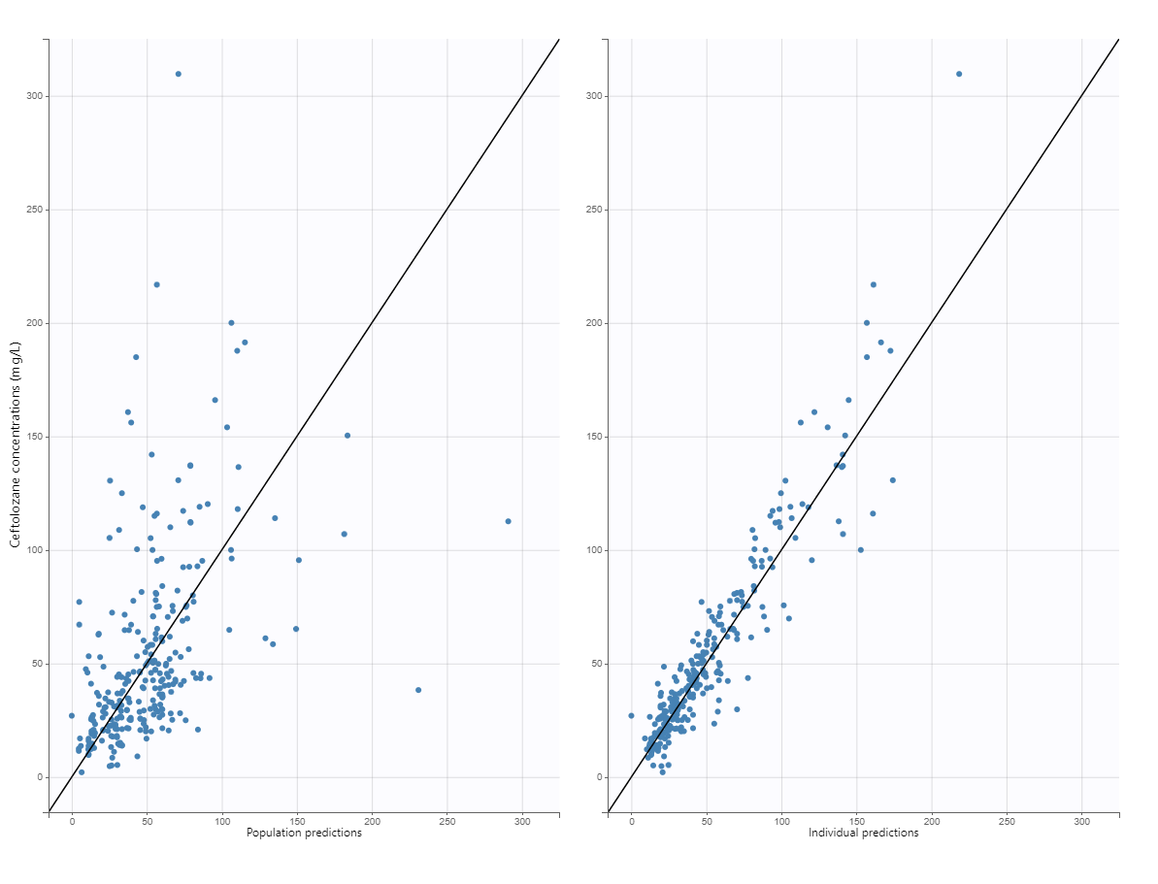A
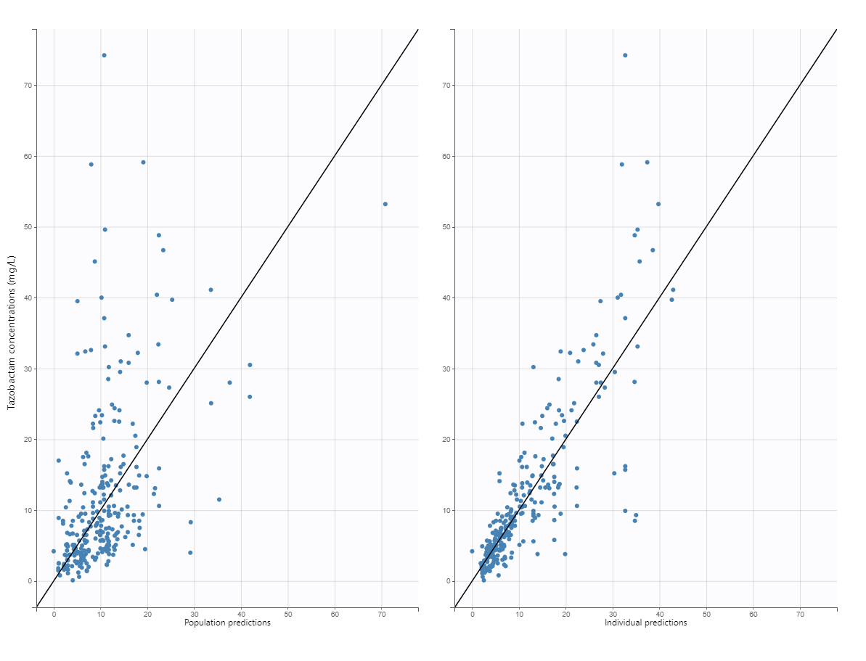B
Figure S3. Scatter plot of the residual vs. time and of the residual vs. individual predictions of ceftolozane (A) and tazobactam (B) for the final population pharmacokinetic model
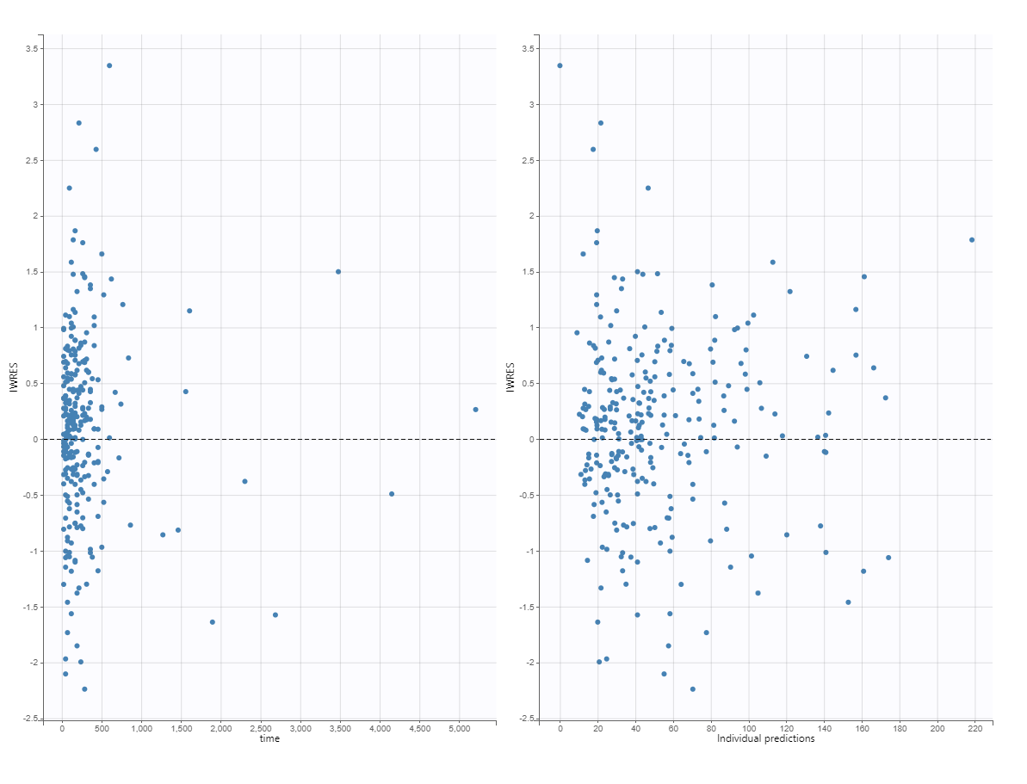A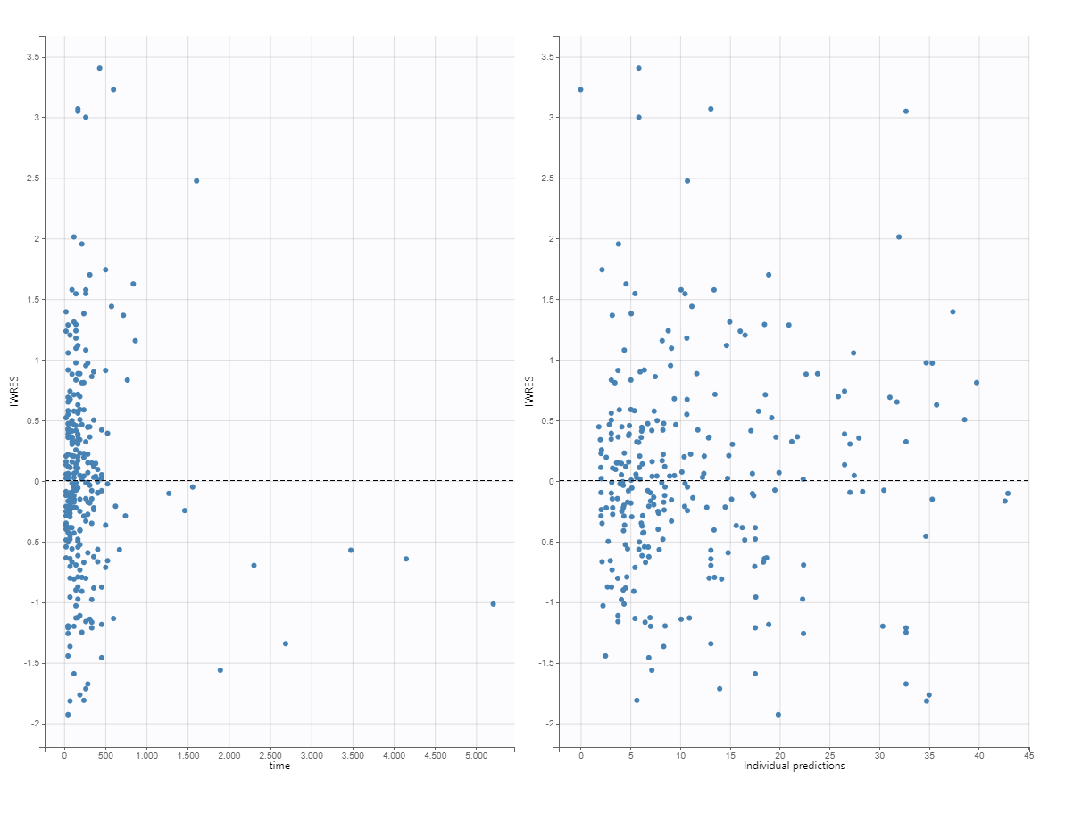B

Figure S4. Distribution of the Individual Weighted Residuals and of the Normalized Prediction Distribution Errors of ceftolozane (A) and tazobactam (B) for the final population pharmacokinetic model
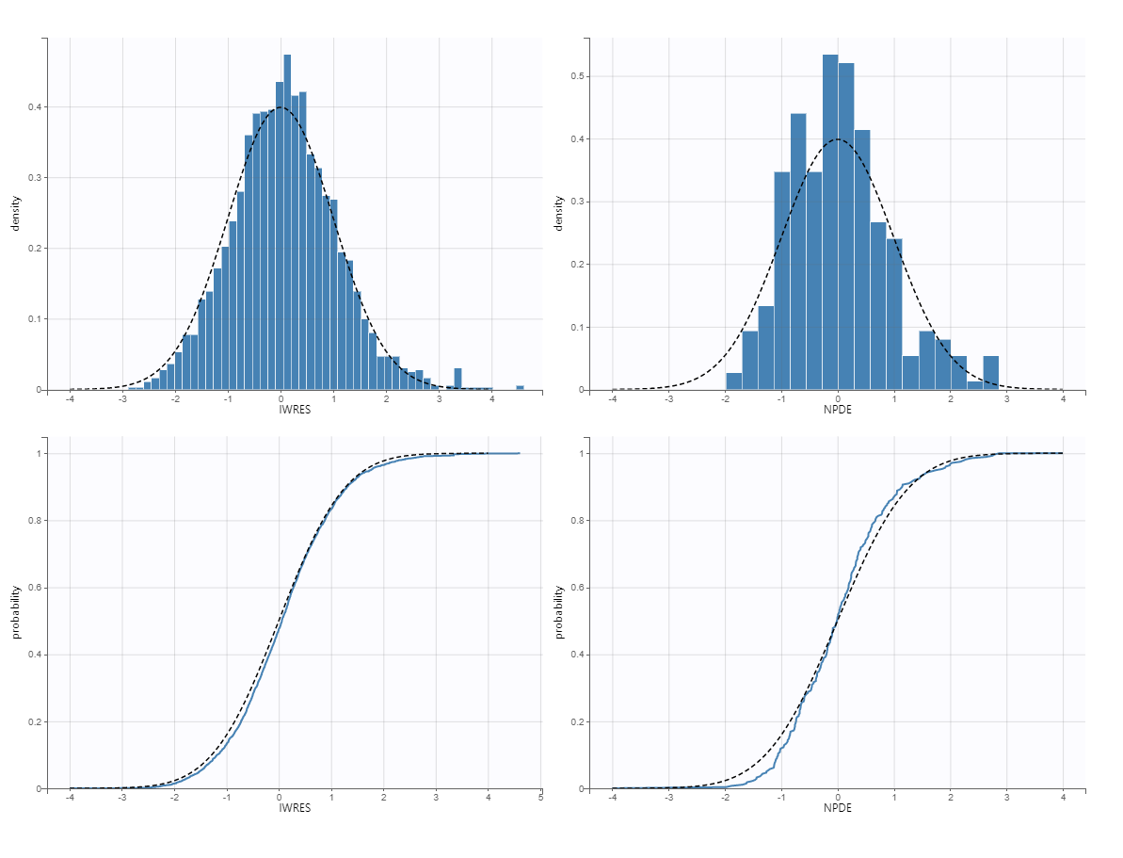A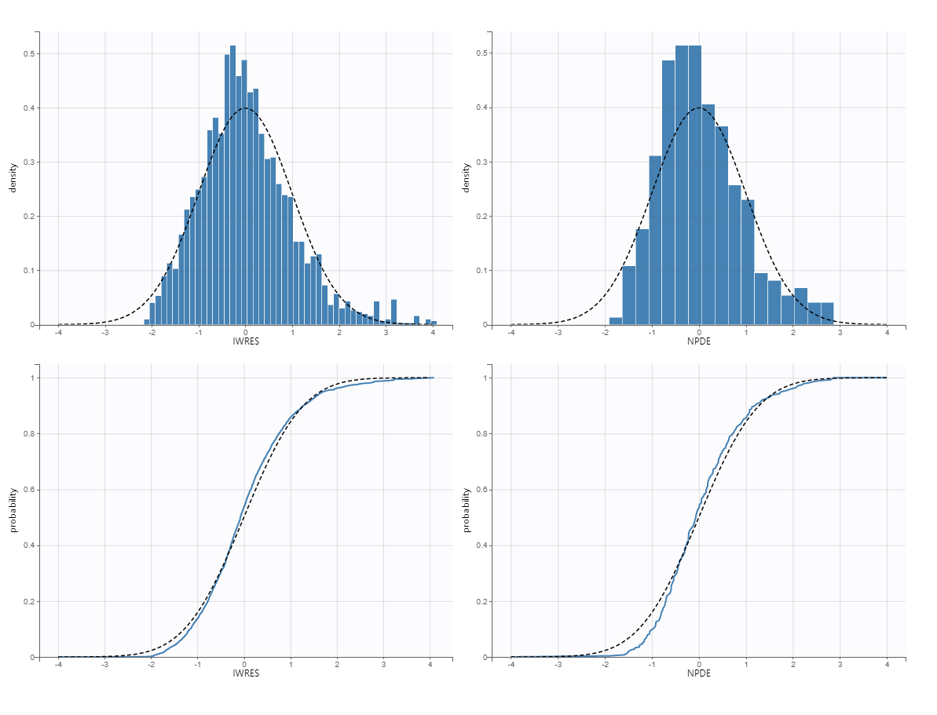B

Figure S5. Visual predictive check (VPC) for the ceftolozane (A) and tazobactam(B) final population pharmacokinetic model
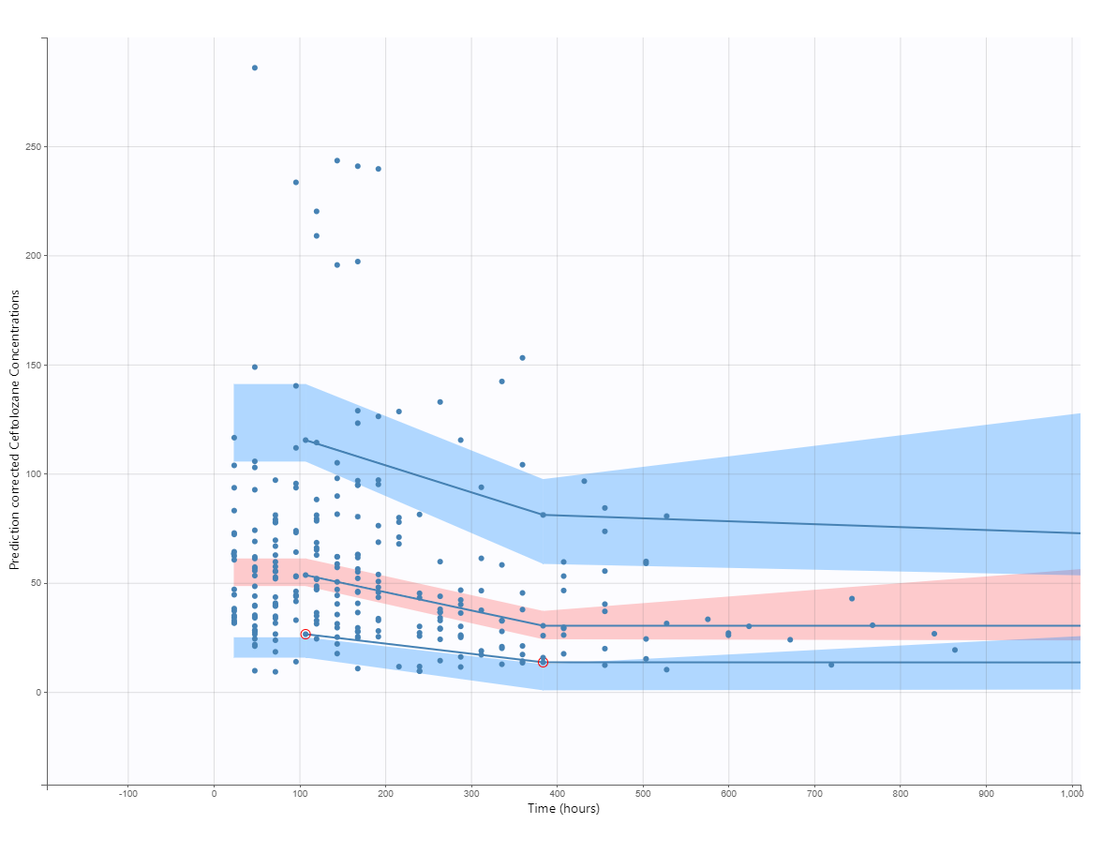A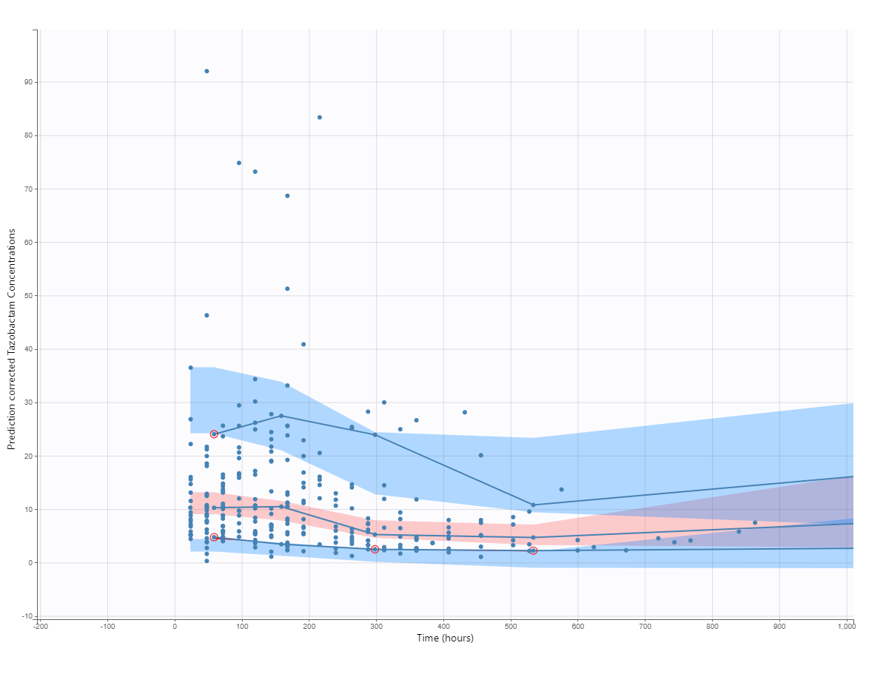B

Figure S6. Distribution of the individual parameters
