Supplemental Materials
This section provides supplementary information and additional analyses to support the findings presented in the main text.

S.1 MCMC Convergence Diagnostics
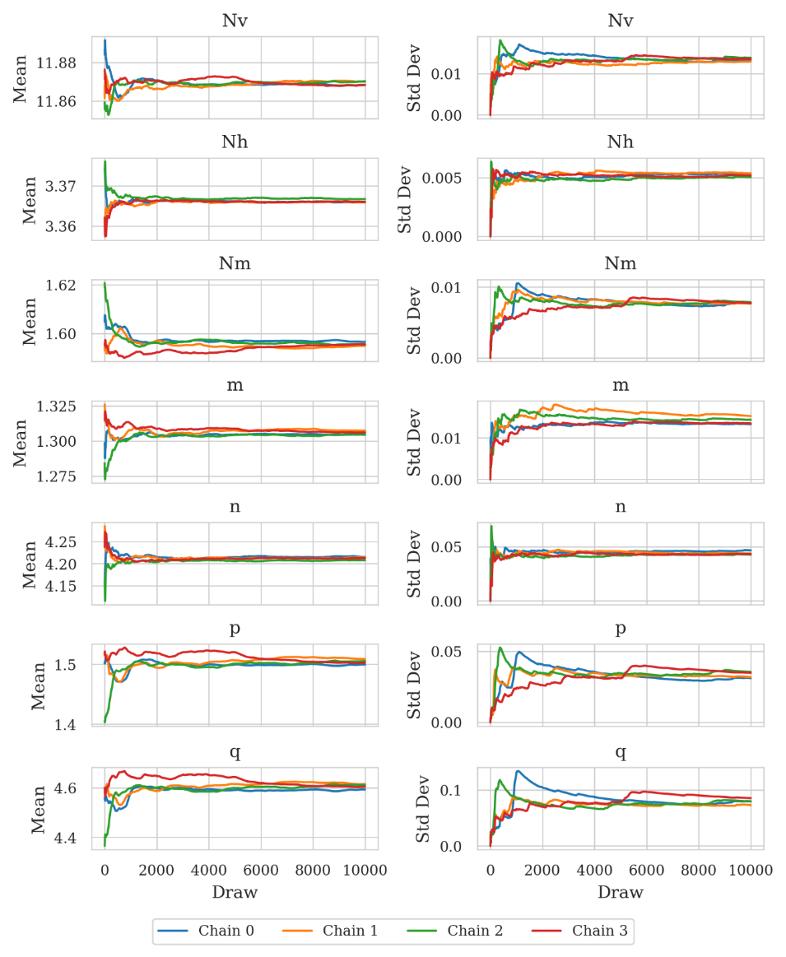
Figure S1. Cumulative mean and standard deviation of the model parameters throughout the MCMC sampling process for the baseline group (A1 experiment).

S.2 PCE Model Coefficients
Table S1 and S2 list the coefficients of the PCE models for vertical (V) and horizontal (H) capacities in the Workflow A and B, respectively.
Table S1. PCE model coefficients for vertical capacity ($V$) and horizontal capacity ($H$) - Workflow A.
PCE Term | V | H | PCE Term | V | H
Constant | 179.143 | 558.948 | Nm·n | -0.246 | 0.949
M | -8.577 | -19.349 | Nm·p | -5.220 | 1.812
M² | -0.168 | -0.286 | Nm·q | -0.973 | 0.014
H | -4.694 | - | m·n | -0.797 | -1.248
H² | -0.069 | - | m·p | -0.985 | 4.291
V | - | -6.789 | m·q | -1.229 | -1.991
V² | - | -0.027 | n·p | 0.410 | 0.717
Nv | -40.553 | 20.501 | n·q | -0.509 | -0.435
Nv² | 1.861 | -5.875 | p·q | 1.077 | 2.487
Nh | 53.295 | -120.108 | M·H | -0.022 | -
Nh² | -7.895 | -0.744 | M·V | - | -0.124
Nm | 49.432 | -165.750 | M·Nv | -0.245 | 1.816
Nm² | -29.891 | -10.714 | M·Nh | 0.306 | -0.701
m | -20.650 | 4.262 | M·Nm | 3.835 | 3.916
m² | -4.404 | -9.017 | M·m | 1.203 | 2.901
n | 7.334 | 3.298 | M·n | 0.108 | 0.206
n² | -0.623 | -0.411 | M·p | -0.406 | -2.121
p | 16.005 | -17.800 | M·q | 0.481 | 0.819
p² | 3.290 | 0.148 | H·Nv | -0.033 | -
q | 4.307 | -1.130 | H·Nh | 1.340 | -
q² | -0.579 | -0.613 | H·Nm | 0.008 | -
Nv·Nh | -1.352 | 10.110 | H·m | 0.415 | -
Nv·Nm | 3.312 | 7.640 | H·n | 0.272 | -
Nv·m | 3.626 | -5.298 | H·p | -0.314 | -
Nv·n | 0.213 | -0.916 | H·q | 0.161 | -
Nv·p | -2.508 | 6.861 | V·Nv | - | 0.874
Nv·q | 0.597 | -1.141 | V·Nh | - | -0.235
Nh·Nm | 5.092 | 16.969 | V·Nm | - | 0.380
Nh·m | -1.073 | 1.681 | V·m | - | 0.824
Nh·n | -1.270 | 2.161 | V·n | - | 0.067
Nh·p | 1.786 | -4.593 | V·p | - | -0.783
Nh·q | -1.188 | 0.508 | V·q | - | 0.206

Table S2. PCE model coefficients for vertical capacity (V) and horizontal capacity (H) - Workflow B.
PCE Term | V | H
Constant | -2.26 | -3.056
$M$ | -2.838 | -0.39
$s_{u}$ | 12.142 | 1.002
$x_{α}$ | 17.639 | 14.759
$M^{2}$ | -0.097 | -0.074
$s_{u}^{2}$ | -0.011 | -0.024
$x_{α}^{2}$ | -18.052 | -14.562
$Ms_{u}$ | 0.136 | 0.106
$Mx_{α}$ | 0.294 | -0.498
$s_{u}x_{α}$ | -2.364 | 2.515
Note. PCE Model B predicts the horizontal (H) and vertical (V) plate-anchor capacities from three physical inputs — the applied moment M, the displacement factor $x_{α}$, and the undrained shear strength $s_{u}$.
The coefficients tabulated above are expressed in monomial form in the physical variables (M, $x_{α}$, $s_{u}$), with the $κ=s_{u}/6$ normalisation already absorbed (each internal κ-coefficient divided by 6 raised to the exponent of $s_{u}$ in that term). Consequently $s_{u}$ may be entered directly in kPa, and a prediction is obtained by direct evaluation of
$$H=Σc_{i}·M^{e_{i,1}}·x_{α}^{e_{i,2}}·s_{u}^{e_{i,3}}$$
where the $c_{i}$ and exponents ($e_{i,1},e_{i,2},e_{i,3}$) are those listed in the table. No orthogonal-basis reconstruction or further normalisation is required.
As a reproducibility check, evaluating this expression at the Fig. 9 reference input ($M=12.02kN·m$, $x_{α}=0.75$, $s_{u}=9kPa$) gives $H=15.58kN/m$ and $V=62.53kN/m$, in agreement with the FEA reference values ($H=15.38kN/m$, $V=62.47kN/m$).

S.3 PCE Polynomial-Order Convergence Study
Table S3 summarises the polynomial-order convergence study (orders 1-3) for both PCE models. Here d is the number of input random variables, p the polynomial order, $P+1=\left(d+p\right)!/\left(d!p!\right)$ the number of PCE basis terms (coefficients), N the number of training samples, and κ(A) the design-matrix condition number. At order 3 for Model B, the Cholesky-generated basis is numerically degenerate given 206 training points; the regression remains well-posed via SVD internally.
Table S3. PCE polynomial-order convergence (orders 1–3) for both surrogate models.
Model (response) | d, N | Order p | P+1 | N/ P+1 | κ(A) | Train $R^{2}$ | Test R²
Model A (V) | n=9, N=1000 | 1 | 10 | 100.0:1 | 1.73 | 0.9283 | 0.9273
Model A (V) | n=9, N=1000 | 2 | 55 | 18.2:1 | 7.77 | 0.9962 | 0.9959
Model A (V) | n=9, N=1000 | 3 | 220 | 4.5:1 | 73.20 | 0.9998 | 0.9996
Model A (H) | n=9, N=1000 | 1 | 10 | 100.0:1 | 5.40 | 0.6058 | 0.6094
Model A (H) | n=9, N=1000 | 2 | 55 | 18.2:1 | 186.62 | 0.9371 | 0.9221
Model A (H) | n=9, N=1000 | 3 | 220 | 4.5:1 | 8,216 | 0.9806 | 0.9564
Model B (V) | n=3, N=206 | 1 | 4 | 51.5:1 | 1.34 | 0.9913 | 0.9739
Model B (V) | n=3, N=206 | 2 | 10 | 20.6:1 | 4.43 | 0.9995 | 0.9984
Model B (V) | n=3, N=206 | 3 | 20 | 10.3:1 | — | 0.9998 | 0.9995
Model B (H) | n=3, N=206 | 1 | 4 | 51.5:1 | 1.34 | 0.9281 | 0.8912
Model B (H) | n=3, N=206 | 2 | 10 | 20.6:1 | 4.43 | 0.9945 | 0.9931
Model B (H) | n=3, N=206 | 3 | 20 | 10.3:1 | — | 0.9983 | 0.9977

In the table, n denotes the number of input random variables, p the polynomial order, N the number of training samples, and P+1 the number of PCE basis terms (coefficients), given by the total-degree truncation $P+1=\left(n+p\right)!/\left(n!·p!\right)$. The sample-to-coefficient ratio is therefore $N/P+1$.

