APPENDIX S4
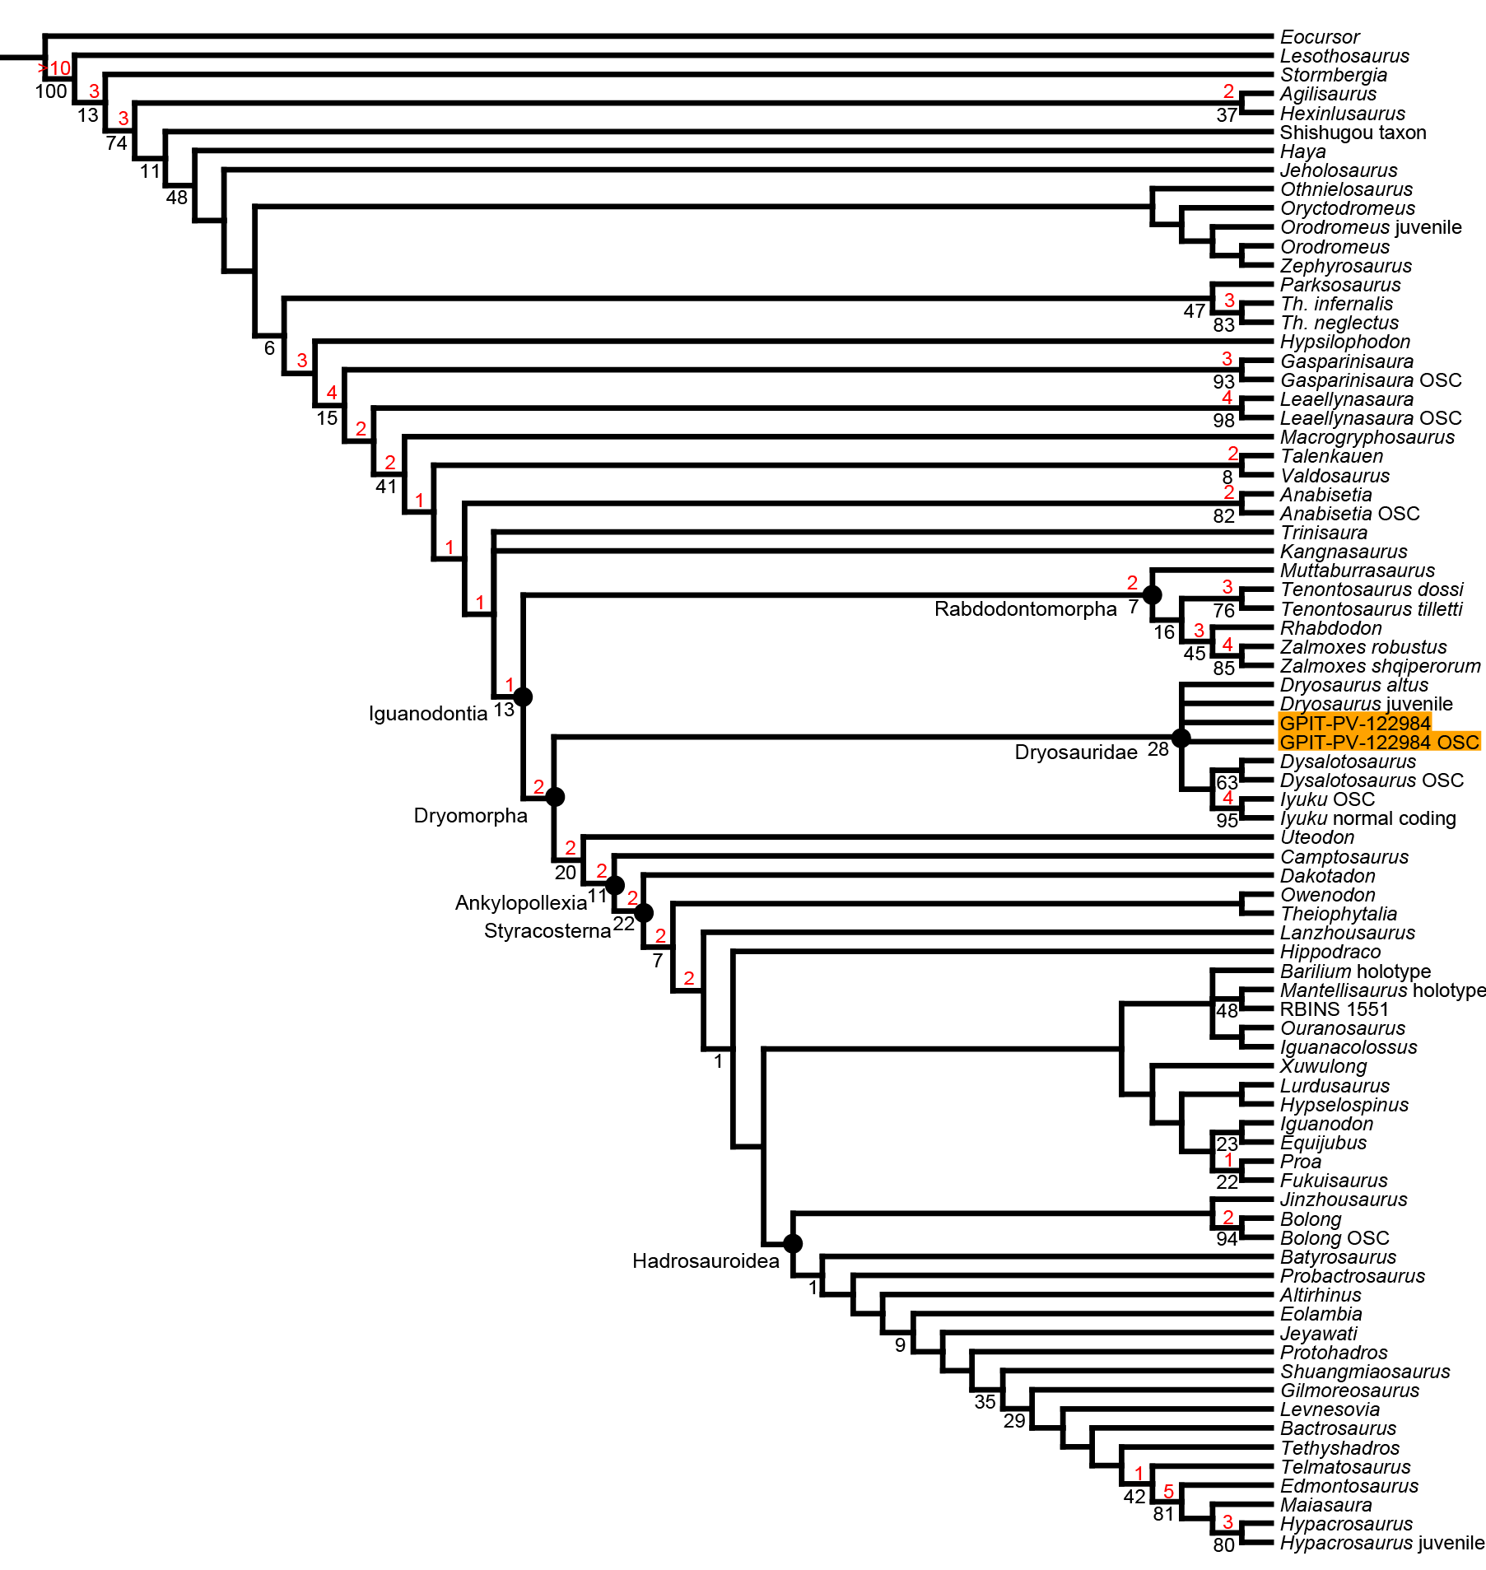
IMPLIED WEIGHTING TREES
FIG. S4.1. Strict consensus tree from the EIW analysis with k = 3. The position of the GPIT-PV-122984 OTUs is highlighted in orange. The numbers above branches (in red) represent Bremer support values, whereas the numbers below branches (in black) represent bootstrap values.

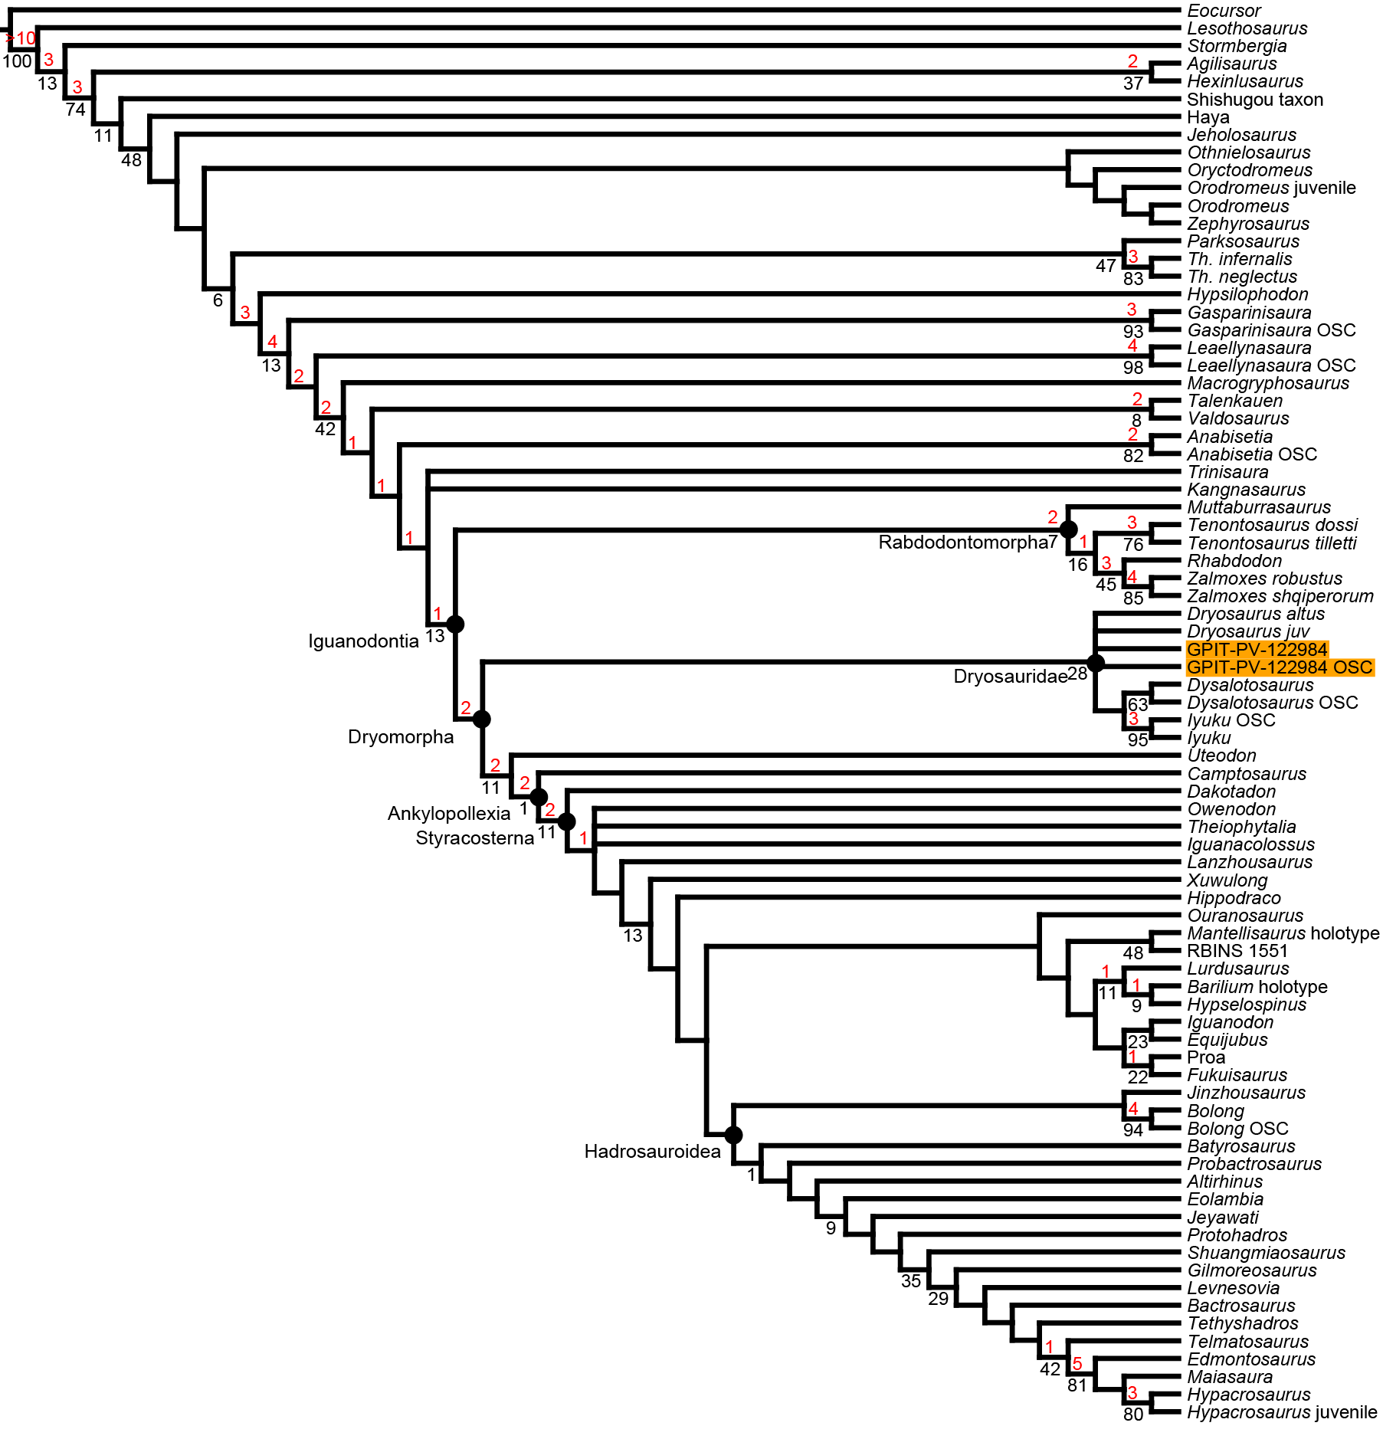
FIG. S4.2. Strict consensus tree from the EIW analysis with k = 5. The position of the GPIT-PV-122984 OTUs is highlighted in orange. The numbers above branches (in red) represent Bremer support values, whereas the numbers below branches (in black) represent bootstrap values.

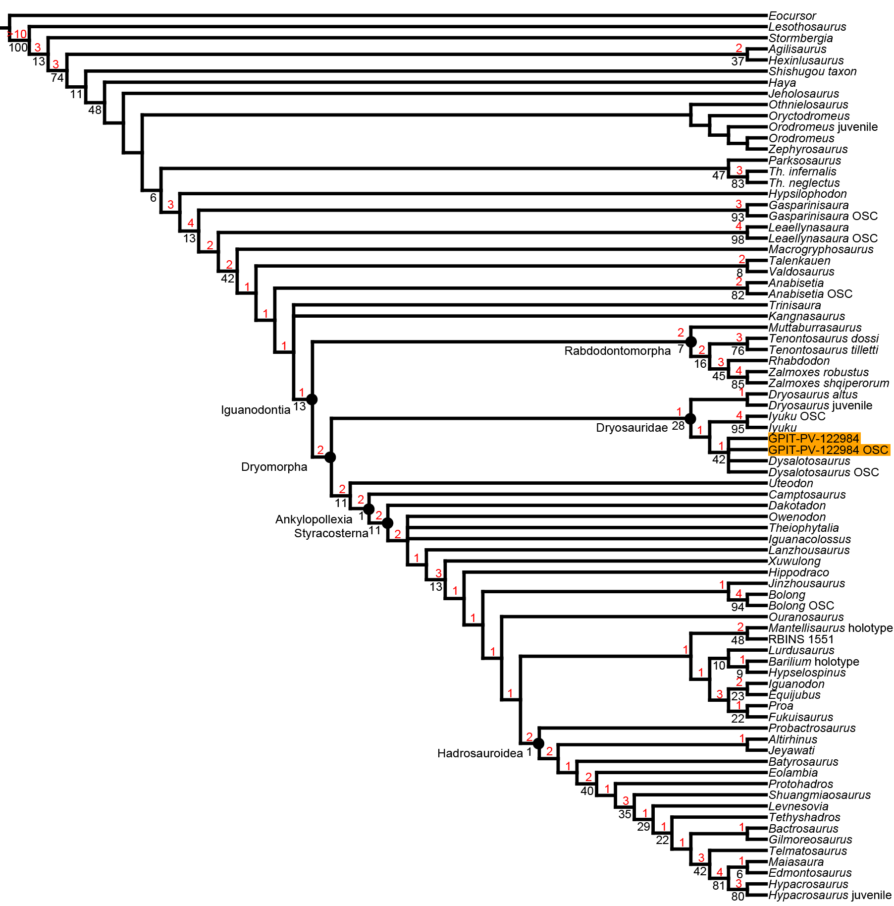
FIG. S4.3. Strict consensus tree from the EIW analysis with k = 10. The position of the GPIT-PV-122984 OTUs is highlighted in orange. The numbers above branches (in red) represent Bremer support values, whereas the numbers below branches (in black) represent bootstrap values.
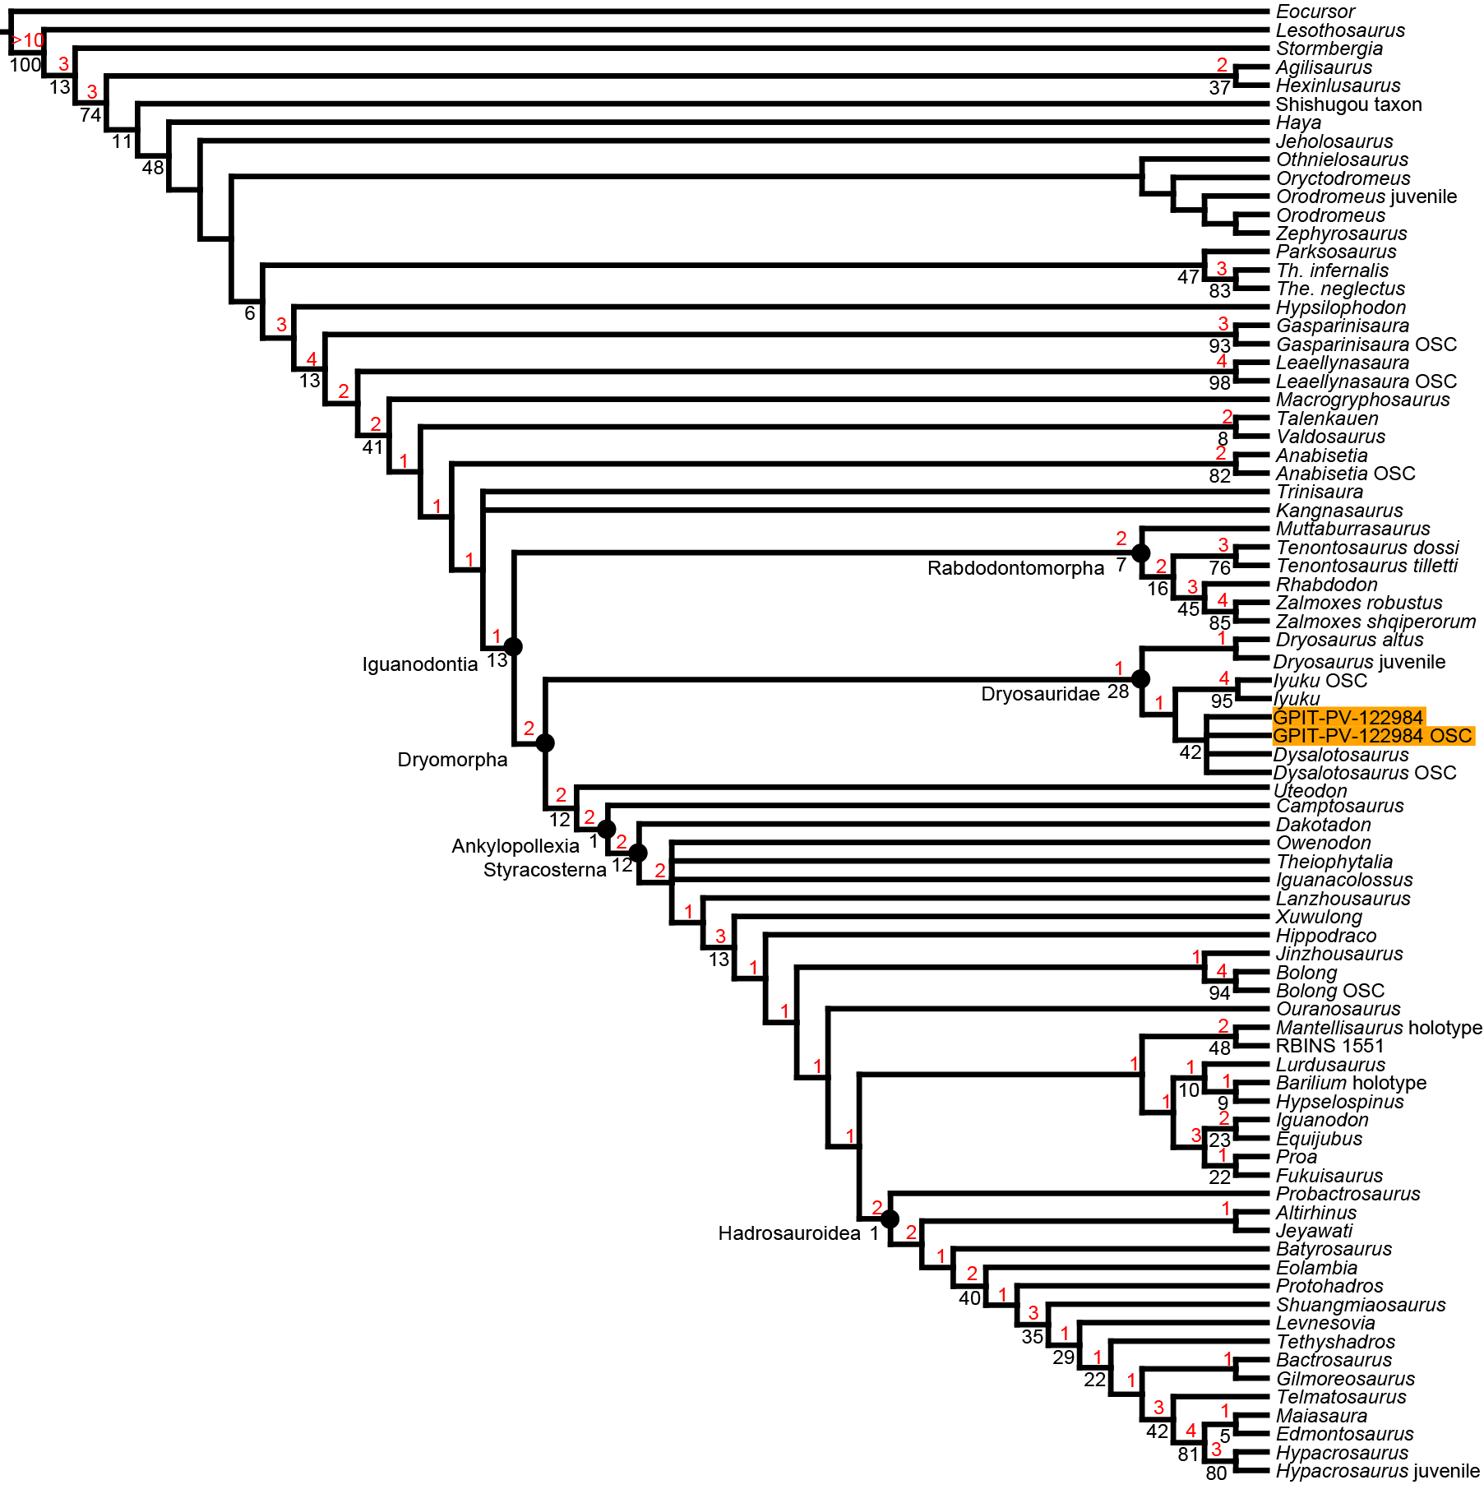
FIG. S4.4. Strict consensus tree from the EIW analysis with k = 11. The position of the GPIT-PV-122984 OTUs is highlighted in orange. The numbers above branches (in red) represent Bremer support values, whereas the numbers below branches (in black) represent bootstrap values.

