Supplementary Materials
Supplementary Table S1. Behavioural ethogram of weaning piglets based on the Welfare Quality (2009) assessment guidelines
Item | Ethogram
Resting | Sleeping and inactivity
Abnormal | Tail biting and ear biting
Positive interaction | Social interaction sniffing, nosing, licking, and moving gently away from the animal without an aggressive or flight reaction from this individual
Negative interaction | Aggressive interaction, including social behaviour with a pig's response to disruption of resting, sleeping, and eating/drinking
Enrichment investigation | Exploring enrichment materials, feeder, and water nipple, including playing/investigation (sniffing, nosing, licking, or chewing)
Pen exploration | Investigation of the pen, including sniffing, nosing, licking, or chewing, all features of the pen (feeder, wall or floor)
Other activities | All other behaviour, including eating and drinking

Supplementary Table S2. Effects of low-protein diets with different amylose/amylopectin ratios on environmental parameters of pig pens.
Item | Diet |  |  | SEM | P-value
Item | CTR | LP¹⁾ | LPLA¹⁾ | SEM | P-value
Phase I: d0 to 21
d0
Light intensity, Lux | 72.70 | 77.70 |  | 4.21 | 0.3982
O₂, Vol% | 20.90 | 20.90 |  | - | -
CO₂, Vol% | 0.19 | 0.20 |  | 0.01 | 0.831
NH₃, ppm | 6.20 | 7.2 |  | 0.96 | 0.410
H₂S, ppm | 0.08 | 0.08 |  | 0.05 | 1.000
CO, Vol% | 0.00 | 0.00 |  | - | -
d7
Light intensity, Lux | 97.90 | 98.7 |  | 6.84 | 0.9254
O₂, Vol% | 20.90 | 20.90 |  | - | -
CO₂, Vol% | 0.31 | 0.31 |  | 0.01 | 0.987
NH₃, ppm | 1.20 | 1.1 |  | 1.09 | 0.9414
H₂S, ppm | 0.0 | 0.0 |  | - | -
CO, Vol% | 0.40 | 0.6 |  | 0.38 | 0.678
d14
Light intensity, Lux | 158.00 | 110 |  | 32.2 | 0.243
O₂, Vol% | 20.90 | 20.90 |  | - | -
CO₂, Vol% | 0.81 | 0.28 |  | 0.30 | 0.1678
NH₃, ppm | 2.50 | 3.3 |  | 1.30 | 0.6222
H₂S, ppm | 0.00 | 0.00 |  | -
CO, Vol% | 0.20 | 1.1 |  | 0.30 | 0.028
d21
Light intensity, Lux | 89.60 | 78.4 |  | 6.37 | 0.1748
O₂, Vol% | 20.90 | 20.9 |  | - | -
CO₂, Vol% | 0.429^{b} | 0.466 |  | 0.02 | 0.2087
NH₃, ppm | 4.30 | 4.15 |  | 0.98 | 0.9028
H₂S, ppm | 0.00 | 0 |  | - | -
CO, Vol% | 0.80 | 0.6 |  | 0.33 | 0.6319
Phase II: d21 to 63
d28
Light intensity, Lux | 81.80 | 87.40 | 78.80 | 7.32 | 0.709
O₂, Vol% | 20.80 | 20.90 | 20.80 | 0.06 | 0.505
CO₂, Vol% | 0.41 | 0.39 | 0.41 | 0.01 | 0.647
NH₃, ppm | 2.90 | 1.20 | 1.50 | 0.93 | 0.411
H₂S, ppm | 0.00 | 0.00 | 0.00 | - | -
CO, Vol% | 2.00 | 2.10 | 2.10 | 0.08 | 0.619
d35
Light intensity, Lux | 67.80 | 66.20 | 70.80 | 7.44 | 0.907
O₂, Vol% | 20.60 | 20.50 | 20.50 | 0.07 | 0.216
CO₂, Vol% | 0.55 | 0.57 | 0.56 | 0.02 | 0.541
NH₃, ppm | 1.50 | 1.60 | 3.10 | 1.13 | 0.551
H₂S, ppm | 0.00 | 0.00 | 0.20 | 0.12 | 0.397
CO, Vol% | 4.30 | 3.80 | 3.50 | 0.52 | 0.560
d43
Light intensity, Lux | 58.90 | 64.70 | 62.70 | 2.96 | 0.399
O₂, Vol% | 20.86 | 20.90 | 20.90 | 0.02 | 0.397
CO₂, Vol% | 0.30 | 0.31 | 0.31 | 0.01 | 0.376
NH₃, ppm | 6.50 | 6.70 | 7.80 | 1.42 | 0.789
H₂S, ppm | 0.04 | 0.04 | 0.00 | 0.03 | 0.619
CO, Vol% | 0.00 | 0.00 | 0.00 | - | -
d53
Light intensity, Lux | 121.00 | 109.00 | 116.00 | 8.96 | 0.684
O₂, Vol% | 20.90 | 20.90 | 20.90 | - | -
CO₂, Vol% | 0.46 | 0.46 | 0.46 | 0.02 | 0.986
NH₃, ppm | 7.20 | 7.30 | 6.80 | 0.35 | 0.581
H₂S, ppm | 0.08 | 0.10 | 0.10 | 0.09 | 0.985
CO, Vol% | 0.00 | 0.00 | 0.00 | - | -
d63
Light intensity, Lux | 84.40 | 86.10 | 156.50 | 31.81 | 0.229
O₂, Vol% | 20.90 | 20.90 | 20.90 | - | -
CO₂, Vol% | 0.45 | 0.45 | 0.45 | 0.03 | 0.991
NH₃, ppm | 4.30 | 4.70 | 5.40 | 0.68 | 0.530
H₂S, ppm | 0.00 | 0.00 | 0.00 | - | -
CO, Vol% | 3.50 | 3.90 | 3.80 | 0.18 | 0.308
Abbreviations: CTR = control group fed a standard diet with medium CP content and a normal AM/AP ratio (d0 to 21: 16.6% CP, 0.17 AM/AP; d21 to 63: 17.2% CP, 0.12 AM/AP), LP = group fed a low-CP diet with a normal AM/AP ratio (d0 to 21: 14.9% CP, 0.16 AM/AP; d21 to 63: 15.0% CP, 0.17 AM/AP), and LPLA = fed a low-CP diet with a low AM/AP ratio (d0 to 21: 14.9% CP, 0.16 AM/AP; d21 to 63: 15.1% CP, 0.08 AM/AP).
¹⁾ The piglets were fed the same diet (14.9% CP, 0.16 AM/AP) from d0 to 21. In Phase 2 (d 21 to 63), pigs assigned to the LP and LPLA treatments were provided with their respective diets: LP (15.0% CP; 0.17 AM/AP) and LPLA (15.1% CP; 0.08 AM/AP).
^{x, y} Different superscripts within a row indicate a tendency for differences among values (P < 0.10).
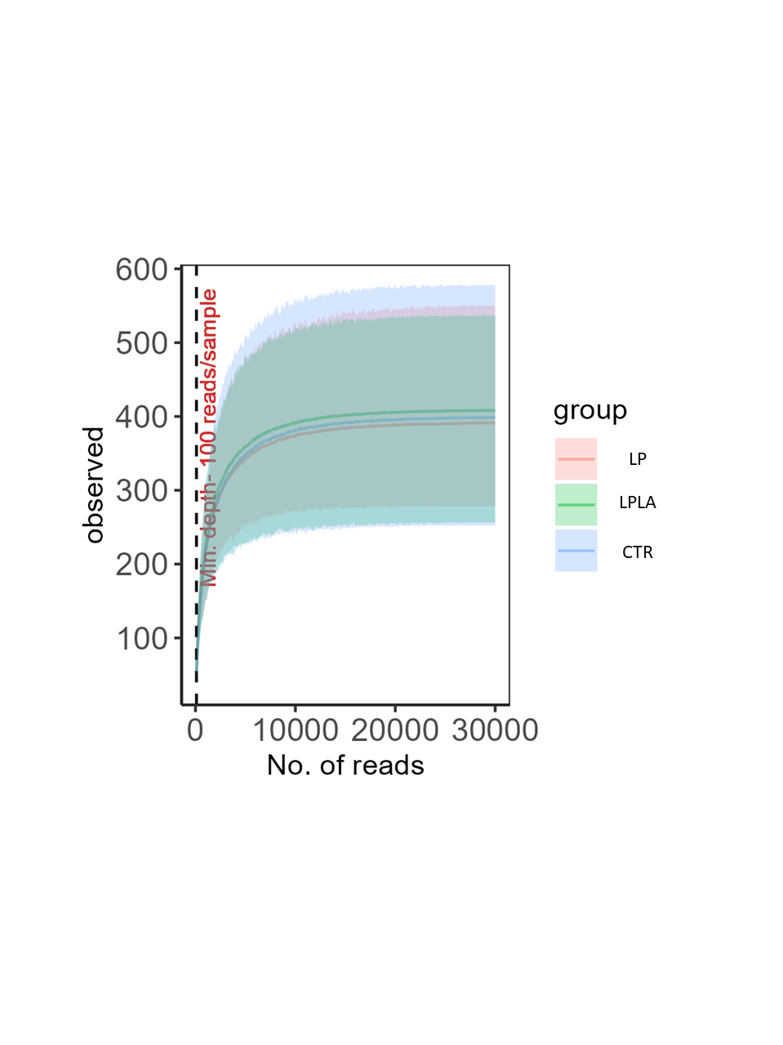
Supplementary Figure S1. Rarefaction curves of piglets’ faecal microbiota. Abbreviations: CTR = control group fed a standard diet with medium CP content and a normal AM/AP ratio (d0 to 21: 16.6% CP, 0.17 AM/AP; d21 to 63: 17.2% CP, 0.12 AM/AP), LP = group fed a low-CP diet with a normal AM/AP ratio (d0 to 21: 14.9% CP, 0.16 AM/AP; d21 to 63: 15.0% CP, 0.17 AM/AP), and LPLA = fed a low-CP diet with a low AM/AP ratio (d0 to 21: 14.9% CP, 0.16 AM/AP; d21 to 63: 15.1% CP, 0.08 AM/AP).
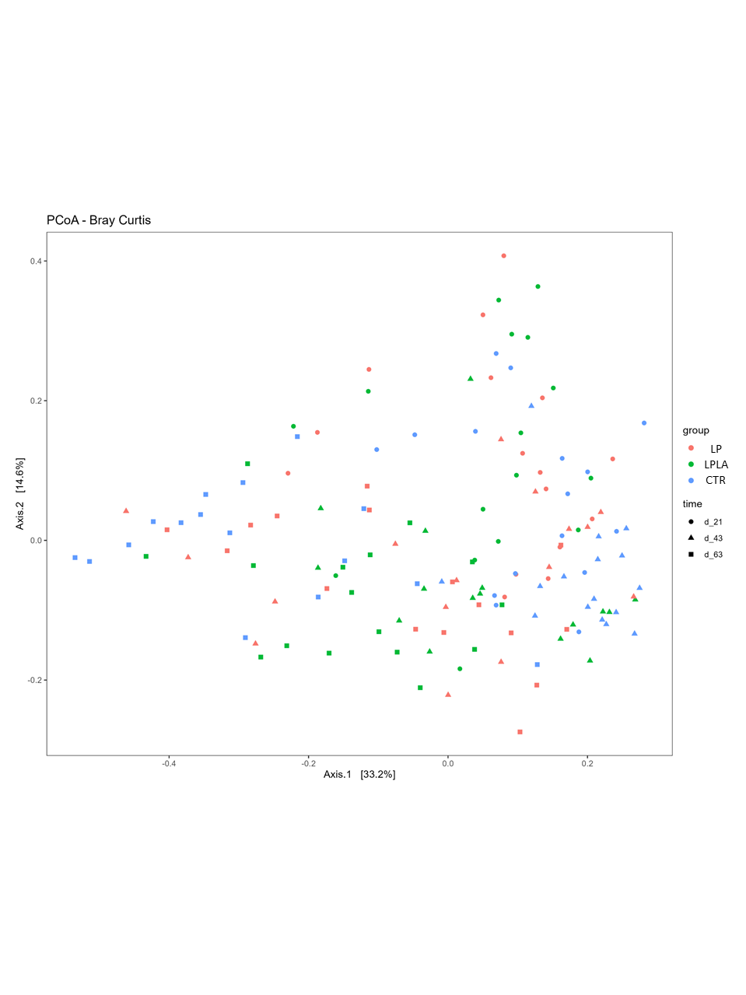
Supplementary Figure S2. Effects of low-protein diets with different amylose/amylopectin ratios on faecal beta diversity of pigs at d21 (P = 0.31, R² = 0.06), 43 (P < 0.011, R² = 0.11), and 63 (P < 0.01, R² = 0.11) post-weaning. Abbreviations: CTR = control group fed a standard diet with medium CP content and a ratio AM/AP ratio (d0 to 21: 16.6% CP, 0.17 AM/AP; d21 to 63: 17.2% CP, 0.12 AM/AP), LP = group fed a low-CP diet with a normal AM/AP ratio (d0 to 21: 14.9% CP, 0.16 AM/AP; d21 to 63: 15.0% CP, 0.17 AM/AP), and LPLA = fed a low-CP diet with a low AM/AP ratio (d0 to 21: 14.9% CP, 0.16 AM/AP; d21 to 63: 15.1% CP, 0.08 AM/AP).

