Supplementary Materials
Methods
- Minimal important difference analysis for the Skindex-29 symptom domain
To aid interpretation of the Skindex-29 symptoms results, analysis of the minimal important difference (MID) was prespecified and outlined in a separate MID analysis plan, which was finalised before database lock. At the time of data cut-off, there was no validated MID specific to the Skindex-29 instrument in the cutaneous T-cell lymphoma population. Therefore, the sponsor developed an analysis plan that employed distribution-based methods to calculate an appropriate MID to be applied to the Skindex-29 data collected in the ALCANZA study. The methods included in the MID analysis plan are consistent with the methods included in European Medicines Agency guidance regarding the use of patient-reported outcome measures in oncology studies. The following methods were used to determine a range of acceptable MID estimates:
1. 0.5 standard deviation (SD) approach:
- 0.5 SD (score change); SD (score change) was calculated as the SD of maximum reduction from baseline of Skindex-29 symptom domain for all patients across different treatment arms
2. Cohen’s moderate effect size:
- X x SD (baseline score); where X is 0.5 for moderate effect. SD (baseline score) will be calculated using baseline Skindex-29 symptom domain scores for all patients across different treatment arms
3. Standard error of measurement (SEM):
SEM=SD (baseline score)√(1 – α).
- Where α is Cronbach’s alpha, the reliability estimate of the Skindex-29 symptom domain at baseline for all patients across different treatment arms, which represents the degree to which items within a scale are inter-correlated with one another
No imputation was used for any missing data for all three methods.

Table S1
Patient compliance with Skindex-29, FACT-G and EQ-5) assessments over time.
 | Skindex-29 |  |  |  | FACT-G |  |  |  | EQ-5D
 | Brentuximab vedotin (n = 64) |  | Methotrexate or bexarotene (n = 64) |  | Brentuximab vedotin (n = 64) |  | Methotrexate or bexarotene (n = 64) |  | Brentuximab vedotin (n = 64) |  | Methotrexate or bexarotene (n = 64)
Study visit | Expected, n | Received, n (%) | Expected, n | Received, n (%) | Expected, n | Received, n (%) | Expected, n | Received, n (%) | Expected, n | Received, n (%) | Expected, n | Received, n (%)
C1D1 | 64 | 63 (98.4) | 63 | 62 (98.4) | 64 | 63 (98.4) | 63 | 62 (98.4) | 64 | 63 (98.4) | 63 | 60 (95.2)
C2D1 | 60 | 58 (96.7) | 57 | 50 (87.7) | 60 | 58 (96.7) | 57 | 51 (89.5) | 60 | 55 (91.7) | 57 | 50 (87.7)
C4D1 | 55 | 52 (94.5) | 36 | 34 (94.4) | 55 | 53 (96.4) | 36 | 36 (100) | 55 | 53 (96.4) | 36 | 35 (97.2)
C6D1 | 46 | 42 (91.3) | 30 | 28 (93.3) | 46 | 43 (93.5) | 30 | 28 (93.3) | 46 | 42 (91.3) | 30 | 27 (90.0)
C8D1 | 41 | 39 (95.1) | 16 | 16 (100) | 41 | 39 (95.1) | 16 | 15 (93.8) | 41 | 39 (95.1) | 16 | 15 (93.8)
C10D1 | 38 | 37 (97.4) | 15 | 15 (100) | 38 | 37 (97.4) | 15 | 15 (100) | 38 | 36 (94.7) | 15 | 15 (100)
C12D1 | 32 | 27 (84.4) | 10 | 10 (100) | 33 | 28 (84.8) | 10 | 10 (100) | 33 | 28 (84.8) | 10 | 10 (100)
C14D1 | 27 | 27 (100) | 6 | 6 (100) | 27 | 27 (100) | 6 | 6 (100) | 27 | 27 (100) | 6 | 6 (100)
C16D1 | 23 | 22 (95.7) | 5 | 4 (80.0) | 23 | 21 (91.3) | 5 | 5 (100) | 23 | 22 (95.7) | 5 | 5 (100)
EOT | 57 | 47 (82.5) | 60 | 42 (70.0) | 57 | 47 (82.5) | 60 | 43 (71.7) | 57 | 47 (82.5) | 60 | 43 (71.7)
Total | 64 | 63 (98.4) | 64 | 62 (96.9) | 64 | 63 (98.4) | 64 | 62 (96.9) | 64 | 63 (98.4) | 64 | 62 (96.9)
C, cycle; D, day; EOT, end of treatment; FACT-G, Functional Assessment of Cancer Therapy-General; EQ-5D, EuroQol 5-Dimension.
Compliance is defined as the number of forms filled out as a proportion of those anticipated. The anticipated number of forms is the total number which should have been filled out by each subject according to the protocol schedule.

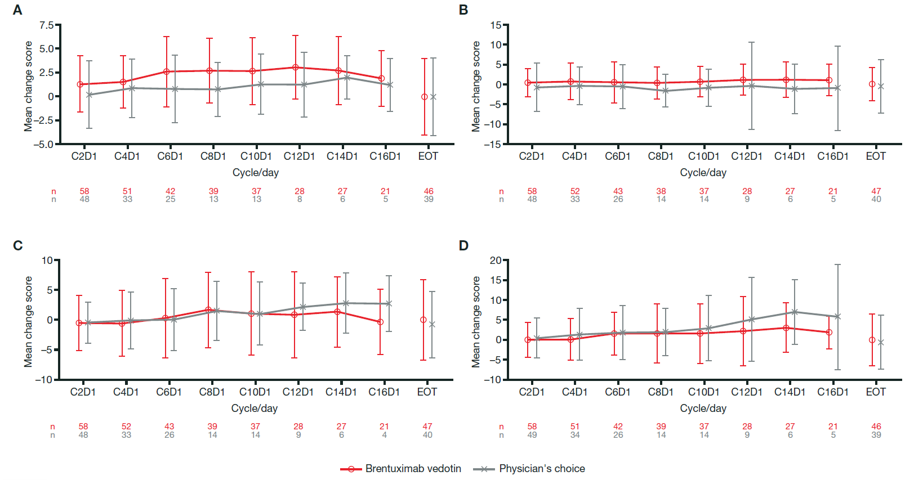
Fig. S1. Mean change from baseline in Functional Assessment of Cancer Therapy-General (FACT-G) scores: (A) emotional subscale, (B) social/family subscale, (C) physical subscale and (D) functional subscale. Bar represents mean ± standard deviation. Higher scores indicate a better quality of life. C, cycle; D, day; EOT, end of treatment.

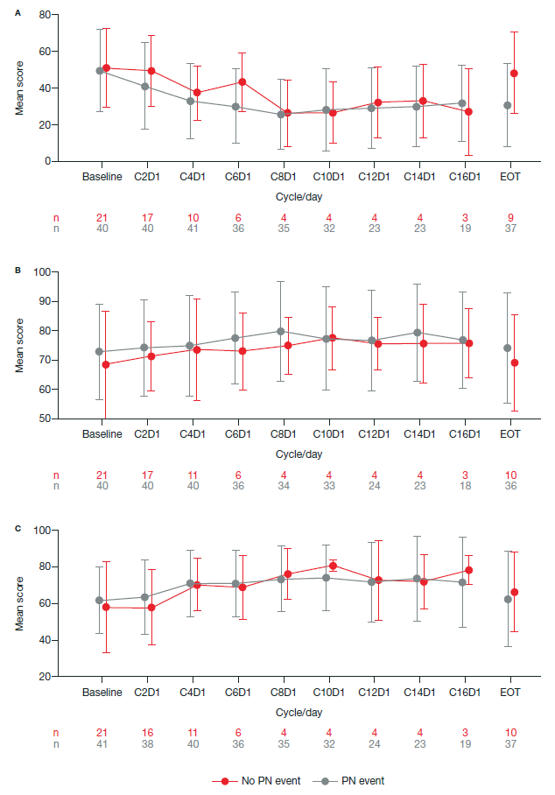
Fig. S2. Mean change from baseline in total scores for (A) Skindex-29, (B) Functional Assessment of Cancer Therapy-General and (C) EuroQoL 5-Dimension in patients with and without peripheral neuropathy. Bar represents mean ± standard deviation. Higher scores indicate a better quality of life. C, cycle; D, day; EOT, end of treatment; PN, peripheral neuropathy.

