Supplementary Information
Mapping the risk of female genital mutilation/modification among girls:
Insights from migrant communities in Italy

Supplementary Figures
Figure S1. – Flowchart illustrating the creation of the analytical sample with inclusion/exclusion criteria.
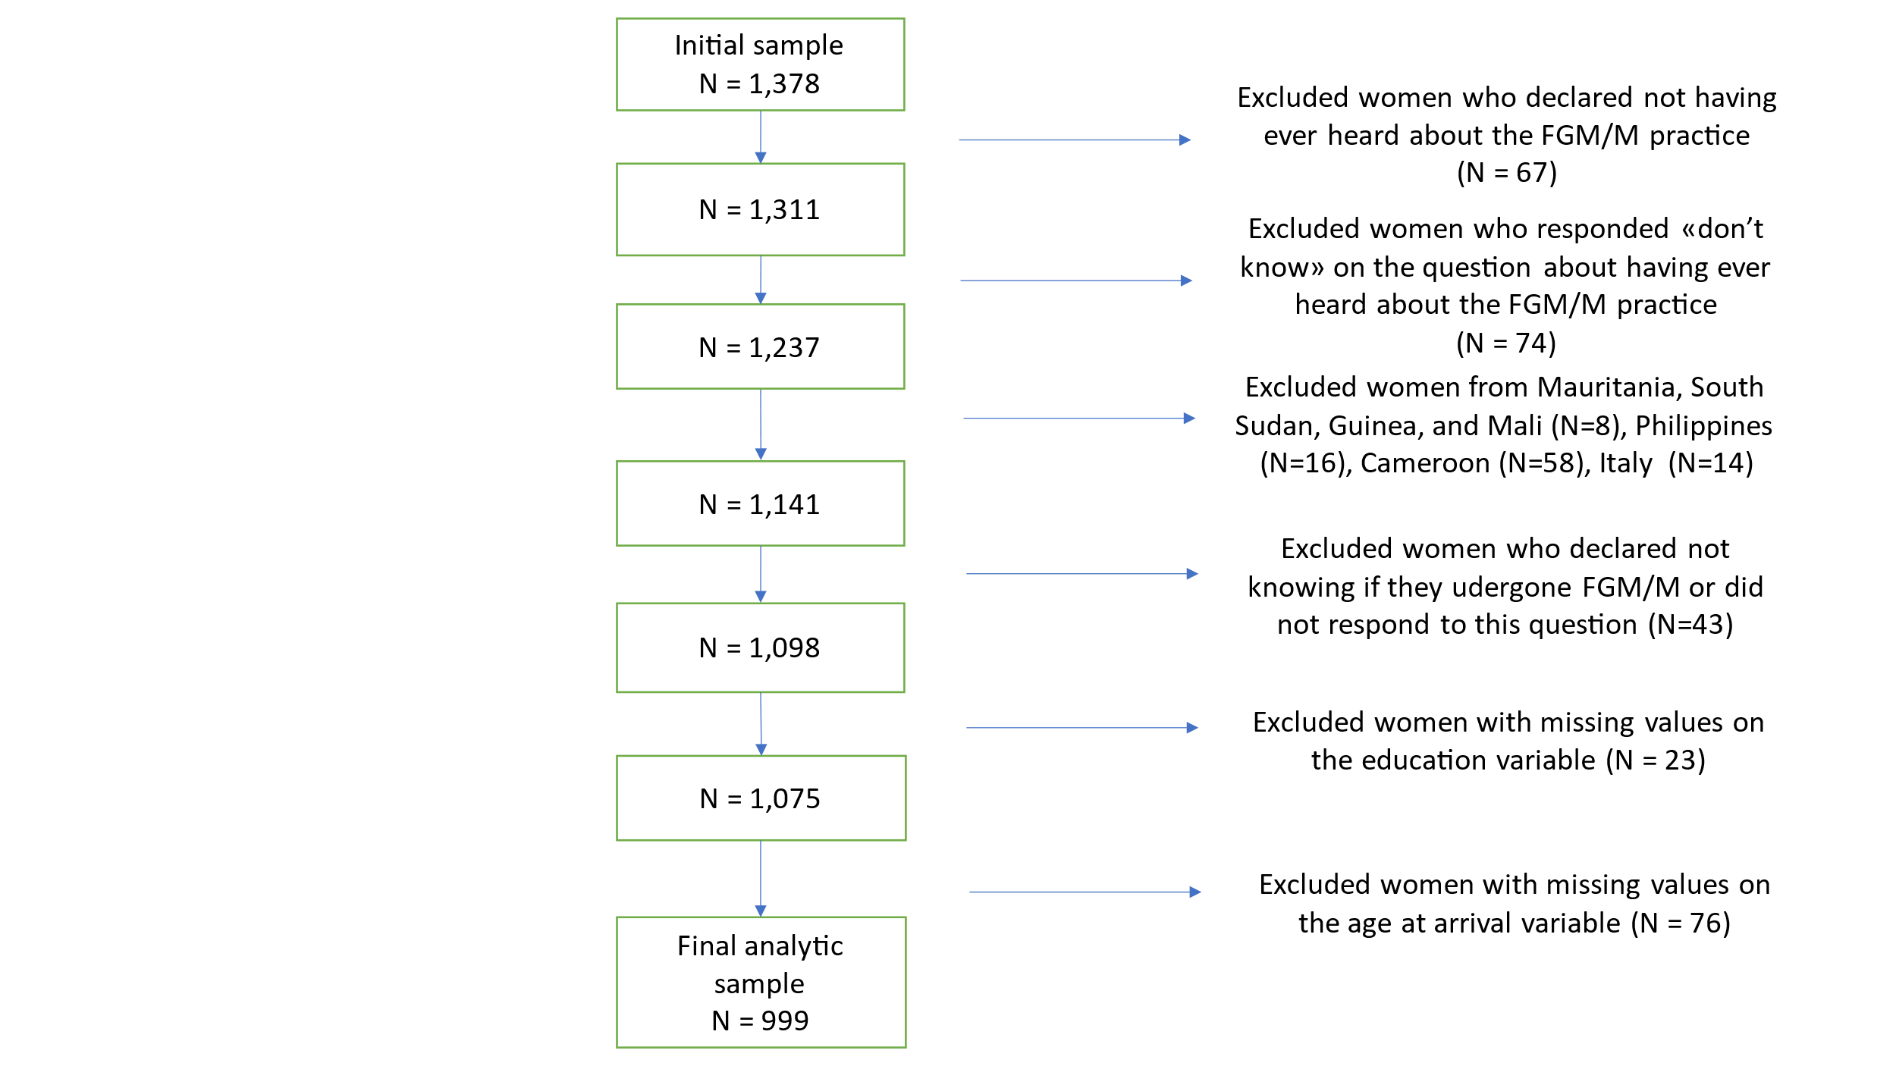

Supplementary Tables
Table S1. – Characteristics of the FGM/M phenomenon in the originating countries selected for this study.
Indicator | Burkina Faso | Côte d’Ivoire | Egypt | Eritrea | Ethiopia | Ghana | Nigeria | Senegal | Somalia
Percentage of girls (aged 0-14) who have undergone FGM | 9.4 | 10.1 | 14.1 | 33.2 | 15.7 | 0.1 | 8.2 | 12.9 | NA
Percentage of girls and women (aged 15-49) who have undergone FGM | 56.1 | 36.7 | 87.2 | 83 | 65.2 | 2.4 | 15.1 | 20.1 | 99.2
Percentage of women (aged 15-49) who think that FGM should be eliminated | 87.1 | 79.4 | 37.5 | 82.2 | 79.3 | 94.4 | 77.4 | 82.2 | 18.9
Percentage of boys and men (aged 15-49) who think that FGM should be eliminated | 81 | NA | 27.9 | 84.9 | 87.6 | NA | 62.1 | 66 | NA
Source: UNICEF datawarehouse.
Data sources. Burkina Faso: DHS 2021; Côte d’Ivoire: UNICEF 2016; Egypt: DHS 2015; Eritrea: Population and Health Survey 2010; Ethiopia: DHS 2016; Ghana: MICS 2017-18; Nigeria: UNICEF 2021; Senegal: continuous DHS 2023: Somalia: SHDS 2020

Table S2. – Background information on the originating countries. Demographic and economic indicators
Indicator | Burkina Faso | Côte d’Ivoire | Egypt | Eritrea | Ethiopia | Ghana | Nigeria | Senegal | Somalia
Infant mortality rate | 44.8 | 46.6 | 16.7 | 25.5 | 35.7 | 28.2 | 60.1 | 30.2 | 67.8
Total dependency ratio | 81.9 | 78.1 | 59.8 | 74.9 | 74.0 | 66.1 | 80.2 | 73.1 | 97.0
Total fertility rate | 4.2 | 4.3 | 2.7 | 3.7 | 3.9 | 3.4 | 4.5 | 3.8 | 6.1
Life expectancy | 61.1 | 61.9 | 71.6 | 68.6 | 67.3 | 65.5 | 54.5 | 68.7 | 58.8
GDP per capita ($) | 1.7 | 4.0 | 13.2 | NA | 2.3 | 4.2 | 5.1 | 2.7 | NA
Gini index | 37.4 | 35.3 | 28.5 | NA | 31.1 | 43.5 | 33.9 | 36.2 | NA
HDI | 0.46 | 0.58 | 0.75 | 0.50 | 0.49 | 0.63 | 0.56 | 0.53 | 0.40
Data are from the UNICEF database for 2023. Infant mortality rate: Deaths per 1,000 live births; Total dependency ratio (%): Number of children (0-14 years old) and older persons (65 years or over) to the working age population (15-64 years old). Total fertility rate: Average number of live births a hypothetical cohort of women would have at the end of their reproductive period if they were subject during their whole lives to the fertility rates of a given period and if they were not subject to mortality. Life expectancy: number of years newborn children would live if subject to the mortality risks prevailing for the cross section of the population at that time.
HDI: Human Development Index, 2023 and GDP data, 2022 are from ourworldindata.org
Gini index is from World Bank data. We report the most recent available data: Burkina Faso (2021); Côte d’Ivoire (2021); Egypt (2021); Ethiopia (2021); Nigeria (2022); Senegal (2021)

Table S3. – Summary statistics of the variable Time.Spent stratified by Birthplace
Country | Min | 1st Qu. | Median | 3rd Qu. | Max | Mean | SD
Burkina Faso | 0 | 2 | 9 | 14 | 28 | 9.26 | 7.42
Côte d’Ivoire | 0 | 7.75 | 12 | 16 | 52 | 12.59 | 7.95
Egypt | 0 | 2 | 7 | 16 | 39 | 9.53 | 8.76
Eritrea&Ethiopia | 0 | 2 | 6 | 28 | 44 | 14.33 | 14
Ghana | 0 | 3.75 | 13 | 17 | 23 | 11.41 | 6.9
Nigeria | 0 | 0 | 1 | 6 | 27 | 4.19 | 6.16
Senegal | 0 | 5 | 9 | 13 | 32 | 9.57 | 5.63
Somalia | 0 | 14 | 23 | 26 | 41 | 19.23 | 11.01

