Differences in facial emotion recognition between bipolar disorder and other clinical populations: a systematic review and meta-analysis

Michele De Prisco ^{1,2,3,4,ψ} (deprisco.michele@gmail.com) (ORCID: 0000-0002-2032-1181);
Vincenzo Oliva ^{1,2,3,5,ψ} (violiva@recerca.clinic.cat) (ORCID: 0000-0002-5961-6032);
Giovanna Fico ^{1,2,3} (gfico@recerca.clinic.cat) (ORCID: 0000-0003-1785-7126);
Laura Montejo ^{1,2,3,4} (lmontejo@recerca.clinic.cat) (ORCID: 0000-0003-4407-9454);
Chiara Possidente ^{2,3,5} (chiara.possidente@studio.unibo.it) (ORCID: 0009-0001-6187-0187);
Lorenzo Bracco ^{2,3,6} (lorenzobracco94@gmail.com) (ORCID: 0000-0002-7698-0901);
Lydia Fortea ^{1,7} (lydiafor94@gmail.com) (ORCID: 0000-0001-6778-2316);
Gerard Anmella ^{1,2,3} (anmella@clinic.cat) (ORCID: 0000-0002-6798-4054);
Diego Hidalgo-Mazzei ^{1,2,3} (dahidalg@clinic.cat) (ORCID: 0000-0002-2693-6849);
Michele Fornaro ⁸ (dott.fornaro@gmail.com) (ORCID: 0000-0002-9647-0853);
Andrea de Bartolomeis ⁸ (adebarto@unina.it) (ORCID: 0000-0002-3188-5652);
Alessandro Serretti ⁵ (alessandro.serretti@unibo.it) (ORCID: 0000-0003-4363-3759);
Andrea Murru ^{1,2,3} (amurru@clinic.cat) (ORCID: 0000-0001-6320-4420);
Eduard Vieta ^{1,2,3,4*} (evieta@clinic.cat) (ORCID: 0000-0002-0548-0053);
Joaquim Radua ^{4,7,9,10} (quimradua@gmail.com) (ORCID: 0000-0003-1240-5438)

¹ Departament de Medicina, Facultat de Medicina i Ciències de la Salut, Universitat de Barcelona (UB), c. Casanova, 143, 08036 Barcelona, Spain.
² Bipolar and Depressive Disorders Unit, Hospìtal Clinic de Barcelona. c. Villarroel, 170, 08036 Barcelona, Spain.
³ Institut d’Investigacions Biomèdiques August Pi i Sunyer (IDIBAPS), c. Villarroel, 170, 08036 Barcelona, Spain.
⁴ Centro de Investigación Biomédica en Red de Salud Mental (CIBERSAM), Instituto de Salud Carlos III, Madrid, Spain
⁵ Department of Biomedical and Neuromotor Sciences, University of Bologna, Bologna, Italy;
⁶ Department of Pathophysiology and Transplantation, University of Milan, 20122 Milan, Italy;
⁷ Imaging of Mood- and Anxiety-Related Disorders (IMARD) Group, IDIBAPS, Barcelona, Spain
⁸ Section of Psychiatry, Department of Neuroscience, Reproductive Science and Odontostomatology Federico II University of Naples, Naples, Italy;
⁹ Early Psychosis: Interventions and Clinical-Detection (EPIC) Lab, Department of Psychosis Studies, Institute of Psychiatry, Psychology & Neuroscience, King’s College London, London, United Kingdom
¹⁰ Centre for Psychiatric Research and Education, Department of Clinical Neuroscience, Karolinska Institutet, Stockholm, Sweden

ψ The authors contributed equally

* Corresponding Author
Prof. Eduard Vieta, MD, PhD
Bipolar and Depressive Disorders Unit,
Institute of Neuroscience
IDIBAPS CIBERSAM
Hospital Clinic, University of Barcelona,
170 Villarroel St 12-0, 08036 Barcelona, Catalonia, Spain.
Email: evieta@clinic.cat
Supplementary Materials

Abbreviations used in the Supplementary Materials 4
Deviations from the original protocol 6
Search Strategy 7
Detailed description of the emotion recognition task adopted by the included studies 17
Quality assessment of the included studies, cross-sectional 21
Quality assessment of the included studies, longitudinal 23
Control Group: Schizophrenia and schizophrenia spectrum disorder (SCZ) 24
Upper level, identification 24
Any emotion, accuracy 24
Any emotion, reaction time 29
Upper level, discrimination 32
Any emotion, accuracy 32
Middle level, identification 36
Positive emotions, accuracy 36
Positive emotions, reaction time 39
Negative emotions, accuracy 41
Negative emotions, reaction time 45
Lower level, identification 47
Anger, accuracy 47
Anger, reaction time 49
Disgust, accuracy 50
Fear, accuracy 52
Fear, reaction time 54
Happiness, accuracy 55
Happiness, reaction time 57
Sadness, accuracy 58
Sadness, reaction time 60
Surprise, accuracy 61
Control Group: Major depressive disorder (MDD) 62
Upper level, identification 62
Any emotion, accuracy 62
Middle level, identification 66
Positive emotions, accuracy 66
Negative emotions, accuracy 70
Lower level, identification 73
Anger, accuracy 73
Disgust, accuracy 76
Fear, accuracy 78
Happiness, accuracy 81
Sadness, accuracy 84
Surprise, accuracy 87
Neutral, accuracy 88
Control Group: Attention deficit/hyperactivity disorder (ADHD) 90
Upper level, identification 90
Any emotion, accuracy 90
Middle level, identification 91
Positive emotion, accuracy 91
Negative emotion, accuracy 92
Lower level, identification 93
Anger, accuracy 93
Fear, accuracy 94
Happiness, accuracy 95
Sadness, accuracy 96
PRISMA Checklist 97
MOOSE Checklist 100

Abbreviations used in the Supplementary Materials

ADHD, Attention Deficit-Hyperactivity disorder;
BD-I, Bipolar Disorder Type 1;
BD, Bipolar Disorder;
C.I., Confidence intervals;
Cohn-Kanade, Cohn-Kanade Action Unit-Coded Facial Expression Database;
DANVA, Diagnostic Analysis of Non-Verbal Accuracy;
DARE, Dynamic Affect Recognition Evaluation Task;
df, degree of freedom;
DSM, Diagnostic and Statistical Manual of Mental Disorders;
ER-40, Penn Emotion Recognition-40;
FEDT, Facial Emotion Discrimination Test;
FEED, Facial Expression and Emotions Database;
FEEL, Facial Expression Emotion Labeling;
FEEST, Facial Expressions of Emotion: Stimuli and Tests;
FEIT, Facial Emotion and Identification Test;
FEPT, Facial Emotion Perception Test;
FOE, The Face of Emotions;
I², Higgin and Thompson’s I² estimating how much of the total variability in the effect size estimates can be attributed to heterogeneity among the true effects;
ICD, International Classification of Diseases;
ISI, Interstimulus Interval;
MDD, Major Depressive Disorder;
METT, Micro-expression Training Tool;
MIMI, MIMI Facial Expression Database;
NA, Not available;
PEAT, Penn Emotion Acuity Test;
POFA, Pictures of Facial Affect;
Q, Cochran’s Q-test of (residual) heterogeneity;
Qp, p-value for the Cochran’s Q-test of (residual) heterogeneity;
RE, random effect;
SE, standard error;
SETT, Subtle Expression Training Tool;
SMD, Standardized Mean Difference
TASIT, The Awareness of Social Inference Test;
tau², estimate of the variance of the underlying distribution of true effect sizes (between-study variance)
TRENDS, Tool for Recognition of Emotions in Neuropsychiatric Disorders
𝛽, estimated coefficient of the model;

Deviations from the original protocol

In the original protocol, we planned to examine differences between people with BD and clinical and non-clinical populations. However, due to the large number of results, we decided to focus only on clinical groups to allow for a deeper and more focused discussion and clearer presentation of results.
In addition, we planned to perform a cumulative analysis to examine the effect of the publication year on our results. However, we decided to use the meta-regressions instead to explore this association in order to provide the reader with a more uniform presentation of our results.
We added the “duration of the stimuli” and the “presence or not of morphed faces” as predictors to be explored through meta-regression analyses.
Finally, following a comment made by a reviewer during the peer review process, we added the “NOS score”, the “% of people with BD treated with antipsychotics”, the “% of people with BD treated with antidepressants”, and the “% of people with BD treated with mood stabilizers” as predictors to be explored through meta-regression analyses.

Search Strategy

PubMed/MEDLINE (26.04.23: 668 results)

("surprise"[Title/Abstract] OR "fearful faces"[Title/Abstract] OR "disgust"[Title/Abstract] OR "happy faces"[Title/Abstract] OR "sad faces"[Title/Abstract] OR "angry faces"[Title/Abstract] OR "facial"[Title/Abstract] OR "facial expression"[Title/Abstract] OR "facial emotion"[Title/Abstract] OR "facial expressions"[Title/Abstract] OR "facial emotions"[Title/Abstract] OR "facial recognition"[MeSH Major Topic]) AND ("bipolar"[Title/Abstract] OR "bipolar disorder"[Title/Abstract] OR "mania"[Title/Abstract] OR "hypomania"[Title/Abstract] OR "manic"[Title/Abstract] OR "hypomanic"[Title/Abstract] OR "bipolar depression"[Title/Abstract] OR "euthymia"[Title/Abstract] OR "euthymic"[Title/Abstract] OR "bipolar disorder"[MeSH Terms])

Scopus (26.04.23: 907 results)

(TITLE-ABS(surprise) OR TITLE-ABS("fearful faces") OR TITLE-ABS(disgust) OR TITLE-ABS("happy faces") OR TITLE-ABS("sad faces") OR TITLE-ABS("angry faces") OR TITLE-ABS(facial) OR TITLE-ABS("facial expression") OR TITLE-ABS("facial emotion") OR TITLE-ABS("facial expressions") OR TITLE-ABS("facial emotions") OR INDEXTERMS("facial recognition")) AND (TITLE-ABS(bipolar) OR TITLE-ABS("bipolar disorder") OR TITLE-ABS(mania) OR TITLE-ABS(hypomania) OR TITLE-ABS(manic) OR TITLE-ABS(hypomanic) OR TITLE-ABS("bipolar depression") OR TITLE-ABS(euthymia) OR TITLE-ABS(euthymic) OR INDEXTERMS("bipolar disorder"))

EMBASE (26.04.23: 1178 results)

(surprise:ti,ab OR 'fearful faces':ti,ab OR disgust:ti,ab OR 'happy faces':ti,ab OR 'sad faces':ti,ab OR 'angry faces':ti,ab OR facial:ti,ab OR 'facial expression':ti,ab OR 'facial emotion':ti,ab OR 'facial expressions':ti,ab OR 'facial emotions':ti,ab OR 'facial recognition'/exp/mj) AND (bipolar:ti,ab OR 'bipolar disorder':ti,ab OR mania:ti,ab OR hypomania:ti,ab OR manic:ti,ab OR hypomanic:ti,ab OR 'bipolar depression':ti,ab OR euthymia:ti,ab OR euthymic:ti,ab OR 'bipolar disorder'/exp)

PsycINFO (26.04.23: 480 results)

(TI(surprise) OR TI(fearful faces) OR TI(disgust) OR TI(happy faces) OR TI(sad faces) OR TI(angry faces) OR TI(facial) OR TI(facial expression) OR TI(facial emotion) OR TI(facial expressions) OR TI(facial emotions) OR TI(facial recognition) OR AB(surprise) OR AB(fearful faces) OR AB(disgust) OR AB(happy faces) OR AB(sad faces) OR AB(angry faces) OR AB(facial) OR AB(facial expression) OR AB(facial emotion) OR AB(facial expressions) OR AB(facial emotions) OR AB(facial recognition)) AND (TI(bipolar) OR TI(bipolar disorder) OR TI(mania) OR TI(hypomania) OR TI(manic) OR TI(hypomanic) OR TI(bipolar depression) OR TI(euthymia) OR TI(euthymic) OR AB(bipolar) OR AB(bipolar disorder) OR AB(mania) OR AB(hypomania) OR AB(manic) OR AB(hypomanic) OR AB(bipolar depression) OR AB(euthymia) OR AB(euthymic))

Excluded studies with reasons

Author, year | Reason
(Aas, Kauppi et al. 2017) | Results not stratified according to our research question
(Almeida 2010) | Conference Abstract
(Almeida 2011) | Conference Abstract
(Almeida, Mourao-Miranda et al. 2017) | Conference Abstract
(Anand 2014) | Conference Abstract
(Asch, Cool et al. 2022) | Conference Abstract
(Bae, Jin et al. 2021) | Conference Abstract
(Bauer, Zeni et al. 2018) | Conference Abstract
(Behere, UmeshTonse et al. 2016) | Conference Abstract
(Bertocci, Bebko et al. 2012) | Unrelated to our research question
(Bjertrup, Jensen et al. 2021) | Conference Abstract
(Bürger, Redlich et al. 2017) | Unrelated to our research question
(Diler, de Almeida et al. 2013) | Unrelated to our research question
(Finner, Chan et al. 2016) | Conference Abstract
(Ford, Neufeld et al. 2012) | Conference Abstract
(Fournier, Chase et al. 2013) | Conference Abstract
(Fournier, Keener et al. 2011) | Conference Abstract
(Frandsen, DelDonno et al. 2021) | Conference Abstract
(Getz 2004) | Conference Abstract
(Goghari and Sponheim 2011) | Conference Abstract
(Green, Sparks et al. 2010) | Conference Abstract
(Hanford, Frey et al. 2011) | Conference Abstract
(Hassel, Almeida et al. 2010) | Conference Abstract
(Kaufmann, Alnaes et al. 2017) | Data not available
(Kim, Arizpe et al. 2013) | No DSM/ICD diagnosis for control group
(Kim, Baker et al. 2011) | Conference Abstract
(Lahera, Herrera et al. 2015) | Conference Abstract
(Lee, Altshuler et al. 2013) | Conference Abstract
(Leibenluft 2015) | Conference Abstract
(Lelli-Chiesa, Kempton et al. 2011) | Conference Abstract
(Lowes, Jacobs et al. 2013) | Conference Abstract
(Manelis, Iyengar et al. 2020) | Unrelated to our research question
(Marin, Munoz et al. 2017) | Conference Abstract
(Menkes, Andrews et al. 2022) | Unrelated to our research question
(Passarotti, Sweeney et al. 2010) | Unrelated to our research question
(Perlman, Fournier et al. 2013) | Unrelated to our research question
(Peters, Van Meter et al. 2016) | Conference Abstract
(Phillips 2011) | Conference Abstract
(Phillips 2011) | Book
(Priyesh, Nayak et al. 2018) | Conference Abstract
(Quidé, Cohen-Woods et al. 2018) | Conference Abstract
(Rossell, Van Rheenen et al. 2014) | Conference Abstract
(Rowland, O'Reilly et al. 2014) | Conference Abstract
(Russo, Spencer et al. 2013) | Conference Abstract
(Schaefer, Luckenbaugh et al. 2010) | Conference Abstract
(Sinha 2018) | Conference Abstract
(Stinar 2014) | Conference Abstract
(Sweeney, Keefe et al. 2011) | Conference Abstract
(Tao, Dai et al. 2023) | No DSM/ICD diagnosis
(Thomas, Brotman et al. 2014) | No DSM/ICD diagnosis for control group
(Thomas, Brotman et al. 2012) | No DSM/ICD diagnosis for control group
(Tripoli, Quattrone et al. 2022) | No BD diagnosis
(Van Rheenen, Joshua et al. 2017) | Conference Abstract
(Vederman, Leon et al. 2010) | Conference Abstract
(Villa, Pinkham et al. 2018) | Results not stratified according to our research question
(Wang, Cheng et al. 2023) | Unrelated to our research question
(Wiggins, Brotman et al. 2016) | Data not available
(Wynn, Mathis et al. 2011) | Conference Abstract
(Yalcin, Hofer et al. 2010) | Conference Abstract

References
Aas, M., K. Kauppi, C. Brandt, M. Tesli, T. Kaufmann, N. E. Steen, I. Agartz, L. Westlye, O. A. Andreassen and I. Melle (2017). "Childhood trauma is associated with increased brain responses to emotionally negative as compared with positive faces in patients with psychotic disorders." Psychological medicine 47(4): 669-679.
Addington, J. and D. Addington (1998). "Facial affect recognition and information processing in schizophrenia and bipolar disorder." Schizophrenia research 32(3): 171-181.
Almeida, J., J. Mourao-Miranda, A. Versace, A. Mechelli, D. Kupfer and M. Phillips (2017). Cerebral blood flow and connectivity differences between bipolar depression and unipolar depression, 19th Annual Conference of the International-Society-for-Bipolar-Disorders.
Almeida, J. R. (2010). Prefrontal-Amygdala Connectivity Abnormalities Differentiate Depression in Bipolar Disorder and Major Depressive Disorder. Annual meeting of the Society of Biological Psychiatry. 67: 200S-201S.
Almeida, J. R., A. Versace, S. Hassel, D. J. Kupfer and M. L. Phillips (2010). "Elevated amygdala activity to sad facial expressions: a state marker of bipolar but not unipolar depression." Biol Psychiatry 67(5): 414-421.
Almeida, J. R., A. Versace, A. Mechelli, S. Hassel, K. Quevedo, D. J. Kupfer and M. L. Phillips (2009). "Abnormal amygdala-prefrontal effective connectivity to happy faces differentiates bipolar from major depression." Biol Psychiatry 66(5): 451-459.
Almeida, J. R. C. (2011). Connectivity and Cerebral Blood Flow Differences Between Bipolar Depression and Unipolar Depression. BIOLOGICAL PSYCHIATRY, ELSEVIER SCIENCE INC 360 PARK AVE SOUTH, NEW YORK, NY 10010-1710 USA.
Anand, A. (2014). Neural Correlates of Sub-threshold Bipolarity. BIOLOGICAL PSYCHIATRY, ELSEVIER SCIENCE INC 360 PARK AVE SOUTH, NEW YORK, NY 10010-1710 USA.
Asch, R., R. Cool, S. Holmes, M. Davis, R. Carson, P. Worhunsky, H. Blumberg and I. Esterlis (2022). Using Multimodal Neuroimaging to Differentiate Depression in BD From MDD. NEUROPSYCHOPHARMACOLOGY, SPRINGERNATURE CAMPUS, 4 CRINAN ST, LONDON, N1 9XW, ENGLAND.
Bae, M. J., B. H. Jin, H.-D. Rim and S. Won (2021). Comparison of face emotional recognition deficits in remitted schizophrenia and euthymic bipolar I disorder. ASIA-PACIFIC PSYCHIATRY, WILEY 111 RIVER ST, HOBOKEN 07030-5774, NJ USA.
Bauer, I. E., C. P. Zeni, I. F. Kazimi, G. Zunta-Soares, R. S. Kahlon, K. Saxena, J. C. Soares, J. Tannous and B. Irungu (2018). "27.3 Brain Activation in Response to Fearful and Happy Stimuli: A Marker of Bipolar Disorder Across the Lifespan." Journal of the American Academy of Child & Adolescent Psychiatry 57(10).
Behere, R. V., UmeshTonse, S. K. Praharaj and P. Sharma (2016). Hemi Facial Emotion Recognition in Schizophrenia Versus Bipolar Disorder. INDIAN JOURNAL OF PSYCHIATRY, MEDKNOW PUBLICATIONS & MEDIA PVT LTD B-9, KANARA BUSINESS CENTRE, OFF LINK ….
Bellack, A. S., J. J. Blanchard and K. T. Mueser (1996). "Cue availability and affect perception in schizophrenia." Schizophrenia Bulletin 22(3): 535-544.
Bertocci, M. A., G. M. Bebko, B. C. Mullin, S. A. Langenecker, C. D. Ladouceur, J. R. Almeida and M. L. Phillips (2012). "Abnormal anterior cingulate cortical activity during emotional n-back task performance distinguishes bipolar from unipolar depressed females." Psychol Med 42(7): 1417-1428.
Bjertrup, A. J., M. B. Jensen, M. S. Schjodt, C. E. Parsons, A. Kjaerbye-Thygesen, R. L. Mikkelsen, M. Moszkowicz, V. G. Frokjaer, M. Vinberg, L. V. Kessing, M. S. Vaever and K. W. Miskowiak (2021). "Cognitive processing of infant stimuli in pregnant women with and without affective disorders and the association to postpartum depression." Eur Neuropsychopharmacol 42: 97-109.
Branco, L. D., C. Cotrena, A. Ponsoni, R. Salvador-Silva, S. J. L. Vasconcellos and R. P. Fonseca (2018). "Identification and Perceived Intensity of Facial Expressions of Emotion in Bipolar Disorder and Major Depression." Arch Clin Neuropsychol 33(4): 491-501.
Bürger, C., R. Redlich, D. Grotegerd, S. Meinert, K. Dohm, I. Schneider, D. Zaremba, K. Forster, J. Alferink, J. Bolte, W. Heindel, H. Kugel, V. Arolt and U. Dannlowski (2017). "Differential Abnormal Pattern of Anterior Cingulate Gyrus Activation in Unipolar and Bipolar Depression: an fMRI and Pattern Classification Approach." Neuropsychopharmacology 42(7): 1399-1408.
Darke, H., S. Sundram, S. J. Cropper and O. Carter (2021). "Dynamic face processing impairments are associated with cognitive and positive psychotic symptoms across psychiatric disorders." NPJ Schizophr 7(1): 36.
Daros, A. R., A. C. Ruocco, J. L. Reilly, M. S. Harris and J. A. Sweeney (2014). "Facial emotion recognition in first-episode schizophrenia and bipolar disorder with psychosis." Schizophr Res 153(1-3): 32-37.
Derntl, B., E.-M. Seidel, F. Schneider and U. Habel (2012). "How specific are emotional deficits? A comparison of empathic abilities in schizophrenia, bipolar and depressed patients." Schizophrenia research 142(1-3): 58-64.
Diler, R. S., J. R. de Almeida, C. Ladouceur, B. Birmaher, D. Axelson and M. Phillips (2013). "Neural activity to intense positive versus negative stimuli can help differentiate bipolar disorder from unipolar major depressive disorder in depressed adolescents: a pilot fMRI study." Psychiatry Res 214(3): 277-284.
Finner, A. M., C. C. Chan and J. S. Bedwell (2016). Transdiagnostic Exploration of Psychiatric Symptoms Related to Misattribution Errors to Neutral Faces. BIOLOGICAL PSYCHIATRY, ELSEVIER SCIENCE INC 360 PARK AVE SOUTH, NEW YORK, NY 10010-1710 USA.
Ford, K. A., R. Neufeld, D. Mitchell, J. Theberge, P. Williamson and E. Osuch (2012). Networks of Functional Brain Activation Differentiate Unipolar Major Depressive Disorder and Bipolar Disorders. BIOLOGICAL PSYCHIATRY, ELSEVIER SCIENCE INC 360 PARK AVE SOUTH, NEW YORK, NY 10010-1710 USA.
Fournier, J. C., H. W. Chase, J. Almeida and M. L. Phillips (2013). Six-Month Stability in FMRI Markers of Emotion Processing in Depressed and Healthy Control Participants. BIOLOGICAL PSYCHIATRY, ELSEVIER SCIENCE INC 360 PARK AVE SOUTH, NEW YORK, NY 10010-1710 USA.
Fournier, J. C., M. T. Keener, B. C. Mullin, J. R. Almeida and M. L. Phillips (2011). Responses to Particular Negative Emotional Stimuli Discriminate Bipolar from Unipolar Depression. BIOLOGICAL PSYCHIATRY, ELSEVIER SCIENCE INC 360 PARK AVE SOUTH, NEW YORK, NY 10010-1710 USA.
Frandsen, S., S. DelDonno, A. Dillahunt, S. Pocius, B. Schubert, M. Kassel, K. Bessette, L. Thomas, J. Stange, L. Jenkins, S. Crowell, S. Langenecker and M. W. Schreiner (2021). "Sex Differences in Neural Activation During Emotional Processing of Subliminal and Supraliminal Faces." Biological Psychiatry 89(9).
Getz, G. E. (2004). Social functioning and facial affect recognition deficits in mood disorders, University of Cincinnati.
Goghari, V. M. and S. R. Sponheim (2011). Differential Deficits in Facial Emotion Recognition in Schizophrenia and Bipolar Disorder. BIOLOGICAL PSYCHIATRY, ELSEVIER SCIENCE INC 360 PARK AVE SOUTH, NEW YORK, NY 10010-1710 USA.
Goghari, V. M. and S. R. Sponheim (2013). "More pronounced deficits in facial emotion recognition for schizophrenia than bipolar disorder." Comprehensive psychiatry 54(4): 388-397.
Golkhatmi, S. H. S., S. Homayoni, N. M. Bakhshani, S. Sadjadi and M. S. Asl (2015). "A Comparative Study of the Ability of Facial Emotional Expression Recognition and its Relationship with Communication Skills in Iranian Patients with Mood Disorders." Galen Medical Journal 4(3): 90-99.
Green, M. J., A. Sparks, B. J. Lino, S. McDonald and P. B. Mitchell (2010). "Social cognitive endophenotypes in bipolar disorder and schizophrenia?" Schizophrenia Research 117(2): 213.
Guyer, A. E., E. B. McClure, A. D. Adler, M. A. Brotman, B. A. Rich, A. S. Kimes, D. S. Pine, M. Ernst and E. Leibenluft (2007). "Specificity of facial expression labeling deficits in childhood psychopathology." J Child Psychol Psychiatry 48(9): 863-871.
Hanford, L., B. Frey, G. Hall and R. Sassi (2011). Emotional Conflict in Offspring of Bipolar Parents-Preliminary fMRI Findings.
Hassel, S., J. Almeida, A. Versace, D. J. Kupfer and M. L. Phillips (2010). Bipolar and Unipolar Depression are Distinguished by Patterns of Abnormal Occipital Activity to Happy and Sad Facial Expressions. BIOLOGICAL PSYCHIATRY, ELSEVIER SCIENCE INC 360 PARK AVE SOUTH, NEW YORK, NY 10010-1710 USA.
Hwang, H. C., S. M. Kim and D. H. Han (2021). "Different facial recognition patterns in schizophrenia and bipolar disorder assessed using a computerized emotional perception test and fMRI." J Affect Disord 279: 83-88.
Kaufmann, T., D. Alnaes, C. L. Brandt, N. T. Doan, K. Kauppi, F. Bettella, T. V. Lagerberg, A. O. Berg, S. Djurovic, I. Agartz, I. S. Melle, T. Ueland, O. A. Andreassen and L. T. Westlye (2017). "Task modulations and clinical manifestations in the brain functional connectome in 1615 fMRI datasets." Neuroimage 147: 243-252.
Kim, P., J. Arizpe, B. H. Rosen, V. Razdan, C. T. Haring, S. E. Jenkins, C. M. Deveney, M. A. Brotman, R. J. Blair, D. S. Pine, C. I. Baker and E. Leibenluft (2013). "Impaired fixation to eyes during facial emotion labelling in children with bipolar disorder or severe mood dysregulation." J Psychiatry Neurosci 38(6): 407-416.
Kim, P., C. Baker, J. Arizpe, B. Rosen, V. Razdan, S. Jenkins, D. Pine and E. Leibenluft (2011). Impaired Fixation to Eyes in Children with Bipolar Disorder or Severe Mood Dysregulation. Neuropsychopharmacology. ACNP 50th Annual Meeting, Neuropsychopharmacology.
Lahera, G., S. Herrera, M. Reinares, A. Benito, M. Rullas, J. Gonzalez-Cases and E. Vieta (2015). "Hostile attributions in bipolar disorder and schizophrenia contribute to poor social functioning." Acta Psychiatr Scand 131(6): 472-482.
Lee, J., L. Altshuler, D. C. Glahn, D. J. Miklowitz, K. Ochsner and M. F. Green (2013). "Social and nonsocial cognition in bipolar disorder and schizophrenia: relative levels of impairment." American Journal of Psychiatry 170(3): 334-341.
Leibenluft, E. (2015). Do the Neural Mechanisms Mediating Irritability Differ Across Diagnoses? NEUROPSYCHOPHARMACOLOGY, NATURE PUBLISHING GROUP MACMILLAN BUILDING, 4 CRINAN ST, LONDON N1 9XW, ENGLAND.
Lelli-Chiesa, G., M. J. Kempton, J. Jogia, R. Tatarelli, P. Girardi, J. Powell, D. A. Collier and S. Frangou (2011). "The impact of the Val158Met catechol-O-methyltransferase genotype on neural correlates of sad facial affect processing in patients with bipolar disorder and their relatives." Psychol Med 41(4): 779-788.
Lowes, A. S., R. H. Jacobs and M. N. Pavuluri (2013). Do Youth with ADHD Have Similar or Different Face-Processing Deficits When Compared to Youth with PBD? BIOLOGICAL PSYCHIATRY, ELSEVIER SCIENCE INC 360 PARK AVE SOUTH, NEW YORK, NY 10010-1710 USA.
Manelis, A., S. Iyengar, H. A. Swartz and M. L. Phillips (2020). "Prefrontal cortical activation during working memory task anticipation contributes to discrimination between bipolar and unipolar depression." Neuropsychopharmacology 45(6): 956-963.
Marin, A., D. Munoz and S. Soncin (2017). Can eye movements differentiate between adult patients with ADHD and bipolar disorder? 6th World Congress on ADHD: From Child to Adult Disorder, Vancouver, Canada.
McClure, E. B., K. Pope, A. J. Hoberman, D. S. Pine and E. Leibenluft (2003). "Facial expression recognition in adolescents with mood and anxiety disorders." American Journal of Psychiatry 160(6): 1172-1174.
Menkes, M. W., C. M. Andrews, T. Suzuki, J. Chun, L. O'Donnell, T. Grove, W. Deng, M. G. McInnis, P. J. Deldin and I. F. Tso (2022). "Event-related potential correlates of affective response inhibition in bipolar I disorder: Comparison with schizophrenia." J Affect Disord 309: 131-140.
Mourao-Miranda, J., J. R. Almeida, S. Hassel, L. de Oliveira, A. Versace, A. F. Marquand, J. R. Sato, M. Brammer and M. L. Phillips (2012). "Pattern recognition analyses of brain activation elicited by happy and neutral faces in unipolar and bipolar depression." Bipolar Disord 14(4): 451-460.
Navarra-Ventura, G., M. Vicent-Gil, M. Serra-Blasco, C. Massons, J. M. Crosas, J. Cobo, A. Jubert, M. Jodar, S. Fernandez-Gonzalo, X. Goldberg, D. Palao, G. Lahera, E. Vieta and N. Cardoner (2021). "Group and sex differences in social cognition in bipolar disorder, schizophrenia/schizoaffective disorder and healthy people." Compr Psychiatry 109: 152258.
Passarotti, A. M., J. A. Sweeney and M. N. Pavuluri (2010). "Emotion processing influences working memory circuits in pediatric bipolar disorder and attention-deficit/hyperactivity disorder." Journal of the American Academy of Child & Adolescent Psychiatry 49(10): 1064-1080.
Perlman, S. B., J. C. Fournier, G. Bebko, M. A. Bertocci, A. K. Hinze, L. Bonar, J. R. Almeida, A. Versace, C. Schirda, M. Travis, M. K. Gill, C. Demeter, V. A. Diwadkar, J. L. Sunshine, S. K. Holland, R. A. Kowatch, B. Birmaher, D. Axelson, S. M. Horwitz, L. E. Arnold, M. A. Fristad, E. A. Youngstrom, R. L. Findling and M. L. Phillips (2013). "Emotional face processing in pediatric bipolar disorder: evidence for functional impairments in the fusiform gyrus." J Am Acad Child Adolesc Psychiatry 52(12): 1314-1325 e1313.
Peters, A. T., A. Van Meter, E. M. Briceno, A. L. Weldon, M. T. Kassel, P. J. Pruitt, A. Vederman, J.-K. Zubieta, M. McInnis and S. L. Weisenbach (2016). HPA-Axis Stress Reactivity Relates to the Degree of Prefrontal, Limbic, and Striatal Activation During Emotional Processing in Unipolar and Bipolar Depression. BIOLOGICAL PSYCHIATRY, ELSEVIER SCIENCE INC 360 PARK AVE SOUTH, NEW YORK, NY 10010-1710 USA.
Phillips, M. L. (2011). Differential Patterns of Emotion Regulation Neural Circuitry Abnormalities Distinguish Bipolar and Unipolar Depression. BIOLOGICAL PSYCHIATRY, ELSEVIER SCIENCE INC 360 PARK AVE SOUTH, NEW YORK, NY 10010-1710 USA.
Phillips, M. L. (2011). "Facial expression perception in schizophrenia and mood disorders."
Priyesh, C., K. R. Nayak, C. Suryavanshi, R. Bhandary, R. Behere, A. Sasidharan and A. Kamath (2018). "ERP based Differences in Facial Emotion Recognition." Indian Journal of Physiology and Pharmacology 62.
Priyesh, C., C. A. Suryavanshi, A. Sasidharan, R. Bhandary, R. V. Behere and K. R. Nayak (2022). "Facial Emotion Recognition, Misattribution, and Response Time in Schizophrenia and Bipolar Disorder." Neurophysiology 53(2): 120-131.
Quidé, Y., S. Cohen-Woods, N. O’Reilly, V. Carr, B. Elzinga and M. Green (2018). "S59. CHILDHOOD TRAUMA IS ASSOCIATED WITH SOCIAL COGNITION AND SCHIZOTYPAL PERSONALITY TRAITS IN PSYCHOTIC AND HEALTHY POPULATIONS." Schizophrenia Bulletin 44(Suppl 1): S347-S347.
Quide, Y., C. Wilhelmi and M. J. Green (2020). "Structural brain morphometry associated with theory of mind in bipolar disorder and schizophrenia." Psych J 9(2): 234-246.
Rossell, S. L., T. E. Van Rheenen, N. R. Joshua, A. O’Regan and A. Gogos (2014). "Investigating facial affect processing in psychosis: A study using the Comprehensive Affective Testing System." Schizophrenia research 157(1-3): 55-59.
Rowland, J. E., M. K. Hamilton, N. Vella, B. J. Lino, P. B. Mitchell and M. J. Green (2012). "Adaptive Associations between Social Cognition and Emotion Regulation are Absent in Schizophrenia and Bipolar Disorder." Front Psychol 3: 607.
Rowland, J. E., N. O'Reilly, L. Girshkin, P. B. Mitchell, V. J. Carr and M. J. Green (2014). Social cognition in neurocognitive subtypes of psychotic disorders. 4th Biennial Schizophrenia International ResearchConference: S361.
Rubin, L. H., J. Han, J. M. Coughlin, S. K. Hill, J. R. Bishop, C. A. Tamminga, B. A. Clementz, G. D. Pearlson, M. S. Keshavan, E. S. Gershon, K. J. Heilman, S. W. Porges, J. A. Sweeney and S. Keedy (2022). "Real-time facial emotion recognition deficits across the psychosis spectrum: A B-SNIP Study." Schizophr Res 243: 489-499.
Ruihua, M., Z. Meng, C. Nan, L. Panqi, G. Hua, L. Sijia, S. Jing, Z. Ke, T. Yunlong and T. Shuping (2021). "Differences in facial expression recognition between unipolar and bipolar depression." Frontiers in Psychology 12: 619368.
Ruocco, A. C., J. L. Reilly, L. H. Rubin, A. R. Daros, E. S. Gershon, C. A. Tamminga, G. D. Pearlson, S. K. Hill, M. S. Keshavan, R. C. Gur and J. A. Sweeney (2014). "Emotion recognition deficits in schizophrenia-spectrum disorders and psychotic bipolar disorder: Findings from the Bipolar-Schizophrenia Network on Intermediate Phenotypes (B-SNIP) study." Schizophr Res 158(1-3): 105-112.
Russo, J. M., L. Spencer, F. Wang and H. P. Blumberg (2013). Amygdala Responses to Emotional Faces: A Possible Marker of Risk for Bipolar Disorder in Adolescents. BIOLOGICAL PSYCHIATRY, ELSEVIER SCIENCE INC 360 PARK AVE SOUTH, NEW YORK, NY 10010-1710 USA.
Schaefer, K. L., J. Baumann, B. A. Rich, D. A. Luckenbaugh and C. A. Zarate, Jr. (2010). "Perception of facial emotion in adults with bipolar or unipolar depression and controls." J Psychiatr Res 44(16): 1229-1235.
Schaefer, K. L., D. A. Luckenbaugh, J. C. Baumann and C. A. Zarate (2010). Face Emotion in Adult Bipolar and Unipolar Depression and Controls. Society of Biological Psychiatry 2010 Annual Meeting, ELSEVIER SCIENCE INC 360 PARK AVE SOUTH, NEW YORK, NY 10010-1710 USA.
Seymour, K. E., M. F. Pescosolido, B. L. Reidy, T. Galvan, K. L. Kim, M. Young and D. P. Dickstein (2013). "Emotional face identification in youths with primary bipolar disorder or primary attention-deficit/hyperactivity disorder." J Am Acad Child Adolesc Psychiatry 52(5): 537-546 e533.
Sinha, S. K. (2018). Neural Correlate of Emotion Recognition in Bipolar Disorder and Schizophrenia: A Comparative Study, Central Institute of Psychiatry (India).
Stinar, L. D. (2014). Effects of Facial Affect Recognition, Self-Stigma, and Self-Esteem on Coping in Severe and Persistent Mental Illness, Seattle Pacific University.
Sweeney, J., R. Keefe and S. Hill (2011). COGNITIVE PHENOTYPES FOR SCHIZOPHRENIA AND PSYCHOTIC BIPOLAR DISORDER IN THE BSNIP STUDY. SCHIZOPHRENIA BULLETIN, OXFORD UNIV PRESS GREAT CLARENDON ST, OXFORD OX2 6DP, ENGLAND.
Tao, P., Z. Dai, J. Shao, H. Tang, S. Zhang, Z. Yao and Q. Lu (2023). "Gamma band VMPFC-PreCG.L connection variation after the onset of negative emotional stimuli can predict mania in depressive patients." J Psychiatr Res 158: 165-171.
Thomas, L. A., M. A. Brotman, B. L. Bones, G. Chen, B. H. Rosen, D. S. Pine and E. Leibenluft (2014). "Neural circuitry of masked emotional face processing in youth with bipolar disorder, severe mood dysregulation, and healthy volunteers." Dev Cogn Neurosci 8: 110-120.
Thomas, L. A., M. A. Brotman, E. J. Muhrer, B. H. Rosen, B. L. Bones, R. C. Reynolds, C. M. Deveney, D. S. Pine and E. Leibenluft (2012). "Parametric modulation of neural activity by emotion in youth with bipolar disorder, youth with severe mood dysregulation, and healthy volunteers." Arch Gen Psychiatry 69(12): 1257-1266.
Thonse, U., R. V. Behere, S. K. Praharaj and P. Sharma (2018). "Facial emotion recognition, socio-occupational functioning and expressed emotions in schizophrenia versus bipolar disorder." Psychiatry Res 264: 354-360.
Tripoli, G., D. Quattrone, L. Ferraro, C. Gayer-Anderson, C. La Cascia, D. La Barbera, C. Sartorio, F. Seminerio, V. Rodriguez, I. Tarricone, D. Berardi, S. Jamain, C. Arango, A. Tortelli, P. M. Llorca, L. de Haan, E. Velthorst, J. Bobes, M. Bernardo, J. Sanjuan, J. Luis Santos, M. Arrojo, C. Marta Del-Ben, P. Rossi Menezes, E. van der Ven, P. B. Jones, H. E. Jongsma, J. B. Kirkbride, S. Tosato, A. Lasalvia, A. Richards, M. O'Donovan, B. P. F. Rutten, J. van Os, C. Morgan, P. C. Sham, M. Di Forti, R. M. Murray and G. K. Murray (2022). "Facial Emotion Recognition in Psychosis and Associations With Polygenic Risk for Schizophrenia: Findings From the Multi-Center EU-GEI Case-Control Study." Schizophr Bull 48(5): 1104-1114.
Van Rheenen, T. E., N. Joshua, D. J. Castle and S. L. Rossell (2017). "Configural and featural face processing influences on emotion recognition in schizophrenia and bipolar disorder." Journal of the International Neuropsychological Society 23(3): 287-291.
Vaskinn, A., K. Sundet, S. Friis, C. Simonsen, A. Birkenaes, J. Engh, H. Jónsdóttir, P. Ringen, S. Opjordsmoen and O. Andreassen (2007). "The effect of gender on emotion perception in schizophrenia and bipolar disorder." Acta Psychiatrica Scandinavica 116(4): 263-270.
Vederman, A. C., H. M. Leon, S. L. Wright, B. Haase, N. Huq, K. E. Hazlett, B. Giordani, D. E. Schteingart, M. N. Starkman and L. A. Rapport (2010). Visual Affect Recognition Accuracy Differences by Psychiatric Illness. BIOLOGICAL PSYCHIATRY, ELSEVIER SCIENCE INC 360 PARK AVE SOUTH, NEW YORK, NY 10010-1710 USA.
Vederman, A. C., S. L. Weisenbach, L. J. Rapport, H. M. Leon, B. D. Haase, L. M. Franti, M. P. Schallmo, E. F. Saunders, M. M. Kamali, J. K. Zubieta, S. A. Langenecker and M. G. McInnis (2012). "Modality-specific alterations in the perception of emotional stimuli in Bipolar Disorder compared to Healthy Controls and Major Depressive Disorder." Cortex 48(8): 1027-1034.
Villa, J., A. E. Pinkham, C. N. Kaufmann, E. Granholm, P. D. Harvey and C. A. Depp (2018). "Interpersonal beliefs related to suicide and facial emotion processing in psychotic disorders." J Psychiatr Res 100: 107-112.
Wang, L. J., T. H. Cheng, J. S. Geng, J. Yang, C. Liu, G. H. Zhu, J. C. Luo, G. Z. Wang, X. H. Zhu, Y. Wang, J. Huang and Y. Y. Wang (2023). "Comparisons of facial emotion recognition in different social contexts among patients with schizophrenia, major depressive disorder and bipolar disorder." Asian J Psychiatr 83: 103566.
Wiggins, J. L., M. A. Brotman, N. E. Adleman, P. Kim, A. H. Oakes, R. C. Reynolds, G. Chen, D. S. Pine and E. Leibenluft (2016). "Neural Correlates of Irritability in Disruptive Mood Dysregulation and Bipolar Disorders." Am J Psychiatry 173(7): 722-730.
Wynn, J. K., C. Jahshan, L. L. Altshuler, D. C. Glahn and M. F. Green (2013). "Event-related potential examination of facial affect processing in bipolar disorder and schizophrenia." Psychol Med 43(1): 109-117.
Wynn, J. K., K. I. Mathis, C. Jahshan, L. Altshuler, D. Glahn and M. F. Green (2011). Facial Processing in Bipolar Disorder and Schizophrenia: An Event-Related Potential Study. Neuropsychopharmacology.
Yalcin, N., A. Hofer, S. Baumgartner, C. Benecke, F. Biedermann, E. Deisenhammer, A. Hausmann, C. Hörtnagl, G. Kemmler and M. Muehlbacher (2010). "FACIAL AFFECT RECOGNITION IN REMITTED PATIENTS WITH SCHIZOPHRENIA AND BIPOLAR DISORDER I." Schizophrenia Research 117(2-3): 523-524.
Yalcin-Siedentopf, N., C. M. Hoertnagl, F. Biedermann, S. Baumgartner, E. A. Deisenhammer, A. Hausmann, A. Kaufmann, G. Kemmler, M. Muhlbacher, A. S. Rauch, W. W. Fleischhacker and A. Hofer (2014). "Facial affect recognition in symptomatically remitted patients with schizophrenia and bipolar disorder." Schizophr Res 152(2-3): 440-445.

Detailed description of the emotion recognition task adopted by the included studies

Study, year | Emotion recognition atlas and/or tool | Facial emotions showed | Neutral | Number of stimuli (duration /ISI) | Presence of practice | Number of posers (M/F ratio) | Emotion intensity (face morphing)
Facial Emotion Discrimination
(Addington and Addington 1998) | POFA | Anger, disgust, fear, happiness, sadness, surprise | Yes | 42 | No | 3 | 100% (no)
(Bellack, Blanchard et al. 1996) | POFA, FOE | Anger, disgust, fear, happiness, sadness, surprise | No | 15 (15 sec) | NA | NA (balanced) | 100% (no)
(Darke, Sundram et al. 2021) | MIMI, FEED | Disgust, fear | No | 60 (2 sec) | NA | 6 (3/3) | From 33% to 100% in five steps (yes)
(Hwang, Kim et al. 2021) | NA | Pleasant, unpleasant | Yes | 108 | NA | NA | 100% (no)
(Lahera, Herrera et al. 2015) | FEDT | NA | NA | 30 (15 sec) | NA | NA | 100% (no)
(Rossell, Van Rheenen et al. 2014) | NA | Anger, disgust, fear, happiness, sadness, surprise | Yes | 22 | NA | NA | 100% (no)
(Vaskinn, Sundet et al. 2007) | POFA | Anger, fear, happiness, sadness, surprise, shame | No | 30 | NA | NA | 100% (no)
Facial Emotion Identification
(Addington and Addington 1998) | POFA | Anger, disgust, fear, happiness, sadness, surprise | Yes | 21 | Yes (3) | 3 | 100% (no)
(Almeida, Versace et al. 2009) | POFA | Happiness, sadness | Yes | 120 (2 sec/4.9 sec) | NA | NA | 50%, 100% (no)
(Almeida, Versace et al. 2010) | POFA | Fear, happiness, sadness | Yes | 180 (2 sec/4.9 sec) | NA | NA | 50%, 100% (no)
(Bellack, Blanchard et al. 1996) | POFA, FOE | Anger, disgust, fear, happiness, sadness, surprise | No | 19 (15 sec/10 sec) | NA | NA | 100% (no)
(Bjertrup, Jensen et al. 2021) | POFA | Anger, disgust, fear, happiness, sadness, surprise | Yes | 250 (0.5 sec) | NA | NA | From 0% to 100% in ten steps (yes)
(Branco, Cotrena et al. 2018) | NA | Anger, disgust, fear, happiness, sadness, surprise | Yes | 78 (0.2 sec, 0.5 sec, 1 sec) | NA | 4 (2/2) | 100% (no)
(Darke, Sundram et al. 2021) | MIMI, FEED | Disgust, fear | No | 60 (2 sec) | NA | 6 (3/3) | From 33% to 100% in five steps (yes)
(Daros, Ruocco et al. 2014) | PEAT | Happiness, sadness | Yes | 40 | Yes (5) | NA (balanced) | 100% (no)
(Derntl, Seidel et al. 2012) | 3D Facial Expression Task | Anger, disgust, fear, happiness, sadness | Yes | 30 (4 sec) | NA | NA | 100% (no)
(Goghari and Sponheim 2013) | Pennsylvania emotive faces | Anger, fear, happy, sad | Yes | 60 | NA | NA (balanced) | 100% (no)
(Golkhatmi, Homayoni et al. 2015) | POFA | Anger, disgust, fear, happiness, sadness, surprise | No | 36 | NA | 6 (3/3) | 100% (no)
(Guyer, McClure et al. 2007) | DANVA | Anger, fear, happiness, sadness | No | 24 (2 sec) | NA | 24 (12/12) | Low and high intensity (no)
(Lahera, Herrera et al. 2015) | FEIT | Anger, disgust, happiness, sadness, shame, surprise | No | 19 (15 sec) | NA | NA | 100% (no)
(Lahera, Herrera et al. 2015) | ER-40 | Anger, fear, happiness, sadness | Yes | 40 | NA | NA | 100% (no)
(Lee, Altshuler et al. 2013) | SETT, METT | Anger, disgust, fear, happiness, sadness, surprise | Yes | 56 (5 sec) | NA | NA | 100% (no)
(Lelli-Chiesa, Kempton et al. 2011) | POFA | Sadness | Yes | 40 (2 sec/5 sec) | NA | 10 (4/6) | 150% (no)
(McClure, Pope et al. 2003) | NA | Anger, fear, happiness, sadness | No | 48 | NA | NA | Low and high intensity (no)
(Mourao-Miranda, Almeida et al. 2012) | POFA | Happiness | Yes | 60 (2 sec/4.9 sec) | NA | NA | 50%, 100% (yes)
(Navarra-Ventura, Vicent-Gil et al. 2021) | POFA | Anger, disgust, fear, happiness, sadness, surprise | No | 60 (5 sec) | NA | NA | 100% (no)
(Priyesh, Suryavanshi et al. 2022) | TRENDS | Anger, fear, happiness | Yes | 192 (0.3 sec/0.6 sec) | Yes (20) | NA | 100% (no)
(Quide, Wilhelmi et al. 2020) | TASIT | Anger, disgust, fear, happiness, sadness, surprise | No | 24 | NA | NA | 100% (no)
(Rossell, Van Rheenen et al. 2014) | NA | Anger, disgust, fear, happiness, sadness, surprise | Yes | 22 | NA | 1 | 100% (no)
(Rubin, Han et al. 2022) | Cohn-Kanade, DARE | Anger, disgust, fear, happiness, sadness, surprise | Yes | 36 | Yes (6) | NA | From 0% to 100% (yes)
(Ruihua, Meng et al. 2021) | POFA | Anger, disgust, fear, happiness, sadness, surprise | No | 20 (0.1 or 0.3 sec) | NA | 10 (4/6) | 100% (no)
(Rowland, Hamilton et al. 2012) | TASIT | Anger, disgust, fear, happiness, sadness, surprise | No | 28 | NA | NA | 100% (no)
(Rowland, Hamilton et al. 2012) | POFA, FEEST | Anger, disgust, fear, happiness, sadness, surprise | No | 60 | NA | NA | 100% intensity (no)
(Ruocco, Reilly et al. 2014) | ER-40 | Anger, fear, happiness, sadness | Yes | 40 | NA | NA (balanced) | 100% (no)
(Schaefer, Baumann et al. 2010) | POFA | Anger, disgust, fear, happiness, sadness, surprise | Yes | 36 (3.9 sec) | NA | 6 (3/3) | From 0% to 100% in 39 steps (yes)
(Seymour, Pescosolido et al. 2013) | DANVA | Anger, fear, happiness, sadness | No | 24 (2 sec) | NA | 24 (12/12) | High and low intensity (no)
(Thonse, Behere et al. 2018) | TRENDS | Anger, fear, happiness, sadness | Yes | 48 | NA | 4 | 100% intensity (no)
(Vaskinn, Sundet et al. 2007) | POFA | Anger, fear, happiness, sadness, surprise, shame | No | 19 | NA | NA | 100% (no)
(Vederman, Weisenbach et al. 2012) | FEPT | Anger, fear, happiness, sadness | Yes | 52 (0.3 sec) | NA | NA | 100% intensity (no)
(Wynn, Jahshan et al. 2013) | POFA | Anger, fear, happiness, sadness, shame, surprise | No | 36 (0.5 sec/1.9 sec) | NA | 36 (18/18) | 100% intensity (no)
(Yalcin-Siedentopf, Hoertnagl et al. 2014) | FEEL | Anger, disgust, fear, happiness, sadness, surprise | Yes | 42 (0.3 sec) | NA | NA | 100% intensity (no)

Quality assessment of the included studies, cross-sectional

ID_number | Representativeness of the sample (SELECTION) | Sample Size (SELECTION) | Non-respondents (SELECTION) | Ascertainment of the exposure (SELECTION) | Comparability (COMPARABILITY) | Assessment of the outcome (OUTCOME) | Statistical Test (OUTCOME) | TOTAL | AHRQ Standards
Almeida et al., 2009 | 0 | 0 | 0 | 2 | 1 | 1 | 1 | 5 | FAIR
Almeida et al., 2010 | 0 | 0 | 0 | 2 | 2 | 1 | 1 | 6 | FAIR
Bellack et al., 1996 | 0 | 0 | 0 | 2 | 0 | 1 | 1 | 4 | POOR
Branco et al., 2017 | 0 | 1 | 1 | 2 | 0 | 1 | 1 | 6 | POOR
Darke et al., 2021 | 0 | 0 | 0 | 1 | 0 | 1 | 1 | 3 | POOR
Derntl et al., 2012 | 0 | 0 | 0 | 2 | 2 | 1 | 1 | 6 | FAIR
Goghari et al., 2013 | 0 | 0 | 0 | 2 | 0 | 1 | 1 | 4 | POOR
Golkhatmi et al., 2013 | 0 | 0 | 0 | 1 | 0 | 1 | 1 | 3 | POOR
Guyer et al., 2007 | 0 | 0 | 0 | 2 | 2 | 1 | 1 | 6 | FAIR
Hwang et al., 2021 | 1 | 0 | 0 | 1 | 0 | 1 | 1 | 4 | POOR
Lahera et al., 2015 | 0 | 0 | 0 | 1 | 0 | 1 | 1 | 3 | POOR
Lee et al., 2013 | 0 | 0 | 1 | 2 | 2 | 1 | 1 | 7 | GOOD
Lelli-Chiesa et al., 2010 | 0 | 0 | 0 | 2 | 2 | 1 | 1 | 6 | FAIR
McClure et al., 1993 | 0 | 0 | 0 | 2 | 0 | 1 | 1 | 4 | POOR
Murao-Miranda et al., 2012 | 0 | 0 | 0 | 2 | 2 | 1 | 1 | 6 | FAIR
Navarra-Ventura et al., 2021 | 1 | 0 | 0 | 1 | 2 | 1 | 1 | 6 | FAIR
Priyesh et al., 2021 | 0 | 0 | 0 | 1 | 2 | 1 | 1 | 4 | POOR
Quidè et al., 2019 | 1 | 0 | 0 | 2 | 0 | 1 | 1 | 5 | POOR
Rossell et al., 2014 | 0 | 0 | 0 | 2 | 1 | 1 | 1 | 5 | POOR
Rowland et al., 2013 | 1 | 0 | 0 | 0 | 0 | 1 | 1 | 3 | POOR
Rubin et al., 2022 | 1 | 0 | 0 | 2 | 0 | 1 | 1 | 5 | POOR
Ruihua et al., 2021 | 1 | 0 | 0 | 1 | 2 | 1 | 1 | 6 | FAIR
Ruocco et al., 2014 | 1 | 0 | 0 | 2 | 0 | 1 | 1 | 5 | POOR
Schaefer et al., 2010 | 0 | 0 | 0 | 2 | 0 | 1 | 1 | 4 | POOR
Seymour et al., 2013 | 0 | 0 | 0 | 2 | 0 | 1 | 1 | 4 | POOR
Thonse et al., 2018 | 1 | 1 | 0 | 2 | 0 | 1 | 1 | 6 | POOR
Vaskin et al., 2007 | 0 | 0 | 0 | 2 | 1 | 1 | 1 | 5 | POOR
Vederman et al., 2012 | 0 | 0 | 0 | 2 | 0 | 1 | 1 | 4 | POOR
Wang et al., 2023 | 0 | 1 | 0 | 2 | 2 | 1 | 1 | 7 | GOOD
Wynn et al., 2012 | 1 | 0 | 0 | 2 | 0 | 1 | 1 | 5 | POOR
Yalcin-Siedentopf et al., 2014 | 0 | 0 | 0 | 2 | 2 | 1 | 1 | 6 | FAIR

Quality assessment of the included studies, longitudinal

ID_number | Representativeness of the exposed cohort (SELECTION) | Representativeness of the non-exposed cohort (SELECTION) | Ascertainment of the exposure (SELECTION) | Outcome of interest was not present at the beginning (SELECTION) | Comparability (COMPARABILITY) | Assessment of the outcome (OUTCOME) | Follow-up long enough (OUTCOME) | Adequacy of follow-up (OUTCOME) | TOTAL | AHRQ Standards
Addington et al., 1998 | 1 | 0 | 1 | 1 | 0 | 1 | 1 | 1 | 6 | POOR
Bjertrup et al., 2020 | 1 | 1 | 1 | 1 | 0 | 1 | 1 | 1 | 7 | POOR
Daros et al., 2014 | 1 | 0 | 1 | 1 | 1 | 1 | 1 | 0 | 6 | FAIR

Control Group: Schizophrenia and schizophrenia spectrum disorder (SCZ)

Upper level, identification

Any emotion, accuracy
Main analysis
Meta-regression analyses
Emotion type | Number of studies | 𝛽 | 95% CI | p-value
Primary outcome (reference category, yes)
Any | 17 | 0.001 | -0.4, 0.403 | 0.995
Age
Any | 17 | 0.031 | -0.026, 0.087 | 0.29
Age at onset
Any | 8 | -0.03 | -0.093, 0.034 | 0.362
Duration of illness
Any | 9 | 0.012 | -0.029, 0.053 | 0.562
Duration of stimuli
Any | 9 | -0.007 | -0.07, 0.06 | 0.819
Morphed (reference category, yes)
Any | 17 | -0.154 | -0.757, 0.449 | 0.616
% of females
Any | 16 | 0.749 | -0.671, 2.169 | 0.301
% of people with BD-I
Any | 8 | -1.156 | -3.032, 0.719 | 0.23
% of euthymic
Any | 12 | -0.124 | -0.777, 0.528 | 0.709
% of depressed
Any | 6 | 0.963 | -1.2, 1.259 | 0.963
% of (hypo)manic
Any | 6 | 1.31 | -0.921, 3.541 | 0.25
Symptoms severity scale, depression
Any | 11 | 0.185 | -0.051, 0.42 | 0.124
Symptoms severity scale, mania
Any | 10 | 0.084 | -0.2, 0.368 | 0.561
% of antipsychotics
Any | 11 | -0.493 | -1.483, 0.496 | 0.328
% of antidepressants
Any | 8 | -0.244 | -1.627, 1.14 | 0.73
% of mood stabilizers
Any | 9 | 0.626 | -0.174, 1.428 | 0.125
Publication Year
Any | 17 | -0.018 | -0.05, 0.009 | 0.198
NOS score
Any | 17 | 0.1023 | -0.0615, 0.2662 | 0.221

Leave-one-out sensitivity analyses
 | SMD | 95% CI | p-value | Qp | tau² | I²
Quidè et al., 2019 | 0.258 | 0.053, 0.464 | 0.014 | <0.001 | 0.119 | 3.553
Rowland et al., 2013 | 0.247 | 0.048, 0.446 | 0.015 | <0.001 | 0.111 | 3.45
Lee et al., 2013 | 0.211 | 0.051, 0.005.37 | 0.01 | 0.005 | 0.054 | 2.191
Addington et al., 1998 | 0.239 | 0.045, 0.433 | 0.016 | <0.001 | 0.103 | 3.285
Bellack et al., 1996 | 0.287 | 0.089, 0.485 | 0.005 | <0.001 | 0.112 | 3.556
Darke et al., 2021 | 0.295 | 0.099, 0.49 | 0.003 | <0.001 | 0.107 | 3.427
Lahera et al., 2015 | 0.281 | 0.078, 0.485 | 0.007 | <0.001 | 0.118 | 3.577
Navarra-Ventura et al., 2021 | 0.292 | 0.091, 0.493 | 0.004 | <0.001 | 0.113 | 3.412
Priyesh et al., 2021 | 0.298 | 0.104, 0.492 | 0.003 | <0.001 | 0.104 | 3.354
Rubin et al., 2022 | 0.262 | 0.054, 0.47 | 0.013 | <0.001 | 0.122 | 3.369
Thonse et al., 2018 | 0.31 | 0.121, 0.5 | 0.001 | <0.001 | 0.094 | 2.96
Wynn et al., 2012 | 0.245 | 0.047, 0.443 | 0.015 | <0.001 | 0.109 | 3.421
Yalcin-Siedentopf et al., 2014 | 0.285 | 0.082, 0.488 | 0.006 | <0.001 | 0.116 | 3.542
Derntl et al., 2012 | 0.271 | 0.068, 0.473 | 0.009 | <0.001 | 0.118 | 3.674
Goghari et al., 2013 | 0.268 | 0.066, 0.469 | 0.009 | <0.001 | 0.118 | 3.673
Rossell et al., 2014 | 0.273 | 0.067, 0.478 | 0.009 | <0.001 | 0.12 | 3.629
Vaskin et al., 2007 | 0.272 | 0.069, 0.475 | 0.009 | <0.001 | 0.118 | 3.671

GOSH plot (Lee et al., 2013 highlighted)
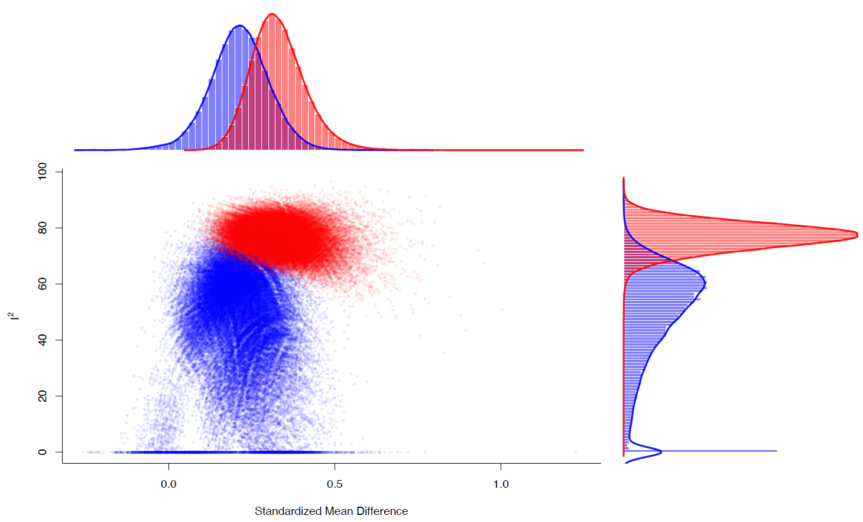
Funnel plot
Egger Test (z = -0.4982, p = 0.6183)

Any emotion, reaction time
Main analysis

Meta-regression analyses
Emotion type | Number of studies | 𝛽 | 95% CI | p-value
Primary outcome (reference category, yes)
Any | 5 | 1.234 | -1.71, 4.179 | 0.411
Age
Any | 5 | 0.186 | -0.208, 0.355 | 0.355
Duration of illness
Any | 3 | -0.111 | -0.619, 0.317 | 0.668
Morphed (reference category, yes)
Any | 5 | -0.089 | -4.864, 2.686 | 0.572
% of females
Any | 5 | -0.431 | -17.246, 8.624 | 0.514
% of euthymic
Any | 3 | 0.25 | -0.348, 0.848 | 0.412
Symptoms severity scale, depression
Any | 3 | -0.155 | -0.505, 0.194 | 0.348
Symptoms severity scale, mania
Any | 3 | -0.029 | -0.255, 0.197 | 0.8
% of antipsychotics
Any | 3 | -0.785 | -4.103, 2.533 | 0.642
% of antidepressants
Any | 3 | 0.341 | -2.637, 3.319 | 0.822
% of mood stabilizers
Any | 3 | 1.955 | -2.212, 6.122 | 0.358
Publication Year
Any | 5 | -0.183 | -0.499, 0.132 | 0.255
NOS score
Any | 5 | 1.3718 | 0.144, 2.888 | 0.076

Leave-one-out sensitivity analyses
 | SMD | 95% CI | p-value | Qp | tau² | I²
Priyesh et al., 2021 | 0.734 | -1.016, 2.484 | 0.411 | <0.001 | 3.099 | 98.323
Rubin et al., 2022 | 0.804 | -0.905, 2.513 | 0.356 | <0.001 | 2.935 | 97.118
Derntl et al., 2012 | -0.219 | -0.402, -0.037 | 0.019 | 0.502 | 0 | 0
Goghari et al., 2013 | 0.688 | -1.081, 2.457 | 0.446 | <0.001 | 3.173 | 98.445
Rossell et al., 2014 | 0.803 | -0.902, 2.509 | 0.356 | <0.001 | 2.929 | 97.719

GOSH plot (Derntl et al., 2012, highlighted)

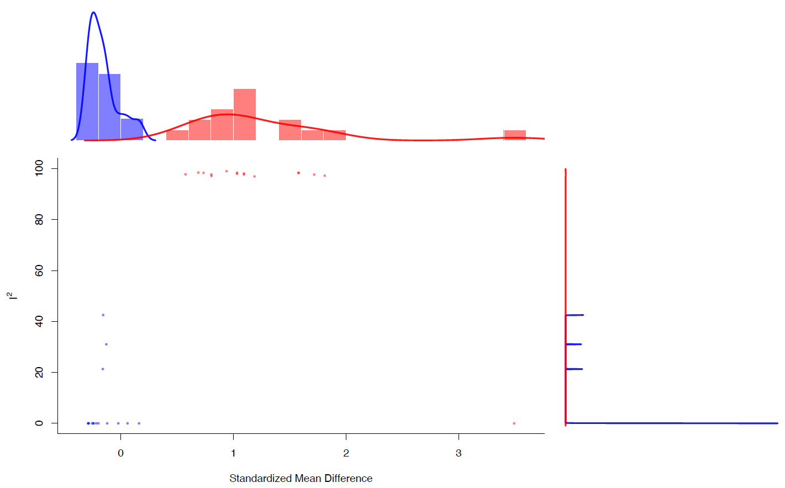

Upper level, discrimination

Any emotion, accuracy
Main analysis
Meta-regression analyses
Emotion type | Number of studies | 𝛽 | 95% CI | p-value
Primary outcome (reference category, yes)
Any | 7 | -0.851 | -1.505, -0.196 | 0.01
Age
Any | 7 | -0.119 | -0.163, -0.075 | 1.06e-07
Age at onset
Any | 3 | 0.138 | 0.007, 0.27 | 0.039
Duration of illness
Any | 4 | -0.103 | -0.169, 0.037 | 0.002
Duration of stimuli
Any | 3 | -0.033 | -0.087, 0.02 | 0.226
Morphed (reference category, yes)
Any | 7 | -0.034 | -1.46, 1.395 | 0.963
% of females
Any | 7 | -1.309 | -5.633, 3.014 | 0.553
% of euthymic
Any | 5 | 0.104 | -0.626, 0.834 | 0.779
% of depressed
Any | 3 | -0.368 | -1.915, 1.18 | 0.641
% of (hypo)manic
Any | 3 | 0.207 | -0.206, 0.621 | 0.326
Symptoms severity scale, depression
Any | 3 | 0.004 | -0.351, 0.36 | 0.981
Symptoms severity scale, mania
Any | 4 | 0.724 | 0.317, 1.13 | 0.005
% of antipsychotics
Any | 5 | -0.161 | -1.476, 1.153 | 0.81
% of antidepressants
Any | 3 | -3.671 | -8.249, 0.908 | 0.116
% of mood stabilizers
Any | 3 | 4.435 | -0.162, 9.032 | 0.059
Publication Year
Any | 7 | 0.02 | -0.029, 0.069 | 0.421
NOS score
Any | 7 | 0.058 | -0.412, 0.528 | 0.808

Leave-one-out sensitivity analyses
 | SMD | 95% CI | p-value | Qp | tau² | I²
Addington et al., 1998 | 0.405 | -0.121, 0.93 | 0.131 | <0.001 | 0.361 | 85.199
Bellack et al., 1996 | 0.51 | 0.014, 1.005 | 0.044 | <0.001 | 0.324 | 85.277
Darke et al., 2021 | 0.446 | -0.077, 0.969 | 0.095 | <0.001 | 0.364 | 86.427
Hwang et al., 2021 | 0.226 | -0.021, 0.473 | 0.073 | 0.22 | 0.031 | 32.879
Lahera et al., 2015 | 0.525 | 0.026, 1.024 | 0.039 | <0.001 | 0.317 | 82.858
Rossell et al., 2014 | 0.517 | 0.013, 1.022 | 0.045 | <0.001 | 0.326 | 83.223
Vaskin et al., 2007 | 0.452 | -0.073, 0.977 | 0.091 | <0.001 | 0.366 | 86.213

GOSH plot (Hwang et al., 2021, highlighted)
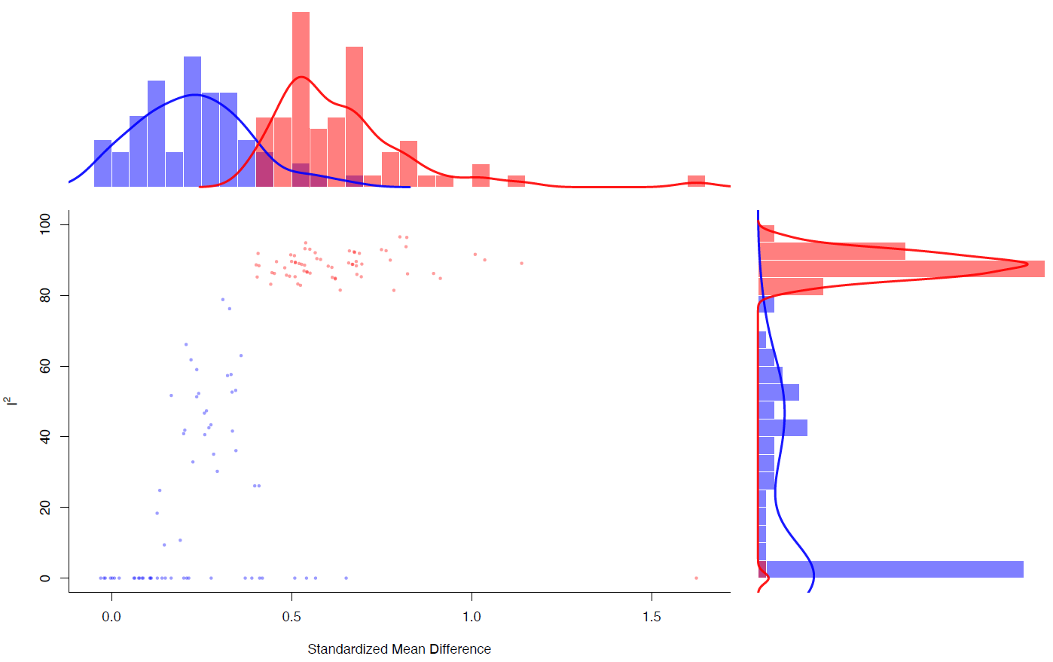

Middle level, identification

Positive emotions, accuracy
Main analysis
Leave-one-out sensitivity analyses
 | SMD | 95% CI | p-value | Qp | tau² | I²
Rowland et al., 2013 | 0.06 | -0.116, 0.236 | 0.507 | 0.379 | 0.001 | 1.073
Priyesh et al., 2021 | 0.134 | -0.034, 0.303 | 0.118 | 0.446 | 0 | 0.019
Rubin et al., 2022 | 0.063 | -0.197, 0.322 | 0.637 | 0.251 | 0.022 | 24.938
Yalcin-Siedentopf et al., 2014 | 0.14 | -0.036, 0.316 | 0.12 | 0.355 | 0 | 0.016
Derntl et al., 2012 | 0.114 | -0.054, 0.283 | 0.184 | 0.259 | 0 | 0
Goghari et al., 2013 | 0.075 | -0.092, 0.242 | 0.377 | 0.361 | 0 | 0.013

GOSH plot
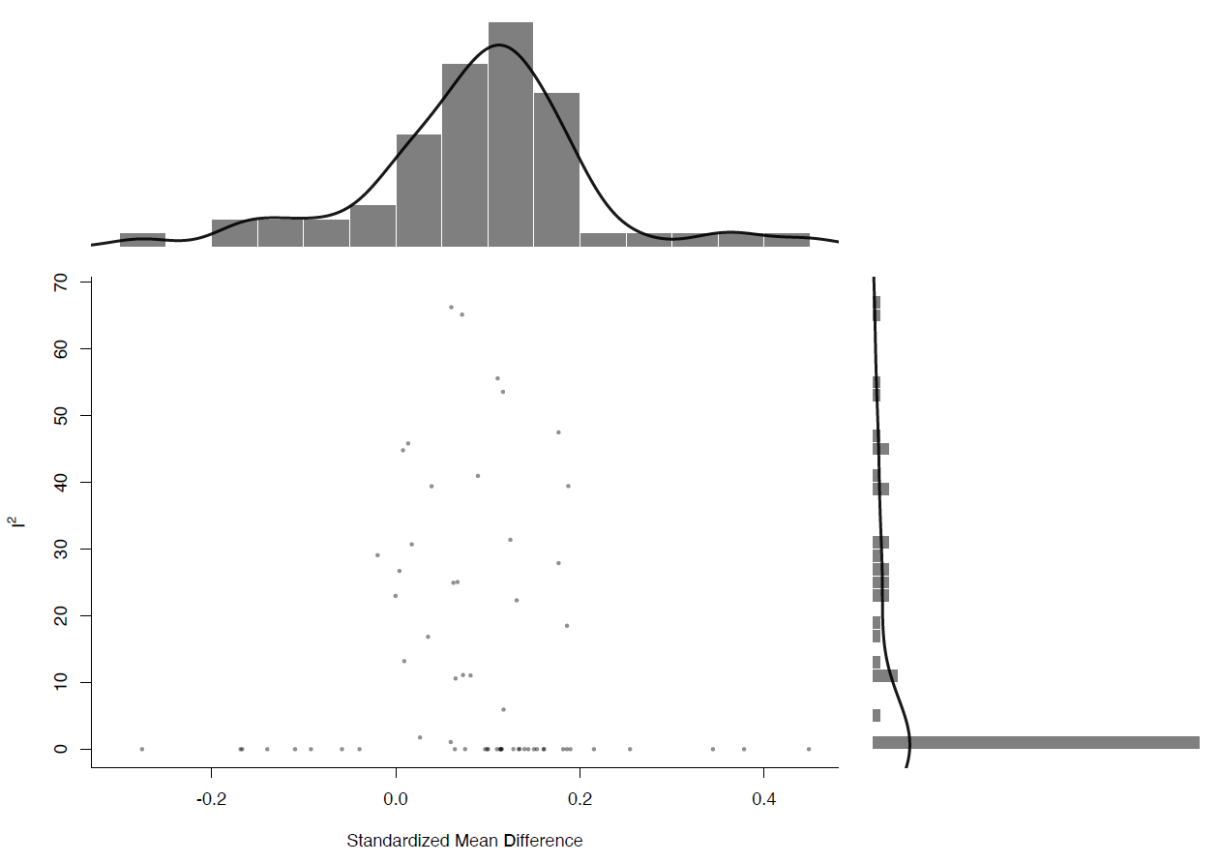

Positive emotions, reaction time
Main analysis

Meta-regression analyses
Emotion type | Number of studies | 𝛽 | 95% CI | p-value
Primary outcome (reference category, yes)
Positive | 3 | 0.515 | -0.369, 1.399 | 0.253
Age
Positive | 3 | 0.047 | -0.067, 0.162 | 0.416
Morphed (reference category, yes)
Positive | 3 | -0.551 | -1.028, -0.074 | 0.024
% of females
Positive | 3 | 1.46 | -2.099, 5.019 | 0.421
Publication Year
Positive | 3 | -0.067 | -0.156, 0.022 | 0.139
NOS score
Positive | 3 | -0.551 | -1.028, -0.074 | 0.024

Leave-one-out sensitivity analyses
 | SMD | 95% CI | p-value | Qp | tau² | I²
Priyesh et al., 2021 | -0.096 | -0.741, 0.549 | 0.771 | 0.048 | 0.167 | 74.377
Rubin et al., 2022 | 0.184 | -0.23, 0.598 | 0.385 | 0.612 | 0 | 0
Goghari et al., 2013 | -0.212 | -0.635, 0.211 | 0.327 | 0.139 | 0.056 | 54.213

Negative emotions, accuracy
Main analysis

Meta-regression analyses
Emotion type | Number of studies | 𝛽 | 95% CI | p-value
Primary outcome (reference category, yes)
Negative | 7 | 0.188 | -0.382, 0.758 | 0.519
Age
Negative | 7 | 0.025 | -0.062, 0.112 | 0.579
Duration of illness
Negative | 4 | 0.036 | -0.04, 0.113 | 0.352
Duration of stimuli
Negative | 4 | -0.016 | -0.189, 0.157 | 0.855
Morphed (reference category, yes)
Negative | 7 | 0.029 | -0.58, 0.637 | 0.927
% of females
Negative | 7 | 0.504 | -1.86, 2.868 | 0.676
% of euthymic
Negative | 5 | -0.307 | -1.073, 0.459 | 0.432
Symptoms severity scale, depression
Negative | 3 | 0.272 | 0.038, 0.507 | 0.023
Symptoms severity scale, mania
Negative | 3 | 0.052 | -0.046, 0.149 | 0.299
% of antipsychotics
Negative | 5 | -1.335 | -2.607, -0.063 | 0.04
% of antidepressants
Negative | 4 | -0.083 | -3.367, 3.202 | 0.961
% of mood stabilizers
Negative | 4 | -0.917 | -3.096, 1.27 | 0.409
Publication Year
Negative | 7 | -0.017 | -0.085, 0.05 | 0.615
NOS score
Negative | 7 | -0.051 | -0.288, 0.186 | 0.675

Leave-one-out sensitivity analyses
 | SMD | 95% CI | p-value | Qp | tau² | I²
Rowland et al., 2013 | 0.105 | 0.153, 0.363 | 0.424 | 0.095 | 0.045 | 46.122
Darke et al., 2021 | 0.234 | 0.027, 0.495 | 0.079 | 0.07 | 0.053 | 52.477
Priyesh et al., 2021 | 0.247 | 0.006, 0.499 | 0.055 | 0.094 | 0.045 | 48.031
Rubin et al., 2022 | 0.108 | 0.188, 0.404 | 0.473 | 0.088 | 0.065 | 48.162
Yalcin-Siedentopf et al., 2014 | 0.193 | 0.113, 0.499 | 0.215 | 0.037 | 0.082 | 60.005
Derntl et al., 2012 | 0.211 | 0.071, 0.493 | 0.142 | 0.043 | 0.068 | 58.37
Goghari et al., 2013 | 0.152 | 0.14, 0.444 | 0.308 | 0.025 | 0.079 | 62.352

GOSH plot
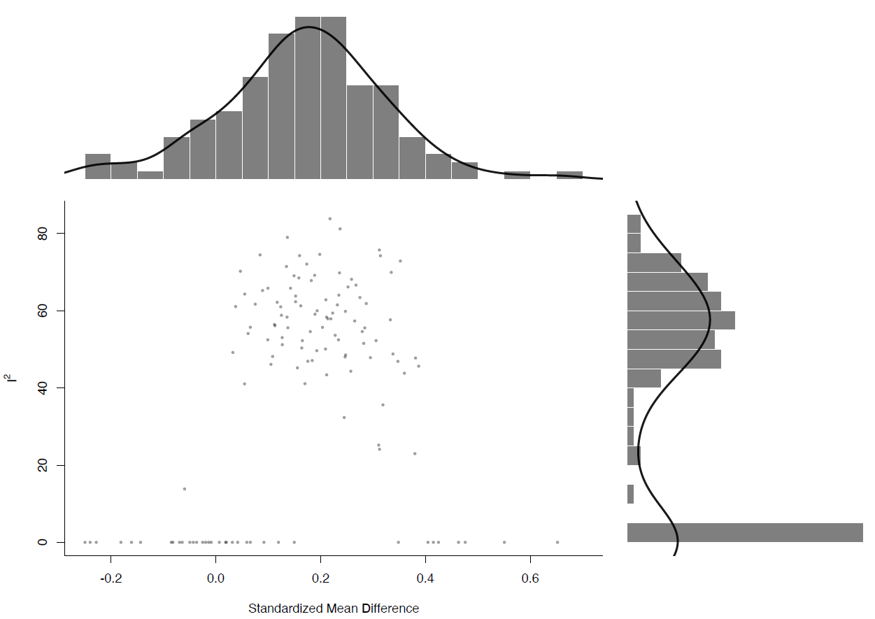

Negative emotions, reaction time
Main analysis

Leave-one-out sensitivity analyses
 | SMD | 95% CI | p-value | Qp | tau² | I²
Priyesh et al., 2021 | -0.165 | -0.471, 0.142 | 0.292 | 0.257 | 0.016 | 22.329
Rubin et al., 2022 | -0.017 | -0.43, 0.397 | 0.937 | 0.51 | 0 | 0
Goghari et al., 2013 | -0.229 | -0.446, -0.012 | 0.038 | 0.736 | 0 | 0

Lower level, identification

Anger, accuracy
Main analysis
Leave-one-out sensitivity analyses
 | SMD | 95% CI | p-value | Qp | tau² | I²
Rubin et al., 2022 | 0.42 | 0.127, 0.714 | 0.005 | 0.76 | 0 | 0
Yalcin-Siedentopf et al., 2014 | 0.481 | 0.273, 0.688 | 5.64e-06 | 0.804 | 0 | 0
Derntl et al., 2012 | 0.472 | 0.276, 0.667 | 2.26e-06 | 0.785 | 0 | 0
Goghari et al., 2013 | 0.442 | 0.249, 0.636 | 7.45e-06 | 0.843 | 0 | 0

Anger, reaction time
Main analysis

Disgust, accuracy
Main analysis
Meta-regression analyses
Emotion type | Number of studies | 𝛽 | 95% CI | p-value
Primary outcome (reference category, yes)
Any | 3 | -0.239 | -1.311, -0.833 | 0.662
Age
Disgust | 3 | -0.007 | -0.239, 0.226 | 0.954
Morphed (reference category, yes)
Any | 3 | 0.239 | -0.833, 1.311 | 0.662
% of females
Disgust | 3 | -5.02 | -9.082, -0.958 | 0.015
Publication Year
Any | 3 | 0.015 | -0.112, 0.141 | 0.819
NOS score
Any | 3 | -0.239 | -1.312, 0.833 | 0.662

Leave-one-out sensitivity analyses
 | SMD | 95% CI | p-value | Qp | tau² | I²
Rubin et al., 2022 | -0.022 | -0.688, 0.645 | 0.949 | 0.056 | 0.169 | 72.601
Yalcin-Siedentopf et al., 2014 | 0.237 | 0.019, 0.454 | 0.033 | 0.674 | 0 | 0
Derntl et al., 2012 | -0.032 | -0.569, 0.505 | 0.908 | 0.022 | 0.123 | 80.984

Fear, accuracy
Main analysis
Leave-one-out sensitivity analyses
 | SMD | 95% CI | p-value | Qp | tau² | I²
Rubin et al., 2022 | 0.227 | -0.064, 0.518 | 0.127 | 0.957 | 0 | 0
Yalcin-Siedentopf et al., 2014 | 0.47 | 0.263, 0.678 | 8.92e-06 | 0.535 | 0 | 0
Derntl et al., 2012 | 0.402 | 0.147, 0.657 | 0.002 | 0.322 | 0.015 | 27.238
Goghari et al., 2013 | 0.384 | 0.124, 0.645 | 0.004 | 0.278 | 0.018 | 31.85

Fear, reaction time
Main analysis

Happiness, accuracy
Main analysis

Leave-one-out sensitivity analyses
 | SMD | 95% CI | p-value | Qp | tau² | I²
Rubin et al., 2022 | 0.021 | -0.292, 0.334 | 0.896 | 0.297 | 0.009 | 11.224
Yalcin-Siedentopf et al., 2014 | 0.283 | 0.077, 0.489 | 0.007 | 0.415 | 0 | 0.006
Derntl et al., 2012 | 0.197 | -0.13, 0.524 | 0.238 | 0.127 | 0.043 | 51.538
Goghari et al., 2013 | 0.094 | -0.23, 0.419 | 0.568 | 0.115 | 0.044 | 53.441

Happiness, reaction time
Main analysis

Sadness, accuracy
Main analysis

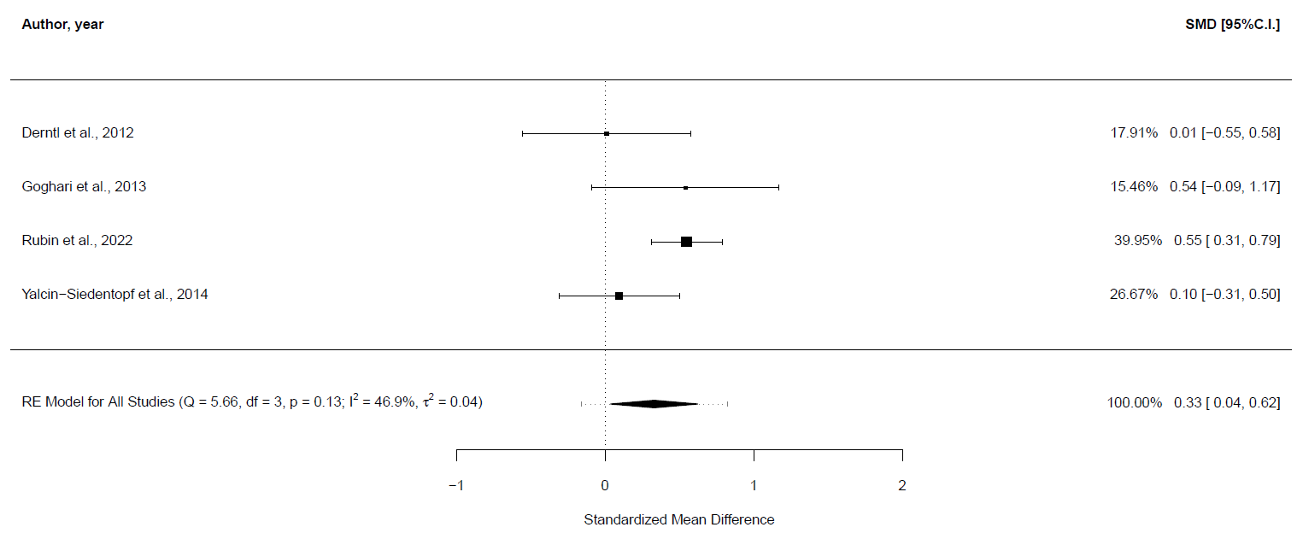

Leave-one-out sensitivity analyses
 | SMD | 95% CI | p-value | Qp | tau² | I²
Rubin et al., 2022 | 0.17 | -0.12, 0.46 | 0.25 | 0.41 | 0 | 0
Yalcin-Siedentopf et al., 2014 | 0.43 | 0.12, 0.74 | 0.01 | 0.22 | 0.03 | 32.95
Derntl et al., 2012 | 0.4 | 0.09, 0.71 | 0.01 | 0.16 | 0.04 | 47.05
Goghari et al., 2013 | 0.28 | -0.08, 0.64 | 0.13 | 0.07 | 0.06 | 61.45

Sadness, reaction time
Main analysis

Surprise, accuracy
Main analysis

Control Group: Major depressive disorder (MDD)

Upper level, identification

Any emotion, accuracy
Main analysis

Meta-regression analyses
Emotion type | Number of studies | 𝛽 | 95% CI | p-value
Primary outcome (reference category, yes)
Any | 7 | 0.062 | -0.428, 0.554 | 0.802
Age
Any | 7 | 0.01 | -0.031, 0.051 | 0.635
Age at onset
Any | 5 | 0.011 | -0.02, 0.041 | 0.494
Duration of stimuli
Any | 6 | 0.053 | -0.107, 0.213 | 0.51
Morphed (reference category, yes)
Any | 7 | -0.537 | -1.43, 0.356 | 0.239
% of females
Any | 7 | -1.291 | -2.672, 0.089 | 0.067
% of people with BD-I
Any | 4 | 0.082 | -1.465, 1.63 | 0.917
% of euthymic
Any | 5 | -0.441 | -1.328, 0.445 | 0.329
% of depressed
Any | 5 | -0.236 | -0.988, 0.515 | 0.538
% of (hypo)manic
Any | 5 | 0.363 | -0.246, 0.972 | 0.242
Symptoms severity scale, depression
Any | 5 | -0.061 | -0.405, 0.282 | 0.727
% of antipsychotics
Any | 3 | 0.321 | -1.85, 2.492 | 0.772
% of antidepressants
Any | 3 | 1.614 | -1.343, 4.571 | 0.285
Publication Year
Any | 7 | -0.019 | -0.094, 0.056 | 0.625
NOS score
Any | 7 | -0.063 | -0.223, 0.098 | 0.442

Leave-one-out sensitivity analyses
 | SMD | 95% CI | p-value | Qp | tau² | I²
Almeida et al., 2009 | -0.213 | -0.409, -0.017 | 0.033 | 0.736 | 0 | 0
Almeida et al., 2010 | -0.226 | -0.424, -0.027 | 0.026 | 0.634 | 0 | 0
Bjertrup et al., 2020 | -0.211 | -0.405, -0.017 | 0.033 | 0.827 | 0 | 0
Branco et al., 2017 | -0.229 | -0.429, -0.029 | 0.025 | 0.624 | 0 | 0
Golkhatmi et al., 2013 | -0.263 | -0.467, -0.059 | 0.011 | 0.688 | 0 | 0
Vederman et al., 2012 | -0.251 | -0.503, 0.001 | 0.051 | 0.621 | 0 | 0
Derntl et al., 2012 | -0.271 | -0.472, -0.07 | 0.008 | 0.775 | 0 | 0

GOSH plot
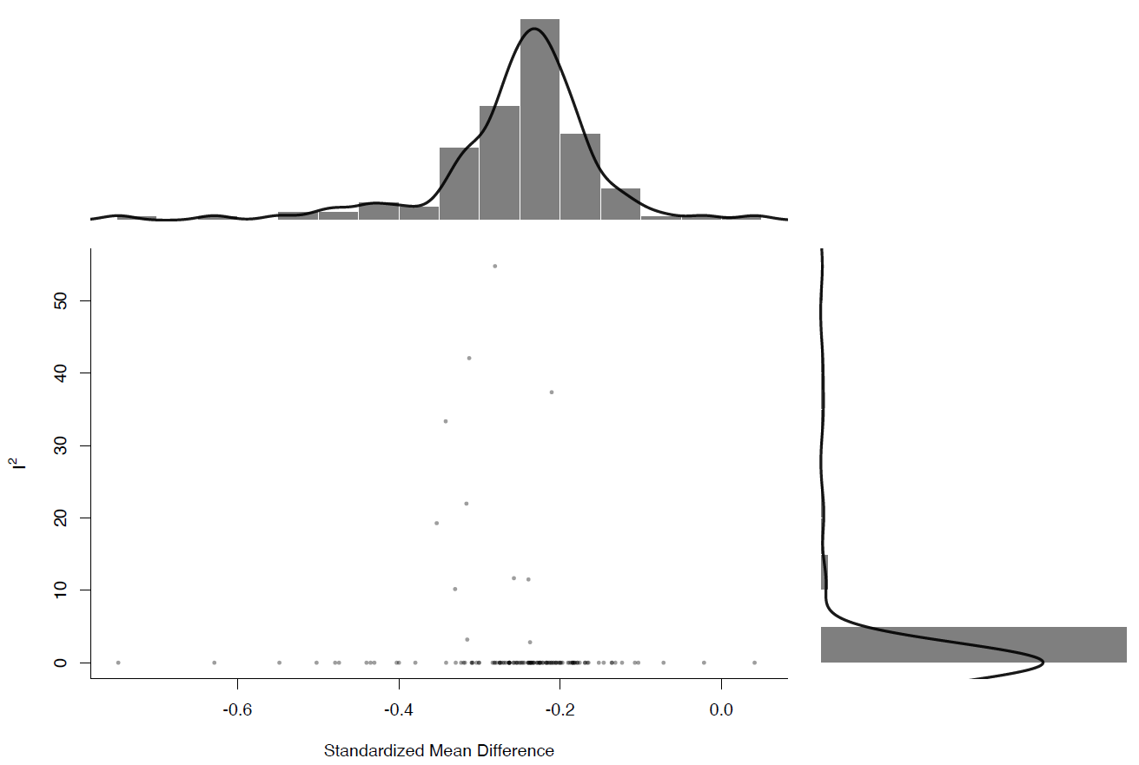

Middle level, identification

Positive emotions, accuracy
Main analysis

Meta-regression analyses
Emotion type | Number of studies | 𝛽 | 95% CI | p-value
Primary outcome (reference category, yes)
Positive | 6 | -0.258 | -1.005, 0.49 | 0.499
Age
Positive | 6 | -0.013 | -0.087, 0.061 | 0.73
Age at onset
Positive | 5 | 0.001 | -0.06, 0.077 | 0.753
Duration of stimuli
Positive | 5 | -0.111 | -0.474, 0.251 | 0.546
Morphed (reference category, yes)
Positive | 6 | 1.094 | 0.175, 2.013 | 0.02
% of females
Positive | 6 | 0.363 | -1.626, 2.354 | 0.72
% of euthymic
Positive | 4 | 1.15 | 0.045, 2.256 | 0.041
% of depressed
Positive | 4 | -0.918 | -1.325, 0.489 | 0.201
% of (hypo)manic
Positive | 4 | -0.21 | -1.982, 1.563 | 0.816
Symptoms severity scale, depression
Positive | 4 | -0.526 | -0.936, -0.115 | 0.012
Publication Year
Positive | 6 | 0.13 | 0.036, 0.224 | 0.007
NOS score
Positive | 6 | 0.134 | -0.119, 0.387 | 0.3

Leave-one-out sensitivity analyses
 | SMD | 95% CI | p-value | Qp | tau² | I²
Almeida et al., 2009 | -0.011 | -0.219, 0.197 | 0.92 | 0.152 | 0 | 0.008
Almeida et al., 2010 | -0.028 | -0.361, 0.305 | 0.869 | 0.072 | 0.065 | 47.327
Bjertrup et al., 2020 | -0.122 | -0.336, 0.092 | 0.265 | 0.409 | 0.003 | 4.622
Golkhatmi et al., 2013 | -0.031 | -0.411, 0.349 | 0.873 | 0.066 | 0.098 | 54.945
Vederman et al., 2012 | -0.096 | -0.528, 0.336 | 0.664 | 0.063 | 0.133 | 55.766
Derntl et al., 2012 | -0.097 | -0.477, 0.283 | 0.616 | 0.054 | 0.101 | 57.139

GOSH plot (Bjertrup et al., 2020, highlighted)
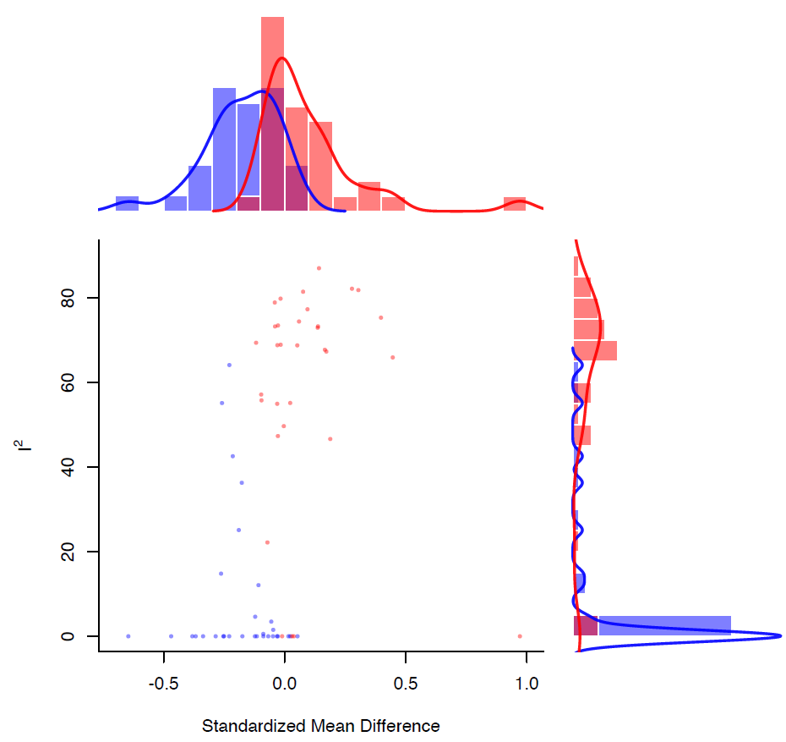

Negative emotions, accuracy
Main analysis
Leave-one-out sensitivity analyses
 | SMD | 95% CI | p-value | Qp | tau² | I²
Almeida et al., 2009 | -0.093 | -0.289, 0.103 | 0.354 | 0.301 | 0 | 0.006
Almeida et al., 2010 | -0.093 | -0.292, 0.105 | 0.356 | 0.278 | 0 | 0.001
Bjertrup et al., 2020 | -0.076 | -0.269, 0.118 | 0.442 | 0.681 | 0 | 0
Branco et al., 2017 | -0.095 | -0.295, 0.104 | 0.349 | 0.265 | 0 | 0
Golkhatmi et al., 2013 | -0.188 | -0.436, 0.059 | 0.136 | 0.272 | 0.02 | 20.033
Vederman et al., 2012 | -0.218 | -0.47, 0.034 | 0.091 | 0.362 | 0 | 0.002
Derntl et al., 2012 | -0.181 | -0.422, 0.06 | 0.141 | 0.269 | 0.018 | 19.291

GOSH plot (Bjertrup et al., 2020, highlighted)
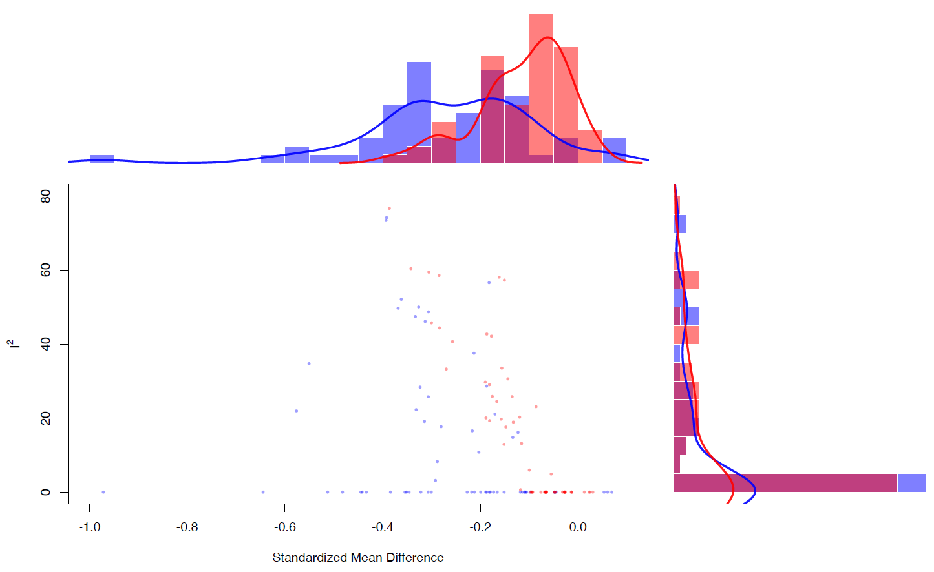

Lower level, identification

Anger, accuracy
Main analysis

Leave-one-out sensitivity analyses
 | SMD | 95% CI | p-value | Qp | tau² | I²
Bjertrup et al., 2020 | 0.007 | -0.205, 0.22 | 0.945 | 0.707 | 0 | 0
Branco et al., 2017 | -0.011 | -0.232, 0.209 | 0.92 | 0.167 | 0 | 0.008
Golkhatmi et al., 2013 | -0.155 | -0.47, 0.161 | 0.337 | 0.164 | 0.035 | 32.598
Vederman et al., 2012 | -0.178 | -0.548, 0.193 | 0.348 | 0.169 | 0.046 | 32.131
Derntl et al., 2012 | -0.114 | -0.444, 0.217 | 0.5 | 0.12 | 0.046 | 40.609

GOSH plot (Bjertrup et al., 2020, highlighted)
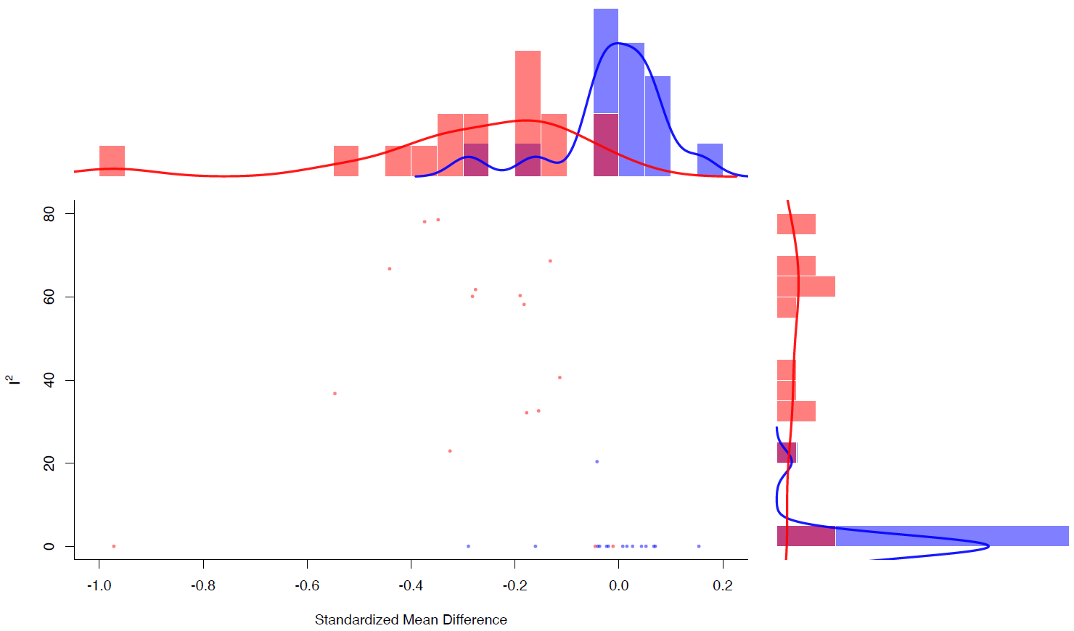

Disgust, accuracy
Main analysis

Meta-regression analyses
Emotion type | Number of studies | 𝛽 | 95% CI | p-value
Primary outcome (reference category, yes)
Disgust | 4 | 0.006 | -1.386, 1.398 | 0.993
Age
Disgust | 4 | -0.022 | -0.099, 0.055 | 0.577
Duration of stimuli
Disgust | 3 | 0.105 | -0.11, 0.321 | 0.338
Morphed (reference category, yes)
Disgust | 4 | -0.644 | -1.923, 0.635 | 0.324
% of females
Disgust | 4 | -1.798 | -3.896, 0.299 | 0.092
% of euthymic
Disgust | 3 | -1.122 | -2.47, 0.226 | 0.103
% of depressed
Disgust | 3 | -0.612 | -3.479, 2.255 | 0.676
% of (hypo)manic
Disgust | 3 | 1.006 | 0.296, 1.717 | 0.005
Publication Year
Disgust | 4 | -0.108 | -0.251, 0.034 | 0.134
NOS score
Disgust | 4 | -0.272 | -0.468, -0.077 | 0.006

Leave-one-out sensitivity analyses
 | SMD | 95% CI | p-value | Qp | tau² | I²
Bjertrup et al., 2020 | 0.158 | -0.391, 0.708 | 0.572 | 0.052 | 0.155 | 65.749
Branco et al., 2017 | 0.136 | -0.498, 0.77 | 0.674 | 0.052 | 0.207 | 66.887
Golkhatmi et al., 2013 | -0.182 | -0.55, 0.187 | 0.334 | 0.582 | 0 | 0
Derntl et al., 2012 | 0.021 | -0.694, 0.736 | 0.953 | 0.02 | 0.288 | 73.25

Fear, accuracy
Main analysis
Leave-one-out sensitivity analyses
 | SMD | 95% CI | p-value | Qp | tau² | I²
Almeida et al., 2010 | -0.04 | -0.261, 0.18 | 0.719 | 0.334 | 0 | 0.001
Bjertrup et al., 2020 | -0.047 | -0.262, 0.167 | 0.664 | 0.452 | 0 | 0
Golkhatmi et al., 2013 | -0.206 | -0.554, 0.142 | 0.246 | 0.177 | 0.051 | 40.731
Vederman et al., 2012 | -0.264 | -0.567, 0.039 | 0.088 | 0.467 | 0 | 0
Derntl et al., 2012 | -0.151 | -0.475, 0.173 | 0.36 | 0.183 | 0.041 | 37.088

GOSH plot (Vederman et al., 2012, highlighted)
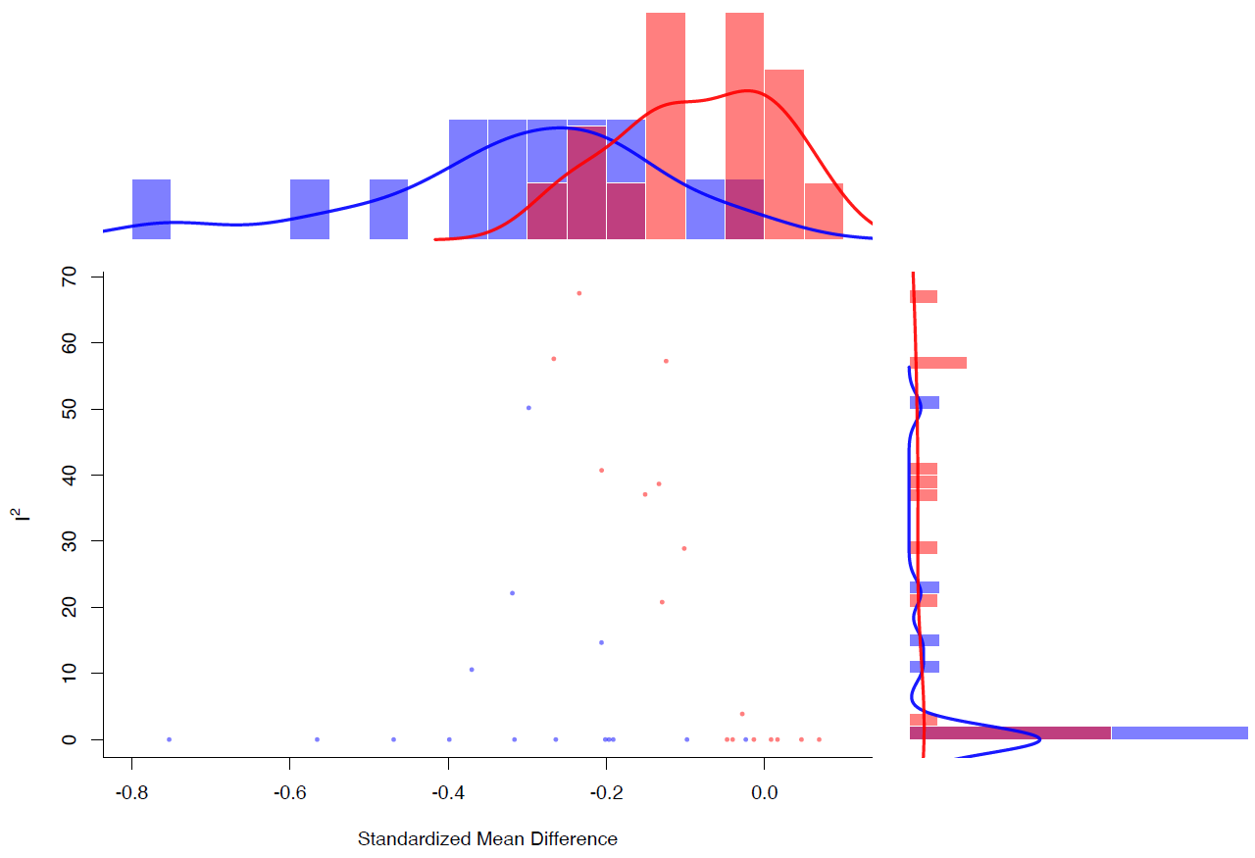

Happiness, accuracy
Main analysis

Leave-one-out sensitivity analyses
 | SMD | 95% CI | p-value | Qp | tau² | I²
Almeida et al., 2009 | -0.059 | -0.273, 0.155 | 0.588 | 0.687 | 0 | 0
Almeida et al., 2010 | -0.079 | -0.296, 0.139 | 0.479 | 0.359 | 0 | 0
Golkhatmi et al., 2013 | -0.108 | -0.363, 0.146 | 0.405 | 0.302 | 0.01 | 12.086
Vederman et al., 2012 | -0.237 | -0.532, 0.058 | 0.116 | 0.502 | 0 | 0
Derntl et al., 2012 | -0.171 | -0.441, 0.098 | 0.213 | 0.326 | 0.017 | 21.215

GOSH plot
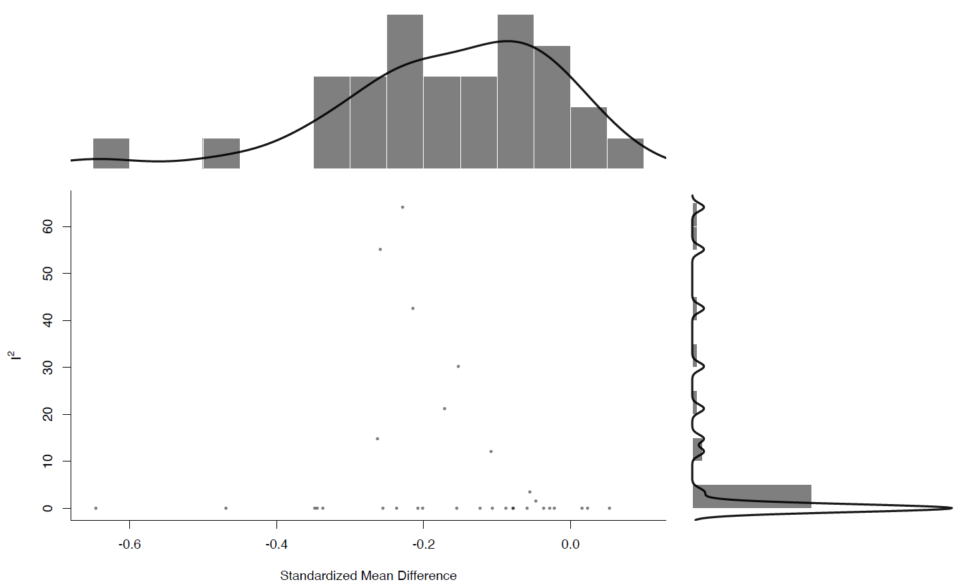

Sadness, accuracy
Main analysis

Leave-one-out sensitivity analyses
 | SMD | 95% CI | p-value | Qp | tau² | I²
Almeida et al., 2009 | -0.302 | -0.554, -0.05 | 0.019 | 0.287 | 0.027 | 28.012
Almeida et al., 2010 | -0.334 | -0.598, -0.069 | 0.013 | 0.269 | 0.033 | 31.306
Bjertrup et al., 2020 | -0.275 | -0.509, -0.04 | 0.022 | 0.395 | 0.019 | 21.784
Branco et al., 2017 | -0.315 | -0.579, -0.05 | 0.02 | 0.273 | 0.032 | 30.288
Golkhatmi et al., 2013 | -0.196 | -0.4, 0.007 | 0.059 | 0.687 | 0 | 0
Vederman et al., 2012 | -0.426 | -0.68, -0.173 | 0.001 | 0.71 | 0 | 0
Derntl et al., 2012 | -0.341 | -0.61, -0.072 | 0.013 | 0.273 | 0.035 | 31.469

GOSH plot (Golkhatmi et al., 2013, highlighted)
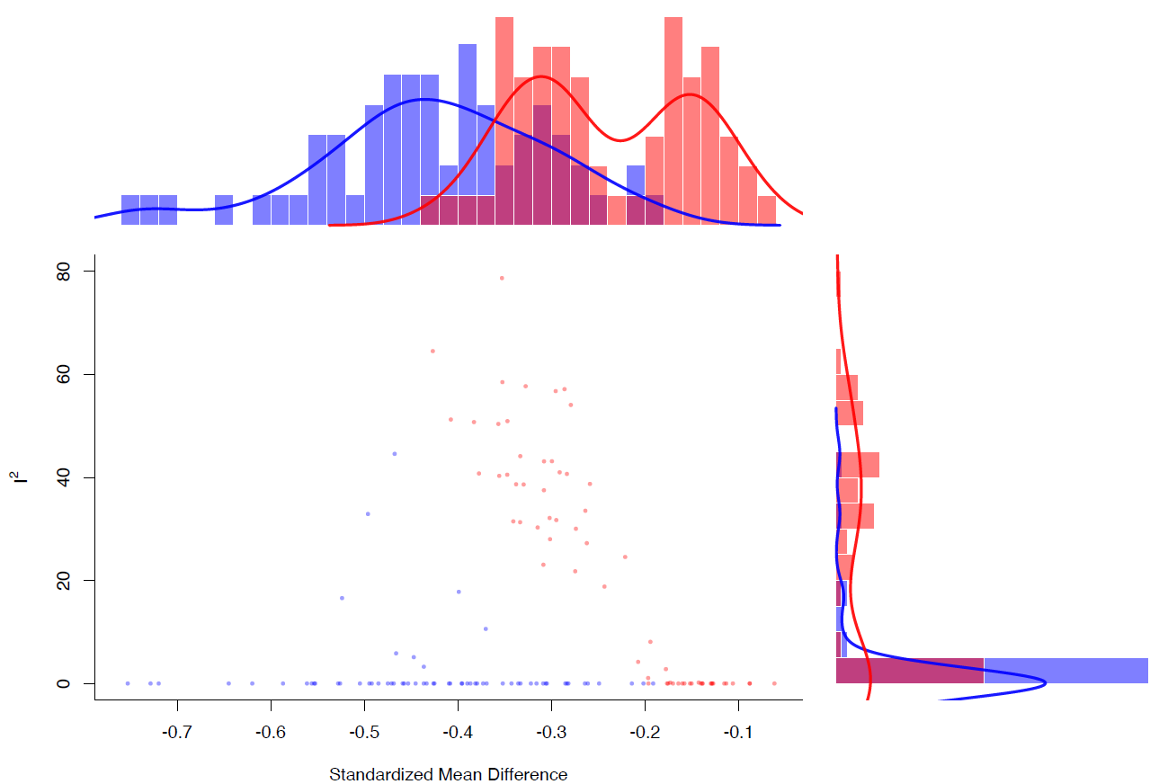

Surprise, accuracy
Main analysis

Neutral, accuracy
Main analysis
Leave-one-out sensitivity analyses
 | SMD | 95% CI | p-value | Qp | tau² | I²
Almeida et al., 2009 | 0.179 | -0.254, 0.612 | 0.418 | 0.303 | 0.006 | 5.913
Almeida et al., 2010 | 0.152 | -0.376, 0.68 | 0.572 | 0.239 | 0.041 | 27.797
Derntl et al., 2012 | -0.104 | -0.57, 0.362 | 0.662 | 0.832 | 0 | 0

Control Group: Attention deficit/hyperactivity disorder (ADHD)

Upper level, identification

Any emotion, accuracy
Main analysis

Middle level, identification

Positive emotion, accuracy
Main analysis

Negative emotion, accuracy
Main analysis

Lower level, identification

Anger, accuracy
Main analysis

Fear, accuracy
Main analysis

Happiness, accuracy
Main analysis

Sadness, accuracy
Main analysis

PRISMA Checklist

1Section and Topic | Item # | Checklist item | Location where item is reported
TITLE
Title | 1 | Identify the report as a systematic review. | 1
ABSTRACT
Abstract | 2 | See the PRISMA 2020 for Abstracts checklist. | 3
INTRODUCTION
Rationale | 3 | Describe the rationale for the review in the context of existing knowledge. | 4-5
Objectives | 4 | Provide an explicit statement of the objective(s) or question(s) the review addresses. | 5
METHODS
Eligibility criteria | 5 | Specify the inclusion and exclusion criteria for the review and how studies were grouped for the syntheses. | 6
Information sources | 6 | Specify all databases, registers, websites, organisations, reference lists and other sources searched or consulted to identify studies. Specify the date when each source was last searched or consulted. | 6
Search strategy | 7 | Present the full search strategies for all databases, registers and websites, including any filters and limits used. | Supp Mat
Selection process | 8 | Specify the methods used to decide whether a study met the inclusion criteria of the review, including how many reviewers screened each record and each report retrieved, whether they worked independently, and if applicable, details of automation tools used in the process. | 6
Data collection process | 9 | Specify the methods used to collect data from reports, including how many reviewers collected data from each report, whether they worked independently, any processes for obtaining or confirming data from study investigators, and if applicable, details of automation tools used in the process. | 7
Data items | 10a | List and define all outcomes for which data were sought. Specify whether all results that were compatible with each outcome domain in each study were sought (e.g. for all measures, time points, analyses), and if not, the methods used to decide which results to collect. | 6
Data items | 10b | List and define all other variables for which data were sought (e.g. participant and intervention characteristics, funding sources). Describe any assumptions made about any missing or unclear information. | 7
Study risk of bias assessment | 11 | Specify the methods used to assess risk of bias in the included studies, including details of the tool(s) used, how many reviewers assessed each study and whether they worked independently, and if applicable, details of automation tools used in the process. | 7
Effect measures | 12 | Specify for each outcome the effect measure(s) (e.g. risk ratio, mean difference) used in the synthesis or presentation of results. | 7-8
Synthesis methods | 13a | Describe the processes used to decide which studies were eligible for each synthesis (e.g. tabulating the study intervention characteristics and comparing against the planned groups for each synthesis (item #5)). | 7-8
Synthesis methods | 13b | Describe any methods required to prepare the data for presentation or synthesis, such as handling of missing summary statistics, or data conversions. | 7-8
Synthesis methods | 13c | Describe any methods used to tabulate or visually display results of individual studies and syntheses. | 8
Synthesis methods | 13d | Describe any methods used to synthesize results and provide a rationale for the choice(s). If meta-analysis was performed, describe the model(s), method(s) to identify the presence and extent of statistical heterogeneity, and software package(s) used. | 7-8
Synthesis methods | 13e | Describe any methods used to explore possible causes of heterogeneity among study results (e.g. subgroup analysis, meta-regression). | 7-8
Synthesis methods | 13f | Describe any sensitivity analyses conducted to assess robustness of the synthesized results. | 7-8
Reporting bias assessment | 14 | Describe any methods used to assess risk of bias due to missing results in a synthesis (arising from reporting biases). | 7-8
Certainty assessment | 15 | Describe any methods used to assess certainty (or confidence) in the body of evidence for an outcome. | 7-8
RESULTS
Study selection | 16a | Describe the results of the search and selection process, from the number of records identified in the search to the number of studies included in the review, ideally using a flow diagram. | 9; Fig1
Study selection | 16b | Cite studies that might appear to meet the inclusion criteria, but which were excluded, and explain why they were excluded. | Supp Mat
Study characteristics | 17 | Cite each included study and present its characteristics. | 9-13; Table 1
Risk of bias in studies | 18 | Present assessments of risk of bias for each included study. | 12; Table 1
Results of individual studies | 19 | For all outcomes, present, for each study: (a) summary statistics for each group (where appropriate) and (b) an effect estimate and its precision (e.g. confidence/credible interval), ideally using structured tables or plots. | 9-13; Table 2; Fig2; Supp Mat
Results of syntheses | 20a | For each synthesis, briefly summarise the characteristics and risk of bias among contributing studies. | Table 1; Supp Mat
Results of syntheses | 20b | Present results of all statistical syntheses conducted. If meta-analysis was done, present for each the summary estimate and its precision (e.g. confidence/credible interval) and measures of statistical heterogeneity. If comparing groups, describe the direction of the effect. | 10-11; Table 2; Supp Mat
Results of syntheses | 20c | Present results of all investigations of possible causes of heterogeneity among study results. | 11-12; Table 2; Supp Mat
Results of syntheses | 20d | Present results of all sensitivity analyses conducted to assess the robustness of the synthesized results. | 12; Supp Mat
Reporting biases | 21 | Present assessments of risk of bias due to missing results (arising from reporting biases) for each synthesis assessed. | 12; Supp Mat
Certainty of evidence | 22 | Present assessments of certainty (or confidence) in the body of evidence for each outcome assessed. | 9-13; Table 2; Fig2; Supp Mat
DISCUSSION
Discussion | 23a | Provide a general interpretation of the results in the context of other evidence. | 14-17
Discussion | 23b | Discuss any limitations of the evidence included in the review. | 17-18
Discussion | 23c | Discuss any limitations of the review processes used. | 17-18
Discussion | 23d | Discuss implications of the results for practice, policy, and future research. | 17-19
OTHER INFORMATION
Registration and protocol | 24a | Provide registration information for the review, including register name and registration number, or state that the review was not registered. | 6
Registration and protocol | 24b | Indicate where the review protocol can be accessed, or state that a protocol was not prepared. | 6
Registration and protocol | 24c | Describe and explain any amendments to information provided at registration or in the protocol. | Supp Mat
Support | 25 | Describe sources of financial or non-financial support for the review, and the role of the funders or sponsors in the review. | 20
Competing interests | 26 | Declare any competing interests of review authors. | 2
Availability of data, code and other materials | 27 | Report which of the following are publicly available and where they can be found: template data collection forms; data extracted from included studies; data used for all analyses; analytic code; any other materials used in the review. | 20

MOOSE Checklist

Item No | Recommendation | Reported on Page No
Reporting of background should include
1 | Problem definition | 4-5
2 | Hypothesis statement | 5
3 | Description of study outcome(s) | 6-7
4 | Type of exposure or intervention used | 6-7
5 | Type of study designs used | 6
6 | Study population | 6
Reporting of search strategy should include
7 | Qualifications of searchers (eg, librarians and investigators) | NA
8 | Search strategy, including time period included in the synthesis and key words | 6; Supp Mat
9 | Effort to include all available studies, including contact with authors | 6-7
10 | Databases and registries searched | 6
11 | Search software used, name and version, including special features used (eg, explosion) | 6; Supp Mat
12 | Use of hand searching (eg, reference lists of obtained articles) | 6
13 | List of citations located and those excluded, including justification | Table 1; Fig 1; Supp Mat
14 | Method of addressing articles published in languages other than English | 6
15 | Method of handling abstracts and unpublished studies | 6-7
16 | Description of any contact with authors | 7
Reporting of methods should include
17 | Description of relevance or appropriateness of studies assembled for assessing the hypothesis to be tested | 9-10; 13; Table 1
18 | Rationale for the selection and coding of data (eg, sound clinical principles or convenience) | 7
19 | Documentation of how data were classified and coded (eg, multiple raters, blinding and interrater reliability) | 6-7
20 | Assessment of confounding (eg, comparability of cases and controls in studies where appropriate) | 6-8; Supp Mat
21 | Assessment of study quality, including blinding of quality assessors, stratification or regression on possible predictors of study results | 7; Supp Mat
22 | Assessment of heterogeneity | 7-8
23 | Description of statistical methods (eg, complete description of fixed or random effects models, justification of whether the chosen models account for predictors of study results, dose-response models, or cumulative meta-analysis) in sufficient detail to be replicated | 7-8
24 | Provision of appropriate tables and graphics | Table 1; Table 2; Figure 2; Supp Mat
Reporting of results should include
25 | Graphic summarizing individual study estimates and overall estimate | Table 2; Figure 2; Supp Mat
26 | Table giving descriptive information for each study included | Table 1
27 | Results of sensitivity testing (eg, subgroup analysis) | 9-13; Supp Mat
28 | Indication of statistical uncertainty of findings | 9-13; Table 2; Supp Mat

