Supporting Information
of
Modelling Solvent Effects and Convergence of ³¹P-NMR Shielding Calculations with COBRAMM

Francesco Calcagno,^{1,2} Boris Maryasin,^{3,4} Marco Garavelli,*¹ Davide Avagliano*¹ and Ivan Rivalta.*^{1,2,5}

¹ Department of Industrial Chemistry “Toso Montanari”, University of Bologna, viale Risorgimento 4 40136 Bologna, Italy.
² Center for Chemical Catalysis – C3, University of Bologna, viale Risorgimento 4 40136 Bologna, Italy.
³ Institute of Organic Chemistry, University of Vienna, Währinger Strasse 38, 1090 Vienna, Austria.
⁴ Institute of Theoretical Chemistry, University of Vienna, Währinger Strasse 17, 1090 Vienna, Austria.
⁵ ENSL, CNRS, Laboratoire de Chimie UMR 5182, 46 Allée d'Italie, 69364 Lyon France.

Table of contents
1. NMR Spectra S1
2. Conformational study for SolM1, SolM2 and SolM3 S2
3. Geometrical effect of QM/MM optimization S4
4. Convergence investigations S5
5. Cartesian coordinates S6
6. Local references S14

1. NMR Spectra
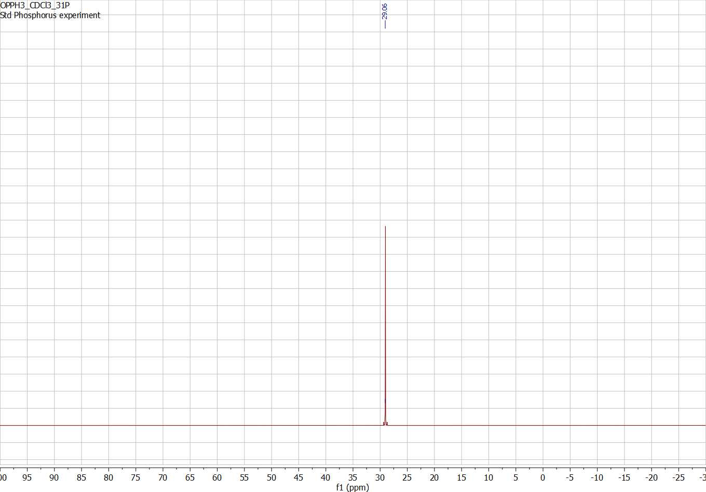
Figure S1. ³¹P NMR spectra of triphenylphosphine oxide (1) recorded in CDCl₃.

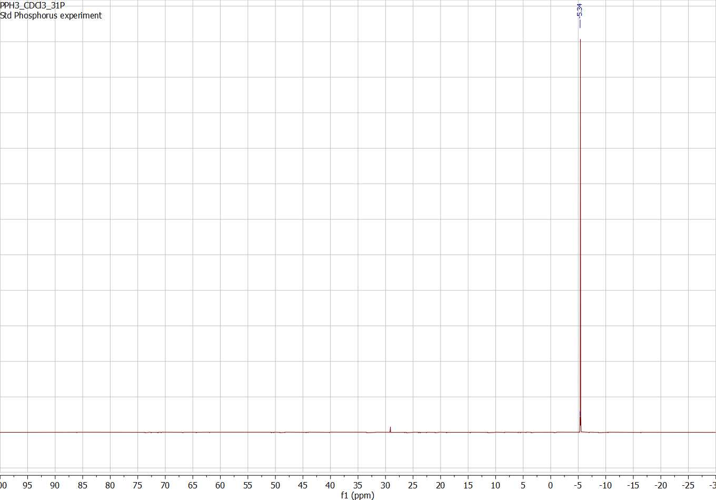
Figure S2. ³¹P NMR spectra of triphenyl phosphine (2) recorded in CDCl₃.

Species | δ (³¹P) ppm
(Ph)₃P | -5.39
(Ph)₃PO | 29.03
Table S1. Experimental ³¹P chemical shifts recorded at 298.15 K.

2. Conformational study for SolM1, SolM2 and SolM3
The number of conformers for compounds 1 and 2 was already investigated in ref¹. In gas phase, two conformers of compound 1 and one of compound 2 were computed. When a molecule of solvent is added, the number of conformers changes: single conformer was characterized for compound 1, while two possible conformers for 2 were found (see the Cartesian coordinates section below for optimized geometries as reported in the main text). Chemical shift values reported in the main text for SolM1, SolM2 and SolM3 were Boltzmann averaged according to equation S1 (Table S2).
$$σ= \sum_{i=1}^{n}{p_{i}σ_{i}}=\sum_{i=1}^{n}{\frac{e^{-\frac{G_{i}}{RT}}}{\sum_{i=1}^{n}{e^{-\frac{G_{i}}{RT}}}} σ_{i}} (eq. S1)$$
With G = G_{frequencies} + (E_{correction} - E_{optimization})
SolM1 | 1 |  | 2
 | Conf1 | Conf2
E_{optimization} | -1111.338892 | -1111.339595 | -1036.113965
G_{frequencies} | -1111.097928 | -1111.096752 | -1035.876353
E_{corrections} | -1111.579345 | -1111.580159 | -1036.321410
G | -1111.338380 | -1111.337316 | -1036.083798
Shielding (ppm) | 308.1012 | 308.3180 | 336.6882
Averaged shielding (ppm) | 308.1542 |  | 336.6882
SolM2 | 1 |  | 2
 | Conf1 | Conf2
E_{optimization} | -1111.338892 | -1111.339595 | -1036.113965
G_{frequencies} | -1111.113465 | -1111.110336 | -1035.886527
E_{corrections} | -1111.597724 | -1111.597766 | -1036.33356243
G | -1111.372296 | -1111.368507 | -1036.106124
Shielding (ppm) | 304.7345 | 305.2207 | 336.8196
Averaged shielding (ppm) | 304.7431 |  | 336.8196
SolM3 | 1 | 2
 |  | Conf1 | Conf2
E_{optimization} | -2530.644420 | -2455.410990 | -2455.412172
G_{frequencies} | -2530.410924 | -2455.172755 | -2455.177250
E_{corrections} | -2531.000401 | -2455.733591 | -2455.733946
G | -2530.766905 | -2455.495356 | -2455.499024
Shielding (ppm) | 301.8276 | 337.5307 | 335.6489
Averaged shielding (ppm) | 301.8276 | 335.6868
Table S2. Computed energies (in Hartree) and shielding for compounds 1 and 2 according to different solution models (SMs).
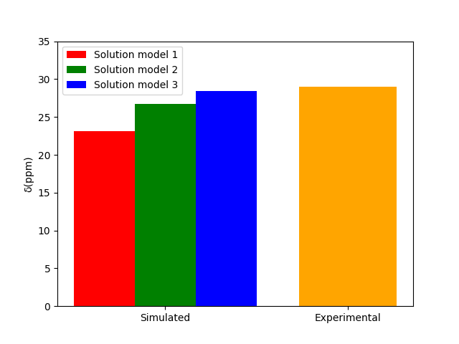
Figure S3. Comparison between theoretical and experimental chemical shift (orange). Selected approaches include computation of NMR shielding tensor in vacuum (red, solution model 1), with PCM (green, solution model 2), and with PCM in the presence of a molecule of solvent, i.e. chloroform, (blue, solution model 3).

3. Geometrical effect of QM/MM optimization
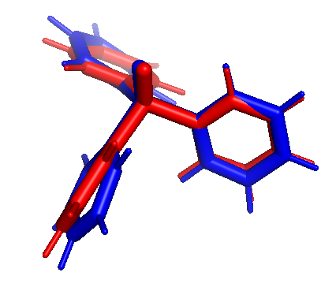
Figure S4. Superposition of geometry of compound 1 from single snapshot, after molecular dynamic sampling with (red) and without (in blue) QM/MM optimization with a M layer of 5 Å (RMSD = 0.402).

4. Convergence investigations
Layer size / Ang. | σ(1), ppm | σ(2), ppm | σ(3) /ppm
0 | 329.8 | 357.2 | 186.5
3 | 328.1 | 357.5 | 188.2
4 | 328.0 | 358.6 | 190.2
5 | N/A | 358.7 | 190.3
Table S3. Convergence study of ³¹P shielding tensor according to increasing solvent layer over 100 snapshots. Shielding values were computed at the MPW1K/pcS-1 level of theory.

Calculation type | NMR | NMR with  QM₂(6-311++(2d,2p))=3Å | NMR with QM₂(pcS-1)=0Å | NMR with QM₂(pcS-1) =3Å | NMR with QM₂(pcS-1)=4Å | NMR with QM₂(pcS-1)=5Å | QM/MM opt. (M layer = 5Å)
Computational cost | 1 | 5.4 | 0.17 | 0.77 | 2.7 | 5.0 | 9.3
Table S4. Comparison of computational cost for calculations for compound 1. Times are reported for calculation carried out on the same snapshot using an Intel® Xeon® CPU E5-2650 v2 @ 2.60GHz machine. Data are referred to the computational cost (set to 1) of single point NMR calculation with 6-311++(2d,2p) basis set (computational time = 11625 sec.).

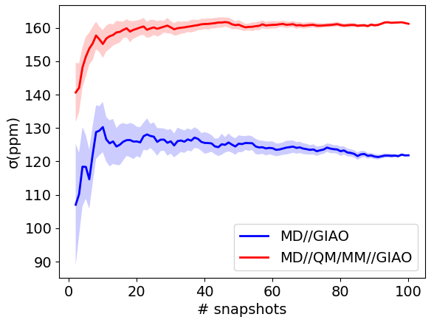
Figure S5. Running average of shielding value (computed at the MPW1K/6-311++G(2d,2p) level of theory) for compound 3 over 100 snapshots (every ns) with (red solid line) and without (blue solid line) QM/MM optimization. Bootstrapped standard deviations over 100 samples are reported in blurred for each simulation. The embedding is treated at MM level.

5. Cartesian coordinates

Solution model 1

Species 1, conformer 1
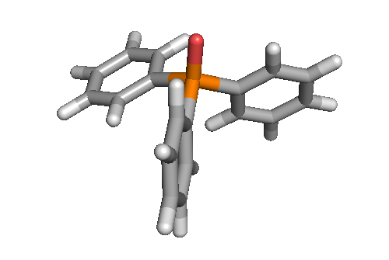
P -0.01712100 -0.03537700 0.91383500
O -0.06423900 -0.16190200 2.39560100
C 0.38493300 1.61812900 0.29164300
C 1.69162600 2.08381200 0.43010800
C -0.58704300 2.46645600 -0.22806700
C 2.02018000 3.37102300 0.04509300
H 2.45261800 1.43581100 0.84096800
C -0.25593900 3.75573100 -0.61420900
H -1.60482500 2.12088400 -0.33202500
C 1.04610100 4.20752500 -0.47974000
H 3.03537100 3.72290500 0.15501000
H -1.01691600 4.40694000 -1.01850400
H 1.30318000 5.21249300 -0.78140400
C -1.60626300 -0.48310400 0.16576300
C -1.80787300 -0.61713000 -1.20512100
C -2.66043700 -0.71514400 1.04172000
C -3.05334600 -0.97120400 -1.69264600
H -0.99314100 -0.45127600 -1.89524800
C -3.90726000 -1.07020300 0.55068100
H -2.48311800 -0.61948100 2.10294300
C -4.10383600 -1.19669100 -0.81427500
H -3.20525500 -1.07562100 -2.75696600
H -4.72335200 -1.25028200 1.23496400
H -5.07496200 -1.47514100 -1.19711100
C 1.22689800 -1.12854900 0.17983400
C 1.63917500 -2.21106100 0.95018600
C 1.75799300 -0.95035700 -1.09443100
C 2.56096800 -3.11319500 0.44542200
H 1.24000000 -2.32366000 1.94758300
C 2.67780400 -1.85505500 -1.59745300
H 1.47175000 -0.09355600 -1.68809300
C 3.07672300 -2.93800300 -0.82886100
H 2.88031900 -3.95025200 1.04874600
H 3.08976700 -1.71069500 -2.58551800
H 3.79686500 -3.64107500 -1.22156800

Species 1, conformer 2
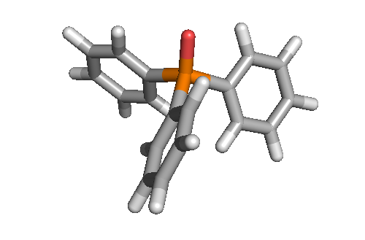
P 0.00000000 0.00000000 0.91079900
C 0.00000000 1.67290100 0.21625700
C -0.56212000 2.67386800 1.00316400
C 0.52585200 1.99330400 -1.03128300
C -0.61593700 3.97637200 0.53685200
H -0.93665400 2.42199800 1.98449600
C 0.46784900 3.29710600 -1.49618000
H 0.99960700 1.23079800 -1.63321800
C -0.10591200 4.28724200 -0.71411100
H -1.05042600 4.75041800 1.15223800
H 0.88024100 3.54180400 -2.46410100
H -0.14614300 5.30428500 -1.07620400
C 1.44877500 -0.83645000 0.21625700
C 1.46332600 -1.45205300 -1.03128300
C 2.59669700 -0.85012400 1.00316400
C 2.62145300 -2.05372200 -1.49618000
H 0.56609900 -1.48108400 -1.63321800
C 3.75160700 -1.45476900 0.53685200
H 2.56583900 -0.39983200 1.98449600
C 3.76581700 -2.05189800 -0.71411100
H 2.62717200 -2.53321300 -2.46410100
H 4.63919600 -1.46551300 1.15223800
H 4.66671700 -2.52557800 -1.07620400
C -1.44877500 -0.83645000 0.21625700
C -2.03457800 -1.82374400 1.00316400
C -1.98917800 -0.54125100 -1.03128300
C -3.13567100 -2.52160300 0.53685200
H -1.62918400 -2.02216500 1.98449600
C -3.08930200 -1.24338400 -1.49618000
H -1.56570600 0.25028600 -1.63321800
C -3.65990500 -2.23534400 -0.71411100
H -3.58877000 -3.28490500 1.15223800
H -3.50741300 -1.00859100 -2.46410100
H -4.52057400 -2.77870600 -1.07620400
O 0.00000000 0.00000000 2.39797300

Species 2
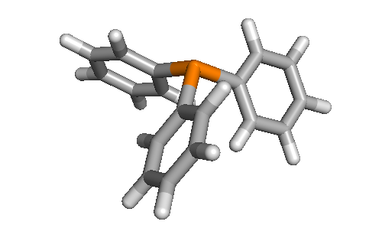
P 0.00000000 0.00000000 1.21646900
C 0.00000000 1.64832900 0.41438000
C -0.77423700 2.64242400 1.01098300
C 0.73363200 1.96651300 -0.72515500
C -0.83172600 3.91587900 0.47120100
H -1.33305000 2.41528600 1.90858600
C 0.68597000 3.24520300 -1.25870900
H 1.34816300 1.21287000 -1.19518200
C -0.09872400 4.22060700 -0.66525300
H -1.43992800 4.67330100 0.94404800
H 1.26341300 3.47826000 -2.14178600
H -0.13432000 5.21639000 -1.08269100
C 1.42749500 -0.82416500 0.41438000
C 1.33623400 -1.61860100 -0.72515500
C 2.67552500 -0.65070300 1.01098300
C 2.46744300 -2.21666900 -1.25870900
H 0.37629400 -1.77397900 -1.19518200
C 3.80711400 -1.23764300 0.47120100
H 2.75822400 -0.05318800 1.90858600
C 3.70451500 -2.02480600 -0.66525300
H 2.38055500 -2.83327700 -2.14178600
H 4.76716200 -1.08963600 0.94404800
H 4.58468600 -2.49187000 -1.08269100
C -1.42749500 -0.82416500 0.41438000
C -1.90128800 -1.99172100 1.01098300
C -2.06986700 -0.34791300 -0.72515500
C -2.97538800 -2.67823600 0.47120100
H -1.42517500 -2.36209800 1.90858600
C -3.15341400 -1.02853400 -1.25870900
H -1.72445800 0.56110900 -1.19518200
C -3.60579100 -2.19580100 -0.66525300
H -3.32723400 -3.58366500 0.94404800
H -3.64396800 -0.64498200 -2.14178600
H -4.45036600 -2.72451900 -1.08269100

Solvation model 3

Species 1
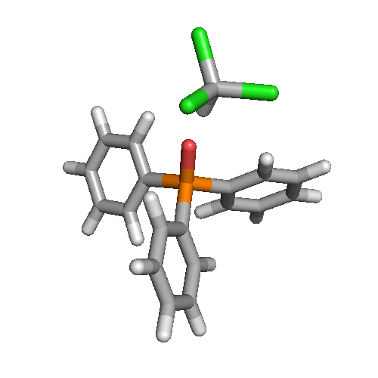
P 0.77136400 -0.00659800 -0.11822200
O -0.65466500 -0.02774100 -0.55723100
C 1.31544900 1.64913500 0.36229500
C 0.35018100 2.50549900 0.88509000
C 2.62932100 2.08851900 0.23357400
C 0.70190100 3.78149500 1.29033100
H -0.67454300 2.17158700 0.95610200
C 2.97773700 3.36504100 0.64374100
H 3.37780800 1.44286500 -0.20323700
C 2.01533400 4.20960300 1.17412200
H -0.05083800 4.44372600 1.69165500
H 3.99807800 3.70345100 0.53915300
H 2.28770500 5.20646300 1.48874400
C 1.88644300 -0.56150600 -1.42838600
C 3.11403900 -1.16841000 -1.18244500
C 1.46748300 -0.35919000 -2.74029300
C 3.92404500 -1.54886800 -2.23984100
H 3.43090300 -1.36210300 -0.16752800
C 2.27840000 -0.74405400 -3.79417700
H 0.49933500 0.08316000 -2.92326100
C 3.50772200 -1.33405200 -3.54433500
H 4.87487900 -2.02276600 -2.04523200
H 1.94826600 -0.58894800 -4.81067300
H 4.13847500 -1.63610000 -4.36763100
C 1.06677300 -1.07992700 1.30590000
C 0.23015100 -2.18274200 1.45281500
C 2.07388300 -0.84960800 2.23806300
C 0.41219300 -3.05460900 2.51260100
H -0.56982300 -2.33989100 0.74444400
C 2.25545500 -1.72693000 3.29447000
H 2.70452900 0.02381400 2.15181800
C 1.42689600 -2.82983300 3.42987700
H -0.24251100 -3.90591400 2.62589100
H 3.03608300 -1.54310400 4.01790900
H 1.56608200 -3.50967300 4.25772500
H -2.57243100 -0.02503300 -0.52151000
C -3.65225400 -0.01752000 -0.41448500
Cl -4.07350000 1.28540900 0.69760800
Cl -4.36873700 0.25451500 -1.99938700
Cl -4.14435400 -1.57950700 0.23844400

Species 2, conformer 1
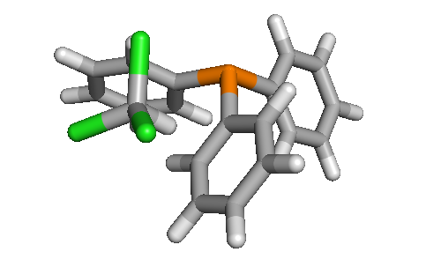
P -1.31731400 -0.04287100 -0.98034400
C -1.38404600 1.61306600 -0.19913800
C -0.38698700 2.52021800 -0.55612400
C -2.36856100 2.01833600 0.69766200
C -0.36103700 3.79310800 -0.01262500
H 0.37319400 2.22669600 -1.26720100
C -2.34993300 3.29786500 1.23098600
H -3.15533700 1.33321600 0.97717800
C -1.34543300 4.18548300 0.88110200
H 0.42208800 4.48145400 -0.29506600
H -3.12265900 3.60023800 1.92305600
H -1.33268700 5.18179100 1.29852100
C -2.96202000 -0.74224900 -0.57560900
C -3.24062900 -1.48800900 0.56663600
C -3.98609700 -0.51716700 -1.49434400
C -4.51439100 -1.98825100 0.78730900
H -2.45831000 -1.68279900 1.28544000
C -5.26139300 -1.00615100 -1.26800200
H -3.77905000 0.04278100 -2.39599900
C -5.52742800 -1.74558000 -0.12621100
H -4.71499400 -2.56817900 1.67663700
H -6.04447600 -0.81933800 -1.98835600
H -6.51933800 -2.13659300 0.04765100
C -0.21803000 -0.96478300 0.16455600
C 0.28332600 -2.18777100 -0.28340700
C 0.16099000 -0.51065700 1.42575100
C 1.12181800 -2.94762700 0.51563000
H 0.01667900 -2.54301900 -1.26925000
C 1.01055800 -1.26587400 2.22207400
H -0.20480200 0.43973700 1.78527600
C 1.48921100 -2.48653700 1.77182200
H 1.49915000 -3.89263800 0.15336500
H 1.29921800 -0.89711600 3.19558900
H 2.15291500 -3.07137600 2.39140000
H 2.59179700 -0.61565800 0.04601700
C 3.49093600 -0.13924400 -0.31836900
Cl 3.20936600 0.33609100 -1.98855800
Cl 3.80373300 1.26319200 0.69688500
Cl 4.80050000 -1.30900100 -0.20463900

Species 2, conformer 2
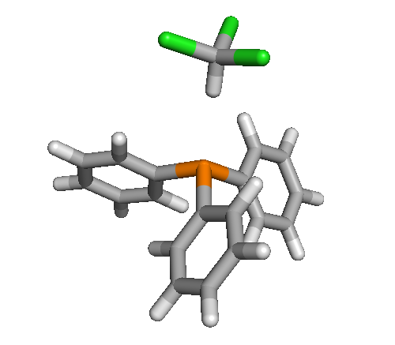
P -0.40760500 0.00188400 -0.00172100
C -1.19757900 0.24931300 -1.63338500
C -0.59879800 1.16206000 -2.50038300
C -2.33764400 -0.42912000 -2.05484900
C -1.13902700 1.40720300 -3.75106900
H 0.29951300 1.68109800 -2.19484000
C -2.87156900 -0.19116000 -3.31169500
H -2.80692700 -1.14912700 -1.40072300
C -2.27665900 0.72870800 -4.15978600
H -0.66515800 2.11939300 -4.41064700
H -3.75500600 -0.72676200 -3.62787000
H -2.69389500 0.91158600 -5.13927400
C -1.18233000 -1.54180600 0.60185400
C -2.32300400 -1.57808200 1.39889800
C -0.57084300 -2.74333100 0.24736200
C -2.84494400 -2.79028600 1.82252200
H -2.80207200 -0.65599900 1.69345300
C -1.09902200 -3.95391200 0.66176300
H 0.32798700 -2.72993000 -0.35400200
C -2.23729300 -3.97909800 1.45248200
H -3.72900600 -2.80444100 2.44343700
H -0.61531400 -4.87672800 0.37673800
H -2.64522400 -4.92252100 1.78486100
C -1.19107500 1.28969400 1.03529300
C -0.58003300 1.58798200 2.25221200
C -2.33810400 1.98891400 0.67033900
C -1.11479400 2.54738000 3.09471000
H 0.32357900 1.06777800 2.53959100
C -2.86667300 2.95718600 1.50961400
H -2.81696700 1.77958100 -0.27485000
C -2.25937300 3.23553500 2.72333400
H -0.63135000 2.76550300 4.03572500
H -3.75562000 3.49489200 1.21306000
H -2.67247100 3.99142600 3.37518500
H 2.27110400 0.00781200 -0.00662100
C 3.35649300 0.00652300 -0.00671000
Cl 3.89281100 0.23190200 1.65445500
Cl 3.89044900 -1.54587900 -0.64150300
Cl 3.89406500 1.33138700 -1.03309600

6. Local references
(1) Maryasin, B. and Zipse, H. Phys. Chem. Chem. Phys. 2011, 13, 5150–5158.

