Student-Teacher Relationships and Sense of Academic Futility: Longitudinal Associations Among Early Adolescents of Immigrant and Non-Immigrant Background
Supplemental Materials

S1. Preregistered Analytical Plan | 2
Figure S1.a | 3
Figure S1.b | 4
Figure S1.c | 5
Figure S1.d | 6
Figure S1.e | 7
S2. Results of Measurement Models and Measurement Invariance | 8
Table S2.a | 10
Table S2.b | 11

S1. Preregistered Analytical Plan
Analyses included in the current study were preregistered after the collection of the data. Following the preregistered analytical plan, five models were sequentially estimated to test the hypotheses of the current study. A visual representation of the five models is provided in Figure S1.a (i.e., inspecting the rank-order stability of our outcome variable; Model 1), Figure S1.b (i.e., examining the role of covariates; Model 2), Figure S1.c (i.e., testing the direct effect of our predictor variable; Hypothesis 1, Model 3), Figure S1.d (i.e., testing the mediating role of sense of class belonging; Hypothesis 2, Model 4) and Figure S1.e (i.e., testing the moderating role of students’ immigrant background; Hypothesis 3, Model 5).

Figure S1.a
Model 1: Sense of Academic Futility at the Student and Classroom Level
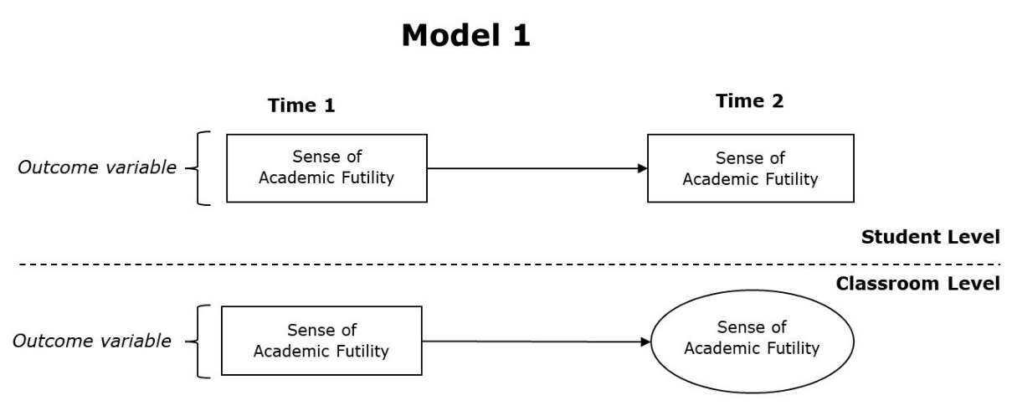

Figure S1.b
Model 2: Control Variables at the Student and Classroom Level
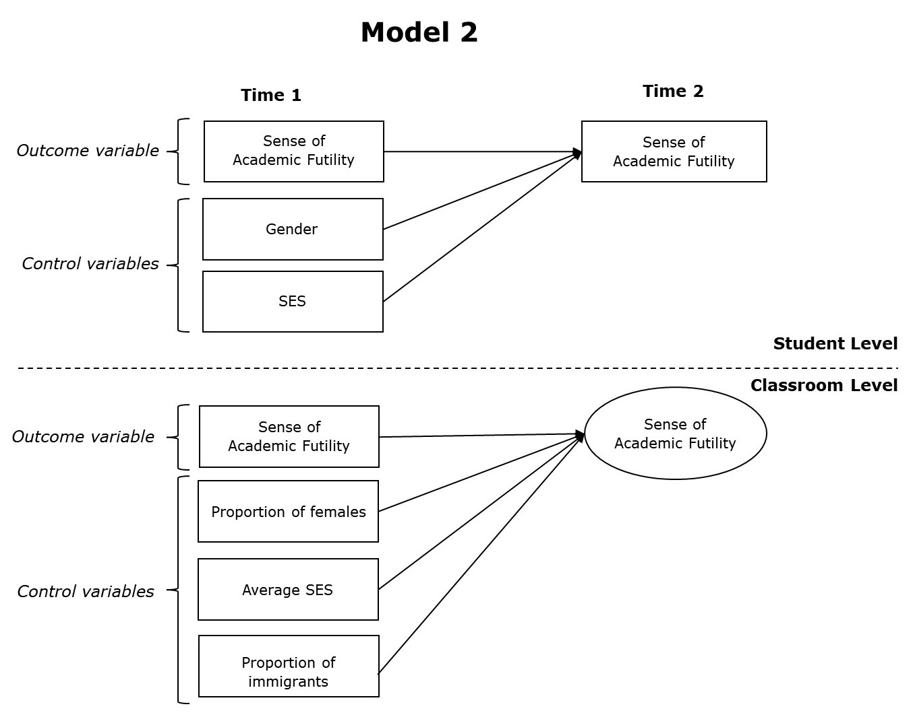

Figure S1.c
Model 3: Control Variables and Fair and Supportive Relationship with Teachers at the Individual and Classroom Level.
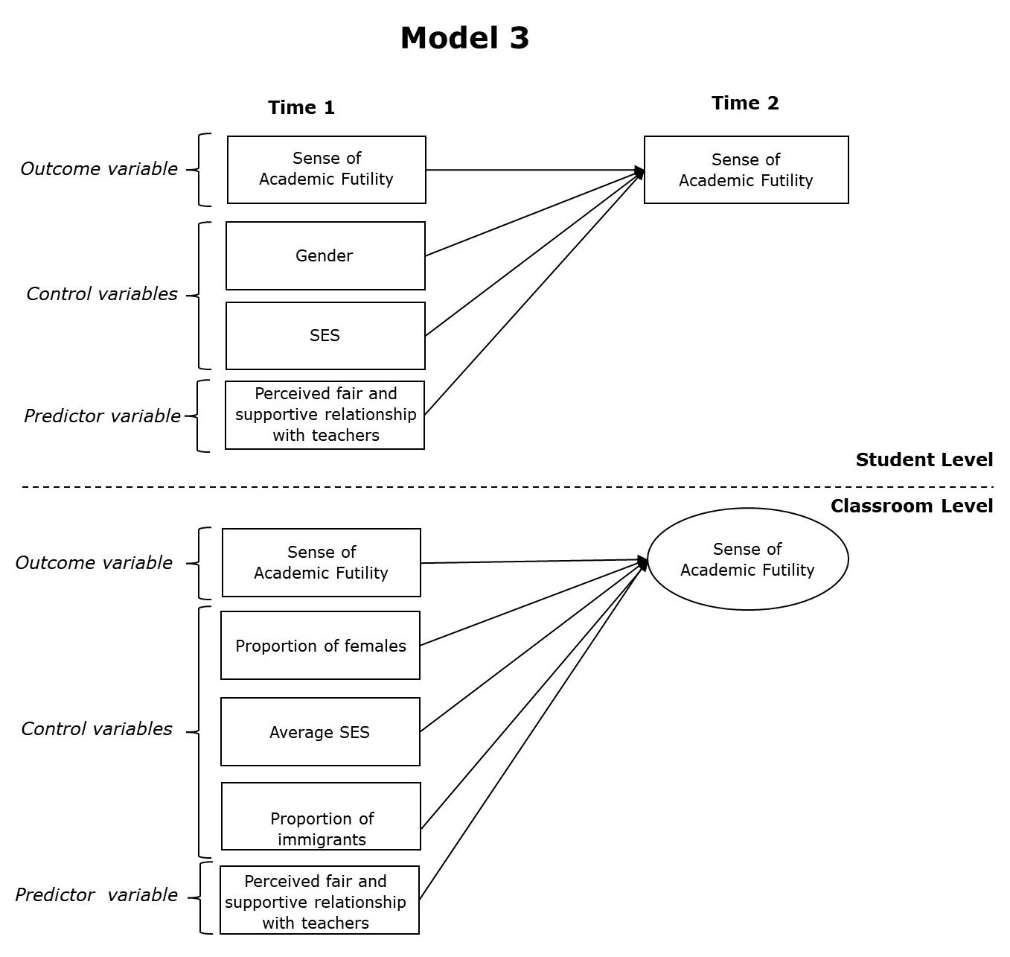

Figure S1.d
Model 4: Half-Longitudinal Multilevel Mediation Model
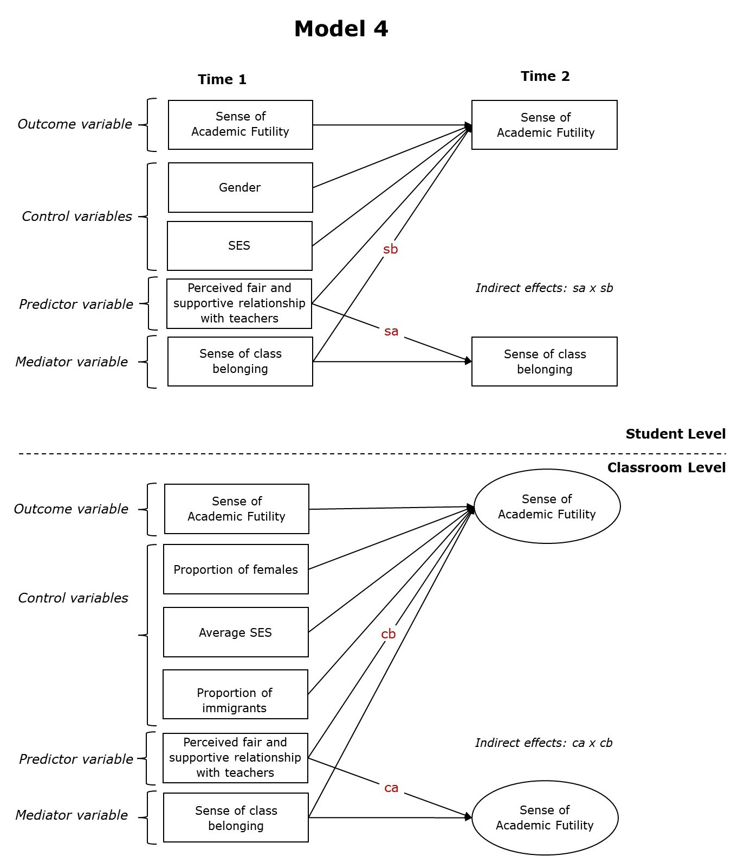
Note. s = student-level effects; c = classroom-level effects; a = effect of the predictor on the mediator; b = effect of the mediator on the outcome.
Figure S1.e
Model 5: Half-Longitudinal Multilevel Moderated Mediation Model
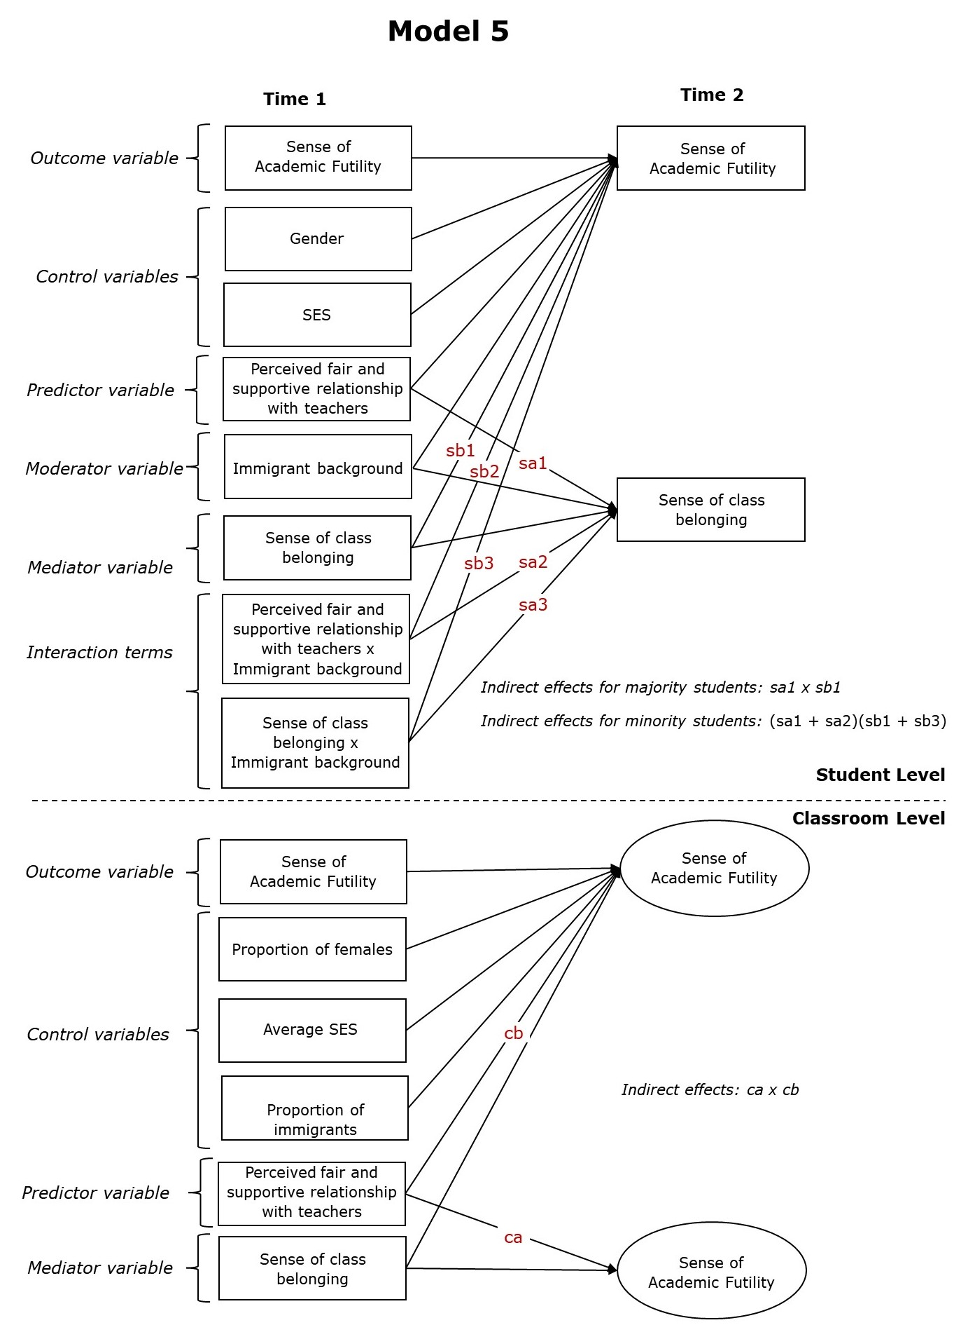
Note. s = student-level effects: a1 = effect of the predictor on the mediator; a2 = effect of the predictor on the mediator for ethnic minority students; a3 = stability of the mediator for ethnic minority students; b1 = effect of the mediator on the outcome; b2 = effect of the predictor on the outcome for ethnic minority students; b3 = effect of the mediator on the outcome for ethnic minority students. c = classroom-level effects: a = effect of the predictor on the mediator; b = effect of the mediator on the outcome.

S2. Results of Measurement Model and Measurement Invariance Tests
First, multilevel confirmatory factor analysis (Hox et al., 2018) was conducted to examine the factor structure of all the scales used in the present study. Second, cross-level measurement invariance was tested to examine whether all items on a scale loaded on the same factor at the student and class level (i.e., configural measurement invariance) and showed the same factor loading (i.e., metric measurement invariance). Specially, we started with estimating a configural invariance model, where factor loadings at the student and class level were freely estimated. Then, we estimated a metric invariance model, where factor loadings between student and class levels were constrained to be equal. Third, longitudinal measurement invariance testing was conducted (Little, 2013) while assuming cross-level measurement invariance. We first estimated longitudinal configural invariance model, where factor loadings and intercepts between time 1 and time 2 were freely estimated. Then, we tested the metric invariance model, in which factor loadings between time 1 and time 2 were constrained to be equal. In the third step, we estimated a scalar invariance model. In this model, factor loadings and intercepts between time 1 and time 2 were constrained to be equal. Since the mean structure was not part of the main analyses, scalar invariance was not needed. Hence, we planned on conducting the main analyses with the metric invariance model in case the scalar measurement model did not hold.
Evaluation of cross-level and longitudinal measurement invariance was based on two approaches, namely change in fit indices and the model selection method (see Van de Schoot et al., 2012). As for the change in fit indices, ΔCFI, ΔRMSEA, and ΔSRMR based on the following cut-off criteria were used. Given that the sample size was adequate (total N > 300), a change of ≤ -0.10 in CFI, ≥ 0.015 in RMSEA, or a change of ≥ 0.030 in SRMR would indicate non-invariance in testing factor loading invariance when comparing the configural and metric invariance model (fit indices of the constrained model minus the fit indices of the unconstrained model) and a change of ≤ -0.10 in CFI, ≥ 0.015 in RMSEA or a change of ≥ 0.010 in SRMR would indicate non-invariance in testing intercept invariance when comparing the metric and scalar invariance model (fit indices of the constrained model minus the fit indices of the unconstrained model). As for the model selection method, BIC was used, as recommended when the goal is to filter trivial non-invariance given that the BIC showed a low rejection rate to no or small non-invariance (Liang & Luo, 2020). BIC was the main criterion for testing measurement invariance because of its low rejection rate to no or small non-invariance. In the longitudinal measurement models, residual covariances between the same items at different time points were included because the item-specific variances were expected to correlate with each other (Little, 2013). We should also note that residual covariance between scale items with similar meanings were included (Bandalos, 2021).
After establishing cross-level invariance, we computed factor ICC(1) and two-level composite reliability, i.e., student level reliability and class level reliability estimate for all scales (Lai, 2021). Lastly, we computed mean scores for each scale which were subsequently used in the main analyses of the present study. We should also note that multilevel modeling (MLM) instead of multilevel structural equation modeling (ML-SEM) is used in the main analyses because sample size requirements for ML-SEM (i.e., at least 100 groups, Hox & Maas, 2001) were not fulfilled. Further, McNeish (2017) showed that MLM has a more desirable small sample performance, whereas ML-SEM showed notable convergence problems, poor confidence interval coverage for the indirect effect, and smaller statistical power for detecting the indirect effect than MLM.
Results are reported in the Tables below. All scales displayed an excellent fit and cross-level metric invariance could be established (see Table S2.a). Moreover, scalar longitudinal measurement invariance was also reached for sense of academic and class belonging (see Table S2.b).

Table S2.a
Multilevel Confirmatory Factor Analysis Results: Cross-Level Measurement Invariance Evaluation
Scale | $$χ^{2}$$ | df | CFI | TLI | RMSEA | SRMR_{W} | SRMR_{B} | BIC
Sense of academic futility
Time 1
Configural invariance | 1.11 | 4 | 1.000 | 1.000 | 0.000 | 0.003 | 0.043 | 7561.48
Metric invariance | 3.79 | 7 | 1.000 | 1.000 | 0.000 | 0.005 | 0.151 | 7543.95
Time 2
Configural invariance | 15.93 | 4 | 0.989 | 0.967 | 0.062 | 0.012 | 0.223 | 6587.09
Metric invariance | 27.45 | 7 | 0.981 | 0.968 | 0.062 | 0.013 | 0.315 | 6574.89
Perceived fair and supportive relationship with teachers
Time 1
Configural invariance | 31.66 | 10 | 0.990 | 0.979 | 0.046 | 0.020 | 0.016 | 11241.94
Metric invariance | 33.25 | 14 | 0.991 | 0.987 | 0.036 | 0.020 | 0.064 | 11217.38
Class belonging
Time 1
Configural invariance | 26.88 | 15 | 0.995 | 0.990 | 0.028 | 0.013 | 0.115 | 15004.62
Metric invariance | 33.46 | 20 | 0.994 | 0.992 | 0.026 | 0.013 | 0.123 | 14975.75
Time 2
Configural invariance | 12.89 | 15 | 1.000 | 1.000 | 0.000 | 0.008 | 0.037 | 11928.09
Metric invariance | 23.69 | 20 | 0.998 | 0.997 | 0.015 | 0.010 | 0.119 | 11901.70
Note. 766-1,033 students in 55 classrooms. Three residual covariances at each time point between scale items with similar meanings were specified for class belonging.

Table S2.b
Multilevel Confirmatory Factor Analysis Results: Longitudinal Measurement Invariance Evaluation
Scale | $$χ^{2}$$ | df | CFI | TLI | RMSEA | SRMR_{W} | SRMR_{B} | BIC
Sense of academic futility
Configural invariance | 40.30 | 40 | 1.000 | 1.000 | 0.003 | 0.019 | 0.155 | 13843.10
Metric invariance | 39.77 | 43 | 1.000 | 1.000 | 0.000 | 0.020 | 0.155 | 13823.93
Scalar invariance | 47.28 | 47 | 1.000 | 1.000 | 0.003 | 0.020 | 0.153 | 13802.75
Class belonging
Configural invariance | 207.65 | 104 | 0.982 | 0.977 | 0.031 | 0.034 | 0.113 | 26614.62
Metric invariance | 205.05 | 109 | 0.983 | 0.980 | 0.029 | 0.035 | 0.112 | 26583.21
Scalar invariance | 213.96 | 115 | 0.983 | 0.980 | 0.029 | 0.035 | 0.110 | 26549.54
Note. 945 students (sense of academic futility) and 1,050 students (class belonging) in 55 classrooms. Three residual covariances at each time point between scale items with similar meanings were specified for class belonging.

