Attenuation of neuroinflammation in microglia cells by extracts with high content of rosmarinic acid from in vitro cultured Melissa officinalis L. cells
Vittoria Borgonetti ¹, Giovanna Pressi ²*, Oriana Bertaiola ², Chiara Guarnerio ², Manuela Mandrone ³, Ilaria Chiocchio ³ and Nicoletta Galeotti ^{1,}*

¹Department of Neuroscience, Psychology, Drug Research and Child Health (NEUROFARBA), Section of Pharmacology and Toxicology, University of Florence, Viale G. Pieraccini 6, 50139 Florence, Italy;
²Aethera Biotech Srl, 36043 Camisano Vicentino (VI), Italy;
³ Department of Pharmacy and Biotechnology, University Bologna, Via Irnerio 42, 40126 Bologna, Italy.

*Correspondence:
Prof. Nicoletta Galeotti, Department of (NEUROFARBA, Section of Pharmacology and Toxicology, University of Florence, Viale G. Pieraccini 6, 50139 Florence, Italy; nicoletta.galeotti@unifi.it;

Highlights:
- Extracts obtained from plant cell culture are standardized and with safety
- Exploiting in vitro cell cultures as a standardized phytocomplex of Melissa officinalis L.
- Melissa officinalis L. extract possessed anti-inflammatory and neuroprotective effects
- These properties are related to the rosmarinic acid concentration.

Abstract:
Plant cell culture is a biotechnology cultivation method that permit to cultivate plants in a short period of time and to obtain extracts with a high degree of standardization and high safety profile. The aim of our study was to evaluate the anti-inflammatory and neuroprotective activity of a standardized Melissa officinalis L. phytocomplex extract (MD) obtained with an in vitro plant cell culture. The MD has been chemically characterized and the content of total polyphenols was 5.17± 0.1% w/w, with a content of rosmarinic acid (RA), its main constituent, of 4.02± 0.1% w/w. MD was tested in an in vitro model of neuroinflammation, in which microglia cells (BV2) were stimulated with Lipopolysaccharides (LPS; 250 ng/mL) for 24 h and its pharmacological activity was compared with that of RA. MD (10 µg/mL) and RA (0.4 μg/ml) reduced pro-inflammatory factors (NF-kB, HDAC, IL-1ß) in LPS-stimulated BV2 cells and counteracted the toxic effect produced by activated microglia medium on neuronal cells. This work shows the efficacy of MD on reducing microglia-mediated neuroinflammation and promoting neuroprotection, highlighting the innovative use of in vitro plant cell cultures to obtain contaminant-free extracts endowed with marked activity and improved quali-quantitative ratio in the constituents’ content.
Keywords: neuroinflammation; microglia; rosmarinic acid; Melissa officinalis L.

1. Introduction

Natural products have always had an enormous importance for healthcare, and still nowadays they represent a precious source of medicines, food supplements, cosmetics and so on. Plants produce a huge variety of metabolites, diversifying the chemical scaffolds to adapt, compete and communicate in the environment. Moreover, the coevolution of plants and animals, gives to plants metabolites high chance to be biologically active and also likely to be substrates for one or more of the many transporter systems that can deliver the compounds to their intracellular site of action(Harvey et al., 2015). Many natural compounds exhibit a wide range of pharmacophores and a high degree of stereochemistry, making them promising hits candidates, with very complex chemical structure often difficult to be obtained synthetically (Drewry et al., 2010). A review work by Newman & Cragg dealing with the new medicines approved by the US Food and Drug Administration (FDA) from 1981 to 2010, highlighted that 34% of those medicines based on small molecules were natural products or direct derivatives of natural products(Newman et al., 2012). Moreover, the documented use of plants in traditional medicine systems represents a further resource to supports natural product-based drug-discovery and to provide valuable information on plant safety profile. Plant cell culture technology is a technique for growing of plant cells under strictly controlled environmental conditions. Since plant cells are considered totipotent, they have the potential to express the full genetic machinery coded in the nucleus, and thus, they can produce the full spectrum of characteristic secondary metabolites, found in mother plants (Georgiev et al., 2018). Plant cells are amenable to good manufacturing practice procedures and can be easily propagated by using large volume bioreactors independently on climate or soil or field management practices (Georgiev et al., 2018). Moreover, in vitro cultured plant cells are characterized with fast growth, and the ability to accumulate large amount of uniform biomass for a short period of time (Yue et al., 2016). Additionally, plant cell culture technology offers a reliable and powerful production platform for continuous supply of contamination-free, phytochemically uniform biomass from herbal, aromatic, medicinal, and even from rare and threatened plant species.

Plant cell cultures are very attractive platforms to produce high-biotech ingredients for cosmetic, nutraceutical and food purposes (Eibl et al., 2018). Their season-independent production and the great water saving compared to traditional agricultural practices make these systems suitable for industrial planning and more sustainable towards environment issues as water, carbon footprint and pesticide or herbicide uses. Moreover, when exploited to get non-food products, plant cell cultures are ethically more acceptable since they do not consume agricultural land(Eibl et al., 2018).

The bioactivity of Melissa officinalis L. extracts is mainly attributed, as for the majority of plant formulation, to the qualitative and quantitative composition of secondary metabolites (i.e., phenolic acids, flavonoids and terpenoids). Rosmarinic acid (RA) is a caffeic acid ester with 3,4-dihydroxyphenyllactic acid and it is a main bioactive component of the Melissa officinalis L. extracts. The RA and phenolic acids content in the Melissa officinalis L. extract is highly variable (Hitl et al., 2021). The variability is associated with multiple factors, which are difficult to control: seasons, plant age, geographical growing areas and tissues used for the preparation of products (Papoti et al., 2019). Furthermore, the preparation of standardized Melissa officinalis L. derivatives with a reproducible content of metabolites is very difficult. The extreme variability in the content of phytoconstituents of plant preparations obtained directly from a plant, or parts thereof, by extraction negatively impacts the effectiveness of the same. An alternative method for obtaining contaminant-free standardized plant preparation in industrial quantities is to use in vitro plant cell cultures (Pressi, Bertaiola, Guarnerio, Barbieri, Guzzo, et al., 2021).

In traditional medicine, Melissa officinalis L. and its essential oil, have been used for the treatment of nervous, gastrointestinal, hepatic, and biliary disorders and in modern medicine, it has been shown to control symptoms associated to anxiety and insomnia (Cases et al., 2011). In recent years Melissa officinalis L. was also associated with beneficial effects in several skin disorders and a protective activity from damages by UVB exposure was described (Sipos et al., 2021). This effect is related to the antioxidant and free radical scavenging properties of its main constituent, rosmarinic acid, indicating a potential antiaging activity of Melissa officinalis L. preparations(Noguchi-Shinohara et al., 2020).
The increasing life expectancy of populations in developed countries makes modulating aging an urgent medicinal priority. Recent evidence highlights chronic low-grade inflammation as a feature of aging, the so-called “inflammaging” (Franceschi et al., 2017; Monti et al., 2017). In particularly, neuroinflammation is an important physiological process responsible for the onset of numerous aging-degenerative diseases. The main cell type involved in this activity are microglia cells, devoted to the maintenance of homeostasis in the CNS. After an insult, microglia assume a pro-inflammatory phenotype (M1) and potentially release a large amount of pro-inflammatory cytokines, which are thought to induce tissue damage, demyelination, and neuronal death in the CNS (Streit et al., 2004; Subhramanyam et al., 2019).
On these bases, the aim of our study was to evaluate the pharmacological profile of an in vitro cell cultured Melissa officinalis L. cells extract (MD) with high content of RA. Our results showed that MD attenuated microglia-mediated neuroinflammation and promoted neuroprotectant effects, highlighting the use of extracts from in vitro plant cell cultures as an innovative and effective strategy.

2. Materials and Methods

2.1 Phytocomplex preparation from selected Melissa officinalis L. cell line

The stabilized and highly selected cell line specified on the synthesis of rosmarinic acid of Melissa officinalis L. was obtained as described in Pressi et al (Pressi, Bertaiola, Guarnerio, Barbieri, Guzzo, et al., 2021). 10 days old cell cultures of Melissa officinalis L. were filtered by 50 µm mesh filter and the medium cultures were discarded. Cells were washed with a double volume of saline solution (0.9% w/v NaCl in sterile water) and added with 1% (w/w) of citric acid and then homogenized with ultraturrax at 15000 rpm for 20 minutes. The biomass of homogenate cells was dried to obtain a phytocomplex (MD).

2.2 NMR analysis

Melissa officinalis L. phytocomplex (MD) was extracted and subjected to ¹H NMR analysis. Thirty mg of freeze-dried material were extracted using 1 mL of mixture (1:1) of phosphate buffer (90 mM; pH 6.0) in H₂O-d₂ (containing 0.1% TMSP) and MeOH-d₄ by ultrasonication (TransSonic TP 690, Elma, Germany) for 20 min. After this procedure, the sample was centrifuged for 10 min (17000 × g), then 700 μL of supernatant were transferred into NMR tube. ¹H NMR spectrum was recorded at 25°C on a Varian Inova instrument (equipped with a reverse triple resonance probe) operating at ¹H NMR frequency of 600.13 MHz, and H₂O-d₂ was used as internal lock. The ¹H NMR spectrum consisted of 256 scans (corresponding to 16 min) with the relaxation delay (RD) of 2 s, acquisition time 0.707 s, and spectral width of 9595.8 Hz (corresponding to δ 16.0). A presaturation sequence (PRESAT) was used to suppress the residual water signal at δ 4.83 (power = -6 dB, presaturation delay 2 s). ¹H NMR spectrum was manually phased and baseline corrected and calibrated to the internal standard trimethyl silyl propionic acid sodium salt (TMSP) at δ 0.0 using Mestrenova software (Mestrelab Research, Spain). The signals elucidation was performed also based on an in-house library and comparison with literature (Mandrone, Chiocchio, et al., 2021; Mandrone, Marincich, et al., 2021).

2.3 UPLC-DAD analysis

100 mg of powder of MD were weighed into a 15 ml test tube and 30 volumes of ethanol (Honeywell) and water 60:40 (v/v) were added. The suspension was mixed for 30 seconds with a vortex mixer and sonicated for 15 minutes in an ice bath; finally, it was centrifuged at 4000 rpm for 15 minutes at 6°C. At the end of centrifugation, the supernatant was recovered. 15 ml of supernatant were transferred into a new tube and preserved in ice until loading into the UPLC system. The sample was diluted 1:10 (first 1:5 in a solvent and then 1:2 in water). The diluted sample was filtered over 0.22 μm filters before being loaded into the UPLC system. Five independent replicates of the MD were extracted and measured. The chromatography system used for quantification of the RA consists in an Acquity UPLC BEH C18 1.7 μm column, size 2.1x100 mm, coupled to an Acquity UPLC BEH C18 1.7 μm VanGuard Pre-Column 3/Pk, size 2.1x5 mm. The platform used for the UPLC-DAD analysis comprises a UPLC system (Waters) consisting of an eluent management module, Binary Solvent Manager model I Class, and an auto-sampler, Sample Manager – FTN model I Class, coupled to a PDA eλ diode array detector. Empower 3 (Waters) software was used to acquire and analyze the data. The chromatography method used was the following: solvent A: water, 0.1% formic acid; solvent B: 100% acetonitrile. The initial condition is 99% solvent A; moreover, the flow remains constant at 0.350 ml/min throughout the duration of the analysis. The chromatography column was temperature controlled at 30°C. Elution of the molecules was conducted by alternating gradient and isocratic phases, as indicated in Table 1.
Table 1. Elution of the molecules in UPLC-DAD analysis
Time from start of the analysis (min) | Percentage of solvent B | Slope
0 | 1%
1 | 1% | linear
11 | 40% | linear
12 | 100% | linear
13 | 100% | linear
13.10 | 1% | linear
15 | 1% | linear

Quantification of total polyphenols and RA in the samples were based on absorbance UV/VIS spectra measured at 330 nm. The amount of RA and the total polyphenols (expressed as equivalent of RA) were evaluated through the comparison with calibration curves obtained from serial dilution of the authentic commercial standard of RA (CAS 20283-92-5; purity≥95%; Sigma Aldrich). The data analysis was carried out with Empower 3 software.

2.4 Cell culture

A microglial line BV-2 (microglial cells, Tema Ricerca, Genova, Italy) was used for this study. The cells were thawed and placed in a 75 cm2 flask (Sarstedt, Nümbrecht, Germany) in a medium containing RPMI with the addition of 10% of heat-inactivated (56 °C, 30 min) fetal bovine serum (FBS, Gibco®, Milan, Italy) and 1% glutamine. Cells were grown at 37 °C and 5% CO2 with daily medium change (Borgonetti, Governa, Biagi, Dalia, et al., 2020). A human neuroblastoma cell line SH-SY5Y was kindly donated by Prof. Lorenzo Corsi (University of Modena and Reggio Emilia, Italy), was cultured in DMEM and F12 Ham’s nutrients mixture (Sigma-Aldrich, Milan, Italy), containing 10% heat-inactivated FBS (Sigma-Aldrich), 1% L-glutamine (Sigma- Aldrich), and 1% penicillin-streptomycin solution (Sigma-Aldrich) until confluence (70–80%). The cells were grown in a humidified atmosphere with 5% CO2 at 37 °C. EDTA-trypsin solution (Sigma-Aldrich) was used for detaching the cells from flasks, and cell counting was performed using a hemocytometer by Trypan blue staining as previously reported (Borgonetti, Governa, Biagi, Pellati, et al., 2020).

2.5 Sulforhodamine B (SRB) assay

Cell viability was assessed by SRB assay. BV2 were seeded in 96-well plates, each corresponding to a different treatment (2x104 cells in 200 μL). 100 μL of serum-free RPMI 1640 were added to the wells followed by 25 μL of 50% TCA trichloroacetic acid. The plate was then incubated at 4°C for 1 h. This was followed by 5 washes with double distilled water (100 μL/well). The plate was left overnight to dry at room temperature. The next day, 30 µL of SRB (4 mg/mL) in 1% acetic acid were added to each well and incubated for 30 min at room temperature. Four washes with 1% acetic acid (200 μL/well) were performed. Then 200 μL of TRIS HCl solution at pH 10 were added and incubated for 5 min. Finally, the absorbance was recorded at a wavelength of 570 nm. The treatments were performed in six replicates in three independent experiments, and cell viability was calculated by normalizing the values to the control’s mean(Wu et al., 1993).

2.6 CCK-8 (cell counting kit) assay

The neuroprotective effect of MD and its constituents was evaluated by assessing the cell viability of the SH-SY5Y cells treated with the LPS-conditioned BV2 medium for 24 h. Unstimulated BV2 medium was used as control. Cell viability was performed using the Cell Counting Kit (CCK-8, Sigma-Aldrich) according to the manufacturer’s instructions. The absorbance was measured at 450 nm using a MP96 microplate reader spectrophotometer (Safas, Monte Carlo, Principality of Monaco). The treatments were performed in six replicates in three independent experiments, and cell viability was calculated by normalizing the values to the control’s mean (Borgonetti, Governa, et al., 2021).

2.7 Preparation of cell lysate

BV2 cells were seeded in 6-well plates (3 × 10⁵ cells/well), pre-treated with MD 10 µg/mL and RA 0.4 µg/mL for 4 h, and then stimulated with LPS 250 ng/mL for 24 h. Then, the conditioned BV2 medium was collected and centrifuged (1000 x g for 10 min, 37 °C). The pellet was discarded, and the supernatant was stored at -80 °C for BDNF dosages or used to treat SH-SY5Y cells (5 × 105 cells/well in 96-well plates). Proteins from cells were extracted using RIPA buffer (50 mM Tris-HCl pH 7.4, 150 mM NaCl 1% sodium deoxycolate, 1% Tryton X-100, 2 mM PMSF) (Sigma-Aldrich) and the insoluble pellet was separated by centrifugation (12000 × g for 30 min, 4 °C). The total protein concentration in the supernatant was measured using Bradford colorimetric method (Sigma-Aldrich) (Borgonetti, Governa, Biagi, Pellati, et al., 2020).

2.8 Supernatant protein precipitation

TCA (25 µL) was added to 50 µL of medium and incubated at 4 °C for 10 min. This was followed by centrifugation at 14000 rpm for 5 min. The supernatant was then removed, the pellet was washed three times by resuspending in cold acetone, and centrifuging again at 14000 rpm for 5 min. At this point the microtubes were placed in the stove, favoring the evaporation of the acetone and the drying of the pellets. Finally, the pellet was resuspended in loading buffer 4x and the samples were stored at -20 °C.

2.9 Western Blotting

Protein samples (40 µg/sample) were separated by 10% SDS-PAGE. Proteins were then blotted onto nitrocellulose membranes (120 min at 100 V) using standard procedures. Membranes were blocked in PBST containing 5% non-fat dry milk for 120 min and incubated overnight at 4 °C with primary antibodies anti-IKB (1:1000, sc-1643, RRID:AB_627772) (Santa Cruz Biotechnology, CA, USA), anti-pp38, phosphorylated on Tyr182 (1:250, sc-166182, RRID:AB_2141746), anti-HDAC1 (1:1000, sc-81598), anti-HDAC2 (1:1000, sc-9959) BDNF (1:500, sc-65514) , anti-IL-1 (1:1000, bs6319R) (Bioss Antibodies, MA, USA). The blots were rinsed three times with PBST and incubated for 2 h at room temperature with HRP-conjugated mouse anti-rabbit (1:3000, sc-235,) (Santa Cruz Biotechnology) and goat anti-mouse (1:5000, bs-0296G) (Bioss Antibodies) and then detected by chemiluminescence detection system (Pierce, Milan, Italy). Signal intensity (pixels/mm2) was quantified using ImageJ (NIH). The signal intensity was normalized to that of GAPDH (1:5000, sc-32233) (Santa Cruz Biotechnology) (Isacchi et al., 2017)

2.10 Statistical analysis

Data are expressed as the mean ± SEM of six experiments and assessed by One-way or two-way ANOVA, followed by Tukey post hoc test. For each test a value of p < 0.05 was considered significant. The software GraphPad Prism (version 5.0, San Diego, CA, USA) was used in all statistical analysis.

3. Results

3.1 UPLC-DAD analysis

The UPLC-DAD analysis was used to estimate the content of total polyphenols and the content of RA in the MD. The chromatographic profile of the MD extract at the wavelength of 330 nm is shown in Fig 1. The data obtained show that the content of total polyphenols in the MD, expressed as equivalent of RA is 5.17± 0.1% w/w and the content of RA is 4.02± 0.1% w/w. Thus, the main component of total polyphenols in the MD is represented by RA.

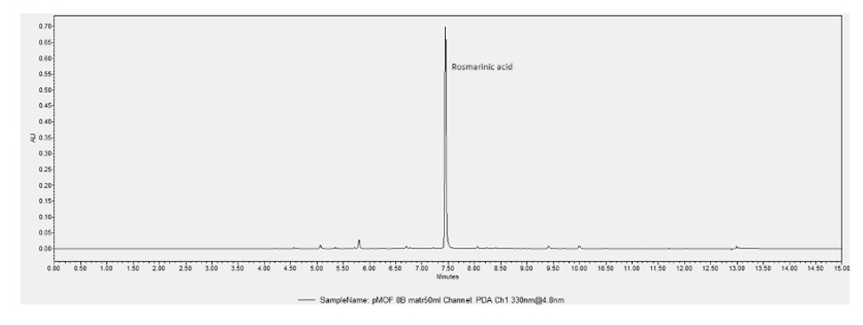

Fig 1. Chromatographic profile of the MD extract. The main peak at retention time 7.5 min corresponds to RA.

3.2 NMR analysis
The ¹H NMR profiling of MD extract (Fig. 2) showed the presence of both primary and secondary metabolites in MD. In particular, sugars, amino acids and organic acids were detected, namely: α-glucose, β-glucose, sucrose, alanine, valine, citrate, and acetate. Moreover, the aromatic region of the spectrum showed quite intense signals ascribable to RA.
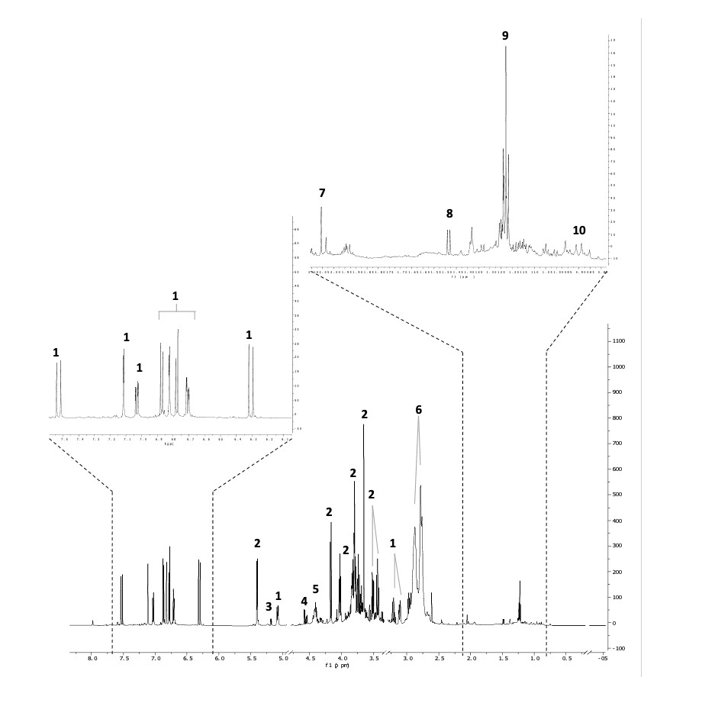
Fig. 2. ¹H NMR profile of MD. The regions of δ 4.94–4.78, δ 3.34–3.30, 0.20 – -0.20 were excluded from the analysis because of the residual signals of solvents and standard. 1= RA, 2= sucrose, 3= α-glucose, 4= β-glucose, 5= unknown sugar, 6= citrate, 7= acetate, 8= alanine, 9= ethanol, 10= valine.

3.3 Concentration-response curve of MD extract in BV2 cells
Before directly evaluating the anti-neuroinflammatory of MD extract, we excluded any cytotoxic effect of the extract by treating BV-2 cells with increasing concentrations (0.1, 1, 10 and 100 μg/mL) of MD for 24 h. Using the SRB test, cellular toxicity was excluded at all tested concentrations (Fig 3A). To optimize the concentration to be used for investigating the anti-inflammatory effect of MD extract, we tested the extract at different concentration (0.1, 1, 10 and 100 μg/mL) in an in vitro model of neuroinflammation. In this model BV-2 cells were treated with LPS 250 ng/mL for 24 h. NF-κBp65 represents a key modulator in microglia activation, indeed it is known to induce an increase of gene transcription involved in inflammation pathway (Shih et al., 2015).
The levels of NF- κBp65 were evaluated indirectly by measuring the IKB⍺ inhibitor. Figure 3B shows the reduction of IKB⍺ levels in LPS-stimulated BV2, compared to untreated cell (CTRL). MD extract 1 μg/mL was already able to reduce the activation of NF-κBp65, but the peak of the effect was observed at the concentration of 10 μg/mL, while MD extract 100 μg/mL started to lose the efficacy. Hence, the concentration of 10 μg/mL which possessed the maximal activity and did not produce alteration on cell viability, was used for further experiments (Fig 3B).

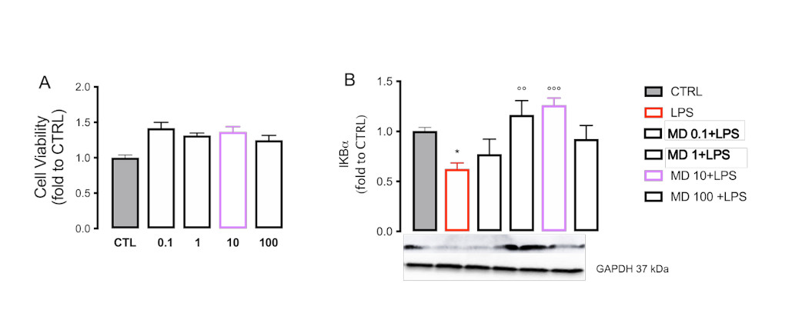
Fig. 3 Dose-response curve for MD. A) SRB assay test to evaluate the maximum non-toxic concentration of MD extract (µg/ml). B) Effect of MD extract on the expression of IKB⍺. B) Effect of MD extract at the concentration of 0.1, 1, 10 and 100 μg/ml on IKB⍺ protein expression in LPS-stimulated BV2. One-way ANOVA *p<0.05 vs CTRL °°°p<0.001 °°p<0.01 vs LPS.

3.4 MD extract reduced the expression of proinflammatory factors in LPS-stimulated BV2
We evaluated the effect of MD extract on different markers of neuroinflammation, namely HDAC1, HDAC2, and p-p38, which are involved in various signaling pathways related to the inflammatory phenotype of microglia. Indeed, we recently reported that HDAC1 and 2 can epigenetically control the expression of NF-κB, and, consequently, the activation of microglia to the proinflammatory phenotype (Borgonetti & Galeotti, 2021b). LPS increased the expression of HDAC1 (Fig .4A) and HDAC-2 (Fig. 4B) after 24 h of stimulation. MD extract 10 μg/mL significantly reduced the expression of both HDAC1 and HDAC2. No effect was observed regarding the activation of p38 (Fig. 4C). The anti-inflammatory effects were evaluated trough the dosage of IL1β, a pro-inflammatory cytokine which resulted overexpressed in LPS-stimulated BV2, in the supernatants. We found that the pretreatment with MD completely prevented this effect (Fig. 4D).
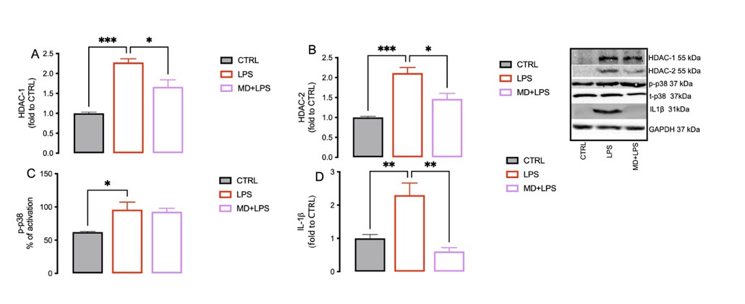
Fig. 4 MD reduction of proinflammatory factors. Effect of MD extract 10 μg/ml on protein expression of HDAC-1 (A), HDAC-2 (B), p-P38 (C) and IL-1ß in LPS-stimulated BV2. One-way ANOVA ***p<0.001 **p<0.01 *p<0.05

3.5 Neuroprotective effect of MD extract on inflammation-induced neurotoxicity in SH-SY5Y cells
Microglial cells are essential for maintaining neuronal homeostasis. Therefore, their shift towards a proinflammatory phenotype can cause the release of numerous factors that destabilize normal neuronal activity(Block et al., 2007).
For this reason, we evaluated the ability of MD extract to modify the release of the neurotrophin BDNF from proinflammatory microglia, to protect neuronal development and its functionality (Martinowich et al., 2007). As reported in Figure 5A, MD extract 10 μg/mL increased BDNF release compared to LPS-stimulated BV2, suggesting a neuroprotective effect of this extract. To better investigate the neuroprotective effect of the MD extract, we treated SH-SY5Y neuronal cells with the BV2 LPS-conditioned medium and evaluated the effect on cell viability. The results obtained (Figure 5B) indicate that the viability of cells treated with LPS alone is reduced compared to controls, while treatment with MD extract reduces the cytotoxicity induced by the model.
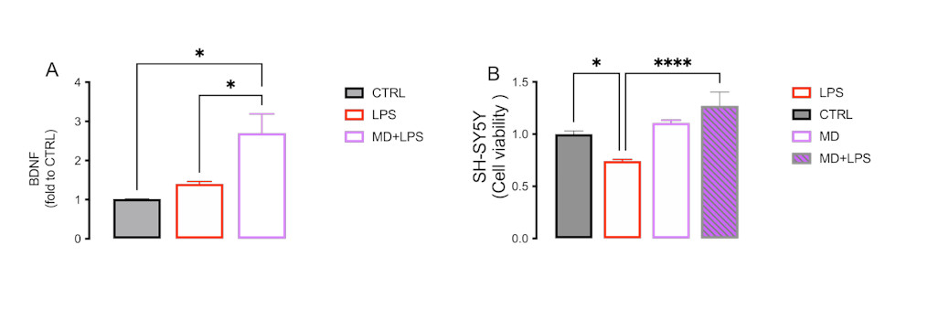
Fig. 5 Neuroprotective effect of MD. (A) Increase of BDNF released from BV2 cells stimulated with LPS by MD extract 10 μg/ml. One way ANOVA *P<0.05. (B) Evaluation of neuroprotective effect of MD extract 10 μg/ml using the CCK8 to evaluate the viability of SH-SY5Y treated with LPS-BV2 conditioned medium. Two -way ANOVA ****p<0.00001 *p<0.05

3.6 RA was the main responsible for the anti-inflammatory and neuroprotective activity of MD extract
To understand if RA was responsible for the activity of the MD extract, we tested the effect of RA in the in vitro model of neuroinflammation, using the concentration present in the active dose of MD (0.4 µg/mL). The anti-inflammatory effect of RA was comparable to that produced by MD extract. Indeed, it induced an increase of IKB⍺ in LPS-stimulated BV2 cells (Fig. 6A), while reducing HDAC1 expression (Fig. 6B). In SHSY5Y, RA reduced the toxicity produced by the LPS-conditioned BV2 medium, with an efficacy comparable to that of MD extract (Fig. 6C).
Fig. 6 RA anti-inflammatory and neuroprotective activity. Effect of RA (0.4 μg/ml) on IKB⍺ (A) and HDAC-1 (B) in BV2 stimulated with LPS in comparison with MD extract 10 μg/ml. (C) Evaluation of the neuroprotective effect of RA (0.4 μg/ml) on the inflammation-induced neurotoxicity model on SH-SY5Y performed with CCK-8 compared to MD extract (10 μg/ml). One-way ANOVA ****p<0.0001, ***p<0.001, **p<0.01, *p<0.05

4. Discussion

Traditional plant extracts are characterized by extreme variability in the extract composition, which depends on several factors, such as climate, soil and cultivation techniques. This variability cannot guarantee the efficacy and reproducibility of the effect of the extract in health care applications. Exploiting in vitro cell cultures, we obtained a standardized phytocomplex (MD) with high content of RA, free from pesticides, contaminates, and residual solvents, maintaining the same biological efficacy in all batches (Pressi, Bertaiola, Guarnerio, Barbieri, Faggian, et al., 2021). The aim of our study was to evaluate the anti-inflammatory and neuroprotective activity MD extract (standardized to contain 5.17% w/w of total polyphenols, equivalent to 4.02% RA) obtained with an innovative process through plant cell cultures. The high and standardized content of RA in Melissa officinalis L. selected cell line is due to the high plasticity of the de-differentiated cells culture in optimized medium and under controlled conditions.

The cell plasticity of the in vitro plant cell culture allows to induce rapid stimuli to the biosynthesis of secondary metabolites by modifying the final liquid medium composition. As described in Pressi et al. 2021 (Pressi, Bertaiola, Guarnerio, Barbieri, Guzzo, et al., 2021) the final liquid medium of Melissa officinalis L. cell line with higher content of sucrose and lower content of plant growth hormones induced the biosynthesis of a high content of RA, in comparison to maintenance liquid medium.

Melissa officinalis L. is known to have anti-inflammatory activity (Shakeri et al., 2016) mainly due to the presence of RA(Rodríguez-Luna et al., 2019). To confirm these properties and to extend to the evaluation of the activity of MD extract also as anti-neuroinflammatory agent, a microglial BV2-based cell model of neuroinflammation was developed. Under normal conditions, microglia cells are activated in response to a stimulus or insult to the body, developing a physiological inflammatory response to maintain the central nervous system homeostasis (Vainchtein et al., 2020). However, the inflammatory process tends to become chronic due to excessive microglial activation, with accelerated aging and loss of function (O’Loughlin et al., 2018). Thus, present method that involves the use of immortalized microglial cells appears ideal to investigate a protectant activity toward neuroinflammation. Cells were stimulated with LPS for 24 h, with the main consequence being the overexpression of inflammation-related genes (Nam et al., 2018). In response to a damaging stimulus, microglia assume a pro-inflammatory phenotype, characterized by morphological changes and overexpression of cytokines and chemokines such as IL-1, IL-6, and TNF-α (Nam et al., 2018). Treating LPs-stimulated BV2 with MD resulted in a reduction of the inflammatory process, with decreased levels of NF-κB, HDAC1, HDAC2, and IL-1β. HDAC is an epigenetic enzyme that regulates the acetylation of histones, modulating the interaction of transcription factors with DNA (Romanelli et al., 2021; Maria Domenica Sanna et al., 2017). We previously identified HDAC1 and HDAC2 as inflammatory markers, as a decrease in levels corresponds to a reduction in microglial activation and neuroinflammation (Borgonetti & Galeotti, 2021a). NF-κB represents a transcription factor, the activation of which induces a signalling pathway that ends in the expression of inflammatory cytokines. The main inhibitor is represented by IKB-α, which regulates the expression of NF-κB and the inflammatory process through a negative feedback mechanism(Iwai et al., 2005). A close correlation between HDAC1 and NF-κB p65 during microglia activation is well documented in the literature(Shih et al., 2015).

The maintenance of neuronal homeostasis, made possible by continuous communication between cells, is among the main activities of microglia, and BDNF is responsible for this interaction. BDNF has a neuroprotective role and modulates synaptic plasticity (Parkhurst et al., 2013; M D Sanna et al., 2014).

Activation of microglia towards a pro-inflammatory phenotype compromises neuronal integrity, due to overexpression of inflammatory cytokines and ROS, and decreased levels of neuroprotective factor(Streit et al., 2009). There is considerable scientific evidence supporting the neuroprotective effect of M. officinalis. For example, a reduction in ROS levels and cellular toxicity was observed in vitro(López et al., 2009). To evaluate the effect of MD on neurotoxicity, we optimized an in vitro model, by treating SHSY5Y neuronal cells with LPS-conditioned BV2 medium for 24 h (Borgonetti, Governa, Biagi, Pellati, et al., 2020). The results obtained confirm the neuroprotective effect of MD, with a reduction in cellular toxicity, associated with decreased levels of inflammatory cytokines such as IL-1β and increased BDNF levels. MD has a high RA content which is known to be an effective antioxidant, antibacterial, antiviral, anti-inflammatory, analgesic, neuroprotective, and cardioprotective agent(Noguchi-Shinohara et al., 2020). Particularly, the anti-inflammatory activity of RA was found to be related to the inhibition of the activation of the complement system, as well as to the reduction of the expression of the gene encoding for cyclooxygenase 2, and of several cytokines and pro-inflammatory mediators (Colica et al., 2018).

RA was tested at the concentration present in the active dose of MD in the neuroinflammation model, leading to a reduction in NF-κB and HDAC1 levels, with and efficacy comparable to that of MD. We thus confirmed that the anti-neuroinflammatory of MD extract is mainly due to its content in RA.

5. Conclusion

In conclusion, this work highlights how an extract obtained by in vitro cultured Melissa officinalis L. cells (MD) containing high concentration of RA can reduce neuroinflammation at the level of microglial cells, which contributes to the neuroprotectant effects. Indeed, this study indicates in vitro cultured Melissa officinalis L. cells MD as an innovative anti-neuroinflammatory approach with potential antiaging activities. Modulating aging is one of the most popular and challenging themes in modern medicine and present findings lay the groundwork to further investigations in more complex models.

6. Patents

Patent ITA102019000004113-PCT/IB2020/052589: Phytocomplex and selected extract of a meristematic cell line of a plant belonging to the genus Melissa
Author Contributions: “Conceptualization, N.G. and GP.; methodology, N.G., V.B., G.P.; software, V.B validation, V.B., G.P.; O.B.; C.G.; M.M. and I.C..; formal analysis, N.G., V.B.; O.B.; C.G.; M.M. and I.C.; investigation, V.B., G.P; data curation, V.B.; O.B.; C.G.; M.M. and I.C.; writing—original draft preparation, N.G., V.B., G.P..; writing—review and editing, N.G., .G.P.; supervision, N.G.; project administration, N.G., V.B..; funding acquisition, N.G.. All authors have read and agreed to the published version of the manuscript.” Please turn to the CRediT taxonomy for the term explanation. Authorship must be limited to those who have contributed substantially to the work reported.
Acknowledgments: Thanks to all technical team of Aethera Biotech Srl for the support in the development of Melissa officinalis selected cell line.
Conflicts of Interest: The authors declare no conflict of interest.

References
Block, M. L., Zecca, L., & Hong, J. S. (2007). Microglia-mediated neurotoxicity: Uncovering the molecular mechanisms. In Nature Reviews Neuroscience (Vol. 8, Issue 1, pp. 57–69). doi: 10.1038/nrn2038
Borgonetti, V., & Galeotti, N. (2021a). Combined inhibition of histone deacetylases and BET family proteins as epigenetic therapy for nerve injury-induced neuropathic pain. Pharmacological Research, 165, 105431. doi: https://doi.org/10.1016/j.phrs.2021.105431
Borgonetti, V., & Galeotti, N. (2021b). Intranasal delivery of an antisense oligonucleotide to the RNA-binding protein HuR relieves nerve injury-induced neuropathic pain. Pain, 162(5), 1500–1510. doi: 10.1097/j.pain.0000000000002154
Borgonetti, V., Governa, P., Biagi, M., Dalia, P., & Corsi, L. (2020). Rhodiola rosea L. modulates inflammatory processes in a CRH-activated BV2 cell model. Phytomedicine, 68, 153143. doi: https://doi.org/10.1016/j.phymed.2019.153143
Borgonetti, V., Governa, P., Biagi, M., Pellati, F., & Galeotti, N. (2020). Zingiber officinale Roscoe rhizome extract alleviates neuropathic pain by inhibiting neuroinflammation in mice. Phytomedicine, 78, 153307. doi: https://doi.org/10.1016/j.phymed.2020.153307
Borgonetti, V., Governa, P., Manetti, F., Miraldi, E., Biagi, M., & Galeotti, N. (2021). A honokiol-enriched Magnolia officinalis Rehder &amp; E.H. Wilson. bark extract possesses anxiolytic-like activity with neuroprotective effect through the modulation of CB1 receptor. Journal of Pharmacy and Pharmacology, 73(9), 1161–1168. doi: 10.1093/jpp/rgab067
Cases, J., Ibarra, A., Feuillère, N., Roller, M., & Sukkar, S. G. (2011). Pilot trial of Melissa officinalis L. leaf extract in the treatment of volunteers suffering from mild-to-moderate anxiety disorders and sleep disturbances. Mediterranean Journal of Nutrition and Metabolism, 4(3), 211–218. doi: 10.1007/s12349-010-0045-4
Colica, C., Renzo, L. di, Aiello, V., de Lorenzo, A., & Abenavoli, L. (2018). Reviews on Recent Clinical Trials BENTHAM SCIENCE.
Drewry, D. H., & Macarron, R. (2010). Enhancements of screening collections to address areas of unmet medical need: an industry perspective. Current Opinion in Chemical Biology, 14(3), 289–298. doi: https://doi.org/10.1016/j.cbpa.2010.03.024
Eibl, R., Meier, P., Stutz, I., Schildberger, D., Hühn, T., & Eibl, D. (2018). Plant cell culture technology in the cosmetics and food industries: current state and future trends. Applied Microbiology and Biotechnology, 102(20), 8661–8675. doi: 10.1007/s00253-018-9279-8
Franceschi, C., Garagnani, P., Vitale, G., Capri, M., & Salvioli, S. (2017). Inflammaging and ‘Garb-aging.’ Trends in Endocrinology & Metabolism, 28(3), 199–212. doi: https://doi.org/10.1016/j.tem.2016.09.005
Georgiev, V., Slavov, A., Vasileva, I., & Pavlov, A. (2018). Plant cell culture as emerging technology for production of active cosmetic ingredients. In Engineering in Life Sciences (Vol. 18, Issue 11, pp. 779–798). Wiley-VCH Verlag. doi: 10.1002/elsc.201800066
Harvey, A. L., Edrada-Ebel, R., & Quinn, R. J. (2015). The re-emergence of natural products for drug discovery in the genomics era. Nature Reviews Drug Discovery, 14(2), 111–129. doi: 10.1038/nrd4510
Hitl, M., Kladar, N., Gavarić, N., & Božin, B. (2021). Rosmarinic Acid-Human Pharmacokinetics and Health Benefits. In Planta Medica (Vol. 87, Issue 4, pp. 273–282). Georg Thieme Verlag. doi: 10.1055/a-1301-8648
Isacchi, B., Bergonzi, M. C., Iacopi, R., Ghelardini, C., Galeotti, N., & Bilia, A. R. (2017). Liposomal Formulation to Increase Stability and Prolong Antineuropathic Activity of Verbascoside. Planta Medica, 83(5), 412–419. doi: 10.1055/s-0042-106650
Iwai, K., Lee, B. R., Hashiguchi, M., Fukushima, A., & Iwashima, M. (2005). IkB-α-specific transcript regulation by the C-terminal end of c-Rel. FEBS Letters, 579(1), 141–144. doi: 10.1016/j.febslet.2004.11.060
López, V., Martín, S., Gómez-Serranillos, M. P., Carretero, M. E., Jäger, A. K., & Calvo, M. I. (2009). Neuroprotective and neurological properties of melissa officinalis. Neurochemical Research, 34(11), 1955–1961. doi: 10.1007/s11064-009-9981-0
Mandrone, M., Chiocchio, I., Barbanti, L., Tomasi, P., Tacchini, M., & Poli, F. (2021). Metabolomic Study of Sorghum (Sorghum bicolor) to Interpret Plant Behavior under Variable Field Conditions in View of Smart Agriculture Applications. Journal of Agricultural and Food Chemistry, 69(3), 1132–1145. doi: 10.1021/acs.jafc.0c06533
Mandrone, M., Marincich, L., Chiocchio, I., Petroli, A., Gođevac, D., Maresca, I., & Poli, F. (2021). NMR-based metabolomics for frauds detection and quality control of oregano samples. Food Control, 127, 108141. doi: https://doi.org/10.1016/j.foodcont.2021.108141
Martinowich, K., Manji, H., & Lu, B. (2007). New insights into BDNF function in depression and anxiety. Nature Neuroscience, 10(9), 1089–1093. doi: 10.1038/nn1971
Monti, D., Ostan, R., Borelli, V., Castellani, G., & Franceschi, C. (2017). Inflammaging and human longevity in the omics era. Mechanisms of Ageing and Development, 165, 129–138. doi: https://doi.org/10.1016/j.mad.2016.12.008
Nam, H. Y., Nam, J. H., Yoon, G., Lee, J.-Y., Nam, Y., Kang, H.-J., Cho, H.-J., Kim, J., & Hoe, H.-S. (2018). Ibrutinib suppresses LPS-induced neuroinflammatory responses in BV2 microglial cells and wild-type mice. Journal of Neuroinflammation, 15(1), 271. doi: 10.1186/s12974-018-1308-0
Newman, D. J., & Cragg, G. M. (2012). Natural Products As Sources of New Drugs over the 30 Years from 1981 to 2010. Journal of Natural Products, 75(3), 311–335. doi: 10.1021/np200906s
Noguchi-Shinohara, M., Ono, K., Hamaguchi, T., Nagai, T., Kobayashi, S., Komatsu, J., Samuraki-Yokohama, M., Iwasa, K., Yokoyama, K., Nakamura, H., & Yamada, M. (2020). Safety and efficacy of Melissa officinalis extract containing rosmarinic acid in the prevention of Alzheimer’s disease progression. Scientific Reports, 10(1), 18627. doi: 10.1038/s41598-020-73729-2
O’Loughlin, E., Madore, C., Lassmann, H., & Butovsky, O. (2018). Microglial phenotypes and functions in multiple sclerosis. Cold Spring Harbor Perspectives in Medicine, 8(2). doi: 10.1101/cshperspect.a028993
Papoti, V. T., Totomis, N., Atmatzidou, A., Zinoviadou, K., Androulaki, A., Petridis, D., & Ritzoulis, C. (2019). Phytochemical content of Melissa officinalis L. herbal preparations appropriate for consumption. Processes, 7(2). doi: 10.3390/pr7020088
Parkhurst, C. N., Yang, G., Ninan, I., Savas, J. N., Yates, J. R., Lafaille, J. J., Hempstead, B. L., Littman, D. R., & Gan, W.-B. (2013). Microglia Promote Learning-Dependent Synapse Formation through Brain-Derived Neurotrophic Factor. Cell, 155(7), 1596–1609. doi: https://doi.org/10.1016/j.cell.2013.11.030
Pressi, G., Bertaiola, O., Guarnerio, C., Barbieri, E., Faggian, M., Carriero, F., Semenzato, A., & Dall’Acqua, S. (2021). Rosa chinensis in vitro cell cultures: a phytocomplex rich of medium molecular weight polysaccharides with hydrating properties. Natural Product Research, 35(15), 2612–2615. doi: 10.1080/14786419.2019.1686374
Pressi, G., Bertaiola, O., Guarnerio, C., Barbieri, E., Guzzo, F., Durand, C., Peno‐mazzarino, L., Cocetta, V., Giacomini, I., & Semenzato, A. (2021). In vitro cultured melissa officinalis cells as effective ingredient to protect skin against oxidative stress, blue light, and infrared irradiations damages. Cosmetics, 8(1). doi: 10.3390/cosmetics8010023
Rodríguez-Luna, A., Ávila-Román, J., Oliveira, H., Motilva, V., & Talero, E. (2019). Fucoxanthin and Rosmarinic Acid Combination Has Anti-Inflammatory Effects through Regulation of NLRP3 Inflammasome in UVB-Exposed HaCaT Keratinocytes. Marine Drugs, 17(8). doi: 10.3390/md17080451
Romanelli, M. N., Borgonetti, V., & Galeotti, N. (2021). Dual BET/HDAC inhibition to relieve neuropathic pain: Recent advances, perspectives, and future opportunities. Pharmacological Research, 173, 105901. doi: 10.1016/j.phrs.2021.105901
Sanna, M D, Quattrone, A., Ghelardini, C., & Galeotti, N. (2014). PKC-mediated HuD–GAP43 pathway activation in a mouse model of antiretroviral painful neuropathy. Pharmacological Research, 81, 44–53. doi: https://doi.org/10.1016/j.phrs.2014.02.004
Sanna, Maria Domenica, Guandalini, L., Romanelli, M. N., & Galeotti, N. (2017). The new HDAC1 inhibitor LG325 ameliorates neuropathic pain in a mouse model. Pharmacology Biochemistry and Behavior, 160, 70–75. doi: https://doi.org/10.1016/j.pbb.2017.08.006
Shakeri, A., Sahebkar, A., & Javadi, B. (2016). Melissa officinalis L. – A review of its traditional uses, phytochemistry and pharmacology. Journal of Ethnopharmacology, 188, 204–228. doi: https://doi.org/10.1016/j.jep.2016.05.010
Shih, R.-H., Wang, C.-Y., & Yang, C.-M. (2015). NF-kappaB Signaling Pathways in Neurological Inflammation: A Mini Review. Frontiers in Molecular Neuroscience, 8, 77. doi: 10.3389/fnmol.2015.00077
Sipos, S., Moacă, E. A., Pavel, I. Z., Avram, Ş., Crețu, O. M., Coricovac, D., Racoviceanu, R. M., Ghiulai, R., Pană, R. D., Şoica, C. M., Borcan, F., Dehelean, C. A., & Crăiniceanu, Z. (2021). Melissa officinalis l. Aqueous extract exerts antioxidant and antiangiogenic effects and improves physiological skin parameters. Molecules, 26(8). doi: 10.3390/molecules26082369
Streit, W. J., Mrak, R. E., & Griffin, W. S. T. (2004). Microglia and neuroinflammation: A pathological perspective. Journal of Neuroinflammation, 1. doi: 10.1186/1742-2094-1-14
Streit, W. J., & Xue, Q.-S. (2009). Life and Death of Microglia. Journal of Neuroimmune Pharmacology, 4(4), 371. doi: 10.1007/s11481-009-9163-5
Subhramanyam, C. S., Wang, C., Hu, Q., & Dheen, S. T. (2019). Microglia-mediated neuroinflammation in neurodegenerative diseases. In Seminars in Cell and Developmental Biology (Vol. 94, pp. 112–120). Elsevier Ltd. doi: 10.1016/j.semcdb.2019.05.004
Vainchtein, I. D., & Molofsky, A. v. (2020). Astrocytes and Microglia: In Sickness and in Health. In Trends in Neurosciences (Vol. 43, Issue 3, pp. 144–154). Elsevier Ltd. doi: 10.1016/j.tins.2020.01.003
Wu, F. Y.-H., Liao, W.-C., & Chang, H.-M. (1993). Comparison of antitumor activity of vitamins K1, K2 and K3 on human tumor cells by two (MTT and SRB) cell viability assays. Life Sciences, 52(22), 1797–1804. doi: https://doi.org/10.1016/0024-3205(93)90469-J
Yue, W., Ming, Q., Lin, B., Rahman, K., Zheng, C.-J., Han, T., & Qin, L. (2016). Medicinal plant cell suspension cultures: pharmaceutical applications and high-yielding strategies for the desired secondary metabolites. Critical Reviews in Biotechnology, 36(2), 215–232. doi: 10.3109/07388551.2014.923986

