Growth, Morphology and Molecular Orientation of Controlled Indigo thin films on Silica Surfaces
Arianna Rivalta,^{*[a]} Cristiano Albonetti,^{*[b]} Davide Biancone,^{[b]} Michele Della Ciana,^{[b,c]} Simone d’Agostino,^{[d]} Laure Biniek,^{[e]} Martin Brinkmann^{[e]} Andrea Giunchi,^{[a]} Tommaso Salzillo,^{[a] †} Aldo Brillante,^{[a]} Raffaele Guido Della Valle,^{[a]} and Elisabetta Venuti^{*[a]}

^{[a]} Department of Industrial Chemistry “Toso Montanari” and INSTM−UdR Bologna, University of Bologna, Viale del Risorgimento, 4 – 40136 Bologna (Italy)
^{[b]} Consiglio Nazionale delle Ricerche - Istituto per lo Studio dei Materiali Nanostrutturati (CNR-ISMN) via P. Gobetti 101, 40129 Bologna, Italy
^{[c]} Consiglio Nazionale delle Ricerche - Istituto per la Microelettronica e i Microsistemi (CNR-IMM) via P. Gobetti 101, 40129 Bologna, Italy
^{[d]} Chemistry Department ‘‘Giacomo Ciamician’’, University of Bologna, Via F. Selmi 2, 40126 Bologna, Italy
^{[e]} Université de Strasbourg, CNRS, Institut Charles Sadron, UPR 22, F-67000 Strasbourg, France
† Present address: Department of Materials and Interfaces, Weizmann Institute of Science, P.O. Box 26, Rehovot 76100, Israel

Supporting information

1 | Lattice phonon Raman spectra of the bulk crystals | Pag. S2
2 | Raman analysis of the intramolecular vibrations | Pag. S3
3 | AFM analysis of indigo large faced structures | Pag. S4
4 | TEM analysis on the average dimensions of the grains | Pag. S5
5 | Indexing on the SAED pattern of the sample grown at 10 ng/min | Pag. S6
6 | SAED pattern of sample grown at 200 ng/min after SVA | Pag. S6
7 | XRD pattern of sample grown at 200 ng/min after SVA | Pag. S7

Lattice phonon Raman spectra of the bulk crystals

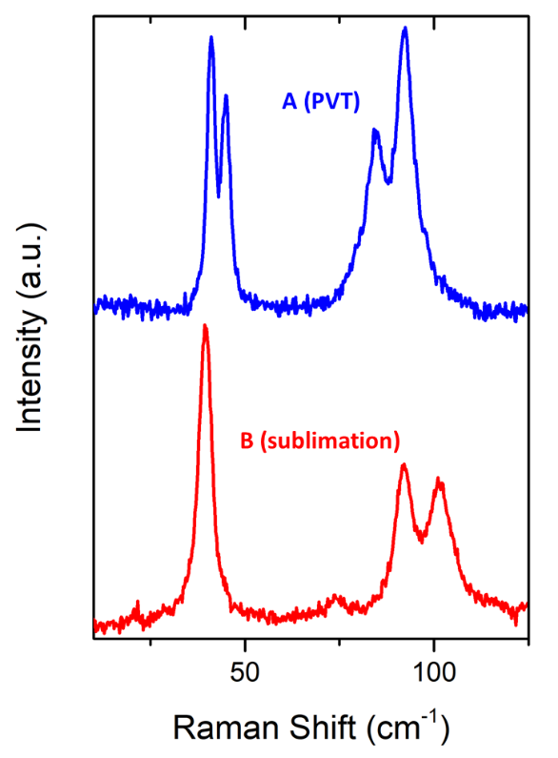
Figure S1: Lattice phonon Raman spectra of the various samples of crystalline indigo, with the two unique patterns that can be identified from the analysis.¹

Raman analysis of the intramolecular vibrations
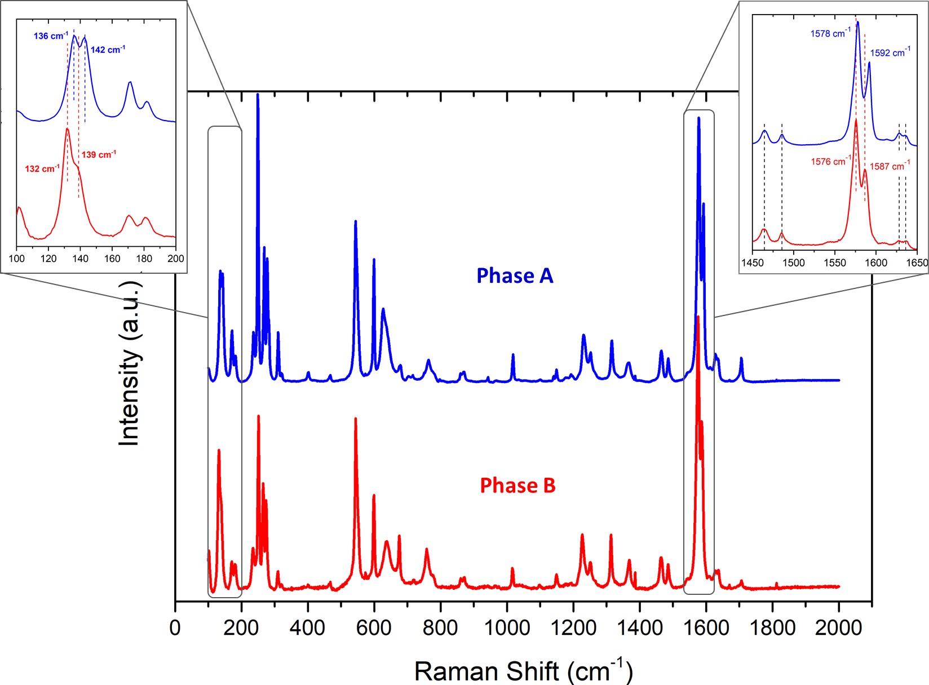
Figure S2: Raman spectra of Indigo polymorphs A (blue) and B (red) in the 100-2000 cm ⁻¹ range. In the picture are shown two zooms into specific wavenumber intervals in which polymorph discrimination can be made on the basis of intra-molecular vibrations.¹

AFM grains analysis of indigo films: large faced structures and small grains
Topographic images of Indigo films grown at 10 ng/min show large faced structures exposing the SiO₂ surface. As visible in Figure 5a (main text), such structures have a stepped height profile that is pronounced for some grains or smoothed for other ones. In all cases, the structure surface show grains on their surface with a diameter D calculated by using the radial autocorrelation function.² To perform this analysis, single structures (5) are cropped from 1μm² images (Figure S3a). The structure curvature is flattened by removing the polynomial background (degree 2 in horizontal and vertical directions) of the structure surface (Figure S3b). This procedure produces an artificial flat surface where the radial autocorrelation function analysis is simplified (Figure S3c). On the other hand, the diameter of grains could be slightly overestimated due to the projection of a spherical cap over a plane.

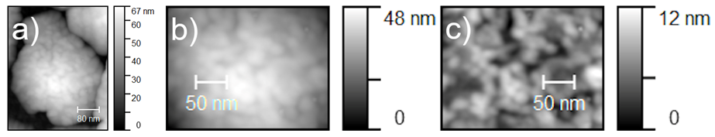
Figure S3: a) Topographic image of a typical grains of indigo film grown at 10 ng/min (cropped); b) Cropped image of the structure surface in Figure (a); (c) Flattened image of Figure (b).

Both average radius R_{avg} of grains and their volumes V_{avg} are statistically calculated through Gwyddion software [David Nečas, Petr Klapetek, Gwyddion: an open-source software for SPM data analysis, Cent. Eur. J. Phys. 10(1) (2012) 181-188]. Topographic images 2×2 μm² are firstly processed by the watershed method in order to separate grains (see Figure S4). Then, grains are schematized as circles and their radius distribution is fitted by a Gaussian curve. The average radius reported in the manuscript is the mean value of the Gaussian fit. On the other hand, the average volume V_{avg} are calculated by counting the number of cubes (three-dimensional pixels) included in each separated grain. Like the average radius, the volume distribution is plotted and fitted with a Gaussian distribution.
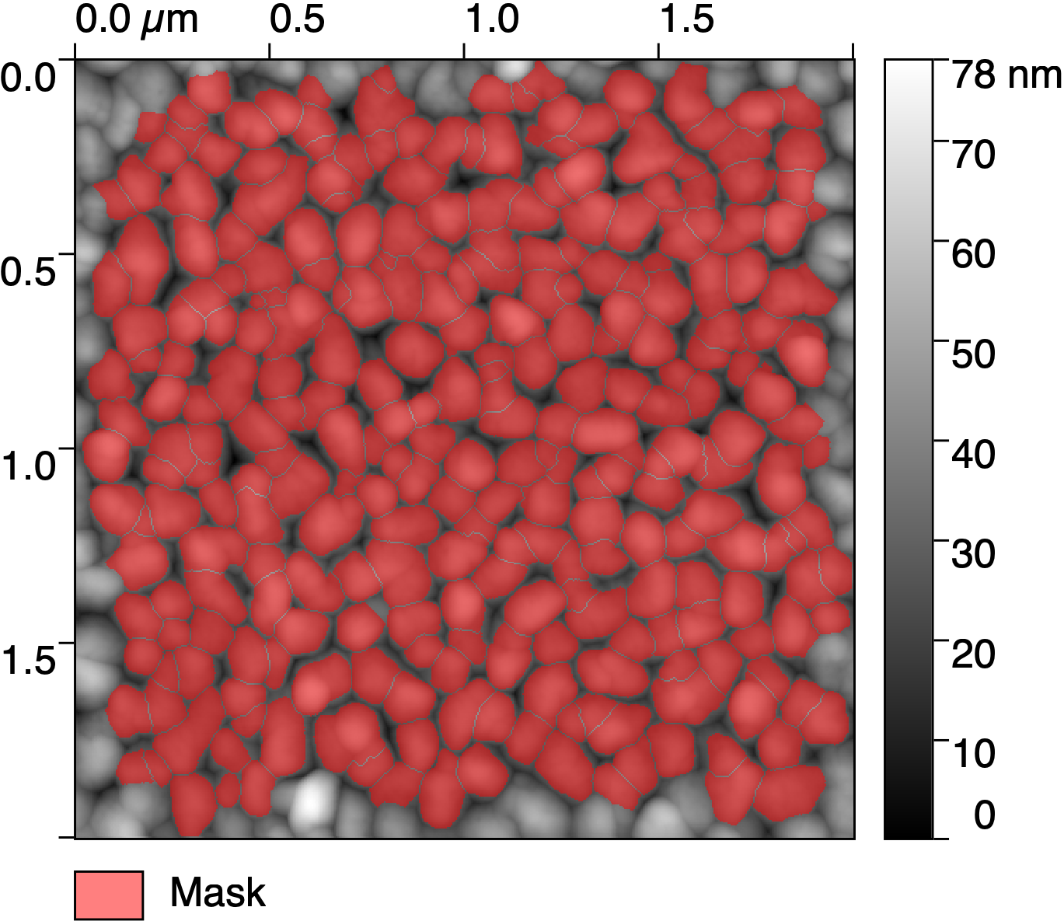
Figure S4: Topographic AFM image of indigo film grown at 200 ng/min. By using the watershed process, grains are successfully separated (see red mask).

TEM analysis on the average dimensions of the grains
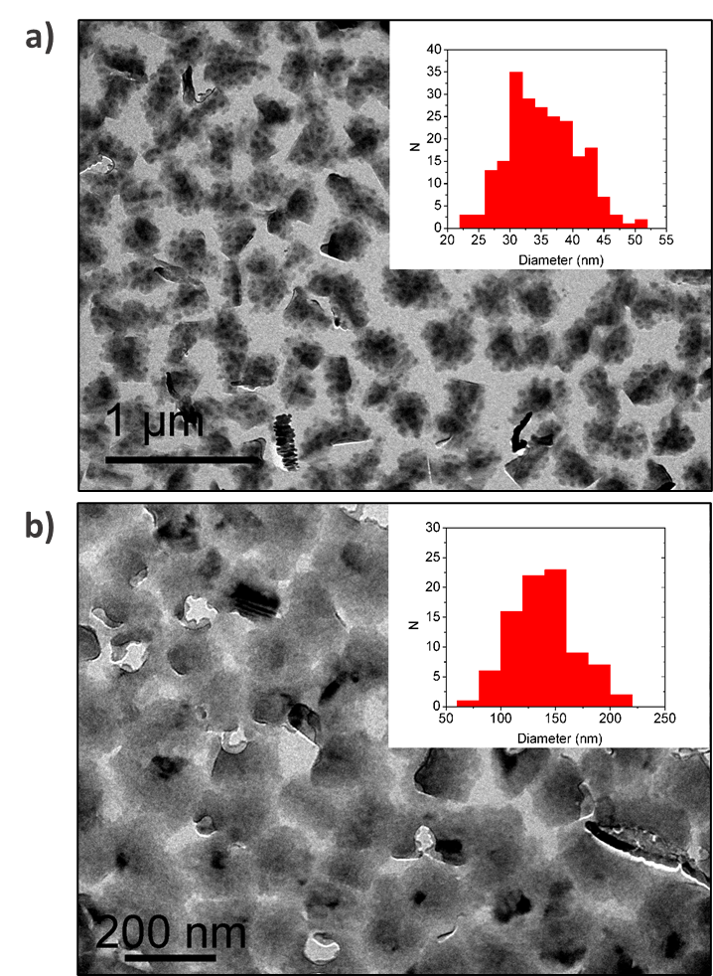
Figure S5: The Figure shows the TEM analysis on the average dimensions of the grains of films grown at 10 (a) and 200 (b) ng/min. They are composed of grains with an average diameter of a) D= (35±1) nm (with N=221) and b) D=(140±10) nm (with N=86).

Indexing on the SAED pattern of the sample grown at 10 ng/min
Figure S6: The SAED pattern of the film grown at 10ng/min was thoroughly indexed as three twin domains oriented along the [2 1 1] axis, as also described in the main text.

SAED Pattern after SVA corresponding to the [4 1 2] zone axis

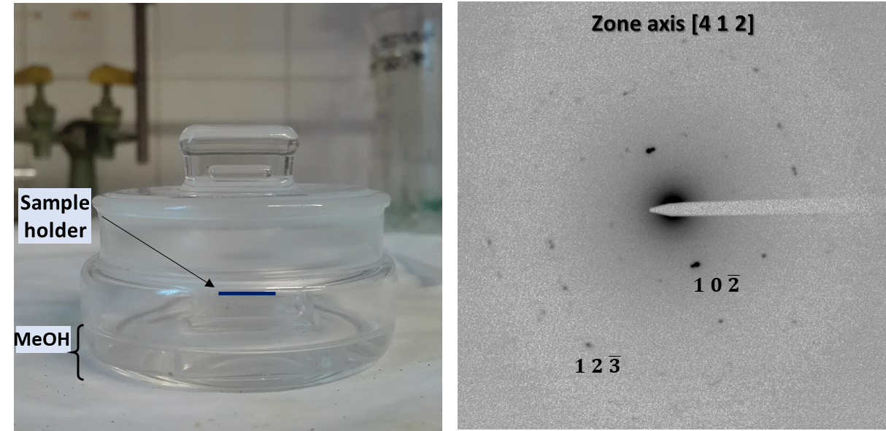
Figure S7: Left: chamber used for the SVA processing of the indigo films; Right: the SAED pattern obtained on the 10 ng/min film after SVA, corresponding to the [4 1 2] zone axis.

X-ray performed after Solvent Vapor Annealing
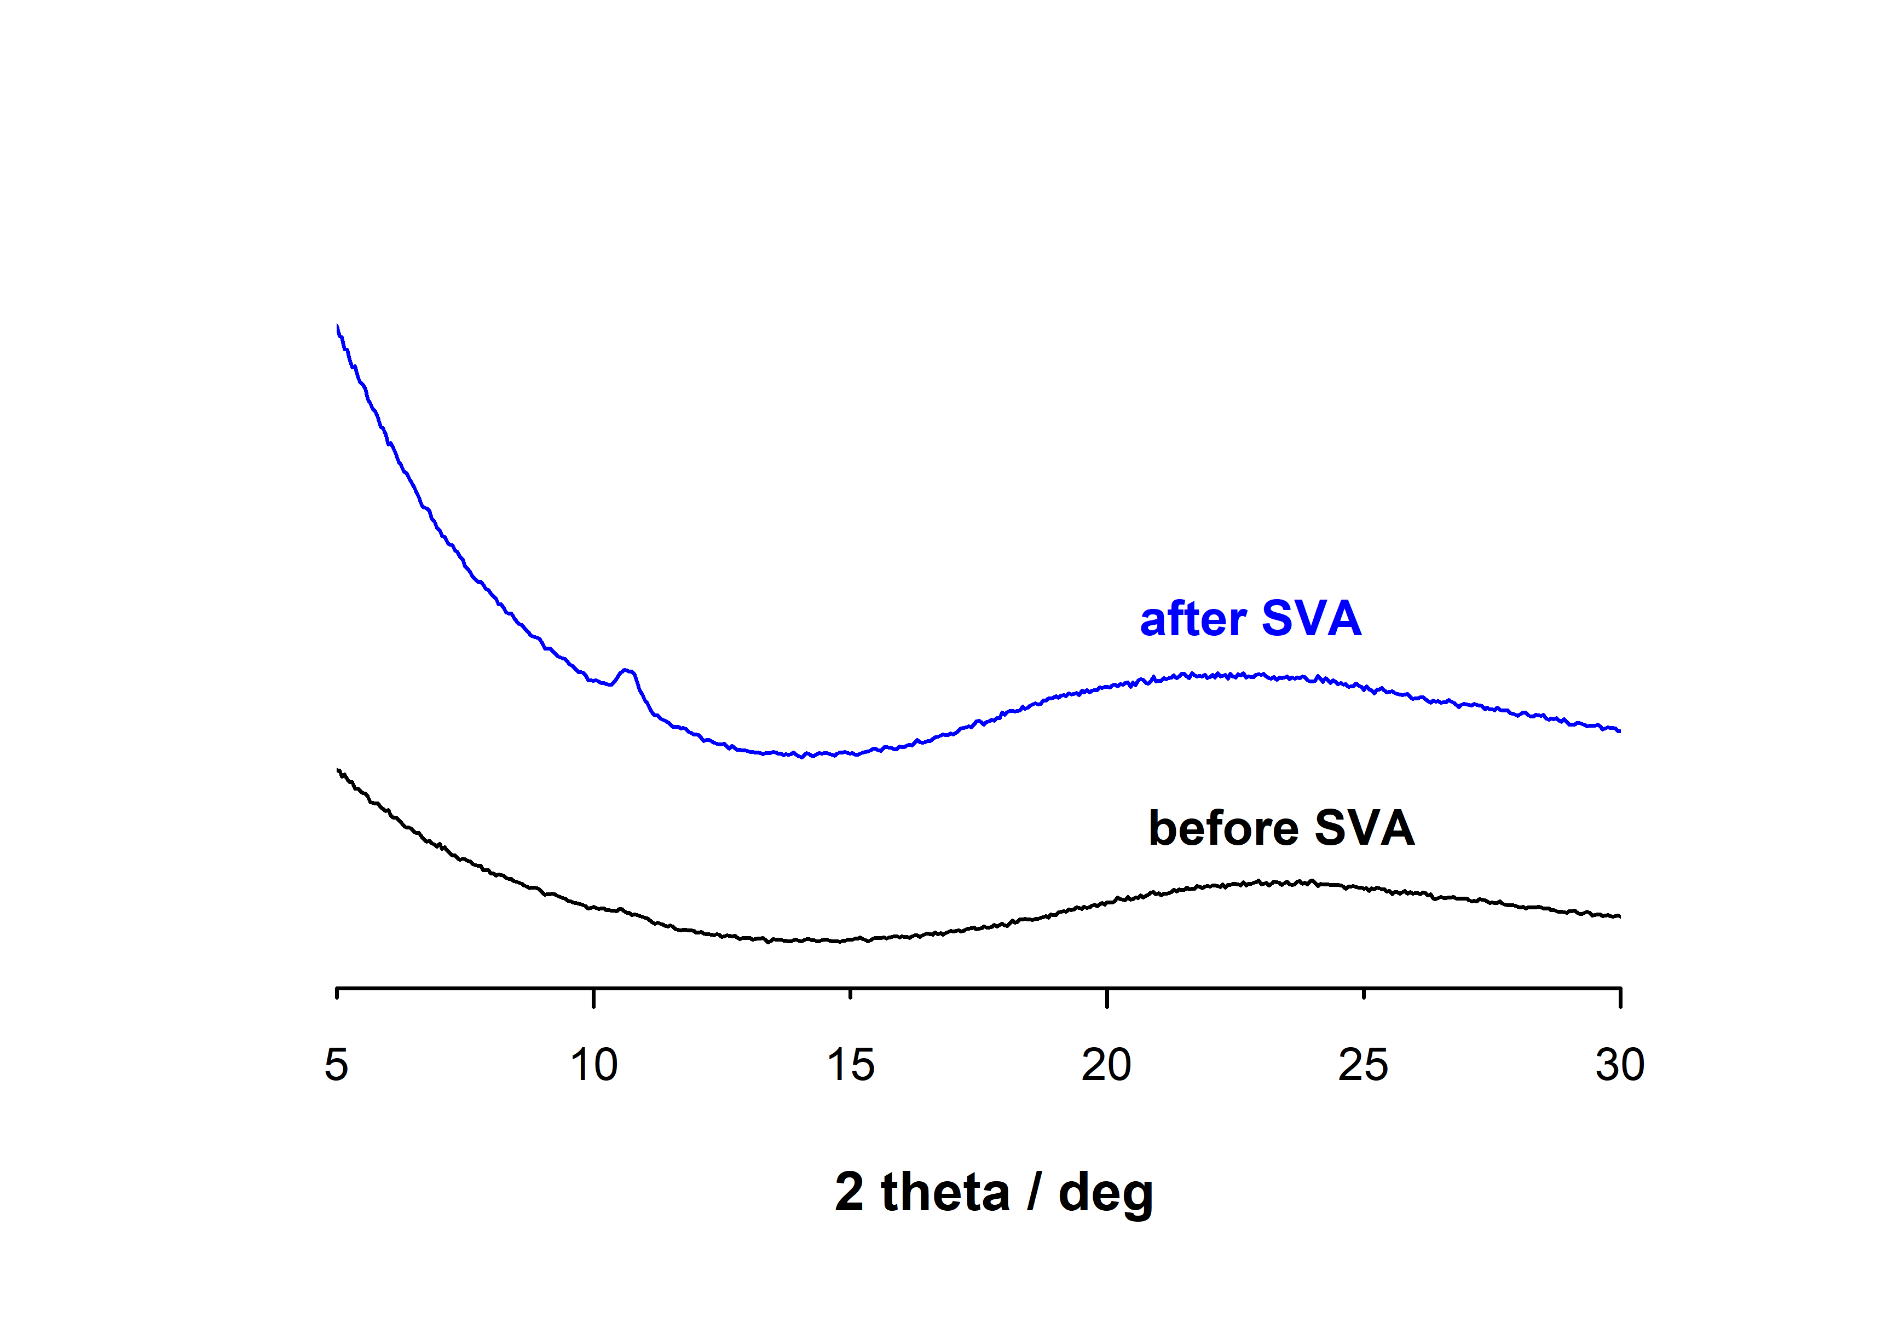

Figure S8: Comparison of indigo films deposited at 200 ng/min before and after SVA treatment.

References
1. Salzillo, T. et al. Structural, Spectroscopic, and Computational Characterization of the Concomitant Polymorphs of the Natural Semiconductor Indigo. J. Phys. Chem. C 122, 18422–18431 (2018).
2. Portale, G. et al. Influence of metal–support interaction on the surface structure of gold nanoclusters deposited on native SiOx/Si substrates. Phys. Chem. Chem. Phys. 16, 6649 (2014).

