Chinese Calligraphy Between Artistic Contaminations and New Expressive-Communicative Languages: The Case of Wang Dongling’s Experimental Ink Movement

Caccin Daniele, Iezzi Adriana

Introduction

Chinese calligraphy (shufa 书法), a cornerstone of the Chinese cultural heritage, has always been more than a means of writing; it embodies the aesthetic values and philosophical principles of Chinese culture (Chiang 1973). Since the 1980s, Chinese artistic production has undergone significant transformations. This was driven by renewed interest in traditional culture and increasing international exchange. These changes have expanded the expressive potential of calligraphy, fostering forms marked by innovative approaches and a redefinition beyond conventional artistic boundaries (Luo 2001; Pu & Guo 2005; Liu 2010; Iezzi 2013).

A central figure in this shifting landscape is Wang Dongling (b. 1945 in Rudong, Jiangsu province), whose six-decade career exemplifies creative dialogue between tradition and innovation (Xu 2007; Gao 2021). His work illustrates how contemporary artists draw from classical models while incorporating modern expressive forms to enrich and expand the tradition (Xu & Wang 2005; Xu 2010; Wang 2010b; Wang 2019). Wang took part in the first group of students to receive a calligraphy diploma from Zhejiang Academy of Fine Arts (now China Academy of Art) in Hangzhou, when academic courses on calligraphy were reopened in 1979 after the Cultural Revolution (Wang 2010a: 132-3). In the mid-eighties, a Modernist movement emerged influenced by Western abstract art and a more pictorial approach to calligraphy «created a new genre of the art» (Barrass 2002: 11). Wang Dongling, as a leading figure of this movement, began blending traditional techniques with modern concepts (Gu 1990; Iezzi 2013). Wang's work, centred primarily in Hangzhou and Beijing as well as internationally, exemplifies the main directions of ‘calligraphic modernity’.

Following Wang’s artistic production, this paper is structured around three main research themes: the continuity and discontinuity with calligraphic tradition as influenced by artistic interrelations with cross-cultural dialogues (sec. 1); the trajectory from abstract ink experiments to performative abstract experiments (sec. 2); the shift from cross-media artworks to digital forms with the integration of digital technology (sec. 3).

The artworks examined in this study are analysed through two levels of perspectives: a) formal / stylistic analysis; and b) linguistic / textual analysis. Also, public/academic resonance and exhibition activity were taken into consideration for their selection and analysis. The methodological approach is qualitative and interpretative, grounded in art theory, performance studies, and digital aesthetics. Primary sources, including exhibition catalogues, artist statements, and direct contact with calligraphers, provide the basis for a critical examination of Wang’s fusion of tradition and innovation in calligraphy.

- Artistic Interrelations, Cross-Cultural Dialogues, and Cross-Media Artworks

Wang Dongling’s early works exemplify the main directions of ‘calligraphy modernity’ of the Modernist calligraphic movement, «a new genre of the art» (Barrass 2002: 11) influenced by the Western abstract art and a more pictorial approach to calligraphy. Wang Dongling, a leading figure of this movement, began blending traditional techniques with modern concepts (Gu 1990; Iezzi 2013). The main directions of ‘calligraphic modernity’ are exemplified by his early works, which have been grouped into four main categories (Wang 2005: 9-10; Iezzi 2014: 164-5): 1) calligraphies on newspaper sheets; 2) traditional aesthetics with unconventional compositions and arrangements; 3) painterly ink works resembling figurative art; and 4) conceptual, abstract pieces using monochromatic ink. This fusion of brushwork techniques and modernist concepts transcends traditional constraints while preserving the essence of calligraphy. With his visit to the U.S. (1989–1992), Wang stated that he was «determined to use the art of calligraphy to build a bridge between the East and the West» (Wang 2007: 394). This intention shaped his artistic vision, which also responds to the conceptual tensions inherited from Western modernism, particularly abstract expressionism, with its focus on gesture, spontaneity, and the materiality. His intensified expressiveness demonstrates «how a Chinese artist can explore diverse directions to return at the end, through a perfect process of synthesis, to themes, philosophical suggestions, and aesthetics values rooted in the very tradition he belongs to» (Salviati 2004: 81). “Dance” (Wu 舞, 1989, fig. 1), together with other works from his American period, reflects these ideas with a performative, trans-linguistic engagement. Rather than prioritizing the meaning of the Chinese characters, Wang sublimates it in the energy (qi 气) permeating his works. This artwork juxtaposes Western images and Chinese calligraphy in a conversation between cultures and artistic forms. The composition centres around the large cursive character wu 舞 (dance) on a newspaper sheet from the New York Times with an article and photo of the legendary American dancer Martha Graham. Elegance, movement, and dynamism emerge from the brushstrokes, inspired by the dancer’s physical posture and movements, shown visually in the photo and semantically in the English article on Martha Graham. The correlation between the image and the calligraphic brushstrokes is further deepened by interlinguistic layers: the poem by Du Fu written by the artist with scarlet red ink refers to the story of Gongsun Daniang 公孙大娘, a Tang dynasty skilled sword dancer whose beautiful performance inspired Zhang Xu 张旭 (active in the 8th century) and his wild cursive script (kuangcao 狂草). All these elements emphasize the close connection between textual and visual elements, calligraphy, dance, and performing arts, which are united by the potential of movement, gesture, and the expression of freedom (Kao 1991: 76-80).

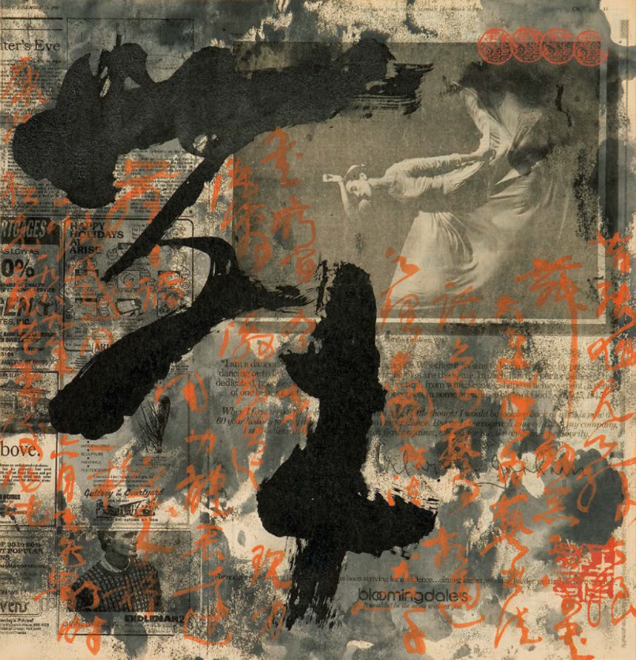
Figure 1. Wang Dongling, Dance (Wu 舞), ink on paper, 55.6cm×53.4cm, 1989. Courtesy of the artist.
These strategies anticipate the cross-cultural and cross-media interrelations that shaped Chinese art in the 1990s (Wu 2002), when «new media began to succeed in its struggle to gain recognition in the Chinese art world and internationally. [...] Seeing the abandonment of traditional mediums as an opportunity to attain new expressive possibilities, ink artists also experimented outside conventional formats, subjects, and styles» (Andrews & Shen 2012: 276). Wang’s later multilayered artworks illustrate this shift. Many of his pieces combine calligraphy with the human body in innovative ways: 1) the series “Calligraphic Styles and Bodies” (Shuti书体, 2012) emphasizes the dynamism of brushstrokes in a correlation between textual content and photographic images, captured by renowned Western photographers; 2) the series “Corporeal Calligraphy – The Calligraphy of the Body” (Shuti_shu zhi ti 书体_书之体) juxtaposes nude bodies with poses that correspond to different calligraphic scripts. These correlations integrate traditional and modern dichotomies, bridging Chinese and Western art forms. They also reconcile the eternal struggle between the “indexicality of the Chinese literati brushstrokes and the iconicity of Western nude painting” (Clarke 2005: 229-248). Wang’s aim is to express calligraphic lines, forms and compositions through the rhythm and the dynamism embodied in the human (female) figure. This approach extends to his performative works, where calligraphy blends with music, dance and the body movement, culminating in resulting “musicalligraphy dance performances” (Iezzi 2024: 181).

- The Shift to Performative Abstract Experiments

Since the1990s, Wang Dongling’s work has shifted decisively toward abstraction and performance, aligning with the emergence of the ‘experimental ink art’ (Salviati 2004: 69; Andrews & Shen 2012: 276) and ‘experimental ink painting’ (Wu 2013: 19-33). An emblematic example of this trend is “Brush array” (Bi zhen tu 笔阵图, 2007, fig. 2). The work consists of four sheets with an ‘array’ of black ink brushstrokes. They are suspended in mid-air to create a three-dimensional calligraphic space, highlighting the spatial dynamics and physical presence of the brush. In these abstract works, «powerfully inked lines convey a vivid sense of the artist’s physical engagement with the works so that it is possible to reexperience the act of creation» (Hearn 2013: 141). Abandoning conventional scripts and recognizable characters, Wang instead uses abstract lines charged with energy and tension to express subjective imagery and emotions. The title refers to the “Diagram of the Battle Formation of the Brush” (Bi zhen tu 笔阵图), a treatise by Madame Wei (Wei Shuo 卫铄) from the Eastern Jin Dynasty (317–420), which explores brush-holding techniques and expressive effects. As Hertel (2016: 15-7) notes, «through their titles, Wang’s abstract calligraphies can be interpreted as quasi-abstracted texts, citations, and reiterations of the specific writings they reference; their titles enable viewers to find access into and read these abstracted works in context (cultural-historically, conceptually, metatextually)». These works, therefore, comment not on textual content, but on the visual, material, and conceptual nature of calligraphy itself.

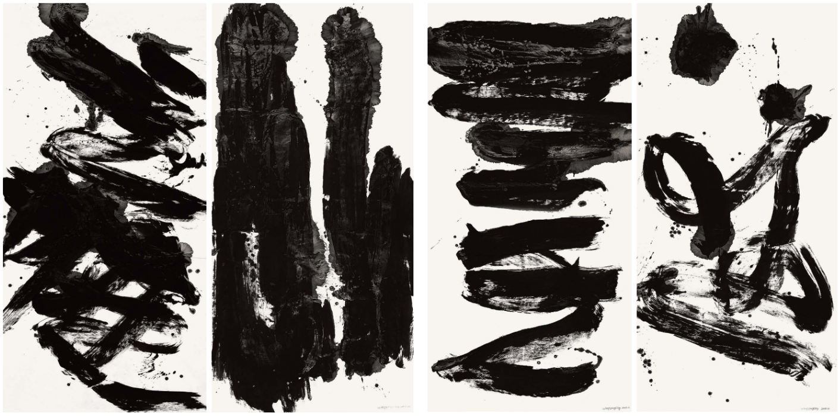
Figure 2. Wang Dongling, Brush Array (Bi zhen tu 笔阵图), ink on paper, 2007. Courtesy of the artist.

At the end of the 20th century, Wang began developing a new form of abstract calligraphy known as luanshu 乱书 (Chaos Script). This misleading term was clarified by the artist himself (Yeung et al. 2016: 13): «In Chaos Script, the strokes of cursive script overlap and interweave, creating unreadable abstract images. [...] It is not haphazard — it appears chaotic but is actually not so. I settled on the name of Chaos Script after some deliberation. Luan evokes disorder and mess, but it also implies zhi ("control", "govern") — after chaos comes control.” Building on his personal interpretation of wild cursive (kuangcao 狂草), «he capitalized on its illegibility, fluidity and lack of uniformity. [...] and has spent more than three decades perfecting it» (Hwang 2023: 11). According to the artist, luanshu draws inspiration from the nature:
“Since returning from the United States, I began photographing withered lotus flowers: a practice I enjoy very much. Luanshu consists of the intersection and overlapping of characters. It is an inspiration drawn from observing nature.” (interview by D. Caccin, 2024). This connection is not merely theoretical but is manifested in Wang’s visual engagement with nature and Daoist texts, as reflected in his renderings of Daoist classics over the years (Wang 2010b: 1-6). For instance, he transcribed the first chapter of Zhuangzi 庄子, titled “Wandering Beyond” (Xiaoyao you 逍遥遊) three times in (legible) cursive script (2003, 2003, 2011), once in (illegible) Chaos Script (2015), and later in a digital (abstract) rendering (2021, see below). The performative aspect of calligraphy in Chaos Script aligns with the contemporary art trends, where the process is as crucial as the final result. Rather than emphasizing readability or formal beauty, Chaos Script explores the expressive potential of brushstrokes, transforming them into pure artistic expression made of intricate and entangled lines (Wang 2023). The motion of the entire body guiding the brush during his large-scale performances highlights the connection between the artist and the art. As described by Guan (2011: 21), these events evoke comparisons with John Cage and Fluxus event-based art, emphasizing spontaneity and shared presence. «The unpredictable direction taken by the artist and audience together fosters a spiritual connection, where each participant interprets the experience subjectively, [...] in which the product of the performance is that of the artist breathing with the audience. » (Vermeeren 2020: 149).

- From Cross-Media to the Digital Turn

For centuries, calligraphers have used the so-called “Four Treasures of the Study” (wenfang si bao 文房四宝, i.e. brush, ink, paper, and inkstone) to shape their artworks. However, in a fusion of contemporary art and calligraphy, new media and materials have been explored and adopted. The installation “The Bamboo Path” (Zhu jing 竹径, 2017, fig. 3) exemplifies this transition: the artist adopts cursive script and Chaos Script, using unconventional mediums, such as 201 towering bamboo poles, measuring 5 m high and 12 to 15 cm in diameter, and 30 hanging transparent propylene panels inscribed respectively with black and white brushstrokes from classical Chinese poetry. The resulting contrast creates a dialogue further enhanced by the dynamic interplay of grey shadows cast by white acrylic scripts on the translucent panels. In this realm of vague perception calligraphic strokes forms and reforms, imbuing the space with a sense of rhythm and fluidity. The installation invites viewers to immerse themselves in a grove of bamboo spanning over 20 m, which transforms the space into a natural environment (Wu 2018). Bamboo symbolizes the intersection of nature and art, bridging temporal and spatial gaps between contemporary viewers and ancient scholars who used bamboo and wood strips in their education. This connection is highlighted by the artist’s choice to inscribe one bamboo pole with clerical script, an explicit reference to Qin (221–206 BCE) and Han dynasties (206 BCE–220 CE) when bamboo and wood were the primary medium for recording documents before paper became widespread. The installation underscores the cultural significance of bamboo in Chinese tradition. Adopting the method of borrowing objects to convey moral values and aspirations’ (jie wu yan zhi 借物言志), bamboo serves as a metaphor of tenacity and inner strength. The artist selected poems from the Classic of Poetry (Shijing 诗经), some lines from the famous “Encountering Sorrow” (Li sao 离骚), as well as from other historical lyrics about bamboo from past dynasties. These include poems by Lu Zhaolin 陆兆麟 (ca. 634 – ca. 684 or 686), Ni Zan (1301 – 1374), Xu Wenchang 徐文长 (1521 - 1593), Jin Nong 金农 (1687–1763), and Huang Yi 黄易 (1744-1802). The seven-character quatrain by Zheng Xie 郑燮 (1693–1765, also known as Zheng Banqiao 郑板桥), titled “Bamboo and Rocks” (Zhu shi 竹石), for instance, praises the indomitable spirit and tenacious vitality of bamboo rooted in fractured rocks:

咬定青山不放松， Firmly gripping the green mountain without letting go,
立根原在破岩中。 Its roots are originally set in fractured rocks.
千磨万击还坚劲， Enduring countless hardships and strikes, it remains strong,
任尔东西南北风。 Unaffected by winds from all directions.

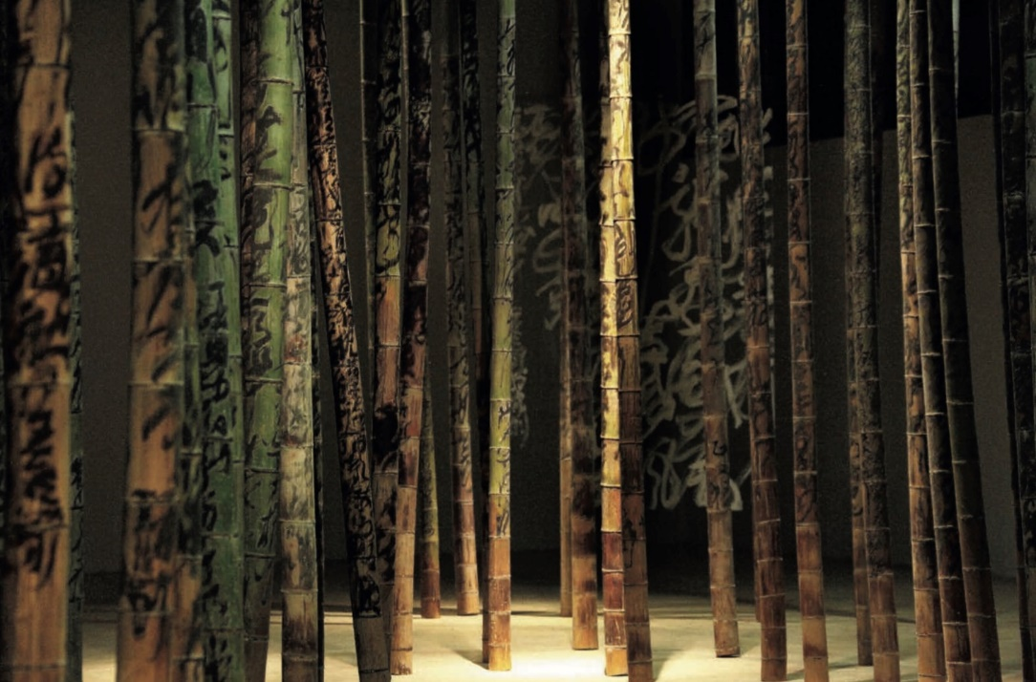
Figure 3. Wang Dongling, The Bamboo Path (Zhu jing 竹径), installation, 2017. Courtesy of the artist.
The use of acrylic and panels is not new in Wang Dongling's artistic production. A recent installation featured the interplay of calligraphy and three-dimensional space, such as for “Li Bai’s ‘Drink Alone Under the Moon’, ‘Raise a Wine Glass to Ask the Sky’” (Li Bai “Yue xia du zhuo”, “Ba jiu wen tian” 李白《月下独酌》、《把酒问天》, fig. 4), realized in 2019 for the “Writing Non-writing: Hangzhou International Modern Calligraphy Festival” (Shu · Feishu: 2019 Hangzhou xiandai shufa yishu jie 书·非书：2019杭州国际现代书法艺术节). The artist uses bright red acrylic to write the two renowned poems by Li Bai (701-762). In particular, “Drink Alone Under the Moon” (744), reflects Li Bai’s frustration with the limitations of officialdom and his unattainable political ambitions. In response to these feelings, he seeks solace and liberation in the solitary act of drinking with his shadow under the moonlit sky. In a parallel quest for freedom, Wang employs his distinctive ‘Chaos Script’ on a six-fold screen of golden leaf measuring 1.7 m high and 3.6 m long, set atop a stainless-steel plate measuring 1 m wide and 4 m long. This arrangement allows the golden screen and the red calligraphy to reflect on the plate, mirroring and integrating the viewer into the work. A parallel emerges between this visual dialogue and the poetic dialogue in Li Bai’s poem. The installation invites a continuous, dynamic interaction between artist, artwork, and viewer.
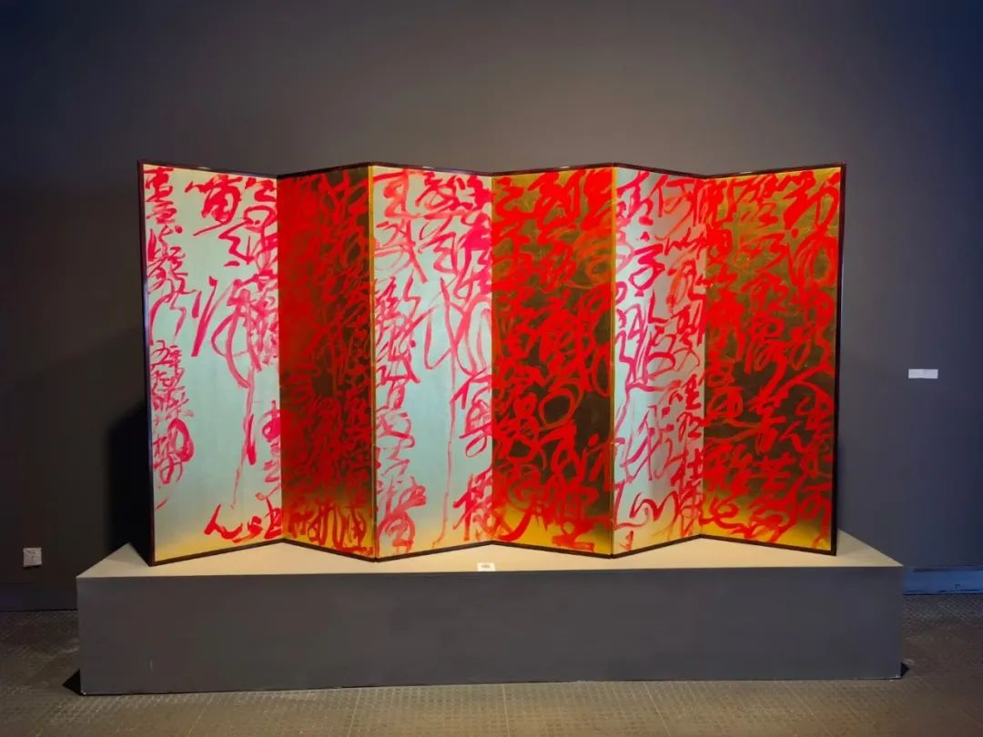
Figure 4. Wang Dongling, Li Bai’s ‘Drink Alone Under the Moon’, ‘Raise a Wine Glass to Ask the Sky’ (Li Bai “Yue xia du zhuo”, “Ba jiu wen tian” 李白《月下独酌》、《把酒问天》), installation, 2019. Courtesy of the artist.
With the digital turn, artists started to merge digital tools in the calligraphic realm, and, in a sense, the future of contemporary calligraphy may also depend on its integration with digital technologies (Vermeeren 2017; 2020). In this context, Wang Dongling’s contribution extends beyond tangible materials, as he also integrates new forms of expression that combine the tactile qualities of calligraphy with the possibilities offered by digital media, further expanding the boundaries of the medium. An example is the huge calligraphy he made in 2015 to cover the exterior of the West Lake Apple Store in Hangzhou. Originally crafted with brush and black ink on xuan paper and then digitally vectorized to be transposed on the shop wall around the red iconic Apple logo, this large-scale calligraphy (3.3x1.5 m) in cursive script (caoshu 草书) – the biggest work he has ever created, displays the last two lines of the poem “Drinking by the Lake: Clear Sky at First, then Rain” (Yin hu shang chu qing hou yu 饮湖上初晴后雨) by Su Shi 苏轼 (1037-1101). These lines praise the picturesque beauty of West Lake, one of the most famous scenic spots in China, through a subtle analogy to the rare beauty of Xi Shi 西施, one of the ‘Four Great Beauties’ of ancient China. For Wang, this poem resonated as the ideal medium to celebrate the enduring cultural essence of Hangzhou and its rich artistic and historical heritage, while the collaboration between the Chinese artist and Apple exemplifies broader efforts to integrate traditional Chinese arts into contemporary international commercials in the digital realm (Vermeeren 2020: 145-147).
As one of the first calligraphic works using iPad innovative technologies, the artwork “Filling the World with Love” (Rang shijie chongman ai 让世界充满爱, fig. 5) is a further example of how digital media has expanded Wang's artistic repertoire. This work features Chaos Script in bright purple overlaid on a background detail of Leonardo’s iconic Mona Lisa, interweaving elements of love and mystery. The work connects the content of the song “Filling the World with Love” composed in 1986 by Guo Feng 郭峰 (b. 1962) with the enigmatic aura of the Mona Lisa, demonstrating Wang’s innovative approach and the transformative role of technology in contemporary calligraphy.

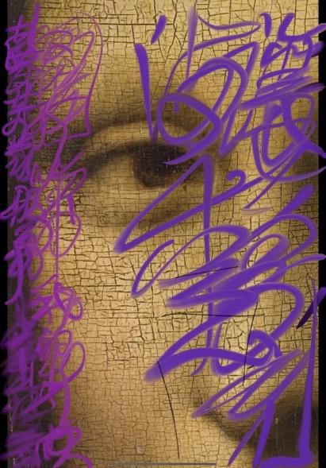
Figure 5. Wang Dongling, Filling the World with Love (Rang shijie chongman ai 让世界充满爱), iPad Wwork, 2488px × 1688px, 2021. Courtesy of the artist.
In one of his latest works entitled “VR - Wandering Beyond” (VR shuxie “Xiaoyao you” VR 书写 《逍遥游》, 2021, fig. 6), the artist blends traditional Chinese calligraphy with digital technology, demonstrating how high-tech has profoundly transformed artistic practices. This artwork turns the ancient text “Wandering Beyond” into a three-dimensional, digital experience using augmented reality (AR). Unlike his previous versions of this text, in this innovative rendering his Chaos Script, shaped by means of AR headsets and touch controllers marks, is reimagined through computerized simulation and data transformation (interview by A. Iezzi, 2021), creating a virtual, intangible trace of his brushstrokes that float and intertwine in space, so that the work embodies the real essence of Chaos Script (Gao 2021: 350). The process of creation also differs from traditional methods, involving a team of engineers who vectorize the movements into digital forms. Wang traces this work in a similar way to his performative abstract realization, in which «the artist appears to roam freely within and outside the scene, inside and outside the text, wandering above the phenomenon, experiencing a transcendent journey akin to a spiritual exploration» (Guan 2011: 21). The idea behind this work is to offer, through technology, a virtual experience that immerses viewers in a world of floating calligraphic lines. The result is a dynamic, continually evolving piece where digital brushstrokes generate, entangle, and disentangle from one another. The work embodies the essence of Chaos Script, as described in Gao (2021: 350), «the ‘Chaos Writing’ consists in its penetrating through calligraphy’s state of torpor with the power of confusion and disorder, in its focus on the essence of the inner structure and “openness” of writing itself, in bringing back to life the original, generative power of calligraphy». This approach was featured prominently in Wang’s retrospective exhibition “From Inception: Wang Dongling 60 Years of Calligraphy”, held at the Zhejiang Art Museum in Hangzhou in 2021. This exhibition represents his largest solo exhibition to date and showcases his six-decade artistic exploration and shift to innovative materials and tools, opening new cultural narratives and artistic forms by merging tradition with digital innovation.

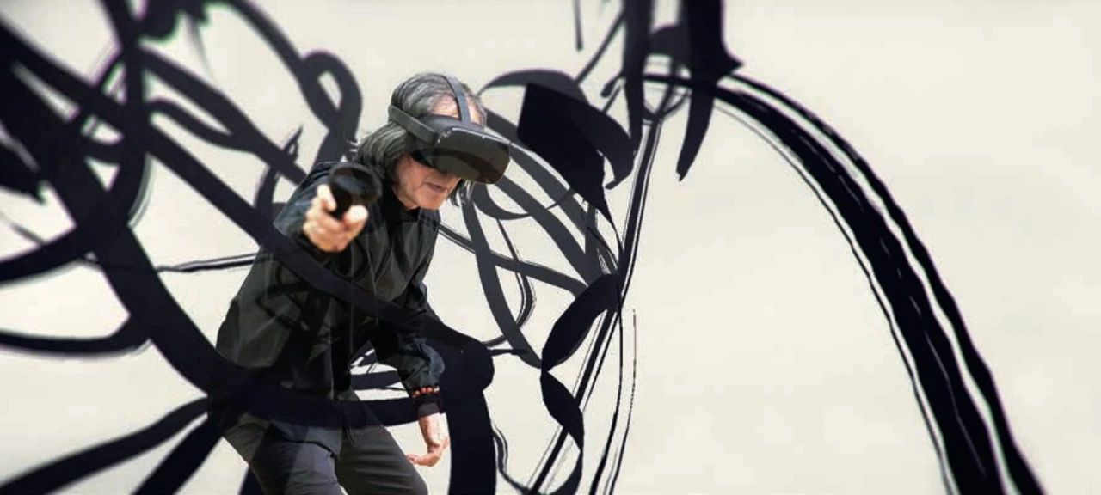
Figure 6. Wang Dongling realizing VR - Wandering Beyond, 2021. Courtesy of the artist.
Conclusion

Wang Dongling’s works exemplify the evolution of Chinese calligraphy as a dynamic blend of heritage and innovation. His artistic journey demonstrates the adaptability and enduring relevance of calligraphy in the modern era. Beginning with cross-cultural and cross-media projects, such as “Dance” and “Calligraphic styles and bodies”, Wang explores performative abstract experiments in works like “Brush Array” and ‘Chaos Script’ oeuvres and performances. The artist embraces diverse materials and techniques to expand the expressive possibilities of this ancient art while both challenging and honouring its tradition. In work such as “Dance”, along with other abstract ink paintings where strokes are created using white acrylic on transparent panels, Wang integrates unconventional mediums to highlight the diversity of materials in his calligraphic practice, showcased in installations like “The Bamboo Path” and “Drinking Alone Under the Moon, Raising a Glass of Wine to Ask the Heavens by Li Bai”. He further ventures into the digital realm, where new media and tools enrich/substitute the textual content. In his digital experiments through iPad works (“Filling the World with Love”) and virtual reality (“VR - Wandering Beyond”), the artist illustrates his fusion with contemporary innovation, offering viewers immersive and multisensory experiences. The medium is no longer limited to paper and ink. Instead, it engages with virtual space, interactivity, and contemporary visual culture. Through these creations, Wang enhances the accessibility and interactivity of art, prompting critical reflections on how cross-cultural, cross-media and digital technologies reshape cultural narratives. By presenting traditional themes through new mediums such as installations, combined artworks and digital forms, Wang preserves the essence and the message of classical texts while inviting viewers to engage with them through fresh perspectives and innovative approaches. This approach integrates calligraphy into the global contemporary art scene. Cross-cultural dialogue, especially with the Western art, has played a key role. It transforms calligraphy into a transnational visual language and attract new audiences, both locally and internationally. Wang’s goal is to enrich the art form by redefining its relationship with contemporary cultural landscapes, demonstrating how calligraphy can remain a vibrant and dynamic component in both Chinese and global art.
References

Andrews, Julia F.; Shen, Kuiyi (2012) The Art of Modern China, Berkeley, University of California Press.
Barrass, Gordon (2002) The Art of Calligraphy in Modern China, London, British Museum Press.
Caccin, Daniele; Iezzi, Adriana (2025) “WRITE. Chinese Calligraphy Between Artistic Contaminations and New Expressive-Communicative Languages”, University of Bologna. https://doi.org/10.6092/unibo/amsacta/8441 [Dataset]
Chiang, Yee (1973) Chinese Calligraphy. An Introduction to its Aesthetic and Technique, Cambridge, Harvard University Press.
Clarke, David (2005) “Iconicity and Indexicality: The Body in Chinese Art”, Semiotica (155), 229-248.
Gao Shiming 高世名 (ed.) (2021) Cong tou kaishi: Wang Dongling shufa yishu 60 nian 从头开始: 王冬龄书法艺术60年 (From Inception: Wang Dongling 60 years of calligraphy), Shanghai, Shanghai shuhua chubanshe.
Gu Gan 古干 (1990) The Three Steps of Modern Calligraphy, Beijing, China Book Publishing House.
Guan Huaibing 管怀宾 (2011) “Wang Dongling yu xiandai shufa de ‘dangdaixing’ jiangou 王冬龄与现代书法的‘当代性’建构” (Wang Dongling and the Construction of ‘the Contemporaneousness’ of Modern Calligraphy), China Art Weekly, 21.
Hearn, Maxwell K. (ed.) (2013) Ink Art. Past as Present in Contemporary China, New York, The Metropolitan Museum of Art.
Hertel, Shao-Lan 何小蘭 (2016) “Lines in Translation: Cross-Cultural Encounters in Modernist Calligraphy, Early 1980s-Early 1990s”, Yishu: Journal of Contemporary Chinese Art, 15 (4), 6-28.
Han Bi 寒碧 (ed.) (2017), “Wang Dongling 王冬龄”, Shi Shu Hua, 3, 161-190.
Kao Yu-Kung (1991) “Chinese Lyric Aesthetics”, in Murck, Alfreda; Wen, C. Fong (eds.) Words and Images. Chinese Poetry, Painting, and Calligraphy, New York, The Metropolitan Museum of Art, 74-83.
Iezzi, Adriana (2013) “Contemporary Chinese Calligraphy Between Tradition and Innovation”, Journal of Literature and Art Studies, 3, 158-79.
—— (2015) “What is ‘Chinese Modern Calligraphy’? An Exploration of the Critical Debate on Modern Calligraphy in Contemporary China”, Journal of Literature and Art Studies, 5 (3), 206-216.
—— (2016) “Chinese Modern Calligraphy as a Reflection of Chinese Contemporary Culture: A Comparison between Modernism (Wang Dongling) and Avant-garde (Xu Bing)”, Italian Association for Chinese Studies. Selected Papers 1, Venezia, Libreria Editrice Cafoscarina, 75-116.
—— (2024) “Art from Calligraphy: Chinese Writing Turns into Pictorial Images, Performative Actions, Design Products and Graffiti Works”, in Cartolano M., Ferrera S., and Ottaviano L., Talking Images. The Interface between Drawing and Writing, New York, Routledge, 165 – 201.
Iezzi, Adriana; Meccarelli, Marco (2024) “New Forms of Calligraphy in Contemporary China”, Kervan International Journal of African and Asian Studies (in press).
Lamb, Anna (2024) “When the Act of Writing Itself Is Part of the Art.” Harvard Gazette, 04/10/2024. https://news.harvard.edu/gazette/story/2024/10/when-the-act-of-writing-itself-is-part-of-the-art/.
Liu Canming 刘灿铭 (2010) Zhongguo xiandai shufa shi 中国现代书法史 (The History of Modern Chinese Calligraphy), Nanjing, Nanjing daxue chubanshe.
Luo Qi 洛齐 (2001) Shufa yu dangdai yishu 书法与当代艺术 (Calligraphy and Contemporary Art), Hangzhou, Zhongguo meishu chubanshe.
Merenda, Martina (2025) “Calligraphy and Performing Arts in Contemporary China: Forty Years of Artistic Expressions in Performance, Music and Dance”, PhD diss., University of Bologna: Department of Interpretation and Translation (DIT).
Pasqual, Valentina; Lučić, Katarina; Bisceglia, Marta Rosa; Merenda Martina; Iezzi, Adriana; Tomasi, Francesca (2024) “Modelling Chinese Contemporary Calligraphy: The WRITE Data Model”, Digital Scholarship in the Humanities, 1-9.
Pu Lieping 濮列平; Guo Yanping 郭燕平 (2005) Zhongguo xiandai shufa dao Hanzi yishu jianshi 中国现代书法到汉字艺术简史 (From Modern Chinese Calligraphy to the Art of Chinese Characters: A Brief History), Chengdu, Sichuan meishu chubanshe.
Salviati, Filippo (2004) “Radici storiche e correnti di pensiero”, in Dalu Jones, Filippo Salviati, Mariagrazia Costantino, Arte contemporanea cinese, Milano, Electa, 34-111.
Xu Jiang 许江; Wang Dongling 王冬龄 (eds.) (2005) Shu feishu—Kaifang de shufa shikong 2005 Zhongguo Hangzhou guoji xiandai shufa yishuzhan zuopinji 书非书—开放的书法时空 2005 中国杭州国际现代书法艺术展作品集 (The Act of Writing and of Non-Writing: The Open Space for Chinese Calligraphy. International Exhibition of Modern Calligraphy 2005), Hangzhou, China Academy of Art Press.
Xu Jiang 许江, “Shu feishu” 2010 teda zhan 书非书2010 特大展 (“The Act of Writing and Non-Writing”: 2010 Special Exhibition), Dangbang Yishu, 3, 2010.
—— (ed.) (2016) Dao xiang · Wang Dongling shufa yishu zhan 道象 · 王冬龄书法艺术展 (Dao Xiang - Wang Dongling Calligraphy Art Exhibition).
—— (ed.) (2007) Wang Dongling shufa yishu 王冬龄书法艺术 (Wang Dongling’s artworks), Beijing, Rongbaozhai chubanshe.
Vermeeren, Laura (2017) “Chinese Calligraphy in the Digital Realm: Aesthetic Perfection and Remediation of the Authentic”, Concentric: Literary and Cultural Studies 43 (2), 163-91.
—— (2020) Inquisitive Ink: A Study of Contemporary Practices of Calligraphy in China, PhD diss., University of Amsterdam.
Vigneron, Frank Joseph E. (2019) “From Antiquarianism to Chaos Script”, in Shu fei shu: 2019 Hangzhou guoji xiandai shufa yishu jie, juan er, lunwen 书非书: 2019 杭州国际现代书法艺术节, 卷二, 论文 (Writing Non-Writing: 2019 Hangzhou International Contemporary Calligraphy Festival), Hangzhou, Art Museum of China Academy of Art, vol. 2, 118-130.
Wang Dongling 王冬龄 (2005) “Xiangshou xiandai shufa de zhihui 享受现代书法的智慧 (Enjoy the Wisdom of Modern Calligraphy)”, Yishu Dangdai, 3, 6-11.
—— (2007) Gong xiaoyao: shufa yishu de zizai zhi jing 共逍遙：書法藝術的自在之境 (Wandering Beyond: The Free Realm of Calligraphy Art), in Wang Dongling shufa yishu 王冬龄书法艺术 (Wang Dongling’s Work) edited by Xu Jiang 许江, 392-395. Beijing, Rongbaozhai Publishing House.
—— (2010a) Wang Dongling tan xiandai shufa 王冬龄谈现代书法 (Wang Dongling Talks about Chinese Modern Calligraphy), Beijing, Renmin University Press.
—— (2010b) Shufa yishu kuajie de jiazhi - 2010 Shu feishu zhanlan de fansi 书法艺术跨界的价值 -- 2010书非书展览的反思 (The importance of going beyond the art of calligraphy. A reflection on the exhibition "The act of writing and Non-writing" of 2010), Journal of the National Academy of Art, 48, 38-52.
—— (2011) Wang Dongling chuangzuo shouji 王冬龄创作手记 (Notes on Wang Dongling's Artistic Creation), Beijing, Zhongguo renmin daxue chubanshe.
—— (2019) Shu fei shu: 2019 Hangzhou guoji xiandai shufa yishu jie 书非书: 2019 杭州国际现代书法艺术节 (Writing Non-Writing: 2019 Hangzhou International Contemporary Calligraphy Festival), Hangzhou, Art Museum of China Academy of Art.
—— (2023) Luanshu: shengsheng bu xi de Zhongguo shufa 乱书：生生不息的中国书法 (Chaos Script: The Everlasting Vitality of Chinese Calligraphy), Hangzhou, Zhejiang Renmin Meishu Chubanshe.
Wu Hung 巫鸿 (1999) Anti - Writing. Transience: Chinese Experimental Art at the End of the Twentieth Century, Chicago, The University of Chicago Press.
—— (2013) “Transcending the East / West Dichotomy: A Short History of Contemporary Chinese Ink Painting.” In Ink Art. Past as Present in Contemporary China, edited by Hearn Maxwell, New York, The Metropolitan Museum of Art: 19-33.
—— (2018) Wang Dongling: Zhu jing 王冬龄：竹径 (Wang Dongling: The Bamboo Path), Shanghai, Shanghai renmin chubanshe.
Yeung, Alan; Dong Xiaokun and Yang Fan (2016), Wang Dongling: luanshu 王冬齡：亂書 (Wang Dongling: Writing Chaos), exhibition catalogue (Beijing, 9.17-11.20, 2016) curated by Britta Erickson, Beijing, Beijing Jinge Printing.

Every part of this paper was discussed and finalized jointly and should not be seen as the result of separately written sections. However, for academic transparency, the contributions can be outlined as follows: Daniele Caccin: Conceptualization (lead); Data curation (equal); Investigation (lead); Methodology (equal); Writing – original draft (lead). Adriana Iezzi: Conceptualization (supporting); Data curation (equal); Methodology (equal); Funding acquisition (lead); Supervision (lead), Writing – Review & Editing (lead).
This multilayered analysis is the result of the three-level analysis (artistic analysis, linguistic analysis and socio-political-economic analysis) that was carried out thanks to the inclusion of the selected artworks in a semantic web archive based on Linked Open Data (LOD) principles called “WRITE digital archive” (Pasqual et al. 2024). The underlining data of this publication, that included extracts from the archive (in jsonld. form) and the artists’ interviews, can be found in: Caccin and Iezzi 2025 [Dataset]. This dataset also includes the description of the main exhibitions in which the selected artworks were displayed and the analysis of the literary texts inserted in those artworks.
For an in-depth analysis of one of the artworks of this series “Calligraphic Styles and Bodies - Edward Weston’s Heart Sutra A”, see Iezzi 2016: 93-99.
One example is Mo wu Xihu - Shufa yu wudao de duihua 墨舞西湖——书法与舞蹈的对话 (“Ink Dance at the West Lake - A Dialogue between Calligraphy and Dance”) held on 31/10/2011, at the Zhejiang Art Museum in Hangzhou. In this performance, seven male and female dancers, directed by Cui Wei 崔巍 (b. 1966), moved gracefully outlining vigorous calligraphic brushstrokes while Wang Dongling wrote large characters on a white scroll (Merenda 2025: 325-327).
The term luanshu has been translated in a myriad of ways, including “Chaos Script” (Yeung et al. 2016), “Chaotic Script Calligraphy” (Lamb 2024), “Chaotic-Writing”, “Messy Calligraphy” (https://bit.ly/3XanSF8), “Entangled Script”, etc. For recent discussions of Wang’s Chaos Script calligraphy, see Vigneron 2019: 118-130.
In addition to Wang Dongling, other Chinese artists experimented new calligraphic tools, e.g., Shao Yan (syringe with ink), Pu Lieping (corn broom), Wang Tiande (incense sticks), Qiu Zhijie (torch), etc. For more information, see Iezzi & Meccarelli 2024: 407-410.
This installation was exhibited for the first time during the exhibition “Wang Dongling: The Bamboo Path”, which took place at Hall A of OCAT Shenzhen (12/08-12/11/2017). For more information, see Wu 2018.
In Chinese tradition, bamboo, along with plum blossom, orchid, and chrysanthemum, is revered as one of the “Four Gentlemen/Four Noble Plants” (Si junzi 四君子). Bamboo, in particular, conveys integrity and nobleness of the spirit, qualities highly valued by literati through the ages, who found inspiration in bamboo and celebrated it in the Three Perfections (san jue 三绝: poetry, calligraphy and painting) as vehicle of self-expression.
Wang Dongling adopted transparent propylene panels and white acrylic paint in several installations and performances (Xu 2016), such as in the “Dao Xiang - Wang Dongling Calligraphy Art Exhibition” (Imperial Ancestral Temple Art Museum of Beijing, 2016) and during the Calligraphic Performance “The Way that Can Be Spoken” (Victoria and Albert Museum, 2016).
This exhibition is the fourth and most recent in a series initiated by Wang Dongling in 2005 presenting Chinese and international artists exploring calligraphy through diverse perspectives and media, and contemporary, intercultural approaches. See Xu & Wang 2005, Xu 2010, Wang 2010b, Wang 2019.
In promotional videos, Wang Dongling expressed his satisfaction in sharing the profound symbolism of Chinese ideograms with a broad audience: https://bit.ly/4dJPy94 (Last accessed on July 11, 2025).
The video "VR - Wandering Beyond" is part of the dataset of this article: Caccin and Iezzi 2025 [Dataset].
The result of this process can be seen in the video: https://bit.ly/4fPYprG (Last accessed on July 11, 2025).
For further details, see the catalogue of the related exhibition (Gao 2021).

