Stronger Conditionality for Stronger Compliance?

Analyzing the NGEU’s Effect on the Implementation of European Semester Recommendations
Author Details

Igor Guardiancich (corresponding author)
Affiliation: University of Padua
Email: igor.guardiancich@unipd.it

Department of Political Science, Law and International Studies (SPGI), University of Padua
Via del Santo 28
35123 Padova
Italy

Mattia Guidi
Affiliation: University of Siena
Email: mattia.guidi@unisi.it

Department of Social, Political and Cognitive Sciences, University of Siena
Via Pier Andrea Mattioli 10
53100 Siena
Italy

Enrico Borghetto
Affiliation: University of Florence
Email: enrico.borghetto@unifi.it

Department of Political and Social Sciences, School of Political Science “Cesare Alfieri”, University of Florence
Via delle Pandette 21
50127 Florence
Italy

Lucia Quaglia
Affiliation: University of Bologna
Email: lucia.quaglia@unibo.it

Department of Political and Social Sciences, University of Bologna
Strada Maggiore 45
40125 Bologna
Italy

Appendix

Table A.1: CSR policy areas reclassification
Nr. | Original category | Version | New category | New cat. nr.
1 | - | Both | Uncategorized | XIV
2 | Access to finance | Old | Financial & Fiscal Governance | V
3 | Access to finance & growth financing (incl. CMU) | New | Financial & Fiscal Governance | V
4 | Active labour market policies | Old | Labour Market Policies | VIII
5 | Active labour market policies, incentives to work & labour market participation | New | Labour Market Policies | VIII
6 | Anti-money laundering | New | Taxation policy | XIII
7 | Broaden tax bases | Old | Taxation policy | XIII
8 | Budgetary framework and fiscal governance | New | Financial & Fiscal Governance | V
9 | Business environment | Old | Business Environment & Market Regulation | I
10 | Business environment (incl. SME policies) | New | Business Environment & Market Regulation | I
11 | Childcare and early childhood education | Old | Education, Skills & Innovation | III
12 | Civil justice | Old | Justice system | VII
13 | Climate adaptation | New | Energy & Transport Infrastructure | IV
14 | Competition & regulatory framework | Old | Business Environment & Market Regulation | I
15 | Competition in services | Old | Business Environment & Market Regulation | I
16 | Corruption | New | Corruption | II
17 | Digital connectivity, infrastructure & market functioning | New | Regional Development, Local Public Services & Housing | XII
18 | Digitalisation of businesses | New | Regional Development, Local Public Services & Housing | XII
19 | Digitalisation of public administration and public services | New | Public administration | XI
20 | Early childhood education & care | New | Education, Skills & Innovation | III
21 | Education | Both | Education, Skills & Innovation | III
22 | Employment protection legislation & framework for labour contracts | Old | Labour Market Policies | VIII
23 | Energy efficiency | New | Energy & Transport Infrastructure | IV
24 | Energy, resources & climate change | Old | Energy & Transport Infrastructure | IV
25 | Environmental policy & resource management | New | Energy & Transport Infrastructure | IV
26 | Fight against tax evasion, improve tax administration & tackle tax avoidance | Old | Taxation policy | XIII
27 | Financial services | Old | Financial & Fiscal Governance | V
28 | Financial services and financial stability | New | Financial & Fiscal Governance | V
29 | Fiscal policy & fiscal governance | Old | Financial & Fiscal Governance | V
30 | Functioning of the labour market, including framework for labour contracts & undeclared work | New | Labour Market Policies | VIII
31 | Health & long-term care | Old | Healthcare | VI
32 | Healthcare | New | Healthcare | VI
33 | Housing | New | Regional Development, Local Public Services & Housing | XII
34 | Housing market | Old | Regional Development, Local Public Services & Housing | XII
35 | Incentives to work, job creation, labour market participation | Old | Labour Market Policies | VIII
36 | Insolvency framework | Old | Financial & Fiscal Governance | V
37 | Justice system | New | Justice system | VII
38 | Long-term care | New | Healthcare | VI
39 | Long-term sustainability of public finances, inc. pensions | Old | Pension systems and active ageing | IX
40 | Non-discrimination and equal opportunities | New | Labour Market Policies | VIII
41 | Pension systems and active ageing | New | Pension systems and active ageing | IX
42 | Poverty reduction & social inclusion | Old | Poverty reduction & social inclusion | X
43 | Poverty, social inclusion & social protection | New | Poverty reduction & social inclusion | X
44 | Private indebtedness | Old | Financial & Fiscal Governance | V
45 | Private sector debt & insolvency framework | New | Financial & Fiscal Governance | V
46 | Public administration | Both | Public administration | XI
47 | Public procurement & concessions | New | Business Environment & Market Regulation | I
48 | Quality of law making | New | Business Environment & Market Regulation | I
49 | Reduce the debt bias | Old | Taxation policy | XIII
50 | Reduce the tax burden on labour | Old | Taxation policy | XIII
51 | Regional development & local public services | New | Regional Development, Local Public Services & Housing | XII
52 | Renewable energy, energy infrastructure & networks | New | Energy & Transport Infrastructure | IV
53 | Research & innovation | Both | Education, Skills & Innovation | III
54 | Shadow economy & corruption | Old | Corruption | II
55 | Single market, competition & state aid | New | Business Environment & Market Regulation | I
56 | Skills & life-long learning | Old | Education, Skills & Innovation | III
57 | Skills, Vocational Education and Training & adult learning | New | Education, Skills & Innovation | III
58 | State-owned enterprises | Both | Business Environment & Market Regulation | I
59 | Tax administration, tax evasion & tax avoidance | New | Taxation policy | XIII
60 | Taxation policy | New | Taxation policy | XIII
61 | Telecom, postal services & local public services | Old | Regional Development, Local Public Services & Housing | XII
62 | Transport | Both | Energy & Transport Infrastructure | IV
63 | Unemployment benefits | Old | Poverty reduction & social inclusion | X
64 | Wages & wage setting | Both | Labour Market Policies | VIII

Table A.2 – Number of sub-CSRs by policy area
New cat. nr. | Policy category | N
I | Business environment and market regulation | 115
II | Corruption | 9
III | Education, skills and innovation | 133
IV | Energy and transport infrastructure | 127
IX | Pension systems and active ageing | 16
V | Financial and fiscal governance | 137
VI | Healthcare | 60
VII | Justice system | 18
VIII | Labour market policies | 88
X | Poverty reduction and social inclusion | 56
XI | Public administration | 25
XII | Regional development, local public services and housing | 137
XIII | Taxation policy | 49
XIV | Uncategorized | 0

Figure A.1: Distribution of the dependent variable
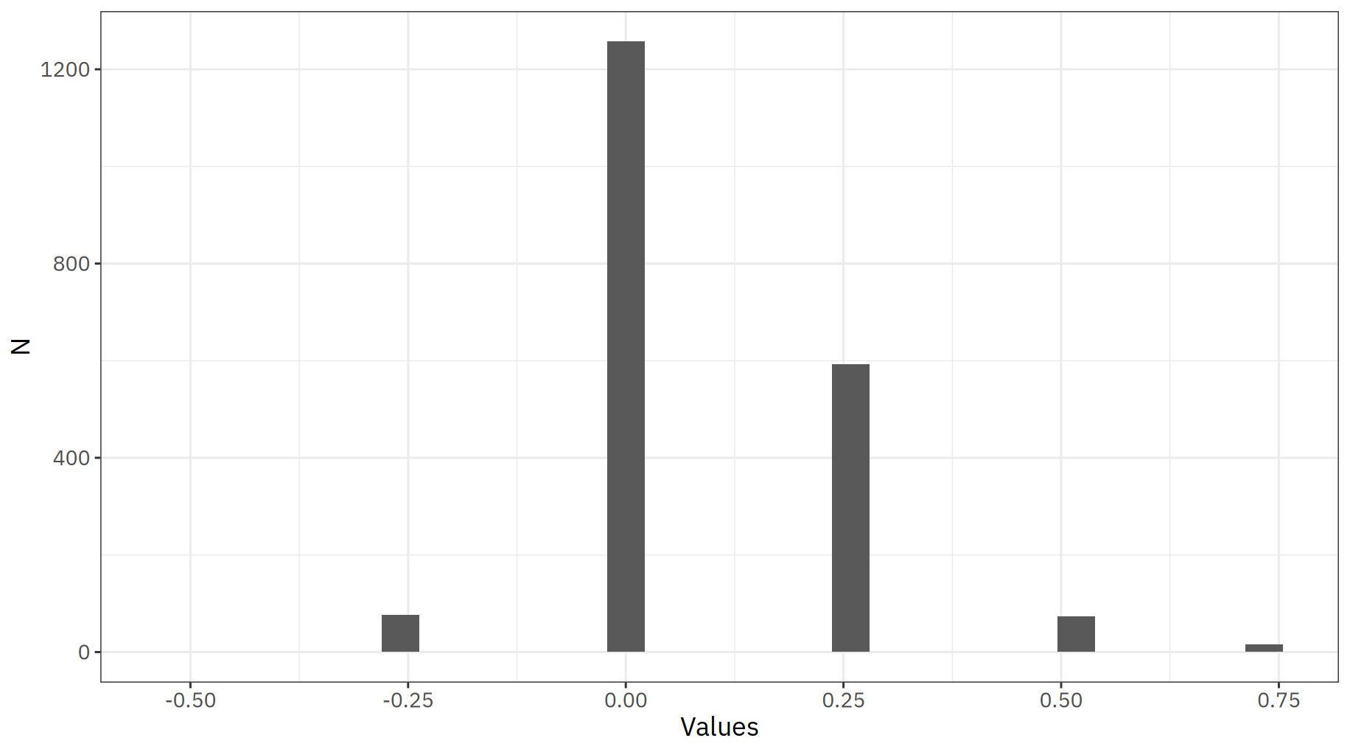

Table A.3: Multinomial logistic regression models
 | (1) |  | (2) |  | (3)
 | worsen | improve | worsen | improve | worsen | improve
RRF grants & loans (as % of GDP) | -0.069 | 0.082+ | -0.098 | 0.087* | -0.117 | 0.091**
 | (0.132) | (0.049) | (0.120) | (0.035) | (0.144) | (0.033)
European Semester related controls
MIP | -0.325 | 0.105 | -0.352 | 0.114 | -0.692 | -0.132
 | (0.898) | (0.316) | (0.876) | (0.313) | (0.711) | (0.319)
Mean number of CSRs (2011-19) | -0.715*** | 0.021 | -0.568*** | 0.037 | -0.584*** | 0.064
 | (0.071) | (0.033) | (0.128) | (0.044) | (0.138) | (0.044)
Assessment in 2021 | 3.998*** | -6.467*** | 3.830*** | -6.520*** | 8.303*** | -6.639***
 | (1.113) | (1.031) | (1.163) | (1.039) | (2.363) | (1.148)
Macroeconomic controls
GDP growth |  |  | 0.051 | 0.015 | 0.065 | 0.018
 |  |  | (0.070) | (0.017) | (0.080) | (0.018)
Unemployment rate |  |  | -0.334 | 0.099 | -0.324 | 0.091
 |  |  | (0.305) | (0.105) | (0.358) | (0.104)
Inflation rate |  |  | 0.038 | 0.078** | 0.049 | 0.078**
 |  |  | (0.083) | (0.024) | (0.098) | (0.026)
Institutional controls
Electoral year |  |  | 0.144 | 0.052 | 0.155 | 0.057
 |  |  | (0.229) | (0.107) | (0.268) | (0.110)
Period under EAP |  |  | 11.101*** | -0.289 | 11.919*** | -0.189
 |  |  | (1.391) | (0.625) | (1.680) | (0.601)
RRF relevant CSR |  |  | -0.416 | 0.281 | -1.302* | 0.479
 |  |  | (0.567) | (0.397) | (0.571) | (0.426)
Government ideology |  |  | 0.181 | 0.065 | 0.197 | 0.065
 |  |  | (0.186) | (0.061) | (0.208) | (0.065)
Policy areas
Healthcare |  |  |  |  | 0.215 | -0.227
 |  |  |  |  | (0.990) | (0.266)
Pension systems and active ageing |  |  |  |  | 2.718* | -1.096
 |  |  |  |  | (1.152) | (0.671)
Financial and fiscal governance |  |  |  |  | -2.695** | 0.817+
 |  |  |  |  | (0.890) | (0.439)
Labour market policies |  |  |  |  | -0.077 | -0.298
 |  |  |  |  | (0.608) | (0.355)
Taxation policy |  |  |  |  | -18.177*** | -0.110
 |  |  |  |  | (0.000) | (0.589)
Education skills and innovation |  |  |  |  | -0.059 | -0.105
 |  |  |  |  | (0.609) | (0.251)
Reg. devel., local public services & housing |  |  |  |  | 0.236 | 0.046
 |  |  |  |  | (0.673) | (0.242)
Energy and transport infrastructure |  |  |  |  | 0.395 | -1.235***
 |  |  |  |  | (0.619) | (0.301)
Business env. and market regulation |  |  |  |  | -0.354 | -0.203
 |  |  |  |  | (1.037) | (0.298)
Public administration |  |  |  |  | 1.152 | 0.698
 |  |  |  |  | (0.819) | (0.476)
Poverty reduction and social inclusion |  |  |  |  | -24.081*** | -0.459
 |  |  |  |  | (0.000) | (0.332)
Corruption |  |  |  |  | -12.761*** | 0.221
 |  |  |  |  | (0.000) | (0.504)
Justice system |  |  |  |  | 1.760 | -0.116
 |  |  |  |  | (1.218) | (0.584)
(Intercept) | -8.694*** | -0.340 | -9.046*** | -1.831*** | -10.689*** | -2.127***
 | (0.710) | (0.512) | (1.107) | (0.498) | (1.243) | (0.598)
Number of observations | 2017 |  | 2017 |  | 2017
McFadden pseudo R² | 0.22 |  | 0.22 |  | 0.28
AIC | 2608.2 |  | 2619.0 |  | 2492.5
BIC | 2967.2 |  | 3045.3 |  | 3064.7
Note: Statistical significance: + p < 0.1; * < 0.5; ** < 0.01; *** < 0.001. For the dependent variable, negative values have been recoded to ‘worsen’, zeros have been recoded to ‘no change’, positive values have been recoded to ‘improve’. Standard errors have been clustered at the country level using a heteroscedasticity-robust variance matrix. Country and year of evaluation fixed effects are included in all models.

Figure A.2: Effect of RFF funds on change in assessment of CSR implementation (multinomial logistic regression model)
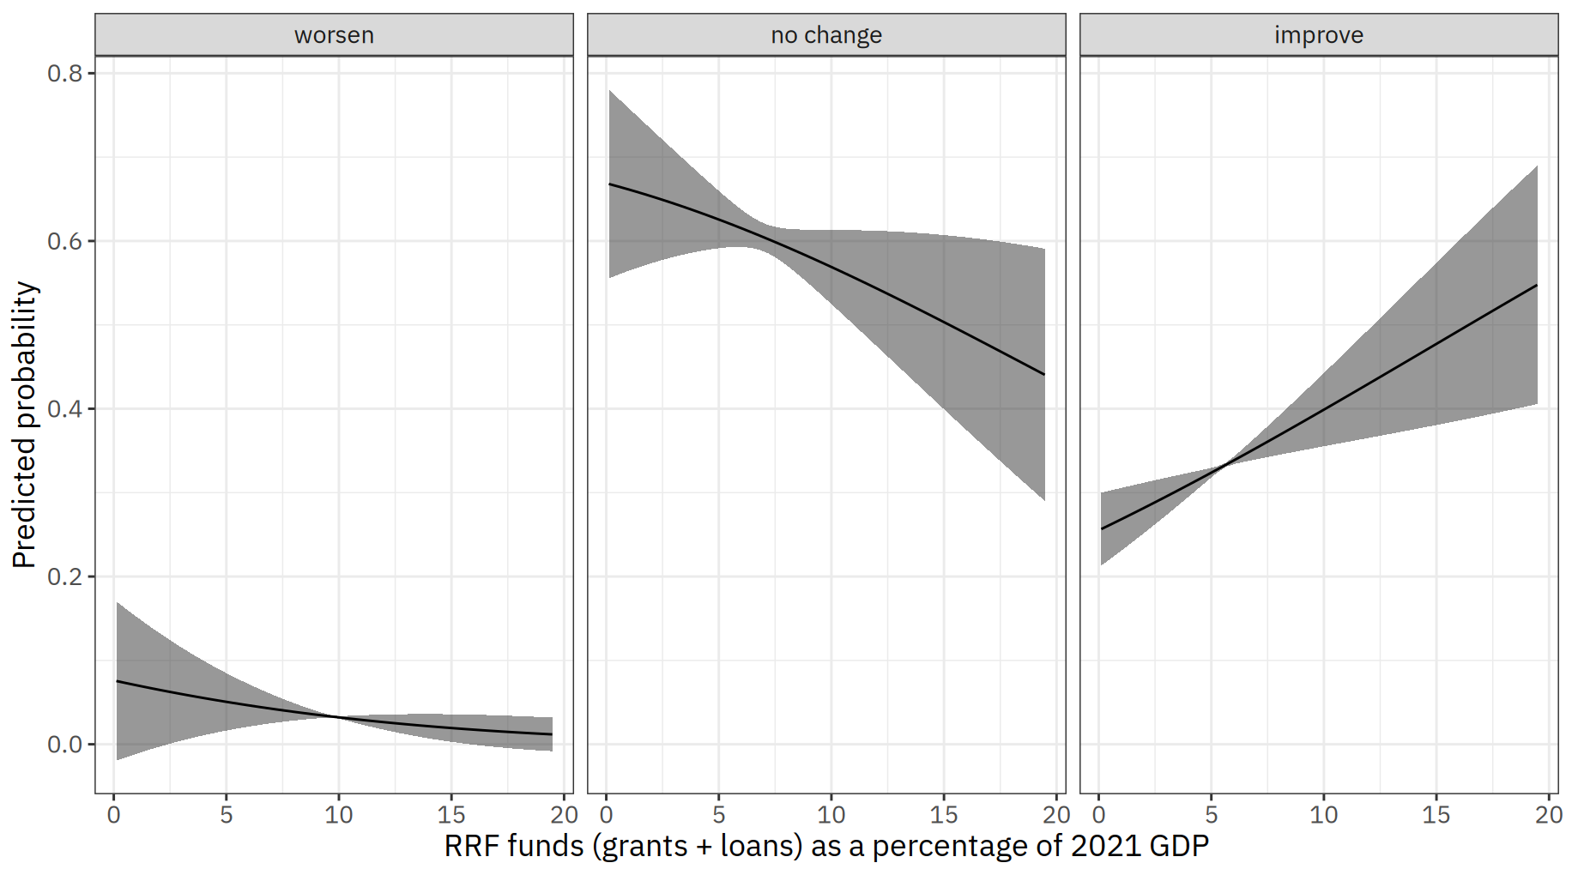
Note: Predicted values based on Model 3

