Supplementary materials

Supplementary Fig. 1: Representative chromatograms of (a) a defatted milk sample and (b) BCM-7 standard.
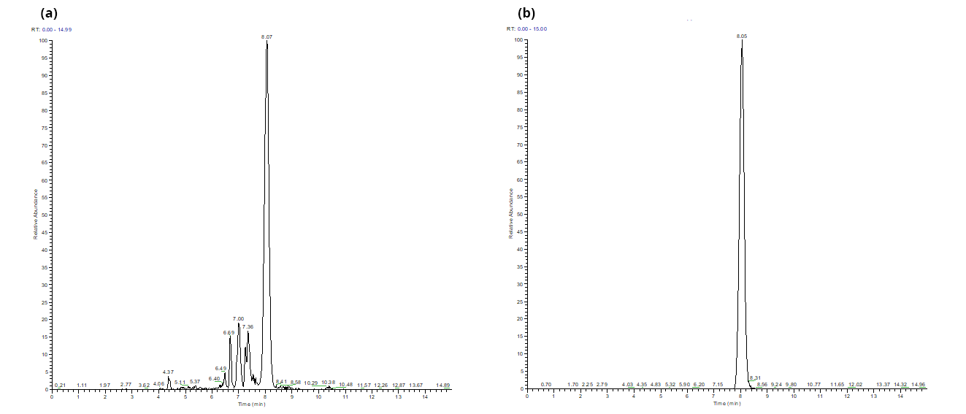

Supplementary Table 1: Concentration of BCM-7 in foods after in vitro simulated digestion, based on literature and experimental data.
Milk
sample | mg/100 g or mL | reference
1 | 0.54 | †
2 | 0.30 | †
3 | 0.49 | †
4 | 0.58 | †
5 | 0.44 | †
6 | 0.41 | †
7 | 0.40 | †
8 | 0.56 | †
9 | 0.42 | †
10 | 0.42 | †
11 | 0.12 | (De Noni and Cattaneo, 2010) ‡
12 | 0.06 | (De Noni and Cattaneo, 2010) ‡
13 | 0.10 | (De Noni and Cattaneo, 2010) ‡
14 | 0.06 | (De Noni and Cattaneo, 2010) ‡
15 | 0.05 | (Cieślińska et al., 2012) ‡
16 | 0.04 | (Cieślińska et al., 2012) ‡
17 | 0.06 | (Cieślińska et al., 2012) ‡
18 | 0.05 | (Cieślińska et al., 2012) ‡
19 | 0.07 | (Cieślińska et al., 2012) ‡
20 | 0.05 | (Cieślińska et al., 2012) ‡
21 | 0.04 | (Cieślińska et al., 2012) ‡
22 | 0.02 | (Cieślińska et al., 2012) ‡
23 | 0.04 | (Cieślińska et al., 2012) ‡
24 | 0.03 | (Cieślińska et al., 2012) ‡
25 | 0.05 | (Cieślińska et al., 2012) ‡
26 | 0.03 | (Cieślińska et al., 2012) ‡
27 | 0.03 | (Cieślińska et al., 2012) ‡
28 | 0.02 | (Cieślińska et al., 2012) ‡
29 | 0.03 | (Cieślińska et al., 2012) ‡
30 | 0.02 | (Cieślińska et al., 2012) ‡
31 | 0.02 | (Cieślińska et al., 2012) ‡
32 | 0.02 | (Cieślińska et al., 2012) ‡
33 | 2.80 | (Asledottir et al., 2017) ‡
34 | 1.86 | (Asledottir et al., 2018) ‡
35 | 0.90 | (Lambers et al., 2021) ‡
36 | 0.62 | (Lambers et al., 2021) ‡
37 | 0.57 | (Lambers et al., 2021) ‡
38 | 0.65 | (Lambers et al., 2021) ‡
39 | 0.58 | (Lambers et al., 2021) ‡
40 | 0.97 | (Lambers et al., 2021) ‡
41 | 0.64 | (Lambers et al., 2021) ‡
42 | 0.51 | (Lambers et al., 2021) ‡
43 | 0.01 | (Nguyen et al., 2021) ‡
44 | 0.01 | (Nguyen et al., 2021) ‡
45 | 0.02 | (Nguyen et al., 2021) ‡
46 | 0.01 | (Nguyen et al., 2021) ‡
47 | 0.01 | (Nguyen et al., 2021) ‡
48 | 0.02 | (Nguyen et al., 2021) ‡
49 | 1.25 | (Cattaneo et al., 2023) ‡
mean | 0.35
Cheese
sample | mg/100 g or mL | reference
1 | 1.00 | (Jarmołowska et al., 1999) ‡
2 | 0.65 | (Sienkiewicz-Szłapka et al., 2009) ‡
3 | 0.17 | (Sienkiewicz-Szłapka et al., 2009) ‡
4 | 0.10 | (Sienkiewicz-Szłapka et al., 2009) ‡
5 | 0.01 | (Sienkiewicz-Szłapka et al., 2009) ‡
6 | 0.00 | (Sienkiewicz-Szłapka et al., 2009) ‡
7 | 0.88 | (De Noni and Cattaneo, 2010) ‡
8 | 1.26 | (De Noni and Cattaneo, 2010) ‡
9 | 1.11 | (De Noni and Cattaneo, 2010) ‡
10 | 0.21 | (De Noni and Cattaneo, 2010) ‡
11 | 0.15 | (De Noni and Cattaneo, 2010) ‡
12 | 1.04 | (De Noni and Cattaneo, 2010) ‡
13 | 2.18 | (De Noni and Cattaneo, 2010) ‡
14 | 0.54 | (De Noni and Cattaneo, 2010) ‡
15 | 0.72 | (De Noni and Cattaneo, 2010) ‡
16 | 1.52 | (De Noni and Cattaneo, 2010) ‡
17 | 3.74 | (Cattaneo et al., 2023) ‡
18 | 5.47 | (Cattaneo et al., 2023) ‡
19 | 6.84 | (Cattaneo et al., 2023) ‡
mean | 1.45

Yogurt and fermented milk
sample | mg/100 g or mL | reference
1 | 0.07 | (De Noni and Cattaneo, 2010) ‡
2 | 0.10 | (De Noni and Cattaneo, 2010) ‡
3 | 0.12 | (De Noni and Cattaneo, 2010) ‡
4 | 0.06 | (De Noni and Cattaneo, 2010) ‡
5 | 0.03 | (De Noni and Cattaneo, 2010) ‡
6 | 0.07 | (De Noni and Cattaneo, 2010) ‡
mean | 0.08
Milk powder
sample | mg/100 g or mL | reference
1 | 3.86 | †
2 | 4.88 | †
3 | 4.99 | †
4 | 9.31 | †
5 | 4.69 | †
6 | 6.11 | †
7 | 6.76 | †
8 | 7.02 | †
9 | 4.96 | †
10 | 3.14 | †
11 | 3.03 | †
12 | 2.94 | †
13 | 5.22 | †
14 | 3.38 | †
15 | 4.83 | †
16 | 5.17 | †
mean | 5.02
† experimental data from our laboratory; ‡ calculated value based on published data.

References
Asledottir, T., Le, T.T., Petrat-Melin, B., Devold, T.G., Larsen, L.B., and Vegarud, G.E. (2017). Identification of bioactive peptides and quantification of β-casomorphin-7 from bovine β-casein A1, A2 and I after ex vivo gastrointestinal digestion. Int Dairy J 71, 98-106. doi: 10.1016/j.idairyj.2017.03.008
Asledottir, T., Le, T.T., Poulsen, N.A., Devold, T.G., Larsen, L.B., and Vegarud, G.E. (2018). Release of β-casomorphin-7 from bovine milk of different β-casein variants after ex vivo gastrointestinal digestion. Int Dairy J 81, 8-11. doi: 10.1016/j.idairyj.2017.12.014
Cattaneo, S., Masotti, F., Stuknyte, M., and De Noni, I. (2023). Impact of in vitro static digestion method on the release of β-casomorphin-7 from bovine milk and cheeses with A1 or A2 β-casein phenotypes. Food Chem 404, 134617. doi: 10.1016/j.foodchem.2022.134617
Cieślińska, A., Kostyra, E., Kostyra, H., Oleński, K., Fiedorowicz, E., and Kamiński, S. (2012). Milk from cows of different β-casein genotypes as a source of β-casomorphin-7. Int J Food Sci Nutr 63, 426-430. doi: 10.3109/09637486.2011.634785
De Noni, I., and Cattaneo, S. (2010). Occurrence of β-casomorphins 5 and 7 in commercial dairy products and in their digests following in vitro simulated gastro-intestinal digestion. Food Chem 119, 560-566. doi: 10.1016/j.foodchem.2009.06.058
Jarmołowska, B., Kostyra, E., Krawczuk, S., and Kostyra, H. (1999). β-Casomorphin-7 isolated from Brie cheese. J Sci Food Agric 79, 1788-1792. doi: 10.1002/(SICI)1097-0010(199910)79:13<1788::AID-JSFA436>3.0.CO;2-T
Lambers, T.T., Broeren, S., Heck, J., Bragt, M., and Huppertz, T. (2021). Processing affects beta-casomorphin peptide formation during simulated gastrointestinal digestion in both A1 and A2 milk. Int Dairy J 121, 105099. doi: 10.1016/j.idairyj.2021.105099
Nguyen, D.D., Busetti, F., Smolenski, G., Johnson, S.K., and Solah, V.A. (2021). Release of beta-casomorphins during in-vitro gastrointestinal digestion of reconstituted milk after heat treatment. LWT 136, 110312. doi: 10.1016/j.lwt.2020.110312
Sienkiewicz-Szłapka, E., Jarmołowska, B., Krawczuk, S., Kostyra, E., Kostyra, H., and Iwan, M. (2009). Contents of agonistic and antagonistic opioid peptides in different cheese varieties. Int Dairy J 19, 258-263. doi: 10.1016/j.idairyj.2008.10.011

