Supporting Information

Influence of Magnetic Field on the Kinetics of Ho(III) Solvent Extraction Using D2EHPA. A Comprehensive Study.
K. Wojtaszek*, A. Cristofolini, A. Popoli, K. Kołczyk-Siedlecka, R. P. Socha, M. Owińska, M. Wojnicki
*kwojtasz@agh.edu.pl

Contents
1. Abbreviations 3
2. Experimental 3
2.1 Kinetic studies 3
2.2 3rd phase analysis 4
2.3 Studies on the structure of the Ho-D2EHPA complex 5
2.4 Numerical simulations of the magnetic field 5
3. Supplementary results and discussion 6
3.1 Numerical simulations of the magnetic field 6
3.2 Kinetic studies 7
Analysis of the influence of the initial concentration of Ho(III) in an aqueous solution on the extraction process rate. 8
Analysis of the influence of the temperature on the extraction process rate. 9
Analysis of the influence of the of the pH of aqueous phase on the extraction process rate. 9
Analysis of the influence of the organic phase concentration on the extraction process rate. 10
Analysis of the influence of the magnetic field on the extraction process rate. 11
Repeatability of measurements 11
3.3 3rd phase analysis 12
XRF Analysis 13
XRD Analysis 13
XPS Analysis 13
FTIR Analysis 15
3.4 Analysis of the Ho-D2EHPA complex 15
NMR Analysis 15
3.5 Error Analysis 16

Abbreviations

- D2EHPA: di-(2-ethylhexyl) phosphate

Experimental

Kinetic studies
Solvent extraction studies were performed. The aqueous phase was Ho(III) ions solution, while the organic phase was di-(2-ethylhexyl) phosphate (D2EHPA) solution in the commercial solvent Orlesol 110/170 (a mixture of hydrocarbons with the number of carbon atoms mainly in the range from C7 to C12, with absolute density: ~0.820 g/cm³ at 15$℃$, melting point /solidification: < -20$℃$ and boiling point in the range: 110 – 180$℃$, Orlen SA, Poland). Ho(III) ions solutions were prepared by dissolving an appropriate amount of holmium (III) chloride (p.a. Onyxmet) in 0.1 M hydrochloric acid (p.a. Chempur), obtaining the final concentration of Ho(III) ions in the range of 0.00625 M - 0.1 M. The solution prepared in this way with a concentration of 0.025 M Ho(III) ions was mixed with an appropriate amount of 8 M sodium hydroxide solution (p.a. Chempur) to obtain solutions with a pH in the range of 1-6. pH was measured using a pH-metric electrode (Hydromet ERH-11, Poland). D2EHPA solutions in Orlesol were prepared by weighing appropriate amounts of extractant into volumetric flasks and then topping up to the calibration line with Orlesol solvent. All reagents used during the study were of the purity as shown above, without additional purification processes. In this way, D2EHPA solutions with concentrations in the range of 0.1 - 2 M were obtained. Deionized water was used in all experiments and was supplied from deionizer Polwater DL3N-150 (Kraków, Poland).
The solvent extraction kinetics was investigated via UV-Vis spectrophotometric measurements (Perkin Elmer Lambda 750, Massachusetts, USA; JascoV-780, Tokyo, Japan; Shimadzu 2501 PC, Kyoto, Japan). Before measurements, the spectrophotometers were calibrated using a holmium glass standard. The temperature control during spectrophotometric measurements was carried out using a thermostated cell equipped with a Peltier cell. The experimental setup involved monitoring UV-Vis spectra during the extraction process of a two-phase system that will be described shortly. A spectrophotometric 10 mm quartz cuvette (Hellma Analytics, catalog number: HL110-10-40) served as the measurement and experimental vessel. The upper phase consisted of the organic extractant solution, while the lower phase contained the Ho(III) ions solution. The volume ratio of the aqueous to organic phase was equal to 1:1. Throughout the experiment, Ho(III) ions migrated from the aqueous phase to the organic phase. The absorbance of the aqueous phase was monitored. The cuvette was positioned so that spectrophotometer beam passed through the aqueous phase only, which was depleted of Ho(III) ions, resulting in a decrease in absorbance over time. Importantly, no mixing occurred within the system. Ho(III) ions concentration changes were measured by the absorbance recorded at the peak maximum at 537 nm and calculated using the Lambert-Beer law. Preliminary attempts were made to perform spectrophotometric measurements of the organic phase during the extraction process, but they were not possible due to overlapping peaks coming from the D2EHPA complex with Ho(III) ions and the Orlesol solvent.
The solvent extraction in this static system is a relatively slow process. For this reason, each experiment lasted at least 16 hours. During this time, absorbance measurements were taken every 15 minutes, yielding 80 data points for each sample. Some samples underwent an 80-hour kinetics study, involving 160 measurement cycles with 30-minute intervals.
If necessary, normalization and baseline corrections of the recorded spectrophotometric spectra were performed using functions available in the Origin software (Origin 2021b, OriginLab), analogously to previous work.^{[1]} The value of the extraction coefficient for Ho(III) ions, the maximum of the most intense peak of the Ho(III) ions spectrum in the tested systems, is 4.12, which was obtained in a previously published work.^{[2]}
The study extensively examined the kinetics of Ho(III) ions migration in the classic solvent extraction process, as a baseline to research in extraction systems affected with magnetic field. Various parameters were considered, including initial concentration of Ho(III) ions in the aqueous phase in range 0.1 M - 0.00625 M, pH of the aqueous phase in range 1 - 6, concentration of the D2EHPA in organic phase in range 0.1 – 2 M, temperature in range from 5 to 35°C and the influence of a magnetic field on selected from above experimental conditions.
Magnetic field-influenced measurements were carried out using a specially designed holder equipped with 8 neodymium magnets, arranged in a "Halbach system" to concentrate the magnetic field in specific directions. Each magnet had a magnetic field strength at it surface of ~0.42T (measured with Gaussometer LakeShore). In the central part of the holder was a place for the spectrophotometer cuvette in which the extraction process took place. The system was prepared in such a way that the magnetic field was focused in the upper part of cuvette, at the height of the organic phase (Figure S1).
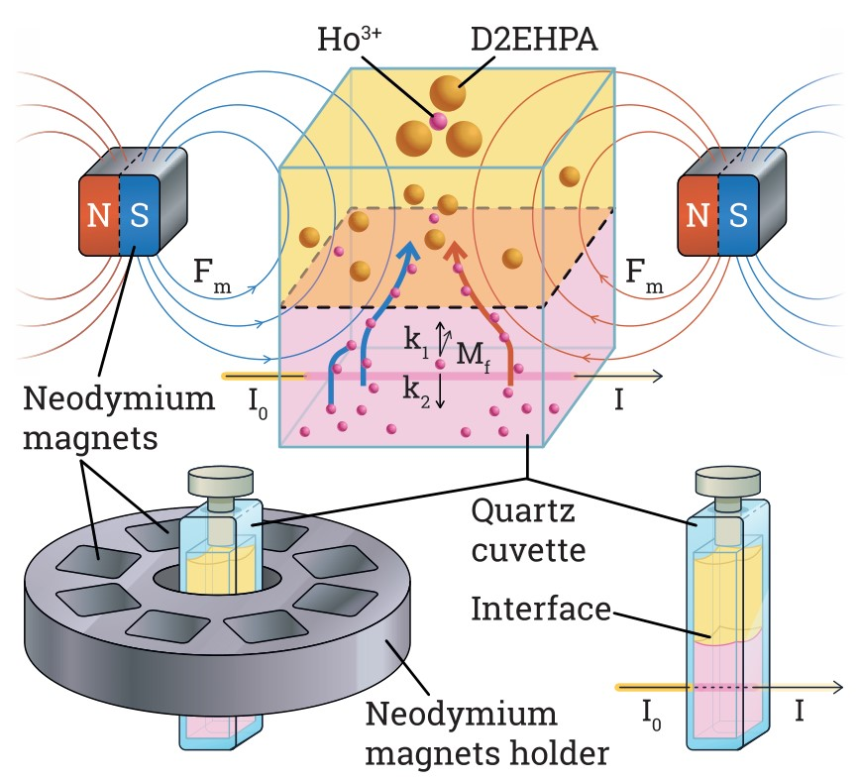
Figure S1. Experimental set-up with Halbach system as a source of magnetic field for spectrophotometric measurements.

3rd phase analysis
During the kinetics study, some D2EHPA samples exhibited the formation of a solid phase at the interface of the aqueous and organic phases, referred to as the "third phase" (3rd phase). This phase manifested as a white precipitate with noticeable magnetic susceptibility. Application of a neodymium magnet attracted the precipitate towards it.
The precipitate was separated from liquid fractions by filtration and washed with distilled water, then with Orlesol 110/170, anhydrous ethanol and finally dried in laboratory dryer (SML-32/250, Lodz, Poland). The properties of the precipitate in contact with organic solvents, acids and at elevated temperatures were investigated. The composition of the formed precipitate was analyzed using X-ray spectrofluorimetry (XRF) (Rigaku Primini II, Tokyo, Japan), and its structure was examined via X-ray diffraction (XRD) (Rigaku MiniFlex II, Tokyo, Japan). FTIR (Nicolet 380 spectrometer) spectrophotometry measurement for the precipitate (3rd phase), was performed using a solid sample adapter after dilution in spectrally pure KBr (IR grade, Acros Organics).
The XRF measurement was carried out for the angular range of 87 - 92 degrees with a step of 0.010 deg and a scanning speed of 0.5 deg/min. The device was equipped with a palladium lamp.
The X-ray diffraction measurement was performed for an angular range of 5-120$°$ 2Θ degrees, with step 0.010$°$ a scanning speed of 0.1$°$ per minute. The phase 3 sample was placed on a plastic holder and secured with hair spray. Additionally, X-ray photoelectron spectroscopy (XPS) (SES R4000, Gammadata Scienta, Sweden) was employed to analyze this precipitate.
The X-ray photoelectron spectra (XPS) of the precipitate were recorded using hemispherical analyzer EA 15 (PREVAC) equipped with dual anode X-ray source RS 40B1 (PREVAC). The measurements were performed using Al Kα (1486.7 eV) radiation and analyzer pass energy of 100 eV. The spectra ware recorded in normal emission geometry with an energy resolution of 1.1 eV. The spectrometer was calibrated with the Ag, Au and Cu foil according to ISO 15472:2010 standard. The ultra-high vacuum (UHV) conditions of 1·10⁻⁹ mbar were maintained during the measurements. The area of analysis was approximately 3 mm² and depth of analysis was about 10 nm.
The powder sample was pressed into an indium foil, mounted and positioned at the dedicated holder, pumped out to high vacuum then transferred into UHV chamber. The survey and high resolution spectra were acquired for every sample. The spectra were analyzed with the use of Casa XPS 2.3.15 software. The electron binding energy (BE) scale was calibrated for the Fermi edge at 0.0 eV. The Shirley type spectrum background was used. The highly resolved spectra were deconvoluted with Voigt function (Gauss to Lorentz profile ratio of 70:30). The spectra were compared in relation to the background level.

Studies on the structure of the Ho-D2EHPA complex
The D2EHPA 0.1 M extraction system in Orlesol was analysed before and after extraction with a 0.1 M Ho(III) ions solution using a high-resolution NMR (Bruker Avance III™ HD 600 MHz, Massachusetts, USA). Both infrared and NMR analyses aimed to identify structural changes in organic complexes following the attachment of Ho(III) ions and to assess how these changes might impact the magnetic properties of the formed complex ions.
The ¹H NMR and ¹³C NMR spectra were recorded on a Bruker Avance III (600 MHz) spectrometer whereas ³¹P NMR spectra were measured on a Jeol JNM-ECZ400S (400 MHz) spectrometer. Deuterated chloroform (CDCl₃) was used as the solvent in all experiments. The frequency scale in parts per million (ppm) in the ¹H NMR spectra were referenced to the resonance of residual protons in CDCl₃ (δ = 7.26 ppm). The position of the signals in the ³¹P NMR spectra were determined relative to an external standard, triphenylphosphine (PPh₃, δ = -4.81 ppm).

Numerical simulations of the magnetic field
The magnetic field distribution produced by the Halbach system was simulated numerically. Thanks to the static conditions and the absence of free current densities ($J=0$) in the geometrical region of interest, the magnetic field $H$ is a curl-free vector ($∇×H=0$) representing the effects of magnetization in materials. If the domain simply connected, the (static) magnetic problem can be thus formulated using a scalar magnetic potential $ψ$, such that:
$H=-∇ψ$,
where this scalar magnetic potential has the same physical properties of an electrical scalar potential (and can be thus treated numerically in the same way). Now, in presence of magnetic media (including permanent magnets) the relation between the magnetic field, the magnetic flux density and the magnetization vector is expressed by the constitutive relation $B=μ_{0}\left(H+M\right)$. Now, combining the two above relations and $∇⋅B=0$ one obtains a governing equation:
$∇⋅\left(-μ_{0}∇ψ-μ_{0}M\right)=0$.
By isolating the magnetic scalar potential in Eq. (2):
$∇^{2}ψ=-∇⋅M$,
which can be rewritten to mirror an electrostatic Poisson problem by relating the magnetization vector to a magnetic charge density $ρ_{m}=-∇⋅μ_{0}M$. ^{[3]}
$∇^{2}ψ=-\frac{ρ_{m}}{μ_{0}}$.
The former reduces to a Laplace-type equation when there are no permanent magnets. The above relation can then be expressed in weak form with well-known procedures ^{[4]} and therefore discretized by means of a finite element method.

Supplementary results and discussion

Numerical simulations of the magnetic field

Figure S2 (A) shows the meshed geometry. A structured quadrilateral mesh is used for the permanent magnets, where each magnet discretized by a $15×15×15$ element grid. The same is done for the cuvette ($30×30×40$ grid), albeit using a decreasing element density along the $z-$direction (cuvette axis). The characteristic mesh length is $∼0.5 mm$ at the cuvette top face, increasing up to $∼0.8 mm$. The cuvette and Halbach system were surrounded by a spherical domain with a radius of $R_{sph}=500 mm$ shown in Figure S2 (B). The spherical domain was discretized by a non-structured tetrahedral mesh and had an external structured layer with a thickness of $0.15R_{sph}$. This additional layer was used to define the infinite element domain where the $ψ=0$ boundary condition is enforced. Finally, an inner spherical domain of radius $R_{in}=1/4R_{sph}$ surrounding the Halbach system was used to control the progressive mesh coarsening from the fine local mesh in the Halbach system region to the external boundary. The magnetic field lines distribution on a horizontal plane tangent to the magnets bottom face is shown in Figure S3.
Regarding the material properties, the magnetic susceptibility of the solution inside the cuvette was set to $5.1⋅{10}^{-4}$ to simulate a 1M concentration of Ho(III), according to the results obtained in ^{[5]}.
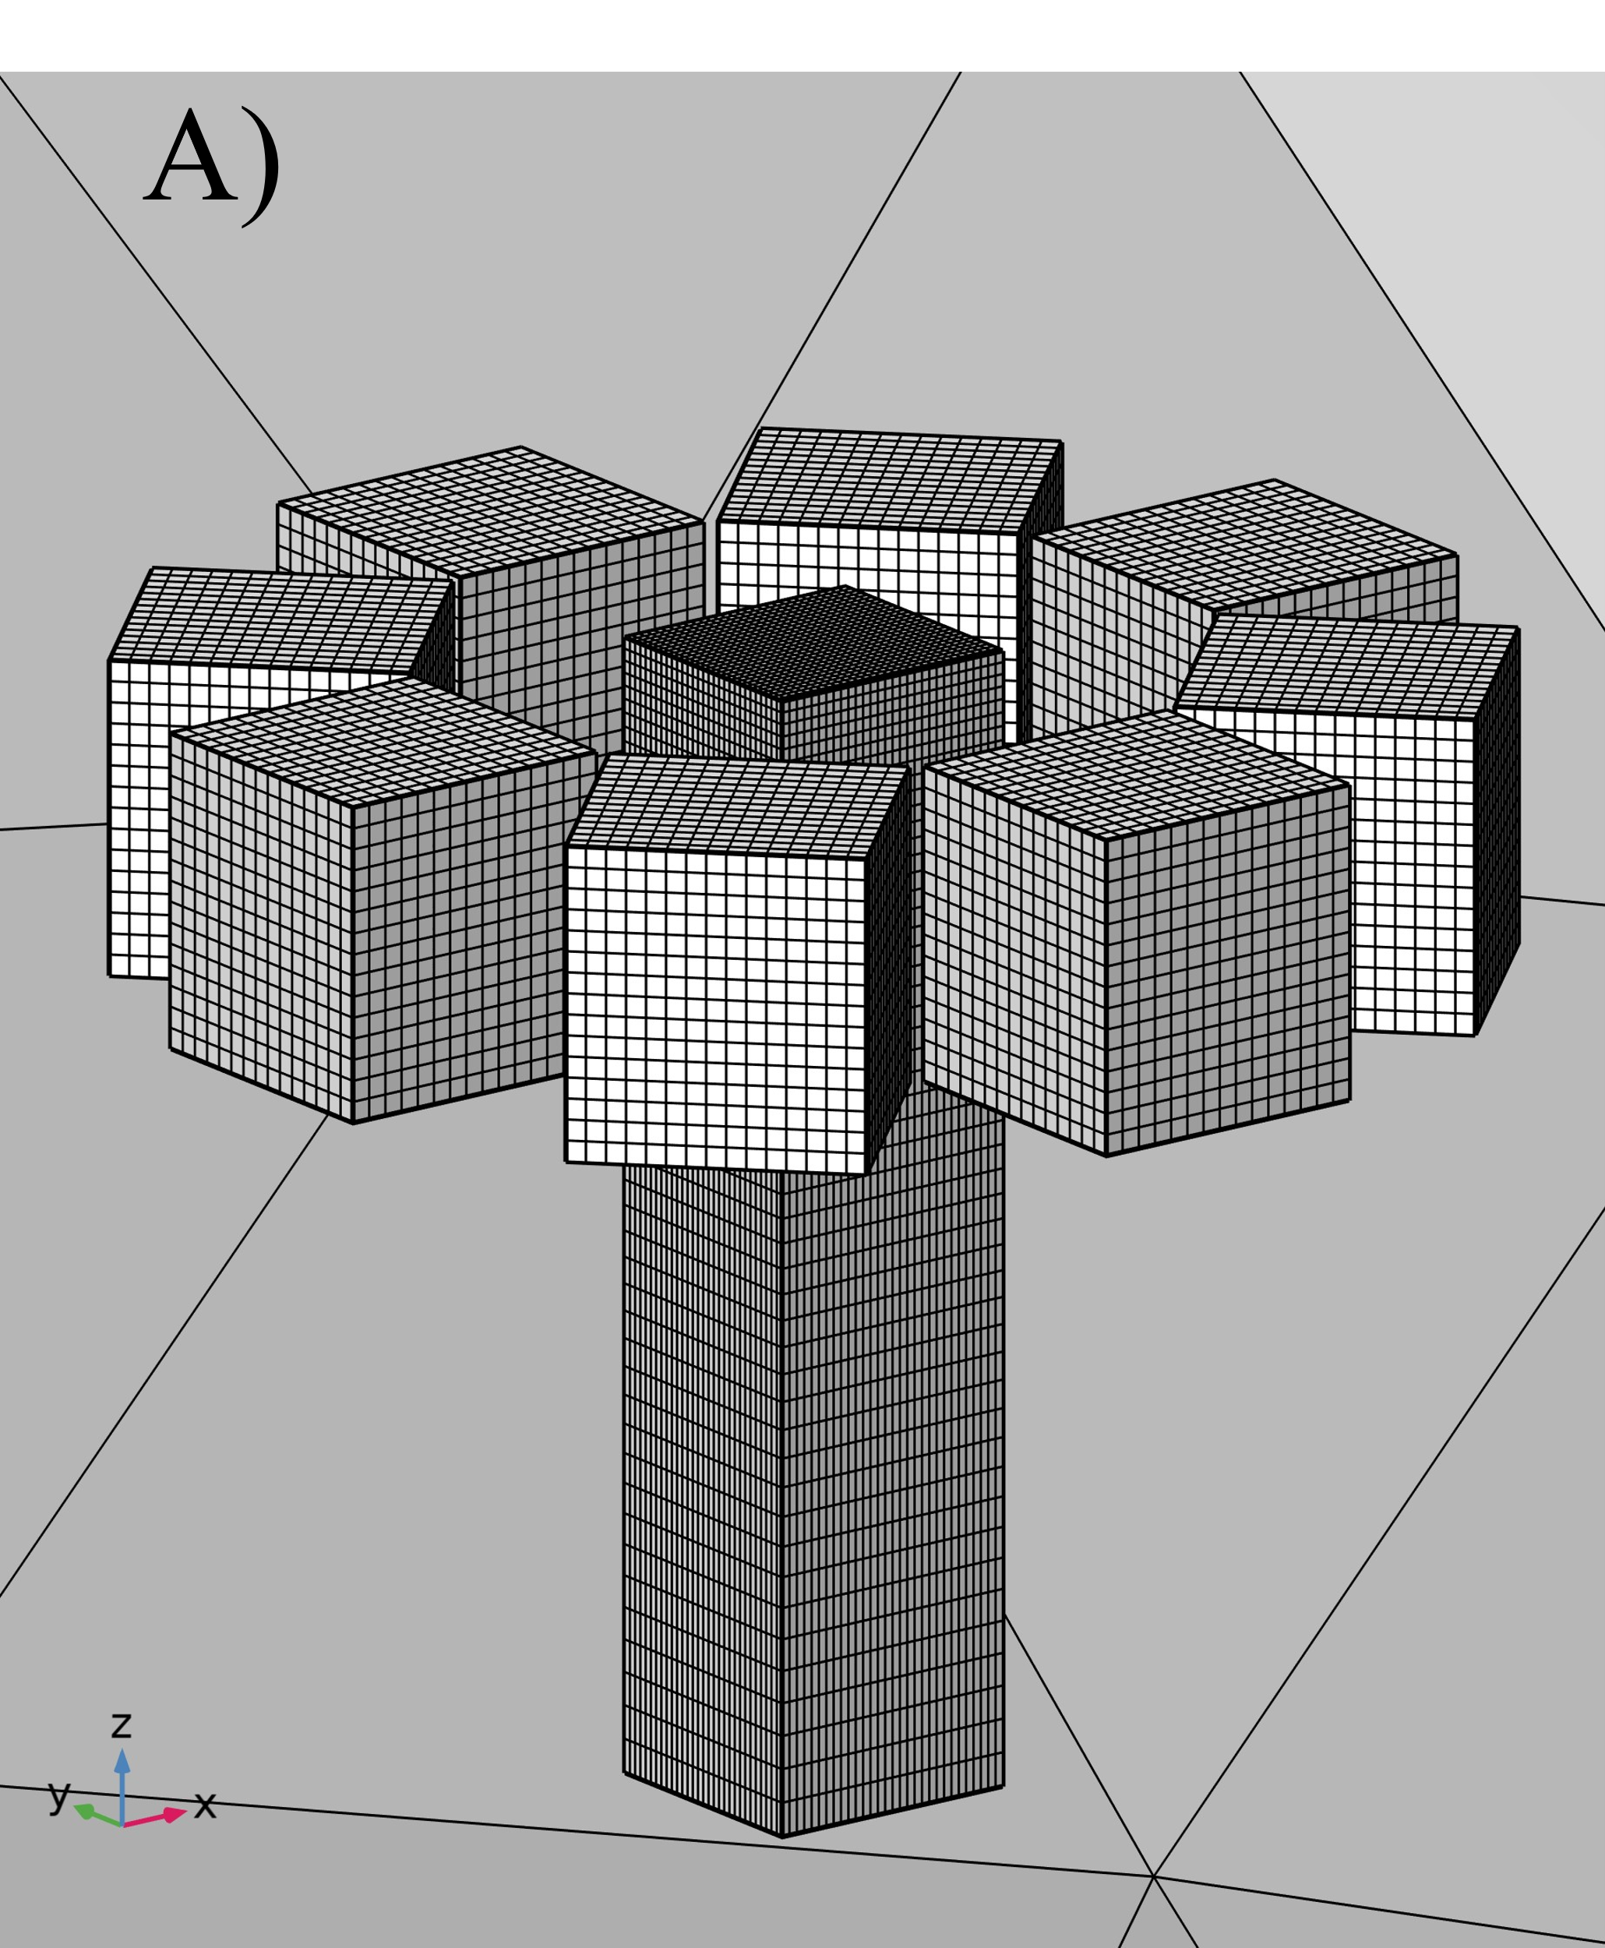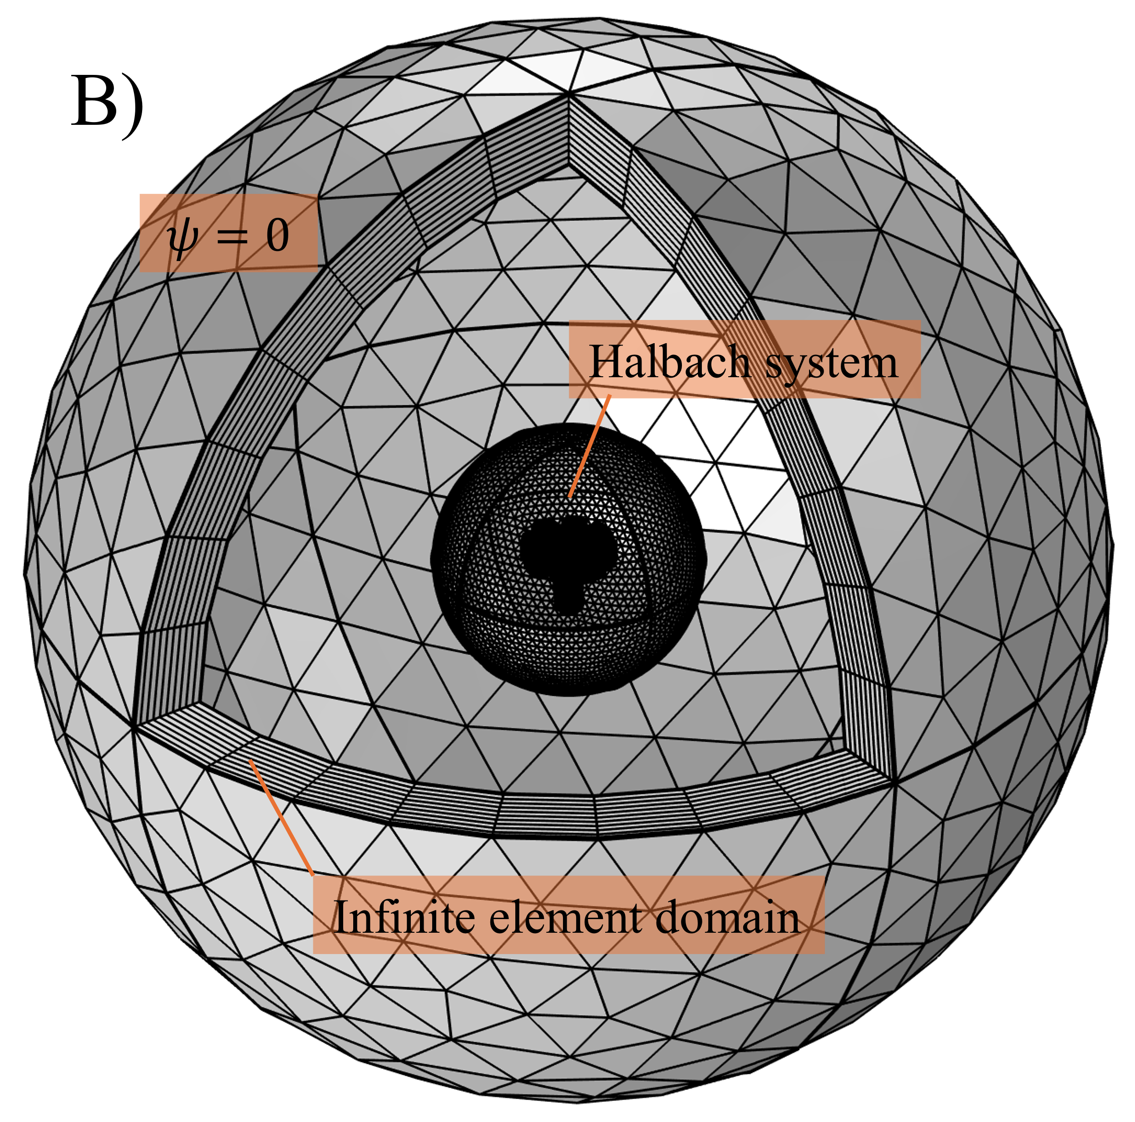
Figure S2. Cuvette and magnets structured mesh A), structure of the computational domain and boundary condition B).

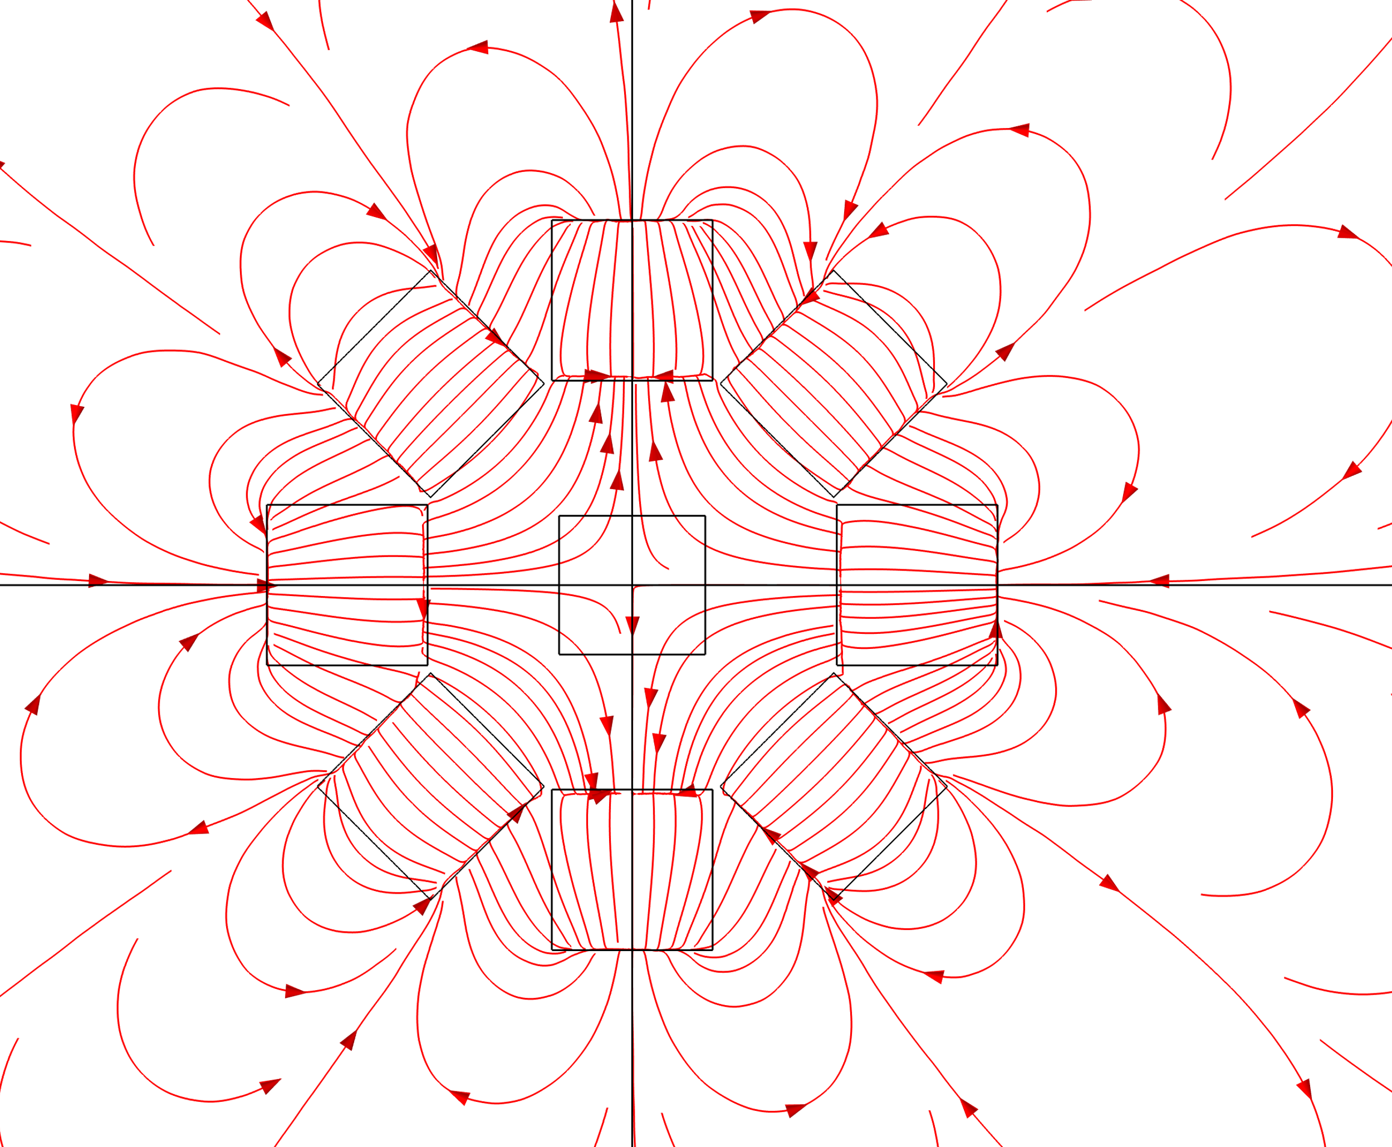
Figure S3. Magnetic field lines on a horizontal plane tangent to the magnets bottom face (see Figure S2).
Finally, Figure S4 shows a detail of the 2D field distributions within the cuvette.
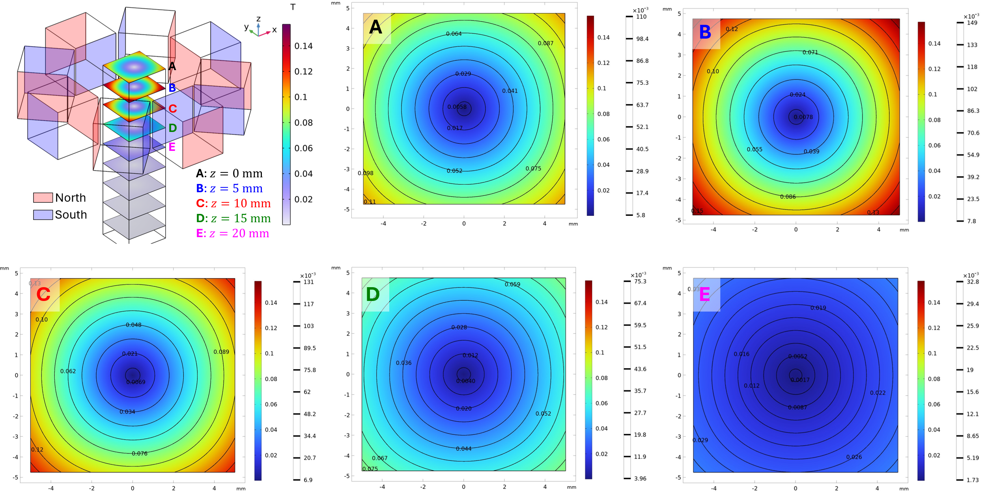
Figure S4. Magnetic flux density norm (T) surface plots. Cuvette cross-sections for selected magnetic field flux penetration depths A), z=0 mm B), z=5 mm C), z=10 mm D), z=15 mm E), z=20 mm F).

Kinetic studies
When considering an experimental series with different concentrations of Ho(III) ions in the aqueous phase, an additional variable should be taken into account, which is the ratio of Ho(III) ions to chloride ions in the system. Each solution was prepared in 0.1 M hydrochloric acid, which adds a constant concentration of hydrogen and chloride ions in the system. However, due to the fact that the precursor for the preparation of these solutions was holmium (III) chloride, this means that an additional three times the molar value of chloride ions compared to Ho(III) ions was added to the system. This means that the lower the concentration of Ho(III) ions in the target solution, the molar ratio Cl––Ho³⁺ increases significantly. Therefore, despite maintaining the same hydrogen ion concentration, it can be expected that for individual concentrations, the percentages of individual forms of complex holmium and chlorine ions will be different. This is confirmed by the calculations of stability constants for simple ions and the Ho–Cl complex depending on the concentration of chloride ions in the system, and in relation to the tested systems with different concentrations of holmium ions (Figure S5). The calculations were carried out based on literature ^{[6]}.
The temperature was assumed to be 25ºC for the calculations, and the Ho(III) ions concentration was 0.00625 M (Figure S5 A). A constant pH of 1 was assumed.
Figure S5. The influence of the mutual concentration of A)Ho(III) ions and B)Chlorine ions on the percentage of individual complex forms in the system.
It can be expected that the percentage of individual complex forms in the tested system will influence the extraction kinetics. Different forms of the complex may show different physicochemical properties, which is confirmed by previously performed studies on the magnetic susceptibility of Ho(III) ions in chloride systems ^{[5]}. The experiments carried out in this work show that individual complex forms of Ho(III) ions and chlorine ions may exhibit different magnetic properties. The experiments performed on the influence of the initial concentration of Ho(III) ions in the aqueous phase are therefore also studies on the influence of complex forms of holmium ions in chloride systems on the kinetics of extraction.

Analysis of the influence of the initial concentration of Ho(III) in an aqueous solution on the extraction process rate.
Extraction kinetics measurements were carried out for various initial concentrations of Ho(III) ions in the range of 0.00625 - 0.1 M at pH=1. Each time, a 0.1 M solution of D2EHPA in Orlesol was used as the organic phase. The temperature during the measurements was 20ºC. No magnetic field was used. The recorded kinetic curves are presented in Figure S6.
Figure S6. The influence of the initial concentration of Ho(III) ions ions in the aqueous phase on the extraction kinetics.

Analysis of the influence of the temperature on the extraction process rate.
Ho(III) ions extraction kinetics were measured in temperatures ranging from 10 to 35°C. The aqueous phase was a Ho(III) ions solution with a concentration of 0.025 M and pH = 1. The organic phase was a 0.1 M solution of D2EHPA in Orlesol, the volume ratio between aqueous and organic phase was equal to 1:1. No magnetic field was used. The recorded kinetic curves are presented in Figure S7.
Figure S7. The influence of temperature on the kinetics of extraction.
For the kinetic curves of Ho(III) ions extraction at individual temperatures, the k_{obs} values were determined, followed by the activation energy of the reaction using the Arrenius method.

Analysis of the influence of the of the pH of aqueous phase on the extraction process rate.
One of the basic variables in hydrometallurgical processes is the pH of electrolytes. In the case of ion exchange extraction, this parameter may be of key importance due to the occurrence of various ionic forms of metals depending on the pH. In this case, as first step, calculations were made of the distribution of holmium ionic forms depending on pH (Figure S8).^{[7]} Then, spectrophotometric measurements were made, aqueous solutions were used with an initial Ho(III) concentration of 0.025M. The concentration of D2EPHA in the organic phase was equal to 0.1M, the temperature during measurements was 20℃.
Figure S8. The influence of pH on the percentage of individual forms of the holmium complex in the system.
Figure S9. Change in the concentration of Ho(III) ions over time depending on the pH of water phase.
A certain dependence of the initial reaction rate on the pH of the aqueous phase was presented in Figure S9.

Analysis of the influence of the organic phase concentration on the extraction process rate.
In the next step of the experimental work, the influence of the concentration of the D2EHPA in organic phase on the rate of change in the concentration of Ho(III) ions in the aqueous phase was analyzed. The aqueous solution of Ho was used with an initial concentration of 0.025 M and a pH of 1.
Figure S10. Change in the concentration of Ho(III) ions over time depending on the concentration of D2EHPA in the organic phase.
Figure S10 presents the effect of the concentration of the organic extractant on the kinetics of extraction of Ho(III) ions from the aqueous phase.

Analysis of the influence of the magnetic field on the extraction process rate.
The experiments was carried out with an aqueous solution of Ho(III) with an initial concentration of 0.025M and pH 1. The concentration of D2EHPA was each time 0.1M. A series of experiments with a magnetic field were carried out in the temperature range from 5℃ to 35℃ (Figure S11).
Figure S11. Change in the concentration of Ho(III) ions over time depending on the temperature in the presence of magnetic field.

Repeatability of measurements
The additional kinetic curves (Figure S12) of the extraction process without a magnetic field at 20°C, initial Ho(III) concentration of 0.025M and D2EHPA concentration of 0.1M were carried out for 80h. Satisfactory convergence of the curves was obtained for two repetitions. Kinetic curves for the extraction carried out for the same conditions, in the presence of a magnetic field was repeated three times (Figure S13). In this case, the process was carried out for 20 hours, similarly to each measurement series presented in the manuscript. The obtained kinetic curves represent good convergence.
Figure S12. Kinetic curves of the Ho(III) ion extraction process for temperature of 20℃, initial Ho(III) concentration of 0.025M and D2EHPA concentration of 0.1M, without a magnetic field.
Figure S13. Kinetic curves of the Ho(III) ion extraction process for temperature of 20℃, initial Ho(III) concentration of 0.025M and D2EHPA concentration of 0.1M, with a presence of the magnetic field.

3rd phase analysis
After separating and drying, the precipitate took the form with consistency similar to polyvinylpyrrolidone - a white salt with low bulk density. It had hydrophobic properties. It did not dissolve in available organic solvents (ethanol, methanol, octanol, decanol, isopropanol, cyclohexane, hexane, dichloromethane, trichloromethane, benzene, ethyl acetate, toluene, kerosene, acetone). However, after 2 min of treating with concentrated acids (nitric, hydrochloric, sulfuric, phosphoric) precipitate took the form of a gelatinous suspension, then after another 2 minutes it changed into the organic liquid phase. During this process, the aqueous phase became light pink in artificial light and straw-yellow in natural light. This proves the transition of Ho(III) ions during the decomposition of the 3rd phase from the precipitate back to the liquid phase.
The phase 3 precipitate was also subjected to a preliminary fusibility test by placing the sample in a laboratory dryer and increasing the temperature gradually from 50$℃$ to 225$℃$ in 25$℃$ steps. However, within the given range, the precipitate did not melt.
The results of the carried tests suggest that hydrogen bonds occur in the structure of the precipitated 3-phase precipitate. This is confirmed primarily by the reaction with concentrated acids. In order to more precisely investigate the nature of the precipitate precipitated during the tests, additional composition and structure tests were carried out.

XRF Analysis
The remaining elements that are part of the tested precipitate are probably carbon, oxygen and hydrogen, which were not analyzed due to the limitations of the method.

XRD Analysis
In order to obtain reliable information about the structure of the tested precipitate, the plastic holder along with the protective layer of hair spray was measured itself, and then both graphs were compared in one drawing (Figure S14). Based on the comparative analysis, it was possible to determine which peaks come directly from the tested phase 3 precipitate. To facilitate analysis, the original plots were superimposed with plots modified by the Savitzky-Golay method. Using this mathematical interpretation of the graphs, the values of the 2Θ angle were determined for which peaks were observed that appear only on the graph for the 3rd phase.
Figure S14. X-ray diffraction pattern for 3rd phase precipitation and plastic holder as quasi-baseline graph.

XPS Analysis
The holmium-phosphorus bond may result from the occurrence of an alternative reaction path of D2EHPA and Ho(III) ions occurring during the solvent extraction process, resulting from the sub-stoichiometric amount of D2EHPA molecules. This alternative reaction path leads to the formation of another product, which is an insoluble phase 3 precipitate. The thermodynamic stability of this product is confirmed by the fact that it does not dissolve secondarily after increasing the concentration of D2EHPA in the reaction medium. The XPS spectra are shown in the Figure S15 and Figure S16.
Figure S15. XPS survey spectrum for 3rd phase precipitate.
Figure S16. Deconvolution of (a)P 2p, (b)Ho 4d, (c)C1s, (d)O 1s core excitation for 3rd phase precipitation.

The P 2p core excitation was deconvoluted into 2 doublets (Figure S16 (a)), assigned to phosphates (A component of P 2p3/2 line at BE of 134.0 eV) and P in D2EHPA (B peak at 138.6 eV).
The C 1s spectrum was deconvoluted into 4 components (Figure S16 (c)). A peak at BE of 285 eV was assigned to aliphatic chains (carbon sp3). B component at 286.8 eV indicates presence of alcohol/hydroxyl groups. C peak at 289 eV is assigned to C-O-P bonds in D2EHPA, and D peak indicates very strong electrophilic environment probably also from D2EHPA.
The O 1s spectrum was deconvoluted into 5 singlets (Figure S16 (d)). The A peak was assigned to In2O3 at the surface of the indium foil which was used as a sample substrate. B component was ascribed to hydroxyl groups at indium foil. C peak at 533.2 eV indicated water adsorbed at the analyzed surface. D and E components indicated oxygen in D2EHPA structure.
An analysis of XP spectra suggests possible differential charging at D2EHPA and In substrate, which can have an influence on interpretation of C 1s and O 1s lines components.

FTIR Analysis
Figure S17. FT-IR spectra of 3rd phase precipitate.
The precipitation of the 3-phase during extraction depends on many factors. As reported in the literature, one of the decisive factors is the solubility of the organometallic complex with the metal ion extracted in the organic phase, but also the reaction of the aqueous phase.^{[8]}

Analysis of the Ho-D2EHPA complex

NMR Analysis
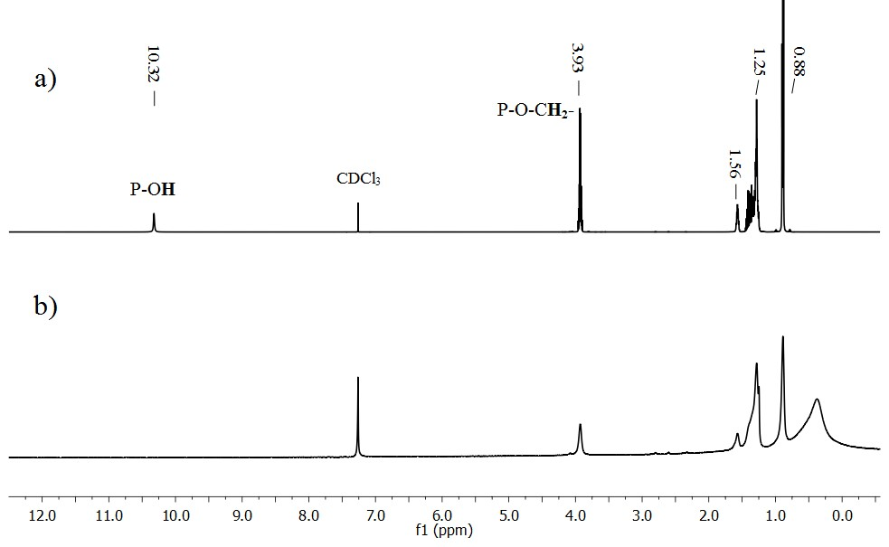
Figure S18. ¹H NMR spectra of a) D2EHPA and b) Ho_D2EHPA.
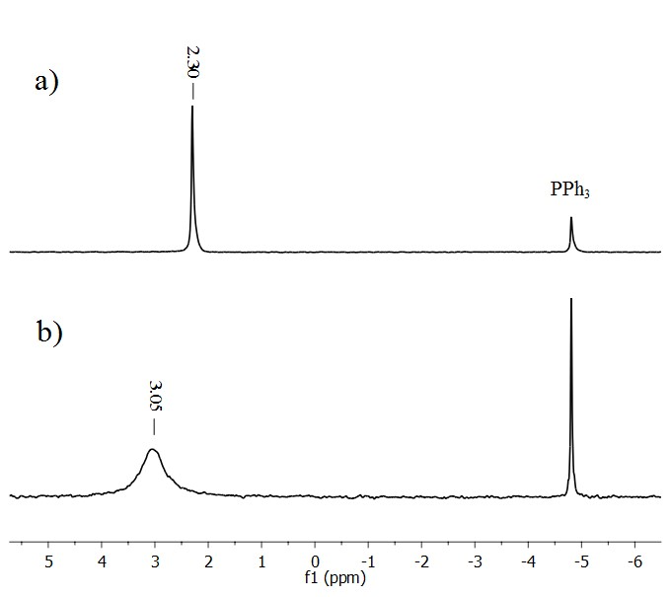
Figure S19. ³¹P NMR spectra of a) D2EHPA and b) Ho_D2EHPA.

Error Analysis

Understanding and addressing potential errors is an essential component of any experimental study, as it ensures the reliability and reproducibility of the results. In this chapter, we discuss the sources of error, methods of uncertainty evaluation, and steps taken to minimize their impact during the kinetic extraction measurements conducted in our study.
The experimental setup relied on a Jasco V-780 spectrophotometer, chosen for its high precision and repeatability. According to the manufacturer’s specifications, the spectrophotometer has a wavelength accuracy of ±0.3 nm at 656.1 nm and ±1.0 nm at 1312.2 nm. Additionally, its photometric accuracy ranges from ±0.0015 Abs for 0 to 0.5 Abs to ±0.0025 Abs for 0.5 to 1 Abs. These specifications indicate that the spectrophotometer’s inherent uncertainties are significantly smaller than the variability introduced during the extraction process itself. As a result, the instrument can be confidently excluded as a primary source of error.
Solution preparation was another critical aspect of the experimental workflow. We adhered to good laboratory practices to ensure consistency and minimize variability. Certified Class A volumetric glassware, such as 50 mL volumetric flasks with an uncertainty of ±0.06 mL, was used throughout. Precision pipettes and laboratory scales with an accuracy of ±0.0001 g ensured reproducible sample preparation. For instance, typical salt weights of 0.5 g were measured with a level of precision that minimized deviations. By standardizing these steps, the risk of systematic errors due to solution preparation was substantially reduced.
The primary source of experimental uncertainty in this study arises from the positioning of the magnet relative to the measurement cuvette during kinetic extraction experiments. Based on numerical simulations of the magnetic field distribution, the field strength varies proportionally to the inverse square of the distance from the magnet .This means that even minor deviations in the magnet's position can result in significant variations in the magnetic field strength, directly impacting the observed extraction kinetics.
Unfortunately, the precise tolerance of the magnet's position within the custom-designed magnet holder used in our experiments is unknown. While the workshop manufacturing tolerance for the holder is approximately ±0.5 mm, it is challenging to ascertain how this positional variability translates into deviations in the field strength at the cuvette. Consequently, we could not perform a detailed error calculation or propagate uncertainties stemming from this factor.
Given the above limitations, we focused on minimizing potential alignment errors during the experimental setup by carefully positioning the magnet and ensuring consistent alignment throughout all experiments. Nevertheless, without a precise measurement of the positional tolerance, the exact impact of this error source on the results remains uncertain.
While we acknowledge this limitation, the study's findings highlight the significant influence of the magnetic field on extraction kinetics, which warrants further investigation. In future work, we aim to refine the magnet holder design to include precision alignment features, enabling better control and quantification of magnetic field variability.

Literature
[1] K. Kolczyk-Siedlecka, M. Wojnicki, X. Yang, G. Mutschke, P. Zabinski, Journal of Flow Chemistry 2019, 9, 175-185.
[2] K. Wojtaszek, K. Kołczyk-Siedlecka, F. Cebula, T. Michałek, M. Wojnicki, 2022, 515-521.
[3] H. A. Haus, (Ed.: J. R. Melcher), Prentice Hall, Englewood Cliffs, N.J. :, 1989.
[4] J.-M. Jin, Third edition ed., John Wiley & Sons Inc., Hoboken. New Jersey, 2014.
[5] K. Wojtaszek, A. Cristofolini, A. Popoli, K. Kołczyk-Siedlecka, M. Wojnicki, The Journal of Physical Chemistry A 2024, 128.
[6] Y. Hasegawa, K. Takashima, F. Watanabe, Bulletin of the Chemical Society of Japan 2006, 70, 1047-1052.
[7] S. A. Stepanchikova, R. P. Biteikina, Russian Journal of Inorganic Chemistry 2006, 51, 1315-1319.
[8] C. S. Kedari, T. Coll, A. Fortuny, A. Sastre, Solvent Extraction and Ion Exchange 2005, 23, 545-559.

