Supporting information for

Morphologically driven sedimentation patterns on a coral reef
Greta Sartoriª*, Elisabeth L Boles^{b}, Stephen G Monismith^{b}, Peter J Mumby^{a, c}, Robert B Dunbar^{d}, Alexandra Khrizman^{d}, Lyvonsky Tatebeª, Rossella Capozzi^{e}
ªPalau International Coral Reef Center, PO Box 7086, Koror, Palau 96940
^{b}Bob and Norma Street Environmental Fluid Mechanics Laboratory, Stanford University, Stanford, California, USA 94305-4020
^{c}Marine Spatial Ecology Lab, School of The Environment, The University of Queensland, St Lucia, QLD 4072 Australia
^{d}Department of Earth System Science, Stanford Doerr School of Sustainability, Stanford University, Stanford, California, USA 94305-4020
^{e}Alma Mater Studiorum University of Bologna, Department of Biological, Geological and Environmental Sciences (BiGeA), via Zamboni 67, Bologna 40127, Italy
*Corresponding author, gretasartori94@gmail.com, ORCID: 0000-0002-8514-9183

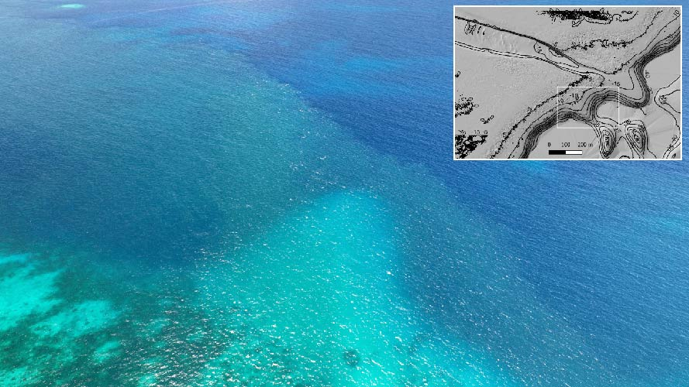
Fig. S1 Sediment plume exiting Ngel channel. The picture was taken at ebbing tide on June 29th 2022 at 11:17 am (picture by Professor Robert Dunbar)
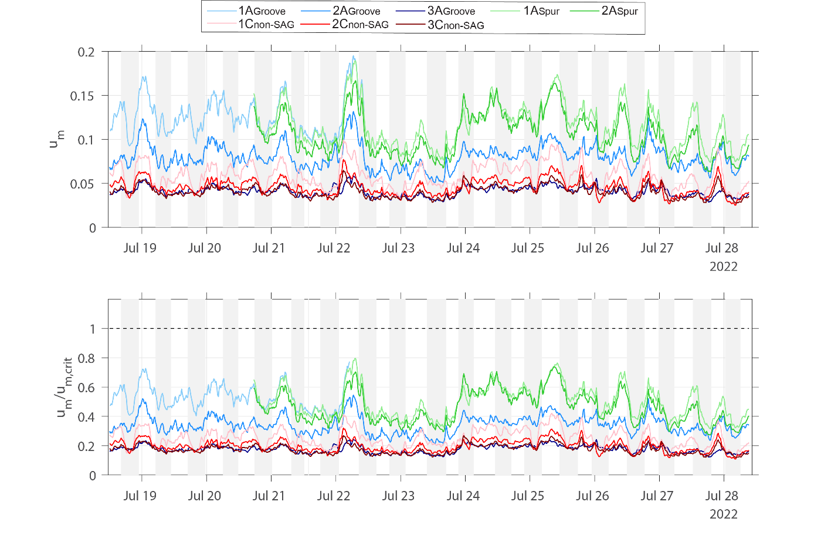Fig. S2 Critical wave velocities from July 18th to July 29th 2022 across spur and groove (SAG; 1-3A_{Groove}, 1-2A_{Spur}) and non-SAG sites (1-3C_{non-SAG}). Wave orbital velocity (above) and sediment movement threshold $u_{m}/u_{m,crit}$ (below): every time the lines of the time series go beyond 1, the sediment is expected to be suspended. The thresholds are expressed as fractions so that 1 indicates the threshold across all the time series and sites
Fig. S3 Bubble plot reporting the cumulative weight of rubble (cumulative proportion of grains > 2 mm in diameter) in SAG and non-SAG sites
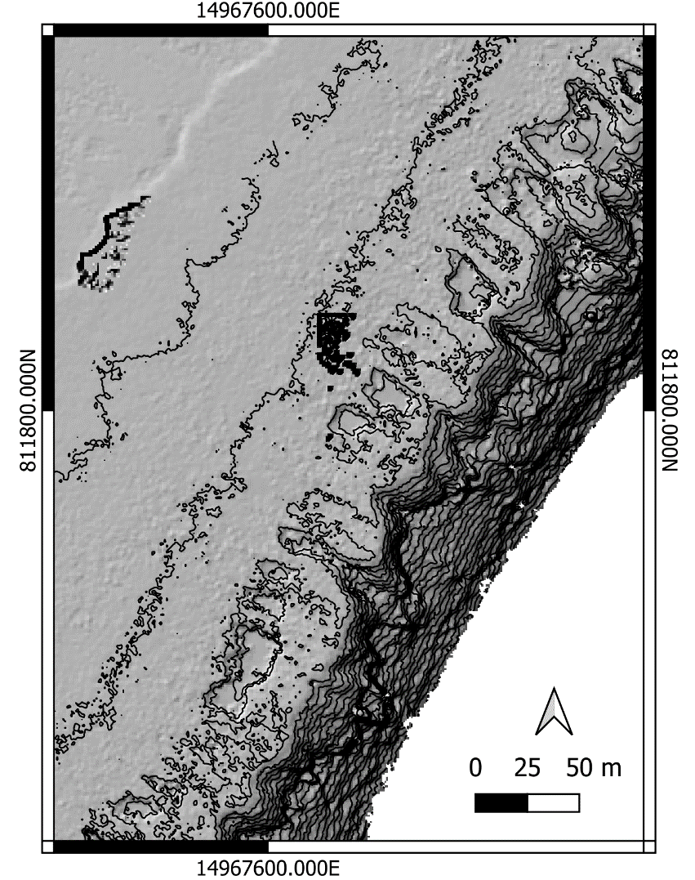
Fig. S4 LiDAR bathymetry of coalescent spur and grooves in Lighthouse Reef
Table S1 Sediment collection sites and depth with median grain size ($d50$), sorting level and graphic mean in Phi (Φ). Sorting is classified as < 0.5 Φ = well sorted, 0.5-1 Φ = moderately sorted, 1-2 Φ = poorly sorted, > 2 Φ = very poorly sorted.

Site | Sample | Depth | d50 (Φ) | Sorting (Φ) | M Φ | Gran size class
1A_{Groove} | 1 | 2.6 | 1.3 | 0.6 | 1.2 | Medium sand
2A_{Groove} | 1 | 4 | 1.4 | 0.58 | 1.45 | Medium sand
3A_{Groove} | 1 | 5.4 | 1.2 | 0.55 | 1.16 | Medium sand
1B_{Groove} | 1 | 2.3 | 1.3 | 0.65 | 1.27 | Medium sand
2B_{Groove} | 1 | 3.4 | 1.4 | 0.45 | 1.37 | Medium sand
3B_{Groove} | 1 | 5.7 | 0.7 | 0.95 | 0.47 | Coarse sand
SAG | 1 | 7 | -0.2 | 1.75 | -0.23 | Very coarse sand
1C_{non-SAG} | 1 | 3 | 1.2 | 0.75 | 1.1 | Medium sand
2C_{non-SAG} | 1 | 4 | -0.8 | 1.45 | -0.57 | Very coarse sand
3C_{non-SAG} | 1 | 4.5 | -1.4 | NA | NA | Gravel
4C_{non-SAG} | 1 | 6.1 | 0.7 | 1.7 | 0.7 | Coarse sand
1A_{Groove} | 2 | 2.6 | 1.3 | 0.65 | 1.26 | Medium sand
2A_{Groove} | 2 | 4 | 1.2 | 0.65 | 1.36 | Medium sand
3A_{Groove} | 2 | 5.4 | 1.2 | 0.83 | 1.28 | Medium sand
1B_{Groove} | 2 | 2.3 | 1.3 | 0.95 | 1.46 | Medium sand
2B_{Groove} | 2 | 3.4 | 1.4 | 0.65 | 1.5 | Medium sand
3B_{Groove} | 2 | 5.7 | 0.6 | 1.025 | 0.45 | Coarse sand
SAG | 2 | 7 | -0.2 | 1.75 | -0.23 | Very coarse sand
1C_{non-SAG} | 2 | 3 | 1.2 | 0.8 | 1.13 | Medium sand
2C_{non-SAG} | 2 | 4 | 1 | 2.7 | 1.2 | Medium sand
3C_{non-SAG} | 2 | 4.5 | -1.85 | NA | NA | Gravel
4C_{non-SAG} | 2 | 6.1 | 0.7 | 1.9 | 0.57 | Coarse sand

